Contents
Abstract 2
Introduction 3
Literature Review 5
Methodology 7
Results and Discussion 8
1. Visualisation of Audio Waves 8
2. Frequency Spectrum 9
3. Spectrogram 11
Conclusion 13
References 14

Abstract
This study presents a computational audio analysis of the multi-wavelength sonification of the Pillars of Creation, found in the Eagle Nebula from NASA’s “A Universe of Sound” audio library. Using the R programming environment, audio data of the optical layer and x-ray layer were analysed to understand the underlying astrophysical phenomena, via R’s tuneR and seewave packages. The main goal was to differentiate the acoustic characteristics of both layers, which are representations of nebular gas and proto-stellar emissions. Evaluations in both time-domain and frequency-domain were conducted using Fast Fourier Transforms (FFT) and Short-Time Fourier Transforms (STFT). The results show that the optical data is continuous, with high amplitude swells, concentrated in the low-frequency range (0-2 kHz) while the x-ray layer is sporadic, with scattered “orbs” of high amplitude distributed throughout the duration of the audio file. The audio essentially represents the nebulous gas clouds of the pillars and high energy x-ray emissions from the newborn stars within the pillars.

Introduction
Sonification is defined as mapping data to sound to represent information using non-speech audio. In recent years, sonification has become more present in the world of astronomy, which allows astronomers to conduct research using sound. Astronomers can use sonification to translate celestial objects like pulsars, cosmic microwaves, and solar eclipses into audio data. NASA has released several sonification projects, such as the Chandra X-ray observatory’s “A Universe of Sound” launched in 2020 (K. K. Arcand et al., 2024).
NASA gets the visual data for sonification from their space telescopes, namely the Hubble Space Telescope (HST) and Chandra X-ray Observatory. The Hubble Space Telescope, as described by (Lallo, 2012) is capable of imaging and spectrophotometric abilities in the optical and ultraviolet (UV) spectrum, and was expected to bring spatial resolution, sensitivity, and observable wavelength range that was unprecedented. The Chandra X-ray Observatory (CXO) is the x-ray component of NASA’s Great Observatories. Chandra provides unprecedented capabilities for sub-arcsecond imaging, spectrometric imaging, and high-resolution dispersive spectroscopy over the x-ray band (Weisskopf et al., 2000).
The Pillars of Creation are towering tendrils of cosmic dust and gas that sit at the heart of M16, or the Eagle Nebula. The Pillars of Creation are part of an active star-forming region within the Nebula and hide newborn stars in their columns. The image of the Pillars of Creation is shown below in figure 1 (NASA, 2018).
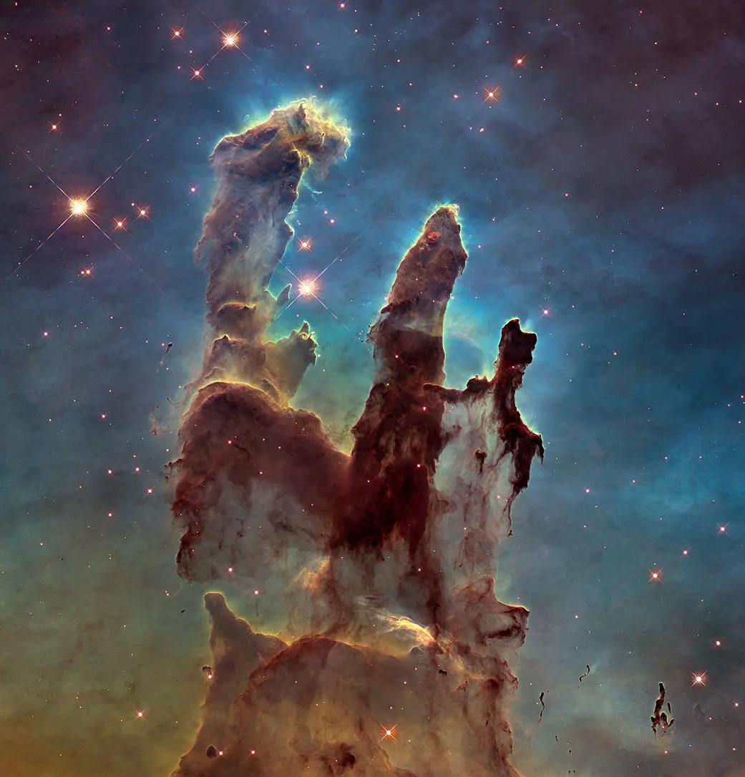
Figure 1: Pillars of Creation. Credit: NASA
The reason why both optical data and x-ray data is used to obtain visuals of cosmic bodies is due to the key differences between the two spectra of data. For instance, a comparison between the optical spectrum and x-ray spectrum was made by (Patnaude & Fesen, 2014) on the young Galactic supernova remnant Cassiopeia A (Cas A) where they highlighted differences between the spectra. One difference is the density and temperature origins. Optical emission arises from small, dense knots of ejecta with densities around 10²⁻³ cm⁻³. With relatively low electron temperatures of approximately 30,000 K. X-ray emissions on the other hand, have a much lower density, 0.1 – 1 cm⁻³ and have a much higher temperature of several million degrees Kelvin. Another difference is that optical emissions are much more susceptible to interstellar extinction along the line of sight to Cas A, whereas x-ray emissions are less obscured by interstellar dust. These key differences highlight the importance of having both optical and x-ray data for visualisation and hence, sonification of cosmic bodies.
This project will use sonification data of the Pillars of Creation from NASA’s “A Universe of Sound” project to perform audio analysis on the optical and x-ray breakdown of the composite audio data of the Pillars of Creation. This project will use the R programming language, utilizing packages like seewave and tuner to generate Time-Domain visualisations (Oscillograms) and Frequency-Domain visualisations (Spectrograms).
Therefore, the objective of this study is to perform comparative audio analysis of the multi-wavelength sonification data of the Pillars of Creation to differentiate the structures contained within the cosmic body.

Literature Review
According to (Dubus & Bresin, 2013), sonification is interdisciplinary, it can be applied to any kind of data, which makes it useful for a large set of different domains. Sonification combines numerous scientific disciplines like human-computer interactions, psychoacoustics, engineering design, human factors and ergonomics, assistive technologies, and cognitive sciences. Translating astronomical data into audio has been documented to promote learning gains, positive emotional engagement, and increased trust in scientific data from the public (K. K. Arcand et al., 2024).
In complex datasets, such as multi-wavelength observations of space structures, stacking visual layers such as X-ray, infrared, and visible light leads to visual clutter and can mask critical spatial structures and anomalies. To overcome these issues, data sonification has been increasingly used to translate the visual layers into audio for better human interpretation. Psychoacoustics suggests that the human auditory system is optimized for processing parallel, time-varying information streams and the human auditory system is also sensitive to pattern variation over time, whether perceived as discrete rhythms or changing pitch (K. Arcand, 2022)(K. K. Arcand et al., 2024).
In a systematic review of sonification strategies, (Dubus & Bresin, 2013) established that the choice of mapping has a significant impact on the listener’s ability to discern patterns and track variations in the audio. In astrophysics, mapping typically follows a spatial or spectral scanning method. According to (NASA, n.d.) the sounds for the Pillar of Creation are generated by moving horizontally across the image from left to right in both visible and x-ray light. The vertical position of the recorded light controls the pitch.
The sonification of the audio layers Pillars of Creation necessitates a time-frequency analysis, where (Sharma et al., 2013) suggests that short-time Fourier transforms (STFT) as the most basic and widely used method for analysis. The signal is compared with window functions that are concentrated in both time and frequency domains. The STFT algorithm and window function can be represented by the equation below.
$$STFT\left[s\left(t\right)\right]=S\left(τ,ω\right)= \int_{-∞}^{+∞}{s(t)χ(t-τ)e^{-jωτ}dt}$$
Where $χ(t)$ is the window function, which has a user defined time duration; and $s(t)$ is the waveform signal in the time domain.
The result of the analysis depends on the window length, where there is a trade-off between temporal and frequency resolution. If the window length is too small, there would be spectral leakage of low frequency components and when it is too large, the result would be blurry. One application of STFTs is a spectrogram. According to (Catherall & Williams, 2010), spectrograms are calculated from the intensity of STFTs. However, spectrograms are not a suitable method when analysing non-stationary signals due to the trade-off between temporal and frequency resolution.
Fast Fourier Transforms (FFT), as suggested by (Halliday et al., 2011) could provide an alternative analysis for time series wave data, like the sonification data of the Pillars of Creation. However, the authors highlighted that the drawback of FFTs is that it fails when trying to predict non-periodic time series data. Thus, in this project, this method is used to analyse the frequency spectrum of the sonification data instead of prediction.

Methodology
To evaluate the structural and spectral difference between the sonified multi-wavelength observation of M16 Pillars of Creation, an acoustic analysis was conducted using digital signal processing (DSP) algorithms. All procedures, visualizations, and analysis were executed using the R programming language, utilizing the tuner and seewave package.
The dataset is comprised of two different sonified audio layers generated by NASA’s multi-wavelength sonification pipeline: the optical spectrum data and the x-ray spectrum data.
The audio files were loaded into R using the “readWave” function. To optimize computational efficiency without compromising low-frequency characteristics of the audio file, the waveforms were down-sampled to a sampling rate of 8000 Hz using the “downsample” function.
The first phase of the analysis focused on the time-domain characteristics of the signals to visualize the amplitude of the audio waves. This is achieved using the “oscillo” function. The duration of the audio file was also obtained using the “duration” function.
The next phase of the analysis is to apply a Fast Fourier Transform (FFT) to compute the spectral density across the duration of the audio files. Using the “seewave” package, the “meanspec” function was used to get the mean frequency spectrum of the audio waves. To get a high frequency resolution, the window length parameter, “wl”, of the function was set to 4096. Next, the overlap parameter, “ovlp” was set to 50 to smooth out the spectrum.
Since the sonification of the Pillars of Creation is generated by scanning the image horizontally from left to right, a Short-Time Fourier Transform (STFT) was used to track the spectral energy over time. This is achieved by using the “spectro” function. A smaller window length, “wl” was used, which was set at 512 to get a better temporal resolution and to reduce computational load. The “dynspec” function was also used to get an animated, dynamic visualisation of the wave.

Results and Discussion

1. Visualisation of Audio Waves
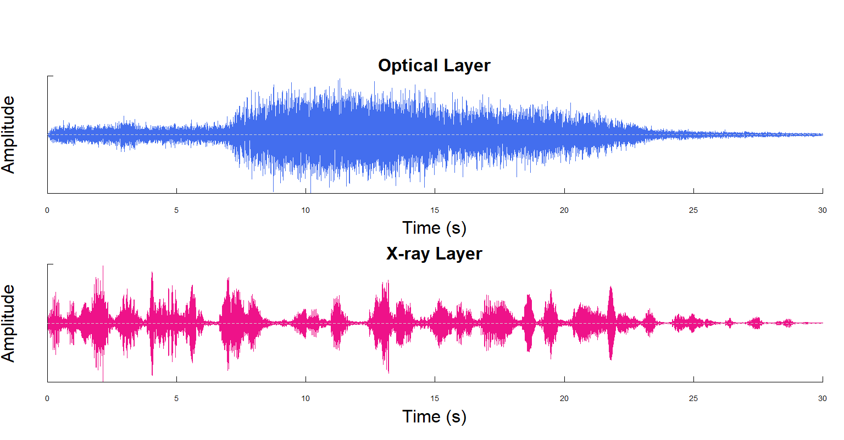
Figure 2: Oscillograms of audio waves
The blue waveform in figure 2 represents the optical layer of the sonification of the Pillars of Creation. There is an observed “swell” in the waveform. Around 8 seconds, the amplitude of the waveform rises, and sustains a high, dense volume. The amplitude starts to decline around 23 seconds. This continuous waveform represents the dense, interconnected nature of the dust and gas clouds of the Pillars of Creation.
The x-ray layer, represented by the pink waveform in figure 2, is sporadic and composed of isolated spikes in amplitude across 30 second timeline. These bursts represent the high-energy x-rays that are created from the newborn stars surrounding the Pillars of Creation (Hancock, 2025).

2. Frequency Spectrum
The frequency spectrum is the result of applying a Fast Fourier Transform to the waveforms. It represents the dominant frequencies across the entire audio file.
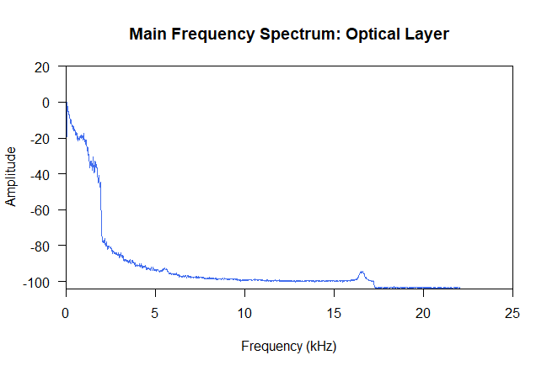
Figure 3: Optical layer frequency spectrum
The plot in figure 3 shows the frequency spectrum for the optical layer. The amplitude or energy starts very high at 0 kHz and drops sharply at around 2 kHz. This shows that the dominant frequency range of the optical layer is very low.
The conclusion is that the structure of the Pillars of Creation (the clouds/pillars), is sonified as a low, rumbling sound. There is no data in the high-frequency range for the optical layer as the line is almost flat at around -100 dB from 5 kHz to 20 kHz.

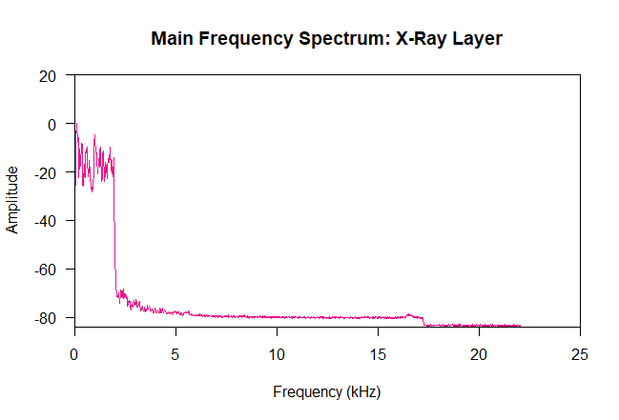
Figure 4: X-ray layer frequency spectrum
Figure 4 shows the frequency spectrum for the x-ray layer. Likewise, at around 2 kHz, the amplitude drops sharply, which suggests that the dominant frequency of x-ray layer is also very low. In contrast to the frequency spectrum of the optical layer, at 0 kHz to around 2 kHz, the amplitude fluctuates between 0 dB to -20 dB, which validates the claim that the x-ray waves are discrete, and contain high-energy.
The baseline of the x-ray spectrum is higher than the optical layer, at -80 dB. This baseline represents the “background noise“of the universe in the x-ray spectrum. Since the high-energy x-ray particles are constantly interacting with the telescope, the sensor can detect a nigher noise level.
The difference between spectrums for the optical layer and the x-ray layer is consistent with the findings of (Coats & Gunderman, 2012), who distinguish between the “hidden” high-energy emissions detectable via x-ray astronomy and light detectable in the optical band. The transition from continuous, low frequency optical structures (the gas clouds) to high-energy bursts show the difference in how the two different wavelengths interact with nebular matter.

3. Spectrogram
The plots below represent the sonification of the optical layer and x-ray layer of the Pillars of Creation. As mentioned in the introduction, the image is mapped to audio by scanning the image from left to right, where the vertical position represents the pitch and the brightness determines the amplitude. Since this is the case, when plotting the spectrogram, the shape and density of the nebular clouds of the actual Pillars of Creation can be observed.
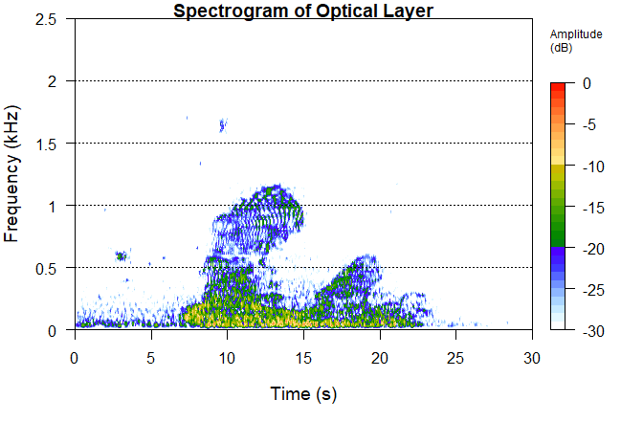
Figure 5: Optical layer spectrogram
In figure 5, from 0 seconds to around 7 seconds, the amplitude is very low, representing the less dense regions of the Pillars. The frequency range is also very low, at under 0.2 kHz.
The major part of the scan is between 7 seconds to 15 seconds, this part is the first pillar of the Pillars of Creation. There is also an increase in amplitude from the previous section, shifting from blue/green to yellow/orange. The thickest part of the dust clouds can be seen from the 0 kHz to 0.5 kHz range. Above 0.5 kHz to about 1.2 kHz, a dense, high frequency region is observed. There are also regions towards the top of this region where there is a high amplitude (about -15 dB). This part of the plot could be a representation of a bright cluster of gas.
A secondary structure can be observed from 15 seconds to 20 seconds. This structure is smaller than the first structure, which means a lower frequency. This suggests that the structure might not have a bright stellar source, which would cause the “arch” as seen in the first structure.
From 20 seconds onwards, the signal slowly fades away, mirroring the first segment of the plot, as the density of the clouds decreases.
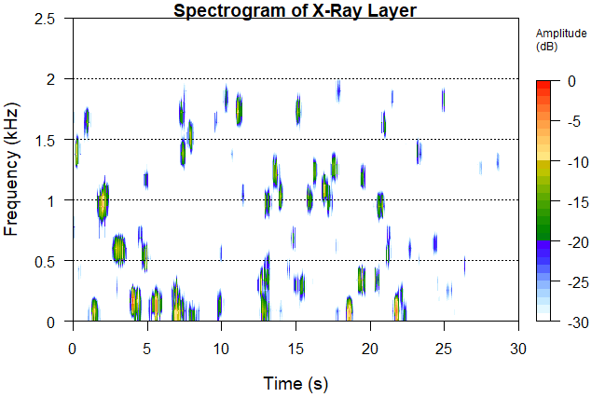
Figure 6: X-ray layer spectrogram
This spectrogram in figure 6 represents the stars surrounding the Pillars when captured using x-ray. Compared to the optical layer, the x-ray layer is more sporadic and has multiple disconnected, scattered “dots”. Each of these dots represents an individual newborn star or a cluster of newborn stars that are emitting high-energy x-ray radiation. These “dots” are scattered throughout the frequency spectrum and throughout the entire timeline, which suggests that these stars are distributed everywhere throughout the field of view. The high amplitude observed in these “dots” show that the stars emit high energy radiation.

Conclusion
This study utilizes audio analysis within the R programming environment to decode the multi-wavelength sonification of the Pillars of Creation. By applying mathematical methods like Fast Fourier Transforms (FFT) and Short-Time Fourier Transforms (STFT), this analysis can quantify and distinguish between the structural and energetic differences between the optical and x-ray layer in both the time-domain and frequency-domain. Time domain analysis using oscillograms show that the optical data is continuous and has high density structures, reflecting the characteristics of the cold, nebulous gas clouds, while in the frequency domain, the meanspec and spectro functions in R provide visualizations of the FFT and STFT which prove that the optical data is dominated by low-frequency energy (0-2 kHz), mirroring the heights of the pillars. On the other hand, the x-ray layer is distinctly different from the optical layer, where the waveform and spectrogram show a scattered distribution of high amplitude bursts of high frequency variation. As supported by (Coats & Gunderman, 2012), this profile is characteristic of the “hidden domain” of the universe, where newly forming stars embedded in the gas clouds emit high energy x-ray radiation. In conclusion, the audio analysis demonstrates that sonification, when paired with computational evaluation, is an effective tool for differentiating between passive cosmic structures and active stellar activity in unstructured datasets.

References
Arcand, K. (2022). CHANDRA’S ACCESSIBLE UNIVERSE: FROM SIGHT TO SOUND & TOUCH. Revista Mexicana de Astronomia y Astrofisica: Serie de Conferencias, 54, 53–56. https://doi.org/10.22201/ia.14052059p.2022.54.11
Arcand, K. K., Schonhut-Stasik, J. S., Kane, S. G., Sturdevant, G., Russo, M., Watzke, M., Hsu, B., & Smith, L. F. (2024). A Universe of Sound: processing NASA data into sonifications to explore participant response. Frontiers in Communication, 9. https://doi.org/10.3389/fcomm.2024.1288896
Catherall, A. T., & Williams, D. P. (2010). High resolution spectrograms using a component optimized short-term fractional Fourier transform. Signal Processing, 90(5), 1591–1596. https://doi.org/10.1016/j.sigpro.2009.11.004
Coats, G. S., & Gunderman, R. B. (2012). X-ray astronomy. In Journal of the American College of Radiology (Vol. 9, Number 1, pp. 3–6). Elsevier. https://doi.org/10.1016/j.jacr.2011.08.013
Dubus, G., & Bresin, R. (2013). A systematic review of mapping strategies for the sonification of physical quantities. In PLoS ONE (Vol. 8, Number 12). https://doi.org/10.1371/journal.pone.0082491
Halliday, J. R., Dorrell, D. G., & Wood, A. R. (2011). An application of the Fast Fourier Transform to the short-term prediction of sea wave behaviour. Renewable Energy, 36(6), 1685–1692. https://doi.org/10.1016/j.renene.2010.11.035
Hancock, E. (2025, January 14). X-ray Echoes Reveal the 3D Structure of Molecular Clouds in our Galaxy’s Center - UConn Today. https://today.uconn.edu/2025/01/x-ray-echoes-reveal-the-3d-structure-of-molecular-clouds-in-our-galaxys-center/
Lallo, M. D. (2012). Experience with the Hubble Space Telescope: Twenty Years of an Archetype.
NASA. (n.d.). Sonifications - NASA Science. Retrieved June 17, 2026, from https://science.nasa.gov/mission/hubble/multimedia/sonifications/
NASA. (2018, February 22). The Pillars of Creation. https://www.nasa.gov/image-article/pillars-of-creation/
Patnaude, D. J., & Fesen, R. A. (2014). A comparison of X-ray and optical emission in Cassiopeia A. Astrophysical Journal, 789(2). https://doi.org/10.1088/0004-637X/789/2/138
Sharma, G. K., Kumar, A., Babu Rao, C., Jayakumar, T., & Raj, B. (2013). Short time Fourier transform analysis for understanding frequency dependent attenuation in austenitic stainless steel. NDT and E International, 53, 1–7. https://doi.org/10.1016/j.ndteint.2012.09.001
Weisskopf, M. C., Tananbaum, H. D., Van Speybroeck, L. P., & O’dell, S. L. (2000). Chandra X-Ray Observatory (CXO): Overview.

