|  |  |  |  |  |  |
| --- | --- | --- | --- | --- | --- |
| **Module No:** | 1 | **IU No:** | 1 | **Exercise No.** | 1 |
| **Learner’s Name** | **Abarca, Francis Roel L.** | | BDSE-0922-113 | | |

|  |  |
| --- | --- |
| **Lab Assessment Statement** | **Assignment 1 - Build an API**  **Project Scenario,**  The scope of this assignment is to develop an API for ‘XYZ Cars Pte Ltd’ as a website developer to develop a Used Car Sales portal.  In this assignment, Users will be able to register in the portal using the  Registration Page. Users of the portal can search for Cars using Make, Model, Registration & Price Range. Users will be able to view the Car information after searching them. The portal allow users to login, post Car for sale.    These are the steps provided to build an API.     1. Create SpringBoot application [Spring Initializr.](https://start.spring.io/) Import the project in your IDE. 2. Create entities for your backend as per the scenario. 3. Create Repositories using JPA repositories. 4. Create service layer to access the data in your API 5. Create controller for your application using REST API   6. Test your API using POSTMAN tool.    **Provide the source code of developed application.**  **Provide screen capture of final result pages for API testing.** |
| **Technical**  **Environment** | -JAVA, JPA, REST API |
| **Guidelines** | - |
| **Duration** | 120 mins |

**Task View Solutions:**

**­­­­­­**Java Version:  
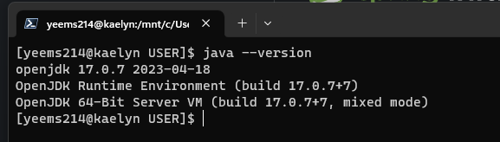

1. Create SpringBoot application using Spring Initializr then Import the project in your IDE.

* Open start.spring.io then configure the Spring Initializr to the appropriate requirements for your project.   
  A screenshot of a computer program

  Description automatically generated with medium confidence
* Add these dependencies to your project.  
  A screenshot of a computer program

  Description automatically generated with medium confidence
* Open

1. Create entities for your backend as per the scenario.
2. Create Repositories using JPA repositories.
3. Create service layer to access the data in your API 5. Create controller for your application using REST API.
4. Test your API using the Postman tool.