**Formative Assignment __**

|  |  |
| --- | --- |
| Module Name | Application Integration |
| Course Name | Bachelor’s Degree in Software Engineering |
| Assignment Title | Implement O Auth Integration for SignUp |

|  |  |
| --- | --- |
| Learner Name | Francis Roel L. Abarca |

|  |
| --- |
| Learner declaration |
| I certify that the work submitted for this assignment is my own and research sources are fully acknowledged.  Student signature: Date: 5/25/23 |

**Trainer--- University training, SSG training,**

**Content development**

**Scope of this Assignment**

The scope of this assignment is to implement O Auth Integration for SignUp

using Facebook for ‘XYZ Cars Pte Ltd’.

These are the steps provided to build an API.

1. Create developers Account on Facebook

2. Create New Application for using social integration.

3. Implement Social login using Facebook in XYZ cars Portal.

4. Use created App Id and App Secret in Application.

5. Login using Facebook.

**Task Wise Solutions**

1. Create developers account on Facebook
   1. Create your Meta Developer account then once you have created it, go to the App section.  
      A screenshot of a computer

      Description automatically generated with medium confidence
2. Create New Application for using social integration.
   1. Inside the app section, Create an App then select “Set up Facebook Login” then click Next.A screenshot of a computer screen

      Description automatically generated with low confidence
   2. Inside Facebook Login, under “Which platform will you use for your app?” select Windows App and under “Are you building a game?”, select “No, I’m not building a game” then click next.A screenshot of a computer

      Description automatically generated with medium confidence
   3. Name your app then select the appropriate App contact email and Business account you want for your app then click Create app.A screenshot of a computer

      Description automatically generated with medium confidence
   4. You will be prompted to enter your password after creation. A screenshot of a computer screen

      Description automatically generated with medium confidence
   5. Once you are done, you will be greeted with the Dashboard site for your newly created app. 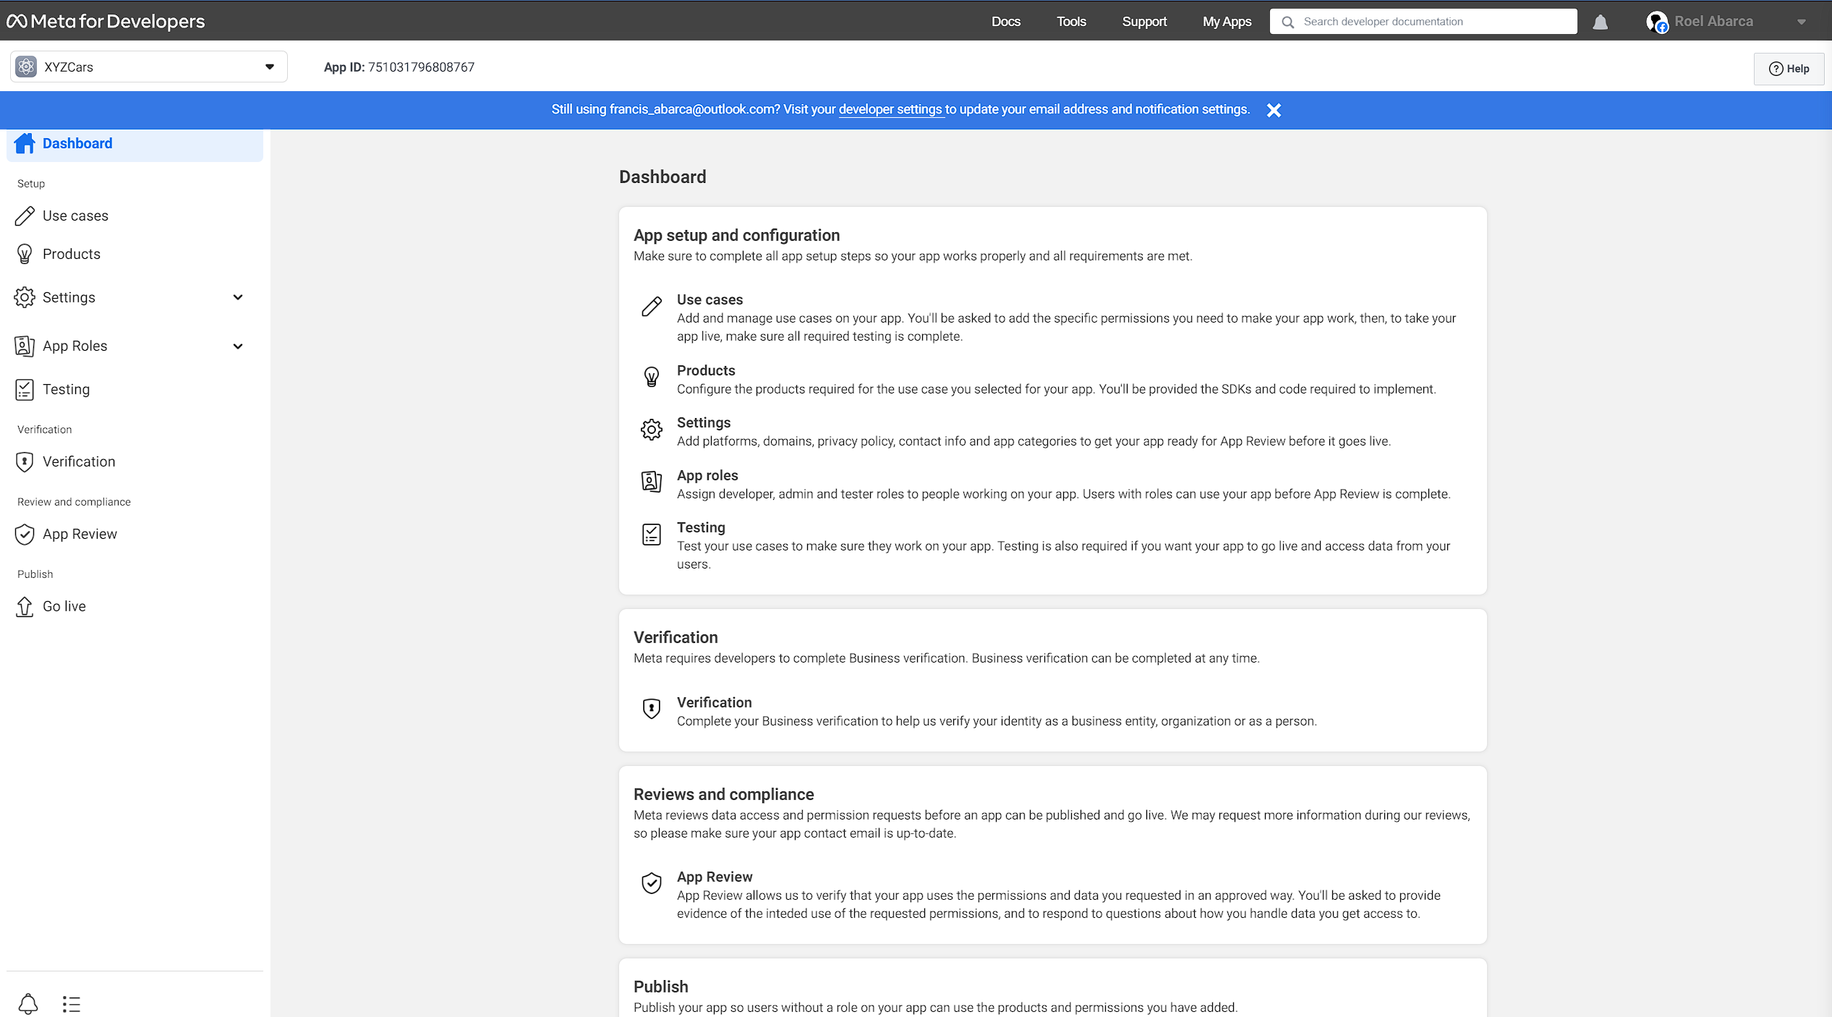
3. Implement Social login using Facebook in XYZ Cars Portal.
4. Use created App Id and App Secret in Application.
5. Login using Facebook.