**Assignment – 2**

|  |  |
| --- | --- |
| Student Name/ID Number: |  |
| Unit Number and Title: | Develop Project Proposal |
| Academic Year: |  |
| Unit Assessor: |  |
| Project Title: | Develop Enterprise Applications |
| Issue Date: |  |
| Submission Date: |  |
| Internal Verifier Name: |  |
| Date: |  |

|  |
| --- |
| **Learner declaration** |
|  |
| I certify that the work submitted for this assignment is my own and research sources are fully acknowledged.  Student signature: Date: |

# **System Requirements: In Group**

**SDLC (software development life cycle):**

### **SDLC (software development life cycle):**

**How does SDLC work?**

### **SDLC models: consider at least 4 models research:**

#### **Waterfall model**

* **What is Waterfall Model?**
* **Characteristic**
* **Where we use it?**
* **Pros and Cons**

|  |  |
| --- | --- |
| **Pros** | **Cons** |
|  |  |

* **Waterfall Model Structure**

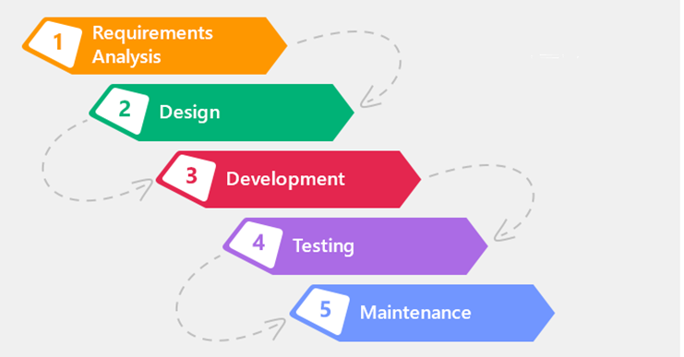

#### **Spiral model**

* **What is spiral model**
* **Characteristic**
* **Spiral model structure**

**Image**

* **When using spiral model**
* **Pros and Cons**

|  |  |
| --- | --- |
| **Pros** | **Cons** |
|  |  |

#### **V Model**

* **What is V-Model?**
* **Characteristic**
* **V model Structure**

image

* **When we use V model?**

**Pros and Cons**

|  |  |
| --- | --- |
| Pros | Cons |
|  |  |

#### **Agile model**

* **What is agile model?**
* **Characteristic**
* **Agile model structure**

Image

* **When we use agile model?**

**Pros and Cons**

|  |  |
| --- | --- |
| Pros | cons |
|  |  |

### **Selected SDLC Model**

* **Agile Module**

**Front-end Tech**

|  |  |
| --- | --- |
| **HTML** | **Pros:**  **Cons:** |
| **React JS** | **Pros:**  **Cons:** |
| **VUE js** | **Pros:**  **Cons:** |
| **Angular Js** | **Pros:**  **Cons:** |

**Back-end Tech.**

|  |  |
| --- | --- |
| Laravel | **Pros:**  **Cons:** |
| Spring Boot | **Pros:**  **Cons:** |
| **Java** | **Pros:**  **Cons:** |

**DATABASE:**

|  |  |
| --- | --- |
| MySQL | Pros:  Cons: |
| PostgreSQL | Pros:  Cons: |
| SQLite | **Pros:**  **Cons:** |

IDE:

|  |  |
| --- | --- |
| VS code | **Pros:**  **Cons:**   * VS code sometimes crashes or lags. |
| INTELLIJ IDE | * **Pros:**   **Cons:** |
| STS | **Pros:**   * Code completion is an important part of working with source code.   **Cons:** |

**Selecting Techlogies etc. :**

1. **Front-End Tech: HTML, CSS, JS**
2. **Back-end Tech.: Spring Boot**
3. **Database: SQL**
4. **IDEs: VSCode**
5. **Tools: Figma, draw.io, Google document, ERDplus**

### **DB Design: ERD diagram and EERD(Physical diagram)**

**EERD Diagram**

**Physical Diagrram**