**Assignment – 1**

| Student Name/ID Number: |  |
| --- | --- |
| Unit Number and Title: | Develop Project Proposal |
| Academic Year: | 2022-2023 |
| Unit Assessor: | Arvinder Kaur - Mentor |
| Project Title: | Develop Enterprise Applications |
| Issue Date: | 06-14-2023 |
| Submission Date: |  |
| Internal Verifier Name: | Arvinder Kaur |
| Date: | 06-14-2023 |

| **Learner declaration** |
| --- |
|  |
| I certify that the work submitted for this assignment is my own and research sources are fully acknowledged.  Student signature: Date: 06-14-2023 |

1. **Project Introduction (Group)**

**1.1. Project Background**

The "Meals On Wheels" project aims to develop an enterprise application for MerryMeals, a charitable organization. MerryMeals provides hot lunch meals to adults who are unable to cook for themselves due to age, disease, or disability. During weekdays, if the members are within 10-km radius from the outsourced kitchen, they will be provided with a hot meal. Otherwise, they will be provided with a frozen meal. During the weekend, frozen meals will be delivered to the members regardless of the distance from the outsourced kitchen. The project focuses on designing software that facilitates member and caregiver registration, partner and volunteer registration, fundraising, menu planning, meal delivery management, food safety, needs reassessment, and management information systems.

The project is being developed by a team of full-stack web developers at Unity One Solutions. The team's responsibilities include creating a software design document, conducting a feasibility study, performing risk analysis, and developing a test plan. The tools and technologies used include Visual Studio Code, PHPMyAdmin, Laravel, Spring/Spring Boot, React, Angular, Apache Tomcat, and MySQL Server.

**1.2. Pain Points**

**SWOT ANALYSIS**

SWOT is a widely used strategic planning tool in businesses and organizations. It is an acronym that represents Strengths, Weaknesses, Opportunities, and Threats. It helps assess both internal and external factors to determine the organization’s current position and develop effective strategies.

The following provides an overview of key strengths, weaknesses, opportunities, and threats associated with Meals On Wheels.

1. **Strengths**
2. Skilled, experienced, and full-stack web developers as the “Meals on Wheels” project’s team members.
3. Clear and defined project goals and objectives for the development of the "Meals on Wheels" software.
4. The reliable and efficient meal delivery system of the “Meals on Wheels” project has a positive social impact.
5. Strong support and access to resources within Unity One Solutions, the leading enterprise solution provider for effective software design and development.
6. **Weaknesses**
7. Limited prior experience in developing a Meals on Wheels software application specifically.
8. Dependency on external stakeholders, such as partners, volunteers, and food service providers, for successful implementation.
9. Need for continuous testing and refinement to ensure the software meets the specific requirements of the project.
10. Potential challenges in coordinating and managing a large team throughout the project lifecycle.
11. Possible constraints in terms of time and budget for design, development, and deployment.
12. **Opportunities**
13. Potential for integrating additional features to enhance user experience and operational efficiency and for future scalability and expansion of the "Meals on Wheels" project to serve a wider geographic area or target audience.
14. Opportunity to provide and integrate innovative technologies and features, and technologically advanced solutions for efficient meal management and delivery.
15. Potential for future partnerships with local healthcare facilities or community organizations for expanding the project's reach.
16. Potential attraction of sponsors or investors due to the project's social impact and community focus.
17. Opportunity to establish strategic partnerships with related initiatives or organizations to leverage shared resources and expertise.
18. **Threats**
19. Technological challenges or limitations that may arise during the development process.
20. Resistance or reluctance from potential users, stakeholders, or partners to adopt and engage with the software application.
21. Changing market dynamics or shifts in user preferences that may impact the demand or relevance of the "Meals on Wheels" solution.
22. Uncertainty regarding the availability and reliability of external resources required for the project's success.

**VMOST ANALYSIS**

VMOST Analysis is a type of strategic planning tool that stands for Vision, Mission, Objectives, Strategy, and Tactics. It is used to structure and communicate a long-term plan for a specific project. VMOST provides a systematic approach in aligning with the project’s efforts towards a common goal.

1. **Vision**

Providing a highly efficient and user-friendly meal delivery system to assist MerryMeals in their goal of reaching adults who are unable to cook for themselves.

1. **Mission**

Developing and implementing a web-based meal delivery and fund-raising system that enhances the efficiency of MerryMeals’ operations, simplifies user interactions, and scales to meet the needs of adults who are unable to cook for themselves.

1. **Objectives**

* Provide a user-friendly interface for the organization managers and customers to use seamlessly.
* Design a system that accommodates multiple users and processes large number of orders at the same time.
* Implement a fundraising system that can be used by organizations to help promote MerryMeals.
* Implement scalable technology infrastructure that will be capable of supporting more user interaction within the coming years.
* Continue providing support for the software for the next 5 years.

1. **Strategy**
2. **User-Centered Design**

Implement a user-centered design from the ground up to ensure website efficiency and ease of use and match the required elements made by MerryMeals and its users.

1. **Operational Efficiency Improvement**

Implement technology solutions that streamline the operations of MerryMeals and accurately improve meal delivery preparation time.

1. **Partnership Development**

Build relationships with local food suppliers and kitchens to ensure stability and reliability.

1. **Scalable Infrastructure**

Implement and design the project for scalability in mind and invest in the infrastructure when the needs increase.

1. **Pilot Testing, Iterations, and Seminars**

Launch a pilot version of the program for testing and gathering feedback then improve the system depending on the feedback received.

1. **Tactics**

* Conduct user interviews and surveys for web interface design and user experience.
* Identify potential local food suppliers, conduct outreach fundraising programs, and negotiate partnership agreements.
* Research relevant APIs and back-end technologies to be used for the project’s core system.
* Research and select a technology infrastructure solution that supports scalability, oversee its implementation and experiment with its scalability.
* Plan and execute a pilot launch for the program onto a subset of the community, grab feedback, and make necessary adjustments to the system.

**PESTLE ANALYSIS**

PESTLE analysis is a strategic framework used to assess the external factors that can impact an organization or project. It stands for Political, Economic, Social, Technological, Legal, and Environmental factors. By analyzing these factors, organizations can gain insights into the external forces that may present opportunities or pose threats to their operations, enabling them to make informed decisions and develop effective strategies.

1. **Political**

* Government regulations and policies related to food safety and distribution may impact how the website will operate.
* Government funding or grants for charitable organizations like MerryMeals can influence the availability of resources.
* Political stability and changes in leadership can affect the organization's operations and support for the project ‘Meals On Wheels’.

1. **Economic**

* Economic conditions and fluctuations may impact the availability of financial resources for the project.
* Economic disparities and poverty rates in different regions can influence the demand for the services provided by Meals On Wheels.

1. **Social**

* Changing demographics and an aging population contribute to the need for services like Meals On Wheels.
* Cultural preferences and dietary restrictions of the target audience must be considered in menu planning and preparation.
* Public awareness and support for charitable initiatives can impact fundraising efforts and community involvement.

1. **Technological**

* Advances in technology can enhance the efficiency and effectiveness of the enterprise application and its various functionalities.
* Availability of internet connectivity and access to digital devices may impact the accessibility and reach of the application.
* Integration with existing technologies and systems used by partners and volunteers is crucial for seamless operations.

1. **Legal**

* Compliance with food safety regulations and standards is essential for meal preparation and delivery for the Meals on Wheels service.
* Comply with applicable privacy laws and regulations when handling personal information of members, caregivers, partners, and volunteers. Implement appropriate security measures to protect sensitive data and ensure confidentiality.
* Respect intellectual property rights when developing the website and utilizing any proprietary technologies. Ensure proper licensing and permissions for software, libraries, or frameworks used in the development process.

1. **Environmental**

* Sustainable practices, such as using environmentally friendly packaging and minimizing food waste, align with societal expectations and may be emphasized in the project.
* Local weather conditions and natural disasters can impact the delivery of meals and the availability of resources.

**1.3. Project Objectives**

The Objectives of the Project “Meals on Wheels” are as follows:

* To properly assess customer needs using a completely automated system that provides a quick food service.
* Provide a user-friendly interface for the organization managers and customers to use seamlessly.
* Design a system that accommodates multiple users and processes large number of orders at the same time.
* Implement a fundraising system that can be used by organizations to help promote MerryMeals.
* Develop a robust database system to securely store and manage member information, meal schedules, and delivery logistics.
* Integrate with partner food service providers' systems to streamline the ordering and delivery process, ensuring quick and reliable meal delivery.
* Incorporate reporting and analytics feature to provide insights into meal distribution, member satisfaction, and resource allocation, aiding in decision-making and program improvement.
* Ensure the software solution is scalable and adaptable to accommodate future growth, additional program features, and potential expansion to other regions.
* Deliver a functional and tested software application that meets the specified requirements, aligns with industry best practices, and adheres to relevant security and privacy standards.

**1.4. Project Goals**

The primary goal of the "Meals on Wheels" project is to develop and implement a comprehensive software solution that enables Merry Meals, a charitable organization, to efficiently prepare and deliver hot noon meals to qualified adults living at home who are unable to cook for themselves or maintain their nutritional status due to age, disease, or disability. The software solution should facilitate the seamless coordination of meal preparation, delivery logistics, and member management, ensuring that eligible individuals receive timely and nutritious meals.

**1.5. Project Scope**

The project scope outlines the specific activities, deliverables, and timelines for the development of the “Meals On Wheels” web application. This includes the functions and features that the application will have and it provides a clear picture of what this project will accomplish.

1. **Design and Development**

The application will be designed with an easy-to-use interface that targets both the administrative staff and end-users’ accessibility. It will be developed using industry-standard technologies that provide the necessary functionality and security

1. **Functionality**

This application will include the following features:

1. Menu planning and preparation management
2. Meal Delivery Management with Scheduling and Routing features.
3. Registration Page for new users and organizations.
4. Fundraising platform with features that simplify online donations and fundraising campaigns.
5. Management information system for decision making.
6. Login system for existing users and organizations
7. **Testing**

This application will undergo a multitude of tests to ensure all the features are working as expected and there are no failures encountered. Tests include Unit Testing, System Testing and User Acceptance Testing. Unit Testing is done to ensure a successful and hassle-free data validation and transaction then System Testing is done to ensure reliability and scalability of the platforms and User Acceptance Testing is done to ensure ease-of-use and customer satisfaction.

1. **Training and Documentation**

Appropriate training will be conducted for all the administrative staff that will be utilizing the system. A comprehensive series of documentation will be prepared as well.

1. **Deployment and Support**

After successful testing and approval, the system will be deployed for use by the MerryMeals organization. Post-deployment support will be provided, including handling of any issues and bugs, seminars, and system upgrades for further scalability.

This project scope is crucial to managing the expectations and ensuring the project meets its defined objectives. Any changes to this scope following the project’s launch will undergo a scope change request process to evaluate its impact on project timelines and costs.

1. **Project Initiation**

**2.1. Project Stakeholder**

1. **Project Sponsor**

Meals on Wheels is a project by Merry Meals - a charitable organization that prepares and delivers meals. It has fundraising activities and donors which support the financial aspect of the project.

1. **Project Manager**

* **Name:** Mr. David
* **Position:** Manager of Unity One Solutions- a leading enterprise solution provider
* **Organization:** Merry Meals
* **Role:** Responsible for managing a team of full-stack software developers and executing the ‘Meals On Wheels’ project.

1. **Team Members**

* **Name:** Aldous, Cyril, Dimple, Francis, Kervin, and Sebastian
* **Position:** Full-stack Software Developers
* **Organization:** Merry Meals
* **Role:** Develop and Design a software application for the ‘Meals On Wheels’ project.

1. **MerryMeals’ Members**

The members of MerryMeals are the qualified adults living at home who are unable to cook for themselves or maintain their nutritional status due to age, diseases, or disability.

**2.2. Feasibility Study**

1. **Technical Feasibility**

The “Meals on Wheels” project is built as a Full Stack JavaScript/Java application which utilizes React (with JSX) for the frontend, Spring Boot for the back-end, and MySQL as the database system. We use these technologies to create our application, which includes managing deliveries, fund-raising features, registration, login, order management and more in a single place. This project aims to modernize the system of handling Meals on Wheels organizations and ensure seamless transactions for MerryMeals, its partners and customers.

1. **Economic Feasibility**

Our project, “Meals on Wheels” aims to utilize economical features and systems. One of the goals we have for this project is to make it as cheap as possible to implement and easier for MerryMeals to currently handle and have the flexibility to scale them when needs arise. The web application will be hosted on a low-cost and power efficient x86 system and the technologies used are mainly open-source software which further eliminates our reliance on other services for our project to function well.

1. **Organizational Feasibility**

In examining the organizational feasibility for the “Meals on Wheels” project, we need to assess first whether the proposed system aligns with MerryMeals’ strategic objectives if the organization has the right capacity to support its implementation and evaluate stakeholder acceptance.

1. **Strategic Alignment**

The “Meals on Wheels” project aligns with the strategic objectives of MerryMeals with the aim to modernize and streamline its operations, which would ultimately improve its efficiency that would allow MerryMeals to better serve its customers and partners. The system would also improve the organization’s fund-raising capabilities, providing an additional source of income that aligns with MerryMeals’ sustainability goals.

1. **Resource Availability**

The project leverages technologies like JavaScript, Java, React, Spring Boot and MySQL, which are common in the industry and within the skillset of the team. Hosting the system on an off-the-shelf x86 system would allow the organization’s existing hardware infrastructure to be used, which significantly reduces the need for new resource allocation.

1. **Management Support**

A modern, streamlined system like the one proposed in this project would be supported by management with the project’s easy scalability features and operational efficiency. Their commitment to allocate necessary resources and provide backing during the implementation phase is critical for the project’s success.

1. **Cultural Fit**

Given that the “Meals on Wheels” project aims for a modernization, improved operations, the proposed system aligns with its culture of embracing technology to better serve its community. The project will also highlight our organization as forward-thinking and enhancing its reputation among its customers, partners, and potential donors.

1. **Change Management**

With a dedicated plan to manage the changes arising from the new system, our organization can ensure a smooth transition. This includes seminar programs for employees to use the new system, regular updates to keep all stakeholders informed about the transition, and robust support structures for any technical assistance needed.

1. **Stakeholder Acceptance**

The new system would likely be well-received by stakeholders due to its promise of improved operations and more efficient fund-raising. To ensure their buy-in, stakeholders, including customers, partners, and staff, would be engaged throughout the development process, providing feedback and helping shape the system to meet their needs

1. **Operational Feasibility**

The “Meals on Wheels” project offers several operational benefits that demonstrate its feasibility.

1. **Enhanced Customer Experience**

The project is designed to improve the customer experience significantly. Customers will have access to meals at their convenience, and additional features like an easily navigable dishes menu will empower them to place orders effortlessly.

1. **Improved Operational Efficiency**

This project aims to streamline the order management process for the organization, making it easier to track, manage, and fulfill orders. Managers in the organization will also be able to monitor deliveries in real-time, leading to improved logistics and operational efficiency.

1. **User Acceptance**

Given the convenience and the improved service quality our project offers, we expect a high user acceptance rating from customers and the staff. The interface is built with user-friendliness in mind which reduces the learning curve and facilitating early adoption.

1. **Training and Support**

While the application is expected to be simple to use for anyone, we will provide necessary seminars and training for both the employees and customers to ensure full usability experience is met among users.

1. **Transition Plan**

To minimize disruption to the existing process, the transition to the new system will be carried out in stages. Each functionality, from order placement to delivery tracking, will be systematically tested and rolled out.

1. **Marketing Feasibility**

Our project, “Meals on Wheels”, exhibits a strong marketing feasibility due to several key factors including:

1. **Market Expansion**

This initiative has the potential to significantly broaden MerryMeals’ customer base, transcending the geographical boundaries defined by our current physical locations. The online meal delivery system will cater to customers in remote locations, increasing our market reach.

1. **Competitive Differentiation**

“Meals on Wheels” offers a unique proposition in the competitive landscape of food delivery services. Our focus on delivering hot meals and an extensive menu selection set us apart from other competitors. Additionally, we plan to leverage incentive programs to attract new customers, providing competitive deals and an exceptional user experience.

1. **Market Growth**

The online food delivery market has demonstrated steady growth over the past few years, a trend that is expected to continue. By entering this market with a strong, unique offering, we position ourselves to capitalize on this growth and secure a strong market presence.

1. **Marketing Strategy**

We plan to utilize a variety of marketing strategies to promote our new service, including social media marketing, SEO, local partnerships, and email marketing. This multifaceted approach will ensure we reach a broad audience and effectively communicate our unique value proposition.

1. **Target Demographic**

Our primary target demographic will be individuals who aren’t able to buy food easily and have no money to do so by providing convenient meal options, fundraising campaigns, and easy meal delivery. Given our unique offering and the sizeable market demand, we foresee a positive response from this demographic.

1. **Legal Feasibility**

Our “Meals on Wheels” project has been designed with careful consideration with all relevant legal requirements:

1. **Data Protection**

The proposed application is designed to comply with local data protection agencies and regulations. We prioritize our customers’ privacy, and our data processing systems have been developed to ensure all personal data is stored and used in accordance with the Data Privacy Act of 2012.

1. **Resource Feasibility**
2. **Familiarity with Application and Technology**

Our team has extensive experience and familiarity with the application of technologies required for the “Meals on Wheels” project. They are proficient in JavaScript, Java, React, Spring Boot and MySQL, and they have successfully completed similar projects in the past. Additionally, we have a thorough understanding of the functional requirements of this project, including order management, fund-raising, and delivery logistics

1. **Project Size**

The “Meals on Wheels” project, although comprehensive, falls well within the capacity of our organization to manage and execute. Our team has handled projects of similar scale and complexity before, and we have the resources and processes in place to ensure this project’s successful execution.

1. **Hardware, Software, and Network Requirements**

Our existing hardware infrastructure is compatible with the requirements of the project, minimizing the need for new investments. The project relies on software technologies that are open source, which eliminates licensing costs. For network requirements, we plan to host the system on an off-the-shelf x86 system, which will efficiently manage the online traffic and data exchange necessary for this project.

1. **Human and Financial Resources**

Our human resources have the necessary skills and experience to execute the project. Management is committed to providing the necessary financial resources for its successful completion. The choice of largely open-source technologies and the use of existing hardware infrastructure makes this project financially feasible.

1. **Support Resources**

A dedicated IT support team is in place to provide technical assistance, perform regular system updates, and address any issues that arise during the implementation and operation of the system.

**Cost Benefit Analysis**

**Cost Analysis**

| **List of cost needed** | **Description of activity** | **Total cost in month** |
| --- | --- | --- |
| Requirement gathering | Collecting and compiling project needs, expectations, and requirements. | $500 |
| Hardware | The tangible physical equipment and devices | $1,000 |
| Software | The computer programs and applications | $1,500 |
| Hosting | Server infrastructure provision | $500 |
| Maintenance | Ongoing support and upkeep | $1,000 |
| Design Implementation | Converting design into a working system | $1,500 |
| Human resource | Project team members | $5,000 |
| Marginal / urgent cost | Unexpected expenses | $500 |
| Total cost | Overall project expenses | $11,500 |
| Total cost expected | Anticipated project cost | $11,500 |

**Benefit Analysis**

| **Benefit gotten** | **Description** | **Const / Month** |
| --- | --- | --- |
| Direct benefit | -Increased meal delivery accuracy  -Enhanced member management  -Streamlined operations  -Improved efficiency | $8,000 |
| Indirect benefit | -Enhanced fundraising  -Enhanced volunteer coordination | $5,000 |

**Return On Investment**

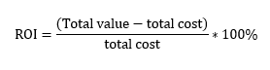

**Direct Cost and Benefit:**

Tangible and intangible costs and benefits are as follows:

**Tangible:**

* **Development Costs-** This covers the costs of recruiting a development team, purchasing essential software and hardware, and funding any licensing fees for the technologies employed.
* **Infrastructure Costs-** The organization may need to invest in servers, databases, networking equipment, and other infrastructure components to support the software application.
* **Maintenance and Support Cost-** Ongoing expenses related to maintaining and updating the software, addressing any bugs or issues, and providing technical support to users.

**Tangible Benefits:**

* **Increased Meal Delivery Accuracy:** The software solution can help in tracking and managing meal delivery, reducing errors, and ensuring that the right meals reach the right individuals.
* **Enhanced Member Management:** The system can streamline member registration, assessment, and communication processes, making it easier to manage member data and respond to their needs.
* **Streamlined Operations:** By automating various tasks such as menu planning, volunteer scheduling, and fundraising, the software can simplify and optimize organizational operations, leading to improved efficiency.
* **Improved Efficiency:** With better coordination and automation of processes, the project aims to increase overall efficiency, potentially reducing costs associated with manual tasks and minimizing wastage.

**Intangible:**

* **Time and Effort:** The project will require significant time and effort from the development team, stakeholders, and users who participate in the requirements gathering, testing, and implementation phases.
* **Disruption during Implementation:** There may be temporary disruptions or inefficiencies during the transition period when the new system is implemented and integrated into existing workflows.

**Intangible Benefits:**

* **Improved Service Quality:** By enabling efficient meal preparation and delivery, the software can enhance the quality and timeliness of services provided by Merry Meals, improving the overall satisfaction of members and caregivers.
* **Scalability and Expansion:** The software solution can be designed to accommodate growth and expansion, allowing Merry Meals to serve more individuals in need in the future.

1. **Schedule Feasibility**

The project timeline of the "Meals on Wheels" project is comprehensively assessed and evaluated, taking into consideration factors such as the scope of work, availability of resources, task dependencies, potential risks, and stakeholder involvement. Through a thorough examination and evaluation of these factors, the team can ensure that the proposed project schedule is realistic and achievable within the desired timeframe, promoting successful project execution and timely delivery of the intended outcomes.

1. **Risk Feasibility**

List of possible risk feasibility will be conducted:

* Avoid SQL Injection and hackers by implementing security.
* Maintenance will be conducted weekly.

1. **Legality Feasibility**

The "Meals on Wheels" project’s compliance with relevant laws, regulations, and legal obligations, obtaining necessary licenses, permits, adherence to zoning regulations, compliance with health and safety standards, protection of privacy, and other legal considerations specific to the project. By ensuring the project's alignment with legal requirements, we aim to mitigate any potential legal risks, maintain ethical practices, and demonstrate our commitment to conducting the project in full compliance with all applicable laws and regulations.

**2.3. UI / UX Design Consideration (Individual)**

1. **Menu Bar (Navbar)**

The menu bar, commonly known as the navbar, is essential for quick navigation and access to various areas of the application or website. It should be user-friendly and intuitive, allowing users to quickly recognize and access the needed features or pages. Considerations for the menu bar include:

* + 1. **Clear and Concise Labeling-** For each menu item, use descriptive and easily comprehensible labels to ensure consumers can immediately identify the material or functionality they are seeking for.
    2. **Logical Grouping-** Group relevant menu items together to organize them logically and intuitively. This makes it easier for consumers to find certain features or areas.
    3. **Visual Cues-** Implement visual signals such as highlighting or indicators to represent the active or chosen menu item, giving users feedback about their current location within the application or website.

1. **Content**

The content of the Meals On Wheels application should be designed with several considerations in mind to enhance the overall UI/UX experience. These considerations include:

* **Layout and Design Clarity-** Ensure that the layout of the content is visually appealing and easy to read. Use proper spacing, typography, and formatting techniques to enhance readability and comprehension.
* **Functionality-** The content should fulfill its intended purpose and provide value to the users. Whether it's informative text, interactive elements, or multimedia content, ensure that it serves a meaningful function and enhances the user experience. When it comes to the functionality of the content, specifically for login and registration, there are a few key considerations to keep in mind:

1. **Login and Registration Process-** Make sure the login and registration procedure is simple and easy to use. The processes should be straightforward and simple, with minimal barriers for users to establish an account or sign in. For increased security, combine basic practices such as email/username and password with extra authentication techniques such as social network integration or two-factor authentication.

* **Responsiveness-** In today's multi-device landscape, it is essential to design content that adapts well to different screen sizes and resolutions. Responsive design allows the content to be easily accessible and usable across various devices, including desktops, tablets, and smartphones.
* **Short Loading Time-** Optimizing the loading time of the content is crucial for a smooth user experience. Minimize unnecessary loading delays by optimizing images, reducing server requests, and employing caching techniques. Fast-loading content improves user satisfaction and reduces the risk of users abandoning the application or website due to slow performance.

1. **Visual Design**

Visual design encompasses the use of various design elements, such as colors, typography, layout, and imagery, to create an appealing and effective visual experience. It focuses on how the visual aspects of a product or application are designed and presented to users.

In the context of Merry Meals, visual design plays a crucial role in conveying the organization's mission, values, and user experience. The visual design of the "Meals On Wheels" application for Merry Meals should reflect the organization's brand identity and create a positive emotional connection with its target audience.

* **Unity-** The visual design of the "Meals On Wheels" application will prioritize several key principles to enhance the overall user experience. Unity will be emphasized by maintaining a consistent visual style throughout the application, ensuring that all elements work together cohesively and align with MerryMeals' branding. A harmonious color scheme will be employed, reflecting the organization's identity and creating a sense of unity across the interface.
* **Balance-** Elements will be distributed evenly across the screen, with careful attention to spacing and alignment. This will help establish visual equilibrium and prevent the interface from appearing cluttered. Text, images, and interactive elements will be strategically placed to maintain a sense of visual balance and optimize usability.
* **Contrast-** Contrast will be utilized to draw attention to important information and interactive elements. By employing contrasting colors, sizes, or typography, key elements will stand out from the rest of the interface. This will improve readability and guide users' focus towards critical actions and content.
* **Scale-** Scale dominance will play a significant role in establishing a visual hierarchy within the application. Important elements, such as primary navigation options, call-to-action buttons, and key information, will be emphasized through larger sizes or bolder styles. This technique will guide users' attention and help them understand the relative importance of different interface components.
* **Dominance-** Dominance in visual design refers to the principle of creating a focal point or hierarchy within a design. It involves emphasizing certain elements or visual cues to attract attention and communicate their significance. Dominant elements are typically larger, bolder, or more visually prominent compared to other elements in the design. In the context of the "Meals On Wheels" application for Merry Meals, dominance can be used to highlight important elements and guide users' attention. For example, primary navigation options, such as "Order Meals" or "Volunteer," can be visually dominant to indicate their significance and encourage user interaction. Similarly, call-to-action buttons, such as "Donate Now" or "Sign Up," can be visually prominent to encourage users to take specific actions.

**2.4. Dependencies**

1. **Logical Dependencies**

Logical dependency refers to the relationship and interconnection between tasks or activities in a project that dictates their sequencing or interdependence.

* Complete Software Design Document.
* Complete Feasibility study.
* Risk Analysis and Evaluation
* Test Plan

1. **Resource Dependencies**

Resource dependency refers to the reliance of project tasks or activities on specific resources for the project's successful execution. It is influenced by constraints.

* The availability of meals relies on the funding obtained from donors or supporters.
* The successful delivery of meals is dependent on the partnership with the food service provider and its riders.
* Problems or issues encountered by the food service providers that resulted to the inability to properly prepare and deliver meals.

1. **External Dependencies**

External dependency pertains to a factor beyond the project's control, influencing on its advancement and results.

* Delivery delays caused by natural disasters.
* Government regulations change related to the food safety, nutritional standards, and healthcare compliance.
* The effectiveness of the organization's operations may be compromised due to disruptions or limitations in the external technology infrastructure.

**2.5. Project Assumptions**

1. **Resources**

* Hardware and Software resources are needed in order to develop the Meals On Wheels website.
* A working staff that can handle orders and deliver the member’s meals.
* A strong internet connection is required for faster communication and development of the website.
* Servers and Databases for all data necessary for the Meals On Wheels service.

1. **Finance**

* Funding for the development, maintenance, and operation of the Meals On Wheels website and its services.
* A budget must be allocated for salaries for the human workers, maintaining the hardware, and gaining access to the software needed for development.
* A financial system must be put in place in order to keep track of the project’s expenses.

1. **Partner**

* Merry Meals will comply with the Food Safety System Certification (FSSC) standards.
* The food will have the necessary HALAL certification and will adhere to HALAL regulations.
* The partners should support Merry Meal’s mission and participate with the planning, preparation, and delivery process.

1. **Project**

* The Meals On Wheels website will be developed and undergo regular maintenance.
* SSL certification to ensure secure data transmission and to build trust with members.
* Regular backups of data every 10 hours.
* Estimated 1 month of work for development and testing of the website.

**2.6. Project Constraint**

1. **Client**

* Hot meals are delivered within 10km-radius from the outsourced kitchen from Monday to Friday.
* Frozen meals are delivered beyond 10km-raidius from the outsourced kitchen from Monday to Friday and on weekends regardless with the distance.

1. **Time**

* 'Merry On Wheels’ project must be developed and implemented under the range of one month.

1. **Scope**

* The project must follow a predetermined set of goals, outputs, and specifications. Any modifications or extensions to the project’s scope might be limited by the resources and time available.

1. **Cost**

* The project must be carried out within a predetermined financial plan. This may require effective management of expenses and resource distribution to remain within the specified financial constraints.

1. **Resources**

* Limited software, technology, hardware, and resources may impact the project’s timeline, scope, and quality.
* ‘Meals On Wheels’ must be completed with the available resources such as manpower, equipment, or materials.

1. **Environment**

* Convenient workplace for developer teams.
* Team members are required to maintain timely and effective communication with clients or other relevant stakeholders.

1. **Skill**

* The allocated personnel with Java expertise must possess the necessary skills that align with Meals on Wheels’ project requirements.

1. **Man Power**

* The team members are comprised with full-stack developers with expertise in Java and ReactJS.

**2.7. Project Milestone: Progress to Measure to Achieve Goals**

1. **Requirement Gathering**

The team responsible for the project “Meals on Wheels” will engage in discussions with all stakeholders of MerryMeals in order to gather insights into their visions and expectations, and understand their ideas.

1. **Validate Expectations for Requirements**

Upon completion of documenting and compiling all the requested requirements, the stakeholders will be notified about the compiled requirements and necessary information.

1. **Predevelopment Planning**

Once the requirements and development plan have been finalized, tasks and responsibilities will be distributed and allocated to each team member.

1. **Implementation**

The project's development commences, drawing upon the requirements and groundwork established during the predevelopment phase.

1. **Quality Assurance Testing**

Quality control is conducted at the conclusion of every team iteration to assess and ensure the team's work meets the requirements and the required standards.

1. **User Acceptance Testing**

In order to ensure alignment with user needs and intended functionality, the project manager actively collaborates with MerryMeals’ users and stakeholders, gathering feedback and identifying any issues that need to be resolved and concerns that require attention.

1. **Deployment**

Once the system's quality and alignment with user needs have been confirmed to meet the required standards, the project is deemed ready for deployment.

1. **Support**

After the project is successfully deployed, the developer team for the "Meals on Wheels" project will remain available to provide continued support to MerryMeals for the agreed-upon duration, offering assistance and resolving any issues that may arise.

**2.8. Project Deliverables**

1. **Internal Deliverables**

* Web design proposal and software design document (SSD)
* User Interface Design
* Database Design
* Member and Caregiver Registration Module
* Partner and Volunteer Registration Module
* Fundraising Module
* Menu Planning Module
* Meal Delivery Management Module
* Food Safety Module
* Management Information Systems Module

1. **External Deliverables**

* Finish Meal on Wheel web application
* Functional Mobile Application of Meal on Wheel
* Member/Caregiver Access Portal
* Partner/Volunteer Access Portal
* Online Donation Platform
* Communication and Notification System
* Integration with Mapping Services
* Reporting and Analytics
* User Support and Training Materials
* Security and Privacy Measures

1. **Planning Deliverables**

* Project Scope
* Budget
* Project schedule
* Resource Plan
* Risk Management Plan
* Communication Plan
* Quality Assurance Plan
* Change Management Plan
* Training and Development Plan
* Stakeholder Management Plan
* Project Kick-off Presentation

**2.9. Functional Description**

| No | User type | Description | Roles based access |
| --- | --- | --- | --- |
| 1 | Member | Customers of Meals on Wheels | * Register * Login * Order and view meal * Update profile, view meals track |
| 2 | Caregiver/Drivers | Meals on Wheels support teams who help the members | * Register * Login |
| 3 | Partners | Preparing the food | * View meal tracks * Helps prepare the meals |
| 4 | Volunteers | Participate in Charity activity that’s done by Merry Meals Organization | * Register * Login * View Other member, update profile |
| 5 | Donator / supporter | Contributes Merry Meals on wheels resources to members/ customers | * Register * Login * Provides Donation |
| 6 | Administrator | Manages distribution of food | * Register * Login * Manage donation * Manage member * Manage menu / order * Manage driver * Manage information systems |

**2.10. Risk Analysis and Description**

1. **Identify possible area of risk in the application development**
2. **Internal Risk**

* **Technology Risk-** Poor quality of code which could lead to bugs and difficulty for the members to use the website.
* **Physical Risk-** The application may rely on hardware components that can malfunction, leading to system crashes, data loss, or unexpected behavior.
* **Human Factor Risk**

1. **Inadequate Requirements Gathering-** Incomplete or inaccurate understanding of user needs and requirements can result in an application that does not meet expectations or lacks critical functionality.
2. **Lack of User Training and Documentation-** Insufficient training materials and user documentation can impede users' understanding of the application, resulting in errors, frustration, and reduced adoption.
3. **External Risk**

* **Political Risk-** Changes in the regulation for data privacy and security.
* **Natural Risk-** Natural disasters that could delay the development or service of the website.
* **Economic Risk-** Fluctuations in the currency exchange rate which could impact the cost of resources for members in different countries.

1. **Analyze and Evaluate**

| **No** | **Risk type** | **Risk description** | **Risk Impact** |
| --- | --- | --- | --- |
| **1** | Technological | Poor quality of code which could lead to bugs and difficulty for the members to use the website. | Website might not function properly and we can’t deliver the food to the customers. |
| **2** | Human Factor | Human error that results in problems with development. | Miscommunication or inadequacies can result in sloppy service or an incomplete website. |
| **3** | Economic | Fluctuations in the currency exchange rate which could impact the cost of resources for members in different countries. | Members in some countries might have to pay extra than other members from other countries. |
| **4** | Physical | Issues regarding food transportation like sudden accidents on the road. | Road accidents are potentially life threatening for the deliverer. |
| **5** | Natural | Natural disasters that could delay the development or service of the website. | Natural disasters might lead to destruction of servers or cause for a country wide black out that prevents development or services from the website. |
| **6** | Political | Changes in the regulation for data privacy and security. | System for saving data might need to be rehauled. |

1. **Prepare Risk Matrix**

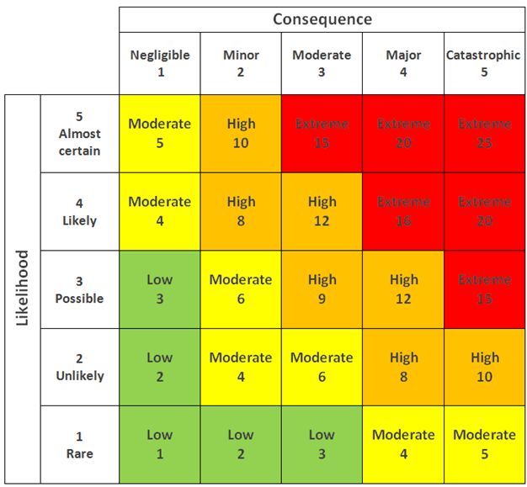

| **No** | **Risk type** | **Risk description** | **Likelihood (1-5)** | **Consequence (1-5)** | **Risk rating** | **Risk level** |
| --- | --- | --- | --- | --- | --- | --- |
| 1 | Technological | Poor quality of code which could lead to bugs and difficulty for the members to use the website. | 3 | 5 | 15 | Extreme |
| 2 | Human Factor | Human error that results in problems with development. | 4 | 5 | 20 | Extreme |
| 3 | Economic | Fluctuations in the currency exchange rate which could impact the cost of resources for members in different countries | 3 | 4 | 12 | High |
| 4 | Physical | Issues regarding food transportation like sudden accidents on the road | 3 | 5 | 15 | Extreme |
| 5 | Natural | Natural disasters that could delay the development or service of the website | 2 | 5 | 10 | High |
| 6 | Political | Changes in the regulation for data privacy and security | 2 | 4 | 8 | High |

1. **Risk Response Analysis**

| **No** | **Risk type** | **Risk description** | **Risk Response Plan** |
| --- | --- | --- | --- |
| **1** | Technological | Poor quality of code which could lead to bugs and difficulty for the members to use the website. | Double check code and properly test all systems. |
| **2** | Human Factor | Human error that results in problems with development. | Choose the correct staff and properly guide them in their work. |
| **3** | Economic | Fluctuations in the currency exchange rate which could impact the cost of resources for members in different countries. | Monitor exchange rates and adjust prices accordingly. |
| **4** | Physical | Issues regarding food transportation like sudden accidents on the road. | Observe proper traffic rules and scout for streets with minimal traffic when delivering food. |
| **5** | Natural | Natural disasters that could delay the development or service of the website. | Create a safe workspace with the necessary tools to mitigate any small disasters while providing spaces that could lessen risk during bigger disasters. |
| **6** | Political | Changes in the regulation for data privacy and security. | Stay updated for any changes regarding laws about data privacy. |

1. **Project Team**

**3.1. Team Members’ Information**

| **Partner** | **Learner ID** | **Full Name** | **Group ID** |
| --- | --- | --- | --- |
| UCPH | BDSE -0922-118 | Aldous Benjamin Maranga | 1 |
| UCPH | BDSE -0922-121 | Cyril Nathanael Orbeta | 2 |
| UCPH | BDSE –0922-124 | Dimple Lavigne Salimbot | 3 |
| UCPH | BDSE -0922-113 | Francis Roel Abarca | 4 |
| UCPH | BDSE -0922-117 | Kervin Curt Delos Reyes | 5 |
| UCPH | BDSE-0922-118 | Sebastian Seth Escarro | 6 |

**3.2. Team Members’ Roles and Responsibilities**

| **Name** | **Module** | **Details Tasks** |
| --- | --- | --- |
| Aldous Benjamin Maranga | Management of User Information | - Develop a user information management system   - Design user registration and profile management functionalities   - Implement data validation and security measures for user information |
| Cyril Nathanael Orbeta | Fund raising through donors/supporters | - Identify potential donors and supporters  - Create fundraising campaigns and initiatives  - Manage donor and supporter relationships  - Track and record donations  - Track and record donations |
| Dimple Lavigne Salimbot | Planning for meals and delivery process | - Design a menu planning system  - Coordinate with partners for ingredient sourcing  - Develop meal preparation schedules  - Manage meal delivery logistics  - Ensure compliance with nutritional requirements |
| Francis Roel Abarca | Registration and Login Process | - Develop user registration and login functionalities  - Implement data validation and security measures for registration and login  - Manage user authentication and authorization  - Handle password reset and account recovery processes |
| Kervin Curt Delos Reyes | Project Management | - Define project scope, objectives, and deliverables  - Create project timelines and milestones  - Allocate resources and manage team coordination  - Monitor project progress and ensure deadlines are met  - Communicate with stakeholders and manage project documentation |
| Sebastian Seth Escarro | Quality Assurance | - Create test plans and test cases  - Perform manual and automated testing  - Identify and report software defects and issues  - Collaborate with developers to resolve bugs  - Ensure overall application quality and functionality |

1. **Project Schedule**

**Schedule**

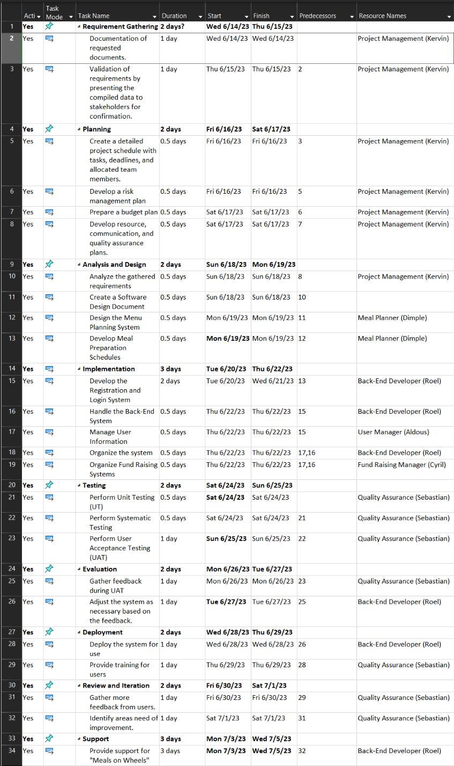

**Gantt Chart**

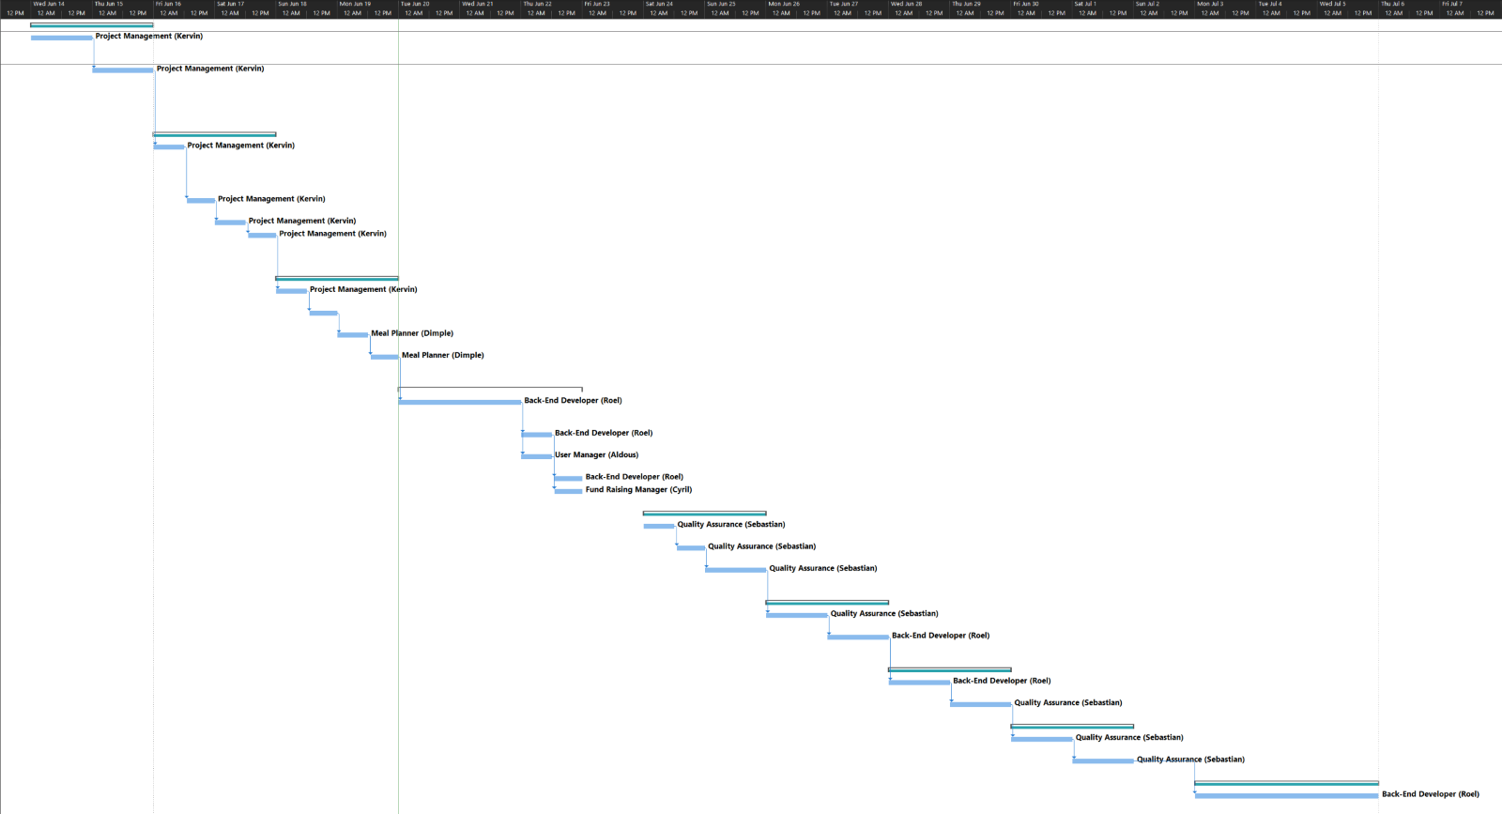

1. **Detailed Plan – Individual – at the features level**

| **Aldous Benjamin Maranga** | | |
| --- | --- | --- |
| **Tasks** | **Start** | **End** |
| Project Goal | 6/15/23 2:00 pm | 6/15/23 4:00 pm |
| Project Objectives | 6/15/23 4:00 pm | 6/15/23 6:00 pm |
| UI/UX Design Consideration | 6/16/23 1:00 pm | 6/16/23 6:00 pm |
| Internal Project Deliverables | 6/19/23 1:00 pm | 6/19/23 2:30 pm |
| External Project Deliverables | 6/19/23 2:30 pm | 6/19/23 4:00 pm |
| Planning Project Deliverables | 6/19/23 4:30 pm | 6/19/23 6:00pm |
| Order Meal Flowchart | 6/20/23 2:00 pm | 6/20/23 5:00 pm |
| Project Testing (Performance Testing) | 6/21/23 2:00 pm | 6/23/23 5:00 pm |

| **Cyril Nathanael Orbeta** | | |
| --- | --- | --- |
| **Tasks** | **Start** | **End** |
| Visual Design - Descriptions | 6/20/23 3:00 pm | 6/20/23 5:30 pm |
| Function Description | 6/20/23 1:00 pm | 6/20/23 7:00 pm |
| Storyboard (Scenario 3) | 6/23/23 10:00 am | 6/23/23 pm |
| Visual Design | 6/23/23 4:00 pm | 6/23/23 6:00 pm |

| **Dimple Lavigne F. Salimbot** | | |
| --- | --- | --- |
| **Tasks** | **Start** | **End** |
| SWOT Analysis | 6/15/23 2:00 pm | 6/15/23 6:00 pm |
| Schedule and Legality Feasibility | 6/16/23 2:00 pm | 6/16/23 6:00 pm |
| Cost Analysis | 6/19/23 11:30 am | 6/19/23 1:00 pm |
| Dependencies | 6/19/23 2:00 pm | 6/19/23 6:00 pm |
| Project Milestone | 6/20/23 2:00 pm | 6/20/23 6:00 pm |
| Flowchart (Scenario 1) | 6/21/23 9:00 am | 6/21/23 11:30 am |
| Portability Testing | 6/21/23 2:00 pm | 6/21/23 3:00 pm |

| **Francis Roel Abarca** | | |
| --- | --- | --- |
| **Tasks** | **Start** | **End** |
| Pain Points – VMOST Analysis | 6/15/23 09:30 am | 6/15/23 2:10pm |
| Project Scope | 6/15/23 3:00pm | 6/15/23 9:00am |
| Feasibility Study – Technical Feasibility | 6/16/23 9:30am | 6/16/23 9:50pm |
| Feasibility Study -Economic Feasibility | 6/16/23 10:00am | 6/16/23 10:20am |
| Feasibility Study – Organizational Feasibility | 6/16/23 10:30am | 6/16/23 10:50am |
| Feasibility Study – Operational Feasibility | 6/16/23 11:00am | 6/16/23 11:20am |
| Feasibility Study – Marketing Feasibility | 6/16/23 11:30am | 6/16/23 11:50am |
| Feasibility Study – Legal Feasibility | 6/16/23 12:00pm | 6/16/23 12:20pm |
| Feasibility Study – Resource Feasibility | 6/16/23 12:30pm | 6/16/23 12:50pm |
| Project Schedule | 6/19/23 2:00pm | 6/19/23 3:00pm |
| Project Gantt Chart | 6/19/23 2:00pm | 6/19/23 3:00pm |
| Scenario 3 – Flowchart | 6/22/23 3:00pm | 6/22/23 3:40pm |
| User Acceptance Testing | 6/22/23 3:50pm | 6/22/23 5:00pm |

| **Kervin Curt Delos Reyes** | | |
| --- | --- | --- |
| **Tasks** | **Start** | **End** |
| Project Objectives | 6/15/23 9:00 am | 6/15/23 11:00am |
| Project Stakeholder | 6/16/23 10:00 am | 6/16/23 3:00pm |
| Benefit Analysis | 6/17/23 9:00 am | 6/17/23 1:00 pm |
| ROI & Direct Cost and Benefit | 6/18/23 10:00 am | 6/18/23 6:00 pm |
| Project Constraint | 6/19/23 8:00 am | 6/19/23 2:00 pm |
| Flowchart (Scenario 2) | 6/20/23 9:00 am | 6/20/23 5:00 pm |
| Compatibility Testing | 6/21/23 10:00 am | 6/21/23 3:00 pm |
| UI/UX (Menu Bar & Content) | 6/23/23 3:00 pm | 6/23/23 5:00 pm |

| **Sebastian Seth Escarro** | | |
| --- | --- | --- |
| **Tasks** | **Start** | **End** |
| Project Background | 6/15/23 3:00 pm | 6/15/23 3:30 pm |
| PESTLE Analysis | 6/15/23 4:00 pm | 6/15/23 5:00 pm |
| Project Assumption | 6/16/23 9:00 am | 6/16/ 11:00 am |
| Risk Analysis and Description | 6/16/23 12:00 pm | 6/16/23 4:00 pm |
| Team Member Roles and Responsibilities | 6/19/23 10:00 am | 6/19/23 12:00 pm |
| Storyboard (Scenario 1) | 6/23/23 10:00 am | 6/23/23 12:00 pm |
| Unit Testing | 6/23/23 2:00 pm | 6/23/23 2:30 pm |

1. **UML / Flowchart / Pseudocode / Storyboards (Individual)**

**Scenario 1:** Registration then Login

**Flowchart:**

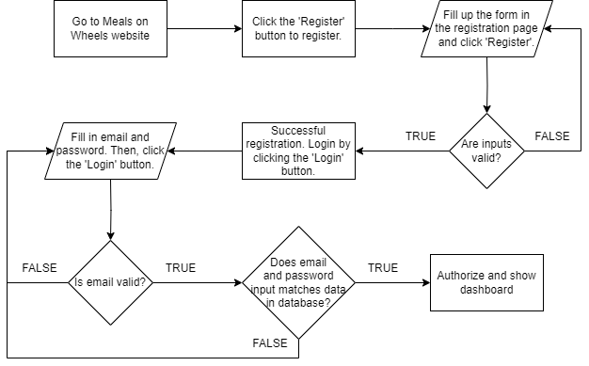

**Storyboard:**

**Scenario 2:** Order Food

**Flowchart:**

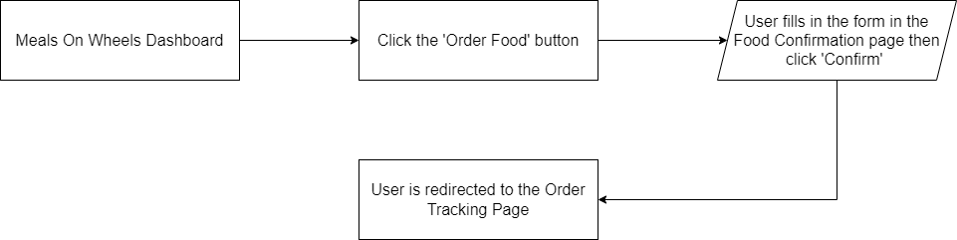

**Storyboard:**

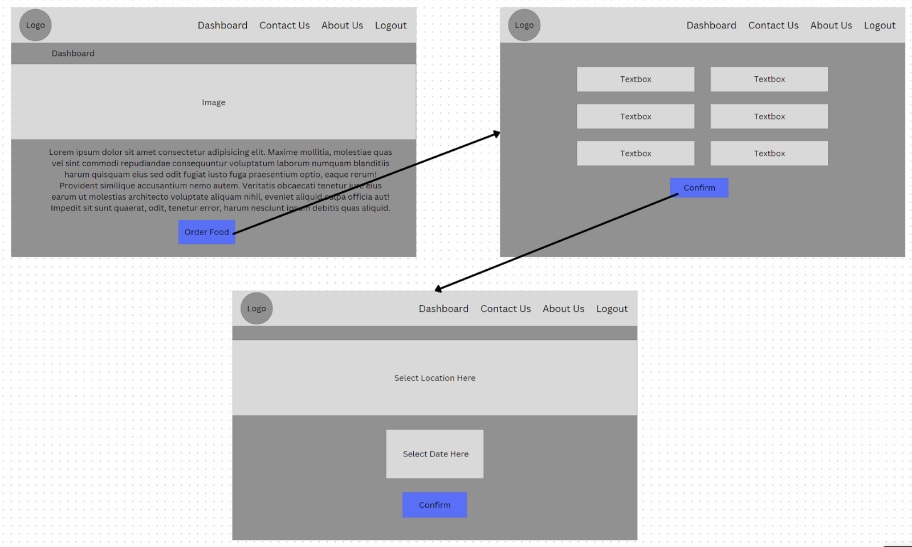

**Scenario 3:** Fundraising

**Flowchart:**

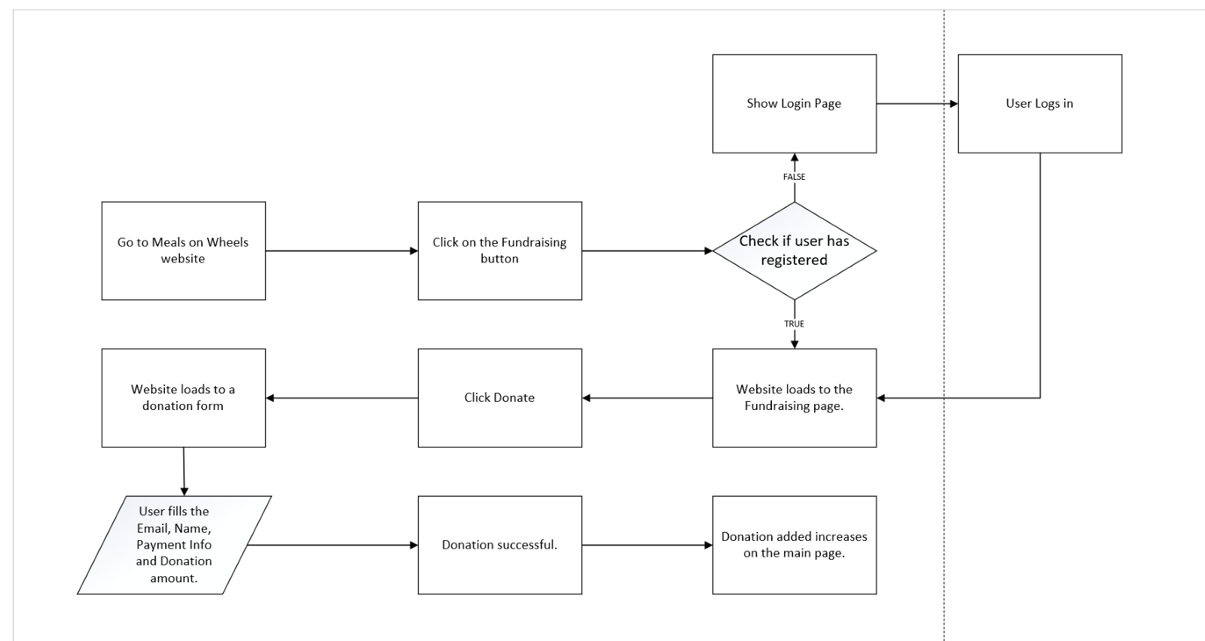

**Storyboard:**

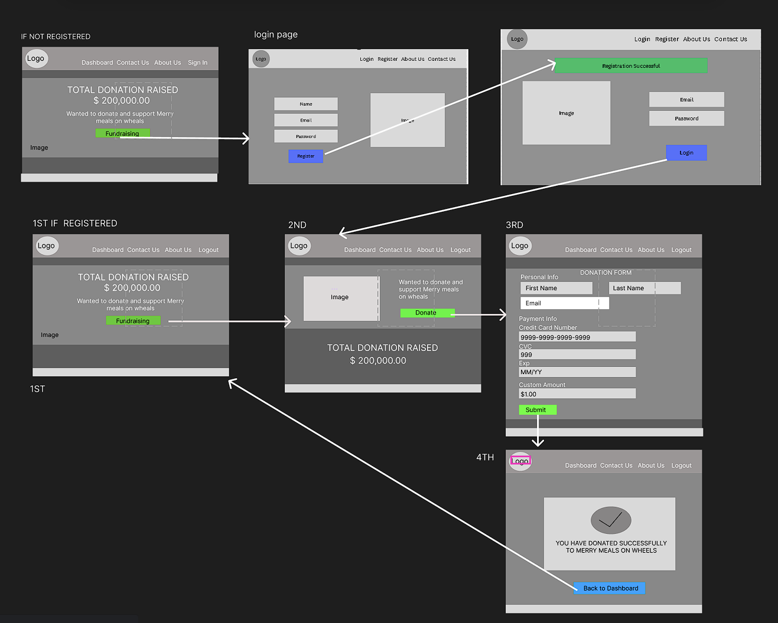

1. **Project Test Planning (Individual)**
2. **Food Safety Management Test Plan**

* **Unit Testing**

| **Type of Testing** | **Test Scenario ID** | **Test Scenario** | **Number of Test Cases** |
| --- | --- | --- | --- |
| Unit testing | TS001 | Verification of menu creation functionality for partners. | 1 |
| TS002 | Validation of menus to display features for partners. | 1 |
| TS003 | Validation of menus to display member functions. | 1 |
| TS004 | Verification of Menu Management Functionality | 1 |

| **Scenario ID** | **Test Case ID** | **Test Case** | **Preconditions** | **Expected Results** |
| --- | --- | --- | --- | --- |
| TS001 | TC001 | Verify if the created menus get saved in the database | Fully developed Meals on Wheels Website | Menus are reflected in the database |
| TS002 | TC002 | Verify if menus are returned when called as partner | Fully developed Meals on Wheels Website | Menu info should be returned |
| TS003 | TC003 | Verify if menus are returned when called as member | Fully developed Meals on Wheels Website | Menu info should be returned |
| TS004 | TC004 | Verify if admin can add, update and delete menus | Fully developed Meals on Wheels Website | Admin should be able to add, edit, and delete menus |

1. **User Acceptance Testing**

| **Type of Testing** | **Test Scenario ID** | **Test Scenario** | **Number of Test Cases** |
| --- | --- | --- | --- |
| User acceptance testing | TS001 | Make sure members can see the entire menu. | 1 |
| TS002 | Make sure your partner can create menus. | 1 |
| TS003 | Allows partners to see their own menu. | 1 |
| TS004 | Allow members to review the Food Safety Statement. | 1 |

| **Scenario ID** | **Test Case ID** | **Test Case** | **Preconditions** | **Expected Results** |
| --- | --- | --- | --- | --- |
| TS001 | TC001 | Make sure members can see the entire menu. | Fully developed Meals on Wheels Website | Menu shows up for registered members. |
| TS002 | TC002 | Make sure your partner can create menus. | Fully developed Meals on Wheels Website | Menu shows up for the registered partners. |
| TS003 | TC003 | Allows partners to see their own menu. | Fully developed Meals on Wheels Website | Partner-created Menu shows up for the specific partner. |
| TS004 | TC004 | Allow members to review the Food Safety Statement. | Fully developed Meals on Wheels Website | Member reviews should successfully show up onto the dashboard and database. |

1. **Performance Testing**

| **Type of Testing** | **Test Scenario ID** | **Test Scenario** | **Number of Test Cases** |
| --- | --- | --- | --- |
| Performance testing | TS001 | Testing the performance of Menus page | 1 |
| TS002 | Testing the performance of Menu Posting page | 1 |
| TS003 | Testing the performance of Menu Detail page | 1 |
|  | TS004 | Testing the performance of Food Safety Declaration page | 1 |

| **Scenario ID** | **Test Case ID** | **Test Case** | **Preconditions** | **Expected Results** |
| --- | --- | --- | --- | --- |
| TS001 | TC001 | Testing the performance of the registration page | Fully developed Meals on Wheels Website | Loading speed should be above 80%-90% or less than 1s |
| TS002 | TC002 | Testing the performance of the login page | Fully developed Meals on Wheels Website | Loading speed should be above 80%-90% or less than 1s |
| TS003 | TC003 | Testing the performance of the dashboard | Fully developed Meals on Wheels Website | Loading speed should be above 80%-90% or less than 1s |
| TS004 | TC004 | Testing the performance of the “Order Meal” Functionality | Fully developed Meals on Wheels Website | Loading speed should be above 80%-90% or less than 1s |

1. **Portability Testing**

| **Type of Testing** | **Test Scenario ID** | **Test Scenario** | **Number of Test Cases** |
| --- | --- | --- | --- |
| Unit testing | TS001 | Open the Meals on Wheels website on a Desktop | 1 |
| TS002 | Open the Meals on Wheels website on a Tablet | 1 |
| TS003 | Open the Meals on Wheels website on a Smartphone | 1 |

| **Scenario ID** | **Test Case ID** | **Test Case** | **Preconditions** | **Steps** | **Test Data** | **Expected Results** |
| --- | --- | --- | --- | --- | --- | --- |
| TS001 | TC001 | Open the Meals on Wheels website on a Desktop | Fully developed Meals on Wheels Website | 1. Open browser on a desktop.  2. Visit the Meals on Wheels website. | Meals on Wheels website url | The website for Meals on Wheels is visible and responsive. |
| TS002 | TC002 | Open the Meals on Wheels website on a Tablet | Fully developed Meals on Wheels Website | 1. Open browser on a tablet.  2. Visit the Meals on Wheels website. | Meals on Wheels website url | The website for Meals on Wheels is visible and responsive. |
| TS003 | TC003 | Open the Meals on Wheels website on a Smartphone | Fully developed Meals on Wheels Website | 1. Open browser on a smartphone.  2. Visit the Meals on Wheels website. | Meals on Wheels website url | The website for Meals on Wheels is visible and responsive. | |

1. **Compatibility Testing**

| **Type of Testing** | **Test Scenario ID** | **Test Scenario** | **Number of Test Cases** |
| --- | --- | --- | --- |
| Unit testing | TS001 | Open partners and volunteer registration page using Microsoft Edge. | 1 |
| TS002 | Open partners and volunteer registration page using Mozilla Firefox. | 1 |
| TS003 | Open partners and volunteer registration page using Google Chrome. | 1 |

| **Scenario ID** | **Test Case ID** | **Test Case** | **Preconditions** | **Steps** | **Test Data** | **Expected Results** |
| --- | --- | --- | --- | --- | --- | --- |
| TS001 | TC001 | Open partners and volunteer registration page using Microsoft Edge. | Fully developed Meals on Wheels Website | 1. Open Microsoft Edge browser.  2. Visit the Meals on Wheels website. | Meals on Wheels website url | The website for Meals on Wheels should be consistent and have the same look and feels. |
| TS002 | TC002 | Open partners and volunteer registration page using Mozilla Firefox. | Fully developed Meals on Wheels Website | 1. Open Mozilla Firefox browser.  2. Visit the Meals on Wheels website. | Meals on Wheels website url | The website for Meals on Wheels should be consistent and have the same look and feels. |
| TS003 | TC003 | Open partners and volunteer registration page using Google Chrome. | Fully developed Meals on Wheels Website | 1. Open Google Chrome browser.  2. Visit the Meals on Wheels website. | Meals on Wheels website url | The website for Meals on Wheels should be consistent and have the same look and feels. |