Service description

Monitor and Control Garage Protocol (MCGP) provide a manage mechanism for users, user can monitor and control his garage through the services defined by the protocol. MCGP provide communication specification for applications, it is a protocol that defined at the application layer of TCP/IP suites. MCGP uses TCP as its transport layer protocol in order to have secure and stable connection. It adopts client-server mode and provide safety mechanism, the mechanism is based by user authentication which is realized by message signing via public-private key and embedding hash-signature in PDU.

After the client pass server’s authentication, user can have a remote connection with his garage. Application that follows MCGP will provide two kinds of services for users. First is monitor service, server may connect to many digital devices in the garage such as thermometer, barometer and hygrometer, user can watch various environment parameters through the client. Second is control service, user can remotely control the door of the garage or the light inside it through client. Figure 1 is the schematic diagram of the MCGP.

Figure 1.

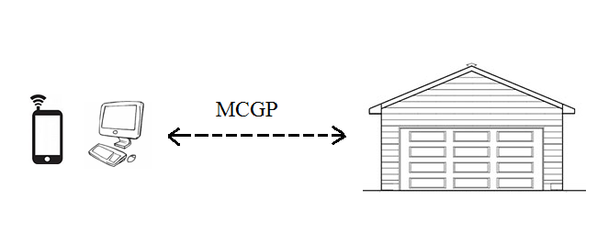

MCGP 协议为用户提供了一种管理机制，用户可以通过它所定义的服务来远程监控和管理自己的车库。MCGP为应用提供了通信规范，MCGP是定义在TCP/IP协议族的application layer的协议，它选择TCP作为传输层协议以提供安全稳定的连接，它采用客户端-服务器模式，并提供了安全验证机制，MCGP安全机制主要由用户验证来提供，这是由message singing via public and private key and embed hash-signature in PDU itself 来实现的。当客户端通过了服务器的验证之后，用户将得以远程连接自己的车库，遵循MCGP的应用将为用户提供两大类服务，第一类服务是监控服务，服务器可能连接了用户车库中很多的电子设备，包括温度计，大气压检测器等，用户可以通过客户端远程监控车库中的各种环境参数，比方说温度，大气压，湿度。第二类服务是控制服务，用户可以通过客户端远程控制车库大门的开关和车库内的灯光。图一展示了是MCGP的示意图。