Future Interns – Prompt Engineering Internship
Task 2: AI-Powered Website using No-Code Tool

1️⃣ Task Details
- Track Code: PE
- Task Name: AI-Powered Website using No-Code Tool
- Tools Used: Wix Vibe AI, WordPress AI, Webflow AI, Figma (for design), Canva, Zapier (for automation), AI Action Blocks.
- Deliverables: Prompt Chain, AI-Powered Website, Screenshots, Live Website Link

2️⃣ Prompt Chain Documentation
- Generate a modern, job-ready website concept for freshers using AI career tools.
- Create a complete website structure including homepage, resume analyzer page, interview practice page, job recommendation page, and contact page.
- Write prompts to generate:
  - Homepage hero content
  - Features/Tools descriptions
  - AI-based Resume Analyzer instructions
- Generate AI workflows (resume analysis, interview scoring, job recommendation system).

3️⃣ Final Website Concept
Title:
AI Career Navigator – Your Smart AI Career Assistant
Website Goal:
Help students and freshers improve their careers using AI tools such as Resume Analysis, Interview Practice, Job Recommendations, and AI-generated resources.

4️⃣ Key AI Features Implemented
- AI Resume Analyzer
  - Upload PDF
  - AI evaluates strengths, weaknesses, ATS score, improvements
  - Uses a structured instruction prompt
- Interview Buddy AI
  - Acts like an HR interviewer
  - Asks questions one by one
  - Gives score, feedback, improvement tips
  - Generates next question automatically
- Job Recommendation Generator
  - Users enter skills, experience, role, location
  - AI returns personalized job suggestions
- AI Blog Generator
  - Auto-writes career blogs (ATS Tips, Interview Questions, Job Search Tips)
- Zapier Automations
  - Automate form submissions
  - Email notifications for resume uploads
  - Save user data to Sheets

5️⃣ Website Screenshots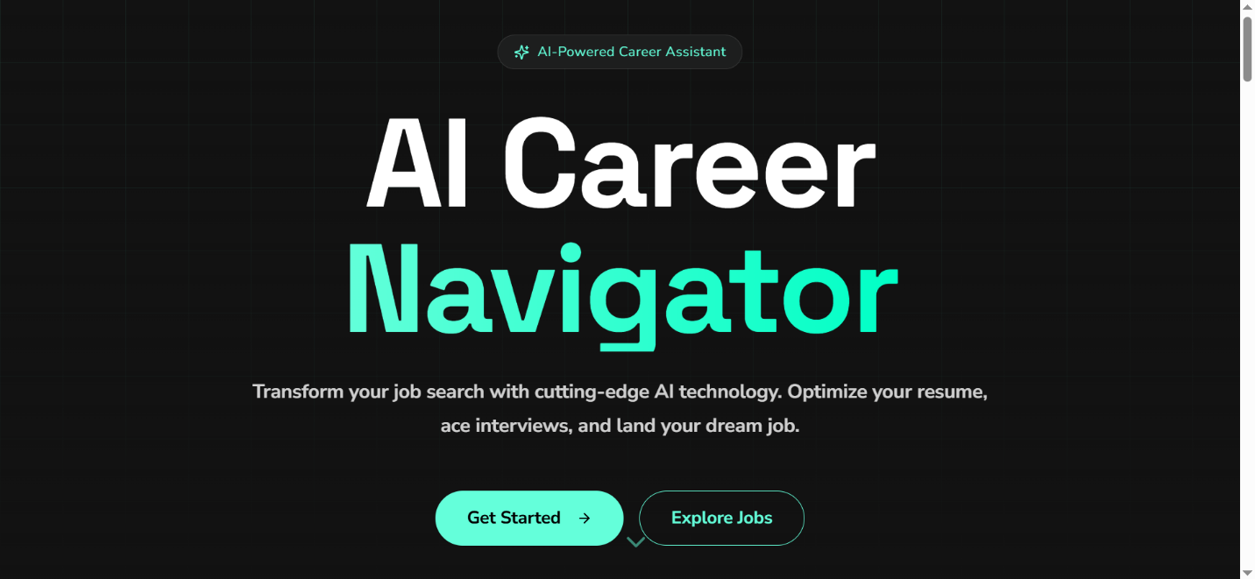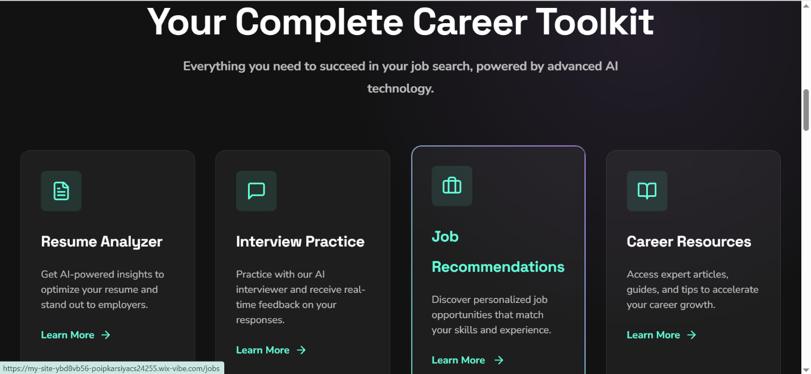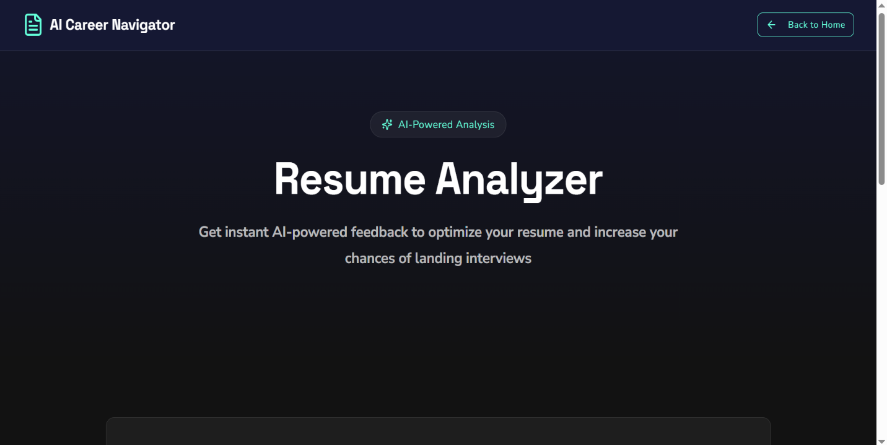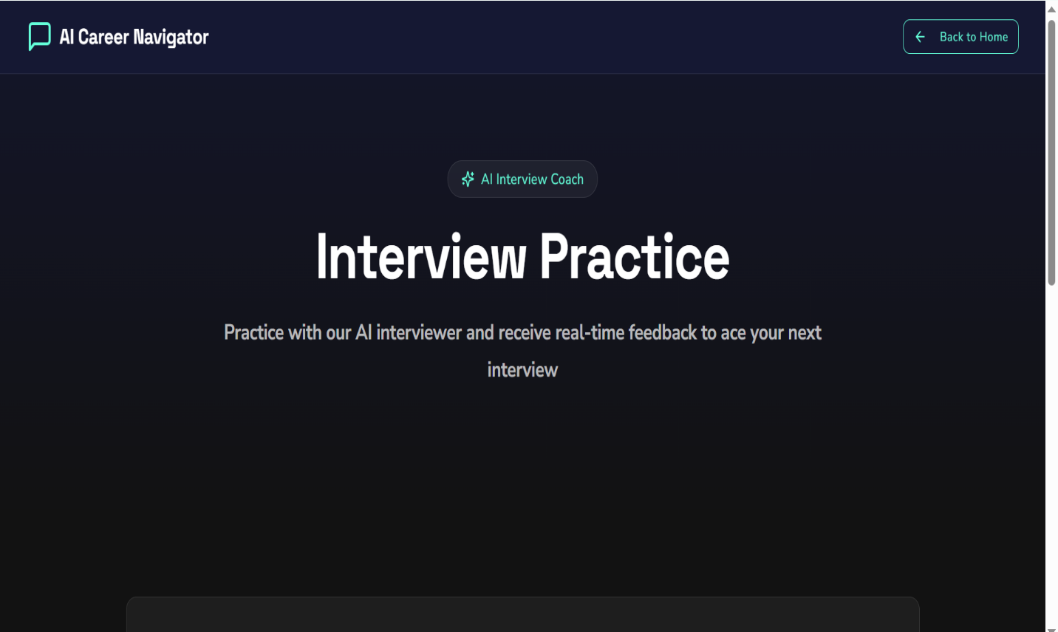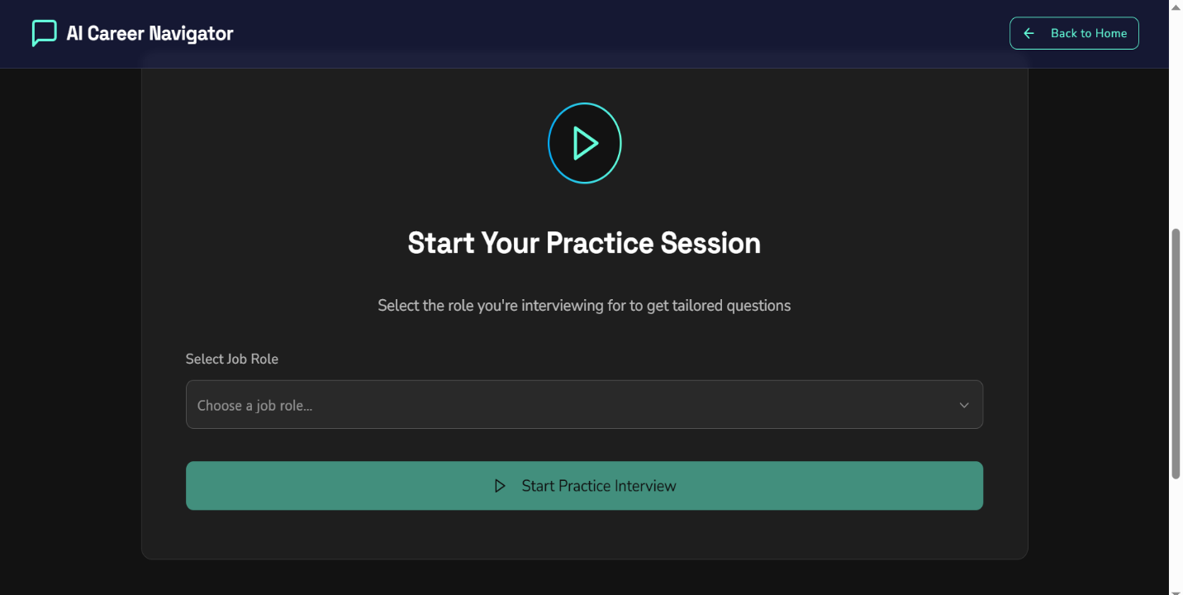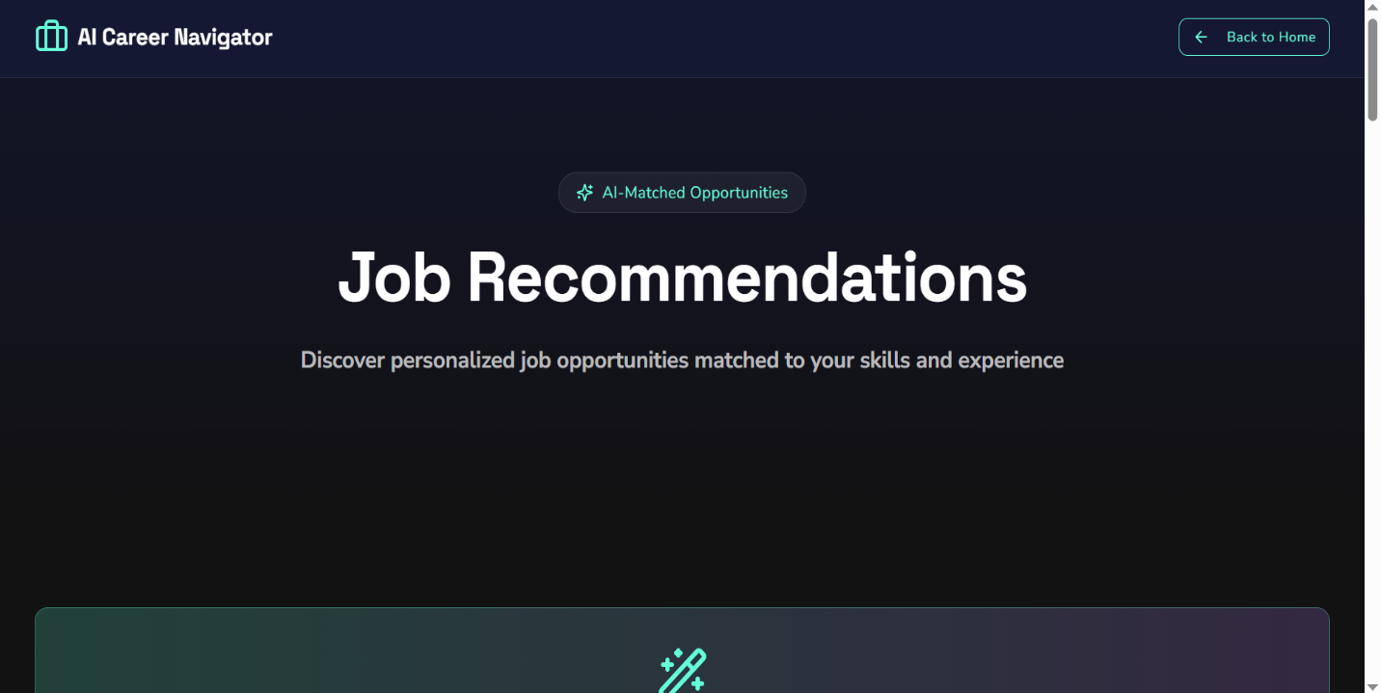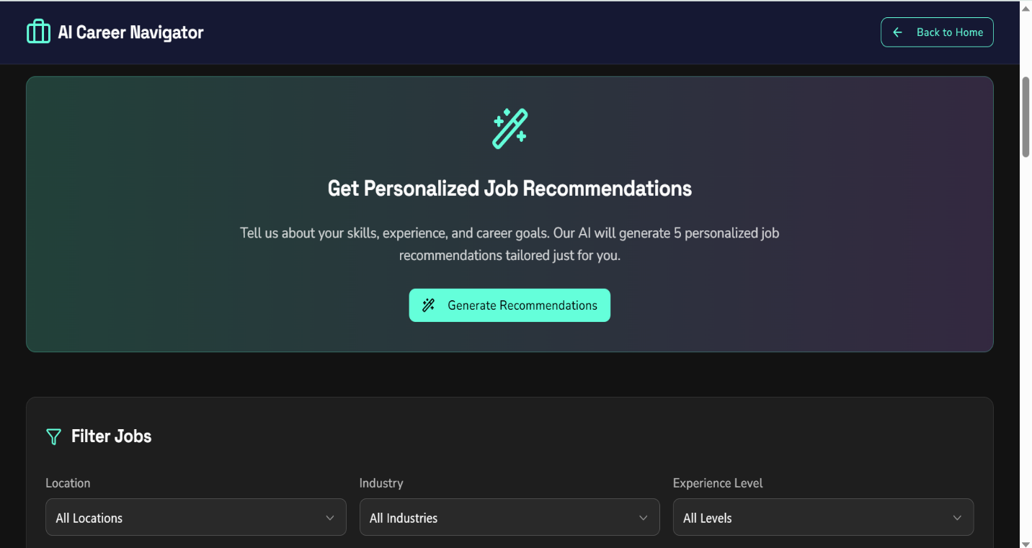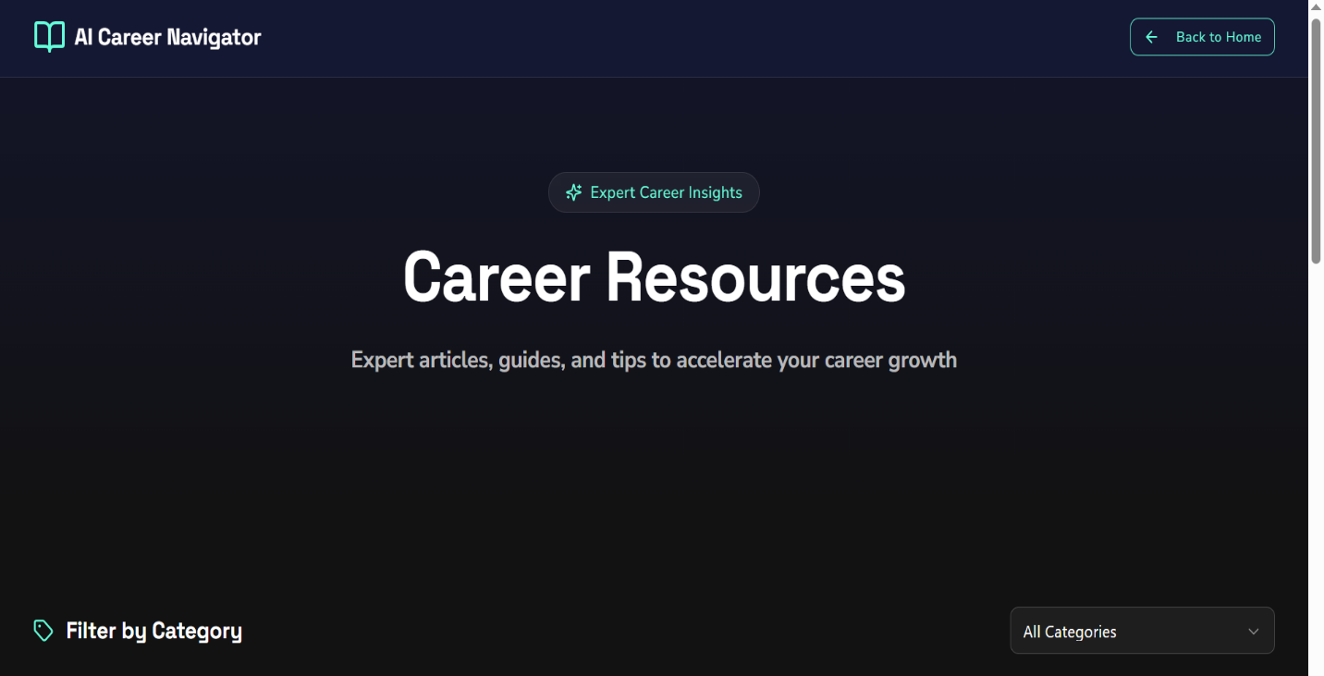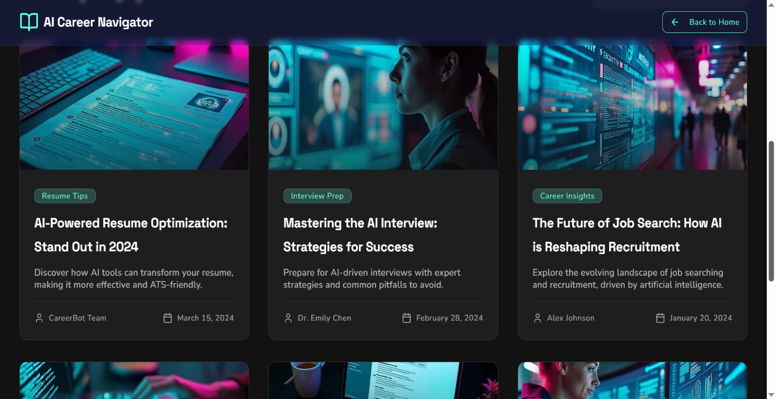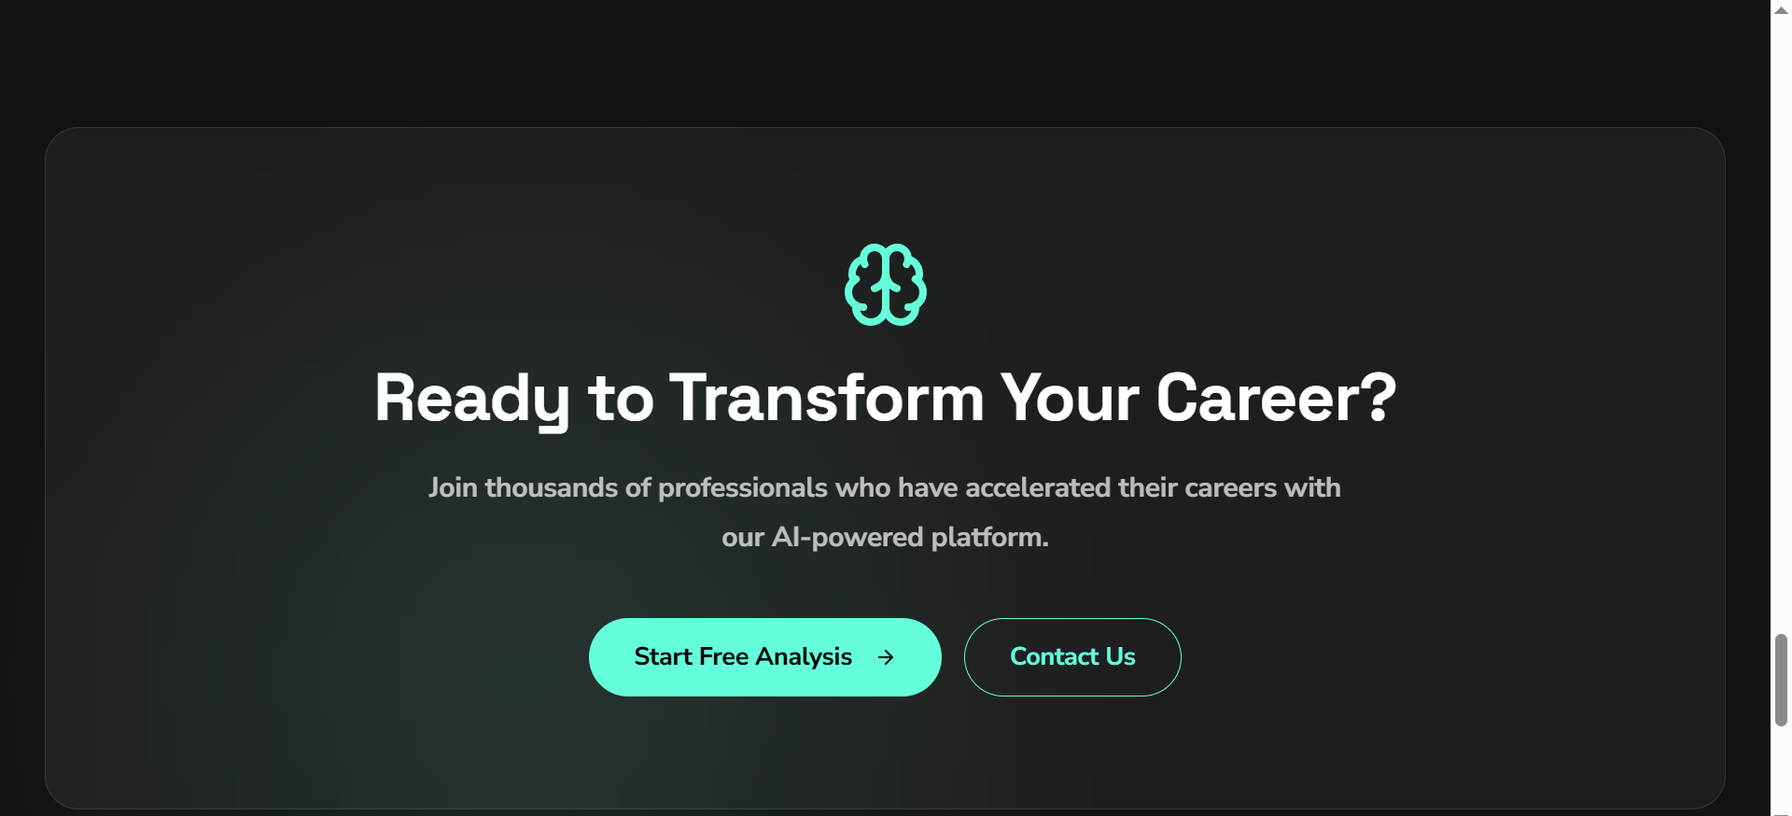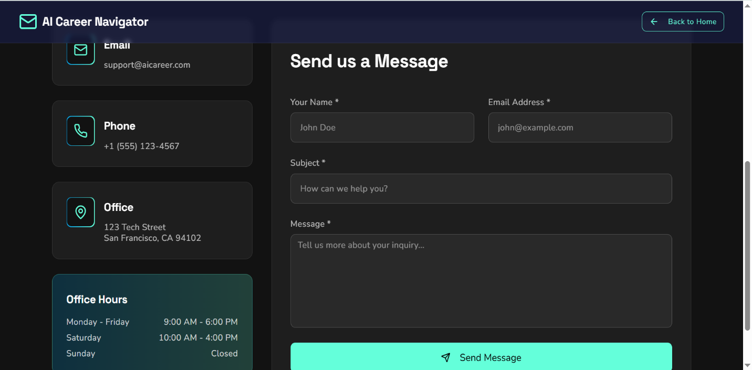
6️⃣ Live Website Link
👉 Published link here:
https://my-site-ybd8vb56-poipkarsiyacs24255.wix-vibe.com/

7️⃣ GitHub Repository
Repo name format: FUTURE_PE_02
👉 https://github.com/poipkarsiya/FUTURE_PE_02

✅ How to Use
- Review the prompt chain to understand AI logic.
- Explore the screenshots to see each feature.
- Visit the live site to test Resume Analyzer, Interview Buddy, and Job Recommendation tools.
- Check the code/prompt folder in the GitHub repo for documentation and prompt structure.

