bbousuite: A set of R packages to facilitate analysis of boreal caribou survival and recruitment data

2 October 2024

# Summary

Although many animal populations are managed based on their abundance (Williams 2002), reliable abundance estimates can be difficult to obtain for mobile low-density populations with large ranges such as boreal caribou (*Rangifer tarandus caribou*). Consequently, such populations may be managed based on their population growth rate (), which can be estimated from the female population recruitment () and adult female survival () rates (Hatter and Bergerud 1991; Hatter 2020) using the following equation.

The bbou suite is a set of R packages (R Core Team 2024) to facilitate simulation and analysis of boreal caribou survival and recruitment data to estimate population growth.

It consists of:

* [bboudata](https://poissonconsulting.github.io/bboudata/), a collection of simulated and anonymized empirical survival and recruitment datasets.
* [bboutools](https://poissonconsulting.github.io/bboutools/), a set of functions to estimate population growth in a Bayesian or Maximum Likelihood (ML) framework, implemented under the hood using the Nimble R package (De Valpine et al. 2017).
* [bboushiny](https://poissonconsulting.github.io/bboushiny/), a Graphical User Interface (GUI) to bboutools ().
* [bbouretro](https://poissonconsulting.github.io/bbouretro/), a set of functions to estimate population growth using traditional frequentist methods.
* [bbousims](https://poissonconsulting.github.io/bbousims/), a set of functions to simulate survival and recruitment data from hypothetical radio-collaring and composition surveys.

Each R package has a website with function documentation and a ‘Get Started’ guide. There are also several vignettes, including bboutools [analytical methods](https://poissonconsulting.github.io/bboutools/articles/methods.html) and [prior selection](https://poissonconsulting.github.io/bboutools/articles/priors.html), bbouretro [analytical methods](https://poissonconsulting.github.io/bbouretro/articles/retro-methods.html), using [bbousims with bboutools](https://poissonconsulting.github.io/bbousims/articles/bboutools.html), and comparison of Bayesian and traditional method estimates with [empirical](https://poissonconsulting.github.io/bbousuite/articles/empirical-comparisons.html) and [simulated](https://poissonconsulting.github.io/bbousuite/articles/simulations.html) data.

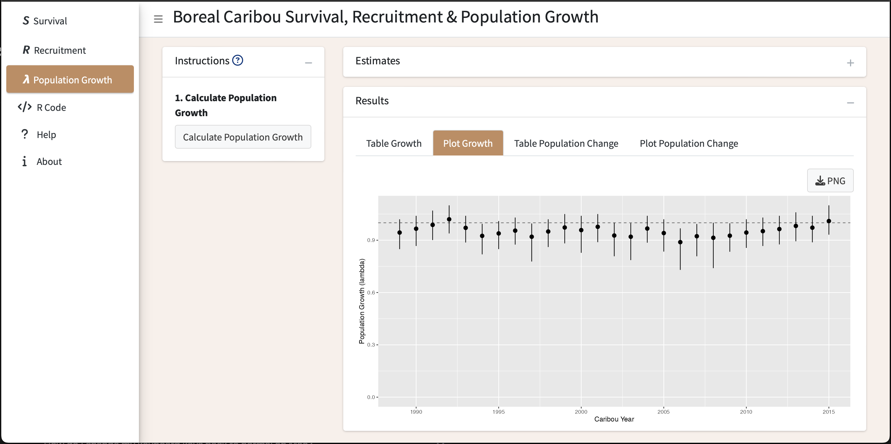

A screenshot of the bboushiny GUI.

# Statement of need

Boreal caribou occur in most provinces and territories in Canada, and are listed as threatened under Canada’s Species at Risk Act (Environment & Climate Change Canada 2023). Each jurisdiction is responsible for monitoring their respective boreal caribou populations. Numerous methods have been used to estimate population growth, which can make cross-jurisdictional conversations on the status of the species complex.

The set of R packages in bbousuite aim to address this challenge. bboutools provides a standardized methodology with simple, general models and reasonable defaults for estimating survival, recruitment, and population growth that can be compared across jurisdictions. In addition, bboushiny provides access to bboutools functionality in a GUI; bbouretro facilitates comparison with traditional methods; and bbousims facilitates comparison of various methods’ ability to recover known parameter values from simulated data.

There is an existing web-based application for estimating boreal caribou population growth rate (Eacker et al. 2019). We consider bbousuite to be an evolution of this application. The methods used are similar, but the bboushiny GUI is more user-friendly and the bboutools, bbouretro, and bbousims R packages provide more fine-grained control of analyses and the ability to compare methods.

The caribouMetrics R package and [associated shiny application](https://github.com/LandSciTech/BayesianCaribouDemographicProjection) also have overlapping functionality. However, the primary goal of these tools is to forecast boreal caribou populations under different monitoring and disturbance scenarios (Dyson et al. 2022).

# Overview of methods

## Survival

Survival is estimated from the monthly fate of radio-collared adult females, with an option to include uncertain mortalites in the total monthly mortalities prior to model fitting.

bbouretro uses the staggered entry Kaplan-Meier method (Pollock et al. 1989). See [here](https://poissonconsulting.github.io/bbouretro/articles/retro-methods.html#survival-s) for more details.

bboutools uses a generalized linear mixed-effects model (GLMM) approach. A survival model including month and year random effects and trend takes the form:

where is the number of mortalities in the month and year, is the number of radio-collared individuals at the start of the month, is the monthly survival probability, is the expected survival in year 0 in a typical month, is a monthly random effect with SD , is an annual random effect with SD and represents the trend.

## Recruitment

Recruitment is estimated from annual aerial composition surveys.

bbouretro follows methods in DeCesare et al. (2012). See [here](https://poissonconsulting.github.io/bbouretro/articles/retro-methods.html#recruitment-r) for more details.

bboutools uses a GLMM approach. A recruitment model including annual random effect and trend takes the form:

where is the calves per adult female in the year, is the expected calves per adult female in year , is the expected calves per adult female in year 0, is an annual random effect with SD and represents the trend.

The model includes demographic stochasticity through the binomial distributions. Groups are aggregated by year prior to model fitting. The calf sex ratio is fixed and can be adjusted by the user, with default of 0.5. The female proportion of the adult population can be estimated from counts of cows and bulls or fixed, with a default of 0.65, which accounts for higher mortality of males (Smith 2004).

In both bbouretro and bboutools estimated recruitment is the female calf recruitment, adjusted following DeCesare et al. (2012), which accounts for recruitment of calves into the yearling/adult age class at the end of the caribou year.

## Population growth

Population growth () is estimated using the Hatter-Bergerud equation (Hatter and Bergerud 1991) presented above. See additional details on bbouretro methods [here](https://poissonconsulting.github.io/bbouretro/articles/retro-methods.html#population-growth-lambda).

## Comparison of methods

A full comparison of bboutools and bbouretro statistical methods is beyond the scope of this paper. Some key differences include:

* bbouretro variances are estimated using approximation formulas (survival) or bootstrap resampling methods. Uncertainty estimates are less precise and reliable than bboutools.
* bboutools models can estimate uncertainty in survival for cases with 0 mortalities in a year.
* bboutools models can include year as a random effect, where individual year effects are assumed to be drawn from a common underlying distribution and information is shared among years.
* bboutools models can include an underlying trend.

In addition, with bboutools models fit in a Bayesian framework:

* models can incorporate prior knowledge, which is especially useful when data are sparse.
* posterior distributions of parameters can be combined to produce derived parameters (e.g., population growth) with full information about uncertainty retained.

We compared estimates from bbouretro and bboutools on anonymized empirical and simulated data.

[Empirical comparisons](https://poissonconsulting.github.io/bbousuite/articles/empirical-comparisons.html) demonstrate that bbouretro methods yield similar estimates to Bayesian fixed-effects models with uninformative priors (). By default, bboutools uses uninformative priors and these can be adjusted by the user. Random effects model estimates tend to be less noisy than traditional and fixed effect model estimates. This is explored in more detail below.

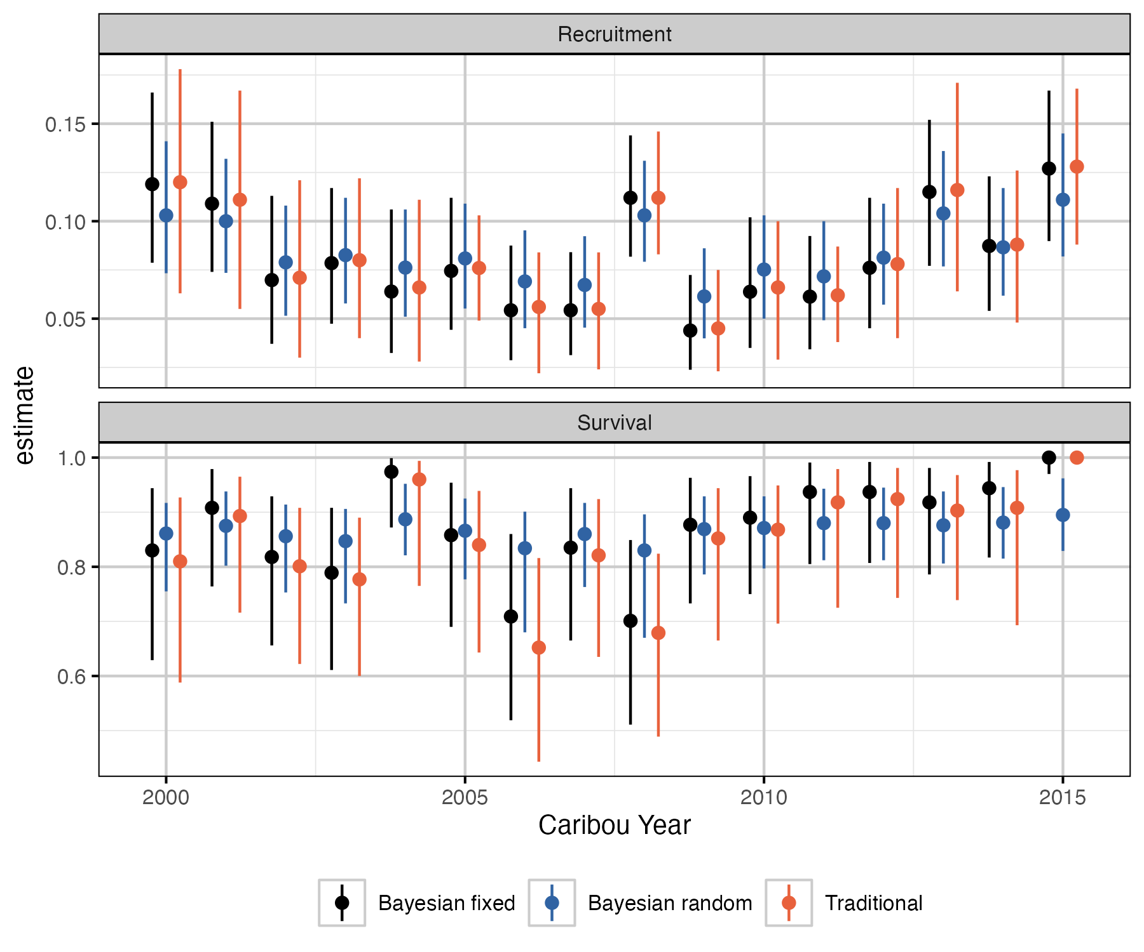

Comparison of traditional and Bayesian estimates of survival and recruitment by year. The bars represent 95% confidence/credible intervals.

Data simulation (i.e., with bbousims) allows for comparison of various methods’ ability to recover known parameter values (i.e., with bias, precision, coverage). We simulated 100 recruitment and survival datasets for each of 5 coverage scenarios from a single, randomly generated, stable population over 20 years.

[Our analysis](https://poissonconsulting.github.io/bbousuite/articles/simulations.html) demonstrates that the Bayesian random effects model generally performs best. For example, a plot of the of bias in point estimates of population growth shows that the random effects model has the greatest precision, especially at lower sample sizes ().

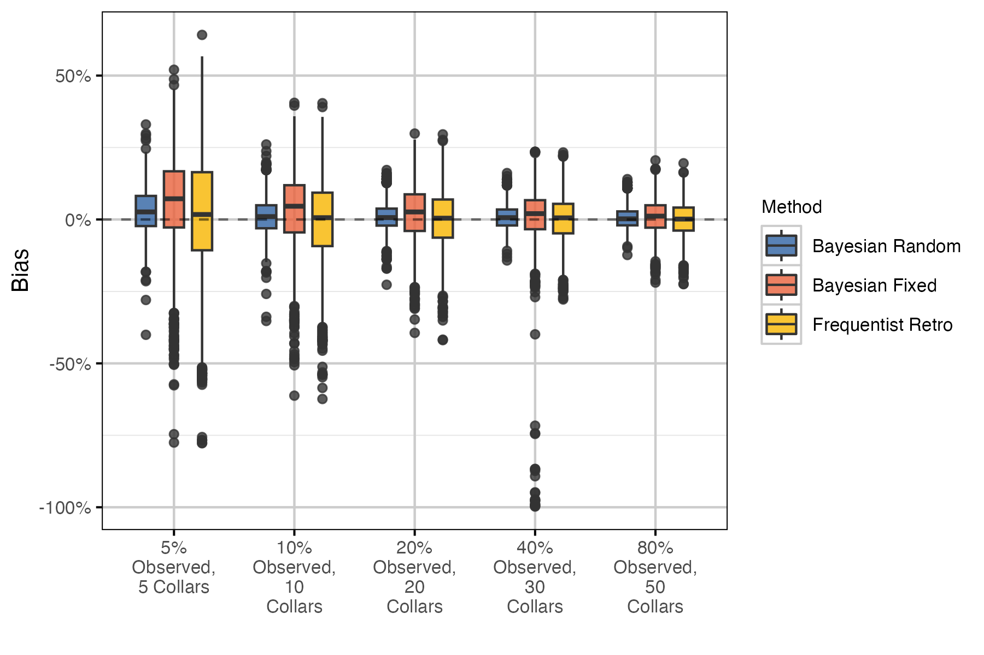

Bias (% difference) in annual population growth point estimates and known population growth for 100 simulations and 20 years, by sample size and statistical method.

Random effect models exhibit ‘shrinkage’, which causes more extreme estimates to be pulled towards the group mean, especially when underlying data are sparse (Kery and Schaub 2011). With higher sample size in each group, the difference between random and fixed effects model estimates is diminished. The simulation analysis demonstrates that the tendency to be skeptical of extreme values at low sample sizes is desirable, as these values are likely to result from the sampling process rather than represent the true values.

The Bayesian methods in bboutools are proposed as a standardized method for comparing estimates across jurisdictions. In particular, the random effects model is recommended by default when there are 5 years of data (Kery and Schaub 2011).

# Acknowledgements

We acknowledge contributions from Alan Constant, Sarah Lyons, Colton Stephens and Nicole Hill. Development of bbousuite was funded by the Province of Alberta and Environment and Climate Change Canada.

# References

De Valpine, Perry, Daniel Turek, Christopher J. Paciorek, Clifford Anderson-Bergman, Duncan Temple Lang, and Rastislav Bodik. 2017. “Programming With Models: Writing Statistical Algorithms for General Model Structures With NIMBLE.” *Journal of Computational and Graphical Statistics* 26 (2): 403–13. <https://doi.org/10.1080/10618600.2016.1172487>.

DeCesare, Nicholas J., Mark Hebblewhite, Mark Bradley, Kirby G. Smith, David Hervieux, and Lalenia Neufeld. 2012. “Estimating Ungulate Recruitment and Growth Rates Using Age Ratios.” *The Journal of Wildlife Management* 76 (1): 144–53. <https://doi.org/10.1002/jwmg.244>.

Dyson, Matt, Sarah Endicott, Craig Simpkins, Julie W. Turner, Stephanie Avery-Gomm, Cheryl A. Johnson, Mathieu Leblond, et al. 2022. “Existing Caribou Habitat and Demographic Models Need Improvement for Ring of Fire Impact Assessment: A Roadmap for Improving the Usefulness, Transparency, and Availability of Models for Conservation.” *bioRxiv*. <https://doi.org/10.1101/2022.06.01.494350>.

Eacker, Daniel R., Mark Hebblewhite, Robin Steenweg, Mike Russell, Amy Flasko, and Dave Hervieux. 2019. “Web‐based Application for Threatened Woodland Caribou Population Modeling.” *Wildlife Society Bulletin* 43 (1): 167–77. <https://doi.org/10.1002/wsb.950>.

Environment & Climate Change Canada, I. 2023. “Caribou in Canada.” *Government of Canada*. <https://www.canada.ca/en/environment-climate-change/services/species-risk-education-centre/caribou.html>.

Hatter, Ian. 2020. “Revisiting the Recruitment-Mortality Equation to Assess Moose Growth Rates.” *Alces: A Journal Devoted to the Biology and Management of Moose* 56: 39–47. <https://alcesjournal.org/index.php/alces/article/view/263>.

Hatter, Ian, and Wendy Bergerud. 1991. “Moose Recuriment Adult Mortality and Rate of Change” 27: 65–73.

Kery, Marc, and Michael Schaub. 2011. *Bayesian Population Analysis Using WinBUGS : A Hierarchical Perspective*. Boston: Academic Press. <http://www.vogelwarte.ch/bpa.html>.

Pollock, Kenneth H., Scott R. Winterstein, Christine M. Bunck, and Paul D. Curtis. 1989. “Survival Analysis in Telemetry Studies: The Staggered Entry Design.” *The Journal of Wildlife Management* 53 (1): 7. <https://doi.org/10.2307/3801296>.

R Core Team. 2024. “R: A Language and Environment for Statistical Computing.” Vienna, Austria: R Foundation for Statistical Computing. <https://www.R-project.org/>.

Smith, Kirby Gordon. 2004. “Woodland Caribou Demography and Persistence Relative to Landscape Change in West-Central Alberta.” 125.

Williams, Byron K. 2002. *Analysis and Management of Animal Populations: Modeling, Estimation, and Decision Making*. San Diego: Academic Press.