Operating System Assignment 1

Name- Qusai Shergardwala

Roll No- 38

Class: AIDS-C

PRN: 12211594

**Problem Statement:**

**Execution of basic Linux commands**

**i) General Purpose Command**

**ii) File & Directory Related Commands**

1. ls Desktop:

(ls – List Directory Contents)

The ls command is used to list directory contents.

**Syntax**: ls [options] [directory]

1. cd – Change Directory

The cd command is used to change the current working directory.

**Syntax**: cd [directory]

1. pwd – Print Working Directory

The pwd command displays the current working directory.

**Syntax**:pwd

1. mkdir – Make Directory

The mkdir command is used to create a new directory.

**Syntax**: mkdir [directory_name]

1. rm – Remove

The rm command is used to remove files or directories.

**Syntax**: rm [options] [file/directory]

1. touch – Create Empty File

The touch command is used to create an empty file.

**Syntax**: touch [file_name]

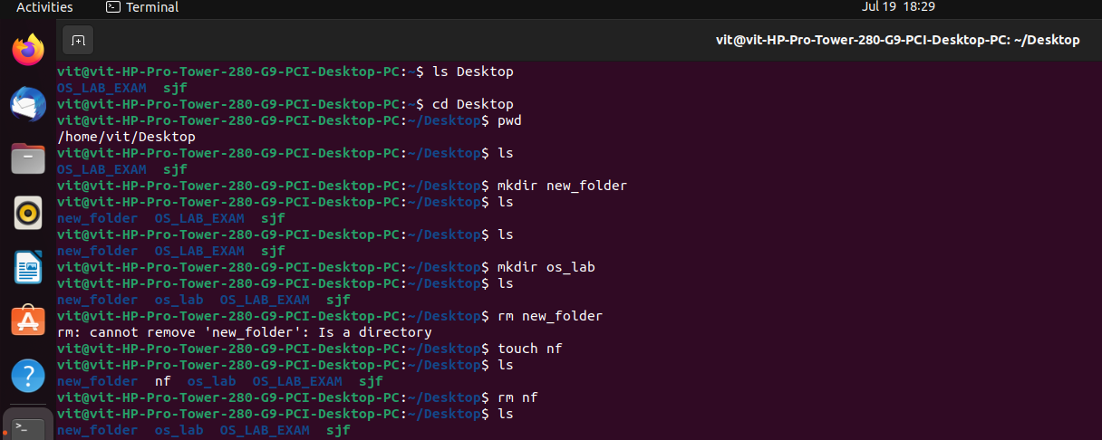

1. date – Display Date and Time

The date command displays the current date and time.

**Syntax:** date [options]

1. ps - process status

The ps command displays information about active processes.

**Syntax:** ps [options]

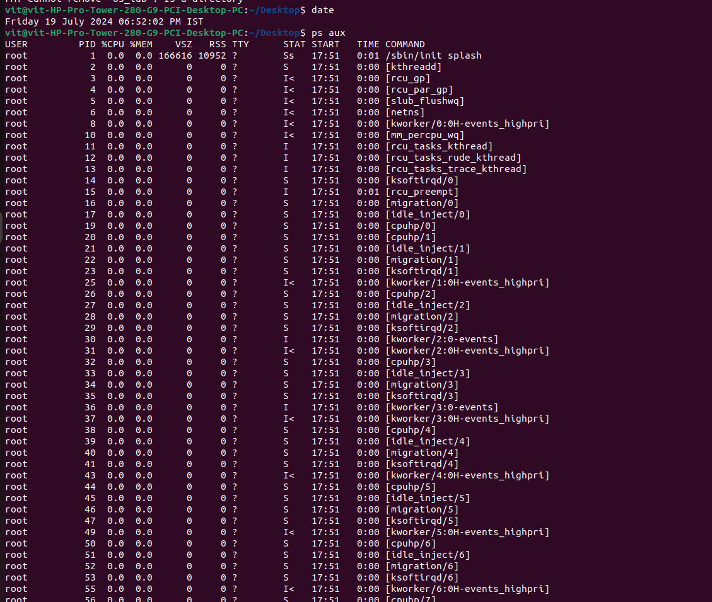

1. top – Display System Activity

The top command displays real-time information about system activity.

**Syntax:** top

1. df – Disk Free

The df command displays disk space usage for filesystems.

Syntax: df [options]

1. grep – Search

The grep command is used to search for patterns in files.

Syntax: grep [options] [pattern] [file]

1. mv – Move

The mv command is used to move files or directories.

Syntax: mv [options] [destination]

1. nano – Text Editor

The nano command launches the Nano text editor.

Syntax: nano [file_name]

1. cat – Concatenate and Display

The cat command is used to display the contents of a file.

Syntax: cat [file]

1. uname – Print System Information

The uname command prints system information such as kernel version and architecture.

Syntax: uname [options]

------------------------------------------------------------------------------------