|  |
| --- |
|  |
| SRS: StarTrack |
| A Star Citizen Trader Companion App |

|  |
| --- |
| SpazzCat & sawser_2k2  11-30-2020 |

# Introduction

StarTrack is software for keeping track of trading activities in the game Star Citizen. It will be comprised of 3 software components.

1. A client (PC) app that runs on the pc to monitor the screenshots folder and process new screenshots
2. A server app that we run and manage to track user’s and rates (eventually)
3. A phone app that allows them to see the data without pulling up the app

It is intended for people who play Star Citizen and run cargo missions. The current scope of the project is to allow users to easily track and keep data regarding their cargo runs. We will eventually have a database running on an actual server when the app is ready for live testing. The client app will allow users to add data and will attempt to pull data from screenshots of the buying screen and selling screen in Star Citizen. The server side will access and store the data received and communicate with the other software via the network. The phone app (android only for now) will allow users to access their trading data and add data from their mobile device. The software will be dependent on OS and access to a network card.

Initial development will be divided into 3 phases.

## Phase 1: Standard App

The standard app will be where we test the principles, so that we can make a more stable pro version with what we learn from the standard version. This app will not use any networking and will instead store the data via JSON to a file locally. The app will have the ability to sort by date (default), profit, or route. The user will be able to put route information in on a separate screen and then simply select the route they used when logging their run. The main screen will be a RecyclerView of all the data (profit color coded, date, route and final aUEC). An Icon will also show the cargo of the run (La for Laranite, Mx for Mixed, etc.). Upon tapping the item on the RecyclerView the app will navigate to a detail page, showing additional information such as notes, time it took. And other data the user might wish to add.

To help build some money for a pro version’s server functionality of the app the standard version will have unobtrusive ads such as banners on the main screen. The Standard Version of the app will always have ads to give incentive to upgrade to the pro.

## Phase 2: Pro Version of App & Revisions to Standard App

The Pro version of the app will include more features and no ads. In addition to all the features the standard app provides, the pro version will be synch-able with the desktop version. Using server space, the pro version will also allow you to view your org’s trading statistics, synch and store your data in the cloud. In addition to these features the pro version will add additional stats as needed.

More features may be added through feedback from alpha and beta testing of the standard app.

## Phase 3: PC Application and Final Testing and Polishing

The PC application will give a more in-depth Star Citizen Experience, showing graphs and statistics of all of your runs from the dashboard. The PC app can also try to log your runs based on screenshots. The software will monitor the screenshots folder and if it sees a new one it will try to fill in as much information as it can from the screenshot and start the timer if it is able to get any information. Then upon completion of the cargo run, the user will take another screenshot and the software will again attempt to read the info (Figure 1). 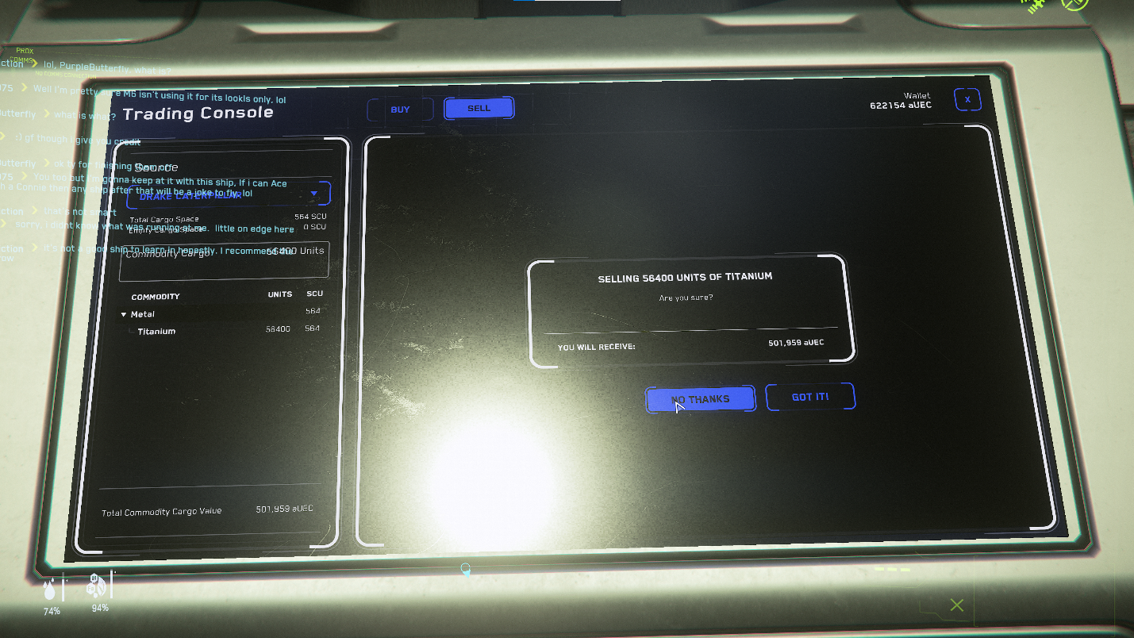The software will then stop the timer and queue the log for review, storing the screenshots, and data it collected to be reviewed by the user to be added to the official log.

Figure : End of a Cargo Run Screenshot