**COMPIL-ATHON**

**TEAM MEMBERS**

**POJESH KUMAR – 22BAI1373**

**AANAND V – 22BAI1373**

**SLOT: B1 +TB1**

**FACULTY: PROF. MERCY RAJASELVI**

**LookUp Table Design**

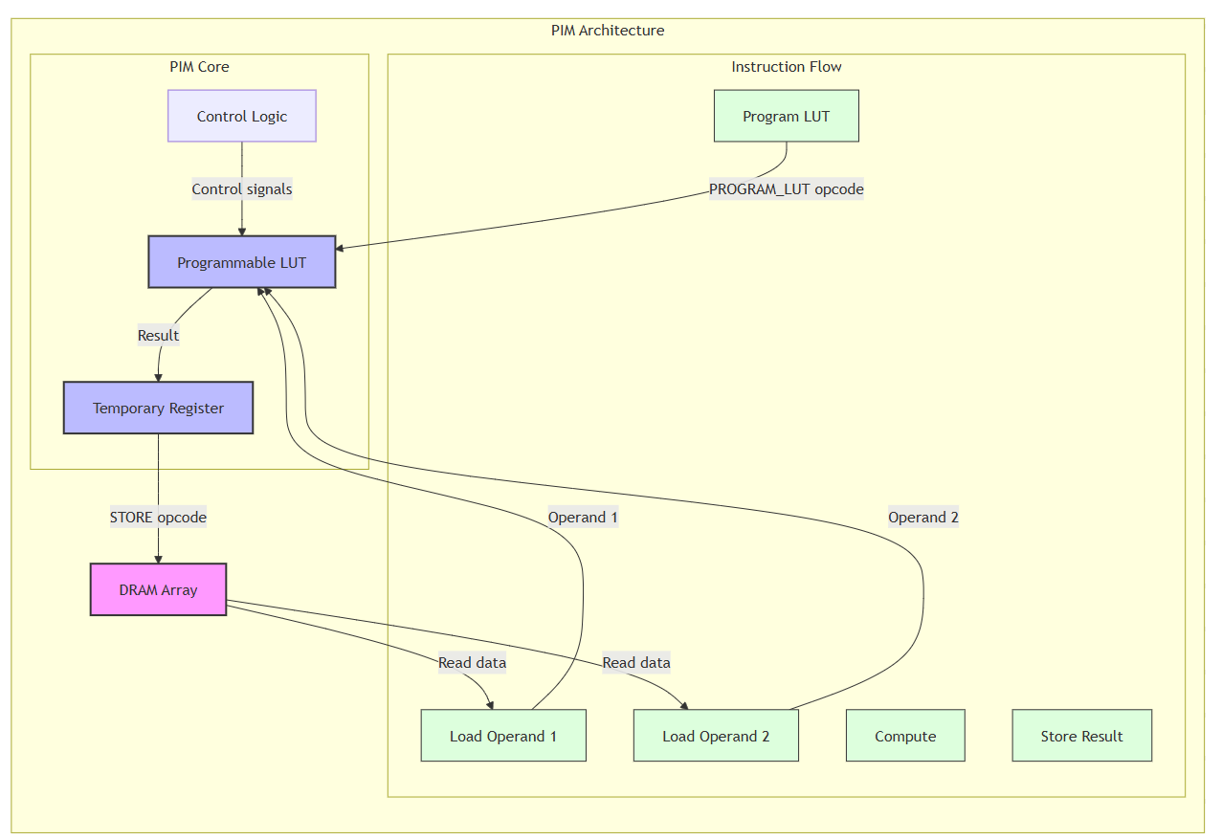

**Workflow Flowchart**

