Minitel
Instructions on how to use a Minitel as a Linux terminal.
Felix Pojtinger
2021-12-11

Introduction

Contributing
Found an error or have a suggestion? Please open an issue on GitHub (github.com/pojntfx/minitel):

QR-Code to the source code on GitHub

License
This document and included source code is Free Culture/Free Software.

Badge of the AGPL-3.0 license
Minitel (c) 2021 Felix Pojtinger
SPDX-License-Identifier: AGPL-3.0

Compatible Minitels
Your Minitel needs to have a Funz or Fnct key and the DIN-5 port at the back side. This includes the following Minitels:
- Minitel 1B
- Minitel 2
- Alcatel ADF 258

Minitel DIN-5 to USB/RS232/Serial Adapter
To build the adapter to connect the Minitel to a PC, you need the following (cheap) components:
- 220 kΩ resistor
- 22 kΩ resistor
- 10 kΩ resistor
- 2N2222 transistor
- Male DIN-5 plug
- PL2303HX USB to UART TTL converter
You will need to check the pinout of the DIN-5 plug/cable; in my case, the following mapping is present:
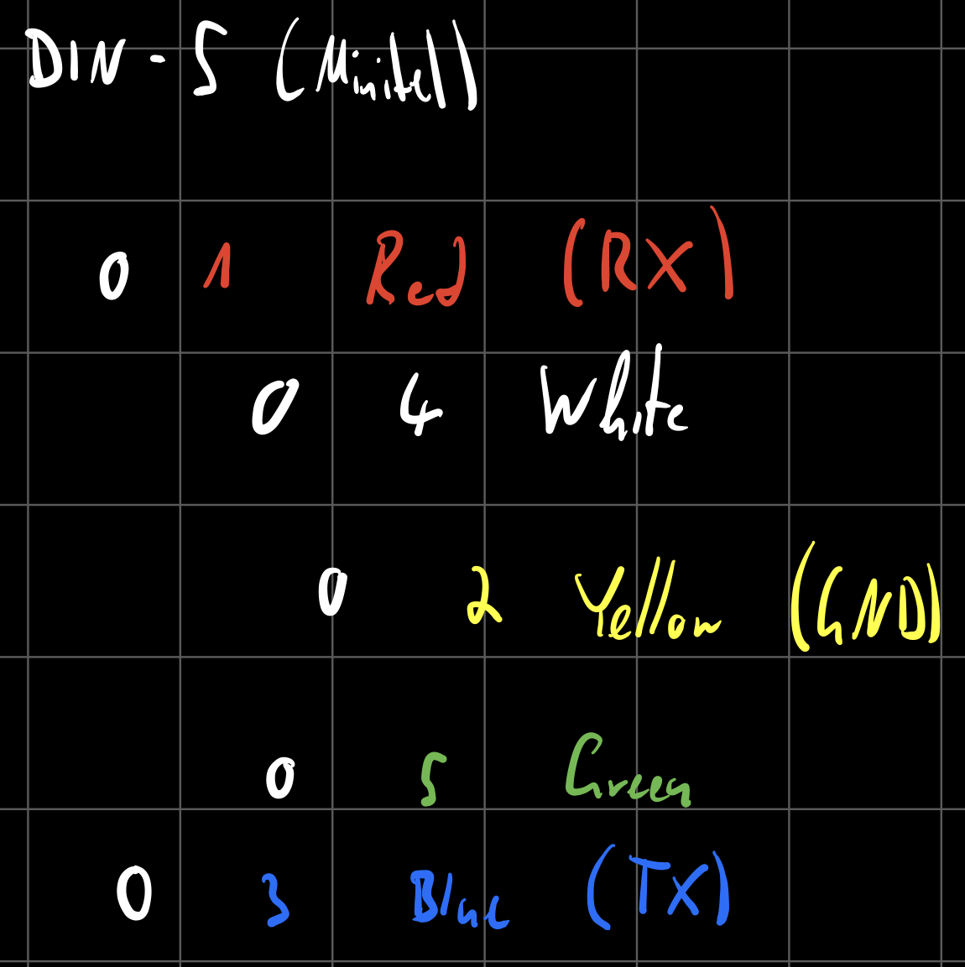
DIN-5 port mapping
Connect like so:
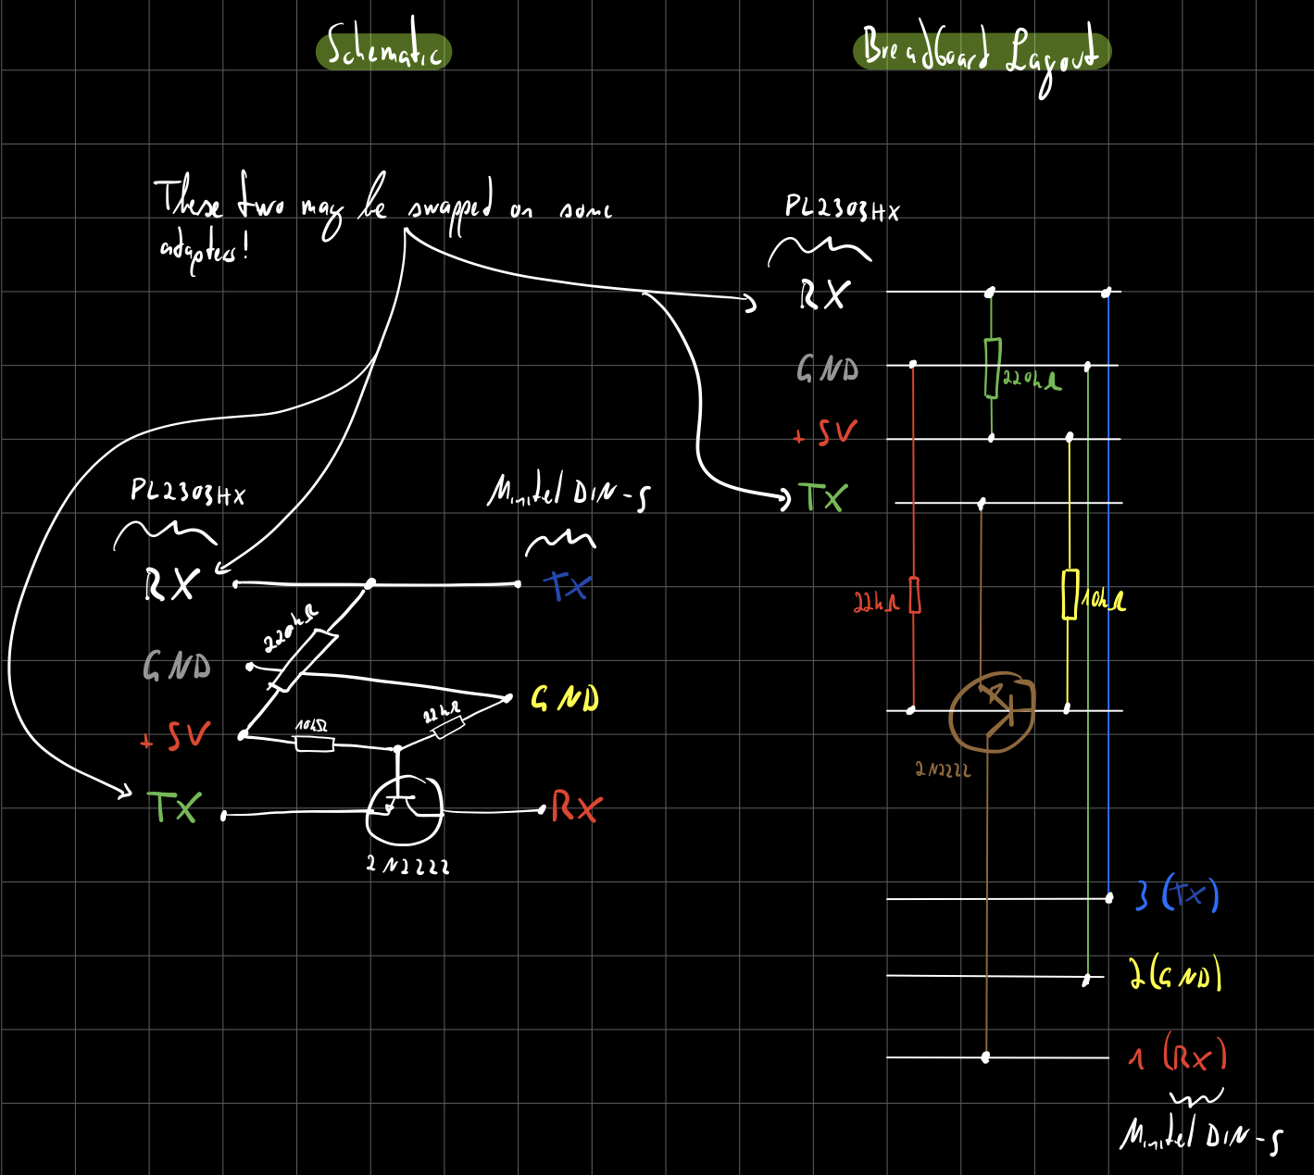
Schematic and breadboard layout
In my case, the breadboard prototype ended up looking like this:
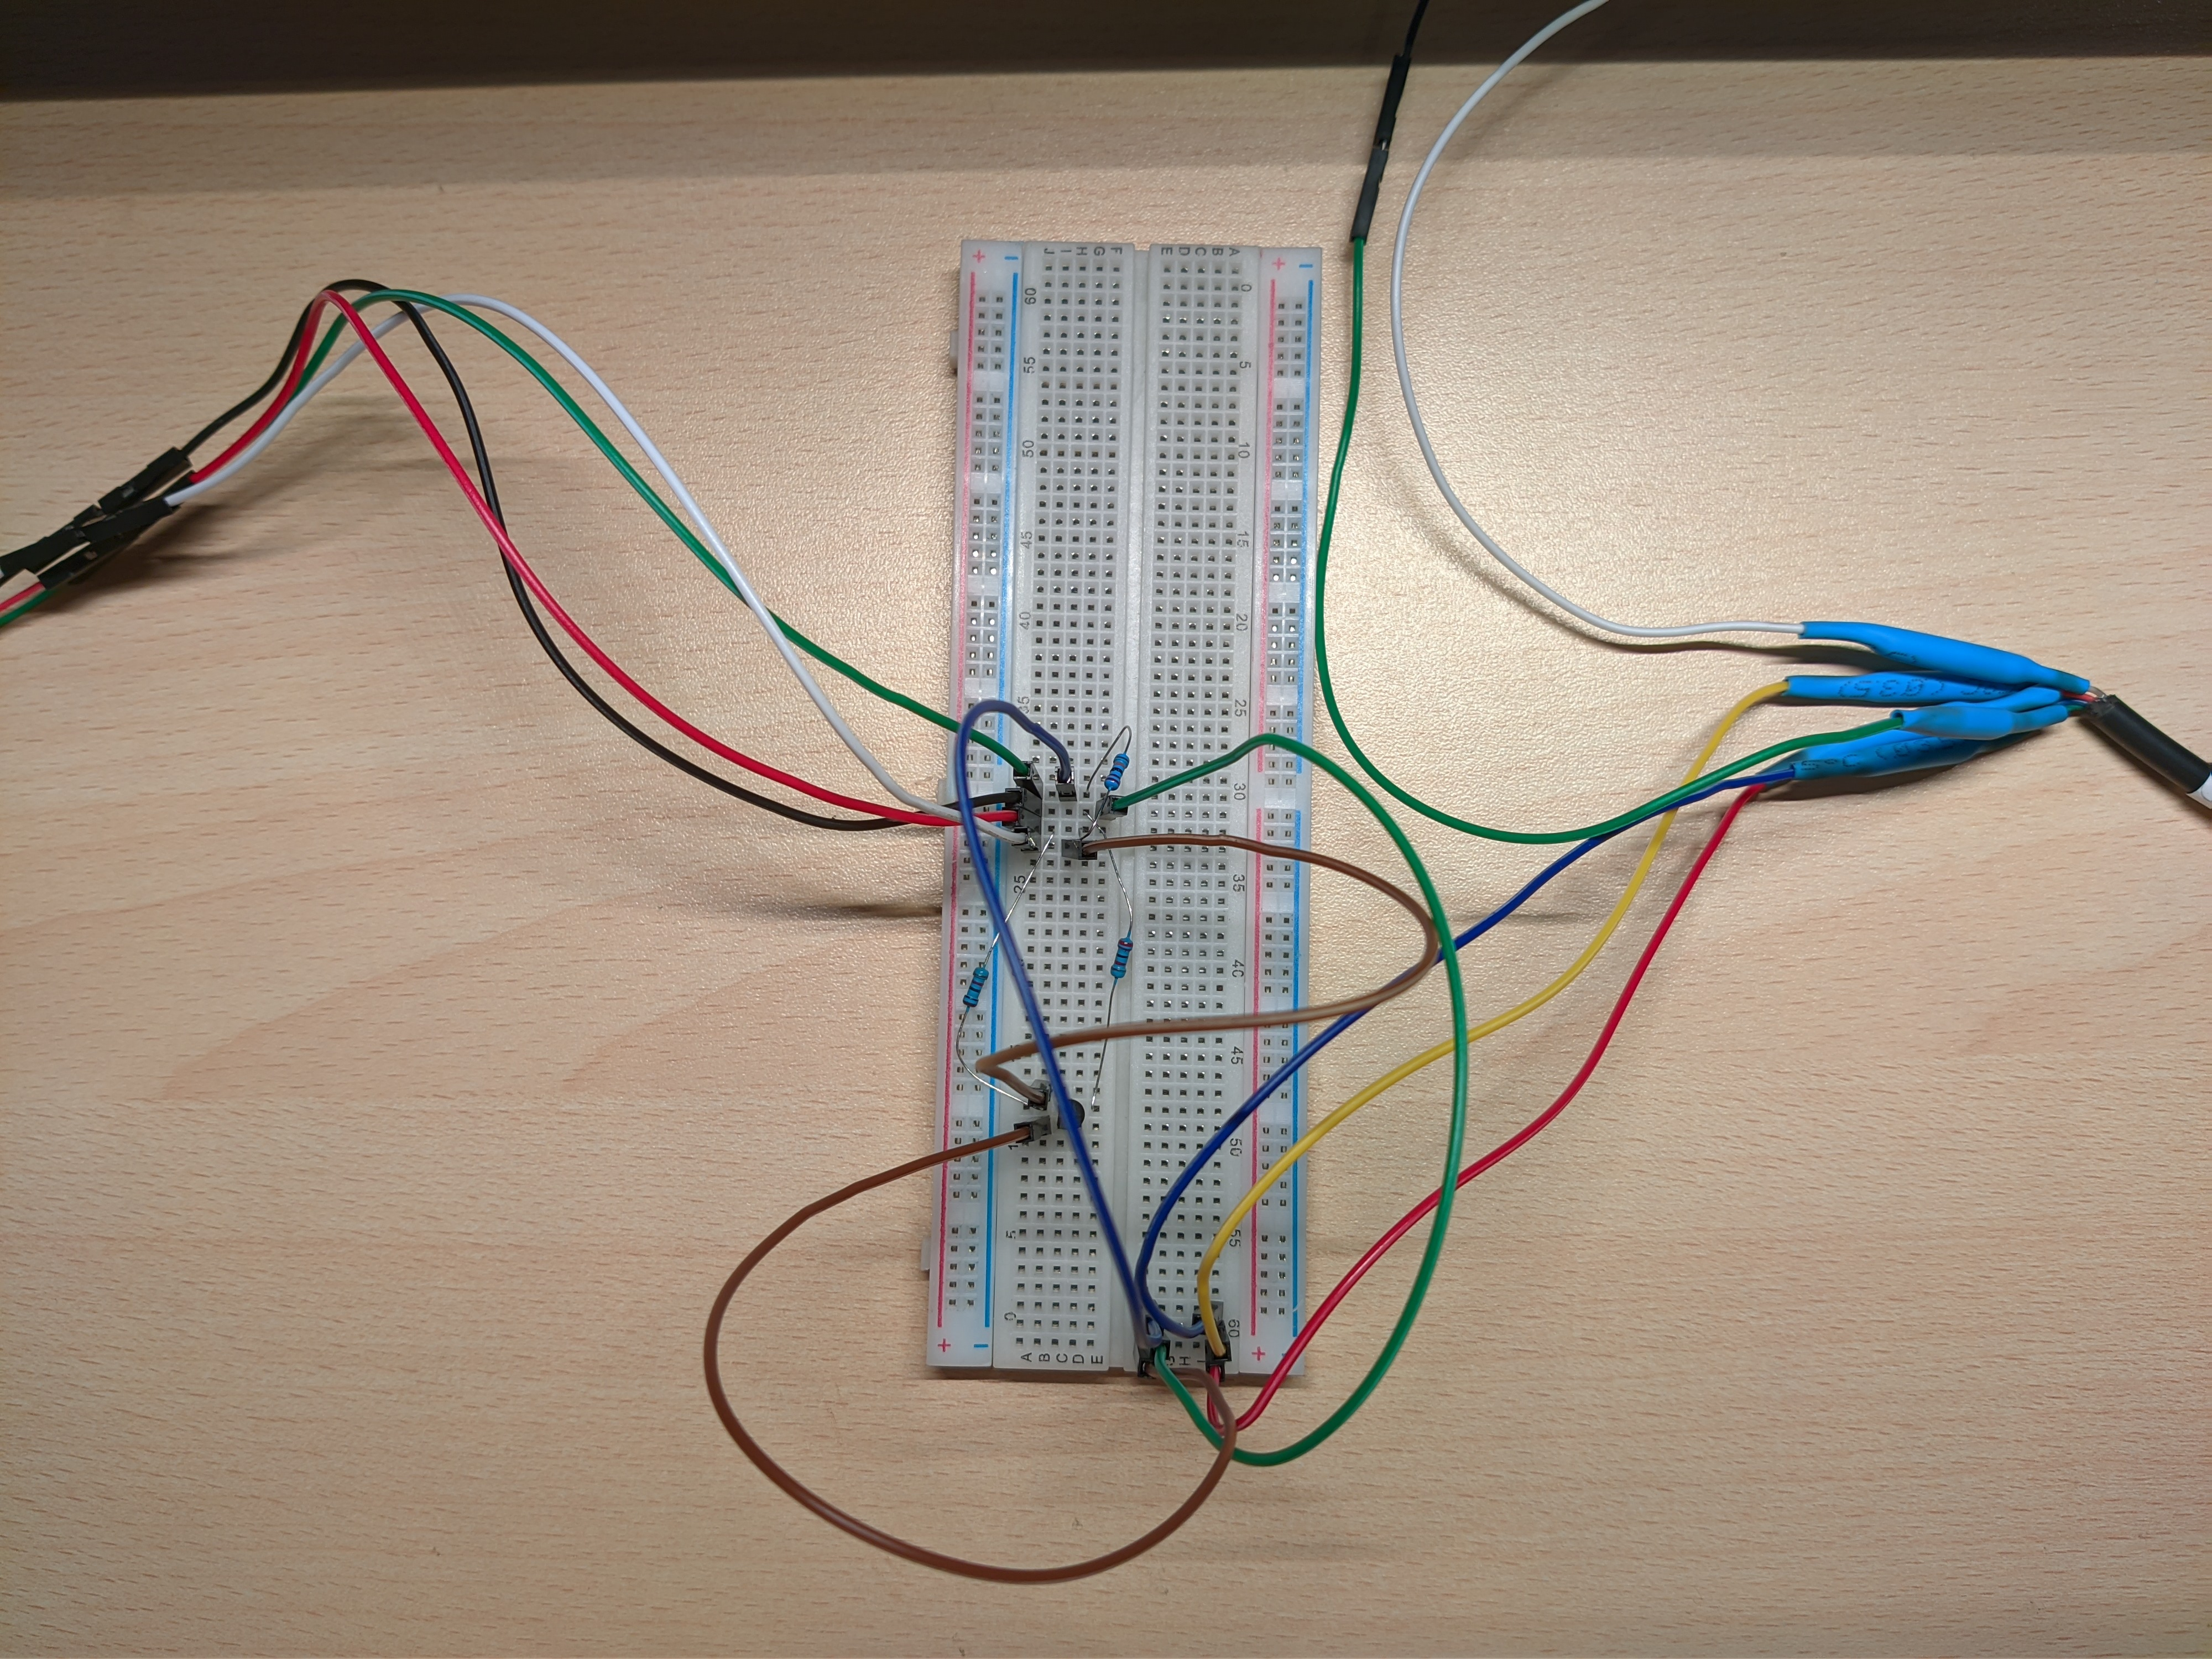
Breadboard prototype
I got this layout from Pila’s blog.

Minitel Shortcuts
Minitel terminals show the integrated phonebook by default; for them to be usable serial terminals, use the following shortcuts:
French Minitel 1B/2:
- Fnct + T A: Enables ASCII mode
- Fnct + T E: Disables local echo
- Fnct + P 4: Sets baud rate to 4800 Baud (the maximum)
More info can be found on Pila’s blog.
Italian Minitel (Alcatel ADF 258):
- Funz + Mem: Switches to terminal mode
- Funz + M A: Enables ASCII mode
- Funz + M E: Disables local echo
- Funz + B 4: Sets baud rate to 4800 Baud (the maximum)
More info can be found on Retronomicon.

