Uni Programming Languages Notes (Structure)
Felicitas Pojtinger (fp036)
2022-10-24

Introduction

Contributing
These study materials are heavily based on professor Ihler’s “Aktuelle Programmiersprachen” lecture at HdM Stuttgart.
Found an error or have a suggestion? Please open an issue on GitHub (github.com/pojntfx/uni-programminglanguages-notes):
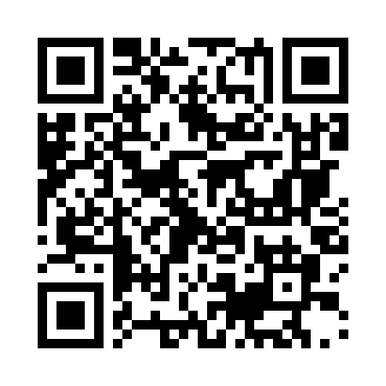
QR code to source repository
If you like the study materials, a GitHub star is always appreciated :)

License

AGPL-3.0 license badge
Uni Programming Languages Notes (c) 2022 Felicitas Pojtinger and contributors
SPDX-License-Identifier: AGPL-3.0

Structure
- Introduction
- Timeline and future
- Syntax
- Type system
- Unique features (regex matching, DSLs, runtime extensions, metaprogramming etc.)
- Package manager
- Interpreters
- Frameworks
- Popular users

