WEB PAGE 01

TravelGo – Bus & Train Booking
HTML, CSS and Output Documentation

Website Description
TravelGo is a simple travel-booking webpage designed to help users explore bus and train travel options in one place. The page includes a welcome banner, a ticket-booking form, popular travel option cards, special offers and a footer. The booking form allows a user to choose a travel type, enter the starting and destination cities, select a journey date and choose the number of passengers. The design aims to make the booking information easy to find and understand.
Technologies used: HTML for webpage structure and CSS for visual design and layout.

HTML Code
The HTML code defines the structure and content of the TravelGo webpage. The screenshot below shows the beginning of the HTML document and the main page sections.
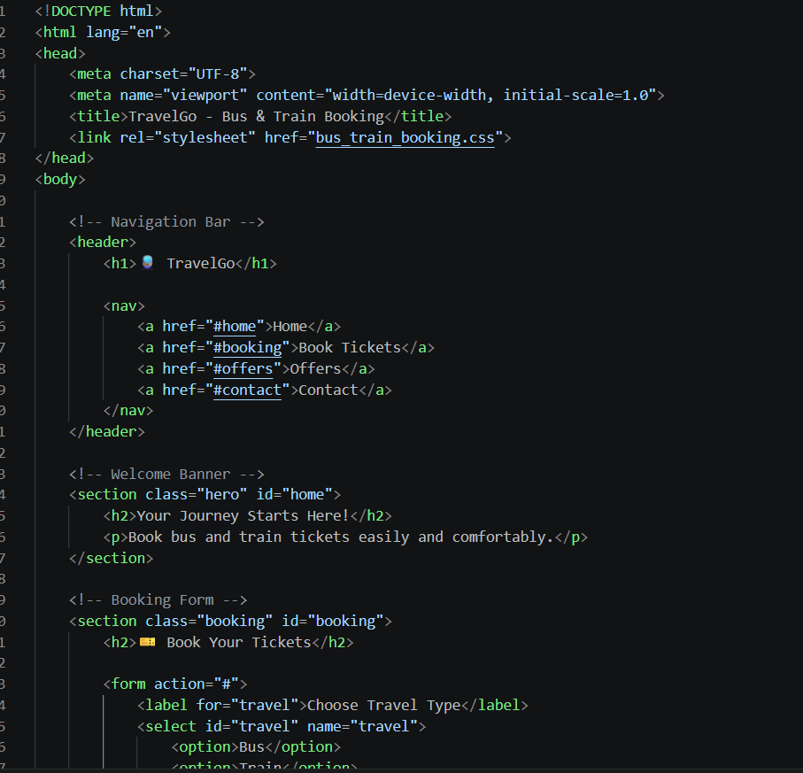
Figure 1: HTML source code screenshot

What I Used in HTML
- DOCTYPE and html tag: Declare the document as HTML5 and set the page language to English.
- head section: Contains the character encoding, responsive viewport setting, webpage title and link to the external CSS file.
- header and navigation: The header contains the TravelGo name. The navigation links point to the Home, Book Tickets, Offers and Contact sections.
- hero section: Displays the welcome message “Your Journey Starts Here!” and a short introduction.
- booking section and form: Organises the ticket-booking fields. Labels identify each field, while select and option elements provide travel and passenger choices.
- section IDs and classes: IDs such as home and booking connect navigation links to page sections. Classes help CSS apply styles to particular sections.

CSS Code
CSS (Cascading Style Sheets) is used to control the appearance of the webpage. It gives the page its colours, spacing, typography and layout.
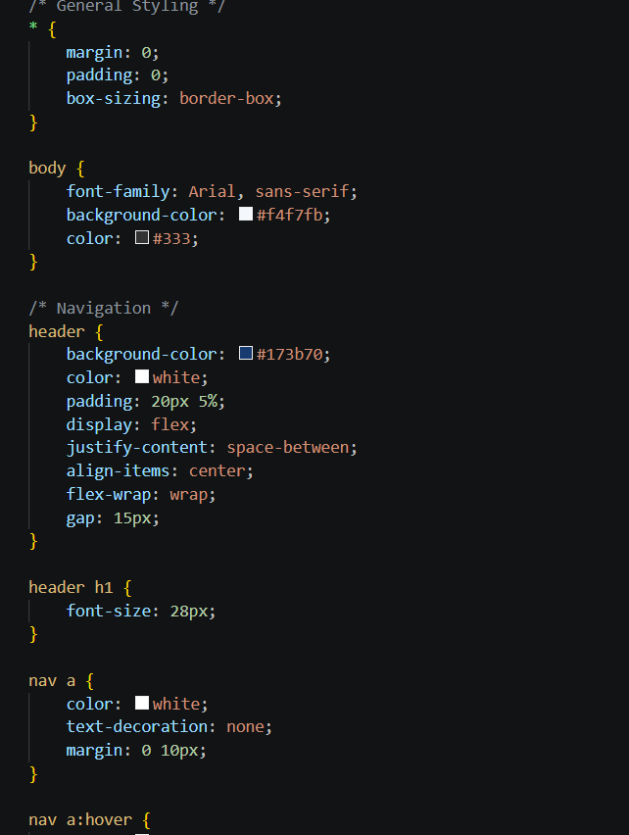
Figure 2: CSS stylesheet screenshot

What I Used in CSS
- Universal selector (*): Resets the default margin and padding and applies border-box sizing for more predictable element dimensions.
- Body styling: Sets the Arial font, a light background colour and dark text for readability.
- Header styling: Uses a dark-blue background with white text, padding and Flexbox properties to arrange the header content.
- Flexbox alignment: display: flex, justify-content and align-items help align the header items. flex-wrap and gap support spacing and wrapping.
- Heading styling: Sets a clear font size for the main website heading.
- Navigation links: Uses white text, removes the underline and adds horizontal spacing between links.
- Hover styling: A navigation hover rule is started in the screenshot to provide a visual response when a user points to a link.

Output
The output screenshot shows the webpage after applying the HTML structure and CSS styling. It demonstrates how the content is arranged in the browser.
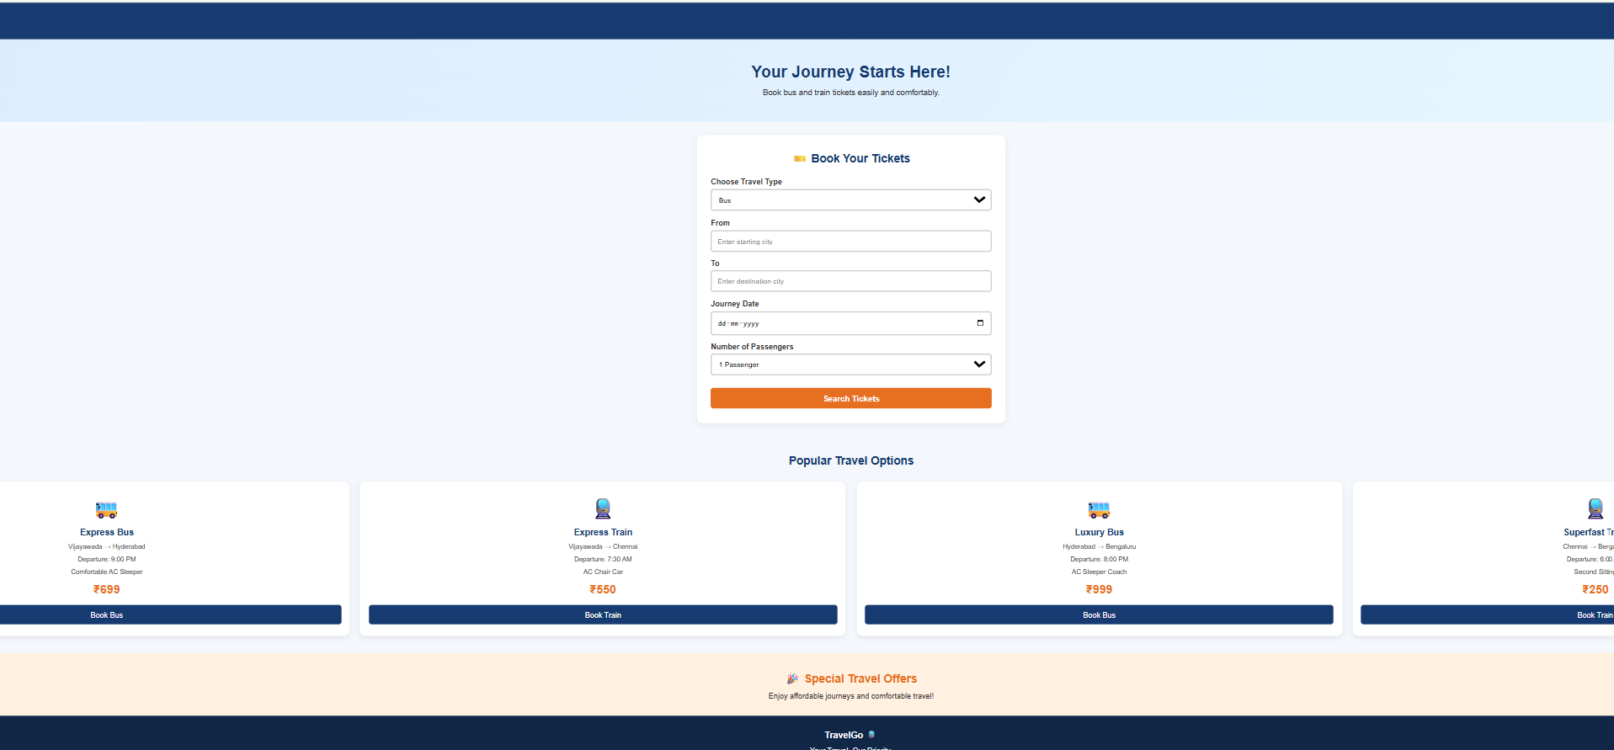
Figure 3: Final TravelGo webpage output

Description of the Output
- Welcome banner: Displays the message “Your Journey Starts Here!” with a short line about booking bus and train tickets.
- Ticket-booking form: Appears in a white panel. It contains controls for travel type, From city, To city, journey date and number of passengers, followed by a Search Tickets button.
- Popular Travel Options: Shows sample bus and train services in separate cards. Each card includes a travel icon, service name, route, departure information, fare and a booking button.
- Special Travel Offers: Highlights promotional travel information in a separate section.
- Footer: Displays the TravelGo name at the bottom of the page.

Conclusion
This project demonstrates how HTML and CSS work together to create a structured and attractive travel-booking webpage. HTML organises the content and form elements, while CSS improves the colours, spacing and alignment. The final TravelGo page presents the main booking details and sample travel options in a clear, user-friendly layout.

