WEB PAGE 03

ShopEasy – Online Shopping Website
HTML, CSS and Output Documentation

Website Description
ShopEasy is an online shopping webpage designed to display different products and special discounts in a simple and attractive layout. The website includes a navigation bar, a promotional banner, a product section, a special offers section and a footer. Customers can view product images, names, short descriptions, ratings, prices and discount details. Each product card also contains a Buy Now button. The webpage uses a purple and light-colour theme to create a neat and pleasant shopping experience.
Technologies used: HTML to create the webpage structure and CSS to design its appearance and layout.

HTML Code
HTML (HyperText Markup Language) is used to create the structure and content of the ShopEasy webpage. The screenshot below shows the product navigation, promotional banner and the beginning of the product section.
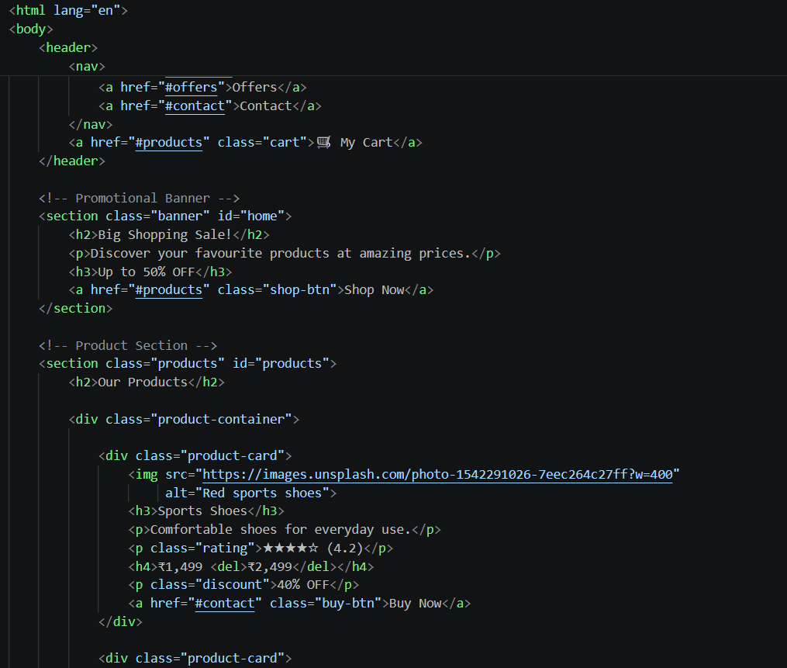
Figure 1: HTML source code – navigation, promotional banner and product section

What I Used in HTML
- HTML and body tags: Define the webpage and contain the content displayed in the browser.
- Header and navigation: The header contains the navigation menu. Links such as Offers and Contact help users move to the related sections.
- Cart link: The My Cart link is included in the header to provide quick access to the shopping cart area.
- Promotional banner: A section with the heading “Big Shopping Sale!”, a short message, a discount offer and a Shop Now link attracts the user's attention.
- Product section: The Products section groups the items under the heading “Our Products”.
- Product container and product cards: The product-container class groups the cards, while each product-card displays an individual item.
- Image and alternative text: The img tag displays the product picture. The alt attribute provides alternative text describing the image.
- Product details: Heading and paragraph tags display the product name and description. Rating, price, discount and Buy Now link elements provide shopping information.
- Classes and IDs: Attributes such as class and id identify sections and elements so that CSS can style them and navigation links can target them.

CSS Code
CSS (Cascading Style Sheets) is used to control the design of the ShopEasy webpage. It sets the colours, fonts, spacing and alignment of the navigation bar and other page elements, helping the website look organised and attractive.
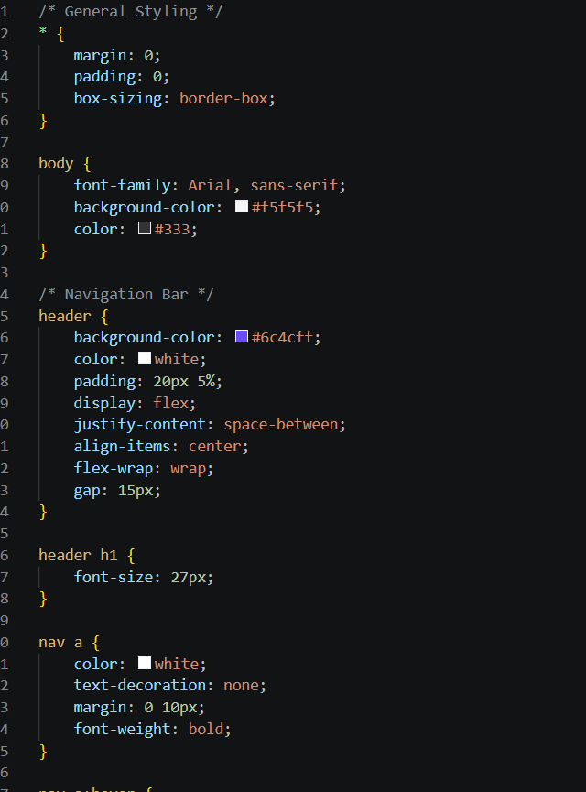
Figure 2: CSS stylesheet – general styling and navigation bar

What I Used in CSS
- Universal selector (*): Resets the default margin and padding and applies box-sizing: border-box for consistent element sizing.
- Body styling: Sets Arial as the font, uses a light grey background and applies dark text for readability.
- Header styling: Gives the navigation bar a purple background with white text and adds padding.
- Flexbox layout: display: flex arranges header items in a row. justify-content: space-between distributes available space, while align-items: center vertically aligns the items.
- Flexible wrapping and gap: flex-wrap: wrap allows items to move to another line when needed, and gap adds space between them.
- Heading styling: Sets the main header text to a suitable font size.
- Navigation link styling: Makes navigation links white and bold, removes the default underline and adds horizontal spacing.

Output
The output screenshot shows the completed ShopEasy webpage in a browser. It demonstrates how the HTML structure and CSS styles combine to present the online shopping page.
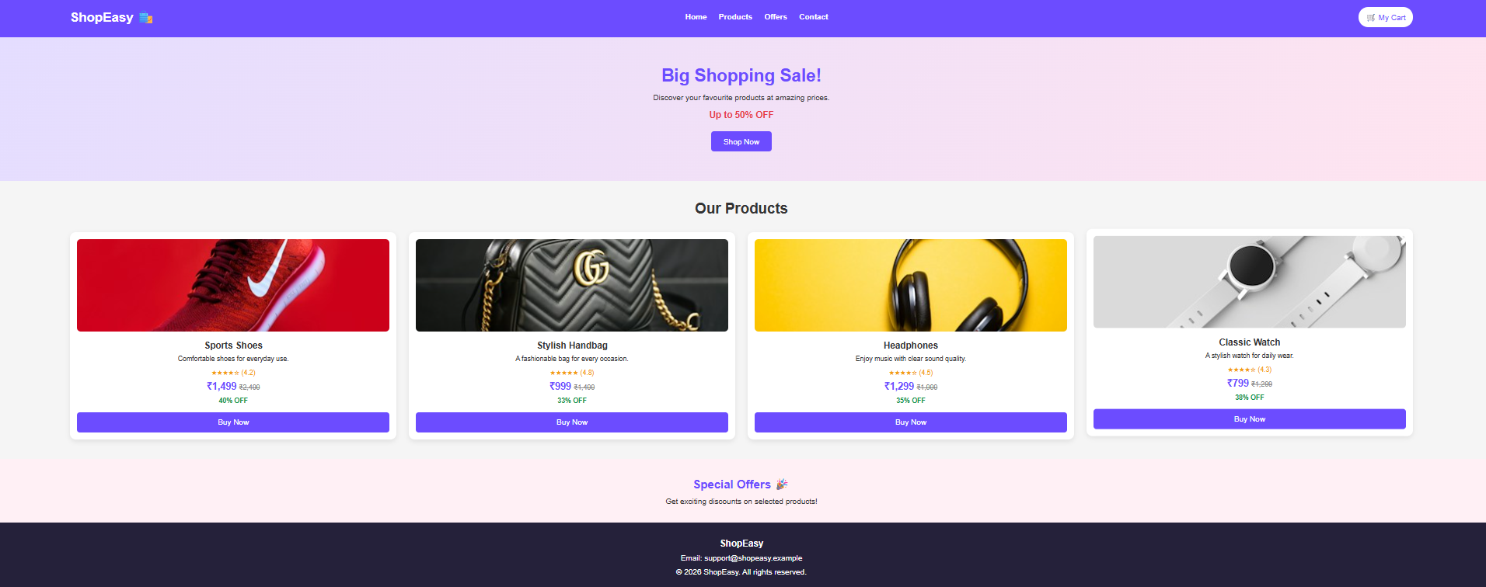
Figure 3: Final output of the ShopEasy – Online Shopping Website

Description of the Output
- Navigation bar: The purple top bar displays the ShopEasy name and links for Home, Products, Offers and Contact, along with the My Cart link.
- Promotional banner: Displays “Big Shopping Sale!”, a short promotional message, an offer of up to 50% OFF and a Shop Now button.
- Our Products section: Shows four product cards: Sports Shoes, Stylish Handbag, Headphones and Classic Watch.
- Product information: Each card displays a product image, name, short description, star rating, current price, previous price, discount percentage and Buy Now button.
- Special Offers section: Highlights discounts available on selected products.
- Footer: Displays the ShopEasy name, support email address and copyright information.

Conclusion
The ShopEasy project demonstrates how HTML and CSS can be used together to create an online shopping webpage. HTML organises the navigation, promotional banner and product details, while CSS controls the colours, spacing and layout. The final webpage presents products and discounts in a clear and user-friendly format.

