WEB PAGE 02

Foodie – Online Food Delivery
HTML, CSS and Output Documentation

Website Description
Foodie is an online food delivery webpage created to present popular food items and make ordering simple for customers. The website includes a navigation bar, a welcome section, a special offer, popular dish cards, a section explaining why customers may choose Foodie, and a footer with contact information. Each dish card displays a food image, name, short description, rating, price and an Order Now button. The page uses a bright orange theme to create an attractive and welcoming food-ordering experience.
Technologies used: HTML to organise the webpage content and CSS to style the page and arrange its elements.

HTML Code
HTML (HyperText Markup Language) provides the basic structure of the Foodie webpage. The screenshots below show the beginning of the HTML file and its main page elements.
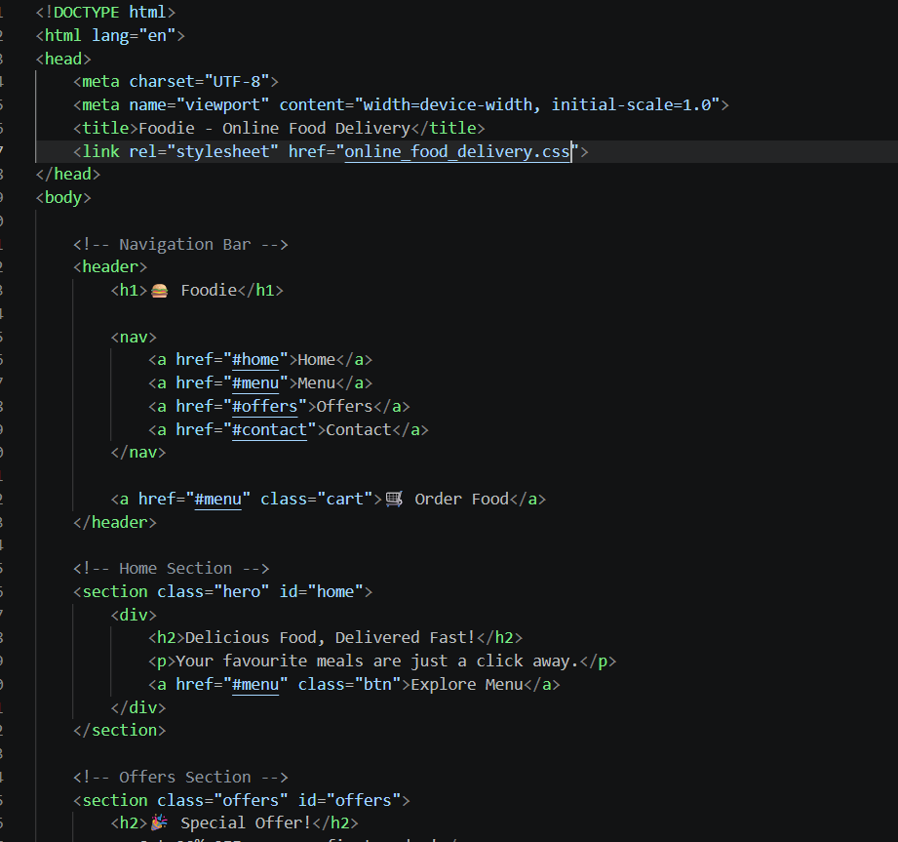
Figure 1: HTML source code – document setup, header and home section

What I Used in HTML
- DOCTYPE and html tag: Identify the document as HTML5 and set the page language to English.
- Head section: Includes UTF-8 character encoding, a responsive viewport setting, the webpage title and the link to the external CSS file.
- Header: Displays the Foodie brand name and contains the navigation area.
- Navigation links: The Home, Menu, Offers and Contact links help users move to the related sections of the webpage.
- Order Food link: Provides a visible link to the menu section for users who want to view and order food.
- Home or hero section: Displays the main message, “Delicious Food, Delivered Fast!”, a short description and an Explore Menu link.
- Offers section: Introduces a special offer to attract customers.
- Section IDs and classes: IDs such as home, menu and offers connect navigation links to page sections. Classes make it possible to style specific elements using CSS.

CSS Code
CSS (Cascading Style Sheets) controls the visual appearance of the Foodie webpage. It is used to set colours, fonts, spacing and alignment so that the content looks organised and is easy to read.
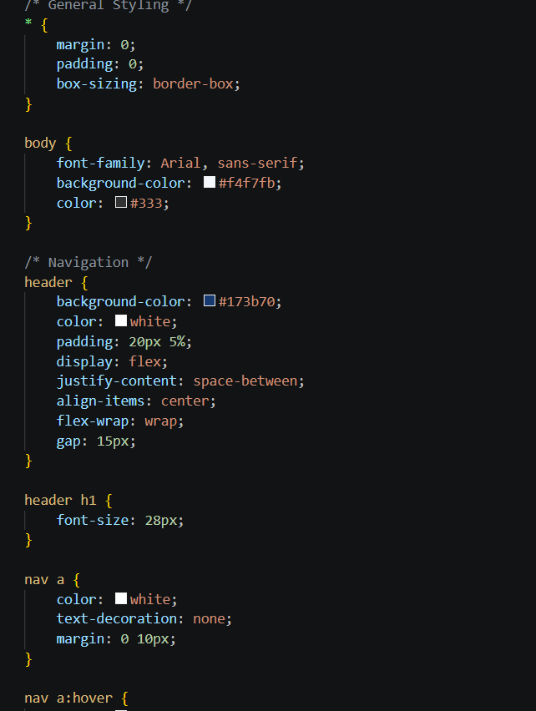
Figure 2: CSS stylesheet – general styling and navigation

What I Used in CSS
- Universal selector (*): Resets the default margin and padding and applies box-sizing: border-box to make element sizing easier to manage.
- Body styling: Uses the Arial font, a light background colour and dark text for readability.
- Header styling: Applies an orange background, white text and padding to make the navigation bar stand out.
- Flexbox layout: Uses display: flex, justify-content and align-items to arrange header content. flex-wrap and gap help manage spacing and wrapping.
- Heading styling: Sets the font size of the website heading so the Foodie brand is clearly visible.
- Navigation link styling: Sets links to white, removes the default underline and adds horizontal spacing between links.
- Hover styling: The navigation hover selector can be used to change the appearance of a link when the pointer moves over it.

Output
The output screenshot shows the completed Foodie webpage in a browser. It demonstrates how the HTML structure and CSS styling work together to create the final design.
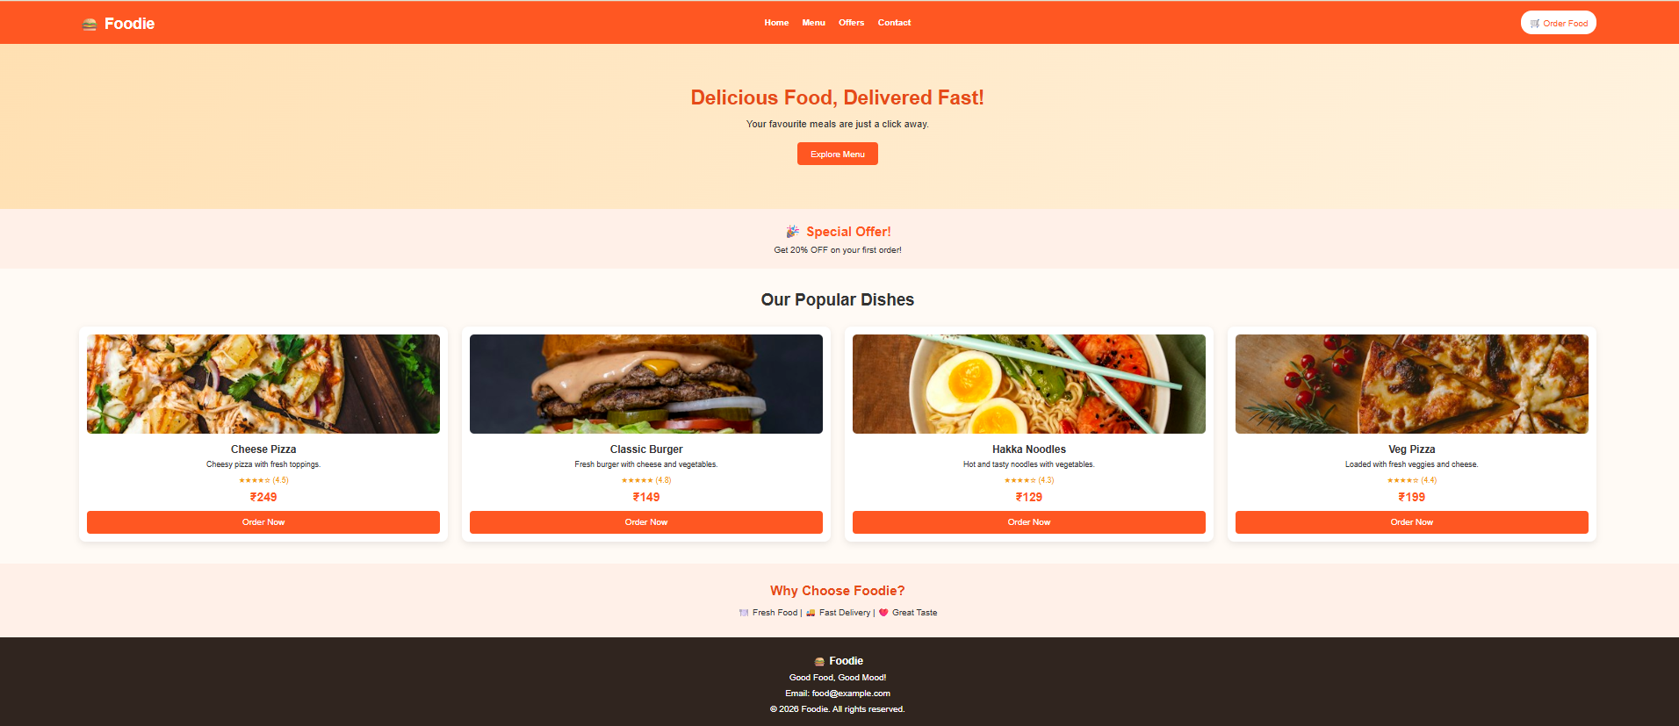
Figure 3: Final output of the Foodie – Online Food Delivery webpage

Description of the Output
- Navigation bar: The orange top bar displays the Foodie name and links for Home, Menu, Offers and Contact, along with an Order Food link.
- Welcome section: Shows the heading “Delicious Food, Delivered Fast!”, a short message and an Explore Menu button.
- Special offer: Highlights a 20% discount on the first order.
- Popular dishes: Displays four food cards: Cheese Pizza, Classic Burger, Hakka Noodles and Veg Pizza. Each card includes an image, description, rating, price and Order Now button.
- Why Choose Foodie section: Highlights key benefits such as fresh food, fast delivery and great taste.
- Footer: Shows the Foodie name, a short tagline, email contact and copyright information.

Conclusion
The Foodie project demonstrates how HTML and CSS can be combined to build an attractive online food delivery webpage. HTML is used to organise the content, navigation and food sections, while CSS is used to improve the colours, spacing and layout. The final webpage presents food choices, prices and ordering links in a clear and user-friendly format.

