EEE591 Python for Rapid Engineering Solution | Project 2
Po-Kan Shih (1214361589)

Perform PCA and show the highest singular values:
Singular value
41.93847565
40.48917972
27.3278636
22.471137
21.19077832
18.80364613
17.2554962
16.02986302
15.67571209
It can be shown that the first few singular values are evidently greater than the rest, which means they present influence much greater than the others. After testing several times, we choose the variables with singular values greater than 18 for our classifiers.

Classifier | Test set | Misclassified | Accuracy | TP | TN | FP | FN
Perceptron | 207 | 50 | 76% | 82 | 75 | 36 | 14
Logistic Regression | 207 | 48 | 77% | 73 | 86 | 25 | 23
Support Vector Machine (linear kernel) | 207 | 50 | 76% | 75 | 82 | 29 | 21
Support Vector Machine (nonlinear kernel) | 207 | 22 | 89% | 74 | 111 | 0 | 22
Decision Tree | 207 | 38 | 82% | 90 | 79 | 32 | 6
Random Forest | 207 | 8 | 96% | 94 | 105 | 6 | 2
K Nearest Neighbor | 207 | 13 | 94% | 91 | 103 | 8 | 5

Perceptron Logistic Regression SVM (linear kernel)
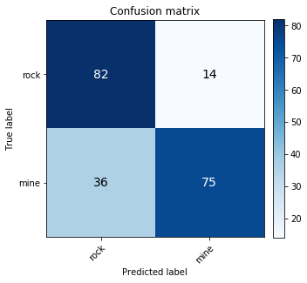
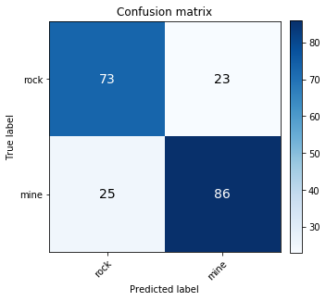
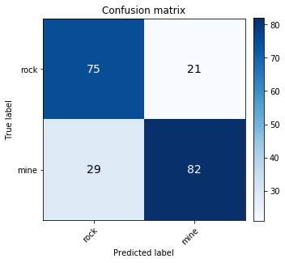

SVM (nonlinear kernel) Decision Tree Random Forest
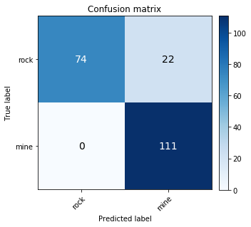
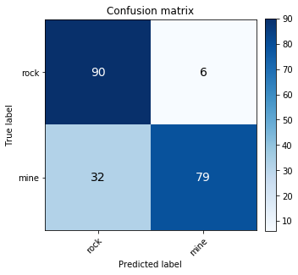
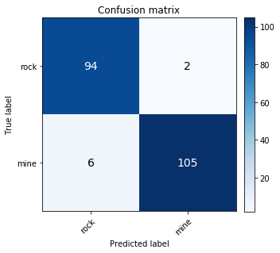
KNN
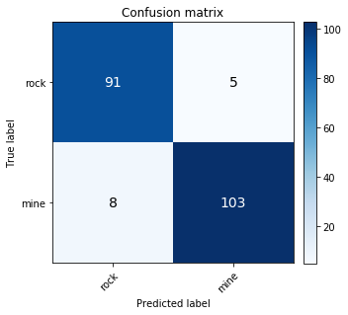
The KNN and random forest obtain the highest total accuracy. SVM with nonlinear kernel outperforms the others in the false positive result (recognize mine as rock), which is the most fatal error. But it does not perform well in the false negative result (recognize rock as mine), which means its false alarm rate is high. Based on the total accuracy and confusion matrix, we will select SVM with nonlinear kernel for highest survival rate (no mines will be recognized as rocks), and then random forest and KNN.

