**Team name**: Codescapes

**Project name**: Audiovision

**Team members**: Miguel Vazquez and Luc Tang

**Current leader**: Luc Tang

**Job Assignment**:

Luc: Back-end lead

Miguel: Front-end lead

**Milestones**:

Week 4:

- REST API for users

- Test API

- Start building the front-end components

- Implement the designs from Figma into each component

Week 5:

- File upload and delete with Amazon S3

- Finish up the user interface

Week 6:

- Audio analysis (p5.js)

- Implement sample p5.js sketch

Week 7: Integration

- Integrate the front-end with back-end

- Fetch audio

- test and debug any issues.

Week 8: Finalize prototype

- Test the prototype thoroughly and fix any bugs

- Present a working prototype

Week 9: Non-essential features

- Exporting audio visual along with audio

- Customizability for audio visualizer

- Choosing visual design / color palette

**Technology Tools**: MongoDB, Axios, Express, p5.js, React, Node, Figma

**The activity/progress/update shown in GitHub repository since last week:**

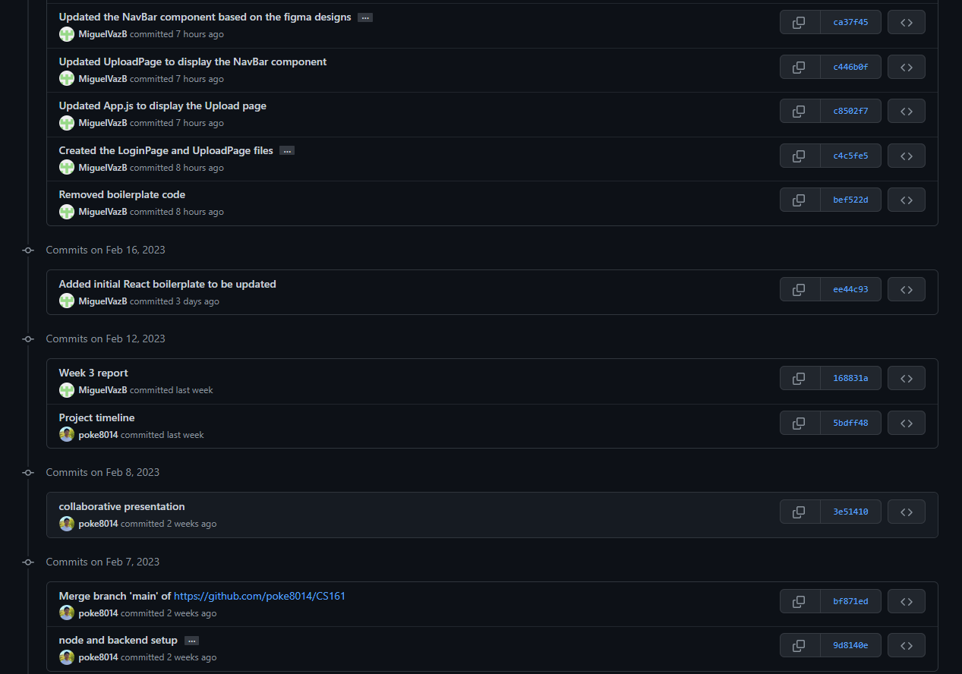

**Milestones Accomplished as a Team:**

* Set up development environment
* Choose the style of the user interface
* Defined use cases
* Came up with more features
* Decided on how the pages will interact with each other
* Decided on the structure of the project

**Conclusion/decisions drawn from your weekly group meeting(s):  
(Sundays, Wednesdays)**

* Each person focuses efforts on backend/frontend
* Extend timeline for front and backend development
* Resume timeline when integrating front and backend

**Github:** <https://github.com/poke8014/CS161>

**Slides:** <https://github.com/poke8014/CS161/tree/main/weekly_team_presentation>