Chess website: Basic idea  
  
  
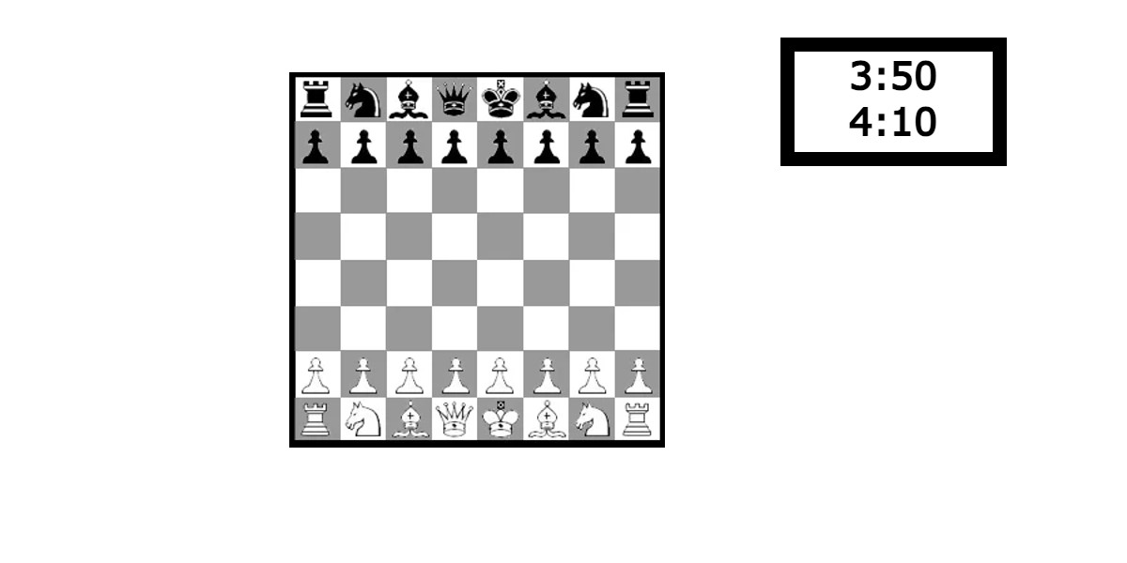

I want to create a working chess game that can be accessed between two users on separate web browsers. Connected using maybe an access code. Similar to this:

Flask  
PIP

Python

REACT