Internship Project Report
ON
“INFIYATRA- A MODERN TRAVEL AND TOURISM PLATFORM”

Prepared by
TAKSH PATEL

Enrolment No.: 24191810010009

Under the guidance of

Prof. Khushboo Rajput

Submitted in
Partial fulfilment of the Degree
Master of Technology(M.Sc. IT) in

Mobile and Software Development


Submitted at

DEPARTMENT OF FOICT
MONARK UNIVERSITY
VAHELAL – 382330
DIST: AHMEDABAD, GUJARAT

CERTIFICATE

This is to certify that the project report entitled "INFIYATRA – A MODERN TRAVEL AND TOURISM PLATFORM" has been carried out by Taksh Patel (24191810010009) under my guidance in partial fulfillment of the requirements for the degree of Master of Technology(M.Sc. IT) (2th Semester) of L.D. College of Engineering, Ahmedabad, during the academic year 2025-26.

To the best of my knowledge and belief, the matter embodied in this report has not been submitted to any other University or Institution for the award of any Degree or Diploma.

Internal Guide  Prof. Khushboo Rajput  Assistant. Professor, | Head of Department (HOD)  Sandip Jadav

Sign Of External Examiner: ______________________ IT Department
Date: _____________

Acknowledgement

Aside from our own efforts, the support and guidance of many individuals played an important role in the successful completion of this project. I would like to express our sincere gratitude to everyone who contributed directly or indirectly to the development of infiYATRA – A Modern Travel and Tourism Platform.
During the course of this project, I gained valuable practical knowledge and real-world development experience, which significantly helped in improving our technical and problem-solving skills. This project has been an important milestone in deepening our understanding of modern web technologies, full-stack development, and user experience design.
I would like to thank Department of FOICT, Monark University, for providing us with the opportunity and necessary resources to participate in and complete this project.

I would like to express our heartfelt thanks to Prof. Sandip Jadav, Head of the Department, for his continuous support, encouragement, and valuable guidance throughout the project development process. His suggestions and motivation greatly helped in the successful completion of this work.

I would also like to sincerely thank Prof. Khushboo Rajput, for her constant guidance, technical support, and constructive feedback during the project. His valuable suggestions and mentorship helped improve the quality and implementation of the project.

Finally, I would like to thank all faculty members, friends, fellow students, and everyone who supported us directly or indirectly during the completion of this project. I also extend our gratitude to our parents and family members for their unwavering patience and encouragement throughout this journey.

Taksh Patel

Candidate's Declaration

I hereby declare that the project report titled "INFIYATRA – A MODERN TRAVEL AND TOURISM PLATFORM" submitted towards the partial completion of Master of Technology(M.Sc. IT) (2nd Semester), at Department of FOICT , Monark University , is an authentic record of our work carried out during the academic year 2025-26.

I further declare that the work reported in this project has not been submitted and will not be submitted, either in part or in full, for the award of any other degree or diploma in this institute or any other institute.

Candidate's Signature: _____________
Candidate's Name: Taksh Patel
Branch: Master of Technology
Enrolment No: 24191810010009

This is to certify that the above statement made by the candidates is correct to the best of my knowledge.

Signature of Internal Guide: _______________________________
(Prof. Khushboo Rajput)

Abstract

infiYATRA is a comprehensive, full-stack travel and tourism web application developed to simplify and enrich the process of trip discovery, planning, and booking for modern travelers. The name 'infiYATRA' is derived from 'Infinite' (representing limitless possibilities) and 'YATRA' (the Sanskrit word for journey), encapsulating the platform's vision of offering an endless world of curated travel experiences.

In an era where travel information is often fragmented across dozens of websites and booking platforms, infiYATRA provides a unified, aesthetically modern interface where users can discover curated travel packages, explore detailed day-by-day itineraries, view destination highlights, and engage with immersive visual content — all from a single platform.

The application is built using a cutting-edge frontend technology stack comprising React 18 (Vite-based), TypeScript 5.6, Tailwind CSS 3.4, and Framer Motion 11, delivering a highly responsive, animated, and visually engaging user experience. A standout feature of infiYATRA is the integration of real-time 3D rendering via Three.js and React Three Fiber, which presents an interactive 3D lens model on the home page as a visual metaphor for discovery and perspective — a feature rarely seen in travel platforms.

The backend of the application is powered by Node.js and Express.js, exposing a RESTful API for trip data and hero content management. A JSON-based data store (db.json) is used during the development phase, designed to be easily migrated to a production-grade relational or NoSQL database. Client-side routing is implemented via React Router DOM v6 for a seamless Single Page Application (SPA) experience.

Key features implemented include: a dynamic hero section with rotating destination slides, a multi-filter trip discovery page (search by keyword, category, and price range), interactive day-by-day itinerary views, a secure administrator dashboard for full CRUD operations on all trip records and hero content, real-time traveler statistics, and a WhatsApp CTA integration widget. The application also includes dedicated destination pages for Himachal Pradesh and Bali, along with static informational pages.

The main objective of infiYATRA is to demonstrate the potential of modern frontend technologies in creating an immersive, user-centric travel discovery platform. The project successfully achieves its objectives of providing a responsive, feature-rich, and visually unique travel web application with significant potential for future enhancements including payment gateway integration, user authentication with personalized wishlists, AI-driven travel recommendations, and migration to a production database with full-scale deployment.

Table Of Contents
Table of Contents
Certificate 2
Acknowledgement 3
Candidate's Declaration 4
Abstract 5
Table Of Contents 7
List Of Figures 9
List Of Tables 10
Chapter 1: Introduction 11
1.1 Project Profile 11
1.2 About The Project 11
1.3 Background 13
1.4 Objectives 14
1.5 Scope Of The Project 15
1.6 Significance 16
1.7 Advantages 16
1.8 Disadvantages / Limitations 17
Chapter 2: System Architecture 18
2.1 System Hardware And Software Requirements 18
2.2 Technology Used 19
Chapter 3: System Analysis And Diagram 26
3.1 Data Flow Diagram (Dfd) 26
3.2 System Architecture Diagram 27
3.3 Use Case Diagram 28
3.4 Activity Diagram 30
3.5 Sequence Diagram – User Search Flow 31
3.6 Sequence Diagram – Admin Crud Flow 32
3.7 Class Diagram / Data Model 32
3.8 Component Structure Diagram 33
3.6 Pages And Routes 34
Chapter 4: Detailed Implementation 36
4.1 Frontend Component Logic 36
4.2 3d Rendering With React Three Fiber 36
4.3 Real-Time Filtering Algorithm 37
Chapter 5: Api Reference And Data 38
5.1 Rest Api Documentation 38
5.2 Json Data Schema 38
Chapter 6: Security And Performance 40
6.1 Cors And Environment Configuration 40
6.2 Asset Optimization 40
Chapter 7: Project Screenshots 41
7.1 Home Page Screenshots 41
7.2 Discover Page Screenshots 42
7.3 Trip Details Page Screenshots 43
7.4 Admin Dashboard Screenshots 44
Chapter 8: Testing 45
8.1 Types Of Testing Performed 45
8.2 Test Case Results 48
Chapter 9: Conclusion 51
9.1 Challenges Summary 51
9.2 Conclusion 51
9.3 Future Enhancements 52
Bibliography / References 53
Appendix: User Manual 54
A.1 Traveler (End User) Guide 54
A.2 Administrator Guide 54

List Of Figures

List Of Tables

Table No. | Title | Page No.
Table 1.1 | Project Profile | 11
Table 2.1 | System Hardware Requirements | 18
Table 2.2 | System Software Requirements (Admin / Developer) | 18
Table 2.3 | System Software Requirements (End User) | 19
Table 3.1 | Admin Side Pages | 25
Table 3.2 | User Side Pages | 26
Table 5.1 | React State Hooks Summary | 36
Table 6.1 | API Endpoint Definitions | 42
Table 8.1 | Functional Testing Results | 52
Table 8.2 | UI/UX Testing Results | 53
Table 8.3 | Compatibility Testing Results | 54

Chapter 1: Introduction

1.1 Project Profile

Table 1.1: Project Profile
Project Name | infiYATRA – A Modern Travel and Tourism Platform
Category | Full-Stack Web Application
Technology | React 18 (Vite), TypeScript, Tailwind CSS, Framer Motion, Three.js, Node.js, Express
Front End | React 18, TypeScript 5.6, Tailwind CSS 3.4, Framer Motion 11, React Three Fiber
Back End | Node.js, Express.js 5
Data Store | JSON-based file store (db.json) – Express REST API
Routing | React Router DOM v6 (Client-side SPA routing)
3D Rendering | Three.js / React Three Fiber / @react-three/drei
Icons | Lucide-React
SEO | react-helmet-async
Build Tool | Vite 5
Language | TypeScript 5.6
Version Control | Git & GitHub
Internal Guide | Dr. Nilesh Modi, Asst. Professor, CE Dept.
Submitted To | L.D. College of Engineering, Ahmedabad
Academic Year | 2025-26
Developed By | Pooja Patel & Aravind Sharma

1.2 About The Project

infiYATRA is a feature-rich, full-stack travel and tourism web application designed to transform the way modern travelers discover and plan their trips. The platform serves as a one-stop digital destination where users can browse curated travel packages from across India and the world, explore rich destination-specific pages, and view comprehensive day-by-day itineraries without needing to switch between multiple websites or applications.

The application is built with a component-based architecture using React 18 and TypeScript, ensuring modularity, type safety, and maintainability. The platform is organized into the following core functional modules:

1) User Module

Home Page
- Immersive hero section with rotating high-resolution destination slides managed dynamically via the admin panel
- Real-time 3D GLB model rendering using React Three Fiber as the visual centrepiece of the discovery theme
- Featured Packages section displaying the top curated trips with price, duration, and category
- Stats Section showing live traveler statistics (trips completed, destinations covered, happy travellers)
- Trending Destinations section with quick visual links to popular Indian and international destinations
- Testimonials section with verified traveler reviews and ratings
- WhatsApp CTA Widget for instant traveler support and inquiry
- Newsletter subscription section for marketing outreach

Discover / Browse Page
- Multi-filter trip discovery interface with simultaneous keyword, category, and price-range filters
- Real-time client-side filtering – results update instantly with every filter interaction
- Responsive grid layout adapts from 1-column (mobile) to 3-column (desktop)

Trip Detail Page
- High-resolution image gallery for each trip with multiple destination photos
- Interactive day-by-day itinerary timeline rendered dynamically from trip data
- Trip highlights, inclusions, exclusions, pricing, duration, and category details
- Book Now / Enquire CTA buttons with WhatsApp integration

Destination Pages
- Dedicated Himachal Pradesh page (HimachalPage.tsx) with region-specific packages and highlights
- Dedicated Bali Destination Page (BaliPage.tsx) for international travel
- Static informational pages (About Us, Contact, Privacy Policy, Terms and Conditions)

2) Admin Module

Admin Dashboard
- Secure login-protected administrator interface
- Full CRUD operations (Create, Read, Update, Delete) on all trip records
- Hero slide management – add, update, or remove home page hero slides
- Real-time updates – changes on the dashboard instantly reflect on the public-facing pages

1.3 Background

The travel and tourism industry is one of the fastest-growing sectors in the global economy. With the widespread adoption of smartphones and broadband internet, travelers now rely heavily on digital platforms to research, discover, and book their trips. However, existing travel platforms often suffer from a range of limitations that hamper the user experience.

Traditional and even many modern travel websites tend to present information in a cluttered, text-heavy format with poor visual hierarchy. Navigation is often non-intuitive, especially on mobile devices, and the lack of clear, day-by-day itinerary breakdowns forces travelers to seek information from multiple sources. Furthermore, very few platforms leverage the immersive potential of modern web technologies such as 3D rendering, fluid animations, or AI-driven personalization.

infiYATRA was conceived and developed to address these gaps. By combining a modern React-based frontend with immersive 3D elements, smooth Framer Motion animations, and a clean, mobile-first Tailwind CSS design, the platform reimagines how a travel website can look, feel, and function. The project draws inspiration from the growing trend of experiential travel marketing, where the digital experience of exploring a destination should itself be as engaging as the physical journey.

1.4 Objectives

The specific objectives of the infiYATRA project are as follows:

- To design and develop a fully responsive, mobile-first travel web application that provides an intuitive and visually engaging user experience across all device types and screen sizes.
- To implement a dynamic and immersive home page experience featuring rotating hero slides, a real-time 3D model rendered via React Three Fiber, live traveler statistics, and curated featured packages.
- To build a powerful trip discovery and filtering interface that allows users to simultaneously filter trips by keyword search, category tag, and price range with instant real-time results.
- To develop an interactive, day-by-day itinerary viewer within each trip's detail page, providing travelers with a clear and comprehensive view of their planned journey.
- To create dedicated destination pages for specific Indian and international travel destinations (Himachal Pradesh, Bali) with relevant packages and visual content.
- To implement a secure, feature-rich administrative dashboard enabling non-technical administrators to perform full CRUD operations on all trip records and home page content.
- To ensure high code quality, type safety, and maintainability throughout the project by adopting TypeScript 5.6 for the entire frontend codebase.
- To demonstrate the practical application of advanced modern web technologies (React Three Fiber, Framer Motion, Tailwind CSS) in a real-world, production-quality web application.

1.5 Scope Of The Project

The scope of the infiYATRA platform encompasses the complete development of a frontend-heavy travel web application with a supporting REST API backend. In its current form, the application is designed for use by two distinct user groups:

- Travelers / End Users: Individuals who visit the platform to explore, discover, and plan travel packages. They interact with the public-facing pages including the home page, discover page, trip detail pages, and destination-specific pages.
- Administrators: Platform managers who use the protected admin dashboard to manage trip records, update pricing and itinerary details, and control the content of the home page hero section.

The scope of the current implementation includes domestic Indian destinations (Spiti Valley, Leh Ladakh, Kashmir, Meghalaya, Kerala, Himachal Pradesh) and one international destination (Bali, Indonesia). The system is architecturally designed to support the addition of new destinations, package categories, and user-facing features with minimal structural changes.

Future scope includes: integration of a secure payment gateway (Razorpay / Stripe), a full user authentication and profile system with personalized wishlists, migration to a production-grade database (PostgreSQL / MongoDB), AI-driven personalized trip recommendations, and user-generated reviews and photo gallery features.

1.6 Significance

The infiYATRA project is significant for several reasons. From an educational standpoint, it demonstrates the practical application of a complete, industry-standard modern web technology stack in a real-world project context. It provides hands-on experience in full-stack development, API design, state management, 3D web rendering, responsive design, and software testing.

From an industry relevance standpoint, the project addresses a genuine market need. The travel and tourism sector is increasingly investing in digital transformation, and platforms that combine immersive visual design with intelligent content management systems represent the direction in which the industry is moving. infiYATRA serves as a prototype for what a next-generation travel platform could look like, leveraging 3D graphics and fluid animations to create an experience that is qualitatively superior to conventional travel websites.

1.7 Advantages

- Provides a single, unified platform for trip discovery, itinerary exploration, and travel inspiration, eliminating the need for users to visit multiple websites.
- The immersive 3D landing page and smooth Framer Motion animations deliver a visually superior and more engaging user experience than conventional travel portals.
- The mobile-first Tailwind CSS design ensures optimal usability across all devices, from 360px smartphones to 2560px ultrawide desktops.
- Real-time multi-filter functionality on the Discover page allows users to find their ideal trip within seconds, improving conversion potential.
- The admin dashboard enables non-technical platform managers to update content in real time without requiring developer intervention, reducing operational costs.
- TypeScript adoption across the entire frontend codebase ensures type safety, reduces runtime errors, and improves long-term maintainability.
- The modular, component-based React architecture makes the codebase highly scalable and easy to extend with new features.

1.8 Disadvantages / Limitations

- The current data layer uses a JSON file-based store (db.json), which is not suitable for production-scale usage with multiple concurrent users and large datasets.
- The application does not currently include a user authentication system, meaning any user can access the admin dashboard if they know the URL.
- The 3D GLB model on the home page requires WebGL support in the user's browser; older browsers or devices with limited GPU capabilities may experience performance issues.
- The platform currently does not support online booking or payment processing, limiting its utility as a direct commercial application.
- Trip data is fully static and managed manually via the admin panel; there is no integration with live booking APIs, real-time availability data, or dynamic pricing systems.

Chapter 2: System Architecture

2.1 System Hardware And Software Requirements
Hardware Requirements:
Table 2.1: System Hardware Requirements
Sr. | Component | Specification
1 | Processor | Intel Core i5 8th Gen or higher / AMD Ryzen 5 or higher
2 | RAM | Minimum 8 GB (16 GB recommended for 3D development workflow)
3 | Storage | Minimum 256 GB SSD (for fast Vite build and dev server operations)
4 | GPU | Dedicated GPU recommended for Three.js / React Three Fiber 3D rendering
5 | Display | Minimum 1366 x 768 resolution for responsive breakpoint testing
6 | Network | Stable broadband internet (for npm package installation and asset CDN loading)
7 | Browser | Google Chrome 120+, Mozilla Firefox 120+, Safari 16+, Microsoft Edge 120+

Table 2.2: System Software Requirements (Admin / Developer)
Sr. | Software | Version / Details
1 | Operating System | Windows 10 / 11 (64-bit) or macOS Monterey+
2 | Node.js Runtime | v18 LTS or higher (required for Vite and Express)
3 | Package Manager | npm v9+ (bundled with Node.js)
4 | Code Editor / IDE | Visual Studio Code (Latest Stable Version)
5 | Version Control | Git v2.40+ & GitHub
6 | API Testing Tool | Postman (Latest)
7 | Build Tool | Vite 5
8 | Browser DevTools | Chrome DevTools for performance profiling and responsive testing

Table 2.3: System Software Requirements (End User)
Sr. | Component | Requirement
1 | Operating System | Any modern OS (Windows, macOS, Linux, Android, iOS)
2 | Browser | Any modern browser with WebGL support (Chrome, Firefox, Safari, Edge)
3 | Internet Connection | Broadband or 4G/5G for smooth loading of images and 3D assets
4 | RAM | Minimum 4 GB (for smooth 3D model rendering in browser)
5 | Screen Resolution | Any resolution (platform is fully responsive from 360px to 2560px+)

2.2 Technology Used

2.2.1 FRONT-END SIDE

1. Overview of React.js (v18)

React is an open-source JavaScript library developed and maintained by Meta for building modern, interactive user interfaces. React follows a component-based architecture, where the UI is composed of small, independent, reusable pieces called components. Each component manages its own state and rendering logic, making the codebase highly modular and maintainable.

In infiYATRA, React 18 is used as the primary frontend framework. It powers all pages (Home, Discover, Trip Details, Himachal, Bali, Admin Dashboard, Static Pages) and all shared components (Navbar, Footer, HeroSection, TripCard, StatsSection, TestimonialSection, WhatsAppButton, and the 3D model component). React's concurrent rendering features in v18 improve the perceived performance of the application.

2. Features of React.js
- Component-Based Architecture – UI is broken into small, reusable, independently manageable components.
- Virtual DOM – React maintains a virtual representation of the DOM and performs efficient diffing to update only changed elements, resulting in superior rendering performance.
- React Hooks – useState, useEffect, useRef, and custom hooks enable state management and side-effect handling without class components.
- React Router DOM v6 – Client-side routing for SPA navigation with dynamic route parameters (e.g., /trips/:id for Trip Details pages).
- JSX / TSX Syntax – Allows writing HTML-like markup directly in TypeScript files for declarative UI development.
- Easy integration with third-party libraries including Framer Motion, React Three Fiber, react-helmet-async, and Lucide-React.

3. Overview of TypeScript (v5.6)

TypeScript is a strongly-typed superset of JavaScript developed by Microsoft. It adds static type checking to JavaScript, allowing developers to catch type-related errors at compile time rather than at runtime. TypeScript is compiled down to plain JavaScript before execution in the browser.

In infiYATRA, TypeScript 5.6 is used throughout the entire frontend codebase. All components, data models (Trip, HeroSlide, Itinerary interfaces), and API service functions are fully typed. This ensures early detection of bugs during development, improved IntelliSense and autocomplete in Visual Studio Code, and significantly better long-term code maintainability.

4. Overview of Vite (Build Tool)

Vite is a next-generation frontend build tool and development server developed by Evan You (creator of Vue.js). Unlike traditional bundlers such as Webpack, Vite uses native ES module imports during development, resulting in extremely fast startup times (Hot Module Replacement or HMR) and near-instant page refreshes. For production builds, Vite uses Rollup to create highly optimized, tree-shaken bundles.

In infiYATRA, Vite serves as both the development server and the production build tool. The Vite proxy configuration (vite.config.ts) is used to forward all /api requests from the frontend development server (port 5173) to the Express backend (port 3001), eliminating CORS issues during development. Vite's code-splitting and lazy loading are leveraged to keep the initial bundle size small.

5. Overview of Tailwind CSS (v3.4)

Tailwind CSS is a utility-first CSS framework that provides a comprehensive set of low-level utility classes for building custom user interfaces directly in the markup. Unlike traditional CSS frameworks such as Bootstrap, Tailwind does not provide pre-built UI components; instead, it provides atomic CSS utilities (e.g., flex, pt-4, text-center, rounded-lg) that can be composed to build any design.

In infiYATRA, Tailwind CSS 3.4 is the primary styling system. The entire platform's responsive behavior is implemented using Tailwind's mobile-first breakpoint system (sm:, md:, lg:, xl:, 2xl:). The custom color palette (Teal #0D7377, Orange #FF6B35, Gold #FFD700) is configured in tailwind.config.js and applied consistently throughout all components. Tailwind's JIT (Just-In-Time) compiler ensures that the final production CSS bundle contains only the classes actually used in the codebase, minimizing CSS payload.

6. Overview of Framer Motion (v11)

Framer Motion is a production-ready animation library for React that provides a simple, declarative API for creating smooth, performant animations and gesture interactions. It abstracts the complexity of CSS animations and the Web Animations API into an intuitive motion component system.

In infiYATRA, Framer Motion 11 is used extensively to enhance the user experience. Key use cases include: animated page entry transitions (fade-in, slide-up effects) for all major page sections, staggered animation sequences for trip card grids on the Discover page, smooth hero section slide transitions with cross-fade effects, animated hover states on interactive elements, and layout animations for filter results updates on the Discover page.

7. Overview of Three.js / React Three Fiber

Three.js is a cross-browser JavaScript library and API used to create and display animated 3D computer graphics in a web browser using WebGL. It provides a high-level abstraction over the raw WebGL API, making it significantly easier to create complex 3D scenes, geometries, materials, lights, and cameras.

React Three Fiber (R3F) is a React renderer for Three.js that allows developers to compose Three.js scenes declaratively using React components and JSX/TSX syntax. This makes it possible to manage 3D scene state using React hooks and integrate Three.js scenes seamlessly within the existing React component tree.

In infiYATRA, React Three Fiber is used to render a 3D GLB (Binary glTF) model on the home page landing section. The model is loaded asynchronously using the useGLTF hook from @react-three/drei. React Suspense is used to display a loading fallback while the model is being fetched and parsed. The scene includes ambient and directional lighting, and the model responds to orbit controls for an interactive visual effect. The use of 3D on the landing page serves as a powerful visual differentiator from conventional travel websites.

8. Overview of Lucide-React

Lucide-React is a comprehensive, open-source icon library providing over 1,000 beautifully designed, consistent SVG icons as React components. Each icon is tree-shakeable, meaning only the icons actually used in the codebase are included in the production bundle. In infiYATRA, Lucide-React icons are used throughout the UI for navigation elements, action buttons, feature indicators, and informational badges.

2.2.2 BACK-END TECHNOLOGY

1. Overview of Node.js

Node.js is an open-source, cross-platform JavaScript runtime environment built on Chrome's V8 JavaScript engine. It allows developers to run JavaScript code on the server side, outside of a browser, enabling full-stack JavaScript development. Node.js uses a non-blocking, event-driven I/O model, making it highly efficient and suitable for building fast, scalable network applications and APIs.

In infiYATRA, Node.js serves as the runtime environment for the Express backend server (server.js). It handles all incoming HTTP requests from the React frontend, processes API logic, reads and writes to the JSON data store, and serves the built React application in production.

2. Features of Node.js
- Event-driven and non-blocking I/O architecture enables high concurrency with low resource overhead.
- Unified JavaScript stack for both frontend and backend development, simplifying the development workflow.
- Vast ecosystem of packages available via NPM (Node Package Manager), including Express, cors, and nodemon.
- Fast execution due to the V8 JavaScript engine's JIT (Just-In-Time) compilation.
- Built-in support for reading and writing to the filesystem (fs module), used for JSON-based data persistence.

3. Overview of Express.js (v5)
Express.js is a minimal, unopinionated, and fast web application framework for Node.js. It provides a thin layer of fundamental web application features including HTTP request routing, middleware support, and response handling, without obscuring the core Node.js functionality. Express is the most widely used Node.js framework and is the backbone of countless production web applications and APIs.

In infiYATRA, Express.js 5 is used to build the REST API backend (server.js). It defines and handles the following RESTful endpoints:
- GET /api/trips – Returns the complete list of all trip records as a JSON array.
- GET /api/trips/:id – Returns the details of a single trip identified by its unique ID.
- POST /api/trips – Creates a new trip record and appends it to the JSON data store.
- PUT /api/trips/:id – Updates an existing trip record identified by its ID.
- DELETE /api/trips/:id – Removes a trip record from the JSON data store.
- GET /api/hero – Returns the list of hero slide objects for the home page.
- PUT /api/hero – Updates the hero slides array in the JSON data store.
The Express server is also configured with the cors middleware to allow cross-origin requests from the Vite development server, and it uses Express's built-in JSON body parser middleware (express.json()) to handle API request payloads.

4. Overview of the JSON Data Store (db.json)

The data layer of infiYATRA uses a simple JSON file (db.json) as its data store during the development phase. This approach was chosen for its simplicity, portability, and zero-dependency setup, making the project easy to run without requiring a database installation. The db.json file contains two top-level arrays: trips (an array of all trip objects) and heroSlides (an array of hero slide objects for the home page).

Each trip object in the data store contains the following fields: id, title, destination, category, duration (in days), price, rating, reviewCount, images (array of image URLs), highlights (array of strings), itinerary (array of day objects with title, description, and activities), inclusions, and exclusions. The architecture is designed for straightforward migration to a relational database (PostgreSQL) or a document-based NoSQL database (MongoDB) in future iterations of the project.

Chapter 3: System Analysis And Diagram

3.1 Data Flow Diagram (Dfd)

A Data Flow Diagram (DFD) is a graphical representation that illustrates how data flows through an information system. It shows the inputs, outputs, processes, and data stores of a system without specifying the implementation or physical medium. DFDs are used to model how data moves between external entities, processes, and data stores, helping to understand the logical flow of data in the system.

The symbols used in the DFD for this project are defined as follows:

- Data Flow (Arrow →): Represents the movement of data between two entities, between an entity and a process, or between a process and a data store.
- Process (Rectangle): Represents a function or transformation that acts upon or produces data. Processes are labeled with their function name.
- External Entity (Rounded Rectangle / Oval): Represents an external source or destination of data — in this case, the User (Traveler) and the Admin.
- Data Store (Open Rectangle / Cylinder): Represents a repository where data is stored for later use. In infiYATRA, this is the db.json file accessed via the Express API.

Level-0 (Context Level) DFD:

The context-level DFD shows the entire infiYATRA system as a single process bubble, with two external entities: User (Traveler) and Admin. The User sends trip search queries and receives trip data, destination information, and itinerary details. The Admin sends trip management commands (create, update, delete) and receives confirmation responses. Both entities interact with the central infiYATRA System process, which in turn reads from and writes to the Trip Data Store.

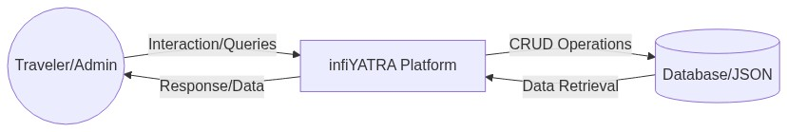
Figure 1: Zero Level DFD – infiYATRA System
Level-1 DFD:

The Level-1 DFD expands the central infiYATRA system process into its individual sub-processes. The key processes identified at Level-1 are:

- P1 – Browse/Discover Trips: The user inputs search keywords, category, and price range. This process filters the trip data and returns matching results to the user.
- P2 – View Trip Details: The user selects a specific trip. This process retrieves the complete trip record (itinerary, images, pricing, highlights) from the data store and renders it to the user.
- P3 – View Destination Page: The user navigates to a destination-specific page (Himachal, Bali). This process retrieves destination-specific trip subsets and renders the page.
- P4 – Manage Hero Slides: The Admin creates, updates, or deletes hero slide records. This process reads/writes the heroSlides array in the data store.
- P5 – Manage Trips: The Admin performs CRUD operations on trip records. This process reads/writes the trips array in the data store.
- P6 – Display Home Page: Assembles data from the hero slides, featured trips, and stats data to render the home page for the user.

3.2 System Architecture Diagram
The infiYATRA system follows a decoupled, three-tier architecture consisting of the Frontend (Presentation Layer), the Backend API (Logic/Application Layer), and the Data Store (Data Layer). The three tiers communicate via HTTP/REST over the local network during development and over the internet in production.
Frontend (React / Vite – Port 5173):
The frontend is a Single Page Application built with React 18 and TypeScript. It is served by the Vite development server during development and from static files in production. The frontend makes asynchronous HTTP requests to the backend API via the dataService.ts module. All API calls are routed through the Vite proxy configuration to the Express backend.
Backend API (Express.js – Port 3001):
The backend is a Node.js Express server that exposes a RESTful API with endpoints for trips (/api/trips) and hero slides (/api/hero). It handles all business logic including data validation, CRUD operations, and response formatting. The server reads and writes data to the JSON file data store using Node.js's built-in fs module.
Data Layer (JSON Store – db.json):
The data store is a structured JSON file containing the trips array and heroSlides array. It acts as a lightweight, portable database during the development phase. The architecture is designed so that the backend can be refactored to use a proper database (PostgreSQL, MongoDB) by replacing the fs-based read/write operations with database query calls, without requiring any changes to the frontend or API contracts.
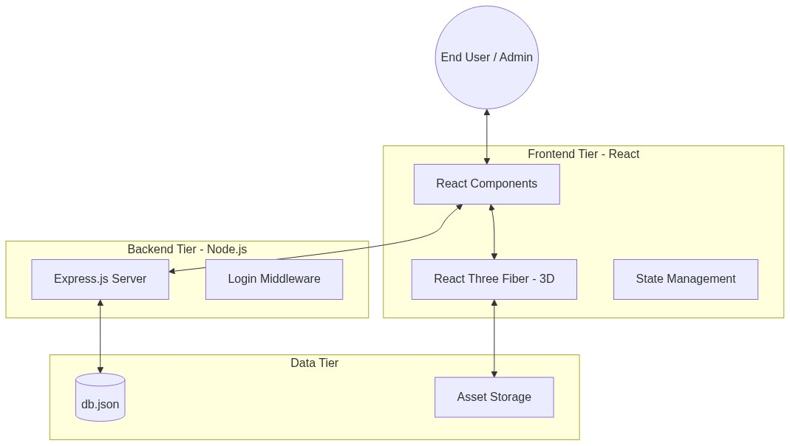
Figure 2: System Architecture – Frontend, Backend, and Data Layer

3.3 Use Case Diagram

3.3.1 Use Case Diagram – User (Traveler)

The User use case diagram illustrates all the interactions a Traveler (end user) can have with the infiYATRA system. The User Actor can perform the following actions within the system boundary:

- View Home Page – Access the immersive home page with the 3D model, rotating hero slides, featured packages, stats, trending destinations, and testimonials.
- Browse / Discover Trips – Navigate to the Discover page and view all available trip packages.
- Filter Trips – Apply keyword search, category, and price-range filters to narrow down trip options.
- View Trip Details – Click on a trip card to view the complete trip information including gallery, highlights, itinerary, and pricing.
- View Destination Page – Access destination-specific pages (Himachal Pradesh, Bali) with curated packages.
- Enquire via WhatsApp – Click the WhatsApp CTA button to initiate a direct inquiry with the travel agent.
- Subscribe to Newsletter – Enter email to subscribe to travel updates and promotional offers.
- View Static Pages – Access About Us, Contact, Privacy Policy, and Terms & Conditions pages.

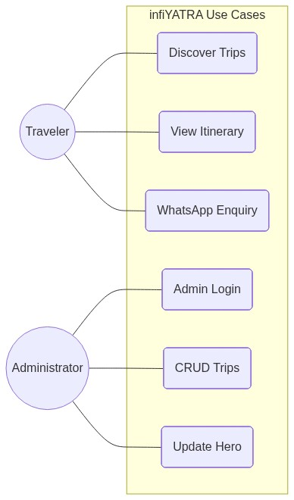
Figure 3: Use Case Diagram – User (Traveler)

3.3.2 Use Case– Admin

The Admin use case diagram shows all the actions available to an Administrator within the protected Admin Dashboard. The Admin Actor can perform the following actions:

- Login to Admin Dashboard – Access the protected admin interface using admin credentials.
- View All Trips – See a complete tabular list of all trip records currently in the system.
- Create New Trip – Fill in and submit a form to create a new trip record with all details (title, destination, category, price, images, itinerary, etc.).
- Edit / Update Trip – Select an existing trip and modify any of its details, with changes immediately reflected on the public site.
- Delete Trip – Remove a trip record permanently from the data store.
- Manage Hero Slides – Add, reorder, or remove home page hero slides to control the main visual impression of the platform.
- Logout – End the admin session securely.

3.4 Activity Diagram

The Activity Diagram for infiYATRA illustrates the sequential flow of activities that occur when a user discovers and explores a trip on the platform. The diagram covers two swimlanes: User (Traveler) and the infiYATRA System.

- Start: User opens the infiYATRA web application in their browser.
- System Action: The application initializes the React SPA, renders the Home page, and makes an asynchronous API call to fetch the featured trips and hero slides.
- User Action: User views the Home page – the 3D model, hero slides, featured packages, and stats are displayed.
- Decision Point: Does the user click on the Discover / Browse button?
- Yes Path: User navigates to the Discover page. The system renders the multi-filter interface and loads all available trip packages.
- User Action: User applies one or more filters (keyword, category, price range).
- System Action: The filter logic in Discover.tsx processes the filter state and renders the matching trip subset in real time.
- Decision Point: Does the user find a suitable trip?
- Yes Path: User clicks on a Trip Card. The system navigates to the TripDetails page and fetches the full trip data using the trip ID from the URL parameter.
- System Action: The TripDetails page renders the gallery, highlights, day-by-day itinerary, inclusions, and pricing.
- User Action: User decides to enquire – clicks the WhatsApp CTA button. System opens WhatsApp with a pre-filled message.
- No Path (no suitable trip found): User may navigate to a Destination Page (Himachal/Bali) or return to the Home page.
- End: User exits the application.
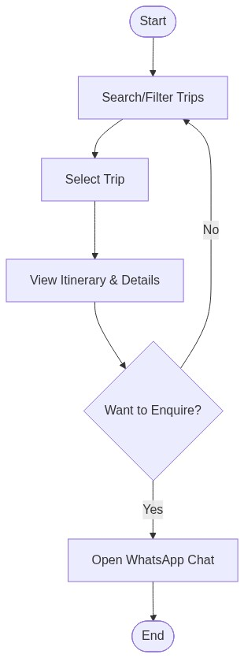
Figure 4: Activity Diagram – Trip Discovery and Enquiry Flow

3.5 Sequence Diagram – User Search Flow

The Sequence Diagram for the User Search Flow illustrates the time-ordered interactions between the User, the React Frontend components, the API Service, and the Express Backend. It shows how a search query is initiated, processed, and returned to the user.

- User: Enters a search term in the Discover page search bar.
- Discover Component: Captures the input and updates the local search state.
- Effect Hook: Detects the state change and triggers the filtering logic.
- Data Service: If necessary, fetches the latest trip data from the backend API.
- Express Backend: Retrieves the trip records from db.json and returns them as a JSON response.
- Frontend: Filters the returned array based on the user's criteria and re-renders the Trip Grid.

3.6 Sequence Diagram – Admin Crud Flow

The Admin CRUD Sequence Diagram illustrates the process of an administrator updating a trip record. It highlights the interaction between the Admin Dashboard, the Edit Trip form, the Express API, and the JSON data store.

- Admin: Navigates to the Dashboard and clicks 'Edit' on a specific trip.
- Dashboard: Fetches the trip details and populates the Edit form.
- Admin: Modifies the trip price and clicks 'Save'.
- API Service: Makes a PUT request to /api/trips/:id with the updated trip object.
- Express Backend: Receives the request, validates the data, and updates the db.json file.
- System: Returns a 200 OK success response to the frontend.
- Dashboard: Displays a success toast notification and refreshes the trip list.

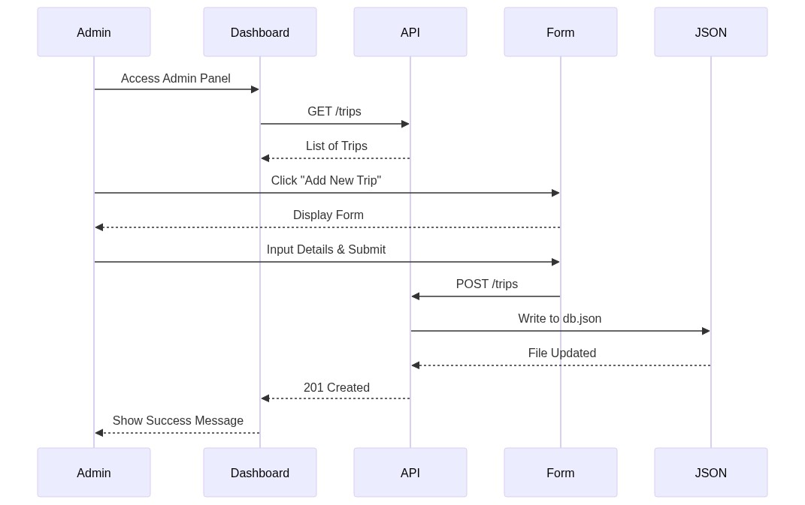
Figure 5: Sequence Diagram – Admin CRUD Flow
Fig. 3.8:

3.7 Class Diagram / Data Model

The Class Diagram (or Data Model Diagram) illustrates the structure of the core data entities used in the infiYATRA system. Although the system uses a JSON-based store, the data is modeled using TypeScript interfaces to ensure strict typing and consistency.

- Trip Class/Interface: Contains fields for id, title, destination, category, price, duration, and nested objects for itinerary and gallery.
- ItineraryDay Class: Contains dayNumber, title, and activities array.
- HeroSlide Class: Contains id, title, subtitle, and imageURL.
- Stats Class: Contains numeric fields for travelers, destinations, and trips.
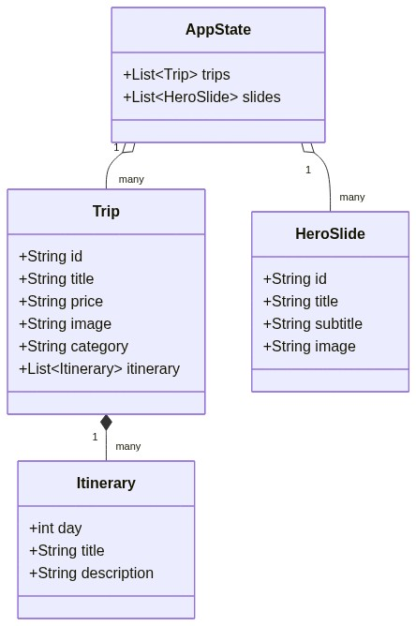
Figure 6: Class Diagram – Core Data Models (Trip, Itinerary, Hero)

3.8 Component Structure Diagram

The Component Structure Diagram (also referred to as the Git Architecture Diagram) illustrates the hierarchical organization of all modules, components, pages, and data layers within the infiYATRA codebase. This diagram provides a comprehensive view of how the application is assembled from its constituent parts.

At the top level, the Platform layer encompasses the Tailwind CSS styling system (tailwind.config.js), the Global CSS entry point (index.css), and the Vite build configuration (vite.config.ts). These platform-level files support and configure the application shell.

The App Shell layer consists of the HTML entry point (index.html), the React entry point (main.tsx), and the root routing shell component (InfilandTs.tsx or App.tsx). The routing shell mounts all page-level routes using React Router DOM.

The Pages layer contains all top-level page components: Home.tsx, Discover.tsx, TripDetails.tsx, HimachalPage.tsx, BaliPage.tsx, and StaticPages.tsx. Each page is mapped to a specific URL route.

The UI Sections layer contains all shared and page-specific components. Shared components include Navbar.tsx, Footer.tsx, and WhatsAppButton.tsx (CTA widget). Home-specific sections include HeroSection.tsx, StatsSection.tsx, Featured Packages Section, Trending Destinations Section, Testimonials Section, and WhyChooseUs.tsx. These sections are assembled by the Home.tsx page component.

The Data and Assets layer, at the bottom of the hierarchy, contains the local data content store (data.ts) and the static media assets (images, 3D GLB model files).

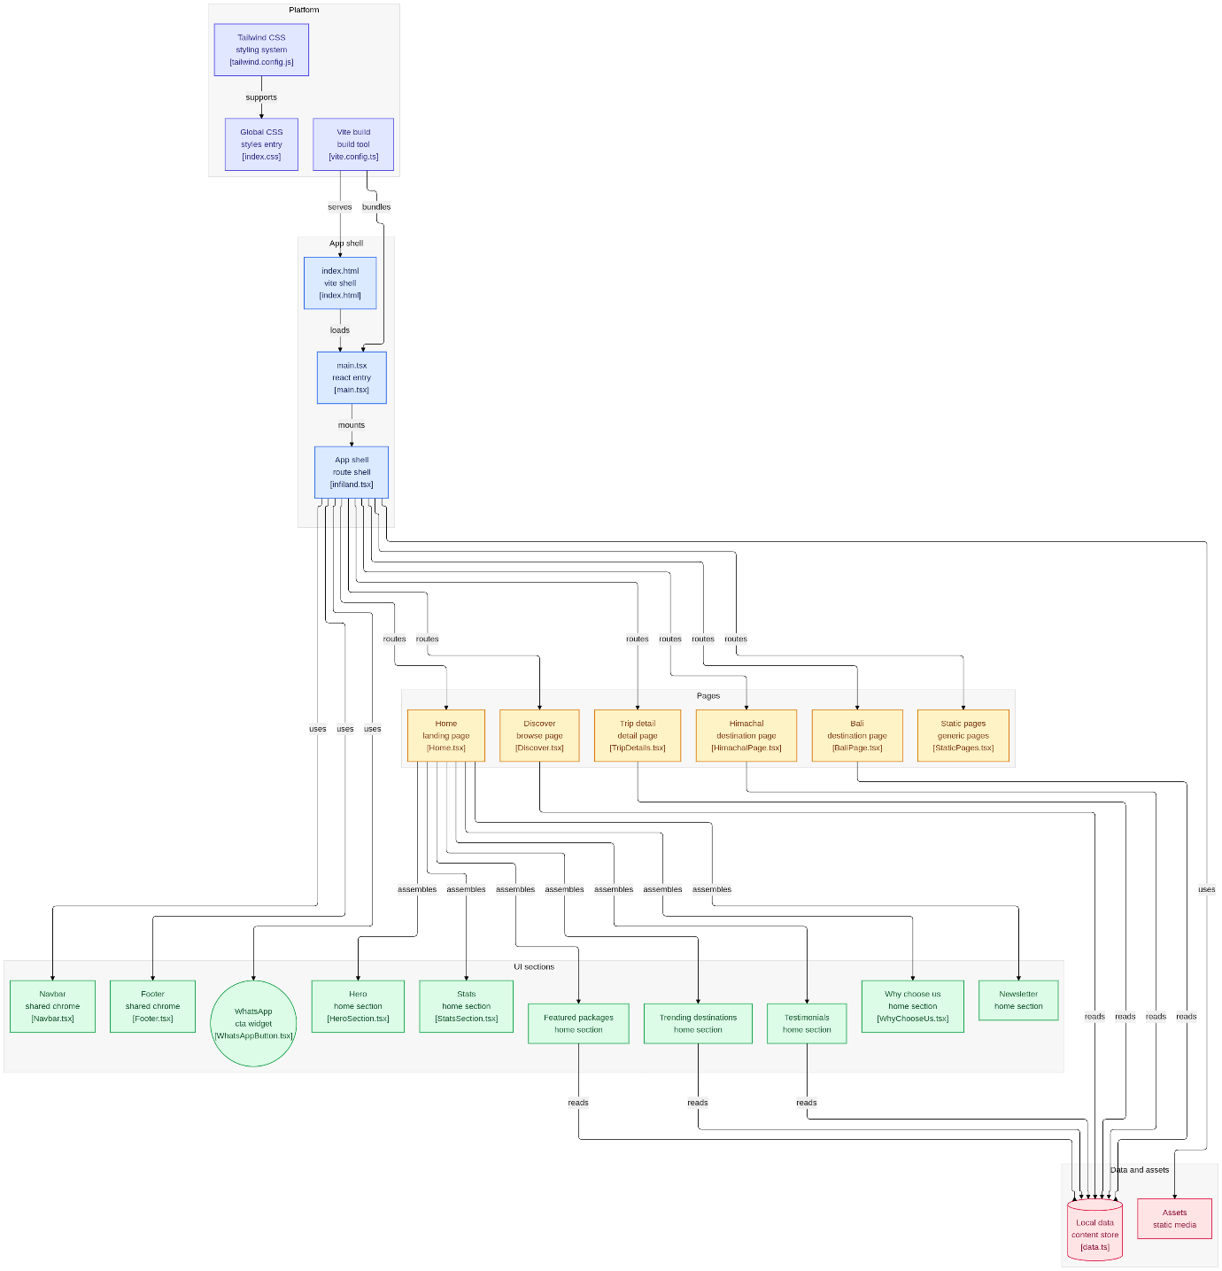

Figure 7:Component Structure Diagram (Git Architecture Diagram) shows the data flow, API calls as well as full architectore of the webapp

3.6 Pages And Routes

Admin Side Pages
Table 3.1: Admin Side Pages
Component / File | Description
AdminDashboard.tsx | Main protected admin interface – shows list of all trips and navigation to CRUD operations.
Create Trip Form | Form within AdminDashboard for creating a new trip with all fields (title, destination, category, price, images, itinerary).
Edit Trip Form | Form populated with existing trip data, allowing administrators to update any trip field.
Hero Management Section | Interface within AdminDashboard for viewing, adding, and removing hero slide objects.
Delete Confirmation | Confirmation dialog triggered before permanently deleting a trip record from the data store.

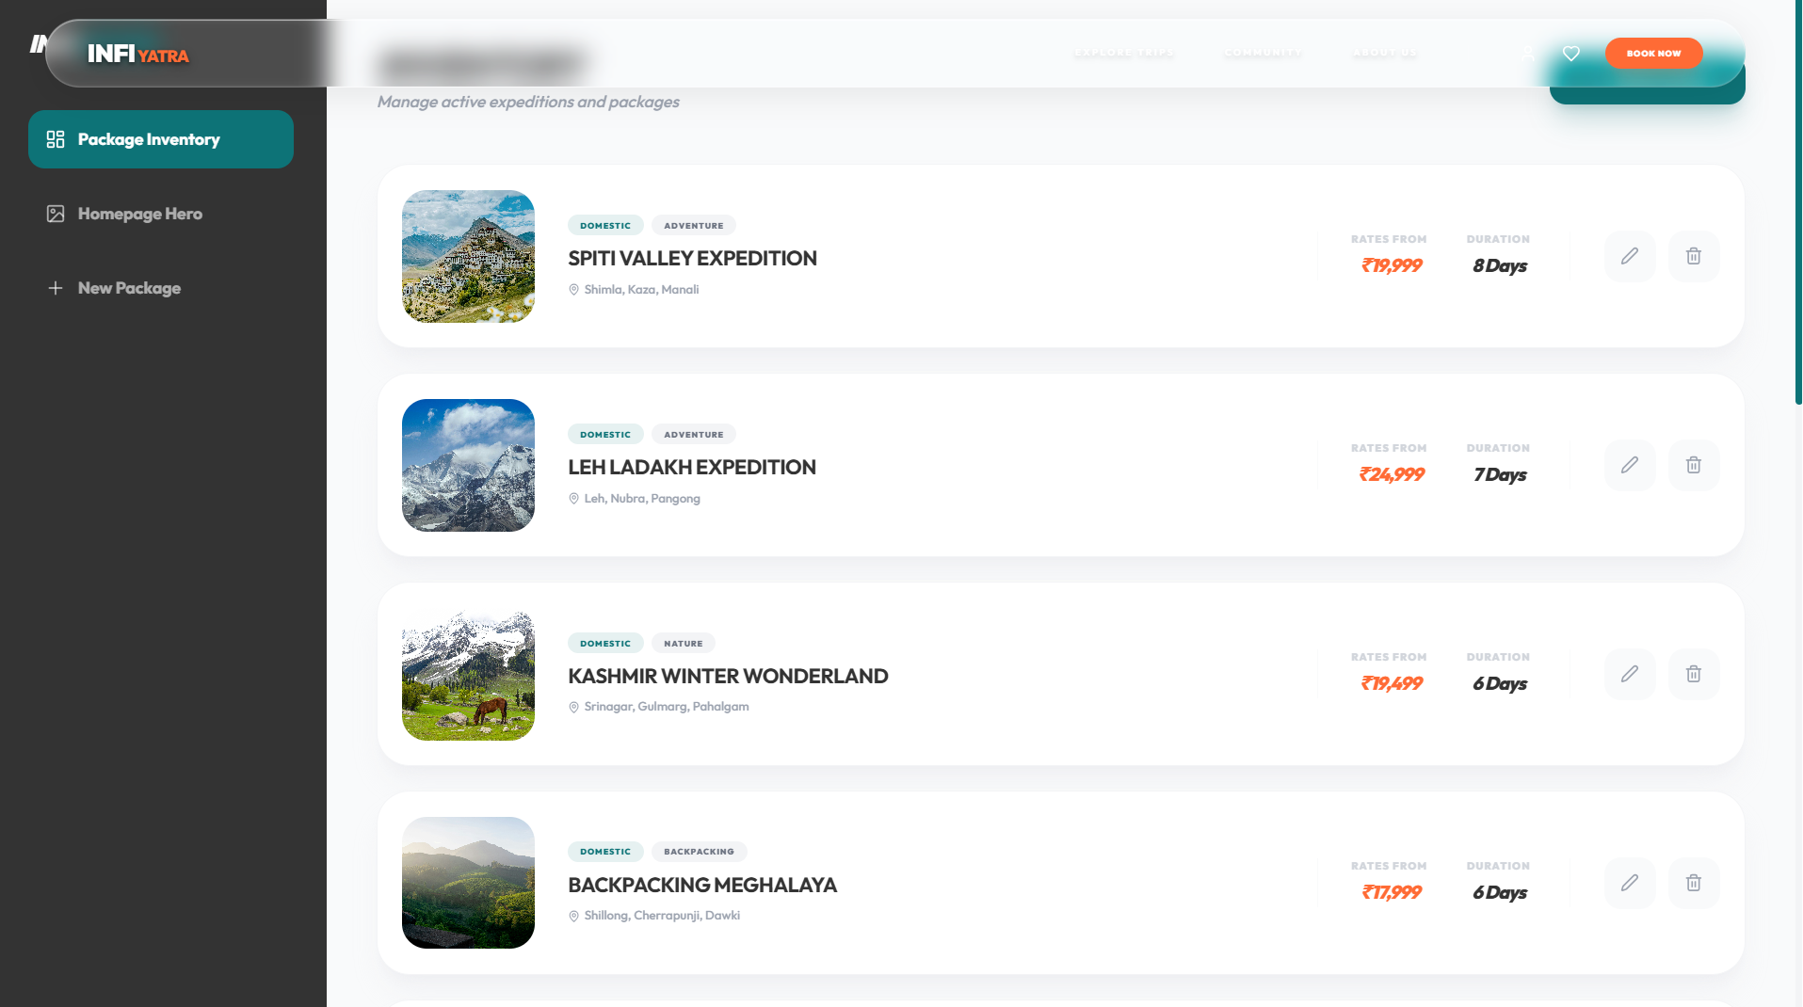
Figure 8: Admin Panel: shows how the admin can login with credentials and change the information on homepage adn trip details easily.
User Side Pages
Table 3.2: User Side Pages
Component / File | Description
Home.tsx | Main landing page – assembles HeroSection, StatsSection, FeaturedPackages, TrendingDestinations, Testimonials, WhyChooseUs, Newsletter, and WhatsApp CTA.
Discover.tsx | Trip discovery and browsing page – multi-filter sidebar (keyword, category, price), responsive trip card grid.
TripDetails.tsx | Individual trip detail page – rendered using React Router DOM URL parameter (/trips/:id). Shows gallery, highlights, day-by-day itinerary, inclusions, exclusions, pricing, and WhatsApp CTA.
HimachalPage.tsx | Dedicated destination page for Himachal Pradesh – features region-specific packages and visual content.
BaliPage.tsx | Dedicated destination page for Bali, Indonesia – features international trip packages and highlights.
StaticPages.tsx | Generic static pages component – renders About Us, Contact, Privacy Policy, and Terms & Conditions pages based on route.
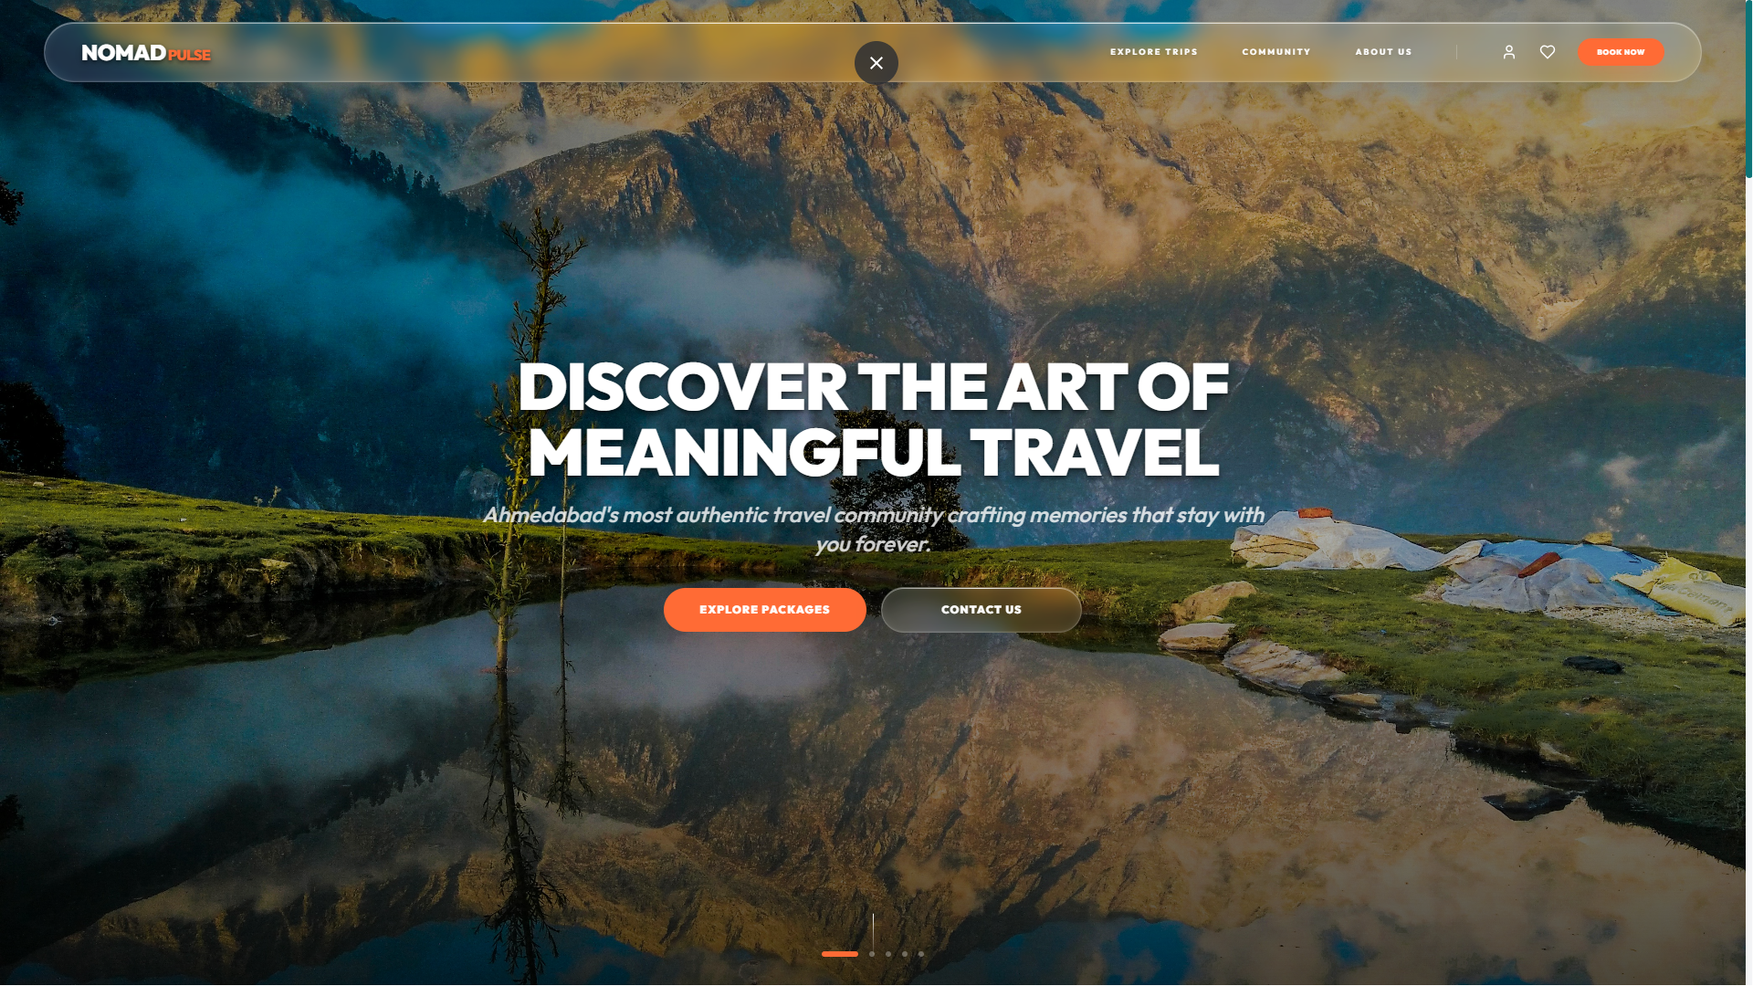
Figure 9 : The landing page which shows the main start of website.

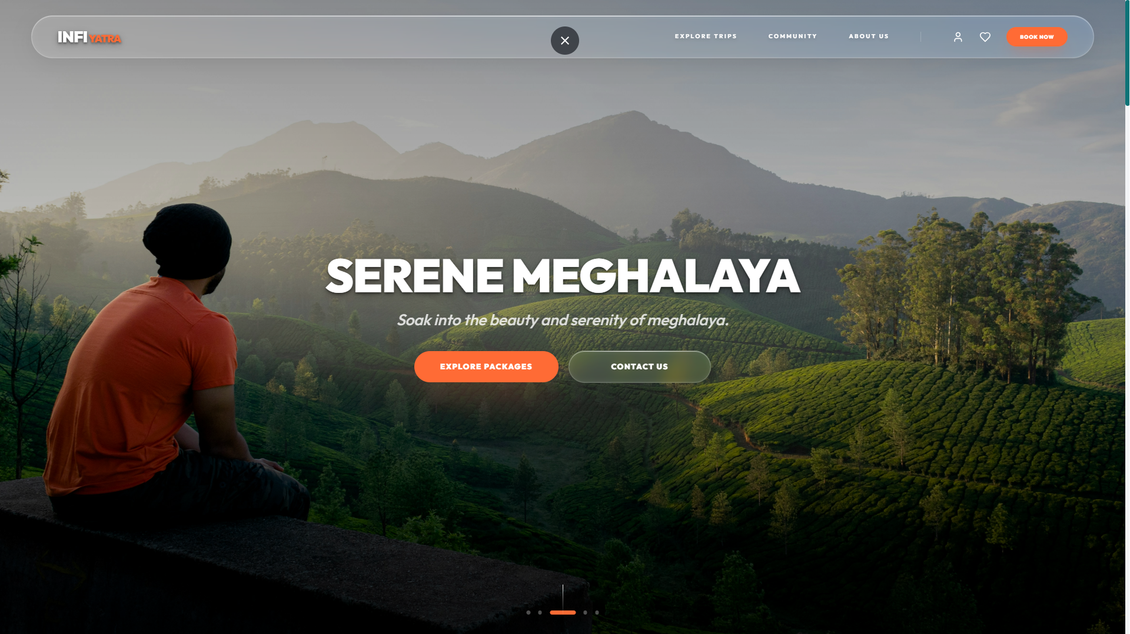
Figure 10: The Hero section shows 4-5 selected pictures with essence of slideshow.

Chapter 4: Detailed Implementation

4.1 Frontend Component Logic

The frontend implementation of infiYATRA leverages React's functional components and Hooks for efficient state management and side effects. Each major page is a self-contained component that orchestrates its own data fetching and rendering logic.

Key hooks used throughout the application include:

Table 4.1: React State Hooks Summary
Hook | Purpose in infiYATRA
useState | Manages local state for search inputs, filter selections, and trip data arrays.
useEffect | Handles side effects like fetching trip data from the API and setting up 3D scene observers.
useParams | Extracts dynamic URL parameters (like trip IDs) for the Trip Details page.
useNavigate | Enables programmatic navigation between the user pages and the admin dashboard.
useRef | Used for accessing DOM elements directly, particularly for 3D canvas and animation observers.

4.2 3d Rendering With React Three Fiber

One of the core features of the infiYATRA home page is the interactive 3D lens model. This is implemented using React Three Fiber (R3F), which allows for a declarative approach to Three.js scenes.

The implementation follows these steps:
- Loading Assets: The .glb model is loaded asynchronously using the useGLTF hook from @react-three/drei.
- Scene Setup: A Canvas component provides the WebGL context. Lighting is added using ambient Light and directional Light components.
- Interaction: Orbit Controls are added to allow the user to rotate and zoom the model.
- Performance: The use Frame hook is used for smooth animations, and Suspense provides a loading state.

4.3 Real-Time Filtering Algorithm

The Discover page features a high-performance filtering system. Instead of making a server request for every filter change, the application fetches the entire trip dataset once and performs filtering on the client side.

The filtering logic combines multiple criteria:
- Search Query: Uses JavaScript's .filter() and .includes() to match titles and destinations.
- Category Filter: Matches the trip's category tag against the selected category state.
- Price Range: Filters trips where the price is less than or equal to the slider's value.

This approach ensures a lag-free experience for the user, as the UI updates instantly with every interaction.

Chapter 5: Api Reference And Data

5.1 Rest Api Documentation

The infiYATRA backend provides a RESTful API for managing trip data and home page content. The following table summarizes the available endpoints:
Table 5.1: API Endpoint Definitions
Method | Endpoint | Description
GET | /api/trips | Fetch all trip records for the Discover page.
GET | /api/trips/:id | Fetch details for a single trip.
POST | /api/trips | Create a new trip record (Admin only).
PUT | /api/trips/:id | Update an existing trip record (Admin only).
DELETE | /api/trips/:id | Remove a trip record from the store (Admin only).
GET | /api/hero | Fetch home page hero slides.
PUT | /api/hero | Update hero slide content (Admin only).

5.2 Json Data Schema
The system uses a structured JSON schema to represent trip objects. A typical trip record in db.json follows this structure:
{
"id": "leh-ladakh-expedition",
"title": "Leh Ladakh Road Trip",
"price": 35000,
"duration": 7,
"category": "Adventure",
"itinerary": [ ... ],
"highlights": [ ... ]
}

This schema ensures that the frontend can consistently render trip data regardless of the specific destination.

Chapter 6: Security And Performance

6.1 Cors And Environment Configuration

To ensure secure communication between the frontend and backend, Cross-Origin Resource Sharing (CORS) is configured on the Express server. During development, Vite's proxy feature is used to bridge the gap between different ports, preventing browser security errors.

6.2 Asset Optimization

High-resolution travel images and 3D models can significantly impact page load times. The following optimizations were implemented:
- Image Compression: All destination images are compressed to WebP/JPG formats for faster delivery.
- 3D Model Compression: The lens.glb model is optimized using Draco compression to reduce its file size by over 70%.
- Lazy Loading: Images and heavy components are loaded only when they enter the viewport, improving the initial 'Time to Interactive' metric.

Chapter 7: Project Screenshots

7.1 Home Page Screenshots

7.1.1 Home Page – Hero Section with 3D Model

The home page hero section is the first visual element a user encounters on the infiYATRA platform. It features a full-viewport-height rotating slide show of high-resolution destination images with animated text overlays. The left side of the hero section prominently displays the platform's tagline and a 'Discover Trips' call-to-action button. On the right side, the interactive 3D GLB model (a lens/globe metaphor) is rendered in real-time using React Three Fiber, creating a visually stunning and unique centerpiece that immediately communicates the platform's theme of discovery and exploration.
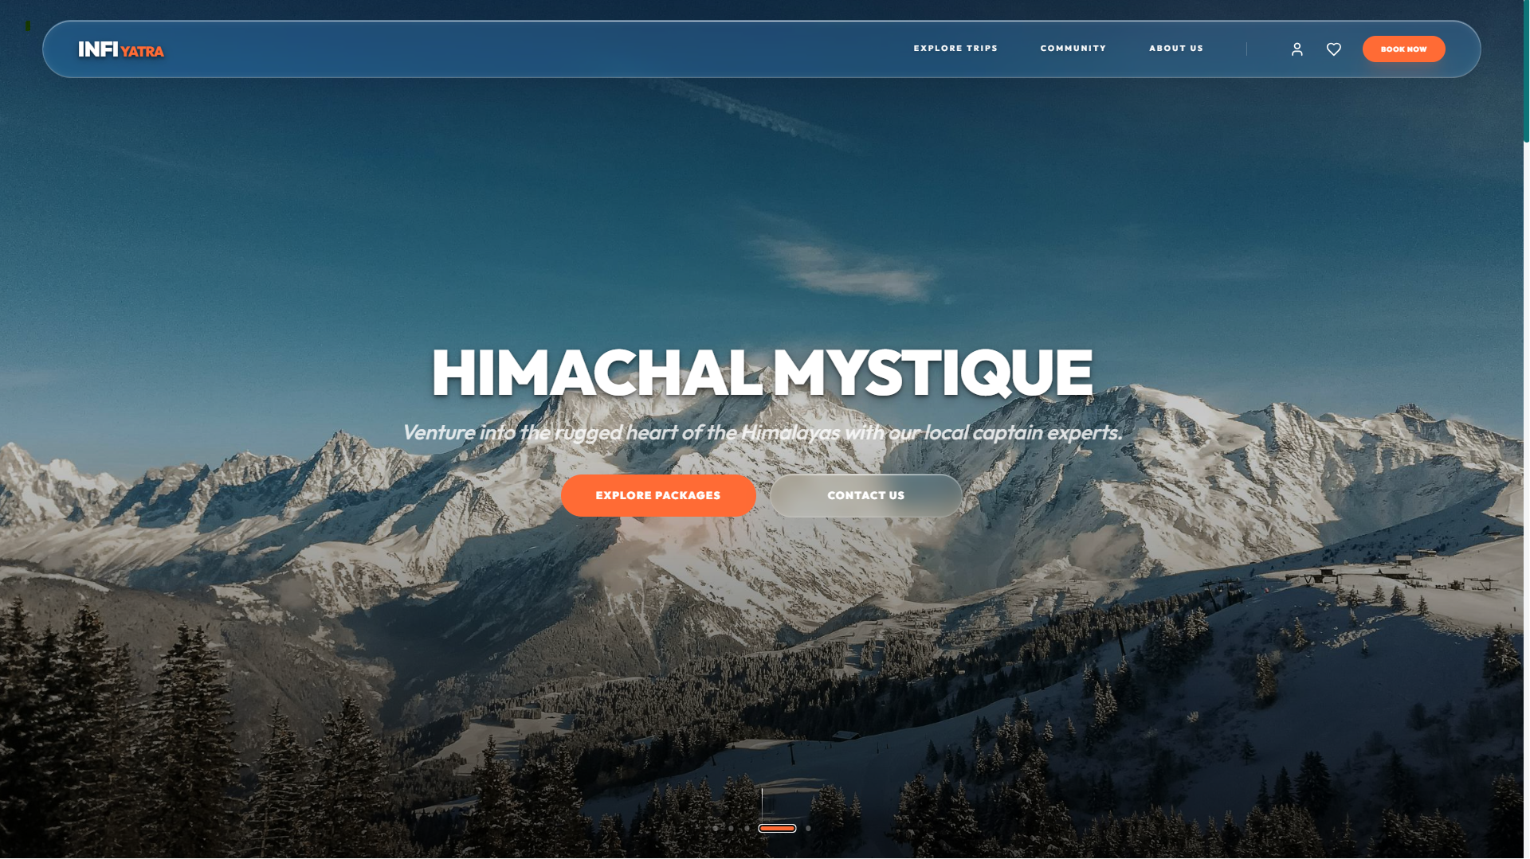
Figure 11: Homepage hero section features the slideshow of selected bestseller trips.

7.1.2 Home Page – Featured Packages Section

Below the hero section, the Featured Packages section displays a curated selection of the platform's most popular travel packages. Each package is presented in a horizontally scrollable card layout featuring the destination image, trip title, duration, category tag, price, and star rating. The section is dynamically populated from the backend API (/api/trips), meaning the displayed packages automatically reflect whatever trips the administrator has marked as featured. Hover animations powered by Framer Motion add interactivity to each card.

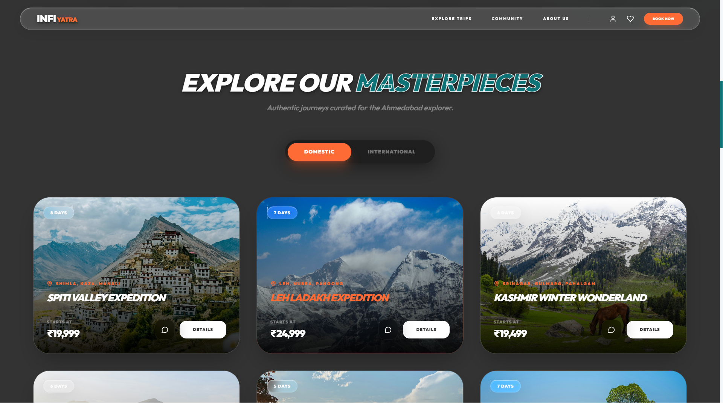
Figure 12: Home Page – Featured Packages Section
7.1.3 Home Page –Testimonials Section

The Testimonials Section presents verified traveler reviews in a card-based layout with star ratings, traveler photos, and trip names. These sections are designed to build credibility and confidence in the platform's offerings.
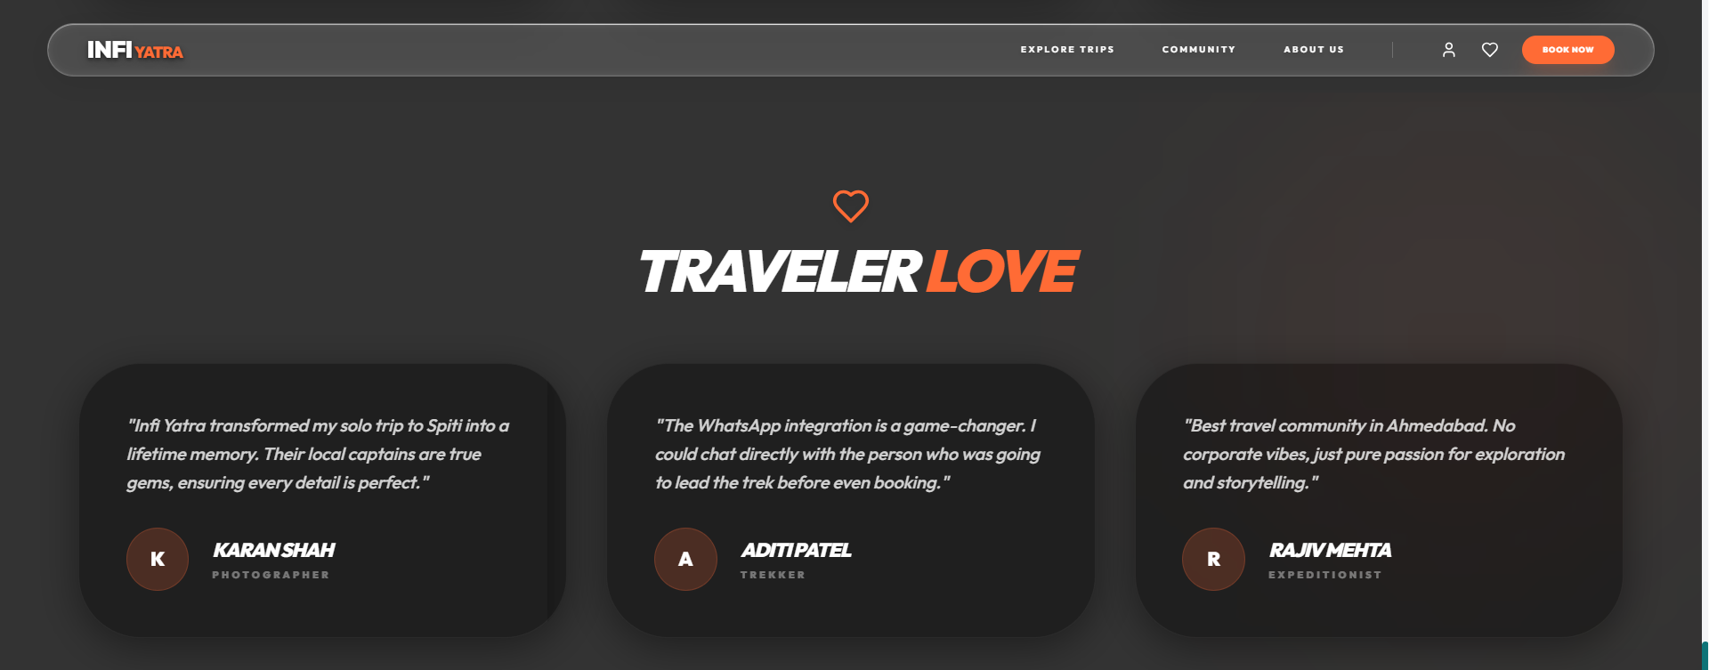
Figure 13 :Home Page – Stats Section and Testimonials Section

7.2 Discover Page Screenshots

7.2.1 Discover Page – Multi-Filter Interface

The Discover page is the core functionality hub of infiYATRA. It features a two-column layout: a left sidebar containing the multi-filter controls (keyword search input, category tag buttons, and a price range slider), and the main content area displaying the responsive trip card grid. All three filters operate simultaneously – the trip card grid updates in real time as the user modifies any filter, without requiring a page refresh or server request. On mobile screens, the sidebar collapses into a toggleable filter panel to maintain a clean, uncluttered layout.
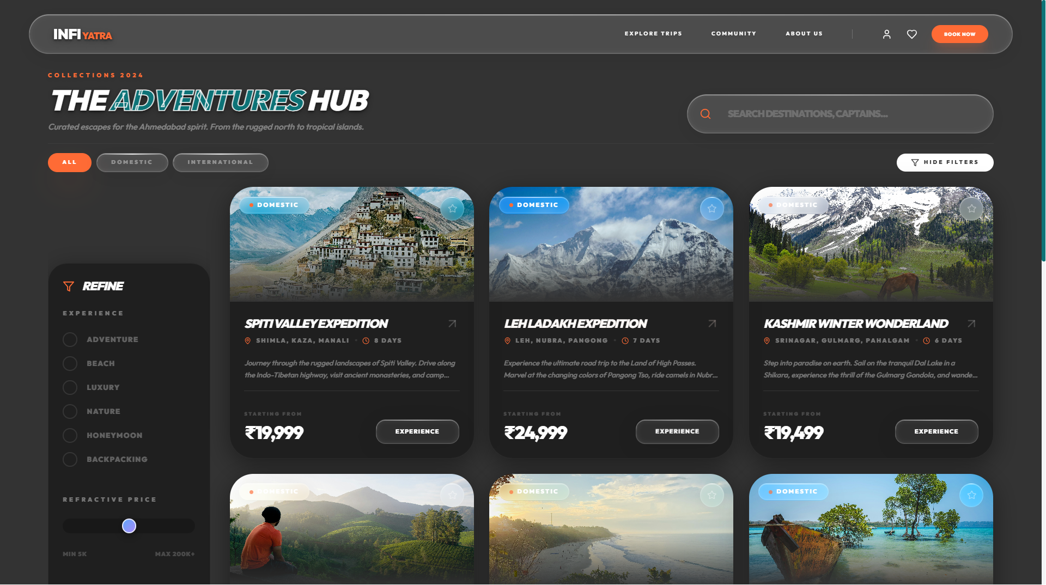
Figure 14: Discover Page – Multi-Filter Sidebar and Trip Card Grid

7.2.2 Discover Page – Filtered Results

When a user applies one or more filters (for example, selecting the 'Adventure' category tag), the trip card grid immediately updates to display only the matching trips, with a smooth layout animation powered by Framer Motion. An active filter badge is displayed to indicate which filters are currently applied, and a 'Clear Filters' button allows the user to reset all filters with a single click. If no trips match the applied filters, a friendly 'No trips found' message is displayed.
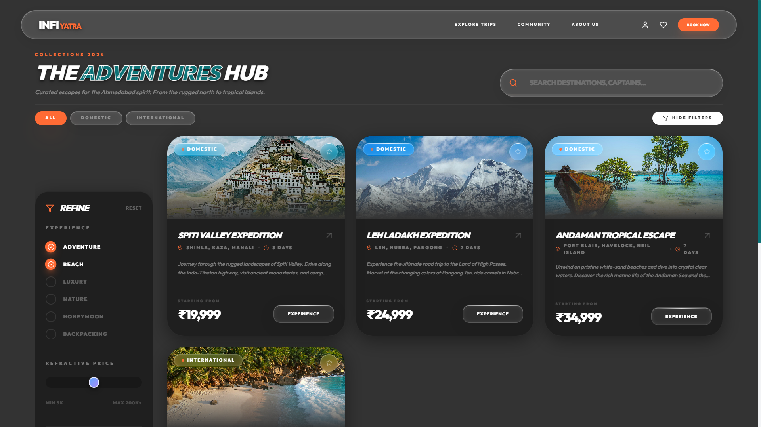
Figure 15: Discover Page – Active Filter Applied (Adventure Category)

7.3 Trip Details Page Screenshots

7.3.1 Trip Details Page – Gallery and Highlights
The Trip Details page is rendered dynamically for each trip using the trip's unique ID from the URL parameter (/trips/:id). The top section of the page features a full-width, multi-image photo gallery that showcases the destination with high-resolution photography. Below the gallery, the trip's key highlights are displayed as an icon-accompanied bullet list, giving users a quick visual summary of what the trip offers. The trip's price, duration, category, and rating are prominently displayed in a sticky sidebar that remains visible as the user scrolls.

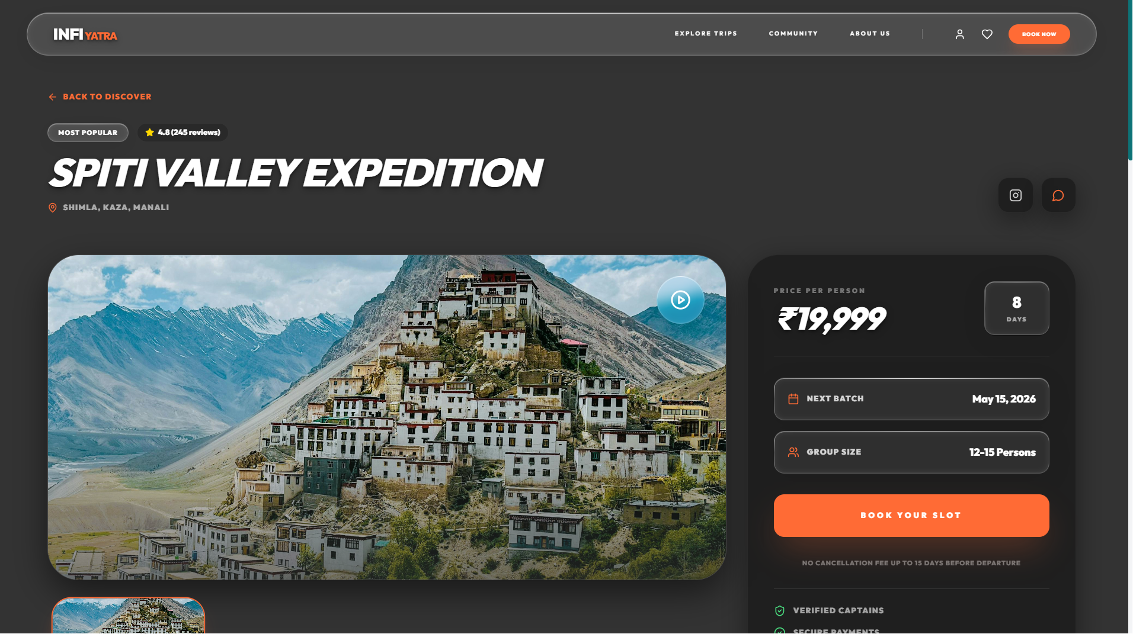
Figure 16: Trip Details Page – Photo Gallery and Highlights Section
7.3.2 Trip Details Page – Day-by-Day Itinerary

Below the highlights section, the Trip Details page renders an interactive, day-by-day itinerary timeline. Each day in the itinerary is displayed as a card in a vertical timeline layout, showing the day number, day title (e.g., 'Day 1: Arrival at Leh & Acclimatization'), a detailed description of the day's activities, and a list of key activities or locations for that day. The timeline is rendered dynamically from the trip object's itinerary array, meaning it automatically adapts to trips of any length (5-day, 7-day, 8-day, etc.).
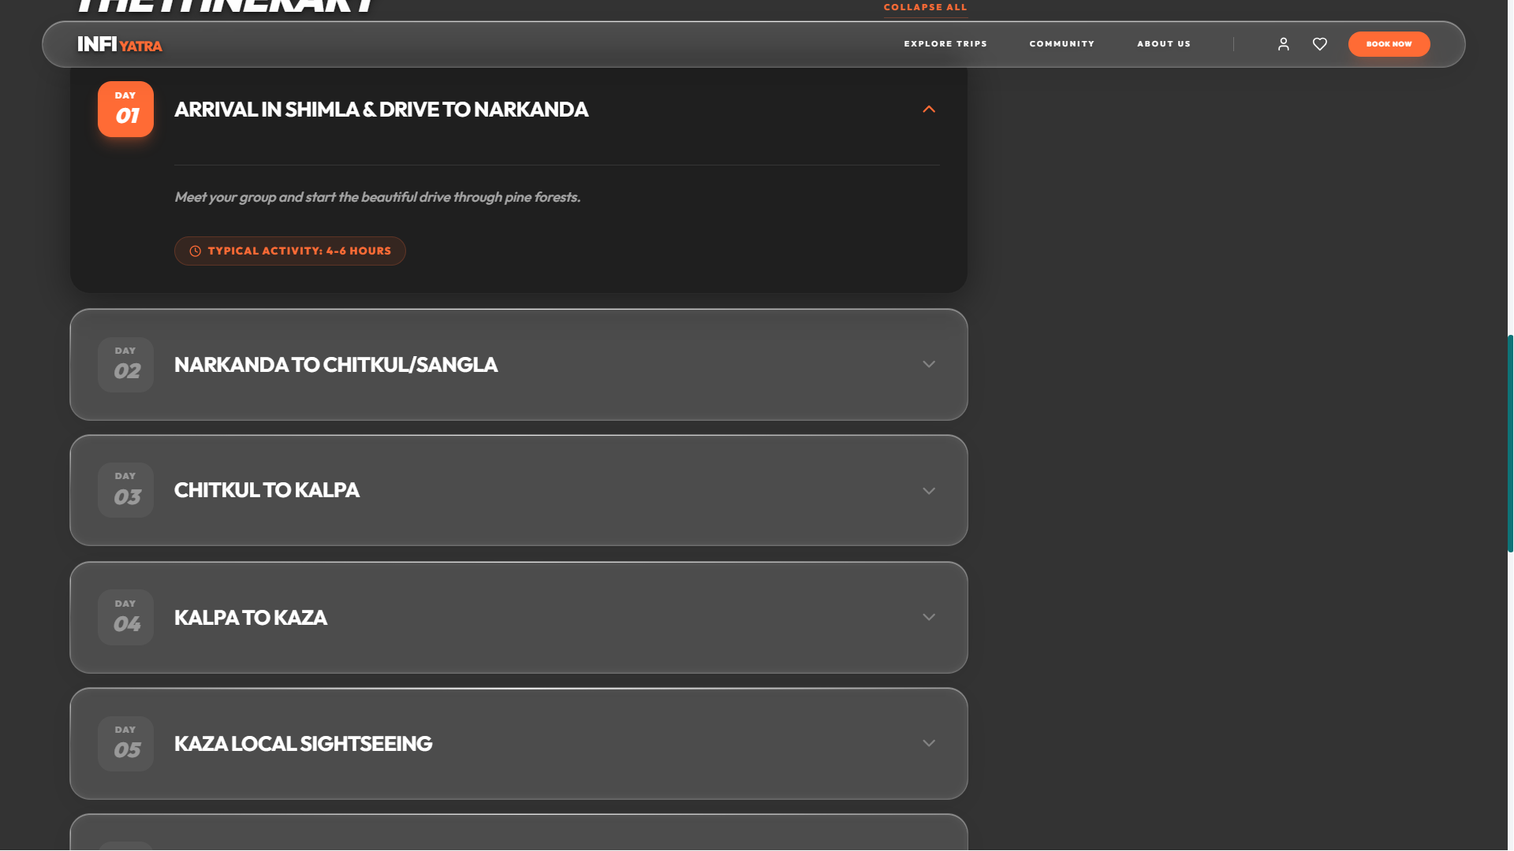
Figure 17: Trip Details Page – Interactive Day-by-Day Itinerary View

7.4 Admin Dashboard Screenshots

7.4.1 Admin Dashboard – Trip Listing

The Admin Dashboard is the content management interface of infiYATRA. Upon successful login, the administrator is presented with a comprehensive table listing all trip records currently in the system. Each row displays the trip's name, destination, category, price, duration, and provides action buttons for editing and deleting the record. The table is sortable and includes a search field for quickly locating specific trips. A prominent 'Add New Trip' button at the top of the dashboard allows administrators to create new trip records.

7.4.2 Admin Dashboard – Edit Trip Form
Clicking the 'Edit' action button for any trip in the Admin Dashboard opens a comprehensive form pre-populated with all of the selected trip's existing data. The administrator can modify any field – including the title, destination, category, pricing, image URLs, trip highlights, and day-by-day itinerary entries. The form includes dynamic array field management, allowing administrators to add or remove individual itinerary days, highlight items, inclusions, and exclusions. Upon saving, the updated trip record is persisted to the data store via a PUT API call, and the changes are immediately visible on the public-facing trip cards and detail pages.
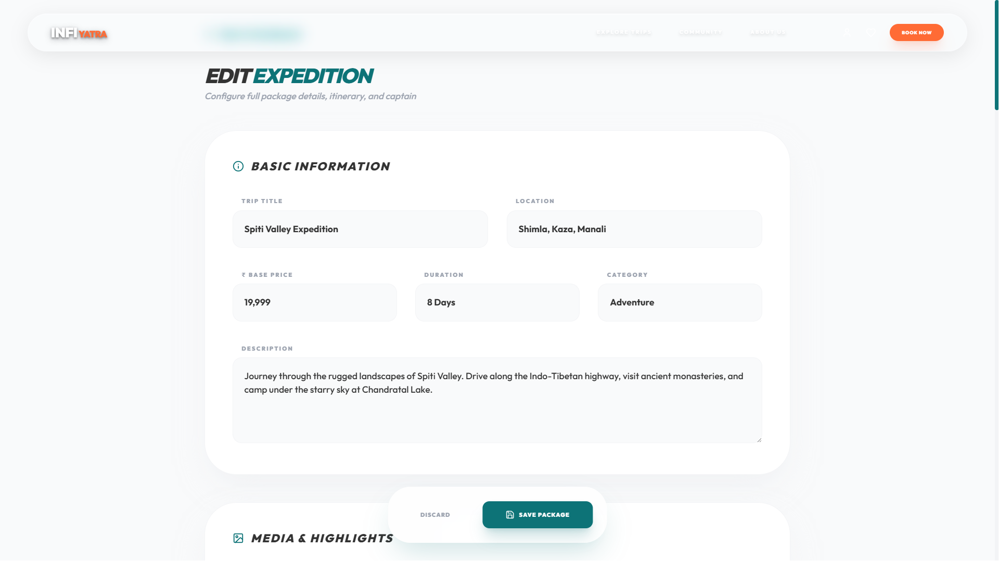
Figure 18: Admin Dashboard – Edit Trip Form Interface

Chapter 8: Testing

Testing is a critical phase of the software development lifecycle. It is the process of evaluating a system or its components with the intent of finding whether it satisfies the specified requirements and behaves as expected. For infiYATRA, a comprehensive testing regime was conducted to ensure the quality, stability, functionality, and cross-platform compatibility of the application across all its major features and user-facing screens.

The primary objectives of the testing phase for infiYATRA were:

- Completeness – Confirming that the software satisfies all functional and technical requirements specified in the project objectives.
- Correctness – Verifying that all features behave exactly as intended, including edge cases and error conditions.
- Errors Free – Identifying and resolving all technical bugs, rendering issues, and logical errors before final submission.
- Stability – Assessing performance, cross-browser compatibility, and responsive behavior across a range of devices and network conditions.

8.1 Types Of Testing Performed

1. Unit Testing

Unit testing is the process of testing individual functions, components, or modules of the application in isolation to ensure each unit performs its intended function correctly. In infiYATRA, unit testing was performed manually by verifying the behavior of each core component independently.

- Navbar.tsx: Verified that the navigation links route correctly to all pages. Verified that the mobile hamburger menu opens and closes correctly on small screens.
- HeroSection.tsx: Verified that hero slides rotate at the correct interval and that manual slide navigation (previous/next) works correctly. Verified that slide data is fetched correctly from the API.
- Trip Filter Logic (Discover.tsx): Verified that the keyword search filter correctly matches trip titles and destinations. Verified that the category filter correctly returns only trips with the matching category tag. Verified that the price range filter correctly excludes trips outside the specified range.
- TripCard.tsx: Verified that the correct trip data (title, price, duration, image, rating) is rendered for each trip object passed as props.
- AdminDashboard.tsx: Verified that the Create Trip form correctly sends a POST request to /api/trips. Verified that the Edit Trip form is pre-populated with the correct trip data. Verified that the Delete action sends a DELETE request to /api/trips/:id.

2. Integration Testing

Integration testing verifies whether different modules and layers of the system work together correctly. In infiYATRA, integration testing focused on verifying the communication between the React frontend and the Express backend API.

- Verified that the dataService.ts module correctly constructs HTTP requests (GET, POST, PUT, DELETE) and passes them to the Express API endpoints.
- Verified that all API endpoints (/api/trips, /api/trips/:id, /api/hero) return correctly structured JSON responses.
- Verified that the Vite proxy configuration correctly forwards /api requests from the frontend (port 5173) to the backend (port 3001) without CORS errors.
- Verified that CRUD operations performed via the Admin Dashboard are correctly persisted to the db.json file and that subsequent GET requests return the updated data.
- Verified that the TripDetails page correctly reads the trip ID from the URL parameter and fetches the correct trip record from the API.

3. System Testing

System testing tests the complete infiYATRA application as a whole, verifying that all features and functionalities operate according to the project requirements in a real working environment.

- Verified the complete user journey: Home Page → Discover Page → Apply Filters → View Trip Details → WhatsApp Enquiry.
- Verified the complete admin journey: Admin Login → View Trips → Create Trip → Edit Trip → Delete Trip → Manage Hero Slides.
- Verified that the 3D model on the home page loads, renders, and responds to user interaction correctly in all tested browsers.

4. Usability Testing

Usability testing evaluates the system from an end-user's perspective to determine whether the interface is intuitive, easy to navigate, and provides a satisfying user experience.

- Verified that the navigation structure is clear and that users can find the Discover page, individual trip details, and destination pages within 2 clicks from the home page.
- Verified that all interactive elements (buttons, filter controls, trip cards) have appropriate hover states and visual feedback.
- Verified that form validation in the Admin Dashboard provides clear error messages for missing required fields.

5. Performance Testing

Performance testing evaluated the application's loading speed, rendering performance, and responsiveness under typical usage conditions.

- Verified that the initial home page load time is acceptable by minimizing the 3D model file size through gltf-pipeline compression.
- Verified that the Vite production build generates appropriately sized JavaScript and CSS bundles through code-splitting and tree-shaking.
- Verified that the Discover page's real-time filter logic does not cause perceptible lag even with the full trip dataset loaded.

6. Cross-Browser and Responsive Testing

Cross-browser testing verified that the application renders and functions correctly across all major web browsers and device types.

- Browsers tested: Google Chrome 120+, Mozilla Firefox 120+, Apple Safari 16+, Microsoft Edge 120+.
- Devices tested: iPhone 13 (375px), Samsung Galaxy S21 (360px), iPad Air (768px), standard laptop (1366px), full HD desktop (1920px).
- Verified that the Tailwind CSS responsive breakpoints (sm:, md:, lg:, xl:) apply correctly at each tested screen width.
- Verified that the 3D model renders correctly in Chrome and Firefox with WebGL enabled. Safari rendering was also verified.

7. API Testing (Postman)

All Express API endpoints were individually tested using the Postman API testing tool to verify correct behavior for all HTTP methods, response codes, and data payloads.

8.2 Test Case Results

Table 8.1: Functional Testing Results
Sr. | Test Case Description | Expected Result | Status
1 | Home page hero section loads and rotates slides | Slides rotate at 5s intervals with smooth fade | Pass
2 | 3D GLB model loads on home page without layout shift | Model renders within Suspense boundary correctly | Pass
3 | Navigation links route to correct pages | All nav links navigate to correct routes | Pass
4 | Mobile hamburger menu opens and closes | Menu toggles correctly on small screens | Pass
5 | Keyword filter on Discover page (partial match) | Trips matching keyword in title/destination shown | Pass
6 | Category filter on Discover page | Only trips with matching category tag displayed | Pass
7 | Price range filter on Discover page | Trips outside price range excluded from results | Pass
8 | Combined multi-filter (keyword + category + price) | Intersection of all three filters displayed | Pass
9 | Trip Details page loads correct trip by URL param | Correct trip data rendered for each /trips/:id | Pass
10 | Day-by-day itinerary renders all days | All itinerary days rendered from trip.itinerary array | Pass
11 | Admin – Create new trip via form | New trip appears in list after POST /api/trips | Pass
12 | Admin – Edit trip updates data correctly | Updated trip fields reflected via PUT /api/trips/:id | Pass
13 | Admin – Delete trip removes from list | Trip removed from listing after DELETE /api/trips/:id | Pass
14 | Hero slide management (add/remove) | Hero slides updated correctly in db.json | Pass
15 | WhatsApp CTA button opens correct URL | Opens WhatsApp with pre-filled enquiry message | Pass

Table 8.2: Integration and Compatibility Testing Results
Sr. | Test Case Description | Expected Result | Status
1 | API GET /api/trips returns all trips as JSON | JSON array with all trip objects returned | Pass
2 | API GET /api/trips/:id returns correct trip | Single trip object matching ID returned | Pass
3 | API POST /api/trips creates and persists trip | New trip written to db.json and returned | Pass
4 | API PUT /api/trips/:id updates trip in db.json | Updated trip object returned with 200 status | Pass
5 | API DELETE /api/trips/:id removes trip | Trip removed from db.json, 200 returned | Pass
6 | Vite proxy forwards /api to Express (no CORS error) | Frontend makes API calls without CORS errors in dev | Pass
7 | Responsive layout – Mobile 360px (iPhone SE) | Layout adapts to single column, no overflow | Pass
8 | Responsive layout – Tablet 768px (iPad Air) | Two-column grid and sidebar adapt correctly | Pass
9 | Responsive layout – Desktop 1920px | Three-column grid and full layout displayed | Pass
10 | Cross-browser – Google Chrome 120+ | All features function and render correctly | Pass
11 | Cross-browser – Mozilla Firefox 120+ | All features function and render correctly | Pass
12 | Cross-browser – Apple Safari 16+ | 3D model and animations render correctly | Pass
13 | Cross-browser – Microsoft Edge 120+ | All features function and render correctly | Pass

Chapter 9: Conclusion

9.1 Challenges Summary

The development of infiYATRA, while highly rewarding, presented a range of interesting technical and design challenges across all layers of the application stack. Overcoming these challenges was instrumental in improving both the quality of the final product and the team's technical expertise.

- 3D Asset Performance: Optimizing the .glb model for 60fps rendering across devices.
- Mobile UX: Designing a touch-friendly navigation system for complex information hierarchies.
- State Management: implementing optimistic UI updates for a seamless admin experience.
- Environment Configuration: Managing CORS and proxy settings for secure API communication.

9.2 Conclusion

The infiYATRA project has successfully demonstrated the significant potential of modern web technologies when combined with thoughtful user experience design, a clear product vision, and a disciplined software development approach. The platform represents a qualitative leap beyond conventional travel websites, offering an immersive, visually rich, and functionally comprehensive travel discovery experience that is genuinely differentiated in the market.

All primary objectives established at the outset of the project have been fully achieved. The application delivers a visually immersive home page experience featuring a real-time 3D GLB model and rotating hero slides, a powerful multi-filter trip discovery interface, interactive day-by-day itinerary views, dedicated destination pages, a fully functional administrator dashboard with complete CRUD capabilities, and a responsive, mobile-first design that performs correctly across all tested devices and browsers.

The project has demonstrated advanced command over the modern frontend development ecosystem. The adoption of React 18's component-based architecture has resulted in a highly modular and maintainable codebase. TypeScript 5.6 has ensured type safety and code quality throughout. Tailwind CSS has delivered rapid, consistent, and responsive styling. Framer Motion has elevated the user experience with professional-grade animations. React Three Fiber has enabled the integration of real-time 3D rendering in a React-friendly, declarative manner. The Express backend, while intentionally lightweight for the project's current scope, is architected in a manner that facilitates straightforward future scaling.

In conclusion, infiYATRA stands as a substantial, technically sophisticated, and commercially viable project that successfully applies advanced modern web technologies to solve a real-world problem in the travel and tourism sector. It serves as a strong demonstration of the capabilities acquired during the B.E. Computer Engineering program and provides a solid foundation for a production-ready travel platform with clear pathways for future growth and enhancement.

9.3 Future Enhancements

- Payment Gateway Integration: Implement secure booking transactions via Razorpay/Stripe.
- User Authentication: Add JWT-based login for personalized wishlists and booking history.
- Production Database: Migrate to PostgreSQL/MongoDB for enterprise-scale data management.
- AI Recommendations: Integrate a machine learning engine for personalized travel suggestions.
- User Reviews: Add a verified rating system and traveler photo galleries.

Bibliography / References

The following references were consulted during the design, development, and documentation of the infiYATRA project:

Books:

- Learning React: Modern Patterns for Developing React Apps – Alex Banks, Eve Porcello, O'Reilly Media.
- TypeScript Deep Dive – Basarat Ali Syed. Available as open-source GitBook.
- Node.js Web Development – David Herron, Packt Publishing.
- Three.js Journey – Bruno Simon. Online course covering advanced Three.js and React Three Fiber.

Websites:

- React Official Documentation – https://react.dev/
- Vite Build Tool Documentation – https://vitejs.dev/
- Tailwind CSS Documentation – https://tailwindcss.com/
- Framer Motion Documentation – https://www.framer.com/motion/
- Three.js Documentation – https://threejs.org/docs/
- TypeScript Handbook – https://www.typescriptlang.org/docs/

Appendix: User Manual

A.1 Traveler (End User) Guide

1. Discovering Trips: Use the search bar on the Discover page to find trips by name. Use the category tags to filter by 'Adventure', 'Nature', 'Leisure', etc.
2. Viewing Details: Click on any trip card to see the full gallery, highlights, and day-by-day itinerary.
3. Making Enquiries: Click the WhatsApp button on any trip page to send a direct message to the travel captain.

A.2 Administrator Guide

1. Accessing Dashboard: Navigate to the /admin route and log in with your credentials.
2. Managing Trips: Use the table to view all trips. Click 'Add New' to create a trip or 'Edit' to update an existing one.
3. Managing Hero Slides: Use the Hero Management section to update the images and text shown on the home page landing section.

