Laguna Poker Developer’s Guide
Revision History
Date | 11-22-2004
Status | Finalization
Customer
Project name | Laguna Poker
Customer project number
Internal project number
Internal project code | Laguna Poker
Working area
Author/s | Olga Nechaeva, Larisa Bolgova
Project manager | Maxim Korablev
QA manager | Irina Myasnilova
Document identification | Laguna Poker_Developer’s Guide
Version | 0.2
Assessment spec no.
Assessment ID
Physical file | Laguna_Poker_Developers_Guide.doc
Electronic file
External
Internal
Assessed by | S. Waldrop (editorial review)

I.OVERVIEW 5
II.BASIC CONCEPTS 8
II.1.Installation 8
II.2. Program Interface 9
II.2.1. Laguna Poker Lobby. 10
II.2.2. The Laguna Poker Table. 11
II.2.3. Tournaments. 13
II.3. Registration 14
II.3.1.Play money. 15
II.3.2. Real money. 16
II.4.Program Options 22
III.SYSTEM ARCHITECTURE 24
III.1.Overview 24
III.2. Protocol 26
III.2.1. Service core 26
III.2.2.Pooled objects. 27
III.2.2.1.SQLAdapter. 27
III.2.2.2. File Manager. 28
III.2.2.3. User object. 29
III.2.2.4. Account object 34
III.2.2.5. API. 38
III.2.2.6. Email. 49
III.2.3. Game actions support modules. 49
III.2.3.1. Game Adapter. 49
III.2.3.2. Tournament object 50
3.2.3.3. Game Engine: interaction with Flash applications 54
IV. Administration 62
IV.1. Admin site 62
IV.1.1. Login. 62
IV.1.2. Main menu 62
IV.2. Desktop Admin 74
IV.2.1. Users 75
IV.2.2. Services 82
IV.2.3. Processes 84
IV.2.4. Affiliates 87
IV.2.5. Charts 90
IV.2.6. History 91
IV.2.7. Misc 92

Figures Index
Figure 1-1. Laguna Poker Lobby. 6
Figure 2-1. Laguna Poker Game Table window. 7
Figure 1-2. Laguna Poker Setup: License Agreement 8
Figure 2-2. Laguna Poker Setup: Installation Folder 9
Figure 3-2. Laguna Poker Setup: Completed 9
Figure 4-2. Laguna Poker Lobby 10
Figure 5-2. Laguna Poker Lobby: Window Title for an Unregistered User 10
Figure 6-2. Laguna Poker Lobby: Window Tittle for a Registered User 10
Figure 7-2. Laguna Poker Lobby: Total Game Information 11
Figure 5-2. Laguna Poker Game Table: Chat Box 12
Figure 9-2. Laguna Poker Game Table: Hand Information Box. 12
Figure 10-2. Laguna Poker Tournament Lobby window. 14
Figure 11-2. Laguna Poker Login window. 15
Figure 12-2. Laguna Poker: Registering a New User. 16
Figure 13-2 Laguna Poker: Cashier Window 17
Figure 14-2 OSC Laguna Poker: Change Mailing Address 18
Figure 15-2 Laguna Poker: Change/Validate email address 19
Figure 16-2 Laguna Poker: Buy chips 20
Figure 17-2. Laguna Poker: Cash out window 21
Figure 15-2. Laguna Poker: Transaction history 22
Figure 1-3: Laguna Poker System Architecture 25
Figure 2-3: Internal structure of the Poker Service 26
Figure 1-4. Admin site: Login 62
Figure 2-4. Admin site: Main Menu 62
Figure 3-4. Admin site: Process List 63
Figure 4-4. Admin-site: New Table Properties 64
Figure 5-4. Admin -site: Users Maintenance List 65
Figure 6-4. Admin site: Sending Message 65
Figure 7-4. Admin site: Tournament List 66
Figure 8-4. Admin site: Adding New Tournament 66
Figure 9-4. Admin site: Properties for an Existing Tournament 67
Figure 10-4. Admin site: Tournament prize template 67
Figure 11-4. Admin site: User List 68
Figure 12-4. Admin site: Adding a New User 68
Figure 13-4. Admin site: User Account Page 69
Figure 14-4. Admin site: Transaction Details 70
Figure 15-4. Admin site: Game Log Page 71
Figure 16-4. Admin site: Category List 71
Figure 17-4. Admin site: Adding a New Category 72
Figure 18-4. Admin site: Statistics List 72
Figure 19-4. Admin site: Affiliate Reports 73
Figure 20-4. Admin site: Game Engines Page 73
Figure 21-4. Desktop Admin: Options 75
Figure 22-4. Desktop Admin: Users, List Registered 76
Figure 23-4. Desktop Admin: User Details (Add New) 77
Figure 24-4. Desktop Admin: User Details (Edit) 77
Figure 25-4. Desktop Admin: User's Account Details 78
Figure 26-4. Desktop Admin: User Filter 79
Figure 26-4. Desktop Admin: List Active 80
Figure 27-4. Desktop Admin: List User Groups 81
Figure 28-4. Desktop Admin: RakeBack Bonus Plan 82
Figure 30-4. Desktop Admin: Services 83
Figure 31-4. Desktop Admin: Adding New Service 83
Figure 32-4. Desktop Admin: Active Processes 84
Figure 33-4. Desktop Admin: Processes 85
Figure 34-4. Desktop Admin: Processes Filtering 86
Figure 35-4. Desktop Admin: Tournaments 87
Figure 36-4. Desktop Admin: Affiliates 88
Figure 37-4. Desktop Admin: Affiliate Details 88
Figure 38-4. Desktop Admin: Client File Details (Edit) 89
Figure 36-4. Desktop Admin: Charts 90
Figure 40-4. Desktop Admin: Chart Options 91
Figure 41-4. Desktop Admin: Games History 91
Figure 42-4. Desktop Admin: System Options 93
Figure 43-4. Desktop Admin: Allowed IP 94
Figure 44-4. Desktop Admin: Game Engine List 95
Figure 45-4. Desktop Admin: Email Templates 96
Figure 46-4. Desltop Admin: Category List 97
Figure 47-4. Desktop Admin: Adding a New Category 98
Figure 48-4. Desktop Admin: Statistics List 99
Figure 49-4. Desktop Admin: Report User 100

I.OVERVIEW
Poker is the most popular card game in the world. Now this famous game has ventured outside of traditional casinos, and is available online through a large (and ever-growing) number of poker game sites that allow players to enjoy playing from the privacy of their home.
We are proud to present Laguna Poker, a cutting-edge game engine which lets participants play for either play money or real money. Players can choose between a wide variety of the most popular games, including Texas Hold‘em, Omaha High, Omaha Hi/Lo, 7-Card Stud. Players can also play in Single and Multi-Table Tournaments as their skills improve.
Laguna Poker offers some unique advantages to players, and is an optimal “learning ground” for novice players. For instance, Laguna Poker by default proposes that new players play poker for play money (with absolutely no financial risk), which provides a safe initial step before playing for real money. Another advantage is the lack of distractions when playing online, allowing players to concentrate more fully on their game strategy: the online player doesn’t see the other players’ faces, or hear them talking. This provides a quiet and comfortable environment to learn and improve playing strategy. At the same time, players do have the option of talking with opponents using the chat client if they wish, and can make notes about other players for future reference.
The program has a well thought-out mechanism for registering users within the system, starting with their main account registration. Players can also register for the bonus system and other options, and the game allows players the freedom to switch between games and tables, and to join in on a preferred one. Laguna Poker requires user registration before giving full access to all of its features. Without registration, it is impossible to enjoy all the game features, which encourages visitors to register and play.
Laguna Poker emulates a real game in full detail, and it is possible for players to earn real money by playing various types of poker at its virtual “tables.” Thanks to the online nature of Laguna Poker, players can play with anyone from around the world, expanding their playing frontiers (and challenges).

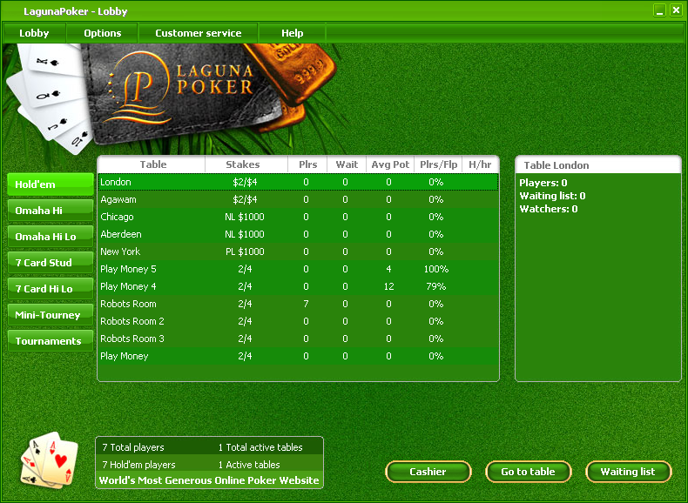
Figure 1-1. Laguna Poker Lobby.
Laguna Poker allows users to perform or access all game actions from its two main game windows:
- The Lobby window is the main program window for navigation between games and game tables, and for choosing between different game options. The Lobby window is shown in Figure 1-1.
- The Table window is a visual prototype of a real poker table. A player can play at up to two game tables simultaneously. The Table window is shown in Figure 2-1.

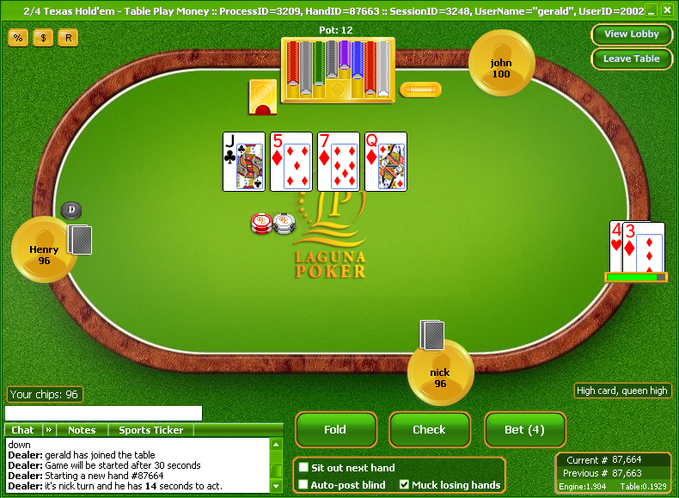
Figure 2-1. Laguna Poker Game Table window.

II.BASIC CONCEPTS

II.1.Installation
To install Laguna Poker, you will need the file lagunapokerinst.exe.
To start installation, double-click on the installation file. An installation wizard will appear which will walk you through the steps for installing Laguna Poker:
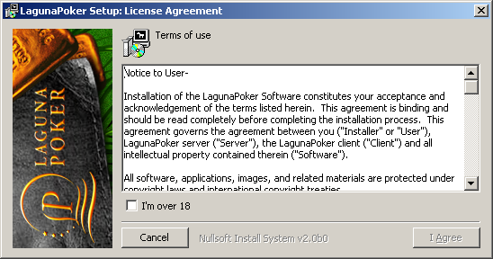
- The first window you will see is the license agreement, which contains important information about the legal age limit for playing poker (or any other gambling games). If you are over 18 years old, then check the box I'm over 18, and click on I Agree to continue with the installation (Figure 1-2).
Figure 1-2. Laguna Poker Setup: License Agreement
- The second step selects the folder (destination) the program will be installed in. The default destination will be in your hard drive under Program Files. To choose another destination, click on the Browse button and select your preferred folder for installation. Once you have chosen a folder, click on Install to continue (Figure 2-2).

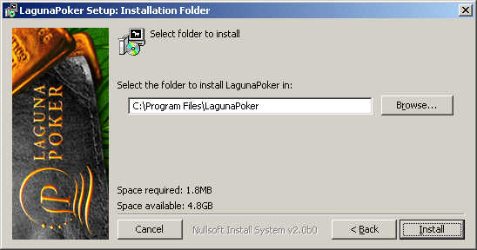
Figure 2-2. Laguna Poker Setup: Installation Folder
- At this point, the installation file will begin to set up the program in your computer. Click on Close once the installation is complete. You may cancel the installation at any time by clicking on the Cancel button (Figure 3-2).
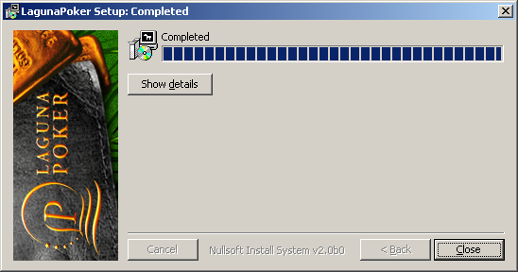
Figure 3-2. Laguna Poker Setup: Completed

II.2. Program Interface
The program interface for Laguna Poker is easy and intuitive enough for both novice and experienced poker players to understand and use. You will be using quite a few of the different game features while playing. Most of these can be accessed from one or the other of the two main Laguna Poker windows, which you should begin to familiarize yourself with.

II.2.1. Laguna Poker Lobby.

The lobby window is the first window you will see once the program is loaded and opened. All of the features that you will need during game play begin here.

This window allows you to see at a glance which players are playing at the current time.
Figure 4-2. Laguna Poker Lobby
When in debug-mode, the Lobby title displays specific information about you, such as your SessionID, UserName and UserID. For instance, information about an unregistered user will appear like this:
Figure 5-2. Laguna Poker Lobby: Window Title for an Unregistered User
The data displayed for registered users is more complete:
Figure 6-2. Laguna Poker Lobby: Window Tittle for a Registered User
The SessionID and UserID parameters allow the server to provide interactivity between players during games.
The Lobby consists of several parts:
- Main Menu
- Game Buttons
- The Tables list.
- Players Information
- Total information
The Main Menu bar is located at the top of the lobby. Menu items include the commands for both the basic and more advanced game options.
The Game Buttons let you choose between different types of poker. By clicking on one of the game buttons, you will be able to view the tables currently open (for real money or play money) within this game option.
The Tables list (Figure 7-2) shows all available tables playing the game that has been selected. It provides quick access to the game tables and shows helpful information about them:
- The Table column displays the different tables’ names. It indicates which tables are currently available and other helpful information.
- The Stakes column shows the betting limits for each poker table.
- The Plrs (Players) column shows the number of players currently playing an individual game.
- The Wait column shows the number of players waiting for an empty seat at a table, in order to join in the game.
- The AvgPot (Average Pot) column shows the average pot size over the past several hands at a table.
- The Plrs/Flp (Players Per Flop) column shows the percentage of players that see the flop.
- The H/hr (Hands Per Hour) column shows the average number of hands played over the past hour at a particular table.
There are also other options that provide information which can be viewed when playing poker.
The names of the real money tables correspond to place names. The play money tables are numbered: Play money #. A dollar sign ($) indicates a real money table. Both the table name and its properties are defined by the administrator. If all tables are full, an empty play money or real money table is automatically generated with a random name assigned to it. You can view the records for a table by clicking on its column title.
Information about the players at a selected table is shown on the right side of the Tables list. It displays the number of players, their login IDs, and the amount of money available to them for the game. In addition, there is a waiting list (those waiting to join in the game), as well as a list of those simply watching the game.
Clicking on a table within the Tables list will highlight it. To open the window for a chosen table, click on the Go to table button or double-click on the table name (see Figure 7-2).
More detailed information about active players and tables is available under the Tables list:
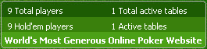
Figure 7-2. Laguna Poker Lobby: Total Game Information
The Waiting list button opens a window that will let you join the waiting list for a game (if it is currently full). The Cashier button allows players to keep an eye on both their real money and their play money, to manage deposits, and to cash out. The Go to table button opens up the window for a selected table.

II.2.2. The Laguna Poker Table.
The Laguna Poker game table is a window which imitates a real poker table, with seats for different players and additional features that can be chosen during a game. The title for a table contains the game name, the game stakes and the table name.
These are the main features of each Laguna Poker table:
- The Player buttons give information about each player during a game. They show the different player’s login names, and how many chips each player has. By rolling a mouse pointer over the button, you can view each player's location (if he/she is not registered as a private player).
- When the player button is animated, it indicates that it is the highlighted player’s turn in the game. The progress bar under the player button counts down the time allowed for making a decision. Each button has a label that can be changed by using a command from the Options menu. The dealer is indicated with a special label (Figure 2-1).
- The following buttons are located at the upper left-hand corner of the table page:
- The % button opens a window that displays your playing statistics
  - The $ button is used to bring more chips to the table
  - The R button allows you to replay the previous hand
- The View Lobby button opens up the lobby in another browser window. The Leave Table button will allow you to leave the table during a game.
- The Chat box shows the dealer's announcements during a game, and allows you to stay current with all actions at the table. There are several options for displaying the dealer’s comments, and the view can be changed by clicking on the  button within the Chat box. The text field is used to send a message by chat. If you want to make notes about other players, click on the Note tab to begin writing (Figure 8-2).
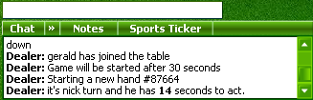
Figure 5-2. Laguna Poker Game Table: Chat Box
The Hand Information box shows the identification number for both the current hand being played, and for previous hands. This becomes useful when you wish to record a hand and replay it later. If there is a problem during a game, you can report the problem to customer service by referring to the hand number.
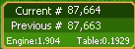
Figure 9-2. Laguna Poker Game Table: Hand Information Box.
- The Betting Action button lets you Fold, Call or Raise during a game, and shows how much each action will cost.
- The Auto Actions box includes the following options:
- Sit out next hand : this lets you wait for another hand without leaving the table
- Auto-post blind: this lets you stake yourself automatically when it is your turn
- Muck losing hand: this allows you to fold your cards at the end of a game, if you are losing the hand.
- After you have chosen a table, you will need to select a seat which is not already occupied by another player. The game will then ask you to indicate how much real money or play money you want to bring to the table. During the hand, you may bring more chips to the table using the $ button in the upper left-hand corner of the Table window.

II.2.3. Tournaments.
Laguna Poker allows players to enjoy competing in two different types of tournaments: mini-tournaments and multi-table tournaments. During tournament play, all players must buy in for the same amount of money (all players start the game with an identical number of chips).
The tournament ends when one player holds all the chips.
There are prizes for First, Second, or Third place. The initial buy-in amount and the amount of prize money are set by the Administrator.
Single table tournaments
During single table tournaments, one table composed of exactly ten players plays. The tournament begins after all players have registered. When one player holds all the chips, the game stops. The Winner receives 50% of the game pot, Second place wins 30% and Third place wins 20%.
Multi-table tournaments
The Tournament Lobby window contains several areas:
- General tournament information, including the time of registration, the tournament start time, the number of registered players, etc.
- Information about the prizes
- A list of tables
- A list of each table's players
- A list of all registered players
The Administrator can create a new multi-player tournament and set its properties, including the: Tournament Name, Registration start time, Tournament start time, Break duration, Poker Type, BuyIn, Fees, Number of chips per participant, and other options. This type of tournament consists of a minimum of at least two tables; the total number of tables depends upon the number of players who register.
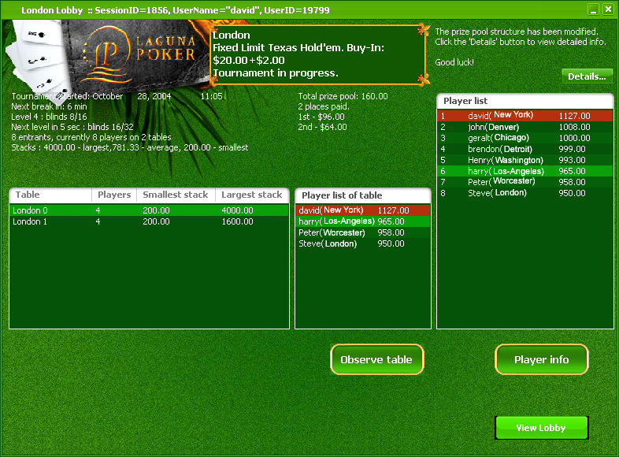
Figure 10-2. Laguna Poker Tournament Lobby window.
When it is time to begin tournament play, all registration is stopped, and players are automatically assigned to a table. During play, every ten hands the tournament level is increased and the stakes are raised. Players who have lost all their money leave the game, and new tables are formed with the remaining players.
Players continue to be eliminated from the game, until a final table remains with ten players. The number of winners is predetermined by the administrator. When the number of players is equal to the predetermined number of winners, the game is stopped and prizes are awarded to the top finishers (as noted above, the money awarded is based on the total number of tournament entries).

II.3. Registration
In order to play on Laguna Poker, you must first register or open an account. There are two types of accounts that can be opened: a play money account or a real money account. The first one is the default setting, but you can choose both options.

II.3.1.Play money.
If you are already a registered player with Laguna Poker, you can login from the Lobby menu. You will be asked to enter your Player ID and a password into the login fields. Then, simply click the Log in button to proceed. (Figure 8-2).
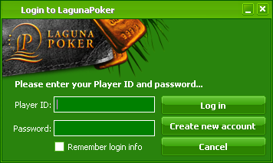
Figure 11-2. Laguna Poker Login window.
If you have not previously registered as a Laguna Poker player, you can register by completing the following steps:
- Click on Create new account from the Lobby menu, or from within the Login to Laguna Poker window (Figure 9-2). At this point, you will see a notice (question) about the age limit for playing on Laguna Poker. Click the OK button if you meet the age requirement, to proceed with registration.
- Fill in the registration page with the requested registration information (Figure 12-2). It is important to not skip any fields, or registration will be unsuccessful.
  - Player ID is the name that you will use when playing. It can be either a real or a fictional name. You can use both letters and numerals to create your Player ID.
  - Your Password should be 6 characters or longer, and contain at least 1 numeral or 1 letter.
  - Under Select Show location , choose ‘Yes’ if you want other players to know where are you from (your location) or ‘No’ for more privacy.

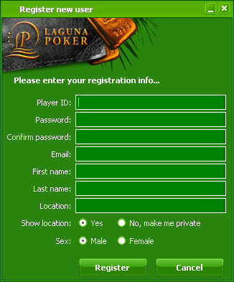
Figure 12-2. Laguna Poker: Registering a New User.
- Once all fields are filled in, click on the Register button to complete registration. Now you can play in all play money games, and change your available options using the Options menu item.
- You can use play money for games in which you want to improve your experience, to test the program, or when you don’t wish to play with real money. The games at both kinds of tables are identical.

II.3.2. Real money.
If you wish to play in real money games, you must first buy chips. To do so, first click on the Cashier button located in the Lobby. The Cashier window is shown in Figure 13-2. It contains four sections:
- Section status shows your PlayerID, Email address, Last logged time, and Total logged time.
- Play money status contains information about your chips, including the number of available chips, the number of chips that are currently in play, and the total number of chips you have at the moment.
- Account status shows both the money available to you, and the money that is currently being used in a game. The Total value is the total amount of money within your account. If all values are equal to zero, it means that you have either not played with real money before, or have no real money in your account.
- Mailing address displays your private information, including your name and permanent address. This section will be blank if you have never previously bought chips with real money.
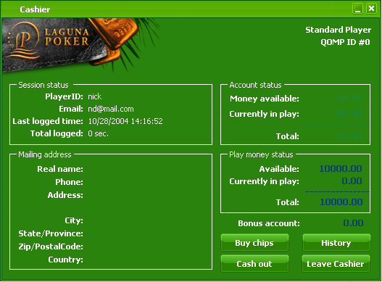
Figure 13-2 Laguna Poker: Cashier Window
The first time you play for real money, you must first fill out the Change mailing address form (shown in Figure 14-2) before buying chips or cashing out. This form is opened by clicking on the Buy chips button at the bottom of the Cashier window.
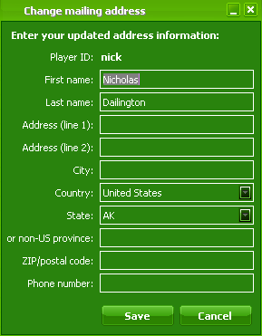
Figure 14-2 Laguna Poker: Change Mailing Address
It is necessary to verify your email address in order to access the full game features using real money. To do so, click on the Buy Chips button (Figure 13-2) again and then click on the Submit your email button. A message containing a validation code will be send to your email address.
Once you receive this, enter in the code into the Validation code field inside the Change/Validate email address window, then click on the Validate button to complete the verification process (Figure 15-2).
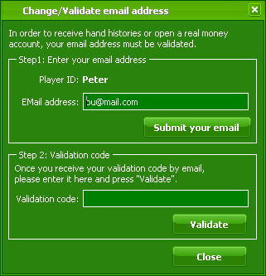
Figure 15-2 Laguna Poker: Change/Validate email address
You can buy chips with your credit card using the Buy Chips option. Click on the Buy Chips button to open the Buy chips window (Figure 16-2). The left-hand side offers different credit card or online banking payment options. The right-hand side has required fields that may vary with the payment system you choose.
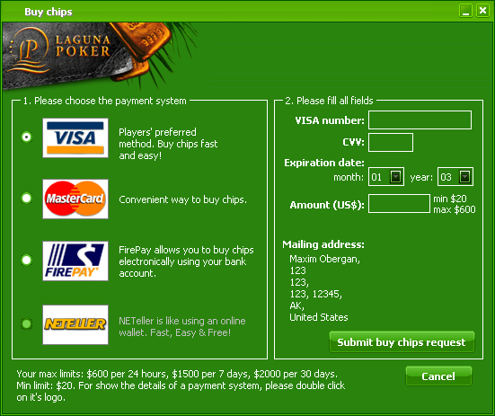
Figure 16-2 Laguna Poker: Buy chips
After you have chosen a payment option, and filled in all the required fields, you will be asked to confirm your purchase. To do so, click on the Submit buy chips request button. If all the information was entered in correctly, you will receive a confirmation message letting you know that your chips purchase was successful.
You will then see two windows displayed, containing information about becoming a Qualified Money Player, and your bonus account. Your initial bonus account is started with 10% of the deposited amount.
Players who fund an account with at least $100 become a Qualified Money Player (QMP). You can become a QMP by any of the following methods:
- If you deposit at least $100 into your account via one of the presented payment methods.
- If you earn 100 points. You can do this by one of the following methods:
- -Being dealt cards in 100 "raked hands" (1 point is earned for every raked hand)
- -Losing $100 at any given point
- -Spending $100 in tournament entry fees (1 point is earned for every $1 paid in tournament entry fees)

You can check your account status in the Cashier window (Figure 13-2). Each time when you want to make a deposit, click on the Buy chips button in the Cashier window, select an amount from $20 up to $600, and submit your request. When you are ready to cash out, click on the Cash out button and enter the amount you wish to withdraw from your account (Figure 17-2).
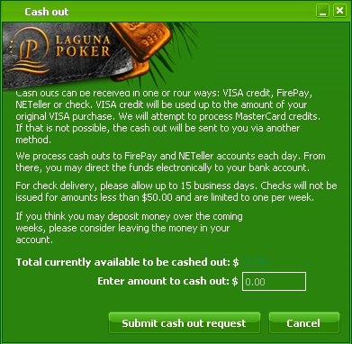
Figure 17-2. Laguna Poker: Cash out window
You can access information about your account deposits and withdrawals by clicking on the History button located in the Cashier window. This will open up a window displaying your transaction history:
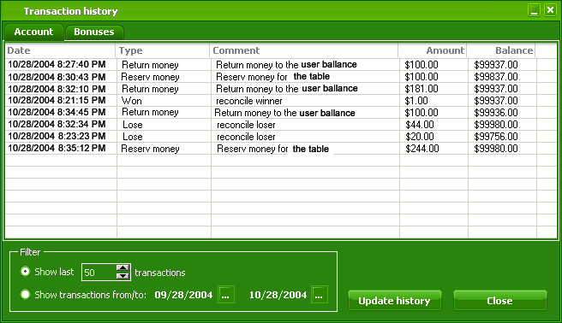
Figure 15-2. Laguna Poker: Transaction history

II.4.Program Options
The Options menu allows you to choose from the following options, and to change your game settings.
All-Ins remaining. At Laguna Poker, a player will be defined as all-in if it is impossible to act due to a connection problem. If you lose your Internet connection at the time of the hand, you will have 30 seconds to reconnect and get back to the hand, or it will be folded.
In the case of lost wagering time, you will be considered all-in, but will still be eligible to win your entitled portion of the pot. If you were able to reconnect successfully online, and returned to the game when it was your turn, but the permitted 30 seconds have already elapsed, your hand will be folded.
There is another All-In scenario that can occur when a player has insufficient funds to call the full amount of a bet. In this instance, you will stay at the table, and will continue to play, while the other players form a side pot.
The All-Ins remaining option shows the number of All-Ins that has occurred. The program default permits at least one All-In during 24 hours. The number of All-Ins can be raised.
- Request All-Ins reset. If you have used up the permitted number of All-Ins, you can reset it by using the Request All-Ins reset option. Your request will be considered on an individual basis by customer service.
- Recorded hands. Each game hand can be recorded. To view them, select the Recorded hands option. In order to replay an important hand, you must enter its ID number. Both the current and previous hands are displayed in the lower right hand corner of the Table window.
- Request hand history. Player can request to replay either a specific hand or a series of hands. The maximum number of hands that can be replayed is 100. This option also allows you to select the number of hands recorded during play.
- The View statistics option opens up a window that displays your playing statistics-i.e., all information about your actions during online playing. These playing statistics can be used to improve your poker skills. The statistic feature begins to automatically record information once you are logged in and have begun playing your first hand. You can clear and reset your statistics if desired at any point. The menu for the statistics window includes the following options:
- Always on top. This feature allows you to display the statistics window on top of the other game windows
- Copy statistic to clipboard. Select this option when you want to print your statistics, store them, or send them by email. The data will be saved to your clipboard, where you can paste it into the desired document or program.
- Reset statistics. If you select this option, data collection is stopped, and your statistics are reset at zero.
- Preserve statistics next session allows you to collect statistics over a number of playing sessions. After you log out, your stats will be stored for the next session.
- Statistics logging. If this option is checked, a special XML file – Statistics.xml – will be created. All statistical parameters will be fixed and refreshed periodically within that file during the game. This file can be used later to examine game strategy.
- The Change profile option lets you modify the personal information within your profile.
- The Change player logo option lets you select a logo for your seat at the game table.
- Change password: this option lets you change your password whenever you wish. Select Change password from the Option menu and fill in all the required fields to create the change.
- Change/validate email address ensures that you’ve entered in your correct email address, and lets you update your email address if it changes. For more information about validation, see subparagraph 2.3.2.
- Change mailing address. Your post office mailing address is used to mail correspondence to you when you request a cash out, making it essential that the information on file is accurate and current. Fill in all required fields to update your information.
- Use 4-color deck. If you prefer using a card deck with 4 suit colors (red, black, blue and green) instead of the traditional black and red, this option can be selected.
- The Enable animation option lets you enable or disable the dealing and chip movement animations at the playing tables.
- Enable chat bubbles. This option lets you choose to disable individual chat bubbles in order to concentrate your attention on the game.
- Enable sounds. You can enable or disable the dealing and chip movement sounds with this option.
- Reverse stereo panning. On some systems, the left and right speaker outputs may be reversed. If stereo panned sounds, such as dealing and betting, seem to be coming from the wrong side of the stereo image, try enabling this option.

III.SYSTEM ARCHITECTURE

III.1.Overview
The Laguna Poker system architecture consists of the following parts:
- PokerService.exe – one executable Windows NT Service that has build-on all-server objects.
- PokerControls.dll – a COM-object that has interfaces that allow the user to manage the Poker Server from the Admin site.
- Admin site – This website based on .NET technology allows you to manage the Laguna Poker System Context.
- Database – Laguna Poker has a MS SQL Server Database with stored procedures, triggers, constraints etc. – which stores all information related to the Poker System and its operation, including User Accounts, Money Transactions, Lists of Categories, Processes, Process States and Statistics, etc.
Laguna Poker could be running on one or more computers. It may run in different modes on each machine dependent on the Registry settings:
  - Action Dispatcher (when set, it works as the Action Server; if it is not set, it acts as the Action Client)
  - Action Processor (when set, it processes actions on Pooled Objects)
  - Client Adapter (when set, it works as the TCP/IP Server for Client Sessions)
  - Game Adapter (when set it creates a pool of different threads for actions to be processed by different processes, and records sessions for the Game Engines)
  - Reminder (when set, it creates, changes, resets, deleted, and processes that must be run during an assigned time.
  - Tournament – (when set, it processes the actions for tournaments).
LagunaPoker.exe, when opened, helps to describe the Laguna Poker system architecture. A general diagram of the Laguna Poker system architecture is represented in Figure 3-1.
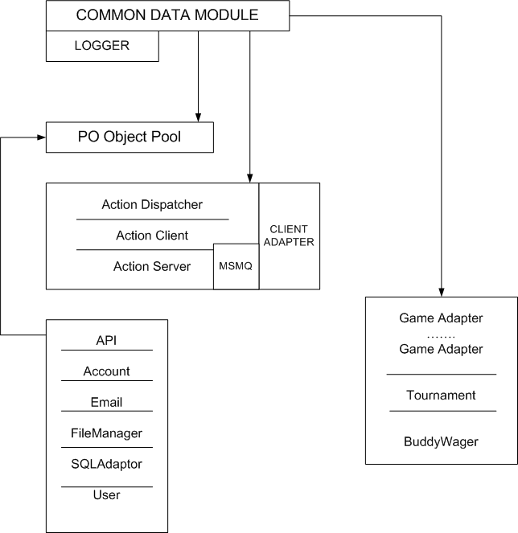
Figure 1-3: Laguna Poker System Architecture
The Poker Service contains the following within its structure:
- Service Core – This includes the Service Data Module and the Common Data Module – this is the center of the system which includes the Logger unit, the Settings unit, the Error Constants and XML Constants units , the Object Pooling unit, and the Process actions routines.
- Internal system Communication modules –These include the Action Dispatcher, the Action Server and Action Client, and the MSMQ Reader.
- External Client-Server communication module – this contains the Client Adapter.
- Pooled Objects used in all Modes: These include the API, the Account, EMail, the File Manager, the SQL Adapter, and the User.
- Game actions support modules: These include the Game Adapter, the Game Engine, and the Tournament Module.
The communication between Poker Services running on different machines are implemented using TCP/IP protocol. One of the Services must be running as the Action Server, and all others as the Action Clients.
The Admin site, the Poker Controls.dll files, and the Poker Service running in MSMQ Reader mode must all be running on one machine.
The database (MS SQL Server) can be running on any machine.
The internal structure of the Poker Service within Laguna Poker is represented in Figure 3-2.
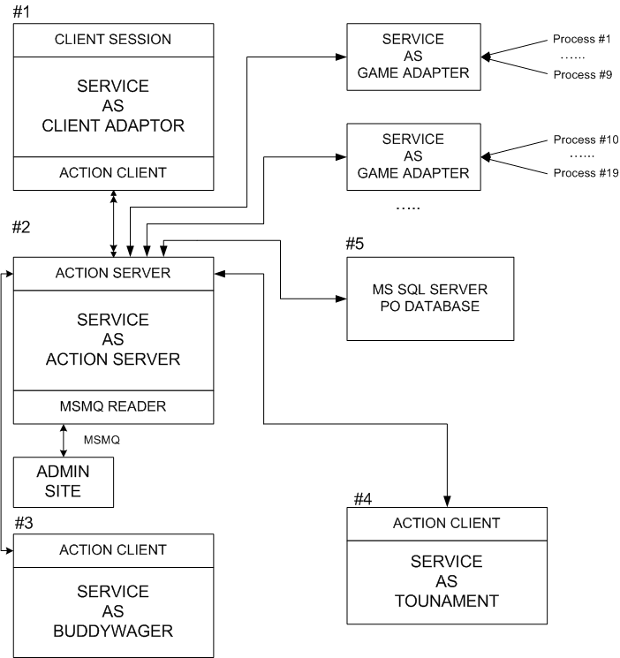
Figure 2-3: Internal structure of the Poker Service
The description of protocol below gives more extensive information about the structure of Laguna Poker and the interactions between its constituents.

III.2. Protocol
There are a defined number of units within Laguna Poker, which are used to send and transmit particular XML packets in response to client requests.

III.2.1. Service core
The Service Core includes the Service Data Module and the Common Data Module, which comprise the center of the system. The modules contain the Logger unit, the Settings unit, the Error Constants and XML Constants units , the Object Pooling unit, and the Process actions routines.
Notification
Notification is the object that is responsible for allocating all incoming data packets from the units to users (clients). When data comes in for a user, Notification object directs all packets with the necessary data into MSMQ. The Client Adapter then directs this information to the correct user. To define the required MSMQ and accordingly notify the user, Notification uses several methods.
Notification object protocols
- NotifyUser() allows Notification object to define the user by their SessionID.
- NotifyUserByHost() allows Notification object to define the user by their host and SessionID.
- NotifyUserByID() allows Notification object to define the user by their userID.

III.2.2.Pooled objects.

III.2.2.1.SQLAdapter.
The system has a database that stores different information about the game, such as the sets of tables, the number of users at a defined table, the game state, etc. While this information can be changed or replaced, it must always stay within the database.
The SQL Adapter is a unit that interacts between the other units and the database. It defines where a database is located using SQLConnectionString(). The SQL Adapter allows actions such as making database alterations, retrieving required records, and others. The SQL Adapter delivers queries to the database from other units using ADO, and receives record sets or XML packets.
SQL Adapter object protocol description.
- The Execute() function sends a request to the database to get a record set.
- ExecuteCommand(). If a developer needs to get not only a record set, but certain parameter values, it is possible to do so using the ExecuteCommand() function. Before the function will execute, it is necessary to first declare certain parameters:
- To declare a procedure name, use the SetProcName() function.
- To add parameters, use one of the following functions:
- AddParam()
- AddParIn()
- AddParString()
- AddParWString()
After ExecuteCommand() completes its task, it is possible to view a parameter value by applying the function GetParam() and entering the desired parameter name.
The ExecuteForXML() function will then return an XML packet containing the requested parameters.
The database maintains a Game Situation record (or Game Stat) that describes the game table type, the number of current users, their cards, the number of watchers and other game information. The current Game situation is stored as a serialized Binary Large Object (BLOB).
The Game Situation appears within the game itself, and must be processed. To do this, the Game Adapter sends a query to the SQL Adapter to get the Blob application with GetBlob().
When the Game Adapter receives the Blob, it deserializes it and begins processing the Game Situation interactions with the Game Engine and the API.
Simultaneously, the Game Engine forms a “Behavior XML” which includes a list of actions to be processed by the Client Side Application. The processed Game Situation is then returned to the SQL Adapter and saved in the database. This last operation is executed with the function SaveBlob().
Here is a set of functions for processing transactions:
  - BeginTrans() declares the beginning of a transaction.
  - CommitTrans() confirms that a transaction has been implemented, and has been archived.
  - RollbackTrans() deletes a transaction which has occurred.

III.2.2.2. File Manager.
File Manager is a unit that replies to client side requests for files which are needed for the stable functioning of the Client Side Applications.
File Manager object protocol description
- fmgetfileinfo : this function gets file information, using the file identifier (FileID)
Request:
<objects>
<object name="filemanager">
<fmgetfileinfo fileid="234"/>
</object>
</objects>
Response:
<object name="filemanager">
<fmgetfileinfo result="0|..."
fileid="1213"
filetype="htm"
filetypeid="1"
version="2"
name="holdem.swf"
location="http://LagunaPoker.com/files/1213.bin"
size="123456"/>
</object>
fmgetprocessfiles: this function gets process file information, using the ProcessID.
Request:
<objects>
<object name="filemanager">
<fmgetprocessfiles processid="234"/>
</object>
</objects>
Response:
<object name="filemanager">
<fmgetprocessfiles result="0|..." processid="234" gameengineid="1">
<file fileid="1213"
filetype="swf"
filetypeid="1"
contenttypeid="1"
version="2"
name="game.swf"
location="http://LagunaPoker.com/files/1213.bin"
size="123456"/>
<fmgetprocessfiles>
</object>
- fmgetsystemfiles –this is initiated when the application loads, and checks for the presence of all required files, including their name, location, type, and so on.
Request:
<objects>
<object name="filemanager">
<fmgetsystemfiles/>
</object>
</objects>
Response:
<object name="filemanager">
<fmgetsystemfiles result="0|...">
<file fileid="1213"
filetype="swf"
filetypeid="1"
contenttypeid="1"
version="2"
name="game.swf"
location="http://LagunaPoker.com/files/1213.bin"
size="123456"/>
</fmgetsystemfiles>
</object>

III.2.2.3. User object.
The User object processes requests related to users’ actions within the system. It allows users to register, use the lobby functions, check their registration information, update their user profile, etc. Most queries for User object tasks are delivered by the ProcessAction() function.
User Object Protocol Description
Uoregister: this packet is sent during initial user registration, and is only implemented one time. It includes the values entered by the user into the registration form, which are stored in the database, and can be changed if necessary. User object also verifies the validity of an indicated player’s name and email address. Once these are verified, it registers the user within the database. User object returns a unique user identify as a result of this process that identifies the user within the system when they log in.
Request:
<objects>
<object name="user">
<uoregister
loginname="Player"
password="qwerty"
firstname="John"
lastname="Smith"
mail="player@mail.com"
showlocation="0|1"
location="Somewhere on planet Earth"
sexid="0"
affiliateid="1"/>
</object>
</objects>
Response:
<object name="user">
<uoregister result="0|..." userid="1213">
</object>
Uologin: there are several ways the system defines users: as registered or unregistered, logged in or logged out. In order to define if a user is using an application (or not) at the current moment, there are also some special parameters stored within the database that it uses.
For example, an unregistered user will not have a personal identifier, which is received only after completing registration. Instead, an unregistered user is defined by the session identifier. The following function is used to implement the “log in” action. User object checks the player’s name and password and, if they are valid, notes within the database that the user has logged in.
Request:
<objects>
<object name="user">
<uologin loginname="player" password="qwerty"/>
</object>
</objects>
Response:
<object name="user">
<uologin result="0|..." userid="1213" emailvalidated="0|1">
</object>
uologout: in order to notify the server that a user is not currently active in the system, the Client side sends it a log out packet. Both the log out action and Exit action are joined together by the Client Side Application, which is why there is not a response packet to this notification.
Request:
<objects>
<object name="user">
<uologout userid="1213"/>
</object>
</objects>
uogetprofile: this function gets the user profile forms and sends a packet to the server containing their user identifier. When this user identifier presents itself to the database, the user object returns a packet containing a set of values for the defined user.
Request:
<objects>
<object name="user">
<uogetprofile userid="1213"/>
</object>
</objects>
Response:
<object name="user">
<uogetprofile result="0|..."
userid="1213"
loginname="Player"
firstname="John"
lastname="Smith"
email="player@mail.com"
emailvalidated="0|1"
emailalerts="0|1"
buddyalerts="0|1"
showlocation="0|1"
location="neverland"
qompid="10023"
bonusaccount="12.67"
avatarid="0"
sexid="0"
userqualification="QPOMP"
qompid="10023"
bonusaccount="12.67"/>
</object>
uoupdateprofile: the following function is used to send a request if the user wants to change his profile (see subparagraph 2.4.). The user object interacts with the database through the SQL Adapter in order to execute the data modification.
Request:
<objects>
<object name="user">
<uoupdateprofile
userid="1213"
firstname="John"
lastname="Smith"
emailalerts="0|1"
buddyalerts="0|1"
showlocation="0|1"
location="neverland"
avatarid="0"
sexid="0"/>
</object>
</objects>
Response:
<object name="user">
<uoupdateprofile result="0|..."/>
</object>
uochangepassword: this function changes the user’s password if this action is requested.
Request:
<objects>
<object name="user">
<uochangepassword userid="1213"
newpassword="12345"
oldpassword="qwerty"/>
</object>
</objects>
Response:
<object name="user">
<uochangepassword result="0|..."/>
</object>
uoforgotpassword: if a user has forgotten his password, they can request that it be sent to them by email. To allow the system to identify the user and determine their password, the Client Application sends a packet with a set of user parameters including first name, last name, email address, etc. User object then analyzes the data received, and sends an email containing the requested password.
Request:
<objects>
<object name="user">
<uoforgotpassword loginname="1213"
firstname="John"
lastname="Smith"
email="player@mail.com"
location="neverland"
sexid="0"/>
</object>
</objects>
Response:
<object name="user">
<uoforgotpassword result="0|..."/>
</object>
uochangeemail: it is possible to change the email address that was entered during registration to a new one (see subparagraph 2.4). In general, email addresses are used to receive messages from customer service. When changing an email address, the system will send a message to the user with a validation code contained within the email body (this validation code is unique to the individual email). If the user receives this email from customer service, then he has a valid email address.
Request:
<objects>
<object name="user">
<uochangeemail userid="1213" email="player@mail.com"/>
</object>
</objects>
Response:
<object name="user">
<uochangeemail result="0|..."/>
<object/>
uovalidateemail: there is a special value within the database that defines whether a user’s email address is a valid (working) one. In order to validate the email address, the user must first enter in the validation code received by email (see above) into the Validate Code field (see Figure 14-2). In order to check that the validation code sent by the user is correct, the system retrieves it from the email it sent as well, and compares the two. If the code validates, the User object marks the email as valid, and changes the user’s status.
There are three different types of user states: enabled, disabled, deleted.
Request:
<objects>
<object name="user">
<uovalidateemail userid="1213" validationcode="1213"/>
</object>
</objects>
Response:
<object name="user">
<uovalidateemail result="0|..."/>
<object/>
uogetstatistics: this gets user statistics, including the date and time they logged in, and the total number of seconds they remained logged into the system.
Request:
<objects>
<object name="user">
<uogetstatistics userid="1213"/>
</object>
</objects>
Response:
<object name="user">
<uogetstatistics result="0|..."
userid="1213"
lastloggedtime="2003/08/25 13:51:09"
totalloggedseconds="873614526">
</object>
uopopupmessages: at times, the system notifies users about special events or actions they can take, such as the opportunity to change their qualification level, or to change their bonus amounts, etc. The following method is applied to inform the user about the different actions (which is why there is only a response packet). If desired, the user has the option of refusing to receive these messages.
Response:
<object name="user">
<uopopupmessages>
<message type="1|2|3" title="" header="" footer="" date="2003-02-25 02:47 PM">
<data value=""/>
<data value=""/>
<data value=""/>
<data value=""/>
</message>
...
</uopopupmessages>
</object>
Type =
  - Refer-A-Friend Bonus
  - Qualification Change
  - Transfer Bonus Account to Balance
uopopupmessageshistory: this function sends all messages to the user which he has not yet received.
Request:
<objects>
<object name="user">
<uopopupmessageshistory userid="1213"/>
</object>
</objects>
Response:
<object name="user">
<uopopupmessageshistory>
<message type="1|2|3" title="" header="" footer="" date="2003-02-25 02:47 PM">
<data value=""/>
<data value=""/>
<data value=""/>
<data value=""/>
</message>
...
</uopopupmessageshistory>
</object>
Type =
  - Refer-A-Friend Bonus
  - Qualification Change
  - Transfer Bonus Account to Balance

III.2.2.4. Account object
The Account Object processes money transactions within the game, and gives information about users’ accounts. All methods described below are sent as packets to the server, with responses received back within packets.
Description of account object protocols
Aocreatenew: this function creates a new record within the database for a user’s account. Each record corresponds to their unique user identifier. There are several different properties defined, based on the type of user account, including: currency type (play or real money), currency amount, deposit amount, etc.
During user registration (using the Create new account command), the system automatically enters 10,000 play money chips into the user’s account. The object then returns the user’s unique account identifier.
Request:
<objects>
<object name="account">
<aocreatenew userid="123"
currencytypeid="1" />
</object>
</objects>
Response:
<object name="cashier">
<aocreatenewaccount result="0|..." accountid="123"/>
</object>
Remark:
if result <> 0 accountid is absent
aochangemailingaddress: if a user wishes to play with real money, they must first buy chips. The first step in making a purchase is to fill out a special form that requests their physical mailing address. This is necessary, since the user (player) will be receiving postal mail notifications about money transactions that occur during the game.
Request:
<objects>
<object name="account">
<aochangemailingaddress userid="50"
firstname="John"
lastname="Smith"
address1="Independence street, 6549"
address2="3rd floor"
city="Las-Vegas"
countryid="1"
stateid="1"
province="Nevada"
zip="95000"
phone="+100180080808080" />
</object>
</objects>
Response:
<object name="cashier">
<aochangemailingaddress result="0|..."/>
</object>
all fields = 50 chars,
zip = 15 digits
aodeposit: Once an email address is validated, the user can deposit money into their game account. This operation is only possible with real money. In order to make a deposit, the user must fill in certain values on the form provided, including: the type of payment system, the credit/bank card number, the card expiration date, the amount of money, etc. (see Figure 15-2).
A packet will then be created that contains these values, along with certain additional ones, which is sent to the Account object. The answer packet returns a response, containing data about the amount of money that was deposited into the user’s account.
Request:
<objects>
<object name="account">
<aodeposit userid="123" currencytypeid="2" amount="70.00">
<card name="visa|mastercard|firepay" number="2000542567465" cvv="0845"
expmonth="05" expyear="04"/>
<neteller ./>
</aodeposit>
</object>
</objects>
Response:
<object name="cashier">
<aodeposit result="0|..." newamount="100.55"/>
</object>
Remark:
if result <> 0 newamount is absent
aowithdrawal: this lets a user withdraw money from his game account (see Figure 17-2). This operation can be implemented with real money only. The user enters in the cash out amount, and submits the request. The Account object returns the new value for the amount of money remaining in the user’s account.
Request:
<objects>
<object name="account">
<aowithdrawal userid="123" currencytypeid="1" amount="100.55"/>
</object>
</objects>
Response:
<object name="cashier">
<aowithdrawal result="0|..." newamount="100.55"/>
</object>
Remark:
if result <> 0 newamount is absent
aogetbalanceinfo: if the Client cashier object needs the full information for a user account, it forms the following packet, containing the user identifier for the account it is requesting information for. In response, it receives a set of values, including: the account identifier, the currency type identifier, the current account status, the amount of reserved money, etc.
Request:
<objects>
<object name="account">
<aogetbalanceinfo userid="50"/>
</object>
</objects>
Response:
<object name="cashier">
<aogetbalanceinfo result="0|..."
<account id="10"
currencytypeid="1"
balance="25.25"
reserved="10.05"
statusname="enabled"
recorddate="09/21/2003"/>
<account id="20"
currencytypeid="2"
balance="15.25"
reserved="5.20"
statusname="enabled"
recorddate="09/11/2003"/>
........
/>
</object>
Remark:
if result <> 0 all other nodes are absent
aogethistory: A user can review the history of their money transactions during games. To do this, they will need to open the History window (see Figure 18-2) and indicate the dates for review, as well as the number of transactions to be displayed.
The following money operations are registered within the database: Deposit, Withdrawal, Reserve money, Return money , Lose , Won, Tourney entry, Tourney won, System Fee, Bet Place, Bet Payout, Bet Return, Admin Correction, Bonus money.
All of the above, except Reserve money and Return money, are displayed in the history window.
Request:
<objects>
<object name="account">
<aogethistory userid="123" currencytypeid="1"
toplast="50" datestart="2003-11-10" dateend="2003-11-20"/>
</object>
</objects>
Response:
<object name="cashier">
<aogethistory result="0|...">
<money>
<transaction amount="123.12" balance="1000" type="deposit" comment="reserve money" date="10-30-2003"/>
<transaction amount="123.12" balance="1000" type="deposit" comment="reserve money" date="10-30-2003"/>
</money>
<bonuses>
<transaction amount="123.12" balance="1000" type="deposit" comment="reserve money" date="10-30-2003"/>
<transaction amount="123.12" balance="1000" type="deposit" comment="reserve money" date="10-30-2003"/>
</bonuses>
</aogethistory>
</object>
Remark:
if result <> 0 newamount is absent
aogetmailingaddress: this function displays the user’s mailing address inside the Cashier window (see Figure 13-2) The Client side sends the following request and the Account object finds the requested data within the database and returns it.
Request:
<objects>
<object name="account">
<aogetmailingaddress userid="50"/>
</object>
</objects>
Response:
<object name="cashier">
<aogetmailingaddress result="0|..."
firstname="John"
lastname="Smith"
address1="Independence street, 6549"
address2="3rd floor"
city="Las-Vegas"
countryid="1"
stateid="1"
province="Nevada"
zip="95000"
phone="+100180080808080"/>
</object>
Remark:
if result <> 0 all other nodes are absent
ReserveAmount()
This function is called by the API. It gets current information about the amount of money within the user’s account, and returns this new value to the game.
ReturnAmount()
This function is the inverse of the previous one. It returns current information about the money earned during the game into the user’s account.
ChangeAccountStatus()
The method is called when changing a user's account status. There are three different types of user status: enabled, disabled, or deleted.
HandResult()
This method is called by the API to create a packet containing values about a game result.
ReturnAllMoneyFromGameProcess()
This method is called if certain exceptions occur during a game. Money transactions that occurred during the game are returned to the players.

III.2.2.5. API.
The API is an object that can implement two types of roles within the system. To better understand these roles, please view Figures 2-3 and 3-3.
In Figure 2-3, the API acts as a connecting link between the Game Engine and the Notification Object by means of a set of functions. In Figure 3-3, the API acts as an object that gets XML packets through ProcessAction() (bypassing the Game Adapter and the Game Engine), processes client requests, and sends packets with a defined structure to the Notification object.
Description of the API object protocol
ProcessAction() Function
As noted above, the Collaboration object creates a unit and calls on the ProcessAction()function to send the host, SessionID and Data. The Data is the part of an XML packet that must be processed by the originating object.
Below are some samples of request and response packets as applied by the API.
apgetcategories returns a list of the categories and subcategories identifiers and names. Each category contains a number of subcategories. For example, the subcategories for Poker are the different types of poker games.
Request:
<objects>
<object name="api">
<apgetcategories/>
</object>
</objects>
Response:
<object name="lobby" sessionid="14428">
<apgetcategories result="0|...">
<category id="1" name="Poker">
<subcategory id="1" name="Hold'em"/>
<subcategory id="2" name="Omaha Hi"/>
<subcategory id="3" name="Omaha Hi Lo"/>
<subcategory id="4" name="7 Card Stud"/>
<subcategory id="5" name="7 Card Hi Lo"/>
<subcategory id="49" name="Mini-Tourney"/>
</category>
</apgetcategories>
</object>
<object name="lobby">
<apgetcategories result="0|...">
<category id="1" name="Poker"/>
<subcategory id="1" name="Texas Hold'em"/>
<subcategory id="2" name="Omaha Hi"/>
<subcategory id="3" name="Omaha Hi/Lo"/>
<subcategory id="4" name="7 Card Stud Hi"/>
<category/>
<category id="2" name="Tetris"/>
<category id="3" name="Chess"/>
<category id="4" name="Solitaire"/>
</apgetcategories>
</object>
apgetprocesses: this lets a client get the statistics for a defined process. The API returns all possible data for the process and displays it in order.
Request:
<objects>
<object name="api">
<apgetprocesses subcategoryid="1"/>
</object>
</objects>
Response:
<object name="lobby">
<apgetprocesses subcategoryid="1" result="0|...">
<columns>
<stats id="1" order="1"/>
<stats id="2" order="4"/>
<stats id="3" order="2"/>
<stats id="4" order="3"/>
</columns>
<processes>
<process id="1" name="Money table #123" currencyid="1" groupid="1">
<stats id="1" value="12"/>
<stats id="2" value="2.57"/>
<stats id="4" value="456"/>
<stats id="7" value="Waiting..."/>
</process>
<process id="1" name="Tournament" currencyid="2" groupid="1">
<stats id="1" value="12"/>
<stats id="5" value="Tetris"/>
<stats id="8" value="456"/>
<stats id="9" value="Waiting..."/>
</process>
</processes>
</apgetprocesses>
</object>
apgetprocessinfo: this returns all information about the users at a defined table (process), including the values for players, watchers and those waiting for a turn. It also gives the players' location and current account states.
Request:
<objects>
<object name="api">
<apgetprocessinfo processid="1213"/>
</object>
</objects>
Response:
<object name="lobby">
<apgetprocessinfo processid="37" result="0">
<group name="Players:" value="4">
<data name="Player 1" city="Sim-City" value="$1000"/>
<data name="Player 2" city="Sim-Town" value="$2000"/>
<data name="Player 3" city="Sim-Village" value="$3000"/>
</group>
<group name="Waiting list:" value="1/2"/>
<group name="Watchers:" value="3"/>
</apgetprocessinfo>
</object>
apgetcurrencies: this returns all possible data about the currencies (real or play money) used during a defined game.
Request:
<objects>
<object name="api">
<apgetcurrencies/>
</object>
</objects>
Response:
<object name="conversions">
<apgetcurrencies result="0|...">
<currency id="1" name="Play money" sign="" isrealmoney="0|1"/>
<currency id="2" name="Real dollars" sign="$" isrealmoney="0|1"/>
</apgetcurrencies>
</object>
apgetstates: this function returns a list of states within the United States.
Request:
<objects>
<object name="api">
<apgetstates/>
</object>
</objects>
Response:
<object name="cashier" sessionid="...">
<apgetstates result="0|...">
<state id="2" name="AK" longname="Alaska" isfundsallowed="1" isUnitedStates="1"/>
<state id="3" name="AL" longname="Alabama" isfundsallowed="0" isUnitedStates="1"/>
...
</apgetcurrencies>
</object>
apgetstats: this function gets all available statistics (instead of all possible table properties), such as the table's name, the average pot, the number of players, and so on.
Request:
<objects>
<object name="api">
<apgetstats/>
</object>
</objects>
Response:
<object name="lobby">
<apgetstats result="0|...">
<object name="lobby" sessionid="14428">
<apgetstats result="0">
<stats id="1" name="Table" propertyid="4"/>
<stats id="2" name="Plrs" propertyid="4"/>
<stats id="3" name="Currency" propertyid="3"/>
...
</apgetstats>
</object>
apupdatesummary: this is used to update game information.
Request:
<objects>
<object name="api">
<apupdatesummary/>
</object>
</objects>
Response:
<object name="lobby">
<apupdatesummary players="2134" processes="576" result="0|..."/>
</object>
apgetcountries: this is used to get a list of available countries to select from during user registration.
Request:
<objects>
<object name="api">
<apgetcountries/>
</object>
</objects>
Response:
<object name="cashier">
<apgetcountries result="0|...">
<country id="1" name="USA" usa="0|1"/>
<country id="2" name="Ukraine" usa="0|1"/>
<country id="3" name="Russia" usa="0|1"/>
</apgetcurrencies>
</object>
It is possible to send some requests together. For example:
<objects>
<object name="api">
<apgetcurrencies/>
<apgetstats/>
<apgetcategories/>
<apgetcountries/>
<apgetstates/>
</object>
</objects>
In the above example, the client sends a request that asks simultaneously for information about the currencies, statistics, categories, countries and states. But each of these requests will be processed separately by their defined unit. The responses will be returned in order, as each request is processed.
apregisteratwaitinglist: when all seats at a game table are occupied, players can use this option to register within a waiting list. They will then be given a seat when one becomes free, after those before them are seated. The system registers a player within the waiting list, and informs them when a table seat becomes free. If the player doesn't take this seat with a certain time interval, the system automatically places his record at the end of the waiting list queue.
Request:
<objects>
<object name="api">
<apregisteratwaitinglist processid="" groupid="" playerscount=""/>
</object>
</objects>
Response:
<object name="process">
<apregisteratwaitinglist result="0|..." processid="" groupid=""/>
</object>
apunregisterfromwaitinglist: this process is the inverse of the previous one, and allows a player to unregister from the waiting list.
Request:
<objects>
<object name="api">
<apunregisterfromwaitinglist processid="" groupid=""/>
</object>
</objects>
Response:
<object name="process">
<apunregisterfromwaitinglist result="0|..." processid="" groupid=""/>
</object>
getnotes: as noted before, players can make notes while in chat about their opponents. This function lets players view their notes about a defined user.
Request:
<getnotes foruserid="324"/>
Response:
<getnotes foruserid="1213" notes="He is the best poker player"/>
savenotes: this is a request to save a note.
Request:
<savenotes foruserid="324" notes="He is the best poker player"/>
apupdateprocess : this allows the system to automatically update the statistics for all Laguna Poker players, and lets them view these changes on a periodic basis (without the need to make a specific request).
Response:
<object name="lobby">
<apupdateprocess processid="1" result="0|...">
<stats id="1" value="17"/>
<stats id="5" value="Tetris"/>
<stats id="8" value="458"/>
<stats id="9" value="Playing..."/>
</apupdateprocess>
</object>
Laguna Poker allows players to record their hands, and then replay them (they receive the files for the recorded hands by email). This function lets them save the most interesting hands for improving their playing strategy (see the discussion under subparagraph 2.4).
Apgetrecordedhands: this gets a list of the recorded hands.
Request:
<objects>
<object name="pi">
<apgetrecordedhands userid="1213"/>
</object>
</objects>
Response:
<object name="process">
<apgetrecordedhands result="0">
<hand order="1" handid="12" comment="I won all players!!!"/>
<hand order="2" handid="13" comment="I won all players!!!"/>
<hand order="3" handid="14" comment="I won all players!!!"/>
<hand order="4" handid="15" comment="I won all players!!!"/>
<hand order="5" handid="16" comment="I won all players!!!"/>
</apgetrecordedhands>
</object>
apsaverecordedhands : this saves the player’s list of favorite recorded hands.
Request:
<objects>
<object name="api">
<apsaverecordedhands userid="1213">
<hand order="1" handid="12" comment="I won all players!!!"/>
<hand order="2" handid="13" comment="I won all players!!!"/>
<hand order="3" handid="14" comment="I won all players!!!"/>
<hand order="4" handid="15" comment="I won all players!!!"/>
<hand order="5" handid="16" comment="I won all players!!!"/>
...
</apsaverecordedhands >
</object>
</objects>
Response:
<object name="process">
<apsaverecordedhands result="0|..."/>
</object>
aprequesthandhistory : this lets a player request that recorded hands be sent to them by email. The system processes the request, which indicates which hands are to be sent, and sends them as a text file.
Request:
<objects>
<object name="api">
<aprequesthandhistory userid="1213"
lasthands="0|1..100"
handid="324|0"
direction="0|1"/>
</object>
</objects>
Response:
<object name="process">
<aprequesthandhistory result="0|..."/>
</object>
apgetrecordedhandhistory: this gets a list of the recorded hands.
Request:
<objects>
<object name="api">
<apgetrecordedhandhistory userid="1213" handid="123"/>
</object>
</objects>
Response:
<object name="process">
<apgetrecordedhandhistory result="0|..." processid="1234" handid="123">
<...>
</apgetrecordedhandhistory>
</object>
apcheckhandid: at times, a player will want to replay a hand. By putting in the hand number, and sending a request, this option will allow him to do so. When the system receives the request, it must first confirm that both the hand and its identifier are valid. It first validates the handID and then processes the request.
Request:
<objects>
<object name="api">
<apcheckhandid handid="123" order="1" comment="Holdem 3/6"/>
</object>
</objects>
Response:
<object name="process">
<apcheckhandid result="0|..." handid="123" order="1" comment="Holdem 3/6"/>
</object>
apcustomsupport: players can send messages by email to customer support for help resolving problems, or for answers to questions. The request packet includes the message and its subject. The response packet returns the results of processing the request.
Request:
<objects>
<object name="api">
<apcustomsupport
subject="all right"
message="All functions are working well. You are great, guys!"/>
</object>
</objects>
Response:
<object name="lobby">
<apcustomsupport result="0|..."/>
</object>
apgetwaitinglistinfo: this returns information about the waiting list for a designated table.
Request:
<objects>
<object name="api">
<apgetwaitinglistinfo processid="123"/>
</object>
</objects>
Response:
<object name="process">
<apgetwaitinglistinfo result="0|..." state="0|1|2"
processid="123" processname="Jamaika" waitingplayerscount="3"
groupid="12"/>
</object>
Now, we will discuss the procedures that run the Game Engine features.
The following three functions are used during game situations:
- GetState(). When the Game Engine needs a specific game situation, it sends a request to the API, which in turn applies to the SQL Adapter, calling for the GetState() function.
- CreateState(). Each game situation is saved within the database. When a new game situation starts, the system reserves space within the database, and then enters the new situation parameters using the CreateState() function.
- SetState(). This function saves a game situation within the database.
The following four functions are used for working with game statistics:
- GetStats(). When the Game Engine needs a certain statistic, it sends a request to the API. The API then calls the GetStats() function to get it from the database.
- CreateStats(). This creates a record with a certain statistical value within the database.
- SetStats(). To save a record with a statistical value, the API calls the SetStats() function.
- SetStatses(). This allows the API to receive all statistical values as one unit.
RegisterParticipant(). When a player opens a table window, the system records him as either a game participant, or a watcher. The function RegisterParticipant() is used to record data about users of a defined process (i.e. game) within the database.
UnRegisterParticipant(). This function is the inverse of the previous one, and deletes the player’s record from the database.
SetParticipantCount(). The API calls on this function to save a count of the active players and watchers during a game into the database.
There are times when it becomes necessary to process a packet at a certain time, and report the results to the system. All such packets are directed to MSMQ by the API.
The Reminder service then selects the packets, and manages the reminders with the following functions:
CreateRemind(). This function creates a reminder that the API is to send special parameters, including the system reminder times. This function then returns a reminding identifier (RemindID). This number lets the system identify a certain reminder within the reminder list.
ChangeRemind(). This function changes the parameters for the reminders created by CreateRemind(). The RemindID is used to define which reminder is to be changed.
RemoveRemind(). This function is used to delete a reminder from a list (of reminders).
ResetRemind(). This function is used to change the time that a reminder will occur.
The following three functions are used to process transactions. They correspond to the functions used by the SQL Adapter (see subparagraph 3.2.4).
- BeginTransaction()
- CommitTransaction()
- RollBackTransaction()
GetProcessInfo(). This function gets information about a defined process (game). It returns the group identifier, the process name, the currency type identifier, etc.
GetCurrency(). This function assigns an identifier to the currency type, and returns both the currency name and symbol.
GetWaitersCount(). This function returns the number of players within a waiting list for a defined process (game).
NotifyProcessCreatingAbout(). After a new process (game) has been created, it becomes necessary to make it available for use by all players. The system does this by notifying all active players about the new game, and the lobby displays it within the list of game tables.
NotifyProcessDeletingAbout(). This function notifies all active players that the process (game) has been deleted. The game identifier is used during this function.
GetParticipantInfo(). This function gets participant information for the Game Engine if they do not have an assigned identifier within the system. This occurs with participants who are unregistered users, or those who have not logged in. The function defines participants by their session identifier and host.
GetUserInfo(). This function resembles the previous one, and returns all possible parameters and values for a registered user’s identifier, such as their user name, location (city), avatar identifier, etc.
GetUserSession(). At times, the session identifier is unknown, but the user identifier is available (such as during tournament play). In this situation, this function returns the session identifier and host with the help of the user identifier.
GetUserBalance(). This function returns the amount of currency available within a player’s account. To obtain the data, this function applies identifiers for the session, the player and the currency type.
ReserveMoney(). When a player who is logged in begins to take a seat at a poker table, this application offers to reserve some money for the game. The ReserveMoney() function processes this action and returns the amount of money reserved, along with a value which will be subtracted from the money available within the account (see Figure13-2).
UnReserveMoney(). This function is called after the player has left a game table, and returns the money that remains in the reserve back to their main account.
HandResult(). This function returns the winning pot (i.e. the amount of money which should be credited to the winning hand’s account).
TournamentPrize(). In order to determine which players should receive prizes, and the prize amounts after a tournament ends, the Game Engine calls the TournamentPrize() function.
ReserveForTournament(). This function resembles the ReserveMoney() function, but is used for tournaments. With this function, the Administrator fixes the amount of money that is to be reserved by tournament players when play begins.
UnReserveForTournament(). The function is analogous to the UnReserveMoney() function but is used during tournaments.
FinishHand(). This function lets the system know a hand is finished, and stops certain game processes such as dealing, when executing others (such as a showdown).
StartHand(). This function returns the identifier for a hand that has just begun playing.
CreateActionLog(). This function saves a log of the activity for the current hand into the database. A complete set of the game activity logs provides a log for the entire hand.
GetHandHistory(). This function returns the complete hand history for later replaying (see subparagraph 2.4., items: Recorded hands, Request hand history). This complete history allows the requester to view the cards for all the players in the game.
GetPersonalHandHistory(). The function returns the history of a game from the position of a particular player. During replay, the requester will only be able to view their own cards (and will not be able to view the cards of the other players).
GetPersonalHandHistoryAsText(). The function allows the personal hand history to be sent as a text message (by email).
CloneProcess(). As noted above, each game subcategory must have a vacant table created if all other tables are filled. In order to implement this, the CloneProcess() function is called. A new cloned process (game table) keeps all the parameters of the parent game table except the name.
InitProcess(). This function initializes the game situation process contained within the database. In order to accomplish this, the API delivers the process identifier to the Game Engine.
RegisterAtWaitingList(). This function calls for registered users within the waiting list and returns the number of waiting registered players.
GetNextFromWaitingListAndLock(). This function gets the next player (based on their user identifier) from the waiting list queue and marks them for entrance into the game.
ReturnToWaitingListAndUnlock(). With this function, the system returns the player (user) to the end of the waiting list queue and unlocks them if they do not respond to the system prompt (for example, the player didn’t take a vacant place at the game table in time, when it was their turn).
UnregisterFromWaitingList(). This function removes a player from the waiting list.
CanUserMakeAllIn()&UserMakeAllIn(). The first function checks whether a player is a candidate for Allin during play (it uses a flag that defines this possibility). The second function lets the player go Allin during a game.

III.2.2.6. Email.
The email object allows the creation of email templates, and lets system users send and receive emails.
Email object protocols
SendUserEmail(). This function creates and sends an email to a user. The send email function has a defined structure which cannot be changed.
SendAdminEmail(). This function creates and sends emails to the administrator. This function has a defined structure which cannot be changed.
SendCustomEmail(). This function sends an email using one of the presented templates.

III.2.3. Game actions support modules.

III.2.3.1. Game Adapter.
The Game Adapter sends packets from other objects to the Game Engine.
Game Adapter object protocols
ProcessAction() is a function of the Game Adapter interface. It transmits the following packets:
Gaaction: this transmits game activity data to the Game Engine, which then defines and processes the actions taken (within the current game situation). This packet includes a process identifier which allows the system to determine the location within the system of the action being processed.
Request:
<objects>
<object name="gameadaptor">
<gaaction processid="1213">
...
<gaaction/>
</object>
</objects>
gadisconnect: if a user is disconnected from the game, the Client Adapter notifies the Game Adapter that the defined user has lost their connection. The Game Adapter then notifies all other programs/processes about the disconnection, and the player’s location when it occurred.
Request:
<objects>
<object name="gameadaptor">
<gadisconnect />
</object>
</objects>
gasetparticipantaslogged: once a player has logged in, the User object sends the following packet to the Game Adapter:
Request:
<objects>
<object name="gameadaptor">
<gasetparticipantaslogged />
</object>
</objects>
This defines the player as registered, with a unique identifier that allows the system to define additional parameters for them (such as a process identifier).

III.2.3.2. Tournament object
The tournament object manages the processes that occur during multi-table tournaments. The properties for multi-table tournaments are set by the administrator (at the Admin site).
At the moment a new tournament is created, the tournament object sets reminders for the following:
- The time registration starts
- The time the tournament starts
- The time interval between the moment when players take seats at their tables, and the start of tournament play
- The time interval for raising the stakes (the number of hands or time elapsed before the stakes are raised)
- The time interval between rest breaks (during breaks, stake levels are not increased)
- Break times.
Tournament object protocols
Togetinfo: this request allows the client side to get and display the information for a defined tournament. The window of the selected tournament will display the information received in response to this request.
Request:
<objects>
<object name="tournament">
<togetinfo tournamentid="123"/>
</object>
</objects>
Response:
<object name="tournament">
<togetinfo result="0|..." tournamentid="123" type="1" state="1" buyin="33.00">
<base>
<data value="Poker World-Wide Super-Duper Tournament"/>
<data value="Pot limit Hol'em. Buy-In: $30+$3"/>
<data value="Tournament in progress."/>
<data value="Registration closed."/>
</base>
<prizerules link="http://www.OSC Poker Engine.com/tournamentprizespool.html">
<data value="The prize pool structure has been modified."/>
<data value="Click the 'Details' button to view detailed info."/>
<data value=""/>
<data value="Good luck!"/>
</prizerules>
<advanced>
<data value="Tournament started: October 3, 2003 1:00 PM ET (running 2h 17 min)"/>
<data value="Next break: in 53 min."/>
<data value="Level 9: blinds 300/600"/>
<data value="Next level: in 8 min. blinds 400/800"/>
<data value="95 entered, currently 11 players at 2 tables"/>
<data value="Stacks: 31785-largest, 12954-average, 5664-smallest"/>
<data value=""/>
<data value=""/>
</advanced>
<prizepool pot="$20000" winnerscount="5">
<data value="1st $1000">
<data value="2nd $900">
<data value="3rd $800">
<data value="4th $700">
<data value="5th $600">
</prizepool>
</togettournamentinfo>
</object>
base = max 4 lines
prizerules = max 4 lines
advanced = max 8 lines
State:
- Announcing the tournament
- Registration
- Sitting
- Running
- Break
- Finish
togetplayers: this displays information about the players for a defined tournament within the tournament window.
Request:
<objects>
<object name="tournament">
<togetplayers tournamentid="123"/>
</object>
</objects>
Response:
<object name="tournament">
<togetplayers tournamentid="123" result="0|...">
<player place="1" userid="345" name="Vasya" city="EarthCore" amount="1500|$1000|Out"/>
...
</togetplayers>
</object>
togetprocesses: this function gets a list of the processes for a defined tournament. The Tournament object in response returns the process identifier, the tournament name, the number of players, and the amounts for the smallest, average, and largest stacks.
Request:
<objects>
<object name="tournament">
<togetprocesses tournamentid="123"/>
</object>
</objects>
Response:
<object name="tournament">
<togetprocesses tournamentid="123" result="0|...">
<process id="1" name="Table 1/3" playerscount="12" minstack="1" avgstack="2" maxstack="3"/>
...
</togetprocesses>
</object>
togetprocessplayers: this gets information about all players within a defined tournament process (for example, at a certain table).
Request:
<objects>
<object name="tournament">
<togetprocessplayers tournamentid="123" processid="543245"/>
</object>
</objects>
Response:
<object name="tournament">
<togetprocessplayers tournamentid="123" processid="543245">
<player place="1" userid="345" name="Vasya" city="EarthCore" value="12435"/>
...
</togetprocessplayers>
</object>
togettournamentinfo: the following request is used to display tournament information on the lobby page. The information received in response corresponds to the selected tournament from within the full tournament list.
Request:
<objects>
<object name="tournament">
<togettournamentinfo tournamentid="1"/>
</object>
</objects>
Response:
<object name="lobby">
<togettournamentinfo tournamentid="1" result="0">
<data value="Poker World-Wide Super-Duper Tournament"/>
<data value="Pot limit Hol'em. Buy-In: $30+$3"/>
<data value="Tournament in progress."/>
<data value="Registration closed."/>
</togettournamentinfo>
</object>
togettournaments: – this gets a list of tournaments and their properties, and displays them in the lobby window.
Request:
<objects>
<object name="tournament">
<togettournaments/>
</object>
</objects>
Response:
<object name="lobby">
<togettournaments result="0|..." activetournamentscount="7" activaplayerscount="100">
<columns>
<stats id="1" order="1"/>
<stats id="2" order="4"/>
<stats id="3" order="2"/>
<stats id="4" order="3"/>
</columns>
<processes>
<process id="1" name="Tournament #1" currencyid="2" groupid="1">
<stats id="1" value="12"/>
<stats id="5" value="Holdem"/>
<stats id="8" value="456"/>
<stats id="9" value="Announced"/>
</process>
</processes>
</apgetprocesses>
</object>
toregister: the following packet is sent to the tournament object to register players for the selected tournament. After the operation executes, the object returns the results.
Request:
<objects>
<object name="tournament">
<toregister tournamentid="123" userid="345"/>
</object>
</objects>
Response:
<object name="tournament">
<toregister tournamentid="123" result="0|..."/>
</object>
totournamentevent: this response packet returns the events for a defined tournament.
Response:
<object name="tournament">
<totournamentevent action="start|changetable"
msg="Tournament will start in 30 seconds."
tournamentid="123" tournamentname="Tournament #1234"
processid="234" processname="12344" [oldprocessid="237"]/>
</object>

3.2.3.3. Game Engine: interaction with Flash applications
Interactions between the Flash applications and the Game Engine occur via XML packets. The XML packet from a Flash application is received by the method ProcessAction for the Game Engine (server). The Game Engine then processes the command (such as motion or an operation) and creates an action appropriate to the game's logic. The Game Engine then sends back packets which contain the results of this processing to either one or several Flash applications. The number of Flash applications which receive these results is determined by both the incoming packet and the logical situation response within the game.
There are the basic XML packets:
Procinit. When a player first enters a process (poker table), the Flash application sends to the Game Engine a request for the ProcInit XML packet.
Request:
<procinit/>
The Flash application scans the game situation in process and sends back the following response.
Response:
<procinit>
<geversion value=”123.456”/>
<name value=”Play Money 112”/>
<pokertype value="1"/>
<playercount value="10"/>
<currencyid value="1">
<currencysign value=""/>
<staketype value="1"/>
<allin value="0"/>
<maxbuyin value="1000"/>
<minbuyin value="10"/>
<defbuyin value="100"/>
<istournament value="[2|1|0]" buyin="20" rake="1" chips="500"/>
</procinit>
In which:
-the geversion value is the Game Engine version number
- the name is the name of the game being played
- the pokertype is the kind of poker being played. The node <pokertype value> can have one of the following eight values:
1 - Texas Hold'em,
2 – Omaha,
3 - Omaha Hi Lo,
4 - Seven Stud,
5 - Seven Stud Hi Lo,
6 - Five Card Draw,
7 - Five Card Stud,
8 - Crazy Pineapple;
- the playercount is the number of players seated at the table
- the currencyid is the type of game currency being used (1=Play Money);
- the currencysign is the value for the currency symbol
- the staketype is the type of game stake. It can take one of the following values:
1 - Fixed Limit,
2 - Pot Limit,
3 - No Limit;
- allin indicates whether a player can go allin during the game
- maxbuyin is the maximum stake allowed to buy into a game in progress
- minbuyin is the minimal stake needed to buy into a game in progress
- defbuyin defines the buy in stake value
- istournament defines the type of tournament currently in progress. It can take one of the following values:
0 - not a tournament,
1 – a single-table tournament
2 – a multi-table tournament;
Procstate. When a player is at a (poker table) but not joining it for the first time, the Flash application sends the Game Engine a request for the ProcInit XML packet.
Request:
<procstate/>
The Flash application returns a response with full information about the current game (process). This is the same response that is sent after requesting procinit. The Flash application processes either procinit or procstat based on the number of times you have entered the game.
Response:
<procstate round="0...6" minstake="3" minstake="6" handid="" prevhandid="" >
<tournament level="1...10" hand="1...10" started="0|1" />
<chairs>...</chairs>
<communitycards .../>
<pots>...</pots>
<rake .../>
<chat .../>
</procstate>
The information returned about the game (process) includes:
- The value of the current round (round), the value of minimal/maximal stakes during a game (minstake/maxstake), and identification of both the current and previous hands (handid, prevhandid);
- Whether a tournament has started (and information about the current tournament if it has)
- Information about seats at the game table: their status (free, busy, reserved etc.), and if player at the present seat is a dealer. If the status=”busy” then there is displayed information about the player sitting at that seat within the node, including their player id, name, city, sex, balance, bet, cards, status (playing|sitout|disconnected), and in game status.
- A numeration of the community cards
- A description of the existing pots
- Information about the rakes
- Information about the chat that has occurred during the game.
Setactiveplayer. When it is necessary to transfer active play from one player to other (activation of a player) the Flash-application sends off to the Game Engine a request for the setactiveplayer XML packet.
Request:
<setactiveplayer/>
In response, the Game Engine returns a packet which contains information about the position of an activated player, their turn time (the time allowed during their turn), the time bank (time remaining during their turn) and possible actions (<actions> node) they can take.
Response:
<setactiveplayer position="0...9" turntime="30" timebank="20">
<actions>
<sitout/>
<ante stake=""/>
<postsb stake=""/>
<postbb stake=""/>
<post stake=""/>
<postdead stake="" dead=""/>
<bringin stake=""/>
<waitbb/>
<fold/>
<check/>
<call stake=""/>
<bet stake="" maxstake=""/>
<raise stake="" maxstake=""/>
<show cards/>
<showcardsshuffled/>
<dontshow/>
<muck/>
</actions>
</setactiveplayer>
Action. When a player performs an action, the action is sent to the server (the Game Engine) via one of the following available action packets:
Request:
<action name="usetimebank" handid="..."/>
<action name="sitoutnexthand" value="0|1" handid="..."/>
<action name="sitout" handid="..."/>
<action name="ante" handid="..."/>
<action name="postsb" handid="..."/>
<action name="postbb" handid="..."/>
<action name="post" handid="..."/>
<action name="postdead" handid="..."/>
<action name="bringin" handid="..."/>
<action name="waitbb" handid="..."/>
<action name="fold" handid="..."/>
<action name="check" handid="..."/>
<action name="call" handid="..."/>
<action name="bet" stake=..."" handid="..."/>
<action name="raise" stake="..." handid="..."/>
<action name="showcards" handid="..."/>
<action name="showcardsshuffled" handid="..."/>
<action name="muck" handid="..."/>
<action name="dontshow" handid="..."/>
<action name="sitdown" position="..." amount="..." handid="..."/>
<action name="leavetable" handid="..."/>
<action name="morechips" amount="..." handid="..."/>
The Game Engine in turn returns one of the following packets to all players and watchers:
Response:
<action position="0...9" name="ante" stake="..." bet="..." balance="..."/>
<action position="0...9" name="postsb" stake="..." bet="..." balance="..."/>
<action position="0...9" name="postbb" stake="..." bet="..." balance="..."/>
<action position="0...9" name="post" stake="..." bet="..." balance="..."/>
<action position="0...9" name="postdead" stake="..." bet="..." balance="..." dead=""/>
<action position="0...9" name="bringin" stake="..." bet="..." balance="..."/>
<action position="0...9" name="waitbb"/>
<action position="0...9" name="fold"/>
<action position="0...9" name="check"/>
<action position="0...9" name="call" stake="..." bet="..." balance="..."/>
<action position="0...9" name="bet" stake="..." bet="..." balance="..."/>
<action position="0...9" name="raise" stake="..." bet="..." balance="..."/>
<action position="0...9" name="allin"/>
<action position="0...9" name="showcards" cards="..."/>
<action position="0...9" name="showcardsshuffled" cards="..."/>
<action position="0...9" name="dontshow"/>
<action position="0...9" name="muck"/>
<action position="0...9" name="turncardsover" cards="..."/>
<action position="0...9" name="morechips" balance="..."/>
<action position="0...9" name="sitout"/>
<action position="0...9" name="leavetable"/>
<action position="0...9" name="back"/>
<action position="0...9" name="usetimebank" timebank="..."/>
Seat. In answer to the Flash application’s request about the changes in status for a seat at the table, the Game Engine returns a packet with information about that seat (chair). If a new player sits in the seat, the response looks like this:
Request:
Response:
<chair position="0...9" isdealer="0|1" status="busy">
<player id="..." name="Nobody" city="Anywhere" sex="1|0" avatarid="..." balance="10.50" bet="3" cards="back,As,Kd" status="playing|sitout|disconnected" ingame="0|1"/>
</chair>
When player leaves the game table, the response from the Game Engine looks like this:
Request:
Response:
<chair position="0...9" isdealer="0|1" status="free">
</chair>
<chair position="0...9" isdealer="0|1" status="hidden">
</chair>
<chair position="0...9" isdealer="0|1" status="reserved">
<player id="..."/>
</chair>
A chat message will occur immediately that says, "Someone has left the table."
Ranking. This is a personal packet delivered from the Game Engine to a player that informs the player about the current combination of cards. This packet is returned after changing the number of cards in a player’s hand. There is one prerequisite for returning the ranking: the total number of cards in the players’ hands and at the center of table must be equal to five or more.
Request:
Response:
<ranking position="0...9" rank="Three of a kind, threes" cards="..."/>
Dealcards. This packet is returned in response to dealing pocket cards in games such as Texas Hold ‘em or Omaha. All packets include the values for the player’s cards, which they will select from to create their final hand.
Request:
Response:
<dealcards round="...">
<deal positions="0" cards="back,back"/>
...
<deal positions="9" cards="6h,As"/>
<communitycards value="Kd,Jh,8s"/>
</dealcards>
Movebets. This function tells the Game Engine to gather in the stakes from a player or watcher during a game.
Request:
Response:
<movebets>
<move position="0...9" potid="0...8" amount="123.50"/>
...
<move position="0...9" potid="0...8" amount="123.50"/>
<returnbet position="0...9" amount="10.50" newbalance="20.50"/>
</movebets>
Each node includes the following information:
- Which position (seat) at the table originated the bet (position)
- Which pot contains the bet that was made (potid)
- The bet amount (amount)
- The new wager balance for a player (newballance).
Endround. This is sent when the current round is over. This XML packet gives information about the amount of the pot rake.
Request:
Response:
<endround round="0...6" wc="0...10">
<communitycards ...>
<pots>...</pots>
<rake/>
</endround>
Finishhand. This is sent from the Game Engine when a hand is finished. After receiving this packet, the pot is divided among the players, the balance of the players is changed, and the winning combination is highlighted. .
Request:
Response:
<finishhand/>
Chat. Chat is an XML packet that is sent out in response to sending a chat message.
Request:
<chat src="2" priority="0" userid="..." username="Nobody" msg="Hello all!"/>
Response:
<chat src="0|1|2" priority="0|1|2" userid="..." username="Nobody" msg="Start new hand #1"/>
The sqr attribute displays the originator of the chat message. It can take any one of the following values:
- src = 0 --- message from the dealer;
- src = 1 --- message from the administrator;
- src = 2 --- message from the players and watchers.
During chat, the administrator and dealer’s messages are given priority.
Procclose. The procclose XML packet creates an automatic response from the Game Engine that occurs when the Flash application is closing. A message is given in the Message-Box CSA notifying players that the application is closing.
Request: (none; the Flash application is closing)
Response:
<procclose reason="..."/>
Message. When certain actions occur during a game, the Game Engine will send a message in response, which are displayed in the Message-box area of the Flash application.
Request: (Specific game action occurs)
Response:
<message title="..." text="..."/>
Autoaction. A player can choose to have certain actions occur automatically during a game, by checking the related checkboxes. Checking the automatic action then sends a request packet from the Flash application to the Game Engine. These XML packets have no response.
Request:
<autoaction name="postante" value="0|1" stake="..." handid="..." round="..."/>
<autoaction name="postblind" value="0|1" stake="..." handid="..." round="..."/>
<autoaction name="fold" value="0|1" stake="..." handid="..." round="..."/>
<autoaction name="check" value="0|1" stake="..." handid="..." round="..."/>
<autoaction name="call" value="0|1" stake="..." handid="..." round="..."/>
<autoaction name="bet" value="0|1" stake="..." handid="..." round="..."/>
<autoaction name="raise" value="0|1" stake="..." handid="..." round="..."/>
<autoaction name="waitbb" value="0|1" stake="..." handid="..." round="..."/>
Response: (none given)
Tournament. One of the features of a multi-table tournament is the ability to pause the game until the other tables within the tournament end their current hands. In this case, the Game Engine sends an XML packet to the Flash application.
Request:
Response:
<tournament state="pause"/>
At this time, the following message will arrive by chat:
<chat src="0" priority="0" msg="Hand-for-Hand play is in progress. The next hand will be dealt when hands at the other tables are completed" />
After the hands end at all tables, the Flash application receives a new procstate that a new hand will begin and the pause status is changed to allow play once again.
Startround. At the beginning of each new round, the Game Engine, in response to the Flash application request, sends out a startround XML packet.
Request:
Response:
<startround round="0...6"/>
Pots. At the end of each round the Game Engine processes the Flash application request and returns information about each player’s pot amount.
Request:
Response:
<pots>
<pot id="0" amount="123.23"/>
...
<pot id="3" amount="777" />
</pots>
Finalpot. When hand is over, the Game Engine sends an XML packet that describes both the winners and the prize amounts. The packet contains information about each winner position, the prize amount, and a new balance for the winner and the winning combination.
Request:
Response:
<finalpot id="0...8">
<winner position="0...9" amount="10.50" newbalance="20.50" cards="As,Kd,Qc,Jh,Th"/>
...
<winner position="0...9" amount="10.50" newbalance="20.50" cards="As,Kd,Qc,Jh,Th"/>
<chat src="0" priority="0" msg="PlayerName wins (10.50 play chips) with a straight, ten to ace"/>
</finalpot>
Rake. The rake is a packet which declares the amount of the pot that will go to the house (casino).
Request:
Response:
<rake amount="12"/>

IV. Administration

IV.1. Admin site
The Admin (administration) site is a .NET-based website that allows the system administrator to manage the Poker System. The admin site lets the system admin configure the system on the server, and to operate the different game processes.

IV.1.1. Login.
To gain entrance to the Admin site, the system administrator must first login. They will be asked to enter their login and password into the appropriate fields (shown in the figure below), then click the Login button.
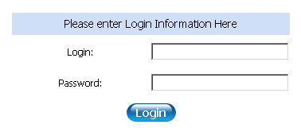
Figure 1-4. Admin site: Login

IV.1.2. Main menu
Main menu is a guide to the different components within the Admin site (Figure 2-4).
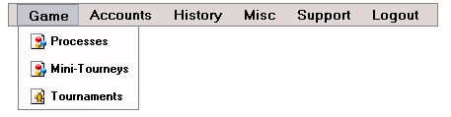
Figure 2-4. Admin site: Main Menu
The admin site contains several components:
- Game
- Accounts
- History
- Misc
- Support
- Logout
Game menu
The Game menu provides information about the game processes (poker tables) and tournaments that run within the system. It includes three different drop-down menu items –Processes, Mini-Tourneys and Tournaments.
The Processes menu item allows the system administrator to view the Process List (see Figure 3-4). This Process List contains information about the processes (poker tables) within the system.
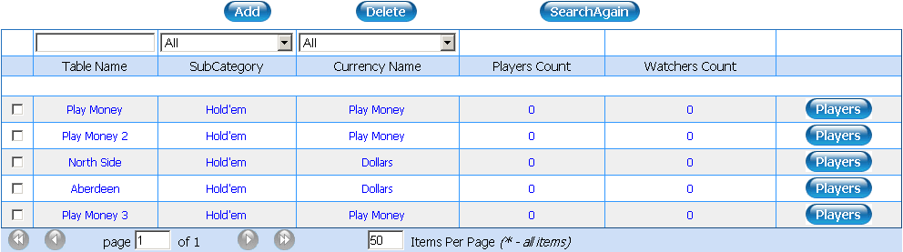
Figure 3-4. Admin site: Process List
If the system administrator wishes to add a new process to the list, they can do so by clicking on the Add button(Figure 3-4). The properties to select from when creating a new table will be displayed in a new window (Figure 4-4). The admin will then enter in the new table name, choose the Engine, Currency and Category for the table, and set the properties for the table. Clicking on the Save button will save the changes and create a new table within the processes list.
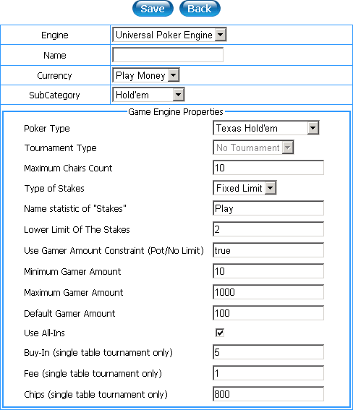
Figure 4-4. Admin-site: New Table Properties
To review the existing properties for a table, click on the table name within the “Table Name” column (Figure 3-4). In case a table crashes, the sys admin can reinstate the process (table) by clicking on the reknit button within the properties for the table.
It is also possible to review the players who have played at a table. The system admin can do this by clicking on the Players button opposite the table name (process). The system admin can also change the status or moderate the capabilities of players within the Users maintenance list (Figure 5-4).

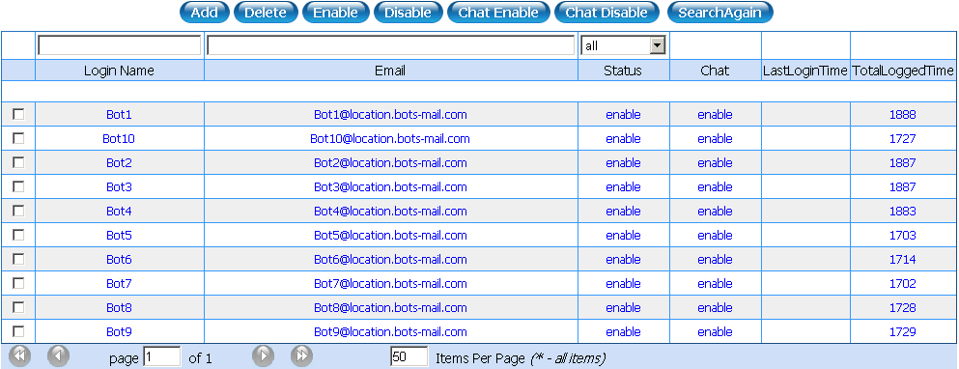
Figure 5-4. Admin -site: Users Maintenance List
Players can be enabled/disabled by the system administrator. For instance, they can enable/disable chat for a selected player if the player’s correspondence does not agree with the rules posted on the game site. In extraordinary cases a player can be kicked out of a game (using the delete button).
The system administrator can send the message to a selected player or to all players. To do this, administrator should to enter in the text within the Sending Message field. Then admin should to click on the Send message button to send the message to one of the players, or to the Send message to All, if the message might be sent to all players (Figure 6-4).
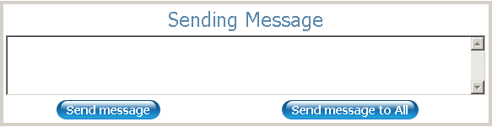
Figure 6-4. Admin site: Sending Message
The Mini-Tourneys menu when clicked will display the mini-tournaments list, which includes information about mini-tourneys and their control functions.
The Tournament menu lets the system admin maintain and administrate tournament play. Information about tournaments is displayed in the Tournament list (Figure 7-4). The system admin can add/delete tournaments within this menu as desired.
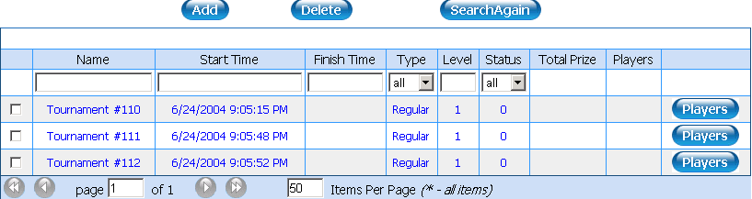
Figure 7-4. Admin site: Tournament List
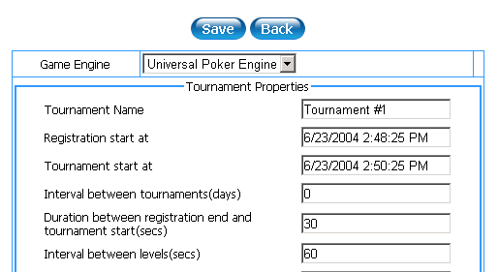
If the system admin wishes to add a new tournament, this can be done by clicking on Add. This will cause the New Tournament properties page to be displayed, within which the admin can select the game engine, create a name for the new tournament and change any other tournament properties. Clicking on the Save button saves these changes, and adds the new tournament to the Tournament List, which can be viewed by clicking on the Back button (Figure 9-3).
Figure 8-4. Admin site: Adding New Tournament
Clicking on a tournament name within the Name column will display its properties (Figure 7-4). The admin can change the prizes list for an existing tournament within the list by going to its properties and clicking on the Prizes button (Figure 9-4).
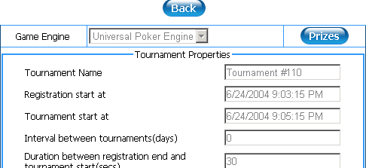
Figure 9-4. Admin site: Properties for an Existing Tournament
Clicking on prizes will cause the Tournament Prize Template to appear. The rows within this template describe the location numbers, while the columns describe the players’ numbers, and the cells describe the prize amounts for a selected location <row> when the players within the corresponding column have played.
A new row or column can be added by clicking on the radiobox within the first row or column, then clicking on the Add button.
Changes to prize amounts and categories can be saved by clicking on the Save button.
It is possible to use a Prize template for setting up the prize structures. The admin can do so by clicking the Copy button and selecting the template they wish to use. (Figure 10-4).
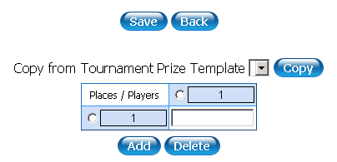
Figure 10-4. Admin site: Tournament prize template
Accounts menu
The Accounts menu contains information about the players (users). It includes two menu items: Users and Add User.
The Users menu item lets the admin manage the user (player) list. The User list also contains scrolled info at the bottom of the list.
The admin can add a user or view/edit the existing user data within this menu (Figure 11-4).
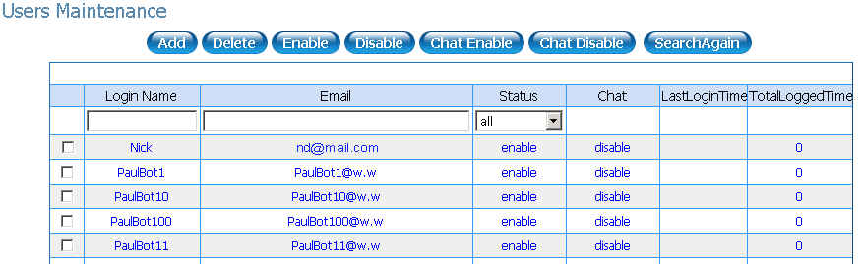
Figure 11-4. Admin site: User List
To add a new user, click on the Add button within User list. Enter the user data and click the Save button (Figure 12-4).
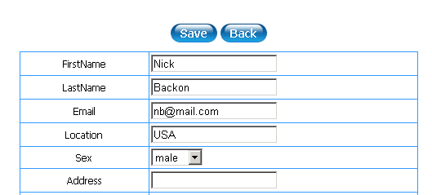
Figure 12-4. Admin site: Adding a New User
To view/edit existing data for a player, click on their name within the user list. Changes can be saved by clicking on the Save button. To view the current User account for a player, click on the User Account button. This will cause the user account page to be displayed, and the admin can then select the currency type to view the corresponding user account information. The admin can also add/remove funds within the user balance (Figure 13-4).)
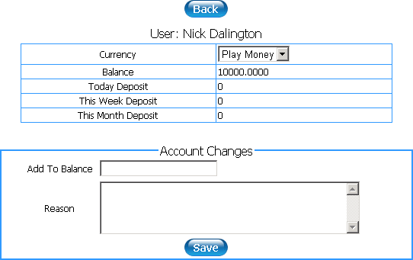
Figure 13-4. Admin site: User Account Page
The Add user menu item adds a new user to the list.
In a similar manner to the process list, the system admin can enable/disable existing users, or enable/disable chat for selected users (Figure 11-4). To do so, they must first select a user or group of users, then checking the desired action within the checkbox.
Administrator can send message to a selected user or to all users (Figure 6-4).
History menu
The History menu describes all transactions that occur within the system. It also provides information about games played by users (players) within the system.
Clicking on the Transactions menu will take the admin to the Transactions list, which displays all transactions conducted. Transactions can be viewed in more detail by clicking on a selected user name.
The selected user’s transaction details will include information about the amount, date and type of transactions which have occurred. It also supplies information about the hand that was finished when the transaction occurred (game log) (Figure 14-4).
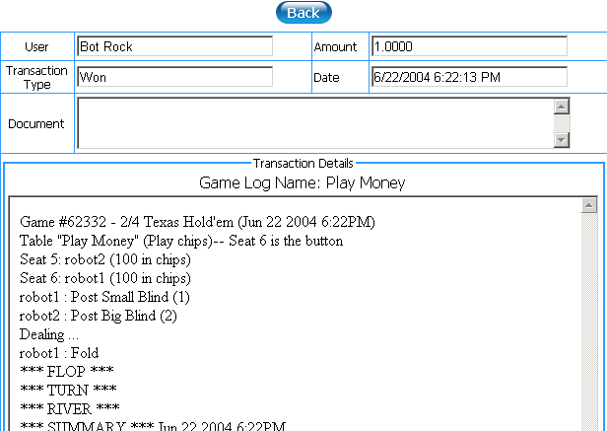
Figure 14-4. Admin site: Transaction Details
The Games menu lets the admin view the list of games that are being played.
The User Games menu lets the admin view the games being played by individual Users.
The admin can send a request for the game log for either kind of game menu by clicking on a name within the list (Figure 16-3).

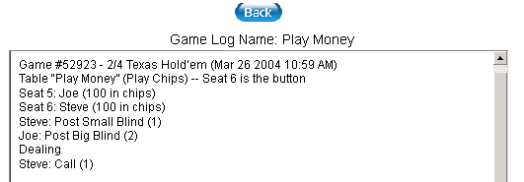
Figure 15-4. Admin site: Game Log Page
Misc menu
The Misc menu consists of several parts.
The Category list menu will take the system admin to the category list that first appears when logging in (Figure 16-4). This list includes information about the different available kinds of poker categories. The system admin can do the following within this area:
- Add a new category
- Delete an existing category
- Edit an existing category
- Delete/enable/disable items or a group of items from within the list
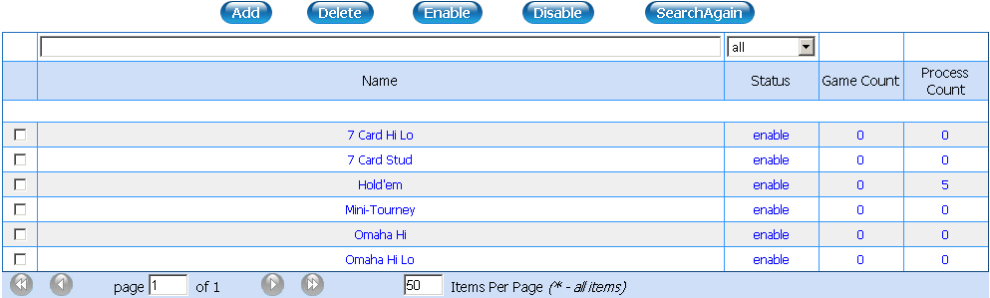
Figure 16-4. Admin site: Category List
Clicking on the Add button adds a new category. The admin can then enter in the category properties into the appropriate fields. Clicking the Save button saves the category data, and adds it to the category list, which can be viewed by clicking on the Back button. (Figure 17-4)

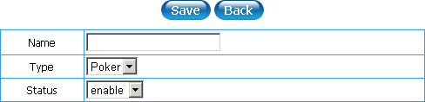
Figure 17-4. Admin site: Adding a New Category
Selecting a category (by checking the box next to it), then clicking on the Delete button will delete an existing category.
The admin can edit an existing category by clicking on the category title within the category list. This will display the statistics list for that category from within the client application Lobby window. The admin can view the different lists and select from it for each category. This feature lets the admin add or delete statistics, and to change the order for the statistics display within the selected list. (Figure 18-4)
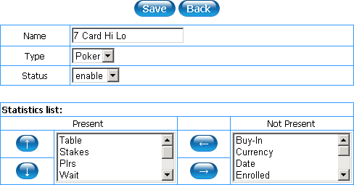
Figure 18-4. Admin site: Statistics List
To delete/enable/disable items or a group of items within a category list, first check the box to the left of the list.
At the bottom of each category list there are navigation buttons and options. After changing the filter or navigation options the admin can refresh the page by clicking on the SearchAgain button.
Clicking on the Affiliate List menu will display the Affiliate list page. The admin can add new affiliates by clicking on the Add button or they can view/edit the existing affiliates by clicking on the appropriative row. Affiliates can be deleted by checking the box next to their name, then clicking on the Delete button.
Administrator can report an affiliates. To do this admin should to select Affiliate Reports menu. Then the following page will be displayed:

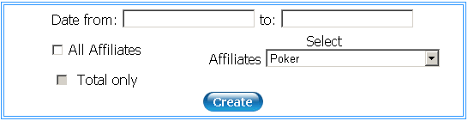
Figure 19-4. Admin site: Affiliate Reports
It is necessary to enter in the report date to generate the affiliate reports. Report can include all affiliates (by checking the All Affiliates box) or the selected affiliate (by selecting needed affiliate from the drop-down list within the Affiliates field). Checking the Total only box cause the total reporting. Clicking on the Create button will generate the report.
The Games menu displays a list of the Game Engines (Figure 20-4).

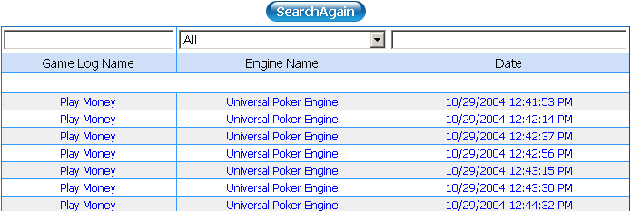
Figure 20-4. Admin site: Game Engines Page
Clicking on the Options menu will display the System options page. This page includes following options which can be edited:
- The total money amounts which can be transferred into a user’s account: this includes the minimum deposits which can be made, the maximum deposits which can be made within a 24-hour period, the maximum deposits which can be made within a week, or during a month
- The Admin email address
- The Support email address
- The URL for the Simple Mail Transfer Protocol server
- The number of all-ins permitted in a 24-hour period, with a count of all-ins per day. This option is intended to help prevent cheating by players
- Game limits: Tournament Limit limits the number of tournaments which can occur simultaneously; Process Limit limits the number of processes (games) which can occur at one time; Tournament Table Limit limits the number of enabled tournament tables; and Record Hand Limit limits the number of hands that may be recorded by an individual player.
The Tournament Prize Template menu includes templates for dispersing tournament prizes which can be used when setting up tournaments.
The Email Templates menu displays the available email templates, which include:
- A Congratulations email
- A Customer support email template
- A Customer support confirmation email
- A generic email template
- A Qualified money player ID email
- A Welcome email
- A notification of account information
- An email address and account validation email.
The administrator can edit and modify these emails to include the correct information.
The Client Application Files menu displays the list of files needed by the client application for proper running, which are automatically checked and downloaded during client connection to the server. Those files are included within the installer that new players download.
The Allowed IP menu displays the list of IP addresses that are allowed to enter the system.
The Report User menu displays the user report, which can be filtered by the administrator.
The Support menu includes only one menu item –the Customer Request List. This list contains information and support requests received from users, including claims, propositions, etc.
The Logout menu lets the system administrator finish their current session and logout from the Admin site.

IV.2. Desktop Admin
The Desktop Admin is a desktop application that allows the system administrator to manage the Poker System. The Desktop Admin lets the system admin configure the system on the server, and to operate the different game processes.
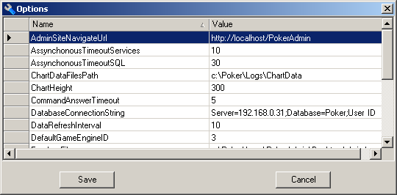
Administrator can to set Desktop Admin options, such as Admin site navigate URL, Data base connection string, Log path etc. To change the options the sys admin should to click on Options above the main menu. The Options window will pop up then:

Figure 21-4. Desktop Admin: Options
Clicking on the Save button will cause the options saving. Clicking on the Cancel will cancel saving.

IV.2.1. Users
The system administrator can operate users of Laguna Poker. To administrate users admin should to click on the Users icon within the main menu. The Desktop Admin will display users area of administration.
At the center of window are located Client's history of connections. It displays the ratio of active users' number (the number of users who are in the process now) to registered users' number (the number of users who are registered but are not in the process). To the left of the client's history of connections there are the info about users: numbers of connected, logged, not logged, registered users (Figure 22-4).
Administrator can manage users' connections. Clicking on the Enable All button cause the enabling of all users' connections.
When clicking on Disable New, connection becomes disabled for all users who are not been connected yet. In this case the sys admin will be asked to confirm the selected action.
To off the connections, admin should to click on Disable All and confirm the action.
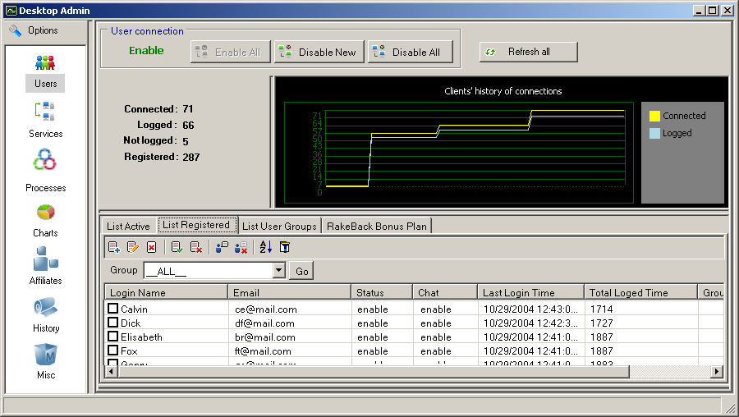
List Registered is the list of all registered users. To administrate or review registered users (players) the sys admin should to click on the List Registered bookmark (Figure 22-4).
Figure 22-4. Desktop Admin: Users, List Registered
All registered users are divided in the several groups (default, excellent, hight and VIP). List Registered can display all groups or one of the groups with the help of the filter. The filter is located above the list. To set the filter on the group admin should to select the group from the drop-down list within the Group field and then click on Go.
The admin can add a user or view/edit the existing user data within this menu.
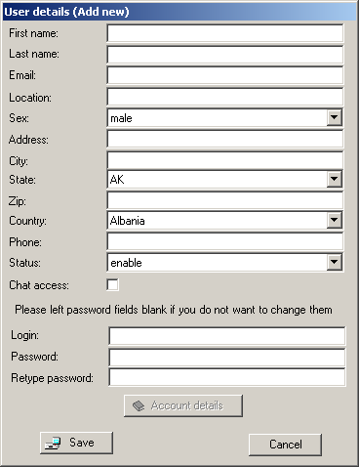
To add a new user, admin should to click on (Figure 22-4). The Desktop Admin will display User details (Add new) window (Figure 23-4).
Figure 23-4. Desktop Admin: User Details (Add New)
Then system administrator should to enter the user data and click the Save button (Figure 23-4).
To view/edit existing data for a player, click on (Figure 22-4). This will cause the current user details editing (Figure 24-4).
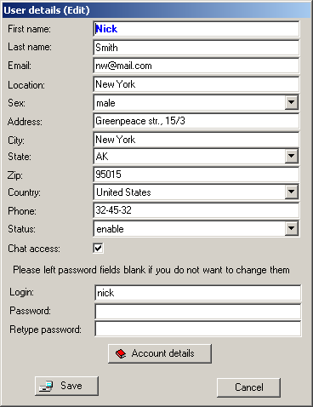
Figure 24-4. Desktop Admin: User Details (Edit)
Changes can be saved by clicking on the Save button. To view the current Account details for a player, admin should to click on the Account details button. This will cause the user's account details to be displayed, and the admin can then select the currency type to view the corresponding user account information. The admin can also add/remove funds within the user balance (Figure 25-4).)
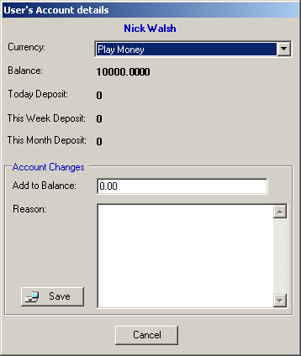
Figure 25-4. Desktop Admin: User's Account Details
Clicking on the Save button will cause user's account details saving.
Deletion the selected user (users) realized with following actions. The sys admin should to select users to be deleted (by checking the boxes to the left of user login name) and then click on (Figure 22-4). After this, admin will be asked to confirm the deletion.
Players can be enabled/disabled by the system administrator. This can be achieved by the checking users to be enabled/disabled and then by the clicking on:
- to enable the selected users;
- to disable the selected users.
They also can enable/disable chat for a selected user if the user's correspondence does not agree with the rules posted on the game site. To do this users should be checked in the appropriative boxes, then the sys admin should to click on:
- to enable chat for the selected users;
- to disable chat foe the selected users.
System administrator can change sort order within the List Registered for handy working by clicking on
The rows within List Registered can be filtered. To filter rows admin should to click on . Then Filter window will pop up:

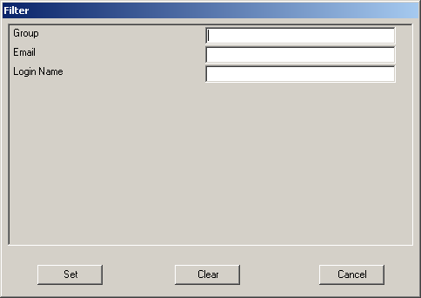
Figure 26-4. Desktop Admin: User Filter
System administrator should to fill in Group, Email and Login Name fields. Clicking on the Set button will cause selecting rows, which contains strings from these fields. Clicking on Clear will clear the fields and thus cancel the filtering.
List Active is the list of active users. In other words, it is the list of users (players) who have played at a table. To review this users the system admin should to click on the List Active bookmark (Figure 26-4).
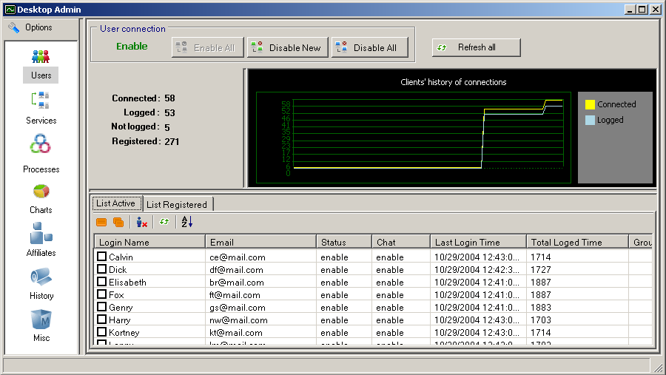
Figure 26-4. Desktop Admin: List Active
The system administrator can send the message to the selected active users or to all active users. To send message to the selected users, it is necessary to check the appropriative boxes to the left of the user's login names and to click on (Figure 26-4).
To send message to all active users, admin should to click on (Figure 26-4).
Within the displayed window admin should to enter in the text of a message and click on Send.
In extraordinary cases users can be kicked out of a game (by selecting them from the list and then clicking on ) (Figure 26-4).
Auto refresh data can be allowed/disallowed by clicking on .
Sort order changing can be caused in a similar manner to the List Registered.
Clicking on the List User Groups bookmark will display the list at the bottom of the window (Figure 27-4)
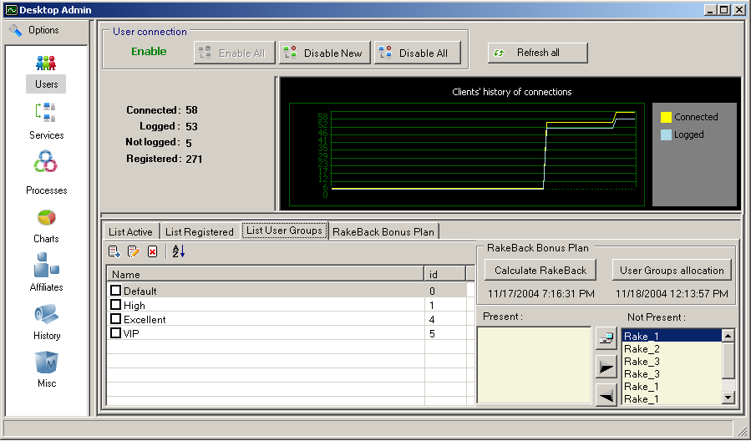
Figure 27-4. Desktop Admin: List User Groups
List User Groups contains group name and group ID. System admin can add a new group, edit the existing group and delete group(s) from this list. Sort order within the list can be changed.
To the right of the list there is the RakeBack Bonus Plan. Admin can calculate RakeBack, allocate User Groups and set a plan as present or not present.
To manage the RakeBack Bonus Plan admin should to select RakeBack Bonus Plan bookmark. At the bottom of the window the Bonus Plan properties will be dispalyed. (Figure 28-4)
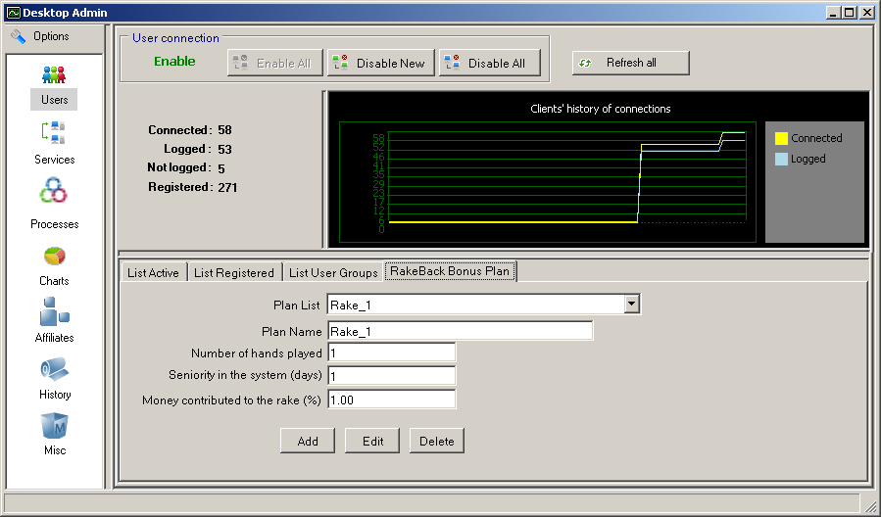
Figure 28-4. Desktop Admin: RakeBack Bonus Plan
System administrator can add a new plan, edit the existing plan or delete plan (Add, Edit and Delete buttons).

IV.2.2. Services
From the Desktop Admin services administration can be realized. To navigate into the services administration area it is necessary to click on the Services icon within the main menu.
The application's window will display existing services and their describing. Info about existing service include service IP,description and status (running or stopped). The table displays service role (Figure 29-4).

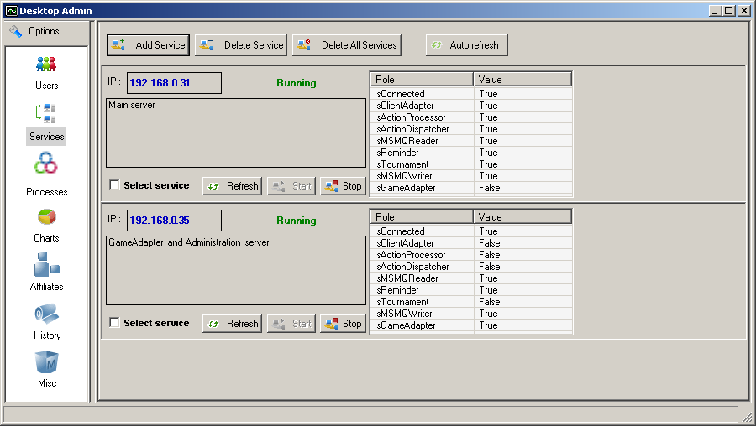
Figure 30-4. Desktop Admin: Services
The system administrator can change the status of the selected service by clicking on Start or Stop under the needed service's info.
Data refreshing can be automatic (for all services) or manual (individual for the selected service). Clicking on Auto Refresh will cause automatic data refreshing. To refresh data for the selected service sys admin should to click on the Refresh button under the needed service's info.
If the system admin wishes to add a new service, this can be done by clicking on Add Service. This will cause the Add service window to be displayed, within which the admin can enter in the machine IP and it's description (Figure 31-4). Clicking on the Add button and confirming the action will create a new service.
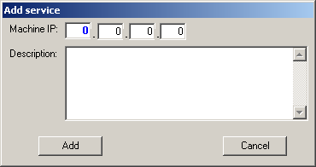
Figure 31-4. Desktop Admin: Adding New Service
Deletion of the selected service can be caused by following actions:
- Selecting the needed service by checking the appropriative box;
- Clicking on Delete Service at the top of the window;
- Confirmation of selected action.
(Figure 30-4)
If the sys admin wish to delete all services, this can be achieved by clicking on the Delete All Services button and further action confirmation.

IV.2.3. Processes
Process management can be realized within the processes administration area. To navigate this area admin should to click on Processes icon within the main menu at the left of Desktop Admin window. Processes administration area provides information about the game processes (poker tables) and tournaments that run within the system (Figure 32-4).
All processes have a status. Processes can be running, paused or stopped. The sys admin can change the processes status by clicking on the Run, Pause or Stop buttons (which are located at the top of the window) and further confirmation of selected action (Figure 32-4).
Refreshing the processes data can be automatically (for active processes) or manual (for all processes). Clicking on Auto refresh Active will cause the automatic data refreshing, whereas clicking on the Refresh all will cause a single data refreshing for all processes.
All processes divides into three groups: processes, mini-tourneys and tournaments. Administration of these processes admin realize separately.
Administrator also can review info about current processes that are active within the system by selecting Active bookmark (Figure 32-4).
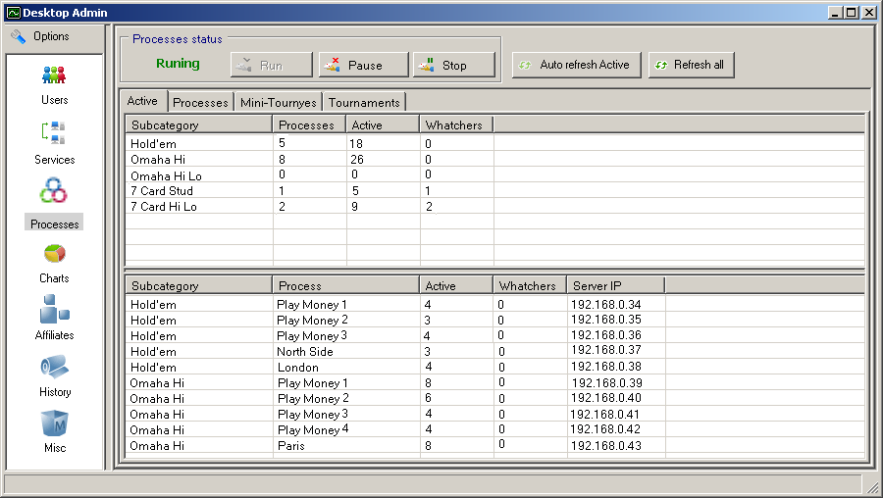
Figure 32-4. Desktop Admin: Active Processes
After clicking on this bookmark, window will display two tables.
The first table include information about active processes sorted by the subcategories. In other words, this table contains the number of processes, active users (players) at all processes number and watchers number for every subcategory.
The second table is located at the bottom of the Desktop Admin window. It will display more detailed info about active processes: process name, subcategory name, number of active users, watchers number and server IP.
All processes, not only active, become available for the administrator after clicking on the Processes bookmark. When sys admin select the Processes, they can to manage the processes and review the information about the processes (Figure 33-4).
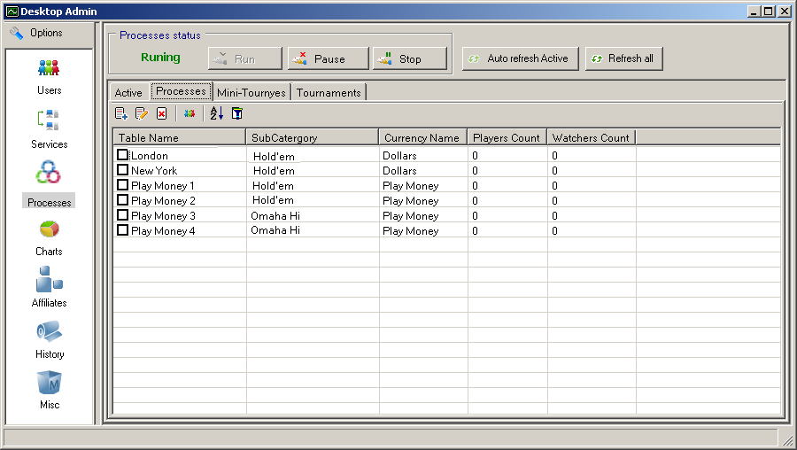
Figure 33-4. Desktop Admin: Processes
If the system administrator wishes to add a new process to the list, they can do so by clicking
on (Figure 33-4). The properties to select from when creating a new process will be displayed in a new window. The admin will then enter in the new process name, choose the Engine, Currency and Category for the process, and set the properties for the process. Clicking on the Save button will save the changes and create a new process within the processes list.
To edit the existing properties for a process, click on (Figure 33-4).This will cause current process properties editing. After changing properties, admin should to click on Save.
Deletion the selected process (processes) realized with following actions. The sys admin should to select processes to be deleted (by checking the boxes to the left of user login name) and then
click on (Figure 33-4). After this, admin will be asked to confirm the deletion.
It is also possible to review information about th users who have played at a table. The system admin can do this by clicking on (Figure 33-4). The system admin can also change the status or moderate the capabilities of users
System administrator can change sort order within the Processes List for handy working by clicking on
The rows within Processes can be filtered. To filter rows admin should to click on .Then Filter window will pop up:
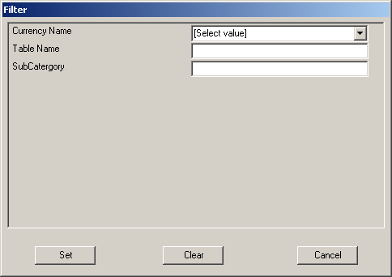
Figure 34-4. Desktop Admin: Processes Filtering
System administrator should to select Currency Name (Play Money or Dollars), and then to fill in the Table Name and SubCategory fields. Clicking on the Set button will cause selecting rows, which contains strings from these fields. Clicking on Clear will clear the fields and thus cancel the filtering.
The Mini-Tourneys bookmark when clicked will display the Mini-tournaments list, which includes information about mini-tourneys and their control functions.
The Tournament bookmark lets the system admin maintain and administrate tournament play. Information about tournaments is displayed in the Tournament list (Figure 35-4).

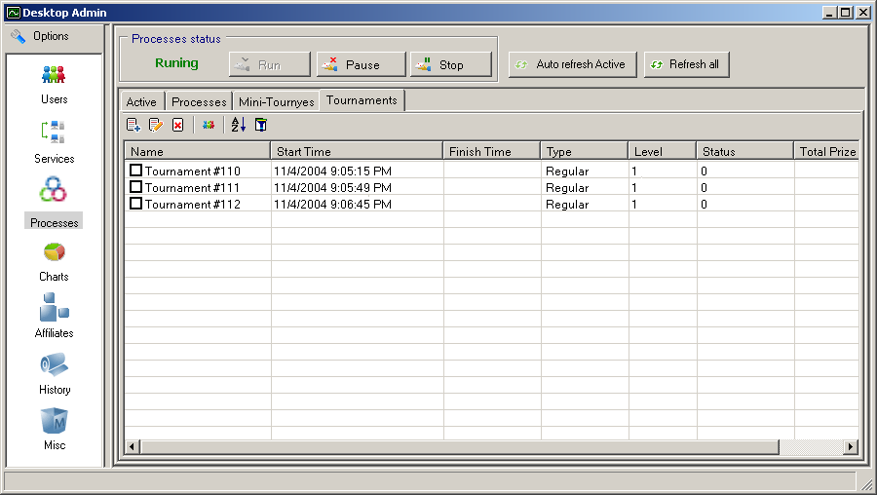
Figure 35-4. Desktop Admin: Tournaments
Adding, editing, deletion, users info reviewing, changing sort order and filtering rows can be accomplished in the same manner like for the processes.

IV.2.4. Affiliates
Clicking on the Affiliates icon within the main menu will display the Affiliate list (Figure 36-4).
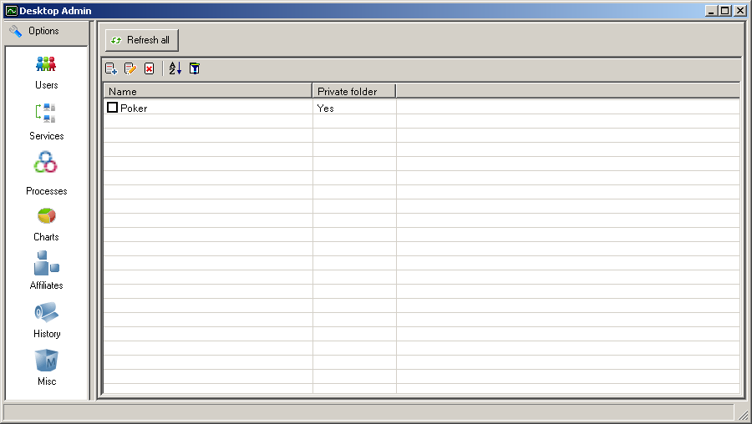
Figure 36-4. Desktop Admin: Affiliates
The admin can add new affiliate by clicking on . Then affiliate name should be entered in the appeared window . Clicking on the Save button adds new affiliate to the Affiliate list.
To edit the existing properties for a affiliate, sys admin should to click on . This will cause current affiliate properties editing. Admin can edit affiliate name and poker email address to the selected affiliate (Figure 37-4).
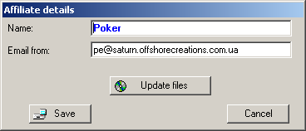
Figure 37-4. Desktop Admin: Affiliate Details
If the system administrator wishes to update files for the selected affiliate, it can be doing by the clicking on the Update files button. This will cause client file details editing (Figure 38-4).
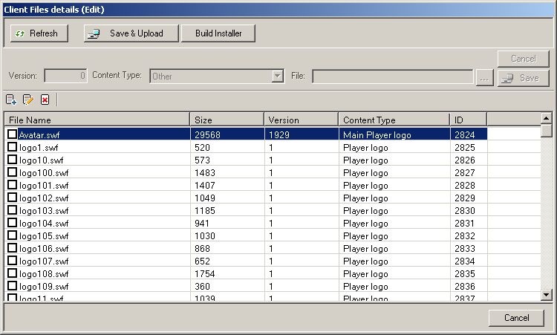
Figure 38-4. Desktop Admin: Client File Details (Edit)
Administrator can add, edit or delete files within the Client files details list.
To add a new file in the list, admin should to click on . Then at the top of he window he should to fill in the Version field, select the file's Content Type and choose the file to be added. Clicking on the Save button will save the new file in the list.
If they needs to edit current file properties, it can be doing by clicking on the . When admin makes changes, he should to click on Save.
Deletion files realized by selecting files to be deleted and clicking on . The system will ask to confirm the deletion.
When Client file details list is edited, admin can save and upload it by clicking on the Save&Upload button. Installer building is caused by clicking on the Build Installer button. Clicking on Cancel will return to the affiliate details editing (Figure 37-4). Clicking on Save within the Affiliate Details (Edit) window will save changes of this affiliate and close the window.
Deletion the selected affiliate or a group of affiliates can be realized with following actions. The sys admin should to select affiliates to be deleted (by checking the boxes to the left of affiliate name) and then click on (Figure 36-4). After this, admin will be asked to confirm the deletion. Clicking on Yes will delete the affiliate (affiliates) from the list.
System administrator can change sort order within the Affiliate list for handy working by clicking on .
The rows within Affiliates can be filtered. To filter rows admin should to click on .Then Filter window will pop up. System administrator should to enter in the affiliate name within the Name field. Clicking on the Set button will cause selecting rows, which contains strings from this field. Clicking on Clear will clear the field and thus cancel the filtering.
Data refreshing can be caused by clicking on Refresh All.

IV.2.5. Charts
The system administrator can to compile charts within the Desktop Admin. Clicking on Charts icon from the main menu will cause the Charts administration area appearance.
To add a new chart sys admin should to click on the Add Chart button at the top of the window. (Figure 39-4)
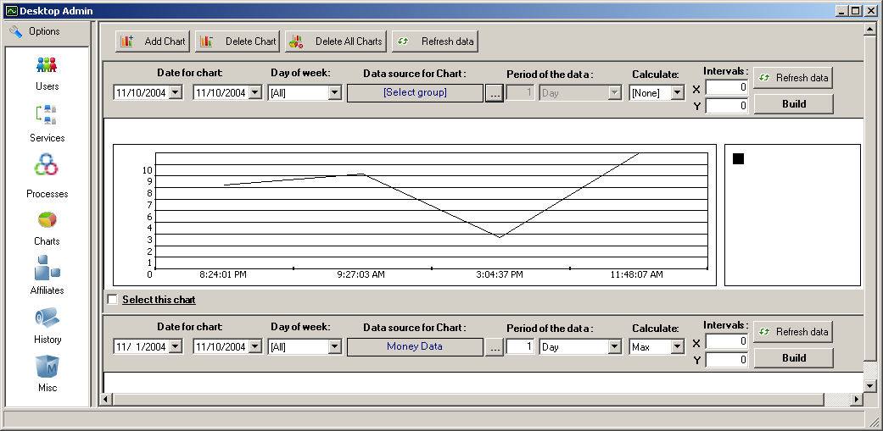
Figure 36-4. Desktop Admin: Charts
To compile the chart it is for admin to:
- Indicate the date for chart.
- Select the day of week to be included in a chart.
- Select data source for chart. To do this admin should to perform following steps.
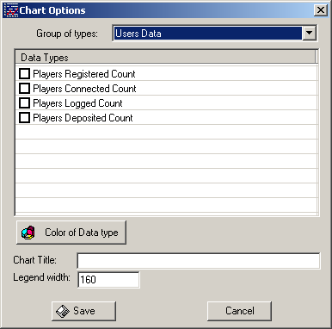
- Click on ... within the Data source for Chart field. The Chart Options window will pop up (Figure 40-4).
Figure 40-4. Desktop Admin: Chart Options
- Within the Group of types field there is a drop-down list. This list include such groups as Users Data, Processes Data, Tournaments Data and Money Data. Admin should to select one of the groups.
- Then the data types will appear within the Data Types list. Checking the box to the left of data type will include this type into the chart.
- Click on the Color of Data type button. This lets the system administrator to select color of data type in the chart.
- Infill the Chart Title and Legend width fields.
- Click on Save to save chart options.
- Select period of the data, what is necessary to calculate (maximal number, minimal number, or average) and intervals for X and Y.
- Clicking on the Build button will cause the chart's compiling. The chart will be displayed within the window.
Clicking on Refresh data button will refresh the data for the selected chart or for all charts and displays any data changes.
To delete chart or a group of charts admin should to check the box/boxes within the Select this chart field and then click on Delete Chart. Clicking on Delete All Charts will delete all charts.

IV.2.6. History
The History menu describes all transactions that occur within the system. It also provides information about games played by users (players) within the system. (Figure 41-4).
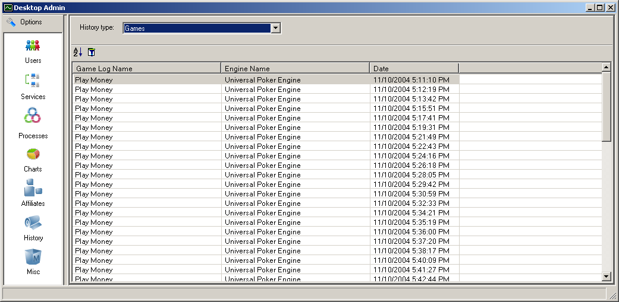
Figure 41-4. Desktop Admin: Games History
Clicking on the History icon will take the admin to the this section of administration. There are several history types: Transactions, Games and User Games. Selecting one of these types from the drop-down list within the History type field will display an appropriative list.
- Transactions list displays all transactions conducted. Info about transactions include user name, transaction type, amount of transaction and contract date.
- Games list lets the admin view the list of games that are being played. The list contains game log name, engine name and date of the game.
- User Games list lets the admin view the games being played by individual users and info about the games. Games info contains user name, game log name, game engine name and date of the game.
Changing sort order can be accomplished by clicking on .
To filter rows from the list admin should to click on . Then within the Filter window system administrator should to enter in the info within a given fields. Filtering will be based on this info. Information differ for each history type. For Transactions it is User Name and Transaction Type, for Games info for filtering include Engine Name and Game Log Name, and for User Games info fills within the User Name, Engine Name and Game Log Name fields.
Clicking on the Set button will cause rows filtering. Clicking on Clear will clear the fields and thus cancel the filtering.

IV.2.7. Misc
Misc menu consist of several different parts. Clicking on Misc icon within the main menu will navigate to this section of administration area.
Clicking on the Options bookmark will display the system options (Figure 42-4).
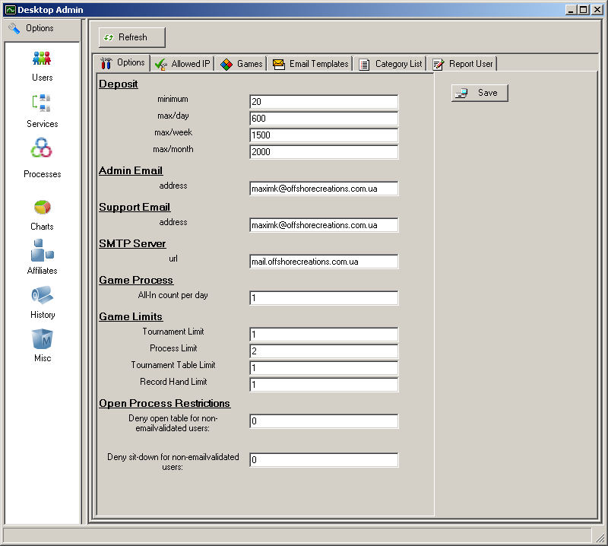
Figure 42-4. Desktop Admin: System Options
The system options includes following options which can be edited:
- The total money amounts which can be transferred into a user’s account: this includes the minimum deposits which can be made, the maximum deposits which can be made within a 24-hour period, the maximum deposits which can be made within a week, or during a month
- The Admin email address
- The Support email address
- The URL for the Simple Mail Transfer Protocol server
- The number of all-ins permitted in a 24-hour period, with a count of all-ins per day. This option is intended to help prevent cheating by players
- Game limits: Tournament Limit limits the number of tournaments which can occur simultaneously; Process Limit limits the number of processes (games) which can occur at one time; Tournament Table Limit limits the number of enabled tournament tables; and Record Hand Limit limits the number of hands that may be recorded by an individual player.
Clicking on the Allowed IP bookmark will cause the list of allowed IP appearance (Figure 43-4).
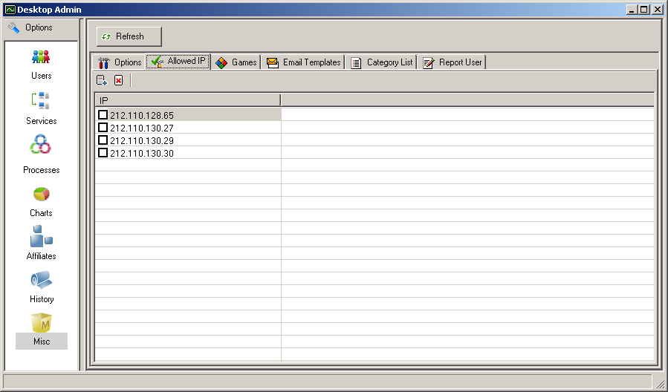
Figure 43-4. Desktop Admin: Allowed IP
IP can be added or deleted by the system administrator.
Clicking on Games bookmark will cause the Game Engine list appearance. (Figure 44-4)

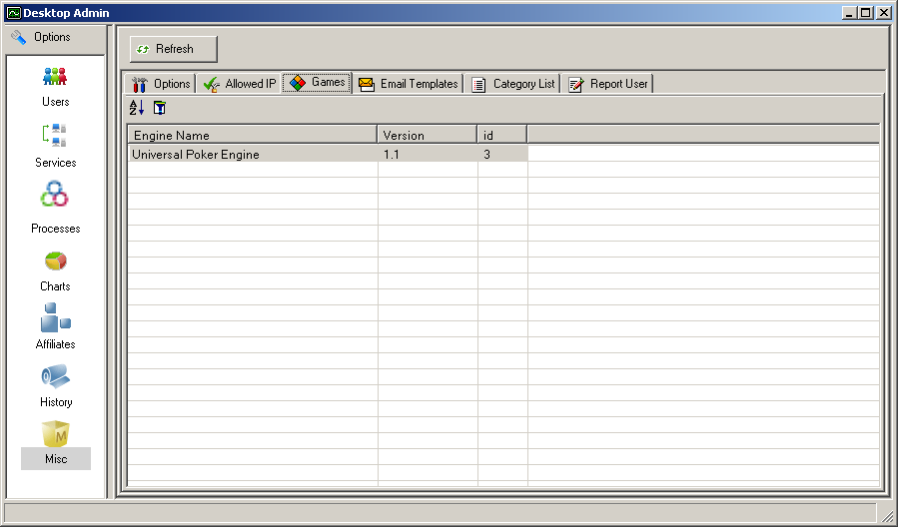
Figure 44-4. Desktop Admin: Game Engine List
Clicking on Email Templates bookmark will display the available email templates, which include:
- A Congratulations email
- A Customer support email template
- A Customer support confirmation email
- A generic email template
- A Qualified money player ID email
- A Welcome email
- A notification of account information
- An email address and account validation email.
The administrator can edit and modify these emails to include the correct information. (Figure 45-4)

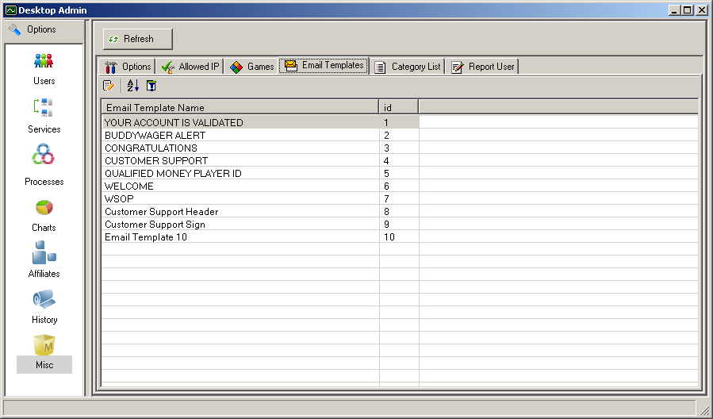
Figure 45-4. Desktop Admin: Email Templates
Clicking on the Category List bookmark will take the system admin to the Category List. (Figure 46-4).
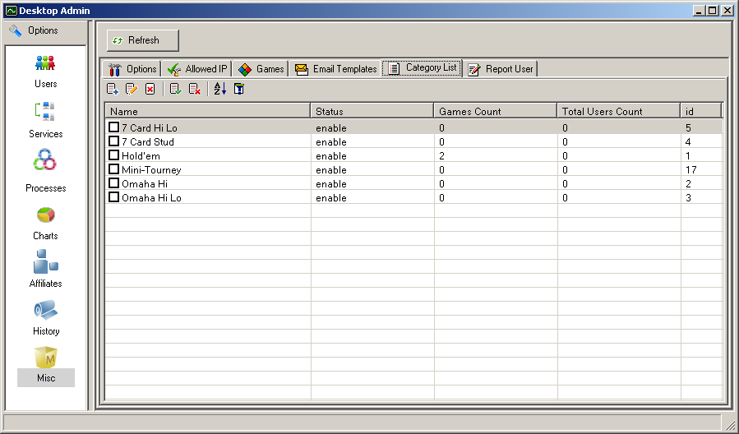
Figure 46-4. Desltop Admin: Category List
This list includes information about the different available kinds of poker categories. The system admin can do the following within this area:
- Add a new category.
- Edit an existing category.
- Delete/enable/disable items or a group of items from within the list.
- Change sort order within the list.
- Filter rows in this list.
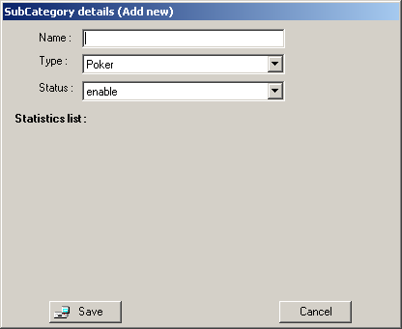
Clicking on adds a new category. The admin can then enter in the category properties into the appropriate fields. Clicking the Save button saves the category data, and adds it to the Category List. (Figure 47-4)
Figure 47-4. Desktop Admin: Adding a New Category
The admin can edit an existing category by clicking on . This will display the statistics list for the current category. The admin can view the different lists and select from it for each category. This feature lets the admin add or delete statistics, and to change the order for the statistics display within the selected list. (Figure 48-4)
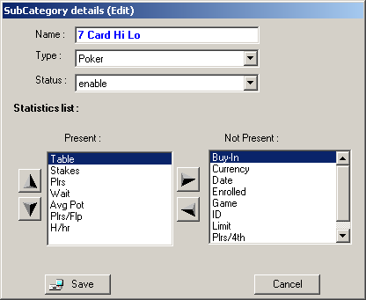
Figure 48-4. Desktop Admin: Statistics List
Selecting a category (by checking the box next to it), then clicking on the will delete an existing category. Desktop application needs to confirm the deletion.
To enable/disable items or a group of items within a category list, first check the box to the left of the list. Then click on to enable items or on to disable items.
Clicking on cause changing sort order within the Category List.
Sys admin can filter rows within the list by clicking on . Administrator should to fill in the Name field. Clicking on the Set button will cause selecting rows, which contains strings from this field. Clicking on Clear will clear the field and thus cancel the filtering.
Admin can report users. This can be achieved by selecting Report User bookmark (Figure 49-4).
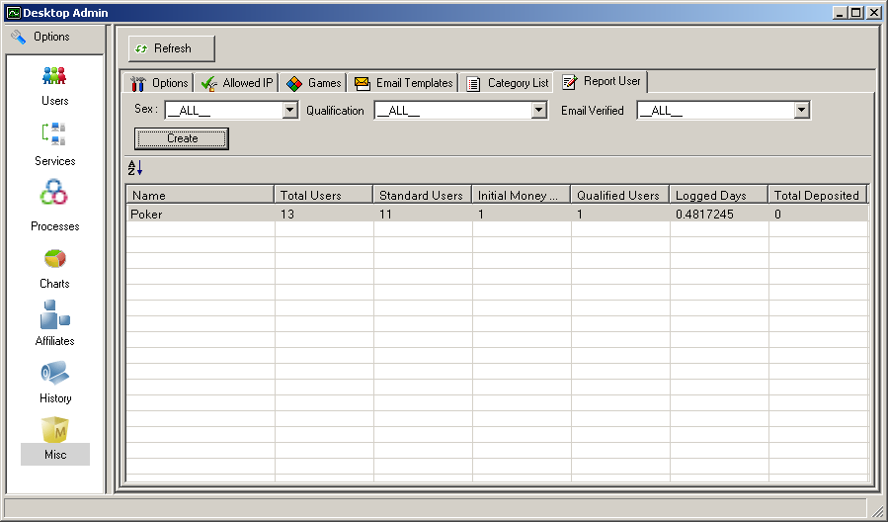
Figure 49-4. Desktop Admin: Report User
Administator can include users in the report filtered by diferent parameters: user sex, qualification and verification of user email. Admin should to set the filter and click on Create to create the report.
Data refreshing can be accomplished by clicking on the Refresh button. This will display modified data within the window.

