RoboPoker
RoboPoker is the application that allows generating of intellect imitation for the Poker Excellence. Application is intended for system administrators.
Intellect imitation is represented by bots. Admin can generate bots and manage game process. Settings of bots may be calculated by the system or initiated by system administrator.

1. RoboPoker Lobby
The lobby window is the first window you will see once the program is loaded and opened. RoboPoker lobby window displays info about bots (Figure 1-1).
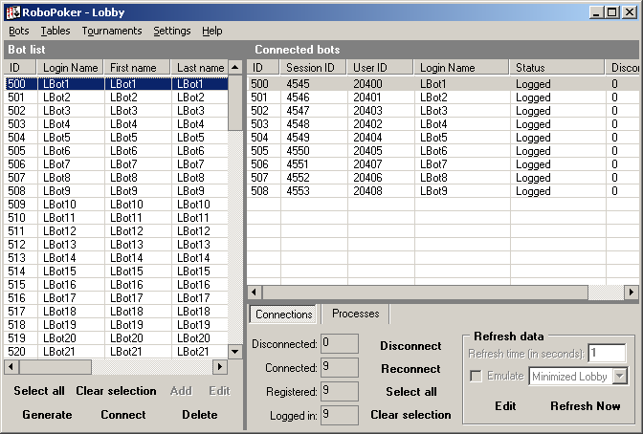
Figure 1-1. RoboPoker: Lobby, Connections
In the left of lobby window there is a Bot list. All existing bots contains within the list. Bot list include bots' IDs, Login names, First names and Last names.
Bots can be generated by clicking on the Generate button. Then the Bot generation window will appear (Figure 2-1).
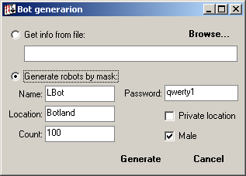
Figure 2-1. RoboPoker: Bot Generation
When bots generation, admin can get info about bots from file or generate bots by mask. Sys admin should to select the way he prefers by clicking on the appropriative radio button.
If bots info will be retrieved from the file, enter in the file path or select the file with the help of browser (Browse button).
If all bots will be generated by mask, enter in bots' name, password and location within the Name, Password and Location fields. Then indicate the number of bots to be created within the Count field. Check the Male box if bots will have male sex. Checking the Private location box will cause concealment of bots location. If the box is not checked, bots location will be displayed within the Poker Excellence Lobby.
Clicking on Generate will generate the bots. To cancel generation, click on Cancel.
For selection of all bots from the list you should to click on Select all. To clear any bots selection click on Clear selection.
To delete an existing bots, administrator should to select bot or group of bots and then to click on Delete. Note: RoboPoker don't require confirming of the deletion.
Bots connection can be realized by clicking on the Connect button at the bottom of the list. Then selected bots will be connected and moved into the Connected bots list (right section of a window). The list includes info about connected bots: bot ID, session ID, user ID, login name, status and disconnects.
Clicking on the Connections bookmark makes available to control the connections and to review info about connections. Admin can disconnect the selected bots by clicking on the Disconnect button. To reconnect the bots they should click on Reconnect.
If administrator wish to refresh the data click on Refresh Now within the Refresh data field. The system executes automatic data refreshing. To edit settings of automatic data refreshing system administrator should to click on Edit within the Refresh data field. Then admin will be able to set refresh time. Checking the Emulate box will cause automatic refreshing of table info. Table info can be refreshed every 10 seconds (Active Lobby) or every 100 seconds (Minimized Lobby). Clicking on the Save button will cause saving changes.
To manage the processes admin should to click on the Processes bookmark. (Figure 3-1)
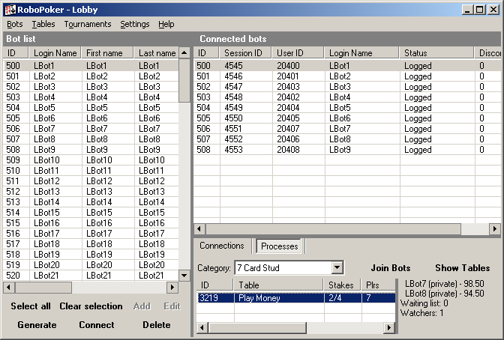
Figure 3-1. RoboPoker: Lobby, Processes
Within the Category field there is the drop-down list. When category is selected, the list at the bottom of the window displays all existing tables (processes) from this category. To the right of the list there is info about the selected table.
To join the bots to the table, admin should:
- Select bots to be joined from the Connected bots list;
- Select the table where bots will be joined;
- Click on Join Bots.
The Main Menu bar is located at the top of the lobby. Menu items include the commands for bots generation, viewing tables' and tournaments' lists and some other options.
Settings menu item lets the admin to set connect and auto-play settings for the RoboPoker. To change settings admin should to select this menu item from the main menu of the Lobby window. The Settings window will appear (see Figure 3-1). Clicking on the Edit button will cause settings editing. Admin can change the settings. On clicking Save button, that will appear instead of Edit button, settings will be saved and immediately applied.

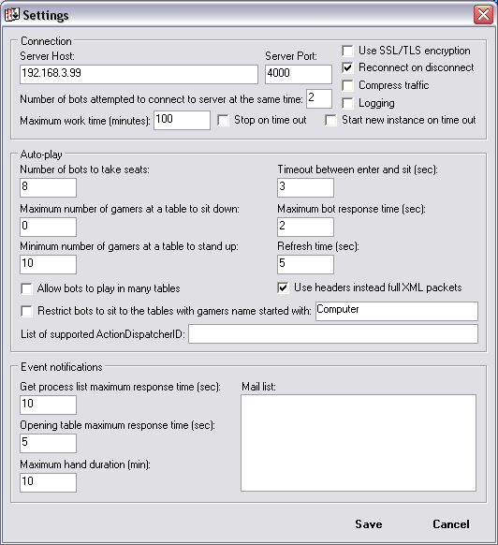
Figure 3-1. RoboPoker: Settings window

2. RoboPoker Tables
Admin can manage tables and bots' game at the tables. Clicking on the Show Tables button (Figure 3-1) will open the RoboPoker Tables window (Figure 1-2).
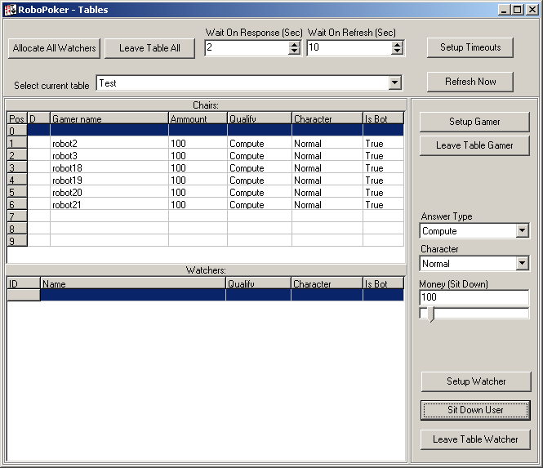
Figure 1-2. RoboPoker: Tables
Allocation of bots at the table
Bots which were joined to the table will be displayed within the Watchers list at the bottom of the window.
If you wish to allocate all watchers at the table, you should to click on Allocate All Watchers. This will allocate watchers at the table disorderly. All allocated bots will be displayed within the Chairs list. When the bots is allocated at the table, the game will start.
To allocate a selected bot on arbitrary free chair, select this bot from Watchers list and click on Sit Down User button to the right of the list.
When 30 seconds after bots joining is over, all bots are automatically sitting down at the chairs.
Bots settings
Within the right part of the window you can operate qualify of selected bot, its amount at the moment of a game beginning and set bots characteristic. To do this, select a bot from the list (this can be Watchers list or Chairs list). Then select qualify of a bot within Answer Type field (compute, cheater or random), bots Character (cautious, normal or aggressive). Moving the slider within the Money (Sit Down) field will cause chips amount changing.
After you set properties of a selected bot, you should setup this. If bot is a watcher, click on Setup Watcher button. In the case of bot is already in game, click on Setup Gamer.
Timeouts
Admin can to select pause between bots' answers. To do this they should to enter the time in seconds within the Wait On Response field. It is also possible to setup time period between info automatic refreshing. This can be achieved by entering time in seconds within Wait On Refresh field.
When you set timeouts, click on Setup Timeouts button to confirm your changes.
You can realize extraordinary refreshing of table info by clicking on Refresh Now button.
Leaving the table
In the case of you have allocated all watchers at the table but there is no activity at the table, server will automatically let them leave the table.
A single bot can be forcedly taken down from the table. If bot is a watcher, click on Leave Table Watcher to this bot leaving the table. And if bot is a gamer, you should to click on Leave Table Gamer to except the bot from the game.
When the game is over, bots must to leave the table. This can be realized by clicking on Leave Table All button located at the top of the window.
Selection of current table
At the top of the window there is the list of active tables. If active tables are more than one, you can operate them. But first of all it is necessary to select table which will be displayed within the window. To do this, within Select Current Table field, from the drop-down list, select a table which you wish to be current.

3. Mathematical reasoning of computer answer.
If the administrator doesn’t want to select bots answer by himself, bots' answers will be calculated by the computer. This is the mathematical reasoning of computer answers.
Every card's rank has a unique hexadecimal number. These are the numbers for every rank:
- Ace = $E;
- King = $D;
- Queen = $C;
- Jack = $B;
- Ten = $A;
- Nine = $9;
- Eight = $8;
- Seven = $7;
- Six = $6;
- Fife = $5;
- Four = $4;
- Three = $3;
- Two = $2;
- One = $1;
Note: in some cases the rank of ace can accept the rank of one (i.e., at a calculation of lower cards combination)
Every cards combination type has a unique hexadecimal number:
- ROYAL FLUSH = $F0000000;
- STRAIGHT FLUSH = $E0000000;
- FOUR OF A KIND = $D0000000;
- FULL HOUSE = $C0000000;
- FLUSH = $B0000000;
- STRAIGHT = $A0000000;
- THREE OF A KIND = $90000000;
- TWO PAIR = $80000000;
- ONE PAIR = $70000000;
- HIGH CARD = $60000000.
Every full cards combination has a hexadecimal number. These numbers are sorted by a winning cards combination.
For example:
- As, Ks, Qs, Js, Ts = $FEDCBA00 (ROYAL FLUSH)
- As, Ad, 4h, 3d, 2s = $7EE43200 (pair of aces)
- 2s, 2d, 2h, Kd, Ks = $2222DD00 (full house deuces full of kings)
- Ks, Kd, Kh, 2d, 2s = $2DDD2200 (full house kings full of deuces)
- 5s, 4s, 3s, 2s, As = $F5432100 (LOW ROYAL FLUSH in Omaha and Seven stud hi/low)
Full cards combination numbers will be named as Points of cards combination in future.
Computer answer is based on full criterion function's calculation (FCF calculation). FCF is calculated by formula:
FCF = ownCF - CorrCfnt * opponentCF,
where:
ownCF - is the criterion function of own cards combination;
opponentCF - is the criterion function of opponent cards combinatio;
CorrCfnt - is the corrective coefficient.
The corrective coefficient CorrCfnt is determined by a character of a computer player and type of a poker.
Let us consider the calculation of criterion function of own cards combination (ownCF):
- Let the certain combination type include possible cards combination. Let's label probability of possible cards combination with N additional unknown cards as
Probability([CC], [TC], N) (1)
where:
[CC] - is the set of all possible combination of cards;
[TC] - is the set of all type of a combination.
Value N is defined by the poker type and round of hand.
So for the Texas Hold'em first betting round (preflop) it is 5, for the flop round it is 2.
For the Omaha first betting round (preflop) it is 5, for the flop round it is 2.
For the Seven Stud first betting round it is 4, for the 4th street round it is 3.
- Let's label full number of a cards combination as
Points([CC]) (2)
- Let's label corrective coefficients of a combination type as
CorrCombCfnt([TC]) (3)
- Let's label sum of values, which Function([SETOF]) possesses within some set [SETOF], as
SUM([SETOFF], Function([SETOF]))
So,
ownCF(N) = SUM([TC], CorrCombCfnt([TC]) * SUM([CC], Points([CC]) * Probability([CC, [TC], N))) (4)

OpponentCF is a criterion function which calculates the opponent cards combination. These are the OpponentCF value for diiferent poker types:
- For Texas Hold'em, Omaha, Omaha hi/low poker type
opponentCF(M) = SUM([TC], CorrCombCfnt([TC]) * SUM([CC], Points([CC]) * Probability([CC, [TC], M))) (5)
Value M is defined by the poker type and round of hand.
So for the Texas Hold'em preflop round it is 7, for the flop round it is 4.
For the Omaha first betting round (preflop) round it is 9, for the flop round it is 6.
- For Seven Stud, Seven Stud hi/low poker type.
Calculate function opponentCF(M) for every opponent player on his visible cards.
Result value is a maximum among value of opponentCF(M) for every opponent.
opponentCF(M) = MAX([OPPONENTS], opponentCF([OPPONENTS], M)) (6)
Value M is defined by the round of hand.
For the Seven Stud first betting round it is 6, for the 4th street round it is 5, for the 5th street round it is 4.
If FCF > 0 then computer player continue to game, else he is folded.
Note: corrective coefficients of a combination type CorrCombCfnt([TC]) can depends on a Poker type and a round of a Poker hand.
These coefficients have been entered for normalization of the Points value and the greater flexibility.

