Soch College of IT

Affiliated to:
Tribhuvan University
Institute of Science and Technology
Final Year Project Report on
Student Result and Performance Analysis System
Submitted to
Soch College of IT
Ranipauwa, Pokhara
In partial fulfillment of the requirement for the Bachelor Degree in Computer Science
And Information Technology
Submitted by:
Sajit Baral (79011984)
Samir Pokhrel (79011986)
Shree Krishna Adhikari (79011991)
April, 2026

DECLARATION
We hereby declare that the project titled “AcadStat: Student Result and Performance Analysis System” submitted to the Faculty of Science and Technology, Tribhuvan University, is an original work carried out under the guidance and supervision of our faculty members at Soch College of IT, Ranipauwa, Pokhara.

This project is submitted in partial fulfillment of the requirements for the award of the degree of Bachelor of Science in Computer Science and Information Technology (B.Sc. CSIT). We further declare that this work has not been previously submitted, in whole or in part, to any other university or institution for the award of any degree or diploma.

Submitted By:

Sajit Baral (79011984)
Samir Pokhrel (79011986)
Shree Krishna Adhikari (79011991)

B.Sc. CSIT, 2079 Batch
Soch College of IT, Pokhara
ACKNOWLEDGEMENT
We would like to express our heartfelt gratitude to Soch College of IT, Pokhara, for providing continuous support, valuable resources, and a motivating academic environment throughout the development of this project. The institution’s dedication to academic excellence has played a significant role in shaping our knowledge and skills.
We extend our sincere appreciation to our respected supervisor, Mr. Prajwal Gautam, for his constant guidance, insightful suggestions, and encouragement throughout the project. His expertise and timely feedback greatly contributed to the successful completion of this work. We are also thankful to all faculty members for their support and cooperation.
Furthermore, we would like to thank our classmates and peers for their encouragement and collaborative spirit. We would like to specially acknowledge the contributions and support of team members whose motivation and assistance played an important role in the successful completion of this project.

Members:
Sajit Baral
Samir Pokhrel
Shree Krishna Adhikari
B.Sc. CSIT, 4th Year

Soch College of IT, Pokhara

ABSTRACT
Student Result and Performance Analysis System is a user-friendly, web-based platform designed to streamline and modernize the management of academic records in educational institutions. It provides a centralized solution for handling student data, result processing, GPA calculation, and performance analysis, overcoming the limitations of traditional manual and spreadsheet-based systems.
The system enables administrators and faculty members to efficiently manage student information, record and update academic results, and generate comprehensive reports. Key features include automated GPA and percentage calculation, detailed performance tracking, and interactive dashboards that visually represent academic progress. These analytical tools assist in identifying trends, evaluating student performance, and supporting data-driven academic decisions.
The main objective of this project is to enhance accuracy, reduce manual workload, and improve transparency in academic result management. By integrating all core functionalities into a single system, it ensures reliable data handling, faster report generation, and improved accessibility for users. Overall, the system contributes to a more efficient, organized, and intelligent academic environment.
Keywords: Student Result System, Performance Analysis, GPA Calculation, Academic Management System, Web-based Application, Educational Analytics

Table of Contents
CHAPTER 1: INTRODUCTION 1
1.1 Introduction 1
1.2 Problem Statement 1
1.3 Objectives 2
1.4 Scope and Limitations 3
1.4.1 Scope 3
1.4.2 Limitations: 3
1.5 Development Methodology 4
1.6 Report Organization 5
CHAPTER 2: BACKGROUND STUDY AND LITERATURE REVIEW 7
2.1 Background Study 7
2.2 Literature Review 8
2.2.1 Study of existing systems 10
CHAPTER 3: SYSTEM ANALYSIS 12
3.1 System Analysis 12
3.1.1 Requirement Analysis 13
3.1.2 Feasibility Analysis 16
3.1.3 Analysis 19
CHAPTER 4: SYSTEM DESIGN 22
4.1 Design 22
4.1.1 System Architecture Diagram 22
4.1.2 Component Diagram 23
4.1.3 Interface Design 24
CHAPTER 5: IMPLEMENTATION AND TESTING 25
5.1 Implementation 25
5.1.1 Tools Used 25
5.2 Testing 27
5.2.1 Test Cases for Login and Account Creation 27
5.3 Result Analysis 30
CHAPTER 6: CONCLUSION AND FUTURE RECOMMENDATIONS 31
6.1 Conclusion 31
6.2 Future Recommendation 32
References 34
Appendix 35

TABLE OF FIGURES
Figure 1: Waterfall Model 4
Figure 1: Use Case Diagram 15
Figure 2: Gantt chart 18
Figure 3: Class Diagram 20
Figure 4: System Architecture 23

LIST OF TABLES
Table 1: Test Case – Login Functionality 27
Table 2: Test Case – Account Creation 28
Table 3: QR Attendance Functionality 29

CHAPTER 1: INTRODUCTION

1.1 Introduction
In today’s digital era, educational institutions generate and manage a vast amount of academic data, including student records, examination results, and performance reports. Maintaining the accuracy and consistency of this data is not only essential for administrative efficiency but also plays a crucial role in evaluating student progress and supporting academic decision-making. However, many institutions in Nepal still rely on traditional methods such as paper-based records and basic spreadsheets, which are often inefficient, error-prone, and difficult to manage.
These conventional systems lack integration, making it challenging to maintain a unified view of student performance. Tasks such as result processing, GPA calculation, and report generation require significant manual effort, increasing the chances of human error and delays. Furthermore, the absence of analytical tools limits the ability of educators and administrators to gain meaningful insights into student performance trends.
The Student Result and Performance Analysis System is developed to address these challenges by providing a centralized, web-based platform for managing academic data. The system is designed to automate result processing, calculate GPA accurately, and present performance data through interactive dashboards and reports. By integrating all core academic functionalities into a single system, it enables administrators, teachers, and students to access reliable information in real time, thereby improving transparency, efficiency, and decision-making in academic institutions.

1.2 Problem Statement
Many educational institutions in Nepal face significant challenges in managing student academic records due to the continued use of manual or semi-digital systems. Student results, grades, and performance data are often stored in physical registers or scattered across multiple spreadsheets, leading to data inconsistency and duplication. As a result, it becomes difficult to consolidate and analyze academic information effectively.
The lack of a centralized system creates several practical issues. Manual GPA calculations are time-consuming and prone to errors, report generation requires repetitive effort, and there is no efficient way to track overall student performance. Additionally, institutions lack real-time visibility into academic progress, making it difficult for administrators and teachers to identify weak areas, monitor trends, or make informed decisions.
Another major limitation is the absence of analytical tools and automated alerts. Existing systems do not provide insights such as performance comparisons, progress tracking, or early identification of underperforming students. This limits the ability of institutions to take timely corrective actions and improve educational outcomes.
These challenges highlight the need for a centralized, web-based Student Result and Performance Analysis System that integrates data management, automation, and analytics into a single platform. Such a system can reduce manual workload, improve accuracy, and provide meaningful insights, ultimately enhancing the overall efficiency and effectiveness of academic management.

1.3 Objectives
The primary objectives of the Acadstat system are to design and implement a smart academic management platform that enhances efficiency, accuracy, and decision-making in educational institutions. The system aims to:
- Develop a centralized web-based platform to efficiently manage student academic records, attendance, evaluations, and fee-related activities in a structured and reliable manner.
- Automate key academic processes such as performance scoring, attendance analysis, fee summaries, and progress tracking to minimize manual workload and reduce human errors.
- Provide insightful analytics through dashboards and visual reports that represent student performance trends, instructor effectiveness, and institutional progress for better academic planning and evaluation.
- Implement intelligent rule-based notifications and alerts for issues such as low attendance, pending dues, weak academic performance, and irregular activity patterns to support timely intervention and decision-making.

1.4 Scope and Limitations

1.4.1 Scope
- The Acadstat system is designed for use in academic institutions such as colleges and universities, focusing on streamlined management of students, faculty, courses and attendance.
- The system supports multiple user roles including administrators, teachers, and students, each with dedicated dashboards and functionalities tailored to their responsibilities.
- The system includes an AI integration module that generates performance analysis reports, identifies at-risk students, and provides academic improvement suggestions.
- It offers real-time dashboards and graphical analytics to visualize student performance trends, attendance rates, and subject-wise statistics.

1.4.2 Limitations:
- The system depends on accurate and consistent data entry by authorized users such as teachers and administrators; incorrect input may affect analysis and reporting accuracy.
- AI-based insights are generated using external APIs (OpenRouter), and their accuracy depends on API availability and model limitations.
- The QR attendance system requires a functioning camera device and proper scanning environment; poor lighting or hardware issues may affect reliability.
- There is no full mobile application included as the system is optimized for web-based usage only.
- Offline functionality is not supported; the system requires an active internet or local server connection to operate.

1.5 Development Methodology
The AcadStat – Student Result and Performance Analysis System is developed using the Waterfall Model, which follows a structured, sequential, and phase-wise approach to software development. This model is suitable for the project as it provides a clear workflow, well-defined stages, and systematic documentation, ensuring that each phase is completed before moving to the next.

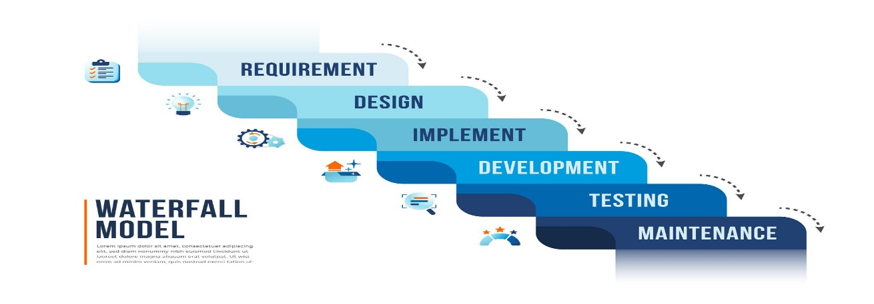
The development process begins with requirement analysis, where all academic needs such as student management, attendance tracking, marks entry, QR-based attendance, and AI-based performance analysis are identified and documented. This is followed by the system design phase, where the overall architecture, database models (Student, Teacher, Subject, Result, Attendance), and system workflows are planned using Django framework structure.
Figure 1: Waterfall Model

In the implementation phase, the system is developed module by module, including authentication, dashboard creation, marks management, QR attendance system, and AI integration using OpenRouter API. Each module is built according to the predefined design without overlapping or iterative changes during development.
After implementation, the system undergoes testing and verification, where each feature such as login authentication, marks calculation, attendance scanning, and AI analysis is tested to ensure correctness, reliability, and proper functionality.
Finally, in the deployment and maintenance phase, the system is deployed for use in academic environments, and necessary fixes or updates are applied based on identified issues.
The Waterfall Model ensures that the AcadStat system is developed in a disciplined and structured manner, making it easier to manage academic workflows such as student performance tracking, attendance monitoring, result generation, and analytical reporting. Since each phase is completed before the next begins, it provides strong documentation, stability, and clarity throughout the development lifecycle.

1.6 Report Organization
This report is systematically organized to present the development of the AcadStat – Student Result and Performance Analysis System in a clear and structured manner, covering all phases from concept to implementation.
Chapter 1 introduces the overall project, highlighting the importance of digital academic management systems in modern educational environments. It defines the problem statement, outlines the objectives, specifies the scope and limitations, and explains the adoption of the Waterfall development methodology.
Chapter 2 presents the background study, discussing key concepts such as academic data management, student performance evaluation, QR-based attendance systems, and AI-driven analytics. It also includes a literature review of existing academic systems and research, providing a foundation and justification for the development of AcadStat.
Chapter 3 focuses on system analysis, where detailed functional and non-functional requirements of the AcadStat system are identified. It includes feasibility analysis covering technical (Django framework, SQLite database), operational (user roles like admin, teacher, student), economic, and schedule feasibility. This chapter also presents system models such as use case diagrams, class diagrams (Student, Teacher, Subject, Result, Attendance), and activity diagrams representing workflows like login, marks entry, and QR attendance.
Chapter 4 describes the system design phase, where the architectural design of the Django-based application is illustrated. It includes database design derived from models, normalization of data, URL routing structure, and template design. The chapter also explains user interface layouts such as dashboards, marks management pages, and QR scanning interface, along with algorithmic logic for result calculation and attendance processing.
Chapter 5 covers the implementation and testing of the AcadStat system. It details the technologies used, including Django, HTML, CSS, JavaScript, and QR code libraries. The chapter explains module-wise implementation such as authentication system, student dashboard, marks management, AI integration module, and QR attendance system. It also includes testing procedures like unit testing, system testing, and validation of features such as mark sheet generation, AI analysis, and notification system.
Chapter 6 concludes the report by summarizing the outcomes and achievements of the AcadStat project. It reflects on how the system improves academic management efficiency and accuracy. Additionally, it provides future recommendations such as mobile application integration, advanced analytics, cloud deployment, and enhanced automation features to further extend the system’s capabilities.

CHAPTER 2: BACKGROUND STUDY AND LITERATURE REVIEW

2.1 Background Study
Although web-based management systems have become standard in many sectors worldwide, their effective adoption in academic institutions—especially in developing contexts like Nepal—remains inconsistent. Many colleges and training institutions still rely on manual or semi-digital methods such as spreadsheets and paper-based records to manage student data, attendance, and academic performance.
Academic institutions operate in a complex environment where multiple entities such as students, teachers, subjects, results, and attendance records must be managed simultaneously. Unlike simple data systems, academic platforms require continuous tracking of student performance across different subjects and examination terminals, along with accurate attendance monitoring and reporting.
With the increasing number of students and growing academic workloads, managing such data manually becomes inefficient and error-prone. Issues such as incorrect mark entries, missing attendance records, delayed result processing, and lack of performance insights are common in traditional systems. These challenges not only affect administrative efficiency but also impact the quality of academic decision-making.
Furthermore, the need for real-time insights and intelligent analysis has become more significant in modern education. Institutions now require systems that can not only store data but also interpret it by identifying weak students, tracking progress trends, and providing actionable feedback.
The AcadStat system is developed as a response to these challenges. By integrating features such as QR-based attendance, automated result processing, AI-driven performance analysis, and centralized dashboards, the system provides a comprehensive and scalable solution for academic data management. It transforms traditional record-keeping into an intelligent, data-driven process, improving accuracy, transparency, and overall institutional efficiency.

2.2 Literature Review
The evolution of academic management systems has attracted significant attention from both researchers and developers, driven by the growing demand for smarter and more efficient educational solutions. Over time, the focus has shifted from traditional record-keeping methods to digitally empowered systems that enhance accuracy, streamline operations, and improve user experience. Existing literature explores a diverse range of technologies, design strategies, and development methodologies that contribute to building robust and scalable academic platforms [1].
A study on web-based management systems replacing manual administrative processes demonstrated that digitization significantly reduces operational inefficiencies. By centralizing data into a single platform, these systems eliminate redundancy and improve data consistency. The research emphasized the importance of structured development methodologies, such as the Waterfall model, in ensuring proper planning, documentation, and execution of system requirements. The use of modeling tools like ER diagrams, use case diagrams, and activity diagrams was found to be essential for designing robust systems [2].
Another research work focused on integrated academic management systems that combine multiple functionalities, including student registration, attendance tracking, and result management. The study concluded that systems offering unified platforms are more effective than standalone applications, as they provide a holistic view of institutional operations. User feedback collected through usability testing indicated that such systems improve user satisfaction and reduce the complexity of managing academic data [3].
The use of the Django framework in developing academic systems has been widely recognized due to its reliability, scalability, and security features. Studies have shown that Django’s built-in authentication system ensures secure access control, while its Object Relational Mapping (ORM) simplifies database interactions. Additionally, the modular architecture of Django allows developers to build and maintain complex systems efficiently. Systems developed using Django demonstrated improved performance, reduced development time, and better maintainability compared to traditional approaches [4].
Research comparing different web technologies highlighted the advantages of Python-based frameworks in rapid application development. These frameworks provide flexibility, ease of integration, and extensive community support. Web-based portals developed using such technologies were found to be highly accessible and user-friendly, enabling institutions to manage data more effectively. The studies also emphasized that centralized systems reduce duplication of effort and enhance collaboration among different stakeholders [5].
Attendance management has been another critical area of research. Traditional attendance methods were identified as time-consuming and prone to errors, including proxy attendance and inaccurate record-keeping. Automated systems, particularly those using QR codes and digital scanning technologies, were found to significantly improve accuracy and efficiency. These systems not only record attendance quickly but also provide data for analyzing attendance patterns and their impact on academic performance [6].
In addition, recent studies have explored the integration of artificial intelligence in academic systems. AI-based analytics enable institutions to analyze large datasets and generate meaningful insights. For example, machine learning models can identify students at risk of poor performance and suggest targeted interventions. Although AI integration is still evolving, its potential to enhance academic decision-making has been widely acknowledged [7].
Database management plays a crucial role in the development of academic systems. Research has shown that relational databases with proper normalization and integrity constraints ensure data consistency and reliability. The use of structured database design principles, including primary and foreign keys, helps maintain relationships between entities such as students, subjects, results, and attendance records. These practices are essential for building scalable and maintainable systems [8].
Furthermore, studies on software engineering practices emphasized the importance of requirement analysis, feasibility study, and systematic testing. It was observed that clearly defined requirements reduce ambiguity and guide the development process effectively. Feasibility analysis ensures that the system is technically, economically, and operationally viable. Testing techniques such as unit testing and system testing were identified as critical for verifying system functionality and ensuring reliability [9].
Overall, the literature suggests that modern academic management systems should focus on integration, automation, and intelligent analysis. The combination of web technologies, database management, and advanced features such as QR-based attendance and AI analytics provides a strong foundation for developing efficient and scalable systems.

2.2.1 Study of existing systems
At present, many academic institutions continue to rely on traditional or partially digital approaches to manage their academic and administrative operations. Student information, attendance records, examination results, and fee details are often maintained using physical registers, files, or basic digital tools. While these methods are simple to implement and require minimal technical expertise, they are inefficient, time-consuming, and highly susceptible to human error.
Manual record-keeping systems create significant challenges in handling large volumes of academic data. Retrieving specific student information, tracking academic progress, or generating reports requires considerable effort and time. Additionally, the risk of data loss, duplication, and inconsistency increases due to the absence of proper validation and backup mechanisms. These limitations make it difficult for institutions to maintain accurate and up-to-date records.
In some cases, institutions utilize spreadsheet tools such as Microsoft Excel to manage student data and academic records. Although spreadsheets offer better organization compared to paper-based systems, they still fall short in terms of automation and scalability. Data related to attendance, marks, and financial records are often stored in separate files, leading to fragmentation and lack of synchronization. Moreover, tasks such as calculating grades, attendance percentages, and generating reports are performed manually, increasing the likelihood of errors and inefficiencies.
Some institutions also adopt generic management or accounting software to handle financial transactions and basic record-keeping. However, these systems are not specifically designed for academic environments and lack essential features such as subject-wise result tracking, student performance analysis, attendance monitoring, and academic reporting. As a result, academic and administrative data remain disconnected, limiting the ability of institutions to gain a comprehensive understanding of student performance and institutional effectiveness.
Another major drawback of existing systems is the absence of advanced analytical capabilities. Most traditional and semi-digital systems do not provide insights such as performance trends, identification of academically weak students, or correlation between attendance and results. Decision-making is therefore often based on assumptions or manual interpretation rather than accurate, data-driven analysis.
Furthermore, current practices lack centralized dashboards that provide real-time visibility into academic operations. Administrators and teachers must manually compile data from different sources to evaluate student performance, attendance status, and overall academic progress. This process is not only inefficient but also delays timely interventions and decision-making.
The absence of automation is also evident in attendance management. Traditional roll-call methods are time-consuming and prone to manipulation, while spreadsheet-based tracking lacks real-time validation. Without modern solutions such as QR-based attendance systems, maintaining accurate and secure attendance records remains a challenge.
In summary, existing academic management systems are fragmented, inefficient, and limited in functionality. They fail to provide integration, automation, and intelligent analysis required in modern educational environments. These limitations highlight the need for a comprehensive, web-based solution like the AcadStat system, which integrates student management, attendance tracking, result processing, and AI-driven analytics into a single unified platform. Such a system enhances accuracy, efficiency, transparency, and supports data-driven academic decision-making.

CHAPTER 3: SYSTEM ANALYSIS

3.1 System Analysis
This section focuses on a comprehensive understanding of the AcadStat – Academic Statistics System by identifying system requirements and evaluating its feasibility. The purpose of system analysis is to ensure that the proposed solution effectively addresses the needs of academic institutions while maintaining reliability, security, and scalability.
The analysis begins with the identification of functional requirements, which describe the interactions between users and the system. These interactions are represented using use case diagrams, illustrating how different users such as administrators, teachers, and students interact with the system.
In addition, non-functional requirements are considered to ensure system quality, including performance, security, usability, and maintainability. These factors play a critical role in determining how efficiently the system operates in real-world academic environments.
Furthermore, an object-oriented approach is adopted for system modeling and design. Various modeling tools are used, including:
- Use Case Diagrams to represent user interactions with the system, illustrating how actors such as Administrator, Teacher, and Student interact with functionalities like login, marks management, attendance tracking, and performance analysis.
- Class Diagrams for object modeling, representing system entities such as Student, Teacher, Subject, Result, and Attendance along with their relationships.
- Activity Diagrams for process modeling, showing workflows such as authentication, marks entry, QR-based attendance, and result generation.
This structured analysis ensures that the AcadStat system is well-defined, efficient, and aligned with modern academic management requirements.

3.1.1 Requirement Analysis
- User Registration and Authentication:
The system shall allow administrators, teachers, and students to securely register and log in using authenticated credentials. Role-based access control ensures that users can only access authorized features.
- Student Registration and Management:
The system shall enable administrators to add, update, and manage student information, including personal details, class, section, semester, and assigned teacher.
- Subject and Teacher Management:
The system shall allow administrators to manage subjects and assign teachers to specific subjects, ensuring proper academic organization.
- Marks Entry and Result Management:
The system shall allow teachers or authorized users to enter, update, and manage student marks for different subjects and examination terminals. It shall also calculate percentages, grades, and generate structured results.
- QR-Based Attendance Management:
The system shall provide a QR code-based attendance mechanism where student attendance is recorded by scanning unique QR codes, ensuring accuracy and preventing proxy attendance.
- Attendance Tracking and Reporting:
The system shall maintain attendance records and generate reports showing attendance percentage and history for each student.
- Mark Sheet Generation:
The system shall generate printable mark sheets for students based on selected examination terminals, including subject-wise marks, total scores, percentages, and grades.
- Student Performance Analysis (AI Integration):
The system shall analyze student performance using AI and generate insights, summaries, and recommendations to identify weak areas and suggest improvements.
- Dashboard and Visualization:
The system shall provide interactive dashboards displaying key metrics such as student performance trends, attendance statistics, and academic summaries using charts and graphs.
- Notification System:
The system shall support automated notifications (email/SMS) to inform students about low performance, attendance issues, or important updates.
- Data Storage and Retrieval:
The system shall securely store all academic data, including student records, results, and attendance, and allow efficient retrieval when required.

System Actors
The primary actors of the AcadStat system are:
- Administrator – Manages system operations, users, subjects, and overall data
- Teacher – Enters marks, manages attendance, and monitors student performance
- Student – Views personal academic records, attendance, and performance analysis.

Use Case Representation
The use case diagram of the AcadStat system illustrates the interaction between these actors and the system functionalities such as login, marks entry, attendance tracking, QR scanning, and performance analysis.
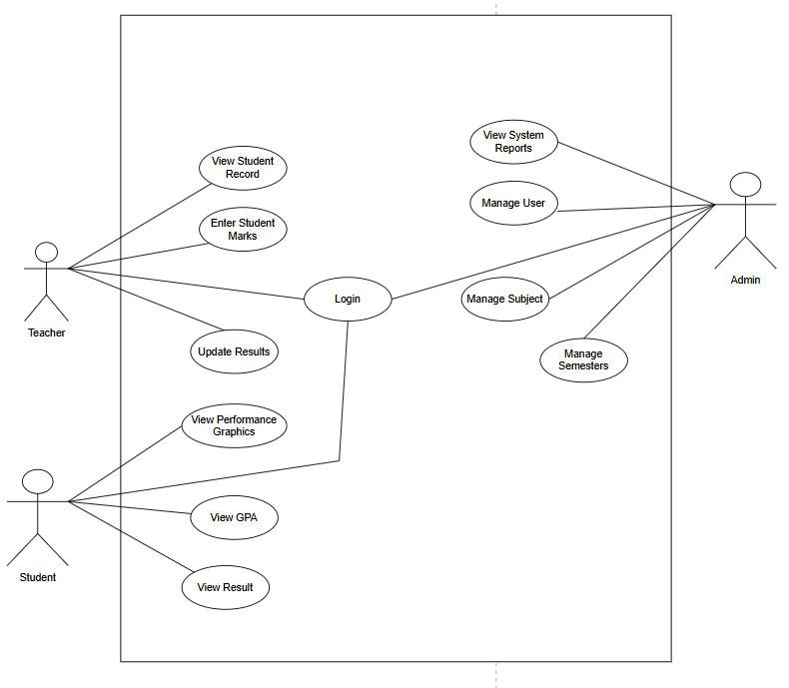
Figure 1: Use Case Diagram

Non-Functional Requirements:
Usability:
The system shall provide a user-friendly and intuitive interface that can be easily understood and operated by administrators, teachers, and students with basic technical knowledge. The design will ensure simple navigation across dashboards, marks management, attendance tracking, and report generation modules.
Security:
The system shall ensure secure authentication through login credentials and implement role-based access control to restrict unauthorized access. Sensitive academic data such as student records, results, and attendance will be protected using secure database practices and controlled access mechanisms.
Performance:
The system shall deliver efficient performance by enabling fast data retrieval, smooth navigation, and timely generation of reports such as mark sheets, attendance summaries, and analytical dashboards without noticeable delay under normal operating conditions.
Reliability:
The system shall maintain data accuracy and consistency by utilizing structured database management through Django ORM. Proper validation mechanisms and controlled data handling will minimize errors and reduce the risk of data loss.

3.1.2 Feasibility Analysis
A feasibility study is a crucial step in system development that evaluates whether the proposed system can be successfully designed, implemented, and maintained. It involves analyzing various aspects of the project to determine its practicality and effectiveness.
For the AcadStat – Student Result and Performance Analysis System, the feasibility study examines the project from technical, economic, legal, operational, and schedule perspectives to ensure that it is achievable within available resources and constraints.

- Technical Feasibility
Technical feasibility evaluates whether the system can be developed using available technologies and tools. The AcadStat system is technically feasible as it is built using widely used and reliable technologies such as Python Django (backend framework), HTML, CSS, and JavaScript (frontend), and SQLite/PostgreSQL (database).
Additionally, features such as QR-based attendance tracking and AI integration via OpenRouter API can be implemented using existing libraries and APIs. These technologies are well-documented, scalable, and supported by strong developer communities, making development and deployment practical within the project scope.
- Economic Feasibility
Economic feasibility determines whether the project is financially viable. The AcadStat system is economically feasible because it primarily uses open-source technologies, which eliminates licensing costs. Development can be carried out using standard computing resources without requiring expensive infrastructure.
After deployment, the system provides significant benefits such as reducing manual workload, minimizing errors in academic records, improving efficiency in data management, and enabling better academic decision-making. These advantages contribute to long-term cost savings and improved institutional productivity.
- Legal Feasibility
Legal feasibility ensures that the system complies with applicable laws and ethical standards. The AcadStat system is legally feasible as it does not violate any legal regulations. It is designed to securely manage student data while maintaining privacy and confidentiality.
The system does not involve unauthorized access to external or government databases. Secure authentication, controlled data access, and proper handling of sensitive information ensure compliance with ethical and legal data protection practices.
- Operational Feasibility
Operational feasibility evaluates whether the system can function effectively within the institution’s environment. The AcadStat system is operationally feasible as it is designed to align with existing academic workflows such as student management, attendance recording, marks entry, and result processing.
The system interface is simple and user-friendly, allowing administrators, teachers, and students to use it with minimal training. It integrates smoothly into daily academic operations without causing major disruptions, improving overall efficiency and coordination.
- Schedule Feasibility
Schedule feasibility determines whether the project can be completed within the given timeframe. The AcadStat system is schedule feasible as it follows the Waterfall development model, where each phase—requirement analysis, design, implementation, testing, and deployment—is completed sequentially.
Core modules such as authentication, student management, marks entry, and attendance tracking are developed first, followed by advanced features such as AI analysis and reporting dashboards. This structured approach ensures effective time management and timely completion of the project.

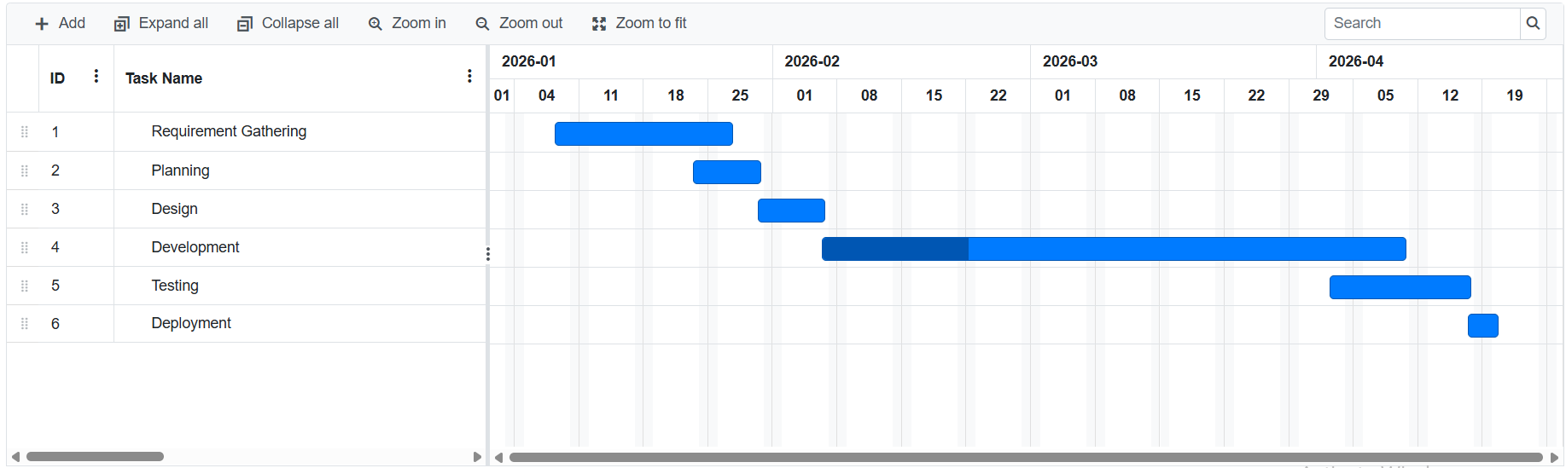
Figure 2: Gantt chart

3.1.3 Analysis

i) Use Case Diagram
A Use Case Diagram is a type of UML (Unified Modeling Language) diagram that represents the interaction between users (actors) and the system. It illustrates how different actors such as Administrator, Teacher, and Student interact with the AcadStat system through functionalities like login, marks management, attendance tracking, QR scanning, and performance analysis. The diagram helps in understanding system behavior from the user’s perspective and defines the scope of system operations.

ii) Class Diagram
A Class Diagram is a fundamental UML diagram used in object-oriented design to represent the structure of a system. It shows the system’s classes, their attributes, methods, and the relationships between them.
In the AcadStat system, the class diagram includes key entities such as Student, Teacher, Subject, Result, and Attendance, along with their associations. It provides a clear representation of how academic data is organized and managed within the system.
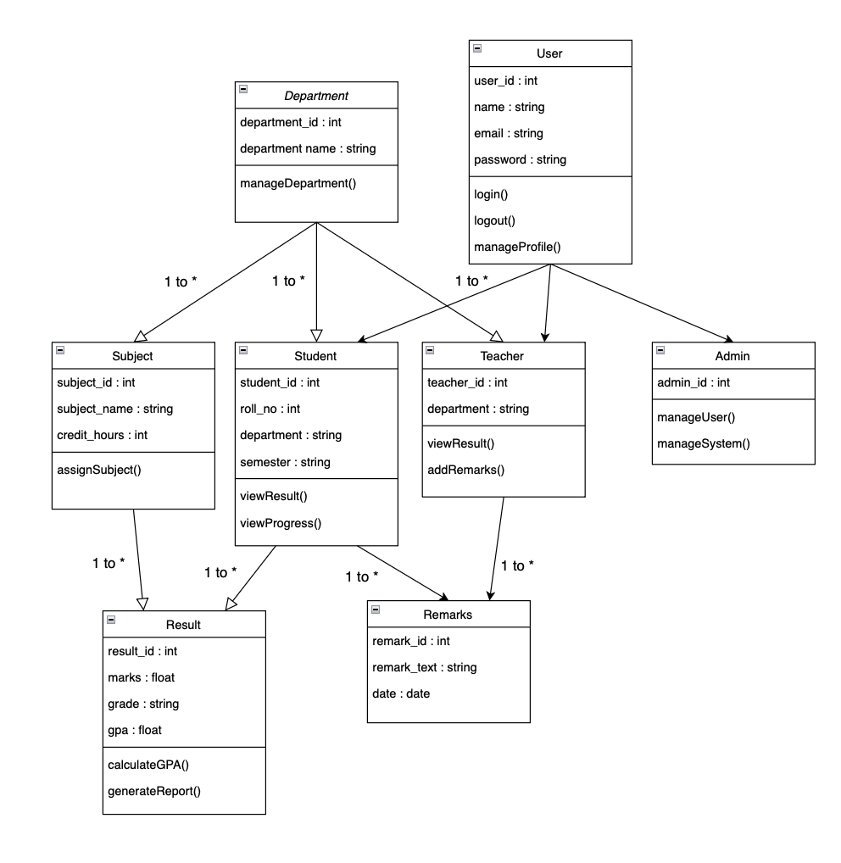
Figure 3: Class Diagram

iii) Activity Diagram
An Activity Diagram is a UML diagram that illustrates the flow of activities or processes within a system. It shows the sequence of actions, decision points, and workflows involved in completing a specific task.
In the AcadStat system, activity diagrams are used to represent processes such as user authentication, marks entry, QR-based attendance tracking, and result generation, helping to visualize how different operations are executed step by step.

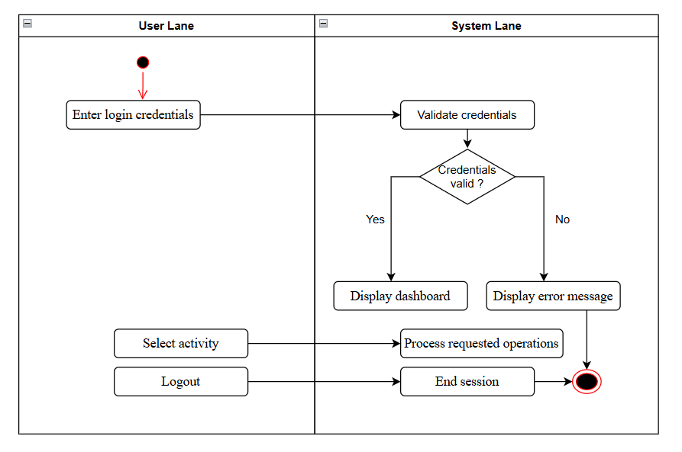
Figure 4: Activity Diagram

CHAPTER 4: SYSTEM DESIGN

4.1 Design

4.1.1 System Architecture Diagram
System architecture design refers to the conceptual model that defines the structure, behavior, and various views of a system. It acts as a blueprint for the system and the development process, outlining how different components interact and the tasks to be performed by the development team.
In the Acadstat system, the architecture follows a three-tier architecture, which includes the presentation layer, application layer, and data layer. The presentation layer (front-end) consists of technologies like HTML, CSS, JavaScript which handle user interaction and interface design. The application layer (backend) processes user requests, performs business logic, and manages communication between the front-end and the database. The data layer (database) stores and retrieves information such as student records, attendance data, and academic results.
This architecture ensures better scalability, maintainability, and separation of concerns, making the system more efficient and easier to manage.
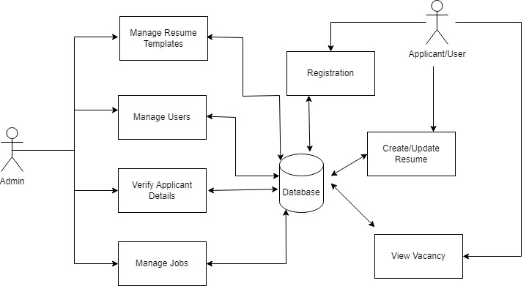
Figure 4: System Architecture

4.1.2 Component Diagram
A component diagram is a type of Unified Modeling Language (UML) diagram that depicts the high-level structure of a system, showcasing the components that make up the system and their relationships. It provides a clear understanding of how different parts of the system are organized and interact with each other.
In the Acadstat system, the component diagram illustrates the major components such as the user interface (front-end), application logic (backend), and database system. The front-end component, built using HTML, CSS, JavaScript that handles user interactions and displays data. The backend component processes requests, manages business logic, and communicates with the database. The database component stores essential data such as student details, attendance records, and academic performance.
Additionally, external components such as APIs and QR scanner modules may be included to enhance system functionality. All these components are interconnected, ensuring smooth data flow and efficient system operation.

fig 4.2: Component diagram

4.1.3 Interface Design
A wireframe design represents the basic structural layout of a web application, providing a simplified view of how different interface components are arranged. It focuses on the placement of key elements such as navigation menus, forms, tables, dashboards, and content sections without including detailed styling like colors, images, or typography. The purpose of wireframing is to establish the overall structure and user flow before full implementation.
In the AcadStat – Academic Statistics System, the wireframe design was derived directly from the system’s Django template architecture. The AcadStat system uses HTML, CSS, and JavaScript for frontend development. Custom CSS is applied to design and style the user interface, ensuring a clean and consistent layout without relying on external frameworks such as Bootstrap.
The wireframe was iteratively developed during implementation, ensuring seamless integration between frontend layout and backend logic (views, models, and URLs). This approach allowed efficient refinement of user interfaces while maintaining consistency across all system modules.
i) Homepage

- Login Page

CHAPTER 5: IMPLEMENTATION AND TESTING

5.1 Implementation

5.1.1 Tools Used
The development of the AcadStat – Academic Statistics System involves a combination of modern web technologies, programming languages, and development tools to ensure efficiency, scalability, and maintainability.
i) Programming Language
Fronend Technologies
- HTML5: HTML5 (HyperText Markup Language) is used to structure the web pages of the AcadStat system. It provides semantic elements and improved support for multimedia, enabling the creation of well-organized and accessible web interfaces.
- CSS: CSS (Cascading Style Sheets) is used to control the visual presentation of the system. It enhances the layout, colors, fonts, and responsiveness of web pages, ensuring a clean and user-friendly interface.
- JavaScript: JavaScript is used to add interactivity and dynamic behavior to the system. It enables features such as form validation, asynchronous requests (AJAX), QR scanner interaction, and real-time updates in dashboards.
- Chart.js: Chart.js are used in the system to create interactive charts and graphs for data visualization. They are implemented in the dashboard to display academic statistics such as student performance, attendance records, and result analysis in a graphical format. These libraries take data from the backend and render it into visual elements like bar charts, line graphs, and pie charts, making the information easier to understand and analyze.

Backend Technologies
i) Python (Django Framework): Python is used as the core programming language for backend development. The system is built using the Django framework, which provides a robust structure for handling server-side logic, database operations, authentication, and URL routing. Django’s ORM (Object Relational Mapping) simplifies interaction with the database and supports rapid development of secure and scalable applications.
- Database Platforms
PostgreSQL: The AcadStat system uses PostgreSQL as it offers advanced features such as transaction management, indexing, and strong data integrity. These database systems efficiently store and manage academic data including student records, results, and attendance.
- Project Management Tool
Trello: Trello is used for managing the development workflow of the AcadStat project. It provides a visual board-based system where tasks are organized into lists and cards. This helps in tracking progress, assigning responsibilities, and managing different phases of development efficiently.
- Configuration Management Tool
GitHub: GitHub is used as a version control and collaboration platform for managing the project source code. It allows developers to track changes, maintain version history, and collaborate efficiently. GitHub ensures proper code management and supports team-based development.
- Drawing Tool
Draw.io (Diagrams.net): Draw.io is used for creating system diagrams such as use case diagrams, class diagrams, and activity diagrams. It provides an intuitive interface for designing clear and professional visual representations of the system architecture and workflows.

5.2 Testing
Software testing is a critical phase in the development process that involves systematically examining the application to identify errors, verify functionality, and ensure that it operates according to specified requirements. It helps in validating that the system performs reliably, produces accurate results, and delivers a smooth user experience.
In the AcadStat – Academic Statistics System, testing ensures that core functionalities such as user authentication, marks management, attendance tracking, QR-based scanning, and performance analysis work correctly and efficiently. By detecting and resolving issues during this phase, the system becomes more stable, secure, and ready for real-world use.

5.2.1 Test Cases for Login and Account Creation
Test Case 1: User Login (Admin/Teacher/Student)
Table 1: Test Case – Login Functionality
S.N | Test Inputs | Expected Output | Actual Output | Result
1 | Valid username and password | Login successful and user redirected to dashboard | Login successful and user redirected to dashboard | Test  Successful
2 | Invalid username or password | Login unsuccessful | Error message displayed: “Invalid username or password” | Test  Successful
3 | Empty username and password fields | Login unsuccessful | Validation message displayed for missing credentials | Test  Successful
4 | Valid student login credentials | Redirect to student dashboard | Student successfully redirected to /student/<id>/ dashboard | Test Successful

Test Case 2: Student Account Creation (via Management Command / Admin Panel)
Table 2: Test Case – Account Creation
S.N | Test Inputs | Expected Output | Actual Output | Result
1 | Valid student details (name, roll number) | Student account created successfully | Student user account created and accessible for login | Test  Successful
2 | Duplicate roll number | Account creation should fail | Error displayed: “Student with this roll number already exists” | Test  Successful
3 | Missing required fields | Account creation unsuccessful | Validation error shown for missing fields | Test  Successful

Test Case 3: QR-Based Attendance
Table 3: QR Attendance Functionality
S.N | Test Inputs | Expected  Output | Actual Output | Result
1 | Valid student QR code scanned | Attendance recorded successfully. | Attendance marked for the student with current date and time | Test Successful
2 | Invalid QR code | Attendance not recorded | Error message displayed: “Invalid QR Code” | Test Successful
3 | Same QR scanned multiple times in a day | Attendance should not duplicate | System prevents duplicate entry or shows warning | Test Successful
4 | QR scan without camera permission | Attendance not processed | Permission error displayed | Test Successful

5.3 Result Analysis
The results demonstrate that the developed AcadStat – Student Result and Performance Analysis System is effective in managing academic and administrative activities within an educational environment. The system successfully handles key functionalities such as user authentication, student record management, marks entry, attendance tracking, QR-based attendance, and performance analysis.
The login mechanism is secure and user-friendly, providing appropriate feedback for invalid credentials and incomplete inputs. Role-based access ensures that administrators and students are directed to their respective dashboards, maintaining system security and usability.
The system efficiently stores and retrieves academic data, ensuring accuracy and consistency across modules. Features such as marks management and attendance tracking function correctly, enabling teachers and administrators to monitor student performance in a structured and organized manner. The QR-based attendance system enhances reliability by automating attendance recording and reducing manual errors.
In addition, the system provides analytical dashboards and reports, including student performance summaries and categorized analysis (critical, warning, and satisfactory levels). The integration of AI-based analysis further improves decision-making by generating insights and recommendations based on student performance data.
Error handling and validation mechanisms are properly implemented to prevent incorrect data entry and duplication. All test cases executed during the testing phase were successful, confirming that the system satisfies both functional and non-functional requirements.
Overall, the AcadStat system is stable, efficient, and user-friendly. It is well-suited for real-world implementation and has the potential to significantly improve academic data management, enhance decision-making, and provide a streamlined user experience for both administrators and students.

CHAPTER 6: CONCLUSION AND FUTURE RECOMMENDATIONS

6.1 Conclusion
The AcadStat – Student Result and Performance Analysis System has been successfully designed and implemented as a comprehensive, integrated, and user-friendly web-based solution that addresses the common challenges of manual academic record management in educational institutions. By centralizing key operations such as student information management, marks recording, attendance tracking, QR-based attendance, and performance analysis, the system eliminates the inefficiencies, inconsistencies, and errors associated with traditional paper-based or spreadsheet-based approaches.
The project has effectively achieved its primary objectives. It provides automated processing of academic data, efficient tracking of student performance, and structured storage of records. Features such as secure login authentication, role-based access control, mark sheet generation, and attendance monitoring ensure smooth and reliable system functionality. The integration of QR code-based attendance enhances accuracy and reduces manual effort, while the AI-powered analysis module adds an advanced layer of insight by generating performance summaries and recommendations.
Throughout the development and testing phases, the system demonstrated significant improvements in efficiency and accuracy. Tasks that previously required considerable time and manual effort, such as result preparation and attendance calculation, can now be completed instantly. The system also improves data visibility through dashboards and analytical reports, enabling administrators and teachers to make informed, data-driven decisions.
Additionally, the system is designed with usability in mind, ensuring that users with basic technical knowledge can easily navigate and operate it. The modular structure of the application, developed using the Django framework, ensures scalability, maintainability, and future extensibility.
Overall, the AcadStat system represents a meaningful step toward the digital transformation of academic management. It enhances transparency, improves operational efficiency, and provides a reliable platform for managing academic data, ultimately contributing to a better and more organized educational environment.

6.2 Future Recommendation
Although the current version of the AcadStat – Student Result and Performance Analysis System successfully achieves its primary objectives as a web-based academic management platform, several enhancements can be introduced to improve its scalability, functionality, and alignment with modern technological trends in education systems.
One major improvement would be the development of a cross-platform mobile application using technologies such as React Native. This would allow students, teachers, and administrators to access the system on mobile devices, enabling features such as real-time attendance marking, instant result checking, and quick notifications. A mobile application would significantly enhance accessibility and user engagement.
Another important enhancement would be the integration of digital notification systems, including email and SMS alerts. This would enable automated communication with students regarding low attendance, poor performance, or important academic updates. Such a feature would improve interaction between the institution and students, ensuring timely awareness and response.
The system can also be improved by incorporating advanced analytics and machine learning techniques. While the current system includes basic AI-based analysis, future versions could implement predictive models to identify at-risk students, forecast academic performance trends, and provide personalized recommendations for improvement. This would transform the system into a more intelligent decision-support platform.
Additionally, the integration of cloud deployment (such as AWS or similar platforms) can enhance system scalability, reliability, and accessibility. A cloud-based system would allow multiple institutions to use the platform simultaneously under a centralized system, supporting a Software as a Service (SaaS) model with secure and isolated data management.
Future enhancements may also include bulk data import/export features, enabling institutions to upload large student datasets efficiently and generate reports in formats such as Excel or CSV. Furthermore, the addition of a parent portal would allow guardians to monitor student performance and attendance, improving transparency and involvement in academic progress.
Another potential improvement is the implementation of real-time dashboards and API-based integrations, which would allow the system to connect with other educational platforms or mobile applications. Enhancing the QR-based attendance system with more automation and verification mechanisms can further improve reliability and prevent misuse.
In conclusion, these future recommendations aim to extend the AcadStat system beyond a basic academic management tool into a scalable, intelligent, and fully integrated digital platform. Implementing these features would significantly enhance usability, efficiency, and overall system value in modern educational environments.

References
[1] V. K. Patil, D. S. Patil, H. B. Satpute, and S. N. Tayade, “Student Record Management System using Django,” International Journal for Research in Applied Science and Engineering Technology, vol. 11, 2023. [Online]. Available: https://doi.org/10.22214/ijraset.2023.51366
[2] Authors, “An Intranet-Based Web Application for College Management System Using Python with Django Web Framework,” International Journal for Research in Applied Science and Engineering Technology, 2023. [Online]. Available: https://www.researchgate.net/publication/368719592
[3] N. S. Ali, A. H. Alhilali, H. D. Rjeib, H. Alsharqi, and B. Al-Sadawi, “Automated Attendance Management Systems: Systematic Literature Review,” International Journal of Technology Enhanced Learning, vol. 14, no. 1, pp. 37–65, 2022. [Online]. Available: https://www.researchgate.net/publication/358178607
[4] D. Gandomani and S. Coetzer, “The Impact of Software Development Practices on Project Outcomes,” Software, vol. 1, no. 3, pp. 265–275, 2022. [Online]. Available: https://doi.org/10.3390/software1030012
[5] R. Ramakrishnan and J. Gehrke, Database Management Systems, 3rd ed. New York, NY, USA: McGraw-Hill, 2003.
[6] I. Sommerville, Software Engineering, 10th ed. Harlow, UK: Pearson Education, 2016.

Appendix

Screenshot of Home Page

Screenshot of Login Page

Screenshot of Admin Panel

