Lab 2.0 – Thermal Camera Interface

# Lab 1 - Camera directional-stand (recap)

The goal of the lab 1 series was to use a PS2 joystick to control the movement of a pan-tilt module. To this end, you implemented the hardware and software interfaces needed to control a PWM generator and an ADC.

* The ADC was used to sample data from the analog PS2 joystick.
* The digital samples were used to control the duty cycle of 2 PWM signal generators and to therefore move the pan-tilt module.

In the final mini-project, you will use the pan-tilt module of lab 1 to mount a PAL camera. We now move on and transfer our focus towards camera systems themselves.

# Lab 2 – Camera acquisition system

The goal of this lab is to learn about the machinery involved in camera acquisition systems (i.e. how to get a frame from the camera sensor onto an image file stored on your computer).

## Background - Camera hardware interfaces

There are many different interfaces used among the various cameras available on the market, but they can all be separated into 2 categories:

* Parallel-data cameras can output a full pixel value on each clock cycle (subject to horizontal and vertical signaling). Interfacing with such cameras is costly, as one requires at least as many free pins as the pixel depth of the sensor. Therefore, many systems may just not have enough pins available to interface with a high pixel depth camera.
* Serial-data cameras output a pixel bit-by-bit over multiple clock cycles (subject to horizontal and vertical signaling). Interfacing with such cameras is very affordable, as only 1 pin is required for communication (note though that you may need 2 pins depending on the electrical signaling used).

In this lab, we will examine serial-data cameras. Such cameras can further be divided into 2 sub-categories:

* Cameras that use a custom serial communication protocol require specific controllers to be built to interface with them.
* Cameras that use a standard serial communication protocol (I2C, SPI, UART …) are more flexible, as most microcontrollers provide such communication interfaces.

## Chosen camera - FLIR Lepton

We are going to use a standard-protocol serial-data camera. To make this even more interesting, we will use a thermal camera, namely the [FLIR LEPTON](http://www.flir.com/cores/content/?id=66257), shown in Figure 1. Its main characteristics are summarized in Table 1.

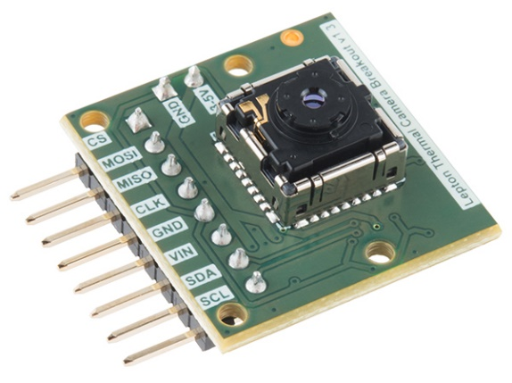

Figure 1. FLIR Lepton

|  |  |
| --- | --- |
| Array width | 80 |
| Array height | 60 |
| Effective frame rate | 8.6 Hz |
| Output format | 14-bit |
| Data interface | Video over SPI (VoSPI) |
| Control interface | I2C |

Table 1. Lepton Specifications

The lepton is easy to interface with, as it provides an SPI data interface and an I2C control interface. This makes it simple for most microcontrollers to use the device. However, since we are going to use an FPGA to interface the lepton, we must design the complete frame acquisition system ourselves (or else what would you be doing in this course? ☺).

### General note about thermal cameras

Thermal cameras are able to capture scenes with a wide temperature range. Therefore, if you take a photo of a standard scene with such a camera, you will obtain a very dark image with almost nothing visible. This is normal as there is not much temperature variation in standard scenes.

To make the temperature differences more visible, you need to interpolate the scene’s pixel values to the minimum and maximum supported by the image format. As an example, Figure 1 contains an interpolated image in the range (0, 16383).

## Camera acquisition system design

Figure 2 shows the block diagram of our camera acquisition system. We will now discuss the various components involved.



Figure 2. Lepton Acquisition System

### SPI controller

The lepton outputs its data over an SPI bus, so we need an SPI interface to capture the data. This component is a generic SPI controller that reads data serially and forwards 8-bit chunks to the lepton controller.

### Lepton controller

The lepton outputs data in the form of two 160-byte VoSPI packets: video and discard. These packets are received in 8-bit chunks from the SPI controller. The lepton controller is in charge of 2 tasks: It filters out the discard packets, and reconstructs 14-bit pixel values from the incoming data stream.

### Statistics computation

This component is in charge of computing the minimum, maximum and average pixel values in an image, which are useful values for numerous image processing algorithms.

These values can be computed in O(W x H) time on a processor (as it must iterate on all pixel values in a frame), but can be computed in O(1) time by the hardware capturing the frame, as all pixels are already flowing through it.

The minimum and maximum can easily be computed while data is flowing through the lepton controller. The average, however, requires a resource-heavy hardware divider, which we would like to avoid in our design. Instead, we chose to compute the sum of all pixel values, and leave the division to be done by the host processor (which most probably has a very efficient hardware divider).

### Level adjustments

As previously stated, standard scene images taken with a thermal camera often produce very dark images due to the low temperature difference among the various entities in the scene. The level adjustments component is responsible interpolating the frame’s pixel intensities to obtain a much more visible image. It uses the minimum and maximum values computed by the statistics computation unit to this end.

### 8192x16-bit RAM

We chose to store the incoming frame in an internal on-chip memory instead of in system memory. This is done mainly in order to provide 2 alternative views of the frame at no extra storage and computation cost.

* Original RAW buffer view
* Adjusted (interpolated) buffer view

Note that the image is not stored twice in the RAM. The 2nd view is computed on-the-fly as data is being read from the RAM, and is then outputted on the Avalon-MM Slave interface (see Figure 1.)

Due to the small frame size of the lepton, the on-chip memory space is not too prohibitive. Pixels are 14 bits wide, so we store them in 16-bit memory words. Storing a full frame therefore requires 80 x 60 = 4800 words. Since memory sizes need to be powers of 2, we resort to using an 8192-word memory.

### Avalon-MM Slave Interface

Table 2 shows the register map of the lepton interface. Notice the 2 views over the data.

|  |  |  |
| --- | --- | --- |
| Byte Offset | R/W | Name |
| 0x0000 | WO | COMMAND |
| 0x0002 | RO | STATUS |
| 0x0004 | RO | MIN |
| 0x0006 | RO | MAX |
| 0x0008 | RO | SUM_LSB |
| 0x000a | RO | SUM_MSB |
| 0x000c – 0x000f | - | RESERVED |
| 0x0010 – 0x258f | RO | RAW_BUFFER |
| 0x2590 – 0x3fff | - | RESERVED |
| 0x4000 – 0x657f | RO | ADJUSTED_BUFFER |
| 0x6580 – 0xffff | - | RESERVED |

Table 2. Avalon-MM Slave Register Map

#### COMMAND register

Table 3 shows the details of the COMMAND register.

|  |  |  |
| --- | --- | --- |
| Bit | 31 .. 1 | 0 |
| Name | RESERVED | START |

Table 3. COMMAND Register

Writing 1 to the START bit will instruct the unit to start capturing a new frame and resets the ERROR bit of the STATUS register.

#### STATUS register

Table 4 shows the details of the STATUS register.

|  |  |  |  |
| --- | --- | --- | --- |
| Bit | 31 .. 2 | 1 | 0 |
| Name | RESERVED | ERROR | BUSY |

Table 4. STATUS Register

* The BUSY bit reads as 1 when the unit is busy, and 0 when idle.
* The ERROR bit reads as 1 when an error is detected, and 0 if no error was detected.

#### MIN, MAX, SUM_LSB, SUM_MSB registers

These registers contain the minimum, maximum, and sum over all pixels in the frame. Note that the sum requires 27 bits to be fully represented, so it is split into 2 registers.

#### RAW_BUFFER, ADJUSTED_BUFFER

These address zones point to the RAW and the adjusted frame address ranges. Remember that only the RAW frame is stored in the internal on-chip memory, and that the adjusted view is computed live when requested for each pixel.

## Your Job

### Task 1 – HW – Statistics computation

Implement the statistics computation component in hw/hdl/lepton/hdl/lepton_stats.vhd.

Figure 3 shows the timing diagram that the component must satisfy. The pix_sof and pix_eof signals inform you about the start and the end of a frame. Remember to generate a pulse on the stat_valid signal when you have valid data in the stat_min, stat_max, and stat_sum registers.

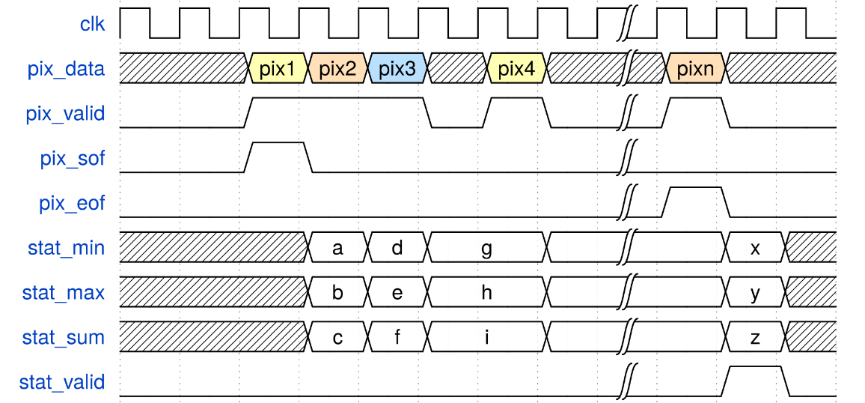

Figure 3. lepton_stats input port chronogram

### Task 2 – HW – Level adjustments

Implement the level adjustments component in hw/hdl/lepton/hdl/level_adjuster.vhd.

We said earlier that hardware dividers are expensive and that they should be avoided when possible. We were able to avoid inserting one in the statistics computation component, but it cannot be avoided in level adjustments, as there is no way to interpolate the pixel values without one.

We provide you with the component declaration for one such divider in lepton_stats.vhd.

### Task 3 – SW – C code completions

#### Nios II SBT project setup

We want the Nios II processor to be able to write a frame to an image file located on your host computer. To do this, we need to enable a specific software package In the BSP Editor. After creating your Nios II SBT project, follow the steps below:

1. Right-click on the BSP project > Nios II > BSP Editor …
2. In the Software Packages tab, enable the altera_hosts package.
3. Save the configuration
4. Press the Generate button.
5. Cloe the dialog.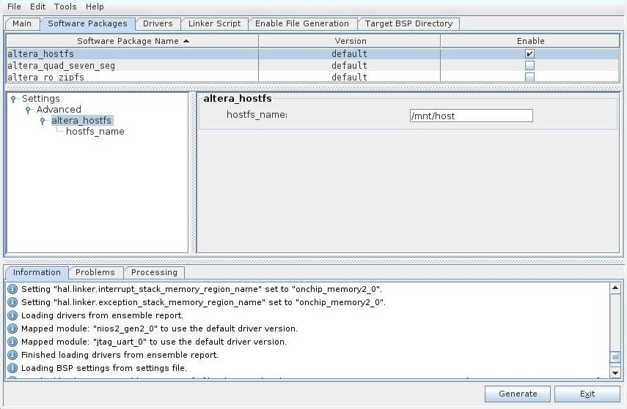

Figure 4. hostfs Software Packaage

You can now continue with the standard software workflow you have used for the previous labs.

#### Lepton library

Implement the following 3 functions in lepton.c:

* void lepton_start_capture(lepton_dev *dev);
* bool lepton_error_check(lepton_dev *dev);
* void lepton_wait_until_eof(lepton_dev *dev);

#### Procedure for capturing a frame

Complete the main(void) function in app.c to capture and write a frame to a [PGM](https://en.wikipedia.org/wiki/Netpbm_format#PGM_example) image file (use the functions implemented in lepton.c.)

Recall the procedure needed to capture a frame with this hardware design:

1. Write 1 to the START bit of the COMMAND register.
2. Wait until the BUSY bit of the STATUS register is 0.
3. If the ERROR bit of the STATUS register reads 1, then start again at 1. Otherwise the frame is available for reading at RAW_BUFFER and ADJUSTED_BUFFER.

#### Wiring the lepton

Figure 5 shows the wiring setup: you will use the ARDUINO_IO pins to make things easier. The ARDUINO_IO pins used by the lepton do not have a 5V output, so we instead use the alternative 5V pin on the back of the lepton breakout board to power the device (red wire in Figure 5).

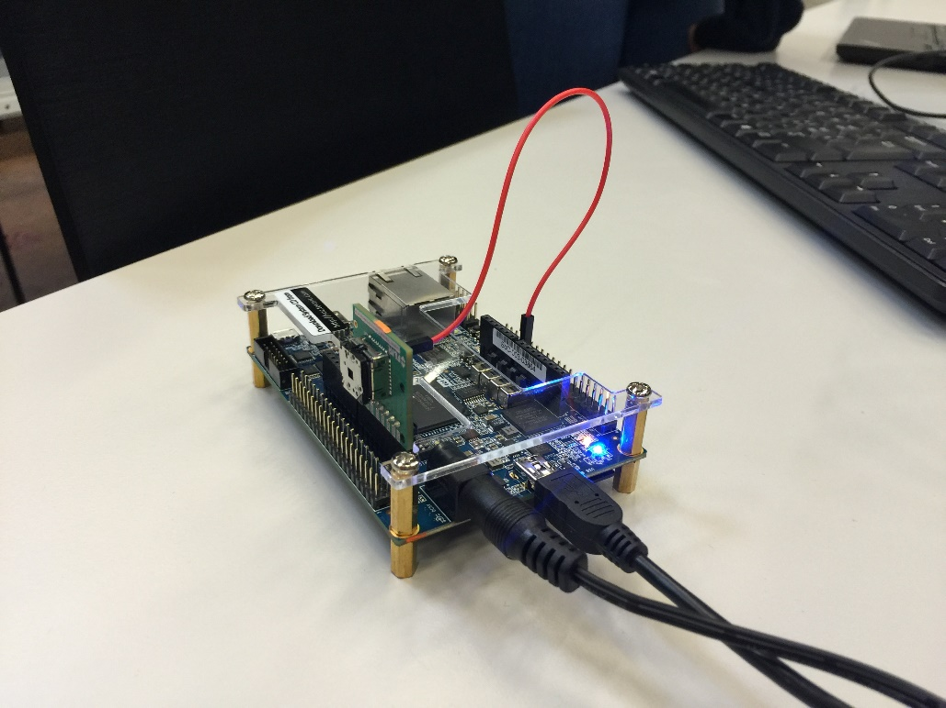

Figure . Lepton Wiring

#### Viewing the results

Once all code segments have been filled, and that you successfully execute the main function, you can find the resulting image file at sw/nios/application/output.pgm