Cd_Inventory

(Functions)

*Introduction:*

With this assignment we were introduced to functions and classes which are not only very convenient tools of organizing code into thematic chapters but are also a way of representing contents of all programs. We learned how to give arguments to functions in different ways in order to operate with results received back from the function back to the main body of code.

*We are here to help:*

From the given task I was “to organize blocks of code into the functions and than” into the classes given which were three : “DataProcessor” , “FileProcessor” and “I/O (input/output)

First of them namely “DataProcessor” included 3 functions each operating on specific tasks in program. (*figure01)*

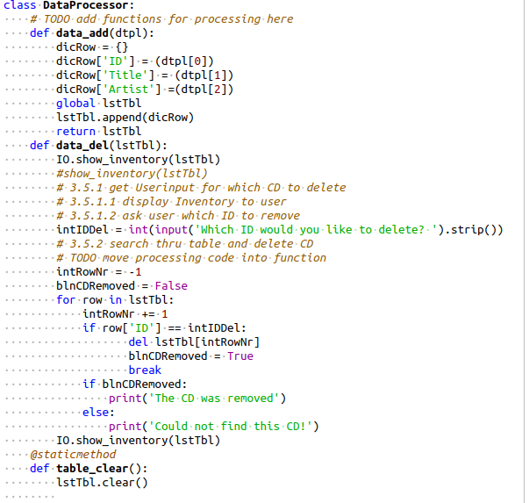

*Figure 1*

In the “data_add” function operates in the part of code where user adds data, I made small changes to the original code, it receives tuple “dtpl” as argument (includes user input data for key and value pairs) and returns modified global variable “lstTbl” back to the main body of code (*figure02)*

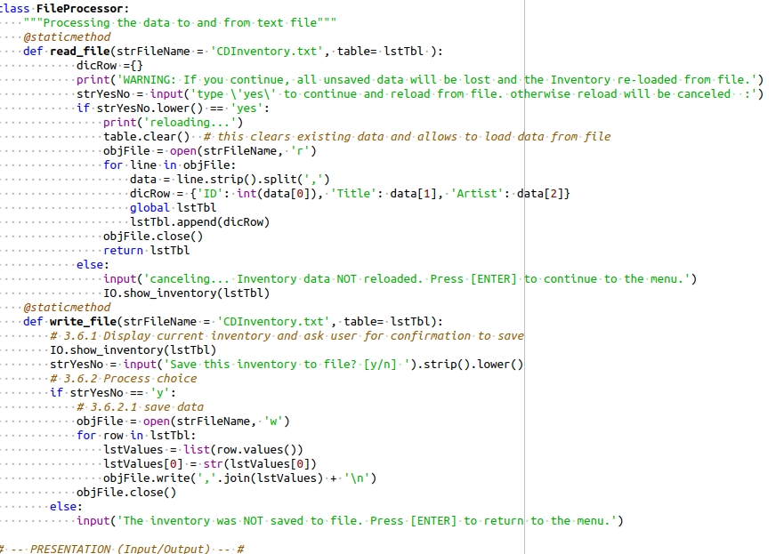*Figure 2*

The next function “data_del” operates on deleting data is basically copy/pasted from original script. I did not quite understand the “blnCDRemoved” variable in this part ( it gives different output for print() function in case of successful removal of entry or error in case entry was not found).

Last (the smallest but bravest :)) function in the code clears all the data from the main data (lstTbl) tab before loading new entries to the program (*figure 04)*

**

*Figure 4*

*W*ith next step we are leaving the “class DataProcessor:” which was basically dealing with the data processing part of program and moving to a new class which is “class FileProcessor:” This class consists from 2 functions one for reading data from file and next to save data to the file both are copy pasted from the original script basically it takes data by row addressing to the each element of row and saves/loads data from/to file formatting data for input/output on fly. (*figure 05)*

*Figure 05*

The next class on our way is I/O class includes functions dealing with from/to user input/output

“menu_choice”- consists of data type strings points out the main menu for the user.

“Usr_input”- is one of main functions in the script deals with data input from user and returns 3 :

int(strID), strTitle, stArtist, back to main part of the script. These returned values are to be served as values in key value pair in the “dtpl” tuple for future use.

“Show_inventory” – appears in the main program most of the time it receives the main data “lstTbl” table as argument and prints out the inventory for the user (*figure06).*

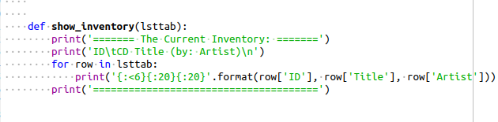

Figure 6

The main part of the CD_Inventory Program as in previous cases is based on a while loop and variable “choice” which is basically output of the function “menu_choice” defined by user input. (*figure07)*

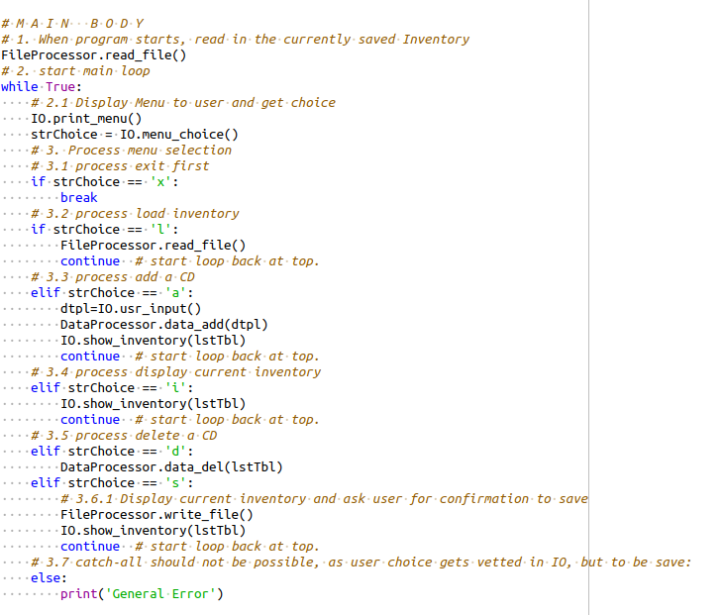

Figure 07

It operates with several if/elif operators each corresponding to choices in the user menu which calls the appropriate function from the class function list defined in the script.

Conclusion: In this assignment I think I learned my lesson from previous mistakes and this code should feel and operate much smoother and better than the previous one, although there is still much to do. For example, I still need to implement try/except functions in my code to eliminate some flaws in current run time of program. Still, I learned quite a lot with this module which can bee seen in the code as well.

