CUCM User Import Tool

ZOOM International

Author: Petr Borovicka

Version 1.3

Date: June 2020

Table of Contents

1 Version Control 4

2 Introduction/Background 5

3 Product Description 6

4 Description of Application behaviour 7

4.1 Creating new users in CUCM 7

4.1.1 Configuring users for user import and QM login only 7

4.1.2 Configuring user for mapping calls with user account only 10

4.1.3 Configuring users both for user import and QM login and for calls mapping 14

4.2 User import 17

4.3 User login 18

4.4 User privileges 19

4.5 Managing imported users 19

4.6 Mapping conversations with User accounts in QM 21

4.7 Disabling the user from QM user import 22

4.8 User delete in CUCM 25

5 Deployment 26

5.1 Deployment prerequisites 26

5.1.1 Prepare API User on CUCM 26

5.1.2 Prepare ZOOM Quality Management 32

5.2 Description of Installation package 41

5.2.1 callrec-zqm-axl-importer tool 41

5.2.2 Installation script 42

5.3 Pre-deployment tasks 42

5.4 Deployment 44

5.4.1 Upload zqm-axl-importer to ZOOM QM server 44

5.4.2 Installation using installation script 45

5.4.3 Adjusting configuration 47

5.4.4 Database description 50

6 Troubleshooting 54

6.1 Understanding the log file 54

6.1.1 zqm-axl-tool initialisation. 54

6.1.2 Calls update 54

6.1.3 User update 55

6.1.4 Error messages 57

6.2 Verification of config file validity 59

6.3 Running one shot 60

6.4 Forcing calls re-scan 60

7 About ZOOM International & Eleveo 61

Contact Details 61

# **Version Control**

|  |  |  |  |
| --- | --- | --- | --- |
| Release | Date | Comments | Owner |
| 1 | 2020-05-07 | Version 1 for User Tool 2.0.0 | Petr Borovička |
| 1.1 | 2020-05-18 | Added support of mapping calls with user accounts. Tool 2.0.2 | Petr Borovička |
| 1.2 | 2020-05-25 | Understanding the log file – added example for wrong AXL user permissions | Petr Borovička |
| 1.3 | 2020-06-24 | Updated Eleveo Brand | Jitka Bártová |
|  |  |  |  |

# Introduction/Background

ZOOM International is a leading provider of multimedia recording and quality management solutions for contact centres, financial trading floors, and emergency services. ZOOM’s solutions are designed to Recording communications and provide analysis while delivering critical business information to support the decision-making processes of your organization.

With the birth of IP telephony as the new communication standard, ZOOM provides solutions, which seamlessly integrate with the unified communication environments for our worldwide clients.

The award-winning [ZOOM Quality Management®](http://www.zoomint.com/en/zoom-callrec-cisco-ip-telephony-contact-center-call-recording.html) (ZOOM QM) software sets new standards for IP Recording solutions, offering full features and quality affordable by companies of all sizes. ZOOM has become the solution of choice for customers who demand cutting-edge technology, exceptional support and attractive cost of ownership.

# Product Description

The callrec-zqm-axl-importer tool was developed to import CUCM users into ZOOM Quality Management to provide Active directory authentication possibility. In addition, it provides the possibility for back office users to simply pair calls with this CUCM AXL back office user.

The tool is delivered in form of Linux unit service for CentOS 7.x. The tool was developed on top of ZOOM version 6.6.x. The tool is to be running on ZOOM server site.

In order to respect different scenarios of customer environment, callrec-zqm-axl-importer tool can run with several different parameters/variables, which change its operational behaviour.

# Description of Application behaviour

The callrec-zqm-axl-importer tool connects to the CUCM AXL service and periodically downloads the list of end users and their associated devices and extensions. In addition to user import, the callrec-zqm-axl-importer ensures mapping of calls created by the phone device to user accounts of imported users in ZOOM Quality Management. User accounts’ updates in CUCM are propagated to ZOOM application.

## Creating new users in CUCM

User management in the CUCM have impact how the users will be managed by the callrec-zqm-axl-importer tool. There are three possible scenarios:

* 1) User needs to login into QM only. His / her phone is not recorded.  
  This case requires to have user account assigned specific Access Control Group in his/her permissions only. Such user is imported as ACTIVE into ZOOM Quality Management. User authenticates with CUCM (LDAP) on login.
* 2) User will not login into QM, but his/her phone is recorded. Phone needs to be associated to this user in the QM UI for search purposes.  
  This case requires to have the device observed by the ZOOM JTAPI application user and device needs to be associated with the use account. Such user is imported as INACTIVE with associated devices. Matching calls with user account in the Quality Management is functional, but the user is not able to login into Quality Management.
* 3) User needs to login into QM and his/her phone is recorded (combination of option 1 and 2).   
  This case requires to have user account assigned specific Access Control Group in his/her permissions. I n addition user must have device associated with the user account and the device must be observed by the ZOOM application user used for call recording. As a result, the user is imported as ACTIVE and matching calls with user account in QM is functional.

### Configuring users for user import and QM login only

This case requires to have user account assigned specific Access Control Group in his/her permissions only. Such user is imported into QM as ACTIVE into ZOOM Quality Management. User authenticates with CUCM (LDAP) on login.

For initial setup, this configuration requires configuration both on CUCM site (Create am Access Control Group) and on ZOOM QM site (configure the Access Group Name in callrec-zqm-axl-importer tool). Chapter describes just the CUCM part.

As a prerequisite for the user import is to create new User Access Control Group. In the CUCM navigate to **User Management -> User Settings -> Access Control Group**



Within the Access Control Group settings clink “**Add new”**

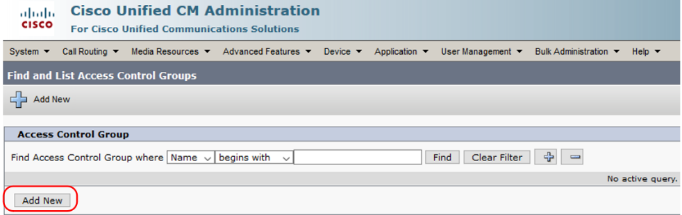

Fill in the **Access Control Group Name** and click “**Save”.**

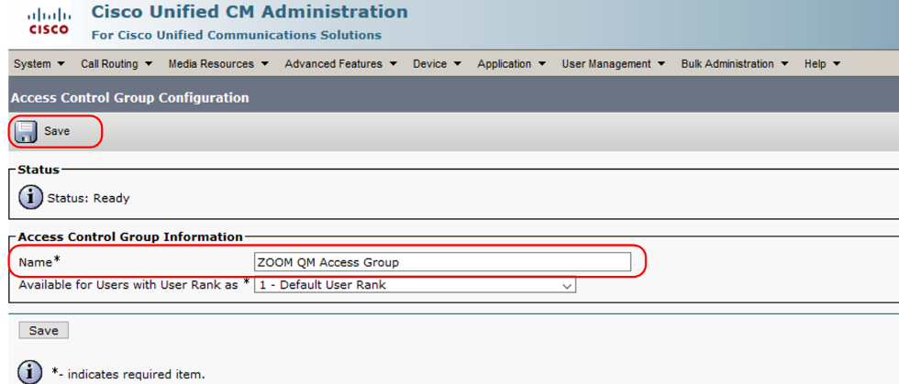

As a next step create a new user or edit the existing one. This user will be imported by the callrec-zqm-axl-importer tool into ZOOM Quality Management.

In the CUCM configuration navigate to User **Management -> End User**.

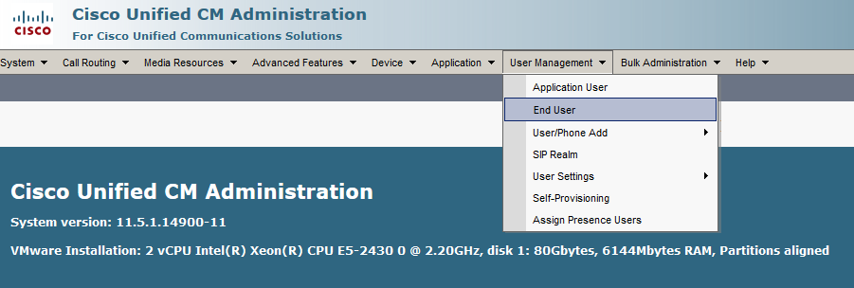

For user import is not required to have device associated with the user account. (device association with user account is required for matching calls with user accounts in ZOOM QM).

To import user into ZOOM Quality Management, add this user into Access Control Group created in previous step. In the user management scroll down to **Permission Information** and click “**Add to Access Control Group**”.

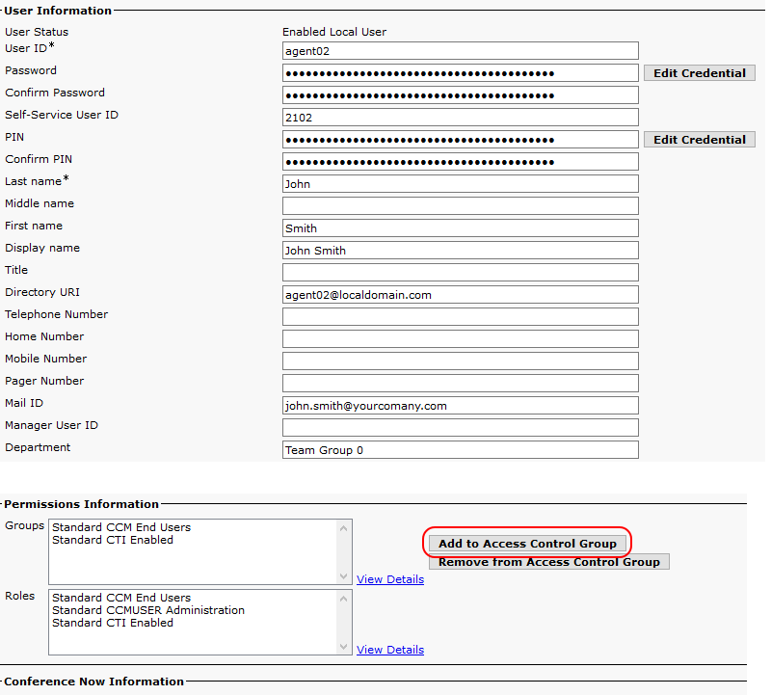

In the list of Control Groups find the group created for callrec-zqm-axl-importer tool usage and click “Add selected”.

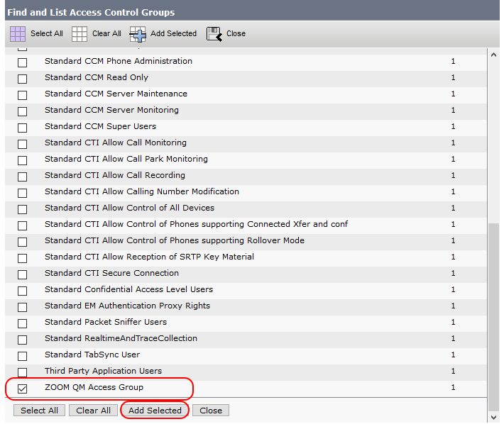

Save the user configuration after the user is added to the group.

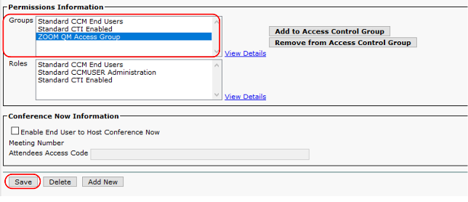

Once the user is added to the Access Control Group used by the callrec-zqm-axl-importer tool, the user will be imported into QM and will authenticate with CUCM.

### Configuring user for mapping calls with user account only

This chapter describes configuration of CUCM when recorded calls needs to be matched with user accounts in ZOOM Quality Management. This case requires to have the device observed by the ZOOM JTAPI application user and device needs to be associated with the use account. Such user is imported as INACTIVE with associated devices. Matching calls with user account in the Quality Management is functional, but the user is not able to login into Quality Management.

The zqm-axl-importer tool supports following methods of mapping:

- Based on the device name

- Based on the line number

- Based on device name and line number

**NOTE:** Review scheduler will not display users with inactive accounts. Review of calls made by inactive users is possible using the conversation screen only.

If the user device is recorded via JTAPI, then it is expected, the device is observed by the ZOOM application user created for call recording. This configuration can be verified in the CUCM under **User Management -> Application user**.

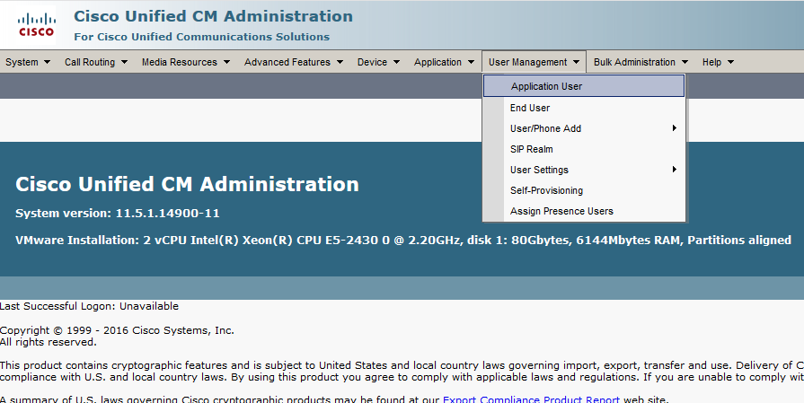

Find the application user used for call capture and check the application user configuration.

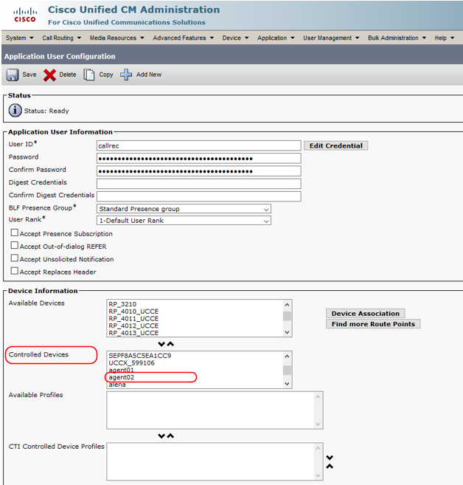

If the device is monitored by the application user created for call recording, then the user accounts associated with this device must be created in CUCM as a prerequisite to user import. The callrec-zqm-axl-importer tool processes CUCM End users only.

**NOTE:** For correct matching calls with user accounts in ZOOM Quality Management is necessary to meet following prerequisites:

* Controlled device associated with the user account is configured for call recording based on the JTAPI notifications.
* One device must be associated with one user only
* One line (directory number) must be assigned to one user only. Shared lines are not supported.
* One user can manage multiple devices if each of these devices is managed by this user only
* One device can have multiple lines configured if the lines are managed by single user only
* All devices managed by a single user may have configured the same lines.

Example1: User uses 2 phones: Jabber (CSFSMITHJ) and desk phone (SEP44547AD4). Both phones have configured lines 20665542 and 23665542. Both phones and lines are not used by any other user. Such scenario is supported

Example2: User uses 1 phone (SEP44547AD4) with 2 lines configured (20665542 and 23111155). Line 23111155 is shared with other users. Such deployment is not supported.

In the CUCM configuration navigate to **User Management -> End Users.**



The user must have to have the controlled device assigned and following roles assigned to match calls to user accounts in ZOOM Quality Management only.

* Standard CCM End Users
* Standard CCM User Administration
* Standard CTI Enabled

The callrec-zqm-axl-importer tool imports only users, who have assigned devices configured for call recording based on the JTAPI notifications.

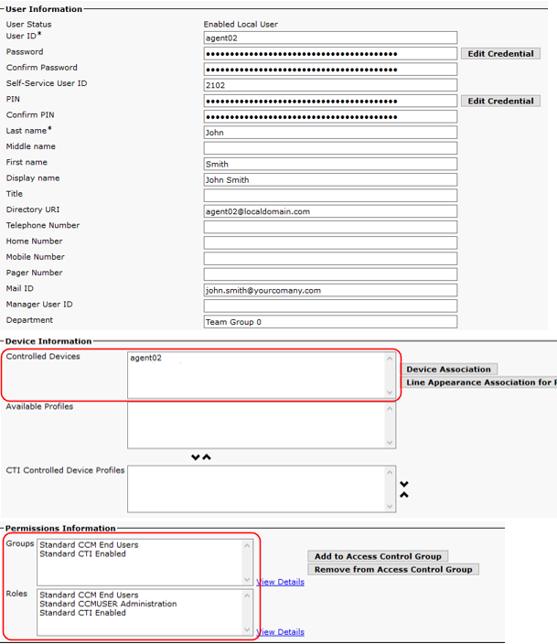

User create without the Access Control Group for callrec-zqm-axl-importer tool, will be imported by the tool as INACTIVE. Calls will be matched with this INACTIVE account and searchable based on the user details. The user will not be able to login into the ZOOM Quality Management UI.

### Configuring users both for user import and QM login and for calls mapping

Users, which have devices to be recorded and mapped to their user accounts in QM and need to login into ZOOM Quality Management is the needed both to finalize configuration described in chapter 4.1.1 and in chapter 4.1.2.

The configuration requires to have user account assigned specific Access Control Group in his/her permissions. I n addition user must have device associated with the user account and the device must be observed by the ZOOM application user used for call recording. The same prerequisites as for the call mapping to user accounts are applied in this case.

**NOTE:** For correct matching calls with user accounts in ZOOM Quality Management is necessary to meet following prerequisites:

* Controlled device associated with the user account is configured for call recording based on the JTAPI notifications.
* One device must be associated with one user only
* One line (directory number) must be assigned to one user only. Shared lines are not supported.
* One user can manage multiple devices if each of these devices is managed by this user only
* One device can have multiple lines configured if the lines are managed by single user only
* All devices managed by a single user may have configured the same lines.

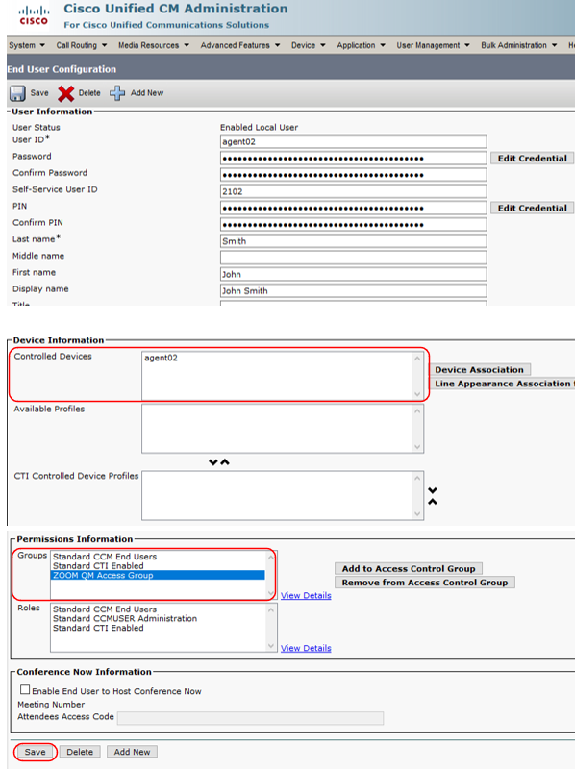

As a result of this configuration, the user is imported as ACTIVE and matching calls with user account in QM is functional.

## User import

The callrec-zqm-axl-importer tool connects to the CUCM AXL service and periodically downloads the list of end users and their associated devices and extensions. These users are imported into ZOOM DB into separate DB table. The list of imported users is pushed into ZOOM QM database, which provides the possibility to log into ZOO QM. In addition, the imported users are paired with recorded calls to provide the possibility to pair the calls with QM imported users.



The user import has its own limitations:

* the user group of imported users into QM is the same for all users (configurable in configuration file of callrec-zqm-axl-importer tool
* the user role of imported users into QM is the same for all users (configurable in configuration file of callrec-zqm-axl-importer tool

User groups and user role must be managed manually

## User login

When users are imported from CUCM, these users can log into ZOOM QM Web User Interface. The user authentication is authenticated by username and password, which is the same as if user would be logging into CUMC (UCCX). When CUCM uses the Active directory for verification, then the password is verified with Active directory. Communication between CUC and active directory is transparent for ZOOM QM authentication process.



Imported users access the ZOOM QM via the standard User Web Interface http(s)://<ZOOM_server>/qm

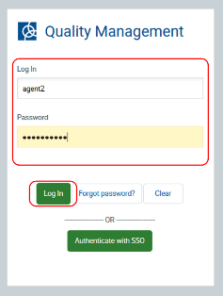

## User privileges

The callrec-zqm-axl-importer uses for all imported users the same user role. The default user role is “Agent”. Users with “Agent” user role is allowed to see just own calls after the login (default permission user role “Agent”).

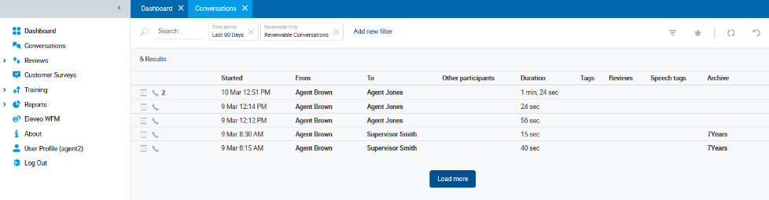

The user role as well as group membership can be edited manually by the QM application administrator (ccmanager by default).

## Managing imported users

The callrec-zqm-axl-importer tool provides imports the users into the ZOOM Quality Management. All these imported users have the same role and are assigned to the same group. Once these users are imported, the privileged user (ccmanager by default) must manually change the role and role assignment within the ZOOM Quality Management.

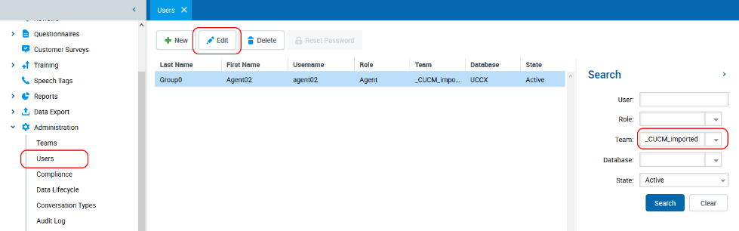

Even it is possible to modify almost all configurations settings, only part of them should be touched.

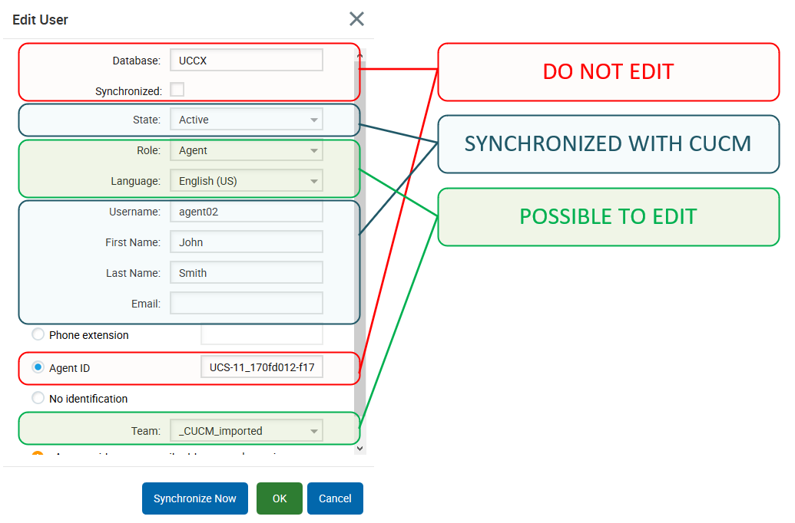

**DO NOTE EDIT**

The correct functionality can be broken by editing of these fields.

Database: Used for use authentication. When UCCX is set, the CUCM AXL is used for user authentication. This value must be set to UCCX

Synchronized Enables User data synchronisation with the Database source set in the Database filed. This value must be DISABLED. Enabling the synchronisation may cause user delete or other states resulting in incorrect functionality of the callrec-zqm-axl-importer tool.

Agent ID Unique ID set by the importer tool. This value is used for user data synchronisation and mapping the calls to the agent. The value consists of CUCM node name and CUCM user pkid.

**POSSIBLE TO EDIT**

Role User Role. All new imported users have the role set by the callrec-zqm-axl-importer role (Default “Agent”). If the imported user has another role, the role must be edited manually. The role settings are not overwritten by the tool.

Language The use import tool uses default language (English US). Ny user can edit its own language settings. The language settings are not overwritten by the callrec-zqm-axl-importer tool.

Team All users are imported to the same group. The group is set by the Import tool. The administrator can edit the team assignment. The team is not overwritten by the tool

**SYNCHRONIZED WITH CUCM**

Following fields are managed by the callrec-zqm-axl-importer tool l. Any manual changes in these fields are overwritten with next run of the callrec-zqm-axl-importer tool. These fields are used for display of the conversations in the conversation screen, quality management and audit logs If any change of these fields is required, the change must be applied on the CUCM server. These fields do not serve to map calls with users. Mapping of calls to users is based on AgentID (CUCM user pkid).

Username CUCM user login name. The username is unique within the CUCM cluster. Similarly, the QM username is unique within the Quality Management.

First Name CUCM user First Name.

Last Name CUCM user Last Name.

Email address CUCM user email address

## Mapping conversations with User accounts in QM

The callrec-zqm-axl-importer tool is also able to pair the recording with user account in the QM. The pairing is based on following conditions:

User AgentID – This parameter is not changed from the imported one. The value consists of CUCM node name and CUCM user pkid.. The value must be unique within installation.

Devices assigned to user - The user has been assigned controlled devices in the configuration of CUCM. These devices are matched to CALLING_TERMINAL and CALLED_TERMINAL information provided by the CUCM CTI notification messages. The device name must unique within the installation.

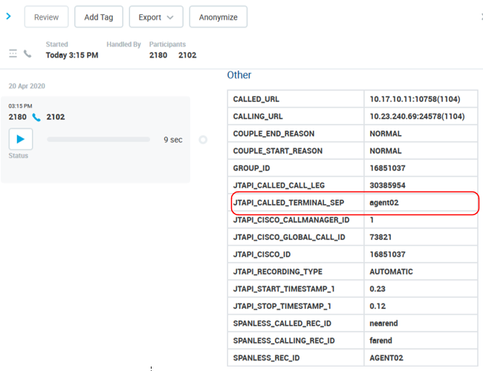

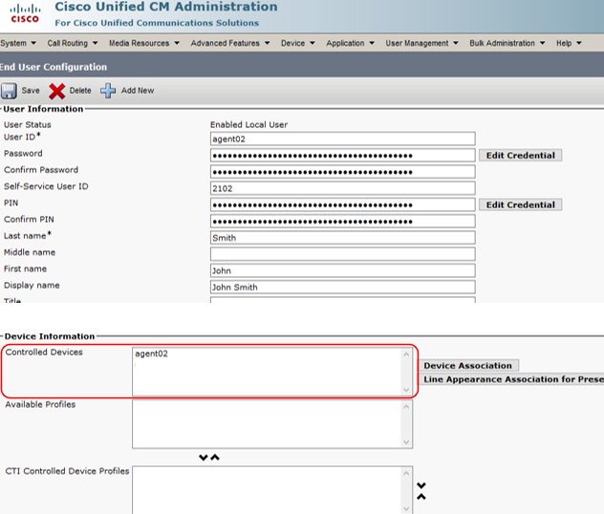

## Disabling the user from QM user import

The user can be disabled to login into ZOOM Quality Management by the configuration change on CUCM site. This change can be done by removing the user from Access Control Group used by the by the callrec-zqm-axl-importer tool for user import. 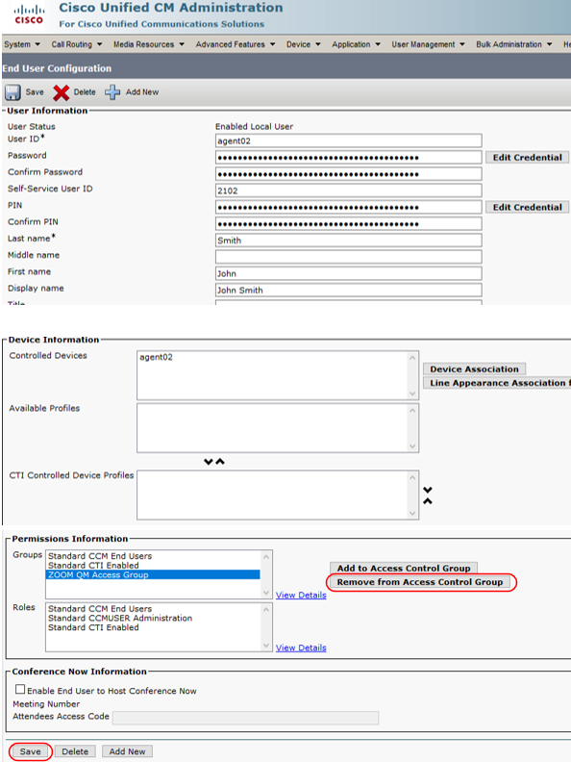

After this change, the by the callrec-zqm-axl-importer tool sets this user in the ZOOM Quality Management as INACTIVE. Calls will be matched with the user account, because the device remains associated with the user, but the user will not be allowed to login into ZOOM Quality Management UI.

Disabling mapping of user account in ZOOM Quality Management UI t with the device can be achieved by remove of controlled device from the user account in the CUCM configuration.

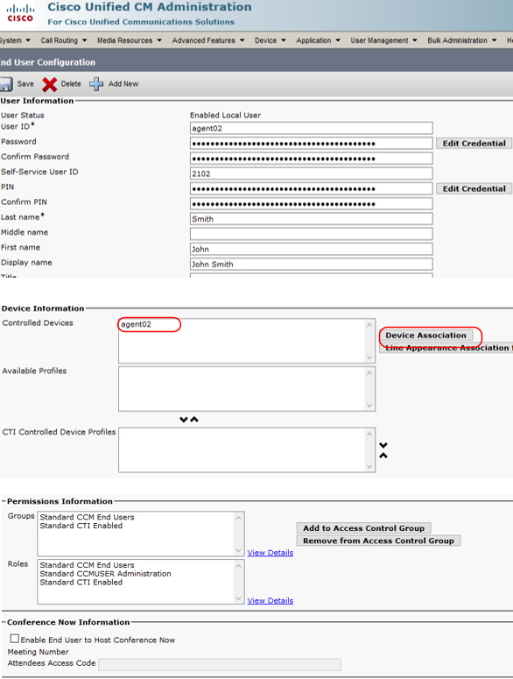

If the device association is removed and ser is not part of the Access control group, as shown on the picture above, the user will be marked in the OOM Quality Management as DELETED.

If the device association is removed, but the user remains in the Access Control Group, the user will remain ACTIVE in the ZOOM Quality Management. Calls will not pair with this account anymore, but the user will be able to login WebUI using authentication with CUCM.

Adding the user back to Access Control Group are associating the device with the user account will activate the appropriate functionality without any impact on the user account itself.

## User delete in CUCM

If the user is deleted in CUCM, the change is propagated into ZOOM application. This use is marked as DELETED in ZOOM application. The recordings of DELETED user remain searchable in the QM.

**NOTE:** By delete of a user in CUCM and creating new one with same parameters causes creating of new user in ZOOM application. The newly created user in CUCM has different user_pkid parameter. Original user in ZOOM application is marked as DELETED and his login is renamed by callrec-zqm-axl-importer tool to ensure the uniqueness of user accounts.

\

# Deployment

## Deployment prerequisites

To successfully deploy and run callrec-zqm-axl-importer tool following prerequisites needs to be met:

* ZOOM Quality Management version 6.x
* CUCM version 11.5 and higher

### Prepare API User on CUCM

The API user is used by the zqm-axl-importer tool to connect to CUCM and download information about devices and users.

#### Prepare Access Control Group

Connect to your CUCM and go to **User Management > User Settings > Access Control Groups**

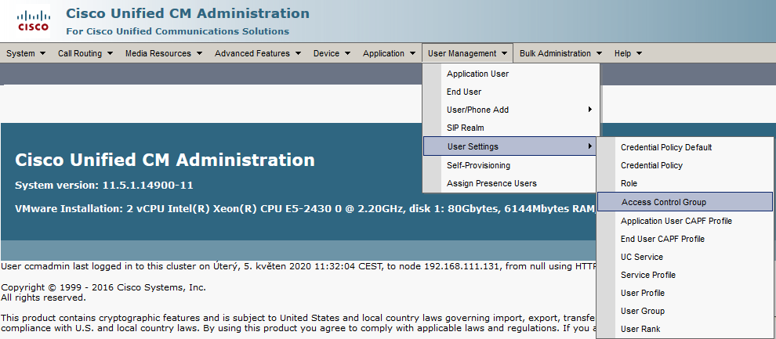

Click **Add New**

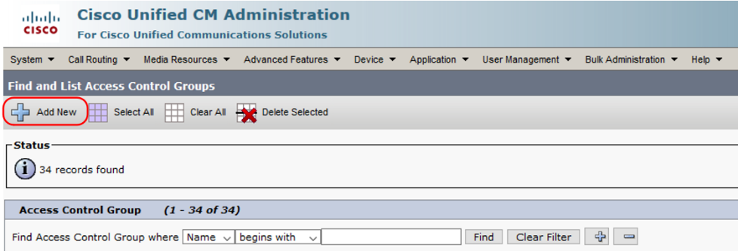

Enter a Name for the access control group (AXL API for example) and save the settings.

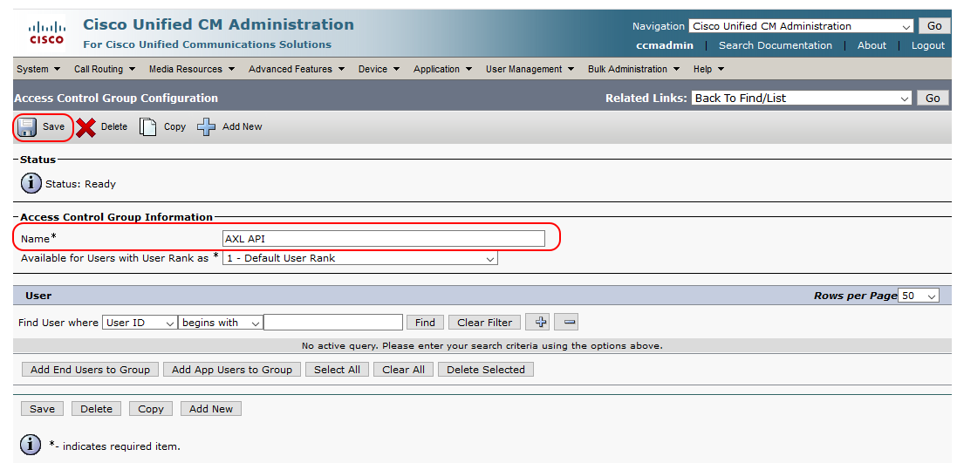

From Related Links, select **Assign Role to Access Control Group**, and click **Go**.

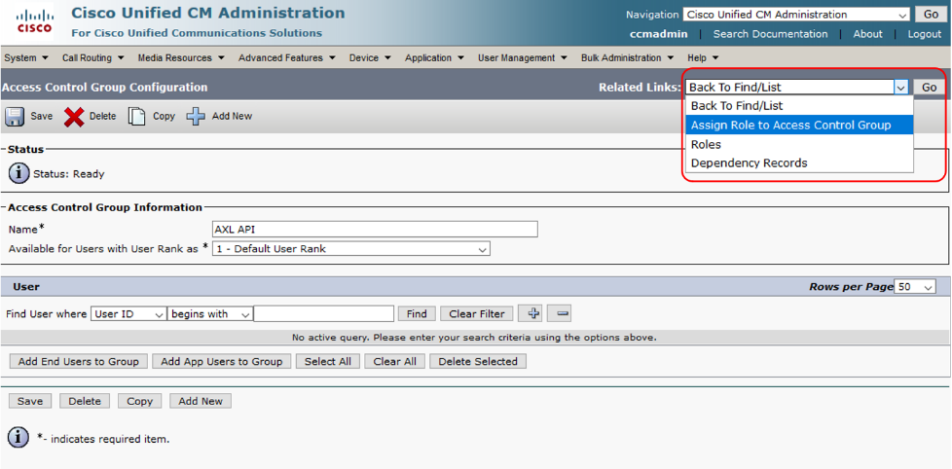

Select **Assign Role to Group**

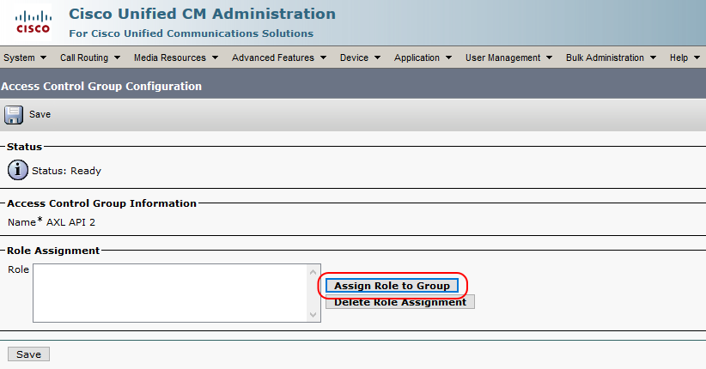

In the search field select "**Name**" "**Contains**" fill value **AXL** and **click Find** to search for existing roles.

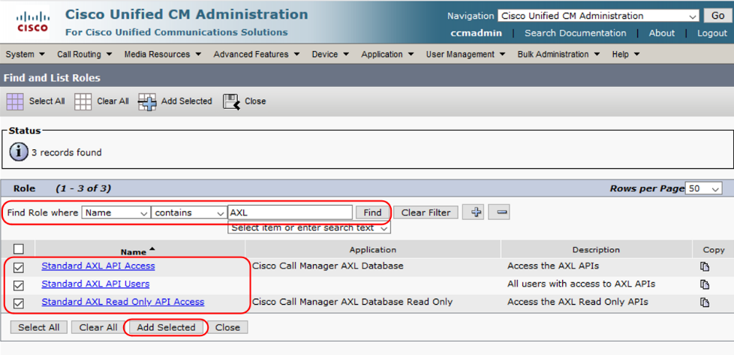

Select following roles:

**Standard AXL API Access**

**Standard AXL API Users,**

**Standard AXL Read Only API Access**

Click Save to apply the configuration.

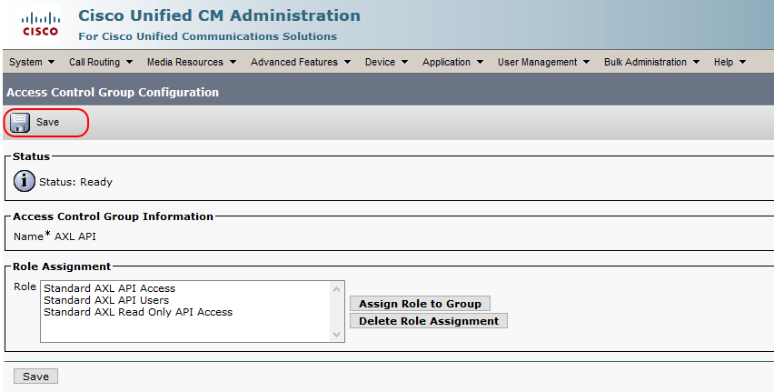

#### Create AXL user and assign privileges

To create a user on your CUCM navigate to **User Management > End User.**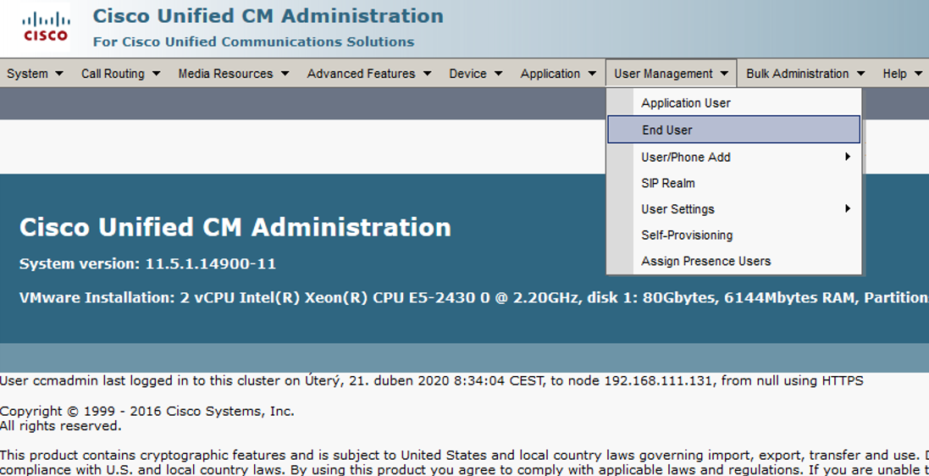

Click **Add new.**

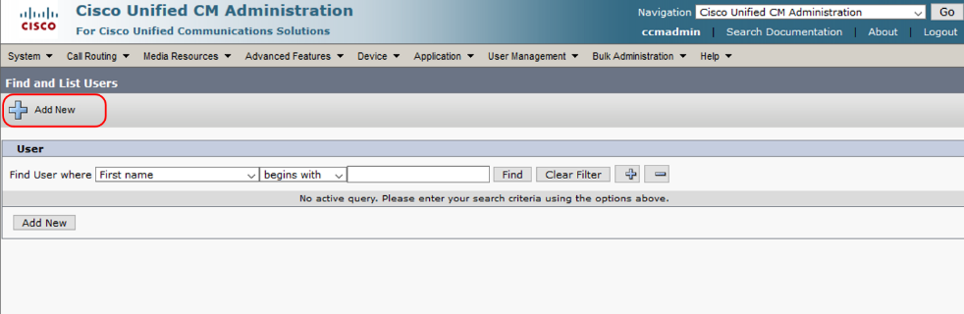

Fill in **User ID**, **Last name** and **password** and click **Save**

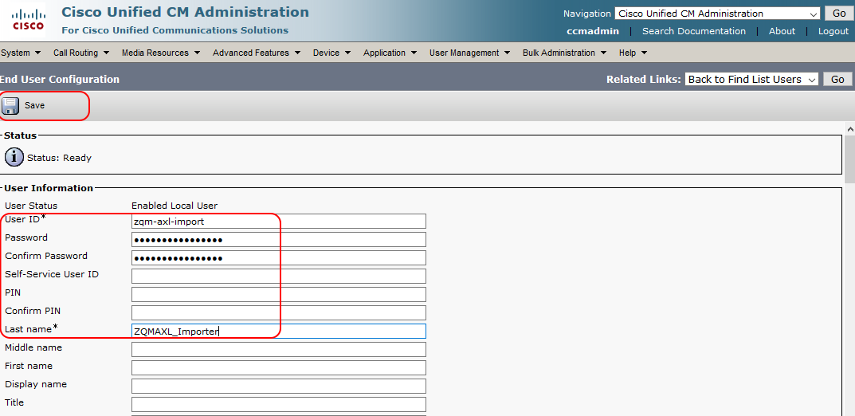

Grant to the user the following **privileges - Groups: AXL API**

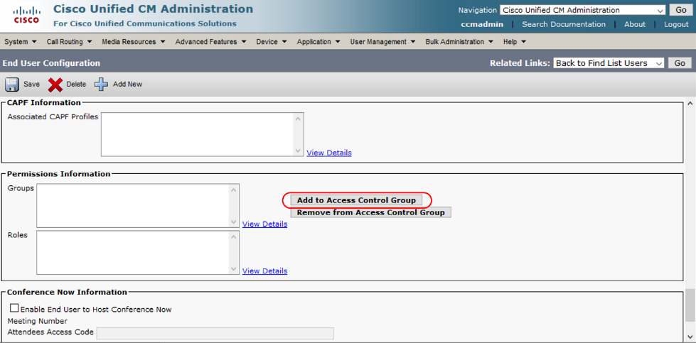

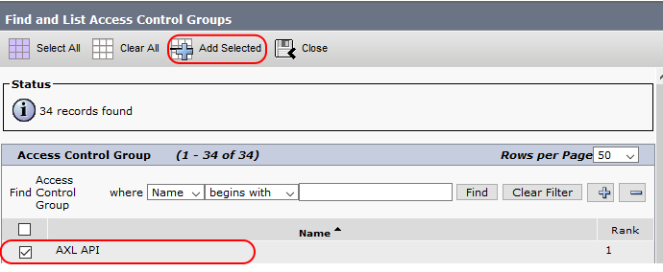

Click **Save** to apply changes

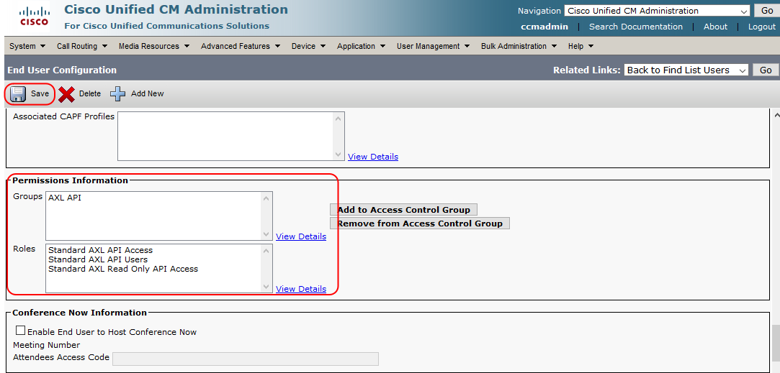

The AXL API user for zqm-axl-importer tool was prepared.

#### Create an Access Control group for user import

Users which should be able to login int ZOOM QM must have created a special Access Control Group on CUCM. Please refer to chapter 4.1.1 or 4.1.3 for more details. The Access Control Group name is one of the configuration parameters,

### Prepare ZOOM Quality Management

The ZOOM Quality Management needs to be configured to allow user authentication with CUCM and user import to specific groups.

#### Import CUCM Certificates into ZOOM application

To authenticate users imported by zqm-axl-importer tool with CUCM, the authentication service needs to connect to the CUCM server via SSL. For the connection to work, the SSL certificate needs to be imported to the Quality Management server.

The process to import the certificate differs if our CUCM has a **self-signed certificate** or whether its certificate was signed by some **Certification Authority**. If the certificate is **self-signed** (i.e. it is signed by itself), import only that certificate. If the certificate has been **signed by some Certification Authority**, import the whole Certification Authority chain (i.e. one or multiple CA's).

As an example, to import the **self-signed certificate,** the following steps must be performed:

Open Internet Explorer (as Administrator), navigate to the CUCM server and click on the certificate. It is necessary to select the **Run as Administrator** option when opening Internet Explorer as it is not possible to save the certificates to a local drive.

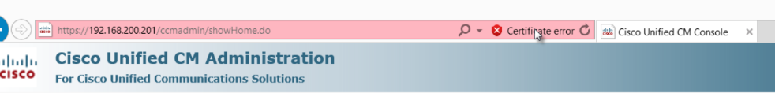

In the next window, click on **View Certificates**

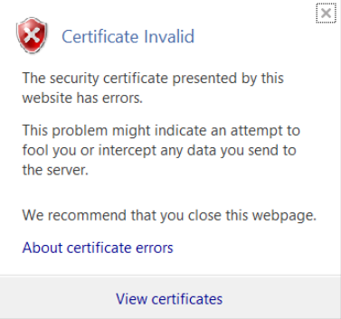

Follow the steps in the next windows.

Select the **Base 64 encoded X.509 (.CER)** format option.

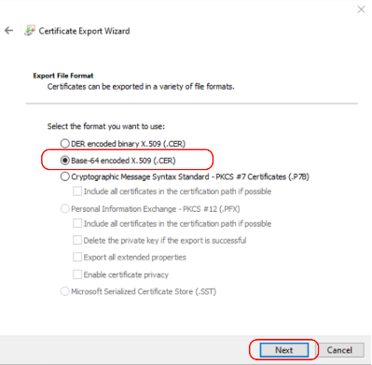

store the file on your local machine in a directory easy to find.

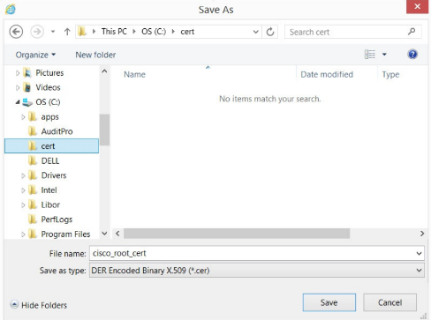

Copy the certificate from your machine to your server, for example using WinSCP. You can use the /tmp directory on ZOOM server.

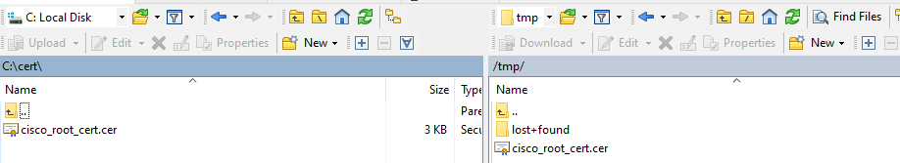

Login to the server with admin privileges and then switch to root.

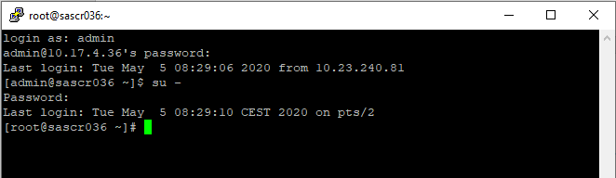

Change the directory to directory, where the zip file was uploaded (in our example /tmp)

[root@sascr036 ~]# cd /tmp/

Make sure the upload certificate exists

[root@sascr036 tmp]# ls -la cisco_root_cert.cer

-rw-r--r-- 1 root root 2350 May 5 13:54 cisco_root_cert.cer

Use the ZOOM cert_tool to import the certificate into web application keystore (tomcat)

[root@sascr036 tmp]# /opt/callrec/bin/cert_tool.sh tomcat -o IMPORT -is /tmp/cisco_root_cert.cer -a c09-cucm-a.devlab.zoomint.com

Certificate with alias c09-cucm-a.devlab.zoomint.com imported to /opt/callrec/certs/ris/.trust.keystore

Where:

-o IMPORT Import certificate

- is <ceert_file_name> Import source (certificate file)

- a <alias_in_trusstore> Alian, under which is the certificate imported.

In case of importing whole certificate chain, repeat the import for all certificates in the chain.

Validate the imported certificate by command:

[root@sascr036 ~]# /opt/callrec/bin/cert_tool.sh tomcat -o LIST

Listing trusted certificates for Tomcat

======================================

/opt/callrec/certs/ris/.trust.keystore

======================================

Alias name: c09-cucm-a.devlab.zoomint.com

Creation date: Tue May 05 14:04:11 CEST 2020

...

...

Owner: CN=c09-cucm-a-ms.devlab.zoomint.com, OU=iSupport, O=ZOOM International s.r.o., L=Prague, ST=CZ, C=CZ

...

...

Restart the callrec-web application to reload the certificate

[root@sascr036 tmp]# systemctl restart callrec-web

The ZOOM application is ready to communicate with CUCM after the restart, as CUCM certificate is trusted.

#### Configure ZOOM Quality Management for authentication with CUCM

The configuration of Quality Management authentication is performed via the CallREC Web UI. Login to the web interface as a user with administrator’s privileges (i.e.: admin)

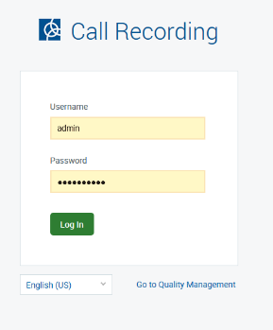

Navigate to **Settings -> Configuration -> Quality Management.**

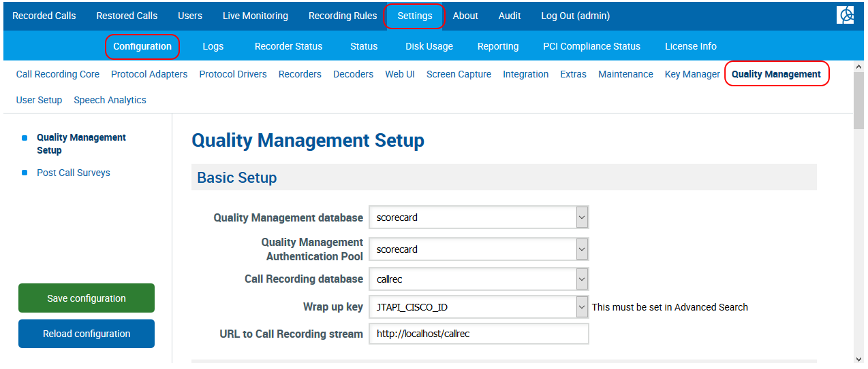

In the Quality Management Integrations select the **UCCX** Integration and click **New**

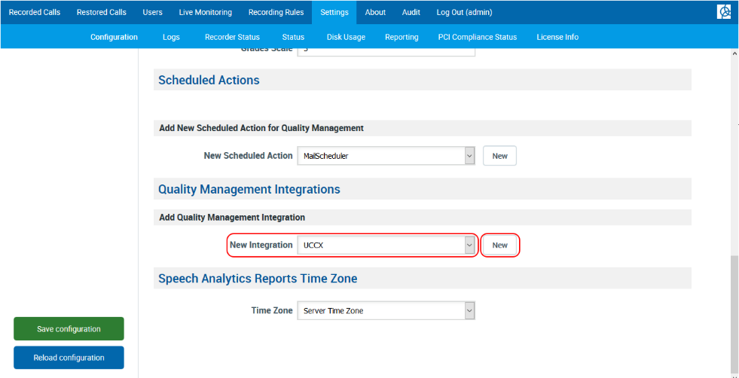

Within the UCCX Quality Management integration fill in CUCM Administrative XML details only. Into the server name fill in the FQDN of CUCM publisher (the same one, filled in as CN in the certificate imported into trust store of the callrec-web application. See chapter 5.1.2.1) ). Fill in the AXL user username and password as created in chapter 5.1.1.2 .

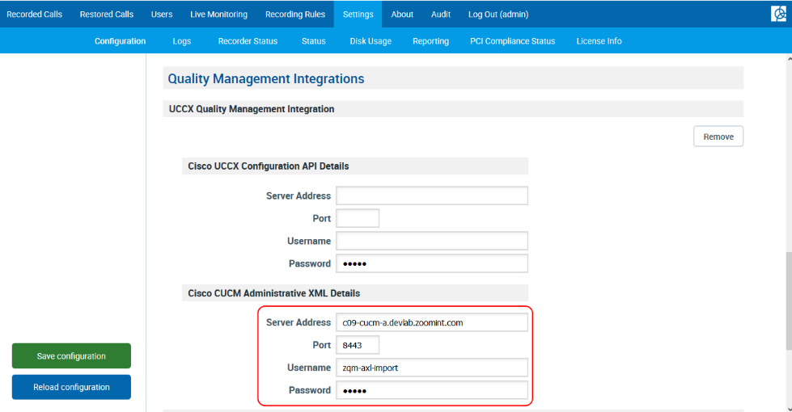

Save the configuration to apply the changes.

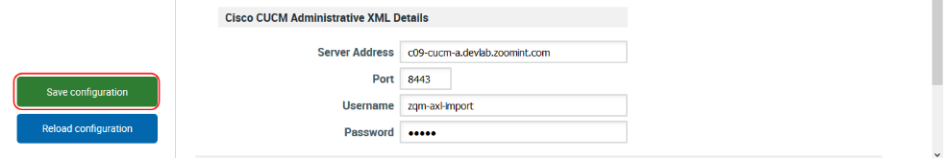

With this configuration will be imported users able to authenticate with CUCM.

#### Configure Quality Management user import Group and Role

The zqm-axl-importer tool imports all users into predefined group in order to provide the possibility to sort the users manually into user defined groups. The default group of zqm-axl-importer tool is _CUCM_imported. This group does not exist and needs to be created.

Similarly, all users are imported with Agent role by default. ZOOM Quality Management configuration for Agent role provides possibility to view own calls and evaluations finished by supervisors. If there is need to import users with other role, this role must be created prior the import.

Login as a ccmanager to ZOOM Quality Management web interface to adjust the Quality Management settings for zqm-axl-importer tool.

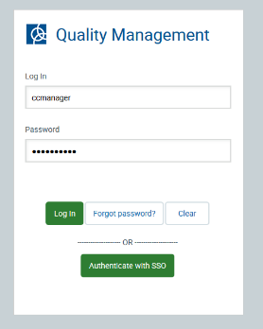

Navigate to **Administration -> Teams** to create new use group.

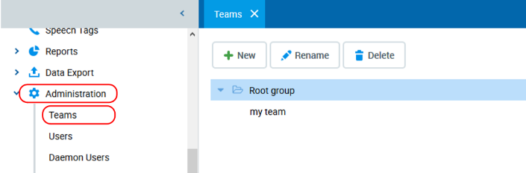

Select Root Group and click New to create new sub-group within the Root group.

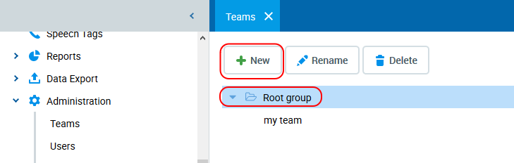

Fill in the group name: _CUCM_imported (or your own group name) and click **Create**

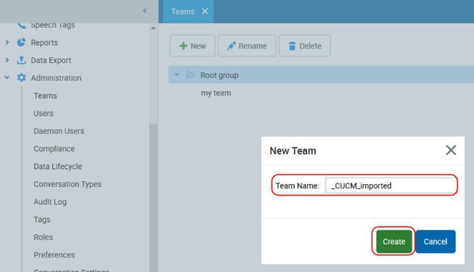

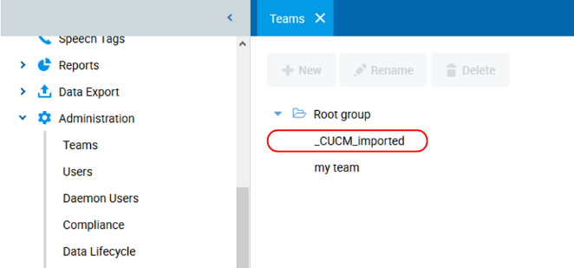

In case a specific role is required to be used for the import create the new role in **Administration -> Roles -> New**

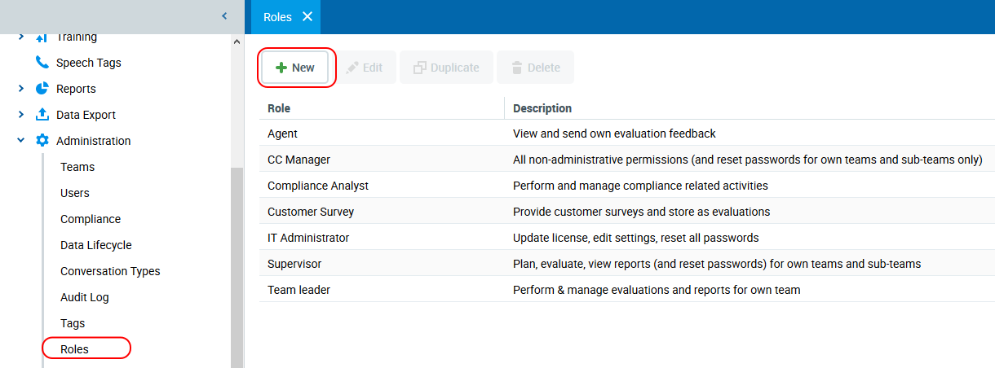

At this moment is the ZOOM Quality Management configured for user import from CUCM by zqm-axl-importer tool.

## Description of Installation package

The callrec-zqm-axl-importer tool is provided in the form of zip file, which contains following files:

**callrec-zqm-axl-importer tool**

**zqm-axl-importer**

**Default configuration**

config.json

config.yaml

**Supporting tools**

jmxterm-1.0.1-uber.jar

flush_sc_cache.txt

**Linux service file**

callrec-zqm-axl-importer.service

**Installation script**

install_zqm_axl_importer.sh

remove_zqm_axl_importer.sh

**SQL scripts**

00_cleanup.sql

01_createschema.sql

02_createtable.sql

### callrec-zqm-axl-importer tool

The callrec-zqm-axl-importer tool consists of main binary file {zqm-axl-importer), configuration file (config.json) and supporting libraries (jmxterm-1.0.1-uber.jar, flush_sc_cache.txt). The tool runs as a linux service (callrec-zqm-axl-importer.service).

#### zqm-axl-importer

The zqm-axl-importer binary file is the main file of the installation. It ensures connection to the CUCM, import phone devices and users into own database tables, periodic reload of users in the ZOOM QM database. The tool is configurable by the configuration file (See configuration). If enabled, the zqm-axl-importer runs as a linux service, together with the ZOOM application services. The tool requires to have the DB structure prepared (see SQL scripts). The correct user structure presentation in the ZOOM QM is ensured by cleaning QM caches, after user reload. Cleaning caches of QM is initiated by the zqm-axl-importer tool after the user reload.

#### Configuration files

The zqm-axl-importer tool supports two formats of configuration files (json, yaml). The json format is used by default. The config.json (yaml) is part of the installation package. The configuration is edited as a part of the installation process.

#### Supporting tools

The zqm-axl-importer tool imports CUCM users directly to the QM database. As the zqm-axl-importer is not directly integrated into ZOOM QM, the tool must force ZOOM QM to drop caches in order to reload the user reload in the QM. This drop of caches is ensured by connecting to tomcat jmx console using the jmxterm-1.0.1-uber.jar and executing list of commands stored in the flush_sc_cache.txt file.

#### Linux service file

The zmq-axl-importer tool runs as a Linux service. The service configuration is set by the callrec-zqm-axl-importer.service, which ensures, correct service start. The service has defined both default directory (/opt/zqm-axl) and configuration file (/opt/zqm-axl/config.json).

### Installation script

The zip file includes installation (iznal_zqm_axl_importer.sh) and removal scripts (remove_zqm_axl_importer.sh). These scripts serve to deploy and setup / uninstall the zqm-axl-importer tool.

The installation script run the SQL scripts to initialize the DB structure required by the zqm-axl-importer tool. The SQL scripts prepare DB scheme (axl_data), DB tables (axl_users, couple_last_update), table views (axl_user_device_view, axl_user_line_view) and procedures with the callrec database.

The removal procedure cleans up the DB structure.

## Pre-deployment tasks

The tool is designed to be deployed on the same server, where the ZOOM Quality Management is running.

Prior to the installation verify the following:

CUCM AXL user exists This user is used by the zqm-axl-importer tool to connect to CUCM and download list of devices, lines and user. see chapter 5.1.1

CUCM JTAPI user/s exist This user is used to import information about recorded devices. See chapter 4.1

ZOOM DB connection is opened pg_hba.conf on DB server)

**Note:** If your ZOOM Quality management is running, then the DB is most probably configured correctly to accept DB connections

Upload the installation zip file to the sever, where ZOOM Quality management application is running. You can use winscp for the upload. In this example will be installation package uploaded to /home/admin directory. The admin username and admin password are used.

Create a new sub-directory in /home/admin directory

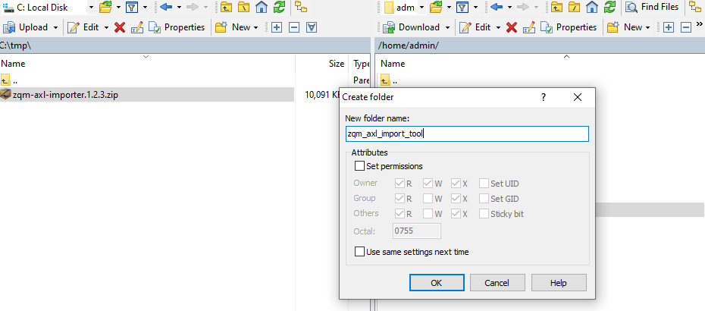

Copy the installation zip file into this newly created directory

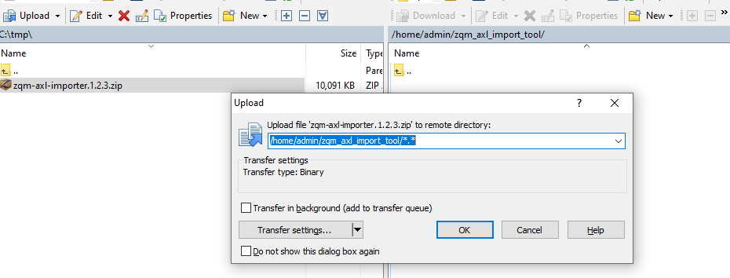

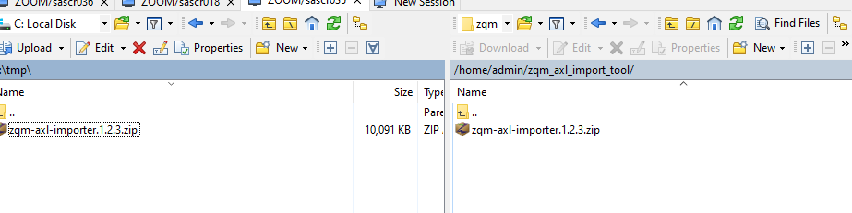

Next steps require ssh connection the server and root privileges.

## Deployment

### Upload zqm-axl-importer to ZOOM QM server

In previous step was the zqm-axl-importer tool uploaded via WinSCP to the server into the /home/admin/zqm_axl_import_tool directory. The deployment procedure requires ssh connection to the server. You can use putty or the ssh client.

Login to the server with admin privileges and then switch to root.



Change the directory to directory, where the zip file was uploaded (in our example /home/admin/zqm_axl_import_tool)

[root@sascr036 ~]# cd /home/admin/zqm_axl_import_tool/

[root@sascr036 zqm_axl_import_tool]#

Unzip the zip archive file

[root@sascr036 zqm_axl_import_tool]# unzip zqm-axl-importer.1.2.3.zip

Archive: zqm-axl-importer.1.2.3.zip

inflating: 00_cleanup.sql

inflating: 01_createschema.sql

inflating: 02_createtable.sql

inflating: callrec-zqm-axl-importer.service

inflating: config.json

inflating: config.yaml

inflating: flush_sc_cache.txt

inflating: install_zqm_axl_importer.sh

inflating: jmxterm-1.0.1-uber.jar

inflating: remove_zqm_axl_importer.sh

inflating: zqm-axl-importer

[root@sascr036 zqm_axl_import_tool]#

Verify the callrec-web-qm service is enabled on this server

[root@sascr036 zqm_axl_import_tool]# systemctl is-enabled systemctl is-enabled callrec-web-qm

enabled

Verify the connection to the DB server is opened (our example uses 10.17.4.35)

[root@sascr036 zqm_axl_import_tool]# psql -U postgres callrec -h 10.17.4.35 -c"select count(1) from sc_users;"

count

-------

3

(1 row)

If the ZOOM QM application is running in the server and your connection to the DB server is opened, we can proceed with installation

### Installation using installation script

The Installation script guides you through the installation and configuration process.

If you are in the directory, where the tool is unzipped, run the installation by following command:

[root@sascr036 zqm_axl_import_tool]# /bin/bash install_zqm_axl_importer.sh

The first step of the installation process is verification, whether all expected files are in place.

INFO The installation and configuration of callrec-zqm-axl-importer tool started.

-------------------------------

Running installation consistency check

INFO SQL consistency - all required files found

INFO TOOLS consistency - all required files found

INFO SERVICE unit consistency - all required files found

If some file is missing the installation reports missing files and stops.

The next step is verification, whether some older configuration file exists. If so, it can be used for re-installation. If not, the default configuration file config.json is used.

Checking old configuration.

INFO Old configuration file not found.

INFO Reading default configuration file: /home/admin/zqm_axl_import_tool/config.json.

INFO Creating temporary configuration file: /home/admin/zqm_axl_import_tool/config.json_tmp

If old configuration was not found (clean install) or old configuration should not be applied, a prompt for new values appears.

New configuration is required to proceed the installation:

----------------------------------------------------------

CUCM publisher address to load users from: [single ip address] [cucm.server] : c09-cucm-a.devlab.zoomint.com

Fill in the hostname of the CUCM publisher, which will be used for user import.

CUCM AXL user username: [username] [cucm.user] : zqm-axl-import

Fill in the CUCM AXL API user username (prepared in previous steps chapter 5.1.1)

CUCM AXL user password: [username] [secret.password] : Pzqm-axl-importP

Password for the CUCM AXL API user (prepared in previous steps chapter 5.1.1)

CUCM Access Group name: [Access Group Name]: [ZOOM QM Access Group] :

CUCM Access Group created as a part of CUCM configuration settings. CUCM user with this access group assigned will be able to login to ZOOM application.

ZOOM JTAPI users used for call recording [space separated list] [jtapi.user] : callrec callrec2

Fill in all application users used for call recording. The list must be **space separated list**.

QM Database IP address [single ip address] [localhost] : 10.17.4.35

IP address of the server, where the database of ZOOM QM is running. Default localhost.

QM default user group [group name (without spaces)] [_CUCM_imported] :

Fill in the user group name that will be used for user import. See chapter 5.1.2.3 for more details.

QM default user role [role name (without space}]: [Agent] :

Fill in role name, the user will have assigned after import. See chapter 5.1.2.3 for more details.

QM default user hours [space separated list 0..23 ]: [4] : 0 2 4 6 8 10 12 14 16 18 20 22

Fill in space separated list of hours, when the users will be updated in the ZOOM Quality Management. The example above shows configuration for update every 2 hours

Which method should be used for mapping calls to users? (Device [D] / Line [L] / Both [B]) [D/L/B]: [both]

Fill in the method, which will be used for mapping of calls to user accounts in the QM. The default method is “both”. If both is set the calls are mapped the mapping attempts to map calls based on the device name first, and if the calls are not mapped, the mapping based on “line: association is used. Mapping based on “line” may be used to support mobility extension.

Please verify the values above.

Are the configuration correct ? If Yes, the configuration will proceed. [Y/N] :

If the filled in values are correct the installation can be confirmed by “Y”.

After confirmation the installation process starts. Installation package files are copied to /mnt/zqm-axl destination directory. Database structure is updated by sequence of SQL scripts:

00-cleanup.sql Cleans up the DB from previous zqm-axl-importer installation. This script may report errors related to missing db schemas in case of first installation.

01_createschema.sql Prepares DB **axl-data** schema and user **axlUser** within the callrec DB. The axlUser will be used to access the callrec DB by the zqm-axl-importer tool

02_createtable.sql Creates new tables, views and functions within the callrec DB.

The callrec-tomcat service is updated to open the port for jmx console. Opened port is set 8765. This port is blocked by FW rules by default and can be access from localhost only. The jmx console will serve to for updates of the caches of ZOOM Quality Management.

At the end of the installation process is possible to perform the initial run of the zqm-axl-importer tool.

INFO Initial user import is recommended.

Do you want import users now ? [Y/N]

If the initial import is not performed, the users will not be imported with the installation. Users will be imported with next run of user import as specified during the installation and set in the configuration file by parameter "userImportHour":

The installation continues by configuration and enabling the callrec-zqm-axl-importer.service.

Completed installation print out the status:  
-------------------------------

INFO Installation is finished.

Database 10.17.4.35 was updated

Configuration can be found in /opt/zqm-axl/config.json .

You can check the service status by command "qm-services".

[root@sascr036 zqm_axl_import_tool]#

The configuration file **config.json** can be found in **/opt/zqm-axl/** directory.

The running services can be verified by the command **qm-services** .

### Adjusting configuration

The configuration can be adjusted be either running the installation script or (better way) editing the configuration file. The configuration file for zqm-axl-importer tool is: **/opt/zqm-axl/config.json**.

#### Configuration file description

The configuration file used by the zqm-axl-tool is config.json. It contains following configuration objects:

axl axl configuration object is used for connection details to CUCM server to download data.

zqm zqm configuration object specifies configuration related to ZOOM Quality Management. It is possible to configure list of jtapi users used to download device information in the configuration part

Log log configuration object servers to specify the mainly the log level and log file

processing configures the processing part of the zqm-axl-importer tool. This configuration specifies the target group in ZOOM Quality Management to be used for user import, imported user role and periodicity of user import. Ii is possible to configure the periodicity, how often will be calls matched with use accounts as well.

##### axl configuration object

This configuration usually does not need any edit after initial installation. The change will be applied mainly in case of some configuration change on CUCM site.

"server" hostname of the CUCM publisher. Only single CUCM cluster is supported.

"user" AXL user created on CUCM, which serves to zqm-axl-importer to connect to CUCM and download required data. See chapter 5.1.1 for more details

"password": Password for the AXL user.

"ignoreCertificate" Provides the possibility to ignore CUCM https certificate validity. It is not recommended to change the configuration unless you are troubleshooting CUCM connection.

Default: false

##### zqm configuration object

The zqm configuration object is edited mainly in case of change list of jtapi users used for call recording. Remaining parts are usually not changed after the initial setup.

"jtapiUser": Array of jtapi users used for call capture. Array starts with “[“ and ends with “]”. Jtapi users are separated by “,”. The jtapi users are used to load devices and users, who have assigned these devices, from CUCM to create ZOOM Quality Management accounts. The user accounts are mapped with calls made by these devices. More detail can be found in chapter 4.1.2 or 4.1.3. Change the value in case the jtapi user for call recording changes.

"dbServer": IP address of ZOOM Quality Management DB Server.

"dbPort" TCP port for ZOOM Quality Management database. Do not change in case the DB port was not changed for ZOOM Quality management DB

Default: 5432,

"dbUser" zqm-axl-importer user for accessing the DB. Do not change unless installation script were modified.

Default: "axluser",

"dbPassword" dbUser password. Do not change unless you have changed the password in the DB manually.

Default: "a4lUs3r.",

"javaXTerm" jar file used for accessing the jmx console for user list reload. Do not change unless you really want to use another file

Default: "/opt/zqm-axl/jmxterm-1.0.1-uber.jar",

"javaFlush" List of commands sent to clean ZOOM Quality Management user list caches. Do not change unless you need to change this background process.

Default: "/opt/zqm-axl/flush_sc_cache.txt"

##### log configuration object

Log configuration is usually needed to change in case of troubleshooting, where standard INFO level does not provide data with enough detail.

"level" Specifies the log level.

Default: "INFO"

"fileName" Specifies the log file name. usually not needed to changes unless you decide to log into separate file.

Default: "/opt/callrec/logs/zqm-axl-importer.log"

"jsonFormat" Provides possibility to log into json format. Usually not required, unless you use tools, which process the json format automatically.

Default: false

"logProgramInfo" provides the possibility to log high level details of zqm-axl-importer tool. This level is used usually for debugging purposes.

Default: false

"maxSize" Maximum log file size in MB. Reaching the max file size triggers log rotation. Usually not change needed to changes, unless you have changed the log level and you need to keep same history

Default: 50

"maxBackups" Specifies how many old logs will be kept. Usually not change needed to changes, unless you have changed the log level and you need to keep same history

Default: 5

"maxAge": complementary to maxSize. Specifies the maximum age of log file.

Default: 30

“quiet" If set to true, logging is disabled.

Default: false

##### processing configuration object

This configuration object will be mainly changed by administrators. It specifies the zqm-axl-importer tool behaviour.

"mappingType" Configuration parameter specifies, whether calls will be mapped with user accounts based on the Device / Line association or Both methods will be applied. If Both is set, the first attempt for mapping is based on Device name, the second one is based on Line. The Line association may be used to support mobility extension.

"hoursBack" This configuration parameter specifies how old calls (in hours) should be processed by the zqm-axl-importer tool. This parameter is applied for the first run of the zqm-axl-importer tool and when the tool is not running for a longer time. Under normal operation is applied value stored in the DB (table: axl_data.couple_last_update)

Default: 24

"userImportHour": Array of whole hours used for user import CUCM into ZOOM Quality Management. Array starts with “[“ and ends with “]”. Hours are separated by “,”. Minimal value (midnight): 0, Maximum value 23. Hours are 24h format.

Default: 4

"defaultTeamName" Name of the Team (Group) in the ZOOM Quality Management, into which users will be imported. More details can be found in chapter: 5.1.2.3.

Default: "_CUCM_imported"

"defaultRoleName" User role, under which the users will be imported into ZOOM Quality Management. More details can be found in chapter: 5.1.2.3.

Default: "Agent"

"updateInterval": Specifies how often (in minutes) will be mapped new calls with user account in ZOOM Quality Management. This interval will be used for updating table couples in ZOOM Database with agent ids stored in the axl_data.axl_users table.

Default: 5

### Database description

Tool accesses the database with own **user axlUser**. The zqm-axl-importer tool uses own **DB schema: axld_data.**

List of relations

Schema | Name | Type | Owner

----------+--------------------------------------+----------+------------

axl_data | axl_user_device_view | view | postgres

axl_data | axl_user_line_view | view | postgres

axl_data | axl_users | table | postgres

axl_data | couple_last_update | table | postgres

The main database table created for zqm-axl-importer is **axl_users**, where all associations between users, devices and lines are stored. Besides the data table itself, two views are available **axl_user_device_view,** which provides association of users and devices, and **axl_user_line_view**, which provides association of users and lines. The cursor for calls update is stored in **couple_last_update** table.

#### Table axl_users

The axl_users table contains following columns:

user_pkid Unique user identifier (unique per deployment) - consist of CUCMcluster_id_

device_pkid Unique device identifier (unique per CUCM cluster) - consist of device identifier unique within the CUCM cluster

line_pkid Unique line identifier (unique per CUCM cluster) - consist of device identifier unique within the CUCM cluster

first_name User first name does not have to be unique

middle_name User middle name does not have to be unique

last_name User last name does not have to be unique

user_id User is unique per CUCM cluster

department User department information

status 1=enabled user

0=disabled user

does not affect user pairing. disabled user is not allowed to login to CUCM, but can make calls

is_local_user t=user is local on CUCM ,

f=Integrated-downloaded from AD

does not affect ZOOM (CUCM is able to make authentication proxy)

directory_uri this may be the email address (on CUCM serves dialling using the directory URI)

mail_id this may be the email address

device_name device name. Pairing device_pkid and device_name is unique; the import script already threw away those records, where this uniqueness is matched. The script reports into the log non-unique pairs

device_description device description

line_number phone line number. Pairing line_pkid and line_number is unique. The import script already threw away those records, where this uniqueness is matched. The script reports into the log non-unique pairs

line_alerting_name in callrec is display name

line_description line description

is_deleted_on_axl the imported user in ZOOM DB is deleted by the CUCM import 5 days after this user is deleted in AXL. This is because ZOOM and CUCM are were asynchronous.

If set to true, then this user will not be paired with calls

wbsc_id 0 - user is not in wbsc DB

other value than 0 - refers to sc_users - userid (sequence number)

date_inserted timestamp when the user was inserted into the DB

date_updated last update timestamp

#### Table couple_last_update

The couple_last_update holds information with timestamps, when the last update of couples was started and what was the last update_ts timestamp processed by the tool.

id Integer (1,2)  
1 ..cursor for update by device name   
2 ..cursor for update by line

last_process Timestamp of the last run of the calls update

last_couple_update_ts Update timestamp of the last updated call.

#### Database procedures

Database procedure are used for users, QM and calls updates.

callrec=# SELECT proname FROM pg_catalog.pg_namespace n JOIN pg_catalog.pg_proc p ON pronamespace = n.oid WHERE nspname = 'axl_data';

proname

------------------------------

axl_update_users

axl_update_qm

axl_update_couples_by_device

axl_update_couples_by_line

# Troubleshooting

## Understanding the log file

The zqm-axl-importer writes logs to /opt/callrec/logs/zqm-axl-importer.log log file by default. The log file provides information about processing the users as well as mapping users to captured calls.

### zqm-axl-tool initialisation.

Initialisation of the zqm-axl-importer tool is on reported on the zqm-axl-importer start.

ApplicationName="ZQM AXL Importer 1.2.3" Arch=amd64 CPUs=2 RuntimeVersion=go1.14 level=info msg="Application Initializing" time="2020-05-06 10:41:33.583"

Provided information:

Application name and version:

Application initialization date and time

After the initilialisation is finished, the scheduled routines are started.

There exist 2 routines.

User import

Call update (mapping users to calls)

level=info msg="start scheduled routines" time="2020-05-06 10:41:33.583"

Provided information

Star if scheduled routines

### Calls update

Calls update is periodic task configured as "updateInterval" value within the configuration file. Calls update updates table couples within the DB, and fills in the calling and called agent identification (callingagent / calledagent) if the external data are match the device name.

Scheduled task starts updating calls with calling and called agent values

level=info msg="now update call data" time="2020-05-06 10:41:33.598" update at="10:41:33.5980"

Command used for calls update together with the reports whether the procedure within the DB is finished successfully.

command=connectUpdateCalls level=info msg="Success update call data" time="2020-05-06 10:41:33.598"

This message is followed by the report about how many calls matched the search criteria:

level=info msg="Prepare couples to processing" process=PREPARE records=2 time="2020-05-06 10:41:33.627"

Provided information:

Process used = PREPARE

**records** presents how many calls match the select criteria - 2 calls for processing found

Follow up report provides information how man calls were updated with calling/called agent value.

level=info msg="Updated couples" process=UPDATE records=0 time="2020-05-06 10:41:33.627"

Provided information:

Process used = UPDATE

**records** presents how many calls were updated with calling/called agent information – o calls updated

The calls update routine ends with setting of new cursor timestamp within the DB

last_ts="2020-05-05 15:04:22 " level=info msg="Stored last update timestamp from couples" process=LAST time="2020-05-06 10:41:33.627"

Provided information:

**last_ts** is the value stored in the DB as last updated call.

**LAST time** is the last updated timestamp from table couples.

### User update

User update runs at specific times configured in configuration files under configuration option userImportHour. The User update procedure connects to the CUCM using the AXL user account.

id=iYsuKZLnxE AXL-DB=11.0 AXLVersion="11.5.1.14900(11)" level=info msg="actual AXL version [11.5.1.14900(11)], DbVersion [11.0]" server=c09-cucm-a.devlab.zoomint.com time="2020-04-28 20:14:34.936"

Provided information:

**AXLversion** provides information about CUCM version

**server** hostname of the CUCM server

**time** timestamp

If the login to the server is successful the confirmation message is printed out.

id=iYsuKZLnxE AxlUser=ccmadmin level=info msg="login to server is valid true" server=c09-cucm-a.devlab.zoomint.com time="2020-04-28 20:14:34.936"

Provided information

**Info msg:** login to server is valid true

**server** hostname of the CUCM server

**time** timestamp

After the login the zqm-axl-importer tool starts to load the users and devices into internal cache. Duplicities are reported and removed from cache before writing them into the DB. In case of duplicate records the error is reported

level=error msg="all duplicate association remove from source data" time="2020-04-28 20:14:35.118"

Provided information

**Info msg:** all duplicate association remove from source data

The information about duplicities is followed by the report of devices associated with multiple users

level=error msg="Device [CSFagent14 - Client 14 2304] associate to next User ID: [agent14, kc.super01]" time="2020-04-28 20:14:35.118"

level=error msg="Device [CSFagent13 - Client 13 2303] associate to next User ID: [agent13, kc.super01]" time="2020-04-28 20:14:35.118"

Provided information

**Device**  Information which device is associated with more than 1 user in format <device_name – device_description>

**User ID:** List of user IDs associated with this device

**time** timestamp

Similarly, duplicities in associated lines are reported

level=error msg="Line [2032 - (019)2032] associate to next User ID: [agent02, agent03, agent04]" time="2020-04-28 20:14:35.118"

Provided information

**Line** Information which line is assigned to more multiple users in format <line – alerting_)name>

**User ID:** List of user IDs associated with this line

**time** timestamp

The zqm-axl-importer tool generates all combinations of users, lines and devices and removes the duplicities. Unique rows are written to the DB

level=info msg="From source AXL table remove 114 rows" removedRows=114 time="2020-04-28 20:14:35.118"

level=info msg="From source AXL table prepare 27 valid rows" time="2020-04-28 20:14:35.118" validRows=27

Valid rows are written to the ZOOM DB (table axl_data.axl_users)

level=info msg="Success update AXL source table" time="2020-04-28 20:14:35.147"

The import into zqm-axl-importer tables is followed by the update of users in the ZOOM Quality Management

level=info msg="now update prepare 27 rows" rows=27 time="2020-04-28 20:14:35.147"

command=connectUpdateQm level=info msg="Success update QM users" time="2020-04-28 20:14:35.148"

Provided information

**msg**: Success update QM users

Executing of DB update with return value succeeded.

The information is followed by the report.

level=info msg="Use parameters for insert" operation=PARAM parameter="Group: _CUCM_imported" time="2020-04-28 20:14:35.168"

level=info msg="Use parameters for insert" operation=PARAM parameter="Role: Agent" time="2020-04-28 20:14:35.168"

Report from DB command for update users in the ZOOM Quality Management database. User group is reported under **Group** parameter and user role is reported in the **Role** parameter.

level=info msg="Add new user to QM" operation=ADD time="2020-04-28 20:14:35.168" user=agent01

level=info msg="Add new user to QM" operation=ADD time="2020-04-28 20:14:35.169" user=agent10

level=info msg="Add new user to QM" operation=ADD time="2020-04-28 20:14:35.169" user=agent09

Adding users into the ZOOM Quality management DB. The operation can have following values:

operation=ADD adding user into the QM DB

operation=UPDATE updating the user account in the QM DB

operation=DELETE marking the user DELETED in the QM DB

### Error messages

In case the ZOOM DB is not initialized properly, the axlUser may be missing in the DB. In such case the update cannot proceed and following error message can be found:

level=error msg="problem connect to DB. failed to connect to `host=localhost user=axluser database=callrec`: server error (FATAL: role \"axluser\" does not exist (SQLSTATE 28000))" time="2020-04-28 10:02:42.555"

Database is not initialized correctly, the database user is missing in the DB.

The process of user import / update into the ZOOM QM is finished, the procedure is followed by the reload of ZOOM QM caches by supporting tool.

level=info msg="success clear cache" process="Clear cache" time="2020-04-28 20:10:35.726"

Error message reporting the ZOOM Quality Management cache was not cleaned up. The reason may be the web UI was not configured properly for jmx console or the web-ui is not running.

error="exit status 1" level=error msg="cache clean command ends with error exit status 1" process="Clear cache" time="2020-04-28 20:14:35.926"

When AXL user privileges are no set correctly, the zam-axl-tool may fail to connect to the CUCM. The error log may look in the following way:

ApplicationName="ZQM AXL Importer 2.0.2" Arch=amd64 CPUs=2 RuntimeVersion=go1.14 level=info msg="Application Initializing" time="2020-05-25 12:05:21.188"  
id=tBMXXvEFCN error="<nil>" level=error msg="not support DB version." server=cucm-lab.testenvironment.com

 time="2020-05-25 12:05:21.478"  
id=tBMXXvEFCN AxlUser=qmsasimporter level=info msg="login to server is valid true" server= cucm-lab.testenvironment.com time="2020-05-25 12:05:21.478"  
id=tBMXXvEFCN error="<nil>" level=error msg="not support DB version." server= cucm-lab.testenvironment.com time="2020-05-25 12:05:21.478"  
level=error msg="problem with AXL connection or DB version not supported" time="2020-05-25 12:05:21.478"

Provided information:

Info. msg login to server is valid true

- The credentials are correct

- username used for login was: AxlUser= qmsasimporter

error.msg not support DB version

- <nil> - the message could not be read

- server =cucm-lab.testenvironment.com – hostname of the server the tools tries to connect to

## Verification of config file validity

Besides running the zqm-axl-importer tool as a service it is possible to run it as a one-shot. Using the “-h” parameter provides help

[root@sascr036 ~]# /opt/zqm-axl/zqm-axl-importer -h

usage: zqm-axl-importer [<flags>]

Flags:

-h, --help Show context-sensitive help (also try --help-long and --help-man).

--show Show actual configuration and ends

--config=cfg.yml Configuration file default is "server.yml".

--cli Run only once and ends

--version Show application version.

To see, whether the configuration file was correctly loaded use following command:

[root@sascr036 ~]# /opt/zqm-axl/zqm-axl-importer --show --config=/opt/zqm-axl/config.json

The tool starts its initialisation and loads the configuration, which prints on the screen

[root@sascr036 ~]# /opt/zqm-axl/zqm-axl-importer --show --config=/opt/zqm-axl/config.json

ApplicationName="ZQM AXL Importer 1.2.3" Arch=amd64 CPUs=2 RuntimeVersion=go1.14 level=info msg="Application Initializing" time="2020-05-06 11:03:51.616"

Application ZQM AXL Importer 1.2.3

- Runtime version go1.14

- CPUs 2

- Architecture amd64

- Config file /opt/zqm-axl/config.json

- Run once false

AXL

- Server c09-cucm-a.devlab.zoomint.com

- User zqm-axl-import

ZQM

- JTAPI User [callrec, callrec2]

- DB Server 10.17.4.35:5432

- DB User axluser

- JAVAX-Xterm /opt/zqm-axl/jmxterm-1.0.1-uber.jar

- Java Flush command /opt/zqm-axl/flush_sc_cache.txt

Processing

- Hours back 24

- Default team name _CUCM_imported

- User import hours 0, 2, 4, 6, 8, 10, 12, 14, 16, 18, 20, 22

- Couple mapping by line

Logging

- Level INFO

- Use JSON format false

- Logging file /opt/callrec/logs/zqm-axl-importer.log

- Logging program details false

- Maximal file size in MB 50

- Number of backups 5

- Maximal age in days 30

- Backup compress true

## Running one shot

For troubleshooting purposes is useful to tun the tools as a one-shot. The one-shot run loads data from CUCM (devices, lines and users) and import users into ZOOM Quality Managent. After that the calls are updated with calling/called agent. To run the one-shot use following command:

root@sascr036 ~]# /opt/zqm-axl/zqm-axl-importer --cli --config=/opt/zqm-axl/config.json

## Forcing calls re-scan

The zqm-axl-importer tool attempts to assign all calls, which are not assigned to agents (callingagent/calledagent ae not filled in) only. The mapping of calls to user accounts runs periodically. The period is set by the configuration parameter: "updateInterval" in configuration file.

It may happen, that users are added to the QM with some delay and some calls were recorded meanwhile. Such calls will not be mapped to these user accounts by normal operation, because the cursor in DB is set to more recent time. The cursor must be set back in time to re-scan these calls.

Keep in mind, that configuration parameter "hoursBack" limits the maximum time interval which is scanned backwards. The default value is set to 24hours.

To set the cursor back in time is possible to use the following command (Example sets time cursor 24hours back. The example updates the local DB).

psql -U postgres callrec -h localhost -c"update axl_data.couple_last_update set last_couple_update_ts=now()-interval'24hours';"

# About ZOOM International & Eleveo

ZOOM International exists to elevate every encounter for contact centers.  Our elevēo software captures customer sentiment at the point of contact, providing actionable insights for improving customer experience, optimizing agent effectiveness and maintaining compliance.

No other WFO software provides a full 360-degree view of omnichannel interactions, survey results, customer sentiment and quality reviews in a single place the way ZOOM does.

We serve over 2200 customers and partners worldwide, ranging from sub-100 agent contact centers to brands like IBM, HCA, Finansbank, Tata Sky, Generali, Allianz, and Vodafone spanning 90 Countries.

Contact Details

Karolinská 650/1 (Danube House)  
186 08 Prague 8 - Karlín

Tel.: +420 222 554 111

Service and Support: +420 222 554 112 and +1 (512) 553-4569

See our web site at: <https://www.zoomint.com/>

For general enquiries email to: [info@zoomint.com](mailto:info@zoomint.com)

For Service and Support for existing customers Global: [helpdesk@zoomint.com](mailto:helpdesk@zoomint.com)

For Service and Support for existing customers for US: [ushelpdesk@zoomint.com](mailto:ushelpdesk@zoomint.com)

For Product documentation go to ZOOM Portal, to the section Documentation: <https://portal.zoomint.com/>