**SQL COMMANDS ASSIGNMENT -1**

**1.**show all employees who work in IT department

Query : select * from employees where department = 'IT';

**2.**Find employees whose salary greater than 60,000.

Query : select * from employees where salary > 60000;

**3.**Get all employees who joined after 1st jan 2020.

Query : select * from employees where joining_date > '2020-01-01';

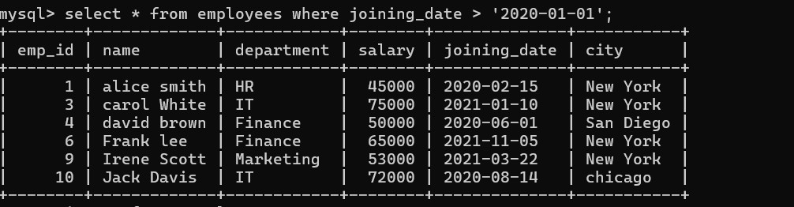

**4.**Find the total salary paid to employees in each department.

Query : select department, sum(salary) as total_salary from employees GROUP BY department;

**5.**show the highest paid employee in finance department.

Query : select * from employees where department = 'Finance' ORDER BY salary desc limit 1;

**6.**list employees who are from Chicago and earn more than 55000.

Query : select * from employees where city = 'Chicago' and salary > 55000;

**7.**Find the number of employees in each city.

Query : select city, count(*) as employee_count from employees GROUP BY city;

**8.**show employees in IT department ordered by salary in descending order.

Query : select * from employees where department = 'IT' ORDER BY salary desc;

**9.**Display average salary of all employees.

Query : select avg(salary) from employees;

**10.** Get the details of the top 3 highest paid employees.

Query : select * from employees ORDER BY salary desc limit 3;

