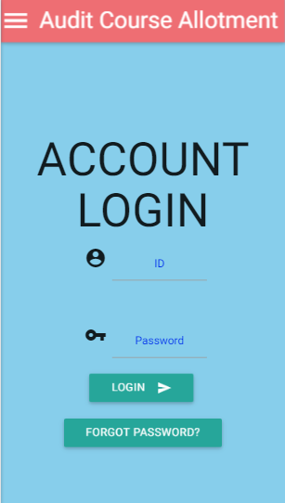

ACAWA

AUDIT COURSE ALLOTMENT WEB APPLICATION

KARTIK SHENOY & RAJ POLADIA | WEB TECHNOLOGY | 19TH October 2016

# INTRODUCTION

Course allotment processes in the colleges (not huge universities) is still done manually in many terms, from creating the form to sorting the list to the final allotment. This way of doing the task is not efficient and is prone to the errors such as multiple submissions by same user and multiple allotment of the courses to the same user. So to overcome this problem and making the whole process efficient and very minimal risk of errors we have developed a WEB APPLICATION which basically automates the process.

## Purpose of development

In out college KJ SOMAIYA COLLEGE OF ENGINEERING (KJSCE) after becoming autonomous an educational activity called AUDIT course is conducted in which each student need to take 1 course per semester, this gives the students the opportunity to learn something that interests them and out of the academic syllabus. Not all student can opt for the same course, so for allocation of courses to student a form is created and is need to be filled and submitted in the given time frames. All the processes i.e. Creation of the form and sorting the form results and allocating the user an appropriate course with respect to his/her priority and availability of the course.

There are some problems in this whole process, although the instruction to fill the form only once is given there might be some exceptional cases in which the student submits the form multiple times and there are multiple courses allocated to that particular student, so to avoid such problems this development took place.

## SCOPE

Scope of this application is not just limited to use in our own college KJSCE, but is vast, it can be implemented for many purposes just the conditions of acceptance and rejection changes in different cases for such processes. Currently the main aim of this development is to make use of this application for the actual allotment process for the real life results.

## REFErences

Development of something cannot take place without references, so here too we have multiple references to the resources that are required to build the application and make the process less erroneous and more efficient.

Major references are:

1. W3SCHOOLS.COM
2. STACKOVERFLOW.COM
3. WIKIPEDIA.ORG
4. YOUTUBE.COM
5. MATERIALIZE.css
6. jQuery, etc.

# OVERALL DESCRIPTION

There are lot of components in this application, each and every component must work efficiently and must interface with the other components for the efficient and error less functioning of the application. Some of the major modules are as follows:

## user interface

Users of the application are of the two types, one type is ADMIN type which will have authority to change the settings of the application and manage the application as required. Second type of users are STUDENT type which can just see the result, fill the form and browse the content, no other stings are exposed to the students.

Users can interact with the system with the help of mouse and keyboard as well as touch input, the website is optimized even for mobile devices, this enables users to perform the required tasks on the go.

## hardware REQUIREMENTS

* A computing device which can access the internet.
* Server to serve the requests of the users and store and manipulate the database.

## software REQUIREMENTS

* Proper operating system installed on the system.
* A web browser which supports latest web technologies.

## website requirement

* A web browser supporting the latest web technologies for security purpose.
* A JavaScript enabled browser.
* Active and consistent INTERNET CONNECTION with the minimum speed of 512kbps for smooth operations.

# PRODUCT(SOFTWARE) FEATURES

The newly developed applications have number of useful features and would be added in the further releases, some of the core features are listed below:

## navigation

The basic feature of any application that decides it’s usability is the NAVIGATION, how simple and logical the navigation of the app is, this all parameters decide the usability of the application. Developers have tried their best to keep the navigation more logical and not too complicated, such as clicking the pie button to get the list of all the sections, on clicking/touching the name of particular section, that particular section is loaded.

## aesthetic layout

Layout of the website is optimized for all the form factors of the devices as well as the most popular screen sizes, so that the application can be used by any device user owns which satisfies the minimum requirement to use the application. Layout is dynamic so that if the size of the windows is changed then the elements on the page will re adjust themselves to make sense rather than randomly settling.

## effective graphic design

Logical and interactive graphics are used throughout the website to make the website more intuitive and interactive, and the statistical data is also displayed using the graphical charts and graphs to make the data more understandable.

## self explanation

The website or application is pretty much self-explanatory, the language used is not too technical and use of the jargons are controlled to make the website usable by not too technical users, logical layout and graphics make the operations feel more natural and performing the task is simple and a special training is not required.

## logical database requirements

Database is stored and manipulated on the server so the basic requirement of the database is the server.

**Database details :**

* Database is used to store the login credentials of the user.
* Details of the students.
* Details of the Courses.
* Details of the submitted choices and allotted course.

**Database name : ACAWA**

**Tables and relations :**

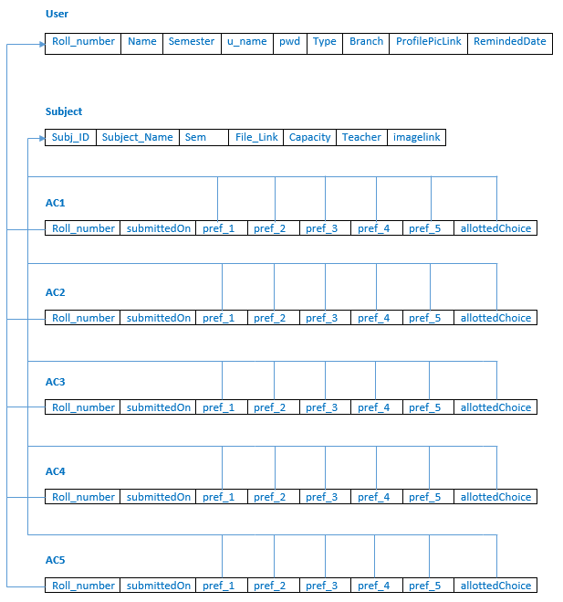

# SELF-LEARNING COMPONENT

AJAX

AJAX is used to dynamically change page’s content after it has been loaded. After a page has been loaded, JavaScript or JQuery function is designed to send queries to another PHP page and communicate with it. The result obtained from another page is manipulated and accordingly displayed on this page.

The syntax and concept of AJAX was learnt from W3Schools the official API documentation of JQuery AJAX.

AJAX has been used in the following pages in our website:

* DeleteThisImportChoices.php
* ImportData.php
* MailReminder.php
* Results.php