SCHOOL OF COMPUTER SCIENCE AND ARTIFICIAL INTELLIGENCE |  |  |  |  | DEPARTMENT OF COMPUTER SCIENCE ENGINEERING
Program Name: B. Tech |  |  |  | Assignment Type: Lab |  |  | AcademicYear:2025-2026
Course Coordinator Name |  |  |  | Venkataramana Veeramsetty
Instructor(s)Name |  |  |  | 1. Dr. Mohammed Ali Shaik  2. Dr. T Sampath Kumar  3. Mr. S Naresh Kumar  4. Dr. V. Rajesh  5. Dr. Brij Kishore  6. Dr Pramoda Patro  7. Dr. Venkataramana  8. Dr. Ravi Chander  9. Dr. Jagjeeth Singh
CourseCode |  |  | 24CS002PC215 | CourseTitle |  | AI Assisted Coding
Year/Sem |  |  | II/I | Regulation |  | R24
Date and Day  of Assignment |  |  | 06-08-2025 | Time(s)
Duration |  |  | 2 Hours | Applicable to  Batches |  | 24CSBTB01 To 24CSBTB39
AssignmentNumber:2.5(Present assignment number)/24(Total number of assignments)
 | Q.No. | Question |  |  |  |  |  | ExpectedTime  to complete
 | 1 | Lab 2: Additional AI Coding Tools and API Configurations  Objective: To build a simple AI weather chatbot that fetches real-time weather data using the OpenWeatherMap API and responds to natural language queries using basic NLP techniques.  Suppose that you are working as a junior developer in an AI services startup. Your team is building a smart assistant for travelers to get weather updates by simply asking questions like “What’s the weather in Mumbai?” or “Is it raining in New York?”  Tasks to be completed are as below  1. API Configuration:  - Register for a free OpenWeatherMap API key.  - Read the documentation and test API calls using tools like Postman or Python requests.  2. NLP Integration:  - Use spaCy or NLTK to extract city names from user input.  - Convert natural language queries to appropriate API parameters.  3. Chatbot Design:  - Develop a basic chatbot using Python with user input and response cycles.  - Integrate it with OpenWeatherMap API to display temperature, condition, and humidity.  Requirements:  - VS Code with Github Copilot or Cursor API and/or Google Colab with Gemini  - 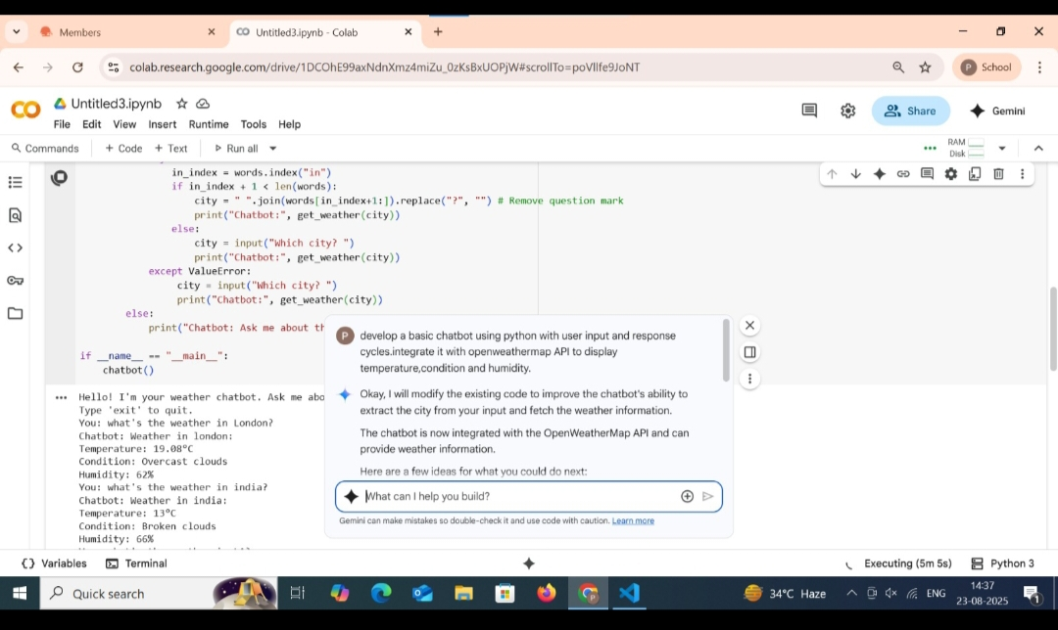  - 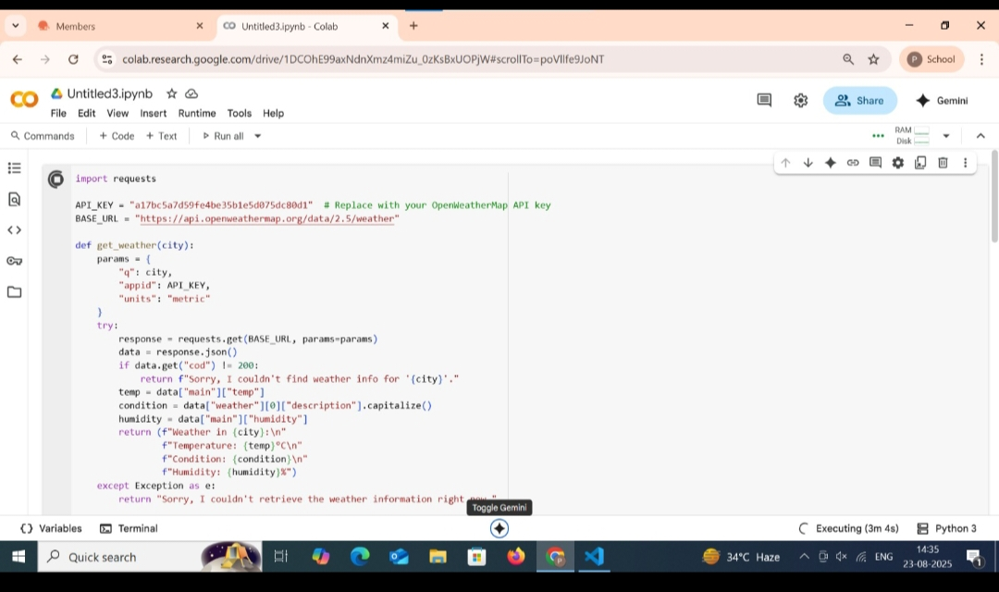  - 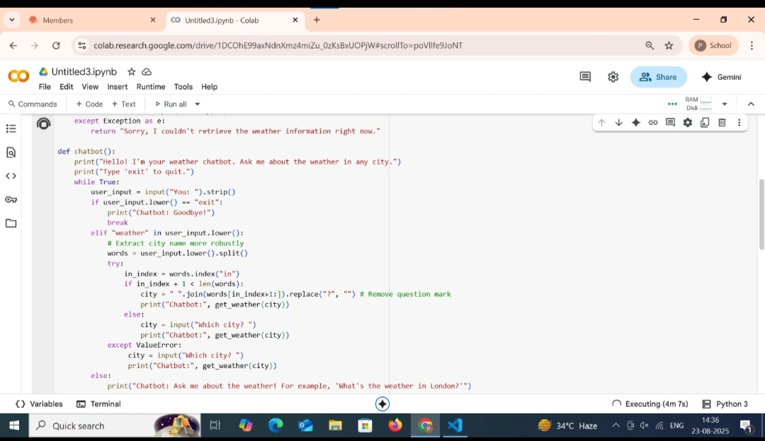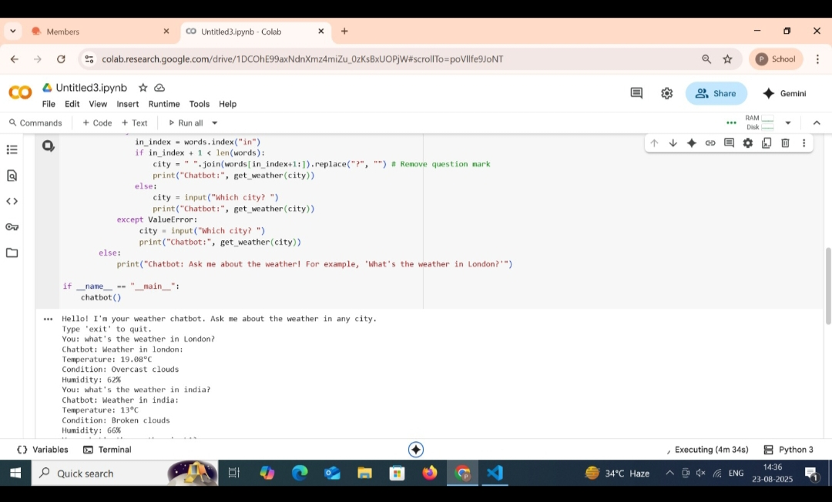  Deliverables:  - A working Python script or notebook.  - A short video demo or screenshot of chatbot interaction.  - A markdown file with steps followed and challenges faced.  . |  |  |  |  |  | 01.08.2025 EOD

