SCHOOL OF COMPUTER SCIENCE AND ARTIFICIAL INTELLIGENCE |  |  |  |  | DEPARTMENT OF COMPUTER SCIENCE ENGINEERING
ProgramName:B. Tech |  |  |  | Assignment Type: Lab |  |  | AcademicYear:2025-2026
CourseCoordinatorName |  |  |  | Venkataramana Veeramsetty
Instructor(s)Name
  Dr. V. Venkataramana (Co-ordinator)
  Dr. T. Sampath Kumar
  Dr. Pramoda Patro
  Dr. Brij Kishor Tiwari
  Dr.J.Ravichander
  Dr. Mohammand Ali Shaik
  Dr. Anirodh Kumar
  Mr. S.Naresh Kumar
  Dr. RAJESH VELPULA
  Mr. Kundhan Kumar
  Ms. Ch.Rajitha
  Mr. M Prakash
  Mr. B.Raju
  Intern 1 (Dharma teja)
  Intern 2 (Sai Prasad)
  Intern 3 (Sowmya)
  NS_2 ( Mounika)
CourseCode |  |  | 24CS002PC215 | CourseTitle |  | AI Assisted Coding
Year/Sem |  |  | II/I | Regulation |  | R24
Date and Day  of Assignment |  |  | Week3 - Thursday | Time(s)
Duration |  |  | 2 Hours | Applicableto  Batches
AssignmentNumber:6.4(Present assignment number)/24(Total number of assignments)
 | Q.No. | Question |  |  |  |  |  | ExpectedTime  to complete
 | 1 | Lab 6: AI-Based Code Completion – Classes, Loops, and Conditionals  Lab Objectives:  - To explore AI-powered auto-completion features for core Python constructs.  - To analyze how AI suggests logic for class definitions, loops, and conditionals.  - To evaluate the completeness and correctness of code generated by AI assistants.  Lab Outcomes (LOs):  After completing this lab, students will be able to:  - Use AI tools to generate and complete class definitions and methods.  - Understand and assess AI-suggested loops for iterative tasks.  - Generate conditional statements through prompt-driven suggestions.  - Critically evaluate AI-assisted code for correctness and clarity.  Task Description #1:  • Start a Python class named Student with attributes name, roll_number, and marks. Prompt GitHub Copilot to complete methods for displaying details and checking if marks are above average.  Outcome :  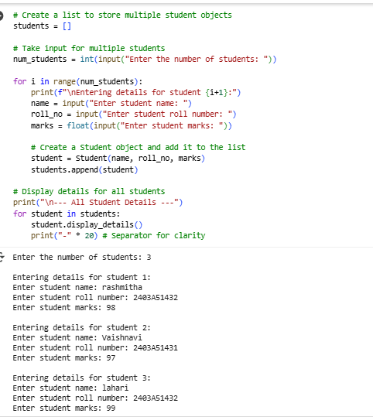  Explanation:  Create a list: We make an empty list called students to hold all the student information.  Ask how many: We ask you how many students you want to enter.  Loop and collect: We repeat the process of asking for name, roll number, and marks for each student you specified.  Make student objects: For each set of details, we create a Student object using the blueprint we made earlier.  Task Description #2:  • Write the first two lines of a for loop to iterate through a list of numbers. Use a comment prompt to let Copilot suggest how to calculate and print the square of even numbers only.  Outcome :  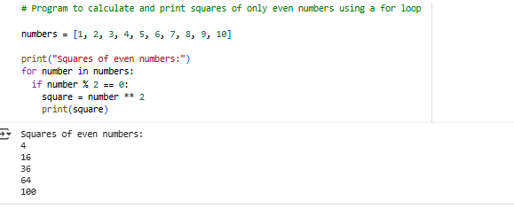  Explanation:  numbers = [1, 2, 3, 4, 5, 6, 7, 8, 9, 10]: This line creates a list of numbers from 1 to 10 and stores it in a variable called numbers.  print("Squares of even numbers:"): This line simply prints the text "Squares of even numbers:" to the output, so you know what the following output represents.  for number in numbers:: This is a loop that goes through each item in the numbers list one by one. In each turn of the loop, the current item is stored in the variable number.  if number % 2 == 0:: This is a condition that checks if the current number is even. The modulo operator (%) gives you the remainder when one number is divided by another. If a number divided by 2 has a remainder of 0, it means the number is even.  Task Description #3:  • Create a class called BankAccount with attributes account_holder and balance. Use Copilot to complete methods for deposit(), withdraw(), and check for insufficient balance.  Outcome :  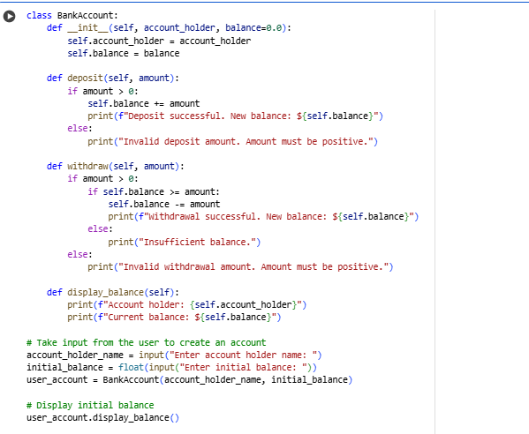  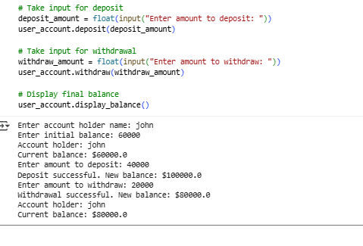  Explanation:  BankAccount Blueprint: We create a blueprint called BankAccount that holds the account owner's name and their money (balance).  Deposit: A method to add money to the balance. It checks if the amount is positive.  Withdraw: A method to take money from the balance. It checks if the amount is positive and if there's enough money.  Display Balance: A method to show the account owner's name and current balance.  User Interaction: The code then asks you for the account holder's name and initial balance to create an account.  Task Description #4:  • Define a list of student dictionaries with keys name and score. Ask Copilot to write a while loop to print the names of students who scored more than 75.  Outcome :  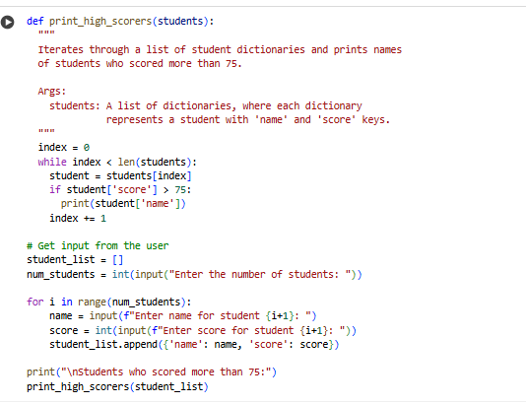  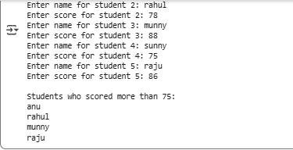  Explanation:  Get Student Count: Ask the user how many students they want to enter.  Create Empty List: Initialize an empty list to store student data.  Input Loop: Loop for the number of students specified, asking for each student's name and score and storing them as a dictionary in the list.  Check and Print: Use a while loop to go through the list. For each student, check if their score is greater than 75 and print their name if it is.  Task Description #5:  • Begin writing a class ShoppingCart with an empty items list. Prompt Copilot to generate methods to add_item, remove_item, and use a loop to calculate the total bill using conditional discounts.  Outcome :  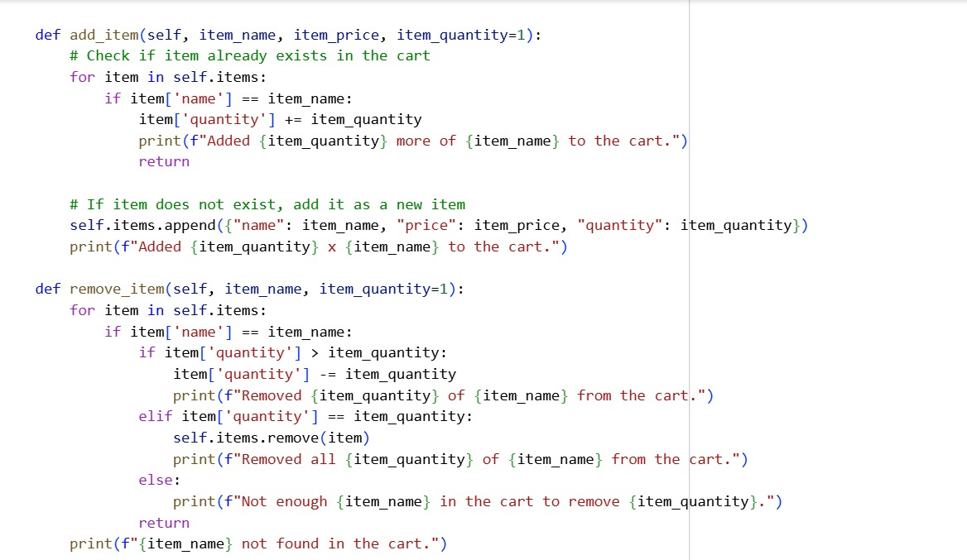  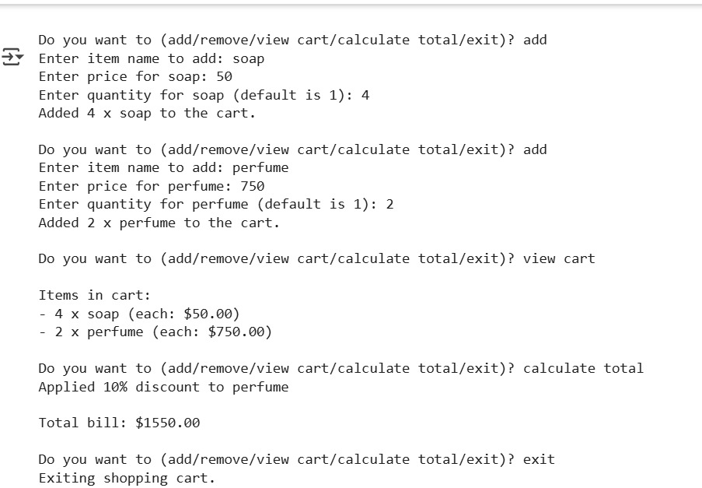  Explanation:  class ShoppingCart:: This defines a blueprint for creating shopping cart objects. Each object will have an items list to store the items in the cart.  _init_(self):: This is the constructor. When you create a new ShoppingCart object, it initializes an empty list called self.items to hold the items.  add_item(self, item_name, item_price, item_quantity=1):: This method adds an item to the cart. It takes the item's name, price, and optionally the quantity. If the item is already in the cart, it updates the quantity. Otherwise, it adds the item as a new dictionary to the self.items list.  remove_item(self, item_name, item_quantity=1):: This method removes an item from the cart. It finds the item by item_name. If the quantity to remove is less than the current quantity, it reduces the quantity. If the quantity is equal, it removes the item entirely from the list. It also handles cases where the item or quantity is not found.  Note: Report should be submitted a word document for all tasks in a single document with prompts, comments & code explanation, and output and if required, screenshots  Evaluation Criteria: |  |  |  |  |  | Week3 - Thursday
  Criteria | Max Marks
  Class | 1
  Loop | 1
  condition | 0.5
  Total | 2.5 Marks

