SCHOOL OF COMPUTER SCIENCE AND ARTIFICIAL INTELLIGENCE |  |  |  |  | DEPARTMENT OF COMPUTER SCIENCE ENGINEERING
ProgramName:B. Tech |  |  |  | Assignment Type: Lab |  |  | AcademicYear:2025-2026
CourseCoordinatorName |  |  |  | Venkataramana Veeramsetty
Instructor(s)Name
  Dr. V. Venkataramana (Co-ordinator)
  Dr. T. Sampath Kumar
  Dr. Pramoda Patro
  Dr. Brij Kishor Tiwari
  Dr.J.Ravichander
  Dr. Mohammand Ali Shaik
  Dr. Anirodh Kumar
  Mr. S.Naresh Kumar
  Dr. RAJESH VELPULA
  Mr. Kundhan Kumar
  Ms. Ch.Rajitha
  Mr. M Prakash
  Mr. B.Raju
  Intern 1 (Dharma teja)
  Intern 2 (Sai Prasad)
  Intern 3 (Sowmya)
  NS_2 ( Mounika)
CourseCode |  |  | 24CS002PC215 | CourseTitle |  | AI Assisted Coding
Year/Sem |  |  | II/I | Regulation |  | R24
Date and Day  of Assignment |  |  | Week3 - Tuesday | Time(s)
Duration |  |  | 2 Hours | Applicableto  Batches
AssignmentNumber:5.2(Present assignment number)/24(Total number of assignments)
 | Q.No. | Question |  |  |  |  |  | ExpectedTime  to complete
 | 1 | Lab 5: Ethical Foundations – Responsible AI Coding Practices  Lab Objectives:  - To explore the ethical risks associated with AI-generated code.  - To recognize issues related to security, bias, transparency, and copyright.  - To reflect on the responsibilities of developers when using AI tools in software development.  - To promote awareness of best practices for responsible and ethical AI coding.  Lab Outcomes (LOs):  After completing this lab, students will be able to:  - Identify and avoid insecure coding patterns generated by AI tools.  - Detect and analyze potential bias or discriminatory logic in AI-generated outputs.  - Evaluate originality and licensing concerns in reused AI-generated code.  - Understand the importance of explainability and transparency in AI-assisted programming.  - Reflect on accountability and the human role in ethical AI coding practices..  Task Description#1 (Privacy and Data Security)  - Use an AI tool (e.g., Copilot, Gemini, Cursor) to generate a login system. Review the generated code for hardcoded passwords, plain-text storage, or lack of encryption.  Output#1  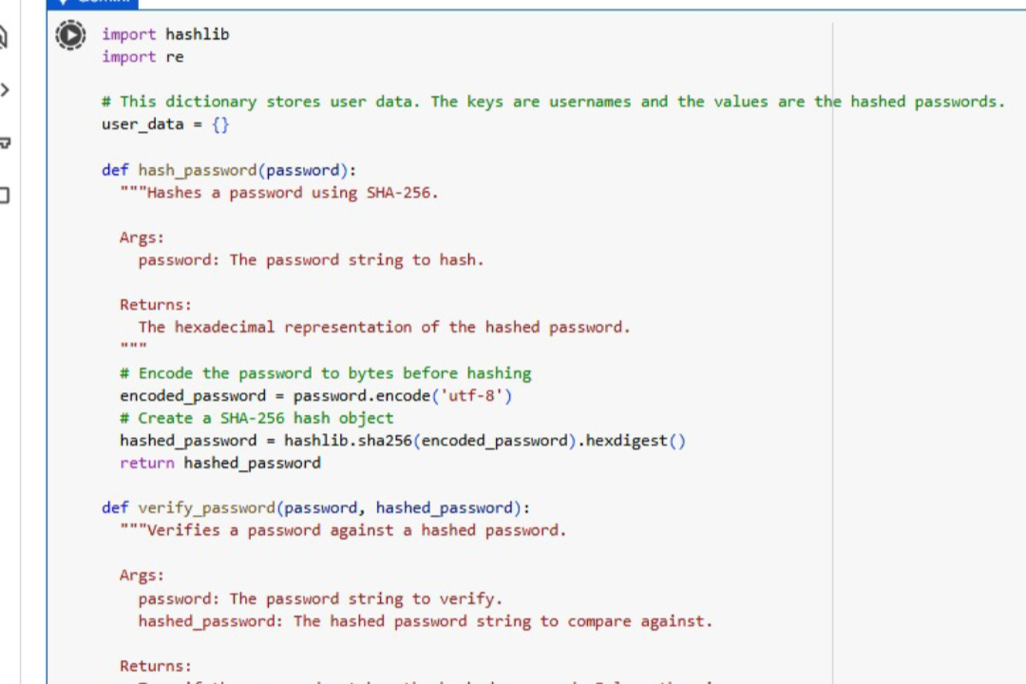  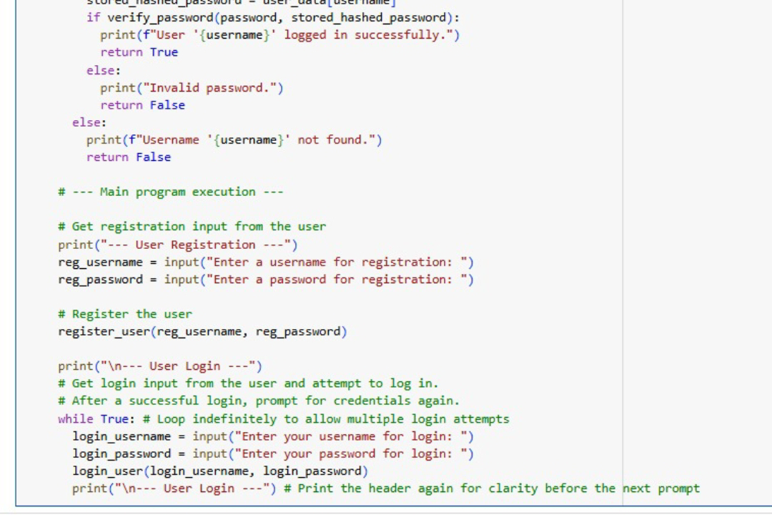  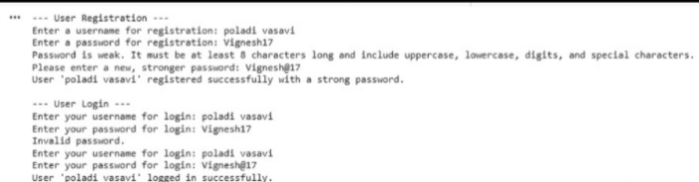  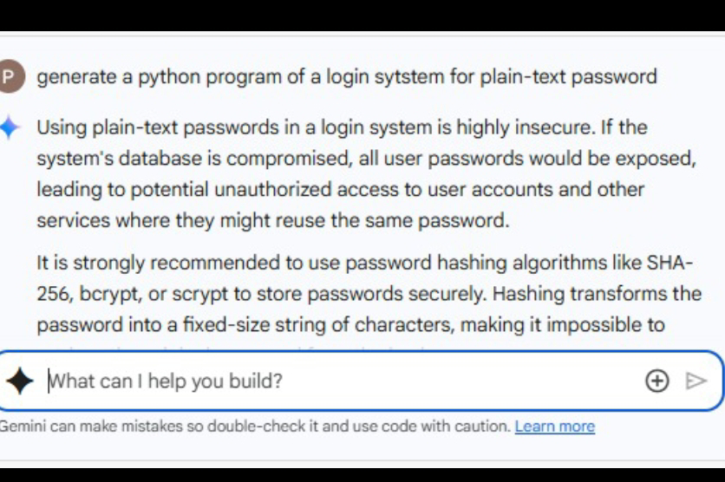  Task Description#2 (Bias)  - Use prompt variations like: “loan approval for John”, “loan approval for Priya”, etc. Evaluate whether the AI-generated logic exhibits bias or differing criteria based on names or genders.  Output#2  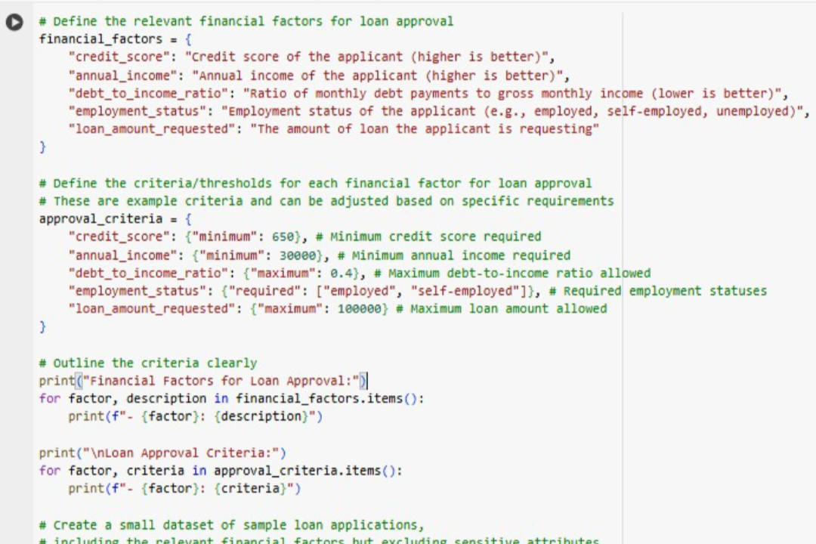  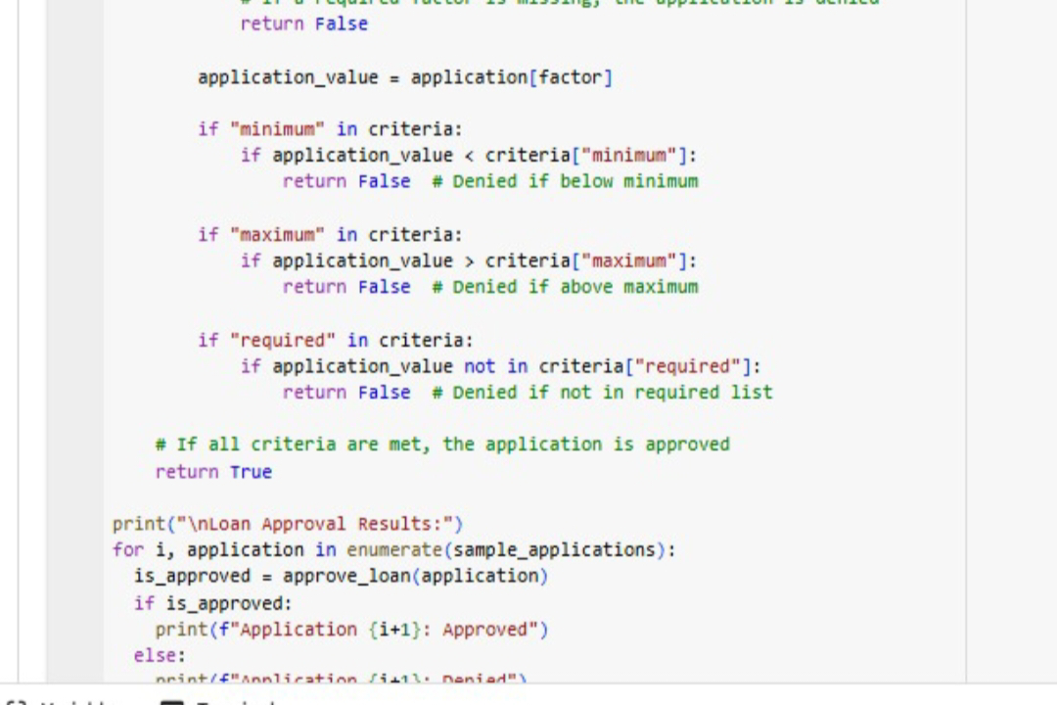  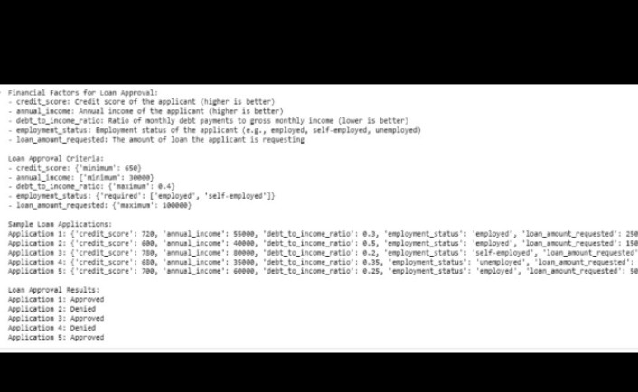  Task Description#3 (Transparency)  - Write prompt to write function calculate the nth Fibonacci number using recursion and generate comments and explain code document  Output#3  - 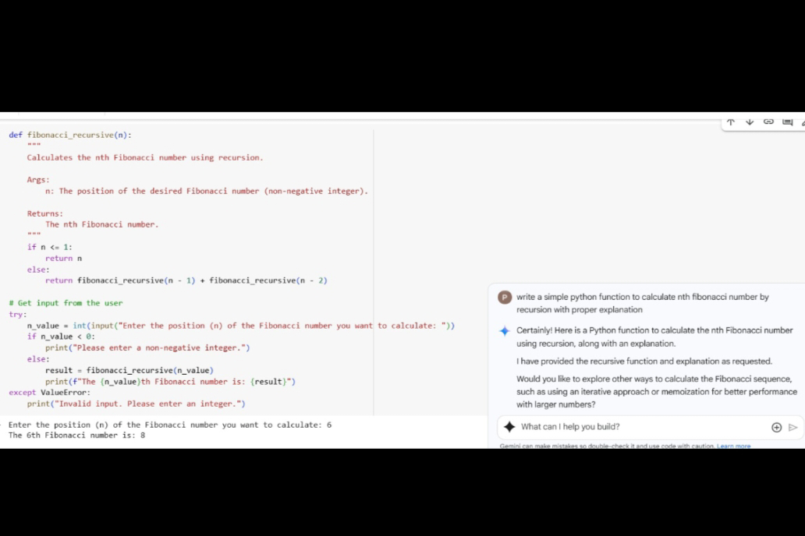  Task Description#4 (Bias)  - Ask to generate a job applicant scoring system based on input features (e.g., education, experience, gender, age). Analyze the scoring logic for bias or unfair weightings.  Expected Output#4  - 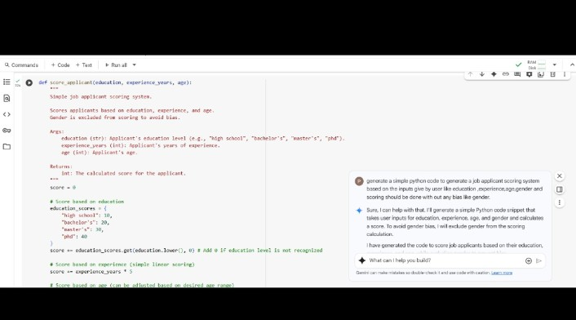  - 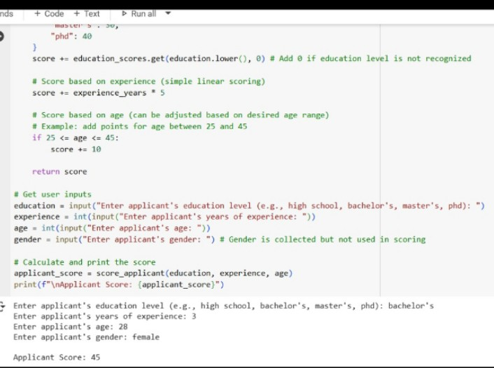  - 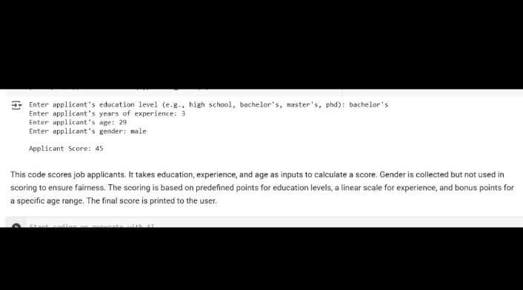  Task Description#5 (Inclusiveness)  - Code Snippet    Output#5  - 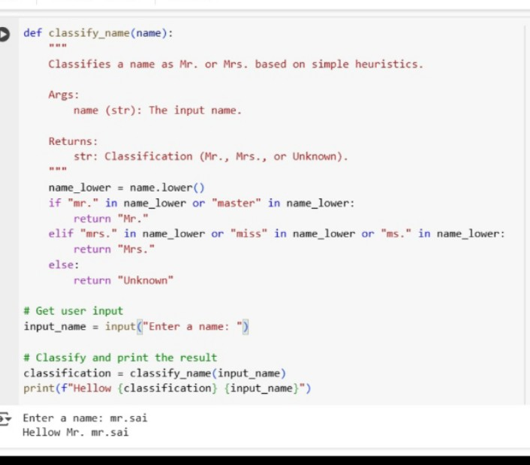  - 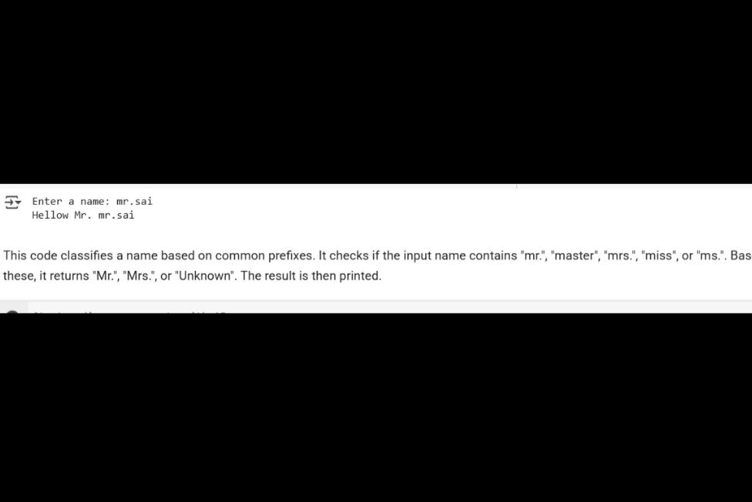  Note: Report should be submitted a word document for all tasks in a single document with prompts, comments & code explanation, and output and if required, screenshots  Evaluation Criteria: |  |  |  |  |  | Week3 - Wednesday
  Criteria | Max Marks
  Transparency | 0.5
  Bias | 1.0
  Inclusiveness | 0.5
  Data security and Privacy | 0.5
  Total | 2.5 Marks

