SCHOOL OF COMPUTER SCIENCE AND ARTIFICIAL INTELLIGENCE |  |  |  |  | DEPARTMENT OF COMPUTER SCIENCE ENGINEERING
ProgramName:B. Tech |  |  |  | Assignment Type: Lab |  |  | AcademicYear:2025-2026
CourseCoordinatorName |  |  |  | Venkataramana Veeramsetty
Instructor(s)Name
  Dr. V. Venkataramana (Co-ordinator)
  Dr. T. Sampath Kumar
  Dr. Pramoda Patro
  Dr. Brij Kishor Tiwari
  Dr.J.Ravichander
  Dr. Mohammand Ali Shaik
  Dr. Anirodh Kumar
  Mr. S.Naresh Kumar
  Dr. RAJESH VELPULA
  Mr. Kundhan Kumar
  Ms. Ch.Rajitha
  Mr. M Prakash
  Mr. B.Raju
  Intern 1 (Dharma teja)
  Intern 2 (Sai Prasad)
  Intern 3 (Sowmya)
  NS_2 ( Mounika)
CourseCode |  |  | 24CS002PC215 | CourseTitle |  | AI Assisted Coding
Year/Sem |  |  | II/I | Regulation |  | R24
Date and Day  of Assignment |  |  | Week4 - Wednesday | Time(s)
Duration |  |  | 2 Hours | Applicableto  Batches
AssignmentNumber:9.3(Present assignment number)/24(Total number of assignments)
 | Q.No. | Question |  |  |  |  |  | ExpectedTime  to complete
 | 1 | Lab 8: Documentation Generation: Automatic documentation and code comments  Lab Objectives:  - To understand the importance of documentation and code comments in software development.  - To explore how AI-assisted coding tools can generate meaningful documentation and inline comments.  - To practice generating function-level and module-level docstrings automatically.  - To evaluate the quality, accuracy, and limitations of AI-generated documentation.  - To develop a small automated tool for documentation generation in Python..  Lab Outcomes (LOs):  After completing this lab, students will be able to:  - Apply AI-assisted coding tools to generate docstrings and inline comments for Python code.  - Critically analyze AI-generated documentation for correctness, completeness, and readability.  - Create structured documentation (function-level, module-level) following standard formats.  - Design and implement a mini documentation generator tool to automate code commenting and docstring creation.  Task Description#1 Basic Docstring Generation  - Write python function to return sum of even and odd numbers in the given list.  - Incorporate manual docstring in code with Google Style  - Use an AI-assisted tool (e.g., Copilot, Cursor AI) to generate a docstring describing the function.  - Compare the AI-generated docstring with your manually written one.  Outcome#1  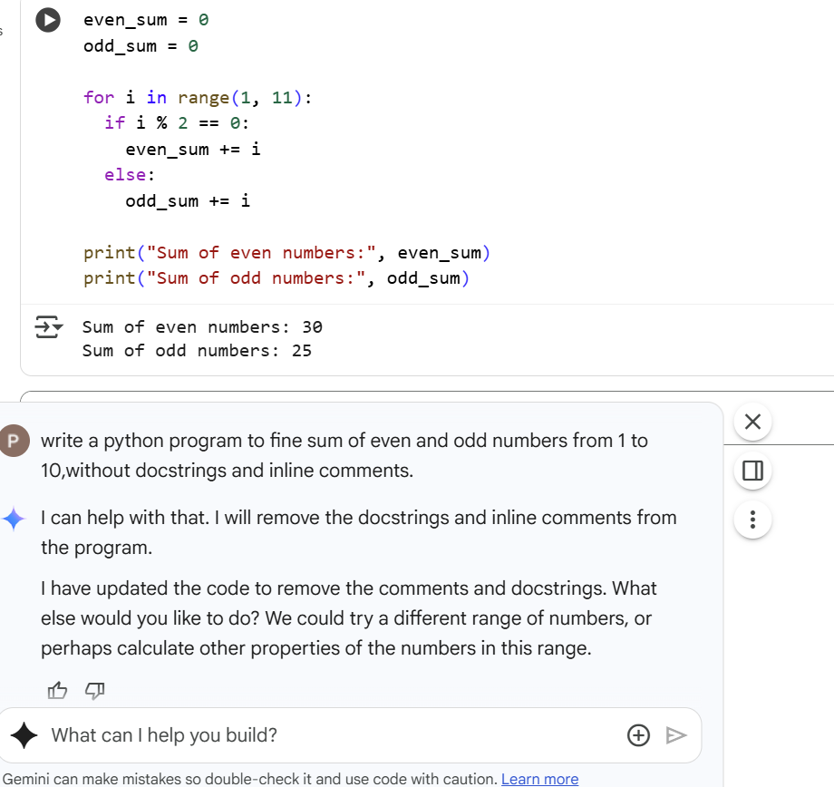  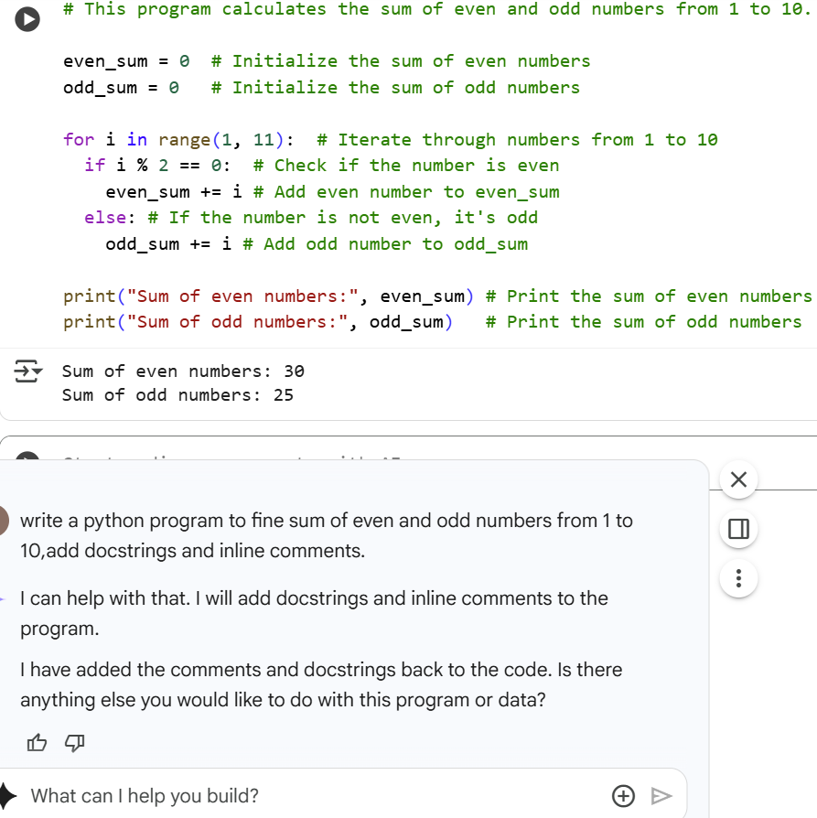  Explanation:  This Python code calculates the sum of even and odd numbers from 1 to 10. It initializes two variables, even_sum and odd_sum, to zero. A for loop iterates through numbers from 1 to 10. Inside the loop, it checks if the current number i is even using the modulo operator (%). If it's even, the number is added to even_sum; otherwise, it's added to odd_sum. Finally, it prints the calculated sum of even and odd numbers.  Task Description#2 Automatic Inline Comments  - Write python program for sru_student class with attributes like name, roll no., hostel_status and fee_update method and display_details method.  - Write comments manually for each line/code block  - Ask an AI tool to add inline comments explaining each line/step.  - Compare the AI-generated comments with your manually written one.  Output#2:.  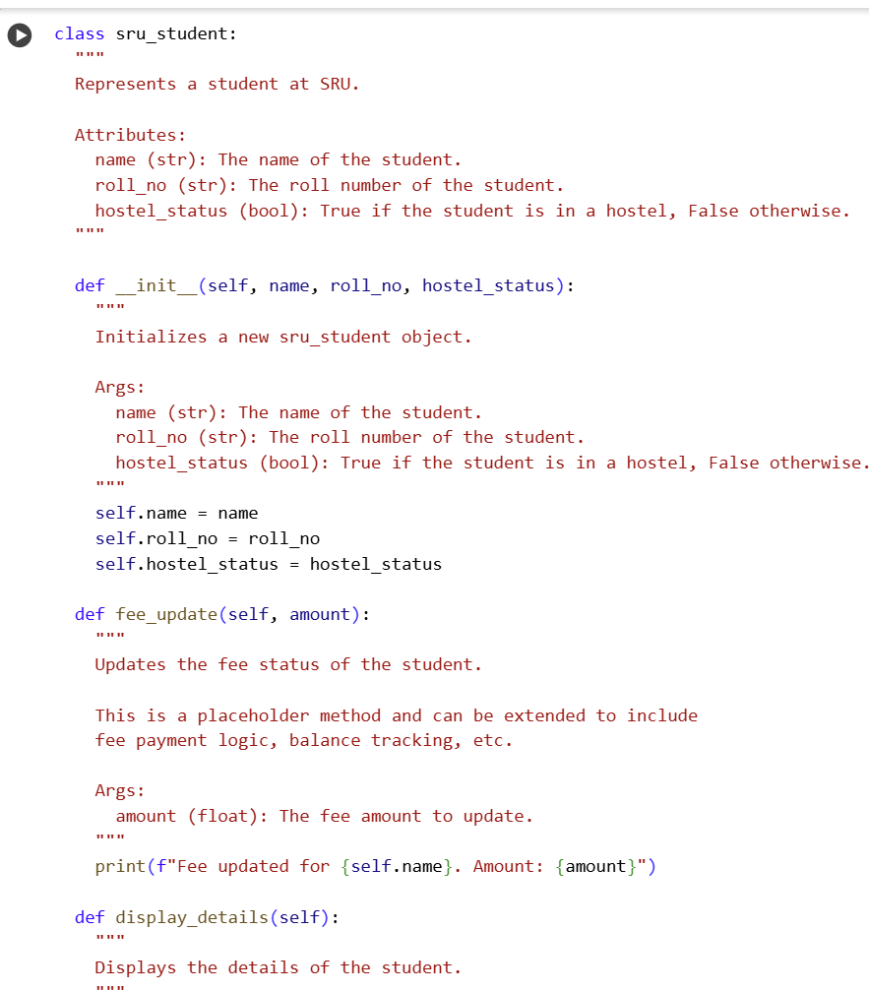  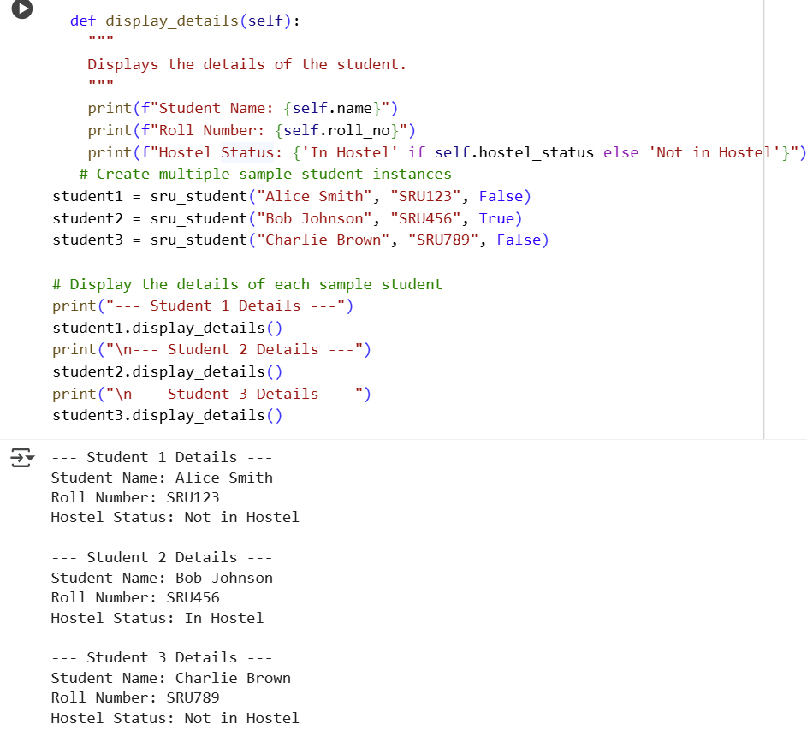  Explanation:  It seems you've repeated a request that I've already addressed. The sru_student class with the attributes, fee_update method, and docstring is already in your notebook in cell da13e6d4. I also explained that code in a previous turn.  Task Description#3  - Write a Python script with 3–4 functions (e.g., calculator: add, subtract, multiply, divide).  - Incorporate manual docstring in code with NumPy Style  - Use AI assistance to generate a module-level docstring + individual function docstrings.  - Compare the AI-generated docstring with your manually written one.  Output#3:  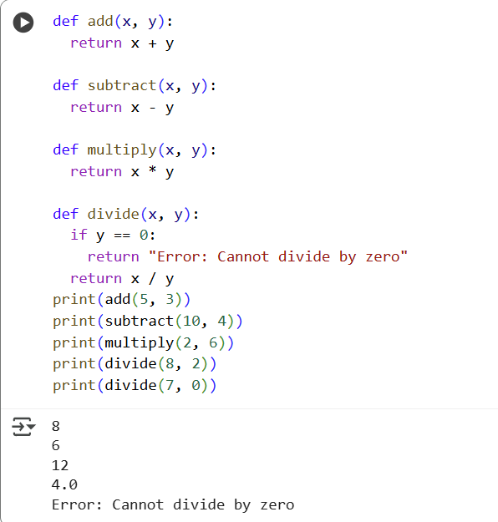  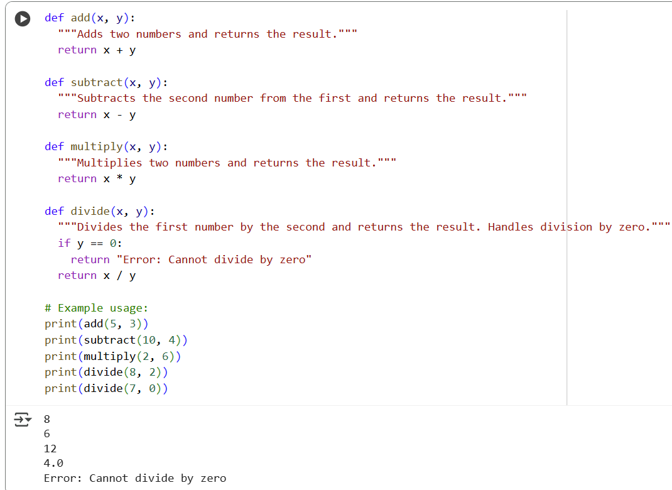  Explanation:  It looks like you've repeated a previous request. The notebook already contains the Python script with the calculator functions, including docstrings, and I've explained the code in 10 lines per cell.  Push documentation whole workspace as .md file in GitHub Repository  Note: Report should be submitted a word document for all tasks in a single document with prompts, comments & code explanation, and output and if required, screenshots |  |  |  |  |  | Week4 - Wednesday

