AUTOMOTIVE PARTS STORE
A Full-Stack E-Commerce Web Application for Automobile Spare Parts

Prepared by:
[POLAGONI TEJA]

Executive Summary
This report provides details of the Industrial Internship provided by Upskill Campus and UniConverge Technologies Pvt. Ltd. (UCT). The internship focused on a project/problem statement provided by UCT, to be completed along with this report within 6 weeks.
My project was the Automotive Parts Store — a secure, full-stack e-commerce web application that allows customers to browse, search, and purchase automobile spare parts online, while giving administrators complete control over products, orders, customers, and store settings. It was built using Node.js, Express.js, MySQL, HTML, CSS, JavaScript, and Bootstrap, following the MVC (Model-View-Controller) architecture.
This internship gave me a very good opportunity to get exposure to industrial problems and design/implement a solution for that. It was an overall great experience to have this internship.

Table of Contents
1. Preface 4
2. Introduction 4
2.1 About UniConverge Technologies Pvt. Ltd. 4
2.2 About Upskill Campus 5
2.3 Objective 5
2.4 Reference 5
2.5 Glossary 6
3. Problem Statement 7
4. Existing and Proposed Solution 7
4.1 Existing System 7
4.2 Proposed System 7
5. Technologies Used 8
5.1 Frontend 8
5.2 Backend 8
5.3 Database 8
5.4 Packages Used 8
5.5 Tools Used 9
6. Proposed Design / Model 10
6.1 High Level Diagram 10
6.2 MVC Architecture Diagram 10
6.3 Low Level Diagram 11
6.4 ER Diagram (Database Design) 13
6.5 Interfaces 16
7. Application Screenshots — Customer Module 17
7.1 User Registration 17
7.2 User Login & Logout 17
7.3 Home Page 18
7.4 Product Browsing & Search 18
7.5 Shopping Cart 19
7.6 Checkout — Delivery Address 19
7.7 Checkout — Payment 20
7.8 Order Confirmation 20
7.9 My Orders 21
7.10 Order Tracking 21
8. Application Screenshots — Admin Module 23
8.1 Dashboard 23
8.2 Product Management 23
8.3 Order Management 24
8.4 Customer Management 24
8.5 Reports 25
8.6 Notifications 25
8.7 Store Settings 26
9. Application Workflow 27
9.1 Customer Order Workflow 27
9.2 Admin Order Fulfillment Workflow 27
10. Security Features 27
11. Folder Structure & GitHub Repository 28
12. Performance Test 29
12.1 Test Plan / Test Cases 29
12.2 Test Procedure 29
12.3 Performance Outcome 29
13. My Learnings 30
14. Future Work Scope 30
15. Conclusion 31

1. Preface
This report presents the work carried out during my Industrial Internship under Upskill Campus in collaboration with UniConverge Technologies Pvt. Ltd. (UCT). The internship provided me with an opportunity to gain practical knowledge in Full Stack Web Development by developing a real-world web application.
During the internship, I designed and developed an Automotive Parts Store, an online e-commerce platform for purchasing automobile spare parts. The application was built using Node.js, Express.js, MySQL, HTML, CSS, JavaScript, and Bootstrap.
The project includes secure user authentication, product management, shopping cart functionality, wishlist, order management, profile management, and a complete administrator dashboard. Security features such as password hashing using bcrypt, session management, route authorization, Helmet middleware, rate limiting, and environment variables were also implemented.
This internship enhanced my understanding of backend development, database management, REST APIs, GitHub version control, debugging, and software deployment. I am thankful to the mentors at Upskill Campus and UniConverge Technologies for their continuous guidance throughout this project.

2. Introduction
The Automotive Parts Store is a full-stack web application developed to simplify the process of purchasing automobile spare parts online. The application provides a user-friendly interface where customers can browse products, search spare parts, filter products by vehicle type, add products to the shopping cart, place orders, and track deliveries.
The system also includes a dedicated administrator dashboard where the administrator can manage products, customers, categories, orders, reports, notifications, and website settings.
The project follows the MVC (Model-View-Controller) architecture and uses MySQL for data storage. The objective is to provide a secure, efficient, and scalable online automobile spare parts management system.

2.1 About UniConverge Technologies Pvt. Ltd.
UniConverge Technologies Pvt. Ltd. (UCT) is a technology company focused on providing software development, cloud computing, artificial intelligence, data analytics, cybersecurity, and web application development solutions.
The organization provides internship opportunities to students where they gain practical exposure to industry-standard technologies, software development methodologies, and project implementation.
During the internship, UniConverge Technologies provided technical guidance, project requirements, and mentorship throughout the project development lifecycle.

2.2 About Upskill Campus
Upskill Campus is an online learning platform that offers industrial internships, certification programs, and skill development courses for students and professionals.
It collaborates with reputed industries and organizations to provide hands-on project experience in domains such as:
- Full Stack Web Development
- Artificial Intelligence
- Machine Learning
- Data Science
- Cyber Security
- Cloud Computing
The internship program helped me improve my technical knowledge and practical implementation skills through real-time project development.

2.3 Objective
The main objectives of the project are:
- Develop an online automobile spare parts shopping platform.
- Provide secure customer registration and login.
- Allow users to browse and search products.
- Implement category and vehicle-based product filtering.
- Enable customers to manage shopping carts and wishlists.
- Allow customers to place and track orders.
- Develop a complete administrator dashboard.
- Manage products, customers, and orders efficiently.
- Ensure application security using authentication and authorization.
- Deploy the project using GitHub and cloud hosting.

2.4 Reference

Documentation
- Node.js Official Documentation
- Express.js Documentation
- MySQL Documentation
- Bootstrap Documentation
- MDN Web Docs
- Express Session Documentation
- Helmet Documentation
- Express Rate Limit Documentation
- Multer Documentation
- Bcrypt Documentation
- Git Documentation
- GitHub Documentation

Development Tools
- Visual Studio Code
- MySQL Workbench
- Postman
- Git
- GitHub
- Google Chrome

Project Repository
The complete source code for this project is hosted on GitHub: https://github.com/polagonitejagoud/Automotive-Parts-Store.git

2.5 Glossary
Term | Description
Node.js | JavaScript runtime used for backend development
Express.js | Web framework for Node.js
MySQL | Relational database management system
HTML | HyperText Markup Language
CSS | Cascading Style Sheets
JavaScript | Programming language for frontend functionality
Bootstrap | CSS framework for responsive design
MVC | Model View Controller Architecture
REST API | Web services used for communication between frontend and backend
Session | Stores user login information
bcrypt | Library used for password hashing
Helmet | Middleware for securing HTTP headers
Rate Limiter | Protects application from brute-force attacks
Multer | Middleware used for image uploads
CRUD | Create, Read, Update and Delete operations

3. Problem Statement
Traditional automobile spare parts stores require customers to physically visit shops, resulting in time consumption, limited product availability, and difficulty comparing products.
Many small automobile stores also struggle with inventory management, customer management, and order tracking due to manual processes.
The objective of this project is to develop a secure web application that allows customers to purchase automobile spare parts online while providing administrators with a centralized dashboard to manage products, orders, customers, and reports efficiently.

4. Existing and Proposed Solution

4.1 Existing System
The traditional system has several limitations:
- Manual inventory management
- No centralized customer database
- Limited product search capability
- No online ordering
- No order tracking
- Limited product categorization
- Poor inventory monitoring

4.2 Proposed System
The proposed Automotive Parts Store provides:

Customer Features
- Secure Registration
- Login
- Product Browsing
- Product Search
- Vehicle Type Filter
- Shopping Cart
- Wishlist
- Checkout
- Order Tracking
- Profile Management

Administrator Features
- Dashboard
- Product Management
- Category Management
- Customer Management
- Order Management
- Reports
- Notifications
- Store Settings

Advantages
- Secure authentication
- Faster product search
- Efficient inventory management
- Easy order management
- Better customer experience
- Improved administrator control

5. Technologies Used

5.1 Frontend
- HTML5
- CSS3
- Bootstrap
- JavaScript

5.2 Backend
- Node.js
- Express.js

5.3 Database
- MySQL

5.4 Packages Used
- Express
- Express Session
- Express Rate Limit
- Helmet
- Bcrypt
- Multer
- Dotenv
- MySQL2

5.5 Tools Used
- Visual Studio Code
- MySQL Workbench
- Git
- GitHub

6. Proposed Design / Model
The project follows the MVC (Model-View-Controller) architecture, using MySQL for data storage and Express.js for routing and business logic.

6.1 High Level Diagram
The high-level diagram below shows how a request flows from the customer or admin, through the frontend and Express.js server, before reaching the MySQL database.
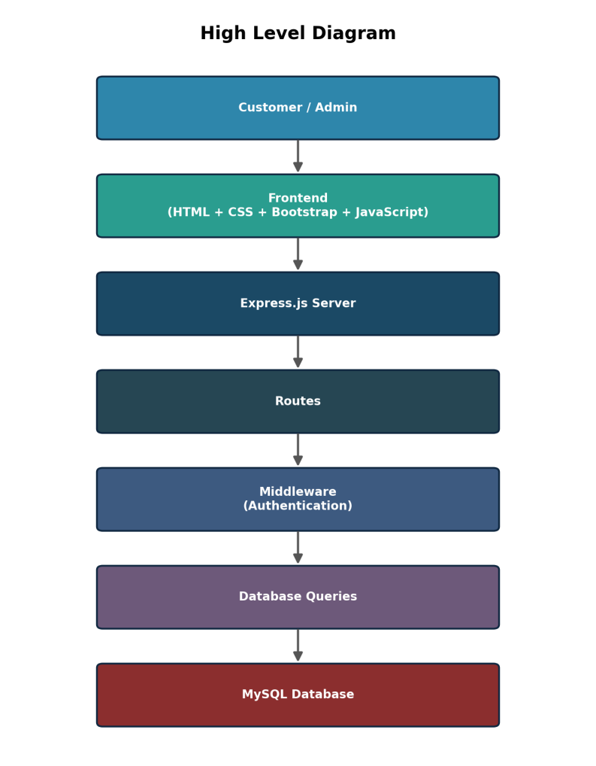
Figure 1: High Level Diagram

6.2 MVC Architecture Diagram
The application is structured using the MVC pattern. The View layer renders HTML/CSS/JS pages, the Controller layer (Express routes and controllers) handles requests and business logic, and the Model layer manages MySQL data access.
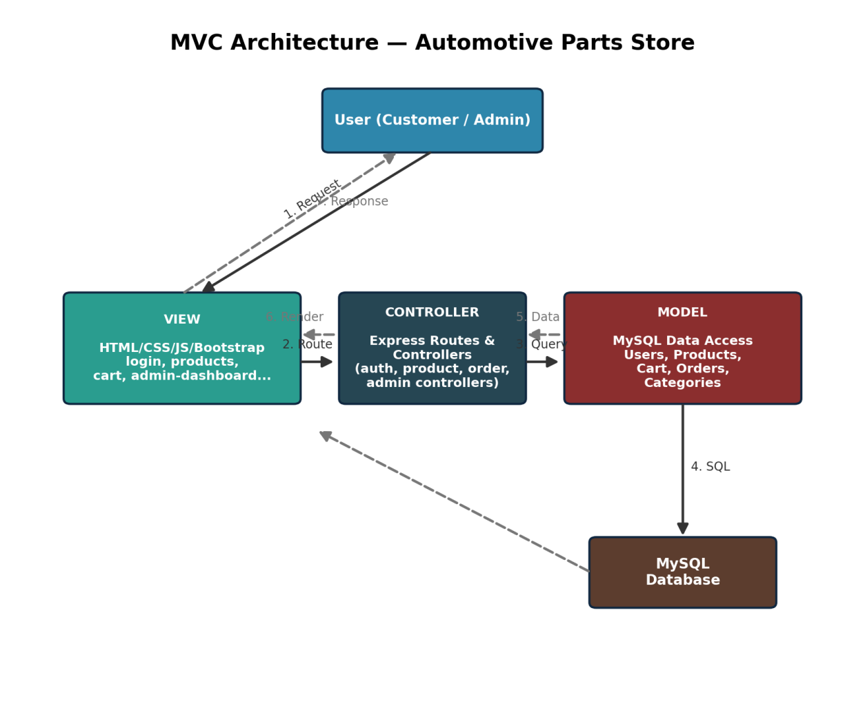
Figure 2: MVC Architecture of the Automotive Parts Store

6.3 Low Level Diagram
The low-level diagram traces the detailed step-by-step flow of the application, from user registration through to admin-side reporting and notifications.
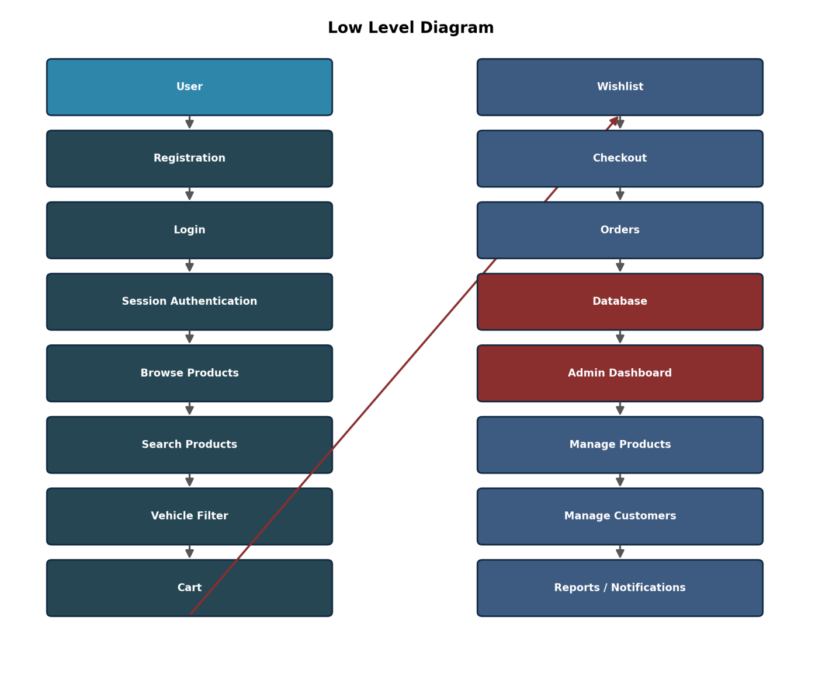
Figure 3: Low Level Diagram

6.4 ER Diagram (Database Design)
The application uses MySQL as the relational database. The Entity Relationship diagram below shows the core tables — Users, Categories, Products, Cart, Orders, Order Items, and Settings — and how they relate to one another.
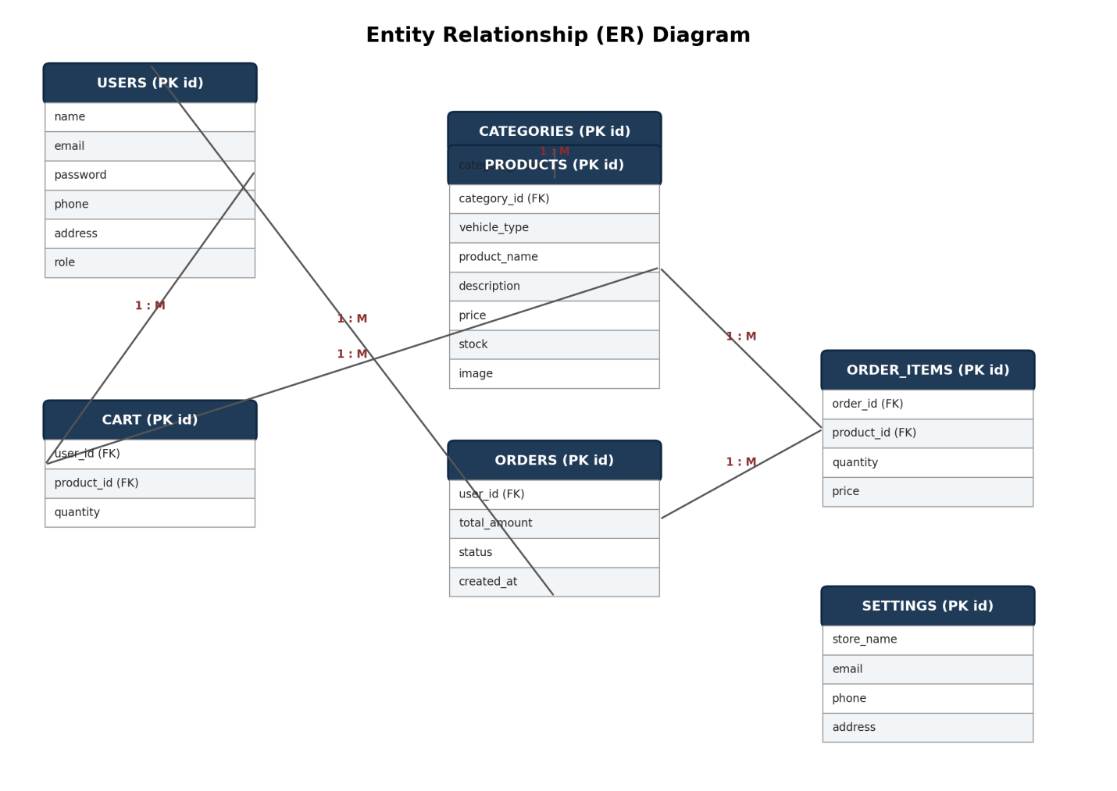
Figure 4: Entity Relationship (ER) Diagram

Users
Stores customer and administrator information.
Fields
id (PK)
name
email
password
phone
address
role

Products
Stores automobile spare parts.
Fields
id (PK)
category_id (FK)
vehicle_type
product_name
description
price
stock
image

Categories
Stores product categories, e.g. Engine Parts, Brake Parts, Electrical Parts, Accessories.

Cart
Stores products added to a customer's cart.
Fields
id (PK)
user_id (FK)
product_id (FK)
quantity

Orders
Stores customer orders.
Fields
id (PK)
user_id (FK)
total_amount
status
created_at

Order Items
Stores individual products within each order.
Fields
id (PK)
order_id (FK)
product_id (FK)
quantity
price

Settings
Stores website information such as Store Name, Email, Phone, and Address.

6.5 Interfaces

Customer Interfaces
- Login Page
- Registration Page
- Home Page
- Products Page
- Product Details
- Shopping Cart
- Wishlist
- Address Page
- Profile Page
- Orders Page
- Payment Page
- Order Tracking
- Order Confirmation

Administrator Interfaces
- Dashboard
- Add Product
- Edit Product
- Customers
- Categories
- Orders
- Reports
- Notifications
- Settings

7. Application Screenshots — Customer Module

7.1 User Registration
Users can create an account using Name, Email, and Password. Passwords are encrypted using bcrypt before being stored in MySQL.

Registration Page
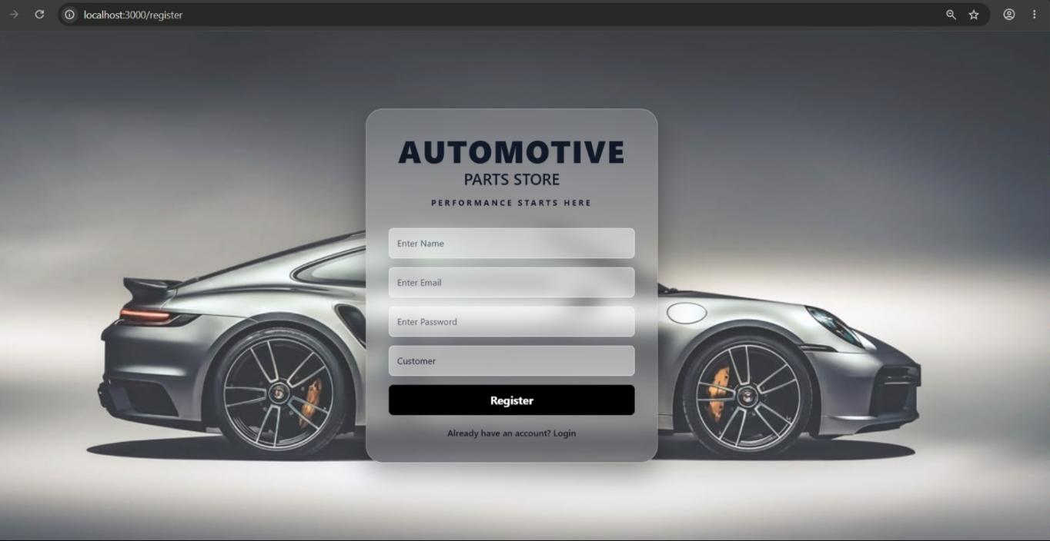
Screenshot: New user registration form

7.2 User Login & Logout
Users can securely log in using their Email and Password. Sessions are maintained using Express Session, and destroyed securely on logout.

Login Page
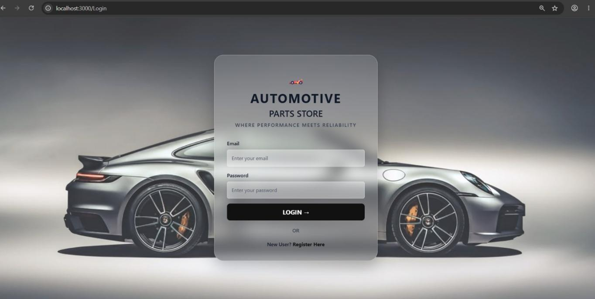
Screenshot: Secure user login form

7.3 Home Page
The landing page showcases featured products and store navigation for customers.

Home Page
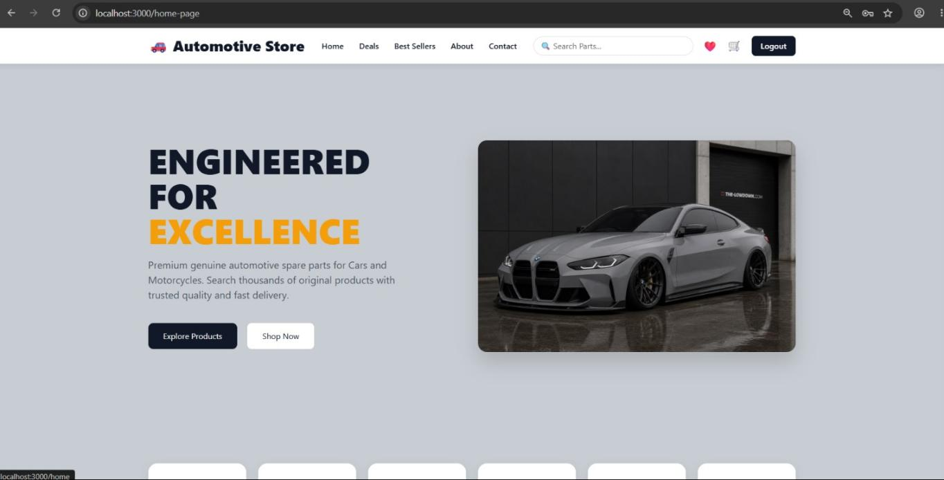
Screenshot: Automotive Store home page

7.4 Product Browsing & Search
Customers can view all products, search products, filter products by vehicle type, and view product details and images.

Products Page
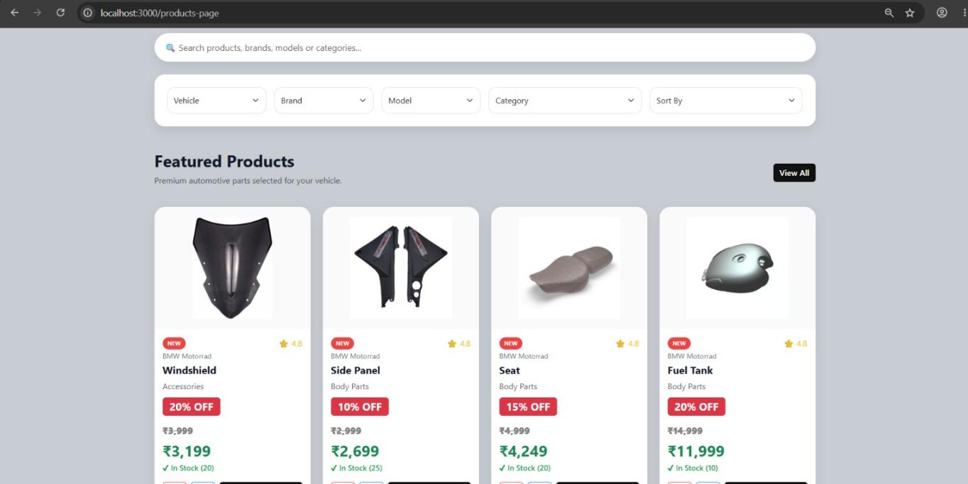
Screenshot: Product listing with search and filters

7.5 Shopping Cart
Customers can add products, remove products, increase or decrease quantity, and view the total amount before checkout.

Shopping Cart
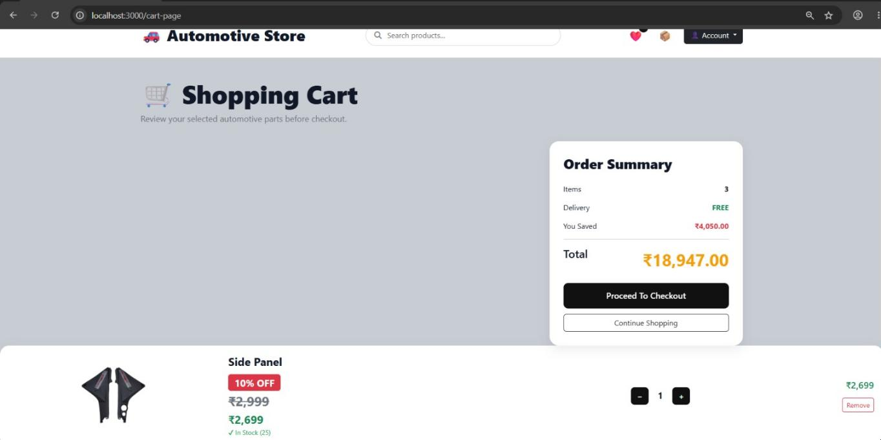
Screenshot: Shopping cart with order summary

7.6 Checkout — Delivery Address
Customers enter their shipping details, with an option to use their current location for faster delivery.

Delivery Address Page
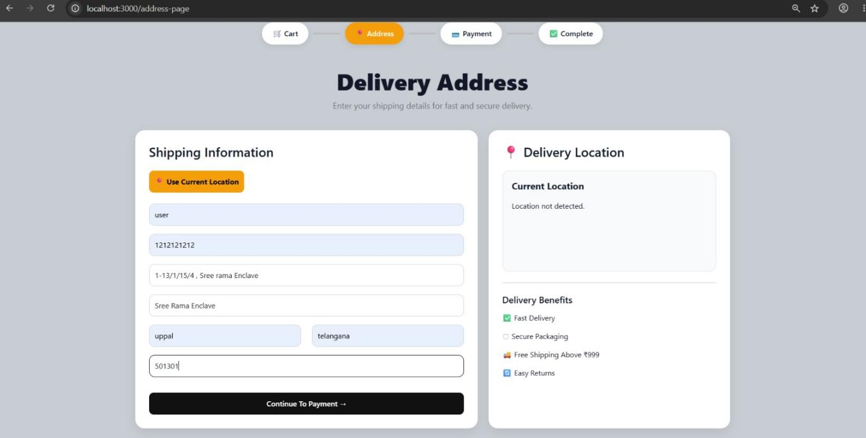
Screenshot: Delivery address entry during checkout

7.7 Checkout — Payment
Customers can choose from multiple payment options: UPI/QR Payment, Credit/Debit Card, Net Banking, or Cash on Delivery.

Payment Page
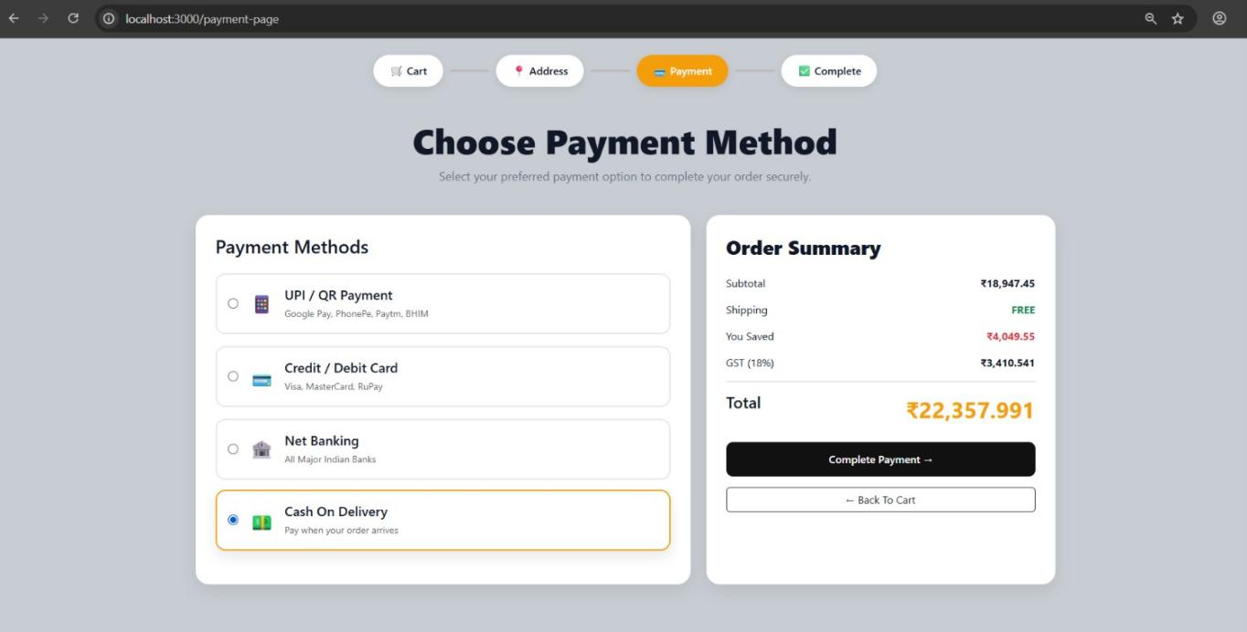
Screenshot: Payment method selection and order summary

7.8 Order Confirmation
Once an order is placed, customers receive an order confirmation with order ID, payment status, and estimated delivery.

Order Confirmed Page
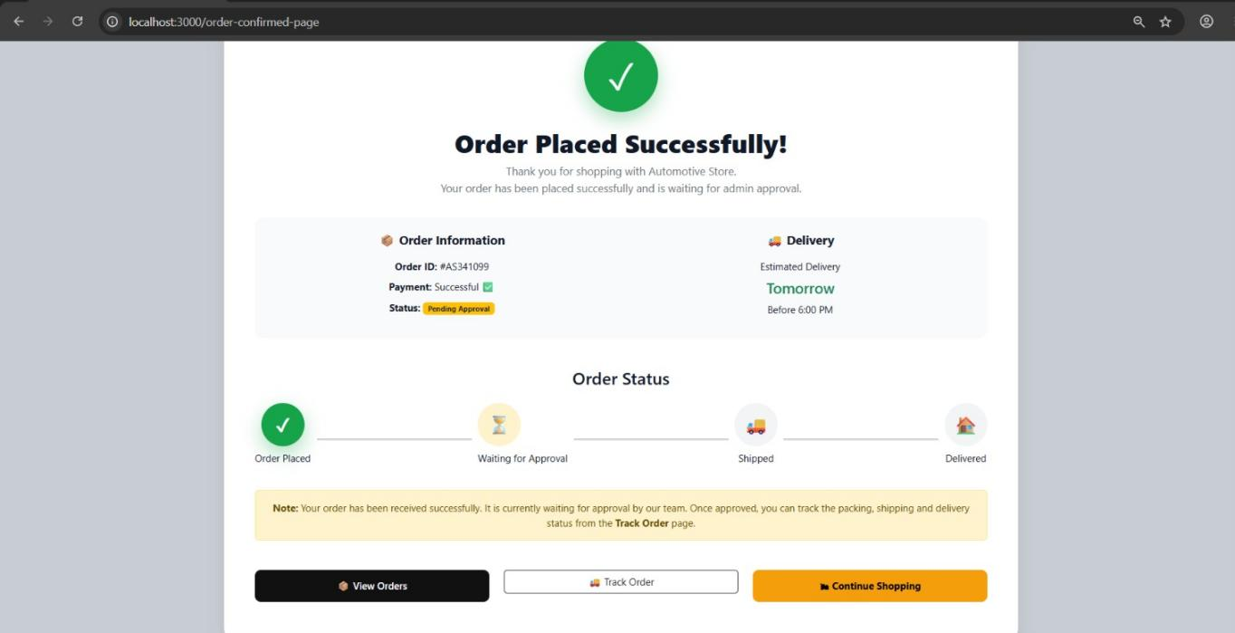
Screenshot: Order placed successfully confirmation

7.9 My Orders
Customers can view their previous orders, track order status, and reorder favourite products.

My Orders Page
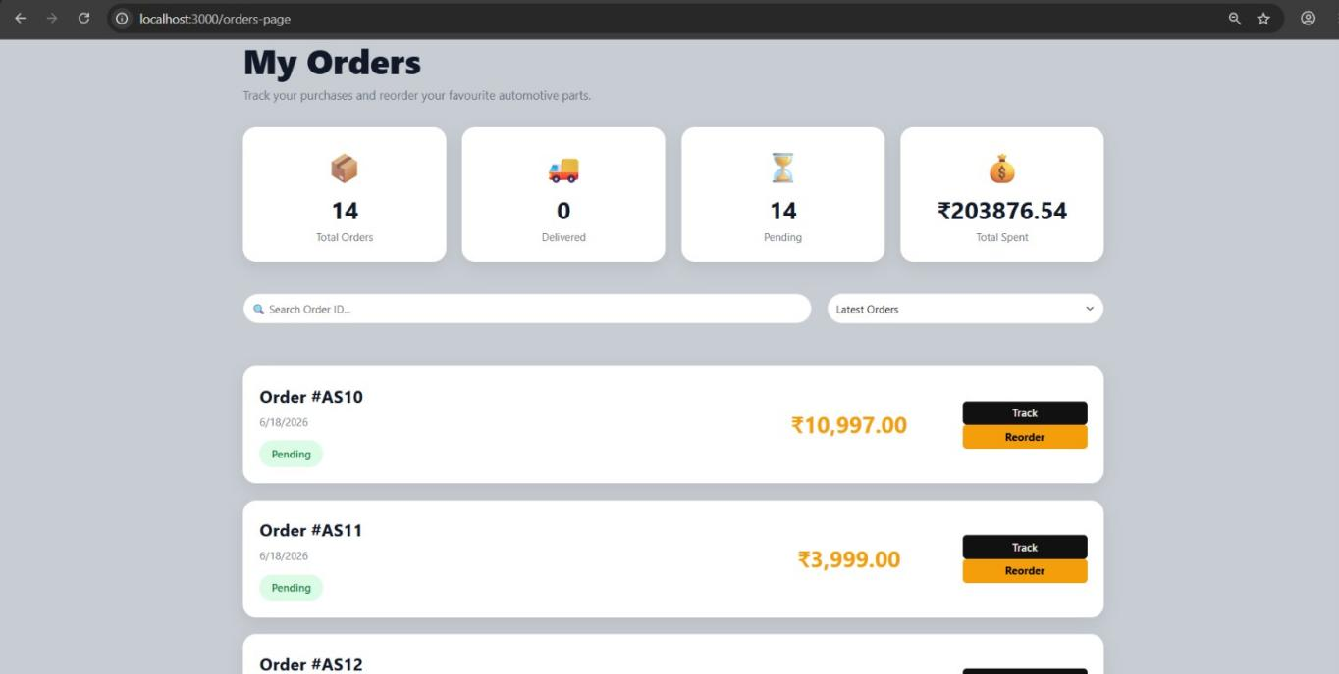
Screenshot: Customer order history

7.10 Order Tracking
Customers can track their order status in real time — from Order Approved to Packed, Ready to Ship, and Delivered.

Live Order Tracking
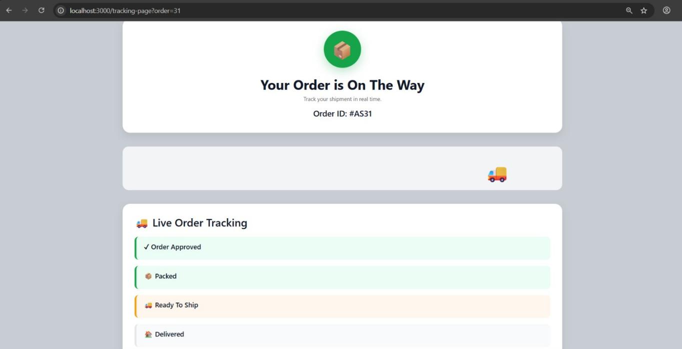
Screenshot: Live order tracking page

8. Application Screenshots — Admin Module
The administrator has complete control over the website through a dedicated admin panel.

8.1 Dashboard
Displays key store metrics: Total Users, Total Products, Total Orders, and Total Revenue, along with the full product inventory.

Admin Dashboard
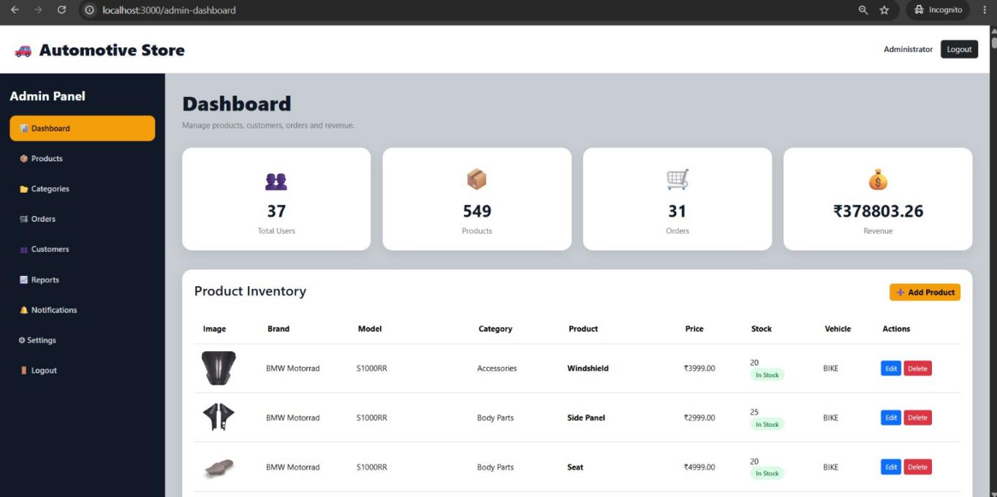
Screenshot: Admin dashboard with store metrics and inventory

8.2 Product Management
Administrators can add, edit, or delete products, including category, brand, model, vehicle type, price, stock, and product image.

Add New Product
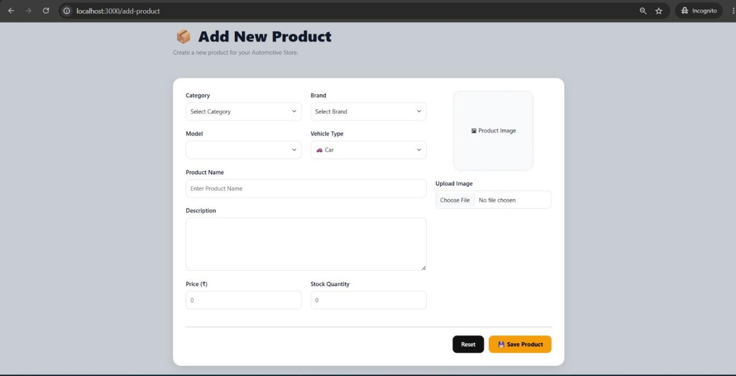
Screenshot: Add new product form

8.3 Order Management
Administrators can approve, pack, ship, deliver, or cancel customer orders from a centralized orders management screen.

Orders Management
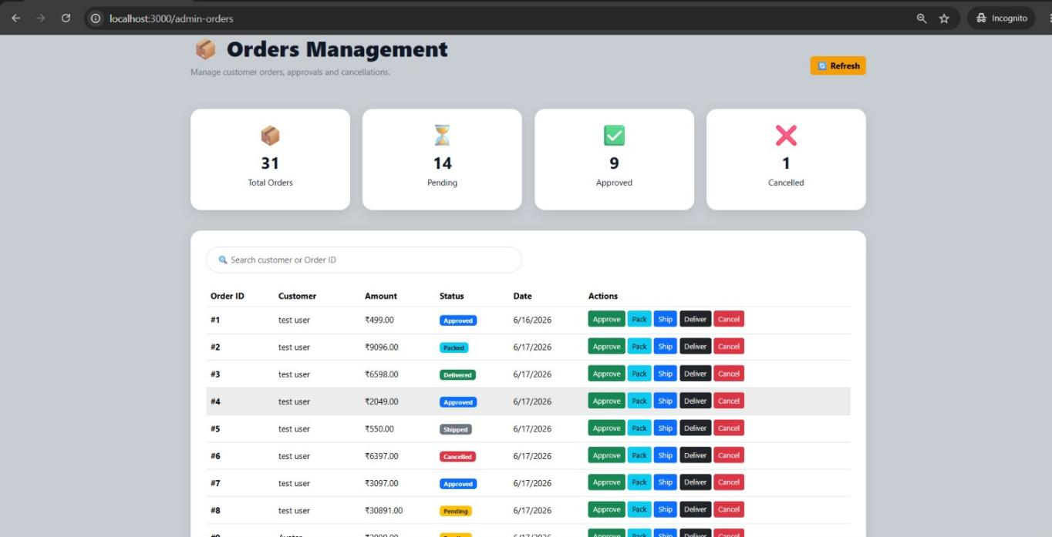
Screenshot: Admin order management with status actions

8.4 Customer Management
Administrators can view all registered customers, search by name or email, and see account roles and status.

Customers
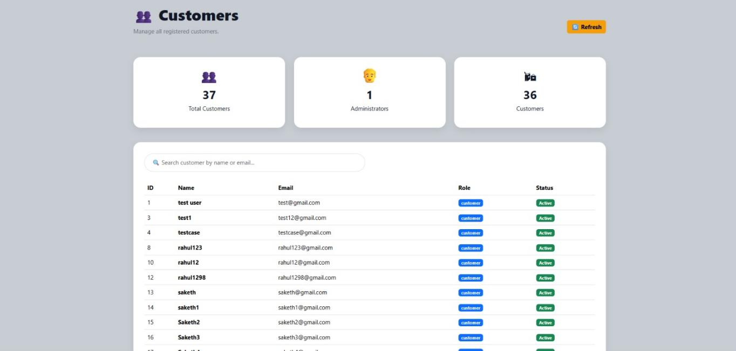
Screenshot: Registered customers list

8.5 Reports
The reports dashboard summarizes Total Revenue, Total Orders, Total Customers, Total Products, and highlights low-stock products needing attention.

Reports Dashboard
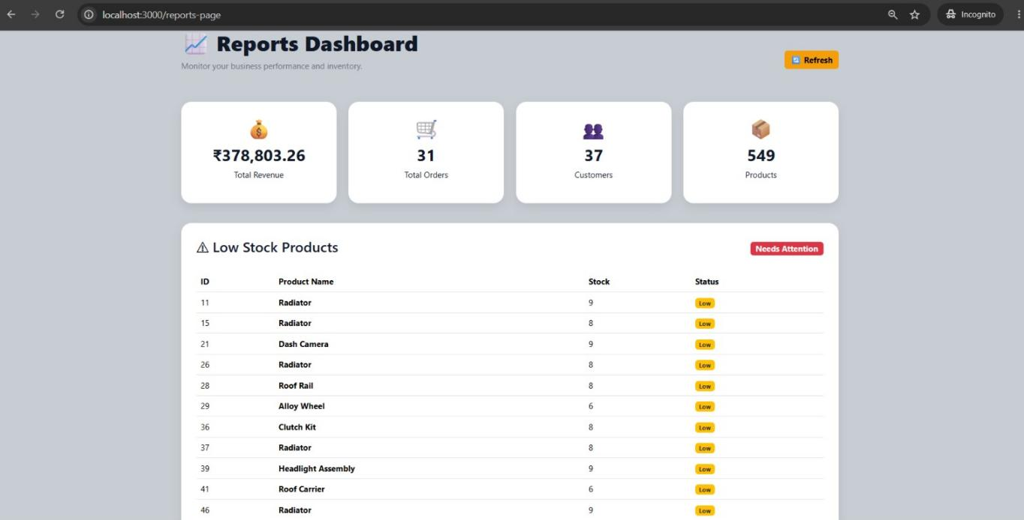
Screenshot: Reports dashboard with business performance metrics

8.6 Notifications
Displays real-time alerts for pending orders, cancelled orders, and low-stock products.

Notifications
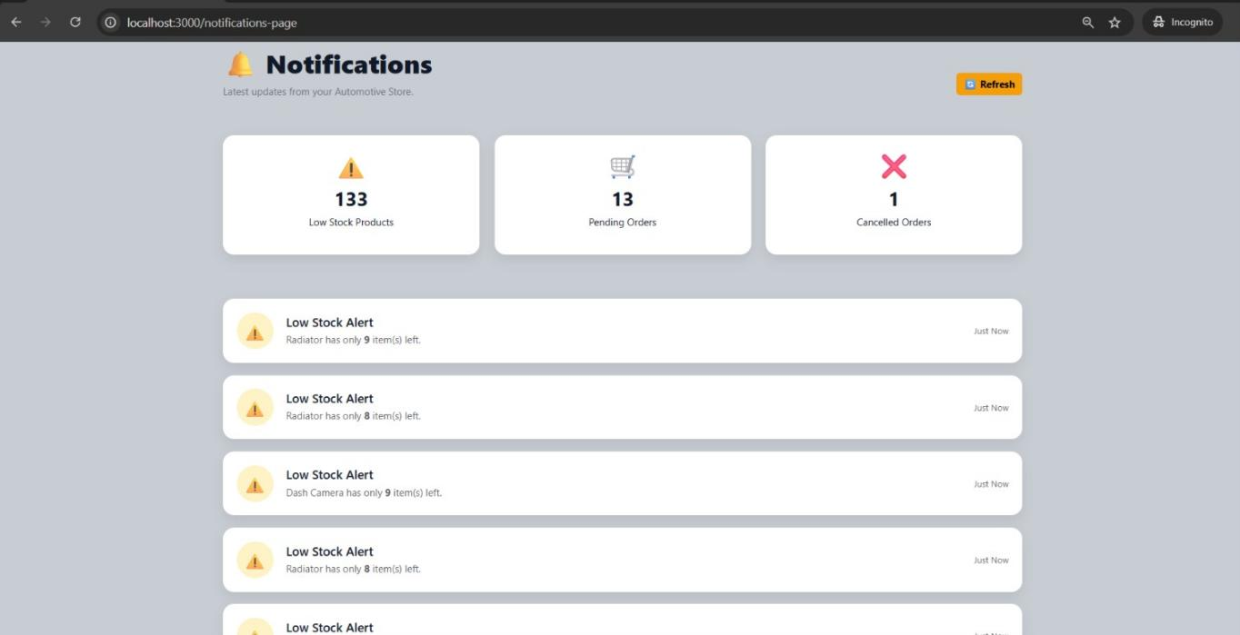
Screenshot: Store notifications and low-stock alerts

8.7 Store Settings
Administrators can update store information such as Store Name, Email, Phone, Address, currency, GST, theme, and admin credentials.

Settings
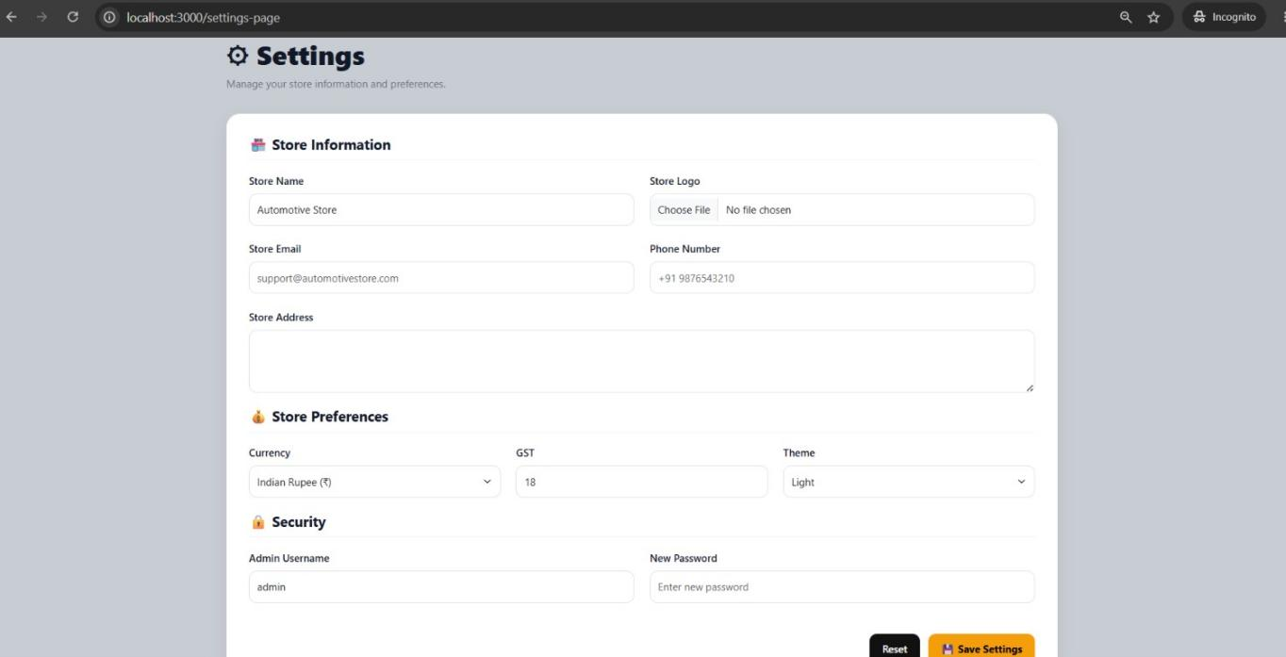
Screenshot: Store settings configuration

9. Application Workflow
The end-to-end flow of the application spans both the customer journey and the admin fulfillment process, as illustrated below.

9.1 Customer Order Workflow
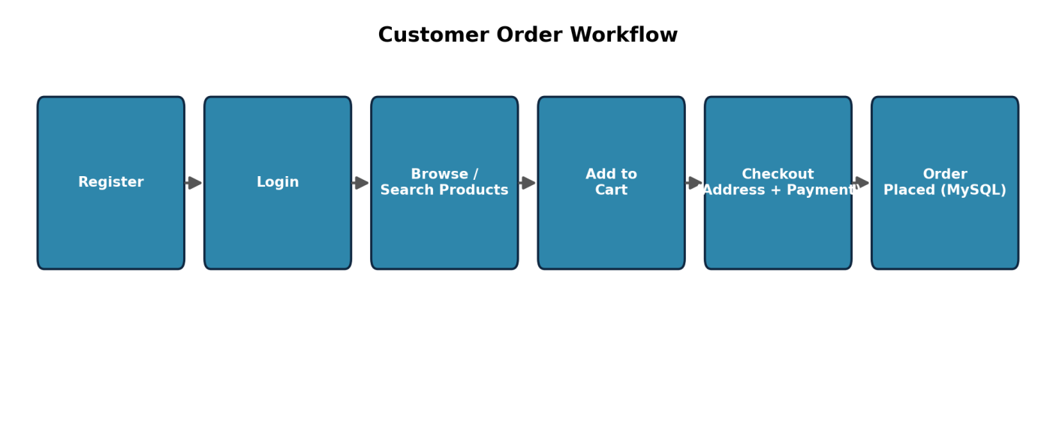
Figure 5: Customer journey from registration to order placement

9.2 Admin Order Fulfillment Workflow
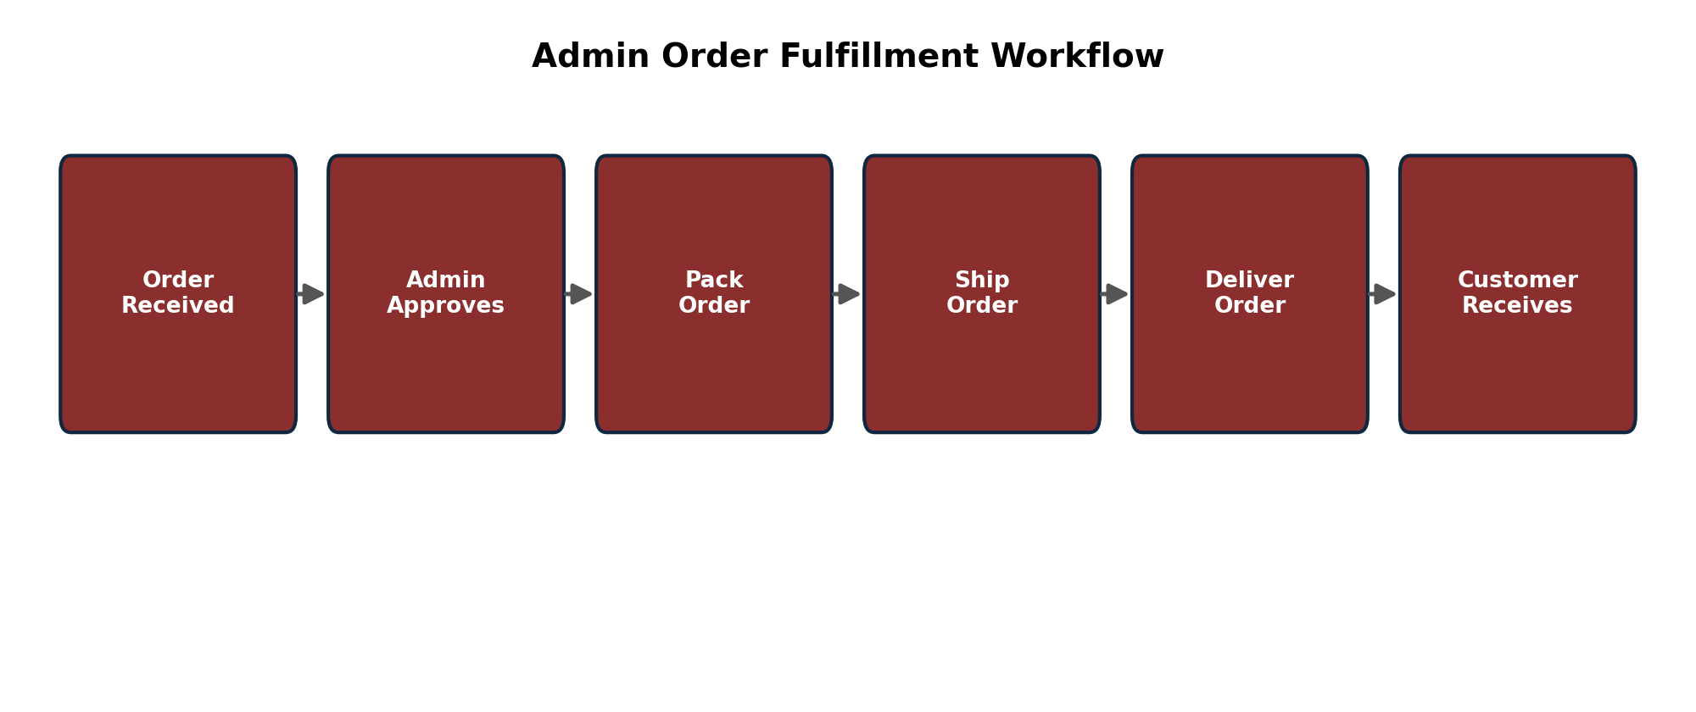
Figure 6: Admin order approval and fulfillment pipeline

10. Security Features

Password Hashing
Passwords are encrypted using bcrypt before being stored in the database.

Session Authentication
Only authenticated users can access protected pages.

Admin Authentication
Only administrators can access admin pages.

Helmet
Helmet secures HTTP headers to protect against common web vulnerabilities.

Rate Limiting
Limits repeated login requests to prevent brute-force attacks.

Environment Variables
Sensitive information such as session secrets and database credentials is stored inside the .env file.

11. Folder Structure & GitHub Repository
GitHub Repository: https://github.com/polagonitejagoud/Automotive-Parts-Store.git
The complete source code, commit history, and setup instructions (README) for the Automotive Parts Store are available at the repository link above.
Automotive-Parts-Store
├── app.js
├── package.json
├── .env
├── database/ db.js
├── middleware/ authMiddleware.js, adminMiddleware.js
├── routes/ authRoutes.js, productRoutes.js, cartRoutes.js,
│ wishlistRoutes.js, orderRoutes.js, adminRoutes.js
├── uploads/
├── public/ css/, js/, images/
└── views/ login.html, register.html, home.html, products.html,
product-details.html, cart.html, wishlist.html,
profile.html, address.html, payment.html, tracking.html,
order-confirmed.html, admin-dashboard.html,
add-product.html, edit-product.html, customers.html,
categories.html, reports.html, notifications.html,
settings.html, admin-orders.html

12. Performance Test

12.1 Test Plan / Test Cases
The following modules were tested:
Test Case | Expected Result | Status
User Registration | User account created | Passed
User Login | Successful login | Passed
Admin Login | Admin dashboard opens | Passed
Product Search | Correct products displayed | Passed
Vehicle Filter | Filtered products shown | Passed
Add to Cart | Product added | Passed
Wishlist | Product saved | Passed
Checkout | Order created | Passed
Order Tracking | Status displayed | Passed
Profile Update | Profile updated | Passed
Product CRUD | Successful | Passed
Category CRUD | Successful | Passed
Reports | Generated correctly | Passed

12.2 Test Procedure
Testing was performed using:
- Manual Testing
- Browser Testing
- API Testing using Postman
- Database Validation using MySQL Workbench
Each module was tested individually and then integrated into the complete application.

12.3 Performance Outcome
The project performed successfully during testing.
- Registration works correctly.
- Login authentication is secure.
- Product search is responsive.
- Cart updates correctly.
- Orders are created successfully.
- Admin dashboard retrieves database information correctly.
- Reports display accurate statistics.
- Security middleware prevents unauthorized access.
The overall performance of the application is stable and suitable for deployment.

13. My Learnings
During this internship, I gained practical knowledge in:
- Full Stack Web Development
- Node.js
- Express.js
- MySQL Database Design
- HTML & CSS
- Bootstrap Framework
- JavaScript
- MVC Architecture
- REST API Development
- CRUD Operations
- Authentication & Authorization
- Password Hashing using bcrypt
- Session Management
- Helmet Security
- Rate Limiting
- Image Upload using Multer
- Git & GitHub
- Debugging
- Software Deployment
- Problem Solving
The internship greatly improved my understanding of industry-standard software development practices.

14. Future Work Scope
The current project can be enhanced with additional features such as:
- Online Payment Gateway Integration (Razorpay/Stripe)
- Email Notifications
- OTP Verification
- Invoice PDF Generation
- Product Reviews and Ratings
- AI-Based Product Recommendation
- Live Order Tracking
- Cloud Image Storage
- Mobile Application
- Multi-Vendor Marketplace
- Business Analytics Dashboard
- QR Code-Based Invoice
- Customer Support Chatbot
- Automated Backup and Recovery
- Continuous Integration and Continuous Deployment (CI/CD)
These enhancements will make the application more scalable, user-friendly, and suitable for commercial deployment.

15. Conclusion
The Automotive Parts Store project successfully demonstrates the development of a secure, full-stack e-commerce application using Node.js, Express.js, and MySQL, following the MVC architecture. It provides a complete online platform for purchasing automobile spare parts while enabling administrators to manage products, customers, and orders efficiently.
The project strengthened my understanding of web development, database management, authentication, security, and deployment practices. It also enhanced my problem-solving abilities and provided valuable experience in building industry-level software applications.
Project source code: https://github.com/polagonitejagoud/Automotive-Parts-Store.git

