Junior Data Analyst - Logistics
Week 1 Task Report
Data Cleaning and Exploratory Data Analysis (EDA)
Submitted by: Lalu Prasad Polai
Internship: Yuva Intern
Tools: Python, Pandas, NumPy, Matplotlib, Seaborn

1. Introduction
Logistics companies generate a large amount of data every day: shipment dates, delivery times, routes, vehicles and costs. If this data is dirty, any decision made from it will be wrong. This report shows the first and most important steps of a data analysis project: cleaning the data and exploring it.
Because real company data is not available, I simulated a logistics dataset of 5,000 shipments using Python. I added common real-world problems on purpose (duplicates, missing values, wrong formats, outliers and invalid values) and then cleaned them step by step.

1.1 Objectives
- Create a logistics dataset with shipment dates, delivery times, route codes and costs.
- Find and fix inconsistencies, missing values and outliers.
- Do EDA to find trends, patterns and anomalies.
- Give insights and recommendations for the next steps.

2. Dataset Description
The raw dataset has 5120 rows and 13 columns (this includes 120 duplicate rows added on purpose). After cleaning, it has 5000 rows and 17 columns (4 new columns were created).
Column | Type | Meaning
shipment_id | Text | Unique ID of the shipment
shipment_date | Date | Date the shipment left the origin
delivery_date | Date | Date the shipment was delivered
route_code | Text | Route code (R01 to R20)
origin / destination | Text | Start and end city of the route
carrier | Text | Courier company (5 companies)
vehicle_type | Text | Bike, Van, Truck or Container
distance_km | Number | Route distance in kilometres
weight_kg | Number | Shipment weight in kilograms
delivery_time_hrs | Number | Hours taken to deliver
shipping_cost | Number | Cost of shipment (INR)
status | Text | Delivered, In Transit, Delayed or Cancelled

New columns created during cleaning: transit_days, cost_per_km, month and is_delayed.

3. Data Quality Issues Found
Before cleaning, I checked the data with shape, info(), isna().sum(), duplicated() and value counts. The table below lists every issue found.
No. | Issue | Count | Where
1 | Duplicate rows | 120 | All columns
2 | Missing values | 1135 | carrier (152), vehicle_type (123), distance_km (101), weight_kg (252), delivery_time_hrs (306), shipping_cost (201)
3 | Mixed date formats (YYYY-MM-DD and DD/MM/YYYY) | 400 | shipment_date
4 | Inconsistent text (UPPER, lower, extra spaces) | 20 carrier values instead of 5; 15 status values instead of 4 | carrier, status, origin, destination
5 | Invalid negative values | 25 weight, 15 distance | weight_kg, distance_km
6 | Delivery date before shipment date | 30 | delivery_date
7 | Extreme outliers | Cost: 150, Time: 40, Weight: 218 | shipping_cost, delivery_time_hrs, weight_kg

4. Data Cleaning Steps

Step 1: Remove duplicates
120 exact duplicate rows were found using df.duplicated() and removed with drop_duplicates(). Duplicates would count the same shipment twice and make costs and volumes look bigger than they are.

Step 2: Standardise text
I used str.strip() to remove extra spaces and str.title() to fix the case. A few names were corrected by hand (for example DTDC and BlueDart). Result: carrier went from 20 values to 5 real values, and status from 15 values to 4.

Step 3: Fix date formats and date logic
400 shipment dates were in DD/MM/YYYY format while the rest were YYYY-MM-DD. Each format was parsed separately with an exact format string, so day and month are never swapped. Then 30 rows where delivery_date was before shipment_date were marked as missing and rebuilt from shipment_date + delivery_time_hrs.

Step 4: Handle invalid values
Weight and distance cannot be zero or negative. Such values were changed to missing (NaN) so they could be imputed with the other missing values.

Step 5: Missing value imputation
- distance_km: median of the same route_code (a route has a fixed distance).
- origin and destination: most common value of the same route_code.
- weight_kg, delivery_time_hrs, shipping_cost: median of the same vehicle_type. I used the median, not the mean, because the median is not pulled by extreme values.
- vehicle_type: most common value (mode).
- carrier: filled with "Unknown" because guessing a company name would be wrong.
After this step, missing values = 0.

Step 6: Outlier detection and treatment
I used the IQR method: any value below Q1 - 1.5 x IQR or above Q3 + 1.5 x IQR is an outlier. Instead of deleting rows, I capped (winsorised) the values at these limits, so no shipment is lost. The lower limit was kept at 0 because cost, time and weight cannot be negative.
Column | Outliers | Lower limit | Upper limit
shipping_cost | 150 | 0 | 8773
delivery_time_hrs | 40 | 0 | 72.3
weight_kg | 218 | 0 | 1064.2
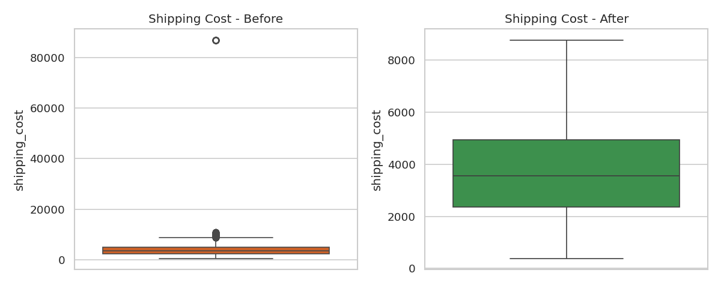
Figure 1: Shipping cost before and after outlier capping

Step 7: Feature engineering
- transit_days = delivery_date - shipment_date
- cost_per_km = shipping_cost / distance_km
- month = month of shipment (for trend analysis)
- is_delayed = 1 if status is Delayed, else 0

5. Exploratory Data Analysis

5.1 Descriptive statistics
Column | Count | Mean | Std | Min | Median | 75% | Max
distance_km | 5,000 | 1,238.3 | 533.98 | 239.7 | 1,314.75 | 1,706.12 | 2,144.2
weight_kg | 5,000 | 438.97 | 256.48 | 17.5 | 384.15 | 574.72 | 1,064.25
delivery_time_hrs | 5,000 | 34.39 | 12.78 | 6.5 | 34.25 | 43.32 | 72.31
shipping_cost | 5,000 | 3,867.58 | 1,944.48 | 378.93 | 3,546.8 | 4,931.85 | 8,772.97
cost_per_km | 5,000 | 3.28 | 1.44 | 1.19 | 3.13 | 3.7 | 33.45

Average shipment: 1238 km, 439 kg, 34.4 hours, costing about INR 3868.

5.2 Distributions
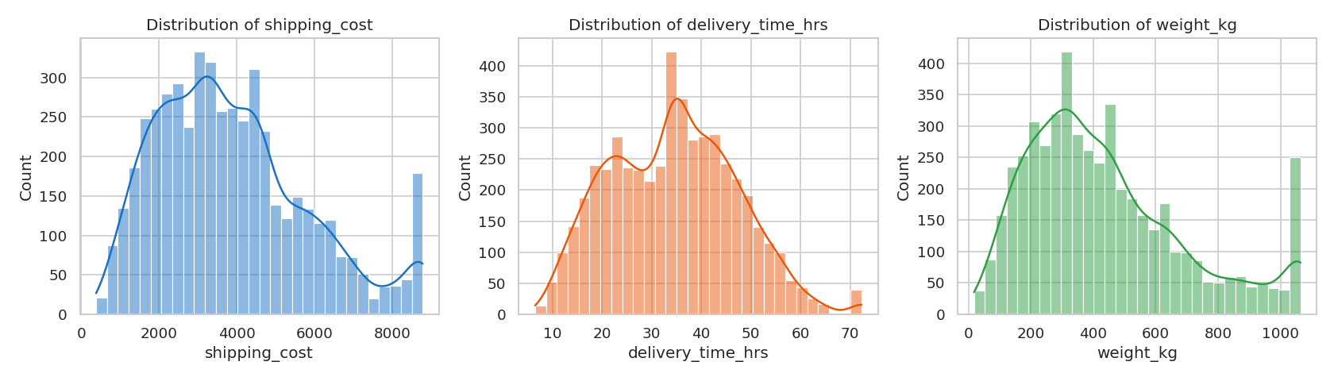
Figure 2: Histograms of cost, delivery time and weight
Delivery time is close to a normal bell shape. Cost and weight are right-skewed: most shipments are small or medium and a few are very heavy and expensive.

5.3 Relationships between variables
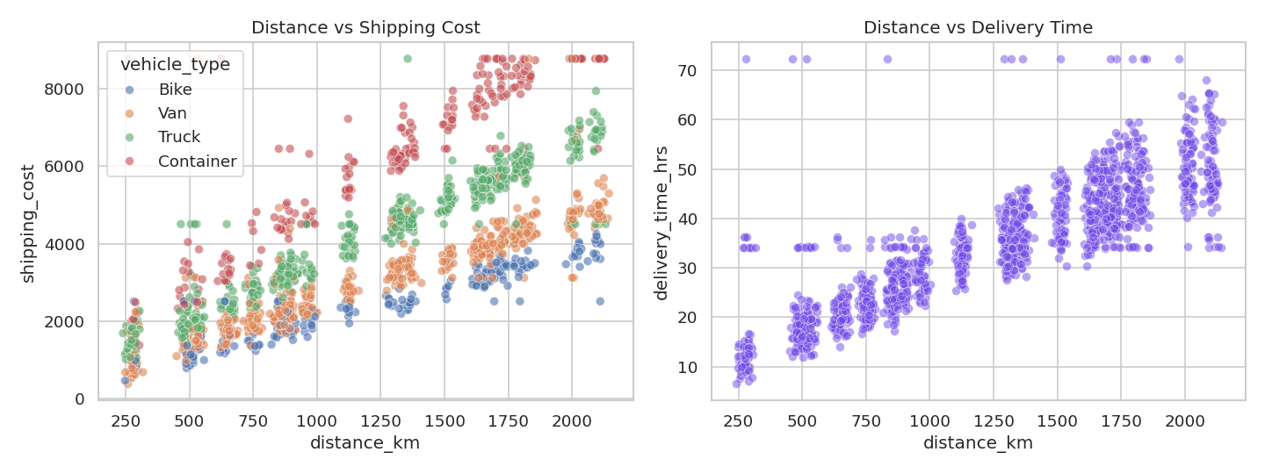
Figure 3: Distance vs cost and distance vs delivery time
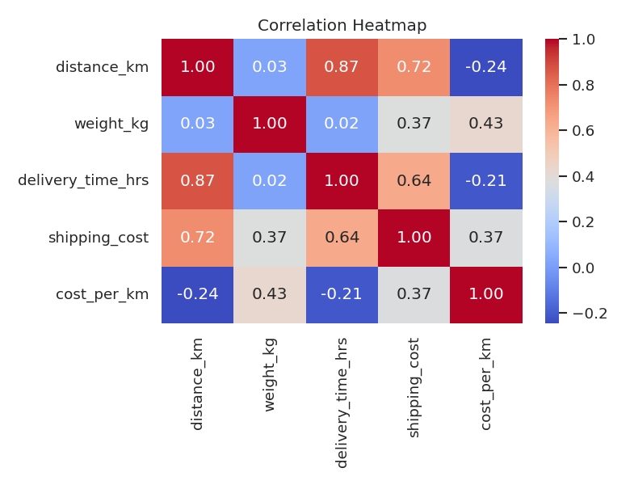
Figure 4: Correlation heatmap
- Distance and delivery time: correlation 0.87 (strong). Longer routes take longer.
- Distance and shipping cost: correlation 0.72 (strong).
- Weight and shipping cost: correlation 0.37 (moderate).

5.4 Vehicle type and carrier performance
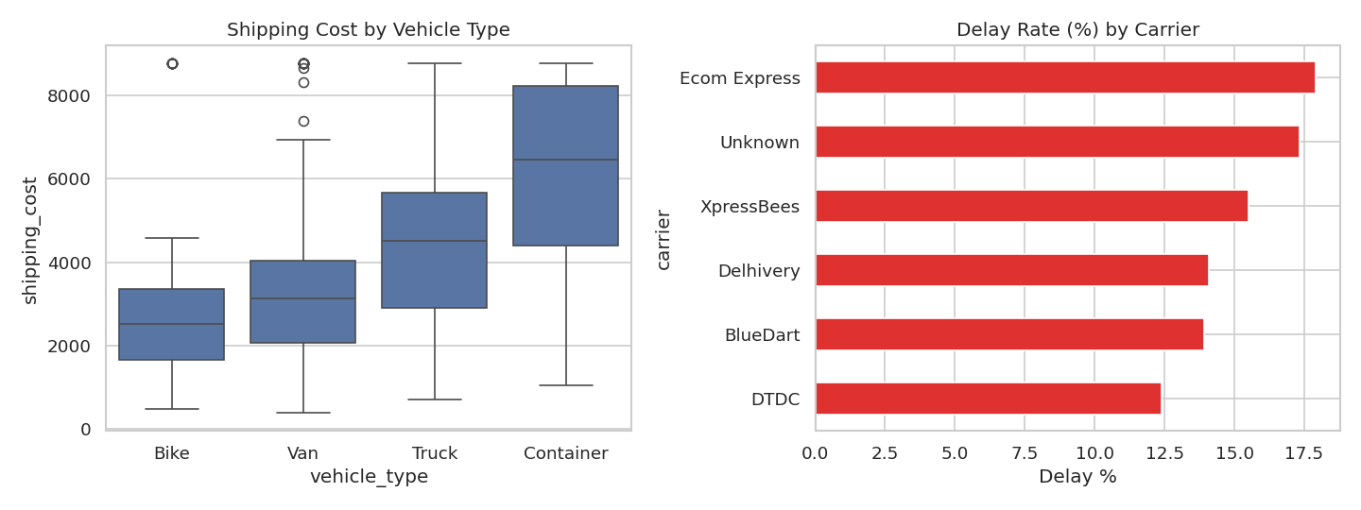
Figure 5: Cost by vehicle type and delay rate by carrier
Average shipping cost by vehicle: Bike INR 2549, Van INR 3077, Truck INR 4326, Container INR 6169. Container shipments cost about 2.4 times more than bike shipments.
Delay rate by carrier: Ecom Express 17.9%, Unknown 17.3%, XpressBees 15.5%, Delhivery 14.1%, BlueDart 13.9%, DTDC 12.4%.

5.5 Shipment status and time trend
Shipment status share: Delivered 71.8%, Delayed 14.9%, In Transit 9.5%, Cancelled 3.7%.
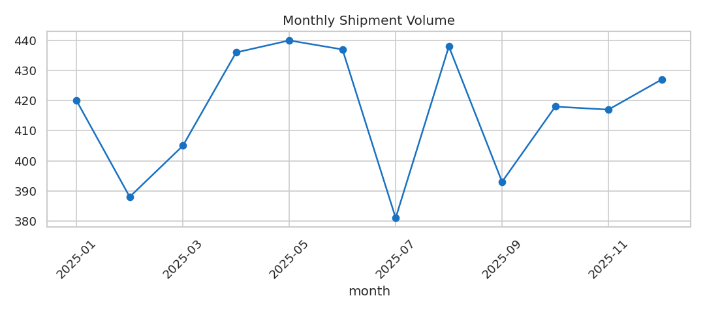
Figure 6: Monthly shipment volume (2025)
Shipment volume is stable across the year. The busiest month is 2025-05 (440 shipments) and the quietest is 2025-07 (381 shipments). The slowest routes on average are R09 (52 hrs), R16 (50.2 hrs), R20 (47.4 hrs).

6. Summary and Insights

6.1 Data quality summary
- About 1.7% of all cells were missing, and almost every column had at least one problem.
- Text columns were the most inconsistent: the same carrier appeared in many spellings, which would split group results wrongly.
- Date errors are dangerous because they create negative delivery times and wrong monthly trends.
- A few extreme values changed the average cost a lot. The median is a safer measure for this data.

6.2 Business insights
- Distance is the main driver of both cost and delivery time, so route planning is the best way to save money.
- Container and truck shipments are the most expensive. Using smaller vehicles for light loads can reduce cost.
- About 14.9% of shipments are delayed and 3.7% are cancelled. Delays are highest for the carrier Ecom Express.
- Long routes with high average delivery time need extra monitoring.

6.3 Recommendations for further analysis
- Build a regression model to predict delivery time and shipping cost.
- Build a classification model to predict which shipments will be delayed.
- Compare carriers on cost per km AND delay rate together, not separately.
- Add data validation at the entry point (fixed date format, dropdown for carrier and status) to stop dirty data at the source.
- Build a dashboard (Power BI or Tableau) with delay rate, cost per km and monthly volume.
- Collect extra columns such as weather, traffic and fuel price to explain delays.

7. Methods, Tools and Reproducibility
All steps were done in Python 3 with these libraries: pandas (cleaning and analysis), numpy (simulation), matplotlib and seaborn (charts). A fixed random seed (np.random.seed(42)) is used, so anyone who runs the code below gets exactly the same data and results. The full code is given in the Appendix, so this document is self-contained.

Appendix: Full Python Code
"""
Week 1 Task: Data Cleaning and EDA on a Simulated Logistics Dataset
Run: python logistics_analysis.py
Needs: pandas numpy matplotlib seaborn
"""
import json
import numpy as np
import pandas as pd
import matplotlib
matplotlib.use("Agg")
import matplotlib.pyplot as plt
import seaborn as sns

np.random.seed(42)
sns.set_theme(style="whitegrid")
log = {} # collects numbers for the report

# ---------------------------------------------------------------
# STEP 1: SIMULATE A DIRTY LOGISTICS DATASET
# ---------------------------------------------------------------
n = 5000
cities = ["Mumbai", "Delhi", "Bengaluru", "Chennai", "Kolkata", "Hyderabad", "Pune", "Bhubaneswar"]
carriers = ["BlueDart", "Delhivery", "DTDC", "Ecom Express", "XpressBees"]
vehicles = ["Bike", "Van", "Truck", "Container"]
routes = [f"R{str(i).zfill(2)}" for i in range(1, 21)]

route_info = {}
for r in routes:
o, d = np.random.choice(cities, 2, replace=False)
route_info[r] = (o, d, np.random.randint(150, 2200))

ship_dates = pd.to_datetime("2025-01-01") + pd.to_timedelta(np.random.randint(0, 365, n), unit="D")
route = np.random.choice(routes, n)
origin = [route_info[r][0] for r in route]
dest = [route_info[r][1] for r in route]
dist = np.array([route_info[r][2] for r in route]) + np.random.normal(0, 15, n)
vehicle = np.random.choice(vehicles, n, p=[0.15, 0.35, 0.35, 0.15])
vmult = {"Bike": 0.8, "Van": 1.0, "Truck": 1.4, "Container": 2.0}
weight = np.round(np.random.gamma(3, 120, n) * np.array([vmult[v] for v in vehicle]), 1)
dtime = np.round(dist / np.random.uniform(35, 55, n) + np.random.normal(6, 2, n), 1)
cost = np.round(dist * np.array([vmult[v] for v in vehicle]) * 2.2 + weight * 0.9 + np.random.normal(0, 150, n), 2)
status = np.random.choice(["Delivered", "In Transit", "Delayed", "Cancelled"], n, p=[0.72, 0.1, 0.14, 0.04])
carrier = np.random.choice(carriers, n)

df = pd.DataFrame({
"shipment_id": [f"SH{100000 + i}" for i in range(n)],
"shipment_date": ship_dates,
"delivery_date": ship_dates + pd.to_timedelta(np.ceil(dtime / 24), unit="D"),
"route_code": route, "origin": origin, "destination": dest,
"carrier": carrier, "vehicle_type": vehicle,
"distance_km": np.round(dist, 1), "weight_kg": weight,
"delivery_time_hrs": dtime, "shipping_cost": cost, "status": status,
})

# --- inject data quality problems ---
df["shipment_date"] = df["shipment_date"].dt.strftime("%Y-%m-%d")
df["delivery_date"] = df["delivery_date"].dt.strftime("%Y-%m-%d")
idx = np.random.choice(n, 400, replace=False) # mixed date formats
df.loc[idx, "shipment_date"] = pd.to_datetime(df.loc[idx, "shipment_date"]).dt.strftime("%d/%m/%Y")
for col, k in [("weight_kg", 250), ("delivery_time_hrs", 300), ("shipping_cost", 200),
("carrier", 150), ("vehicle_type", 120), ("distance_km", 100)]:
df.loc[np.random.choice(n, k, replace=False), col] = np.nan # missing values
for col in ["carrier", "status", "origin", "destination"]: # messy text
i = np.random.choice(n, 500, replace=False)
df.loc[i, col] = df.loc[i, col].astype(str).str.upper() + " "
j = np.random.choice(n, 300, replace=False)
df.loc[j, col] = df.loc[j, col].astype(str).str.lower()
df.loc[np.random.choice(n, 40, replace=False), "shipping_cost"] = df["shipping_cost"].max() * 8 # outliers
df.loc[np.random.choice(n, 40, replace=False), "delivery_time_hrs"] = 400 # outliers
df.loc[np.random.choice(n, 25, replace=False), "weight_kg"] = -50 # invalid
df.loc[np.random.choice(n, 15, replace=False), "distance_km"] = -100 # invalid
bad = np.random.choice(n, 30, replace=False) # date logic error
df.loc[bad, "delivery_date"] = "2024-12-01"
df = pd.concat([df, df.sample(120, random_state=1)], ignore_index=True) # duplicates
df.to_csv("logistics_raw.csv", index=False)

# ---------------------------------------------------------------
# STEP 2: INITIAL INSPECTION
# ---------------------------------------------------------------
log["raw_shape"] = list(df.shape)
log["missing_before"] = df.isna().sum()[lambda s: s > 0].to_dict()
log["duplicates"] = int(df.duplicated().sum())
log["neg_weight"] = int((df["weight_kg"] < 0).sum())
log["neg_distance"] = int((df["distance_km"] < 0).sum())
log["raw_carrier_values"] = int(df["carrier"].nunique())
log["raw_status_values"] = int(df["status"].nunique())

# ---------------------------------------------------------------
# STEP 3: DATA CLEANING
# ---------------------------------------------------------------
# 3.1 remove duplicates
df = df.drop_duplicates().reset_index(drop=True)

# 3.2 clean text columns
fmt = {"origin": str.title, "destination": str.title, "carrier": str.title, "status": str.title}
for c in ["origin", "destination", "carrier", "status", "vehicle_type"]:
df[c] = df[c].astype("string").str.strip().str.title()
df["carrier"] = df["carrier"].replace({"Bluedart": "BlueDart", "Xpressbees": "XpressBees", "Dtdc": "DTDC"})
log["clean_carrier_values"] = int(df["carrier"].nunique())
log["clean_status_values"] = int(df["status"].nunique())

# 3.3 fix dates
sd = df["shipment_date"].astype(str)
iso = sd.str.match(r"^\d{4}-") # YYYY-MM-DD vs DD/MM/YYYY
df["shipment_date"] = pd.NaT
df.loc[iso, "shipment_date"] = pd.to_datetime(sd[iso], format="%Y-%m-%d", errors="coerce")
df.loc[~iso, "shipment_date"] = pd.to_datetime(sd[~iso], format="%d/%m/%Y", errors="coerce")
df["shipment_date"] = pd.to_datetime(df["shipment_date"])
log["mixed_date_formats_fixed"] = int((~iso).sum())
df["delivery_date"] = pd.to_datetime(df["delivery_date"], errors="coerce")
bad_dates = df["delivery_date"] < df["shipment_date"]
log["bad_dates"] = int(bad_dates.sum())
df.loc[bad_dates, "delivery_date"] = pd.NaT

# 3.4 invalid values -> missing
df.loc[df["weight_kg"] <= 0, "weight_kg"] = np.nan
df.loc[df["distance_km"] <= 0, "distance_km"] = np.nan

# 3.5 fill missing values
df["distance_km"] = df["distance_km"].fillna(df.groupby("route_code")["distance_km"].transform("median"))
for c in ["origin", "destination"]:
df[c] = df[c].fillna(df.groupby("route_code")[c].transform(lambda s: s.mode()[0]))
df["carrier"] = df["carrier"].fillna("Unknown")
df["vehicle_type"] = df["vehicle_type"].fillna(df["vehicle_type"].mode()[0])
for c in ["weight_kg", "delivery_time_hrs", "shipping_cost"]:
df[c] = df[c].fillna(df.groupby("vehicle_type")[c].transform("median"))
df["delivery_date"] = df["delivery_date"].fillna(
df["shipment_date"] + pd.to_timedelta(np.ceil(df["delivery_time_hrs"] / 24), unit="D"))

# 3.6 outliers: IQR method, cap values
def cap_iqr(s):
q1, q3 = s.quantile([0.25, 0.75])
lo, hi = max(q1 - 1.5 * (q3 - q1), 0), q3 + 1.5 * (q3 - q1)
return int(((s < lo) | (s > hi)).sum()), s.clip(lo, hi), (round(lo, 1), round(hi, 1))

log["outliers"] = {}
before = df[["shipping_cost", "delivery_time_hrs"]].copy()
for c in ["shipping_cost", "delivery_time_hrs", "weight_kg"]:
cnt, df[c], bounds = cap_iqr(df[c])
log["outliers"][c] = {"count": cnt, "bounds": bounds}

# boxplots before / after
fig, ax = plt.subplots(1, 2, figsize=(10, 4))
sns.boxplot(y=before["shipping_cost"], ax=ax[0], color="#e8590c"); ax[0].set_title("Shipping Cost - Before")
sns.boxplot(y=df["shipping_cost"], ax=ax[1], color="#2f9e44"); ax[1].set_title("Shipping Cost - After")
plt.tight_layout(); plt.savefig("fig_outliers.png", dpi=120); plt.close()

# 3.7 new columns
df["transit_days"] = (df["delivery_date"] - df["shipment_date"]).dt.days
df["cost_per_km"] = (df["shipping_cost"] / df["distance_km"]).round(2)
df["month"] = df["shipment_date"].dt.to_period("M").astype(str)
df["is_delayed"] = (df["status"] == "Delayed").astype(int)

log["clean_shape"] = list(df.shape)
log["missing_after"] = int(df.isna().sum().sum())
df.to_csv("logistics_clean.csv", index=False)

# ---------------------------------------------------------------
# STEP 4: EXPLORATORY DATA ANALYSIS
# ---------------------------------------------------------------
num = ["distance_km", "weight_kg", "delivery_time_hrs", "shipping_cost", "cost_per_km"]
desc = df[num].describe().T.round(2)
log["describe"] = desc.reset_index().values.tolist()
log["status_pct"] = (df["status"].value_counts(normalize=True) * 100).round(1).to_dict()
log["carrier_delay"] = (df.groupby("carrier")["is_delayed"].mean() * 100).round(1).sort_values(ascending=False).to_dict()
log["vehicle_cost"] = df.groupby("vehicle_type")["shipping_cost"].mean().round(0).sort_values().to_dict()
log["route_time"] = df.groupby("route_code")["delivery_time_hrs"].mean().round(1).sort_values(ascending=False).head(3).to_dict()
log["corr_dist_cost"] = round(df["distance_km"].corr(df["shipping_cost"]), 2)
log["corr_dist_time"] = round(df["distance_km"].corr(df["delivery_time_hrs"]), 2)
log["corr_weight_cost"] = round(df["weight_kg"].corr(df["shipping_cost"]), 2)
monthly = df.groupby("month").size()
log["peak_month"] = [monthly.idxmax(), int(monthly.max())]
log["low_month"] = [monthly.idxmin(), int(monthly.min())]

# charts
fig, ax = plt.subplots(1, 3, figsize=(14, 4))
for a, c, col in zip(ax, ["shipping_cost", "delivery_time_hrs", "weight_kg"], ["#1971c2", "#e8590c", "#2f9e44"]):
sns.histplot(df[c], bins=30, kde=True, ax=a, color=col); a.set_title(f"Distribution of {c}")
plt.tight_layout(); plt.savefig("fig_hist.png", dpi=120); plt.close()

fig, ax = plt.subplots(1, 2, figsize=(12, 4.5))
sns.scatterplot(data=df.sample(1500, random_state=1), x="distance_km", y="shipping_cost", hue="vehicle_type", alpha=.6, ax=ax[0])
ax[0].set_title("Distance vs Shipping Cost")
sns.scatterplot(data=df.sample(1500, random_state=1), x="distance_km", y="delivery_time_hrs", alpha=.5, color="#7048e8", ax=ax[1])
ax[1].set_title("Distance vs Delivery Time")
plt.tight_layout(); plt.savefig("fig_scatter.png", dpi=120); plt.close()

fig, ax = plt.subplots(1, 2, figsize=(12, 4.5))
sns.boxplot(data=df, x="vehicle_type", y="shipping_cost", ax=ax[0], order=["Bike", "Van", "Truck", "Container"])
ax[0].set_title("Shipping Cost by Vehicle Type")
(df.groupby("carrier")["is_delayed"].mean() * 100).sort_values().plot(kind="barh", ax=ax[1], color="#e03131")
ax[1].set_title("Delay Rate (%) by Carrier"); ax[1].set_xlabel("Delay %")
plt.tight_layout(); plt.savefig("fig_groups.png", dpi=120); plt.close()

plt.figure(figsize=(9, 4))
monthly.plot(marker="o", color="#1971c2"); plt.title("Monthly Shipment Volume"); plt.xticks(rotation=45)
plt.tight_layout(); plt.savefig("fig_monthly.png", dpi=120); plt.close()

plt.figure(figsize=(6.5, 5))
sns.heatmap(df[num].corr(), annot=True, cmap="coolwarm", fmt=".2f"); plt.title("Correlation Heatmap")
plt.tight_layout(); plt.savefig("fig_corr.png", dpi=120); plt.close()

json.dump(log, open("results.json", "w"), indent=2, default=str)
print(json.dumps(log, indent=2, default=str))

