GLOBAL SUPERSTORE
Data Cleaning, Power Query & Dashboard Project
Project Documentation
2026-08-20

1. Objective
This project cleans, transforms, and analyzes the Global Superstore transactional dataset (51,290 orders placed between 2011 and 2014 across 147 countries) to answer a set of core business questions about sales performance, profitability, regional strength, and the impact of discounting. The end deliverable is a fully formula-driven Excel workbook with an interactive executive dashboard, supported by a documented Power Query (M code) transformation pipeline and this written report.

1.1 Deliverables
- Superstore_Dashboard.xlsx — the full workbook (raw data, cleaning log, Power Query M code, cleaned data, pivot-style summary tables, dashboard with 8 charts, and a business Q&A sheet).
- This document (Superstore_Project_Documentation.docx) — objective, methodology, cleaning log, dashboard walkthrough, and findings.
- A GitHub repository containing both files plus the original and cleaned CSV data.

2. Data Source
The source file is Global_Superstore.csv, a transaction-level export with 51,290 rows and 27 columns covering order/customer/product attributes, shipping details, and financial metrics (Sales, Profit, Discount, Shipping Cost, Quantity). The dataset spans four fiscal years (2011-2014) and seven market groupings (US, Canada, EU, EMEA, LATAM, Africa, APAC).

3. Business Questions
The analysis was scoped around six questions, chosen to cover profitability, geography, time trend, pricing strategy, and customer/product concentration:
- Which product Category and Sub-Category generate the most Sales and Profit — and which Sub-Categories sell well but lose money?
- Which Regions and Markets are the strongest and weakest in Sales and Profit?
- How do Sales and Profit trend year-over-year (2011-2014)?
- How does Discount level affect Profit Margin?
- Which Customer Segment and Ship Mode combinations are most profitable?
- Who / what are the Top 10 customers and products by Sales?

4. Data Cleaning Process
The raw file required targeted cleaning rather than heavy repair: no missing values or duplicate rows were found, but three real data-quality issues were identified and resolved, and several analysis-ready columns were added. Every step below is also implemented as an auditable Excel formula or Power Query step in the workbook (see the "2_Cleaning_Log" and "3_Power_Query_M_Code" sheets).
Step | Action & Rationale
Step 0 | Source load: 51,290 rows x 27 columns imported from Global_Superstore.csv
Step 1 | Removed column 'ji_lu-shu': constant value across all rows (nunique=1), carries no information.
Step 2 | Duplicate check: 0 fully duplicated rows found, 0 duplicate 'Row ID' values found. No removal needed.
Step 3 | Missing value check: 0 null cells found across all columns. No imputation needed.
Step 4 | Trimmed leading/trailing whitespace on 12 text columns (0 cells altered).
Step 5 | Detected corrupted date fields: 'Order Date' and 'Ship Date' held the same placeholder text ('00:00.0') for all 51290/51290 rows. Renamed originals to *(Raw-Corrupted)* and added 'Order Date (Estimated)', derived from Year + weeknum (Monday of the ISO week), for time-based analysis. ASSUMPTION: estimated date, not the true order date.
Step 6 | Verified 'Market' (7 granular regions) vs 'Market2': confirmed Market2 is a consolidated grouping (US+Canada -> 'North America'), no conflicting labels found. Renamed 'Market2' to 'Market Group' and kept both for reference; documented rather than dropped.
Step 7 | Range validation: Sales<0: 0, Quantity<=0: 0, Discount outside [0,1]: 0. All within expected bounds.
Step 8 | Added calculated columns: 'Profit Margin' (Profit/Sales), 'Unit Price' (Sales/Quantity), 'Order Year' (from Year) for downstream pivot analysis.
Step 9 | Reordered columns into a logical layout (30 total columns) for readability.
Step 10 | Final cleaned dataset: 51,290 rows x 30 columns.

4.1 Key Assumption
The "Order Date" and "Ship Date" columns in the source file were corrupted — every one of the 51,290 rows held the identical placeholder text "00:00.0" instead of a real date. Since the true dates cannot be recovered, the original columns were preserved (renamed to flag them as corrupted) and a proxy "Order Date (Estimated)" was derived from the Year and week-number (weeknum) fields — the Monday of that ISO week. This estimated date is used only for year-level trend analysis; it should not be treated as the literal order date.

5. Power Query (M) Implementation
To make the cleaning process reproducible and refreshable inside Excel itself (not just in this one-off workbook), the full transformation pipeline was also written as Power Query M code — see the "3_Power_Query_M_Code" sheet in the workbook. The M query performs, in order: source load and header promotion, removal of the junk column, a distinct-rows check, whitespace trimming on text fields, renaming and derivation of the estimated order date, consolidation of the Market/Market2 fields, type enforcement, and the addition of the Profit Margin and Unit Price calculated columns.
Because Power Query’s interactive editor cannot be scripted outside of the Excel desktop application, the workbook includes step-by-step instructions for loading this query as a Blank Query via Data > Get Data > Launch Power Query Editor > Advanced Editor, so the same cleaning can be reproduced and refreshed against the original CSV on any machine.

6. Workbook Structure
Superstore_Dashboard.xlsx contains 10 sheets:
- 0_ReadMe — project overview, business questions, and a map of every sheet.
- 1_Raw_Data — the original, unmodified data as imported (Excel Table).
- 2_Cleaning_Log — the step-by-step cleaning log shown in Section 4.
- 3_Power_Query_M_Code — the M code from Section 5, plus setup instructions.
- 4_Cleaned_Data — the final analysis-ready dataset (Excel Table, 51,290 rows x 30 columns).
- 5_Summary_Pivots — ten pivot-style summary tables (by Category, Sub-Category, Region, Market, Year, Segment, Ship Mode, Discount Band, Top 10 Products, Top 10 Customers), built entirely with SUMIFS / AVERAGEIFS / LARGE / INDEX-MATCH formulas referencing the Cleaned_Data table — no hardcoded results.
- 6_Dashboard — the executive dashboard described in Section 7.
- 7_Business_Questions — the six business questions with their data-driven answers (Section 8).
- Helper_Product_Agg / Helper_Customer_Agg — hidden helper sheets aggregating Sales/Profit per product and per customer, used to drive the Top-10 rankings via LARGE/INDEX/MATCH formulas.

7. Dashboard & Visualizations
The dashboard opens with four KPI cards (Total Sales, Total Profit, Overall Profit Margin, Total Orders) followed by eight charts covering every business question: Sales & Profit by Category, Sales & Profit by Sub-Category, Sales Share by Market (pie), Sales & Profit Trend by Year (line), Discount Band vs. Average Profit Margin, Top 10 Products by Sales, Sales & Profit by Segment, and Sales & Profit by Ship Mode. Every chart pulls live from the "5_Summary_Pivots" formulas, so the whole dashboard recalculates automatically if the underlying data changes.

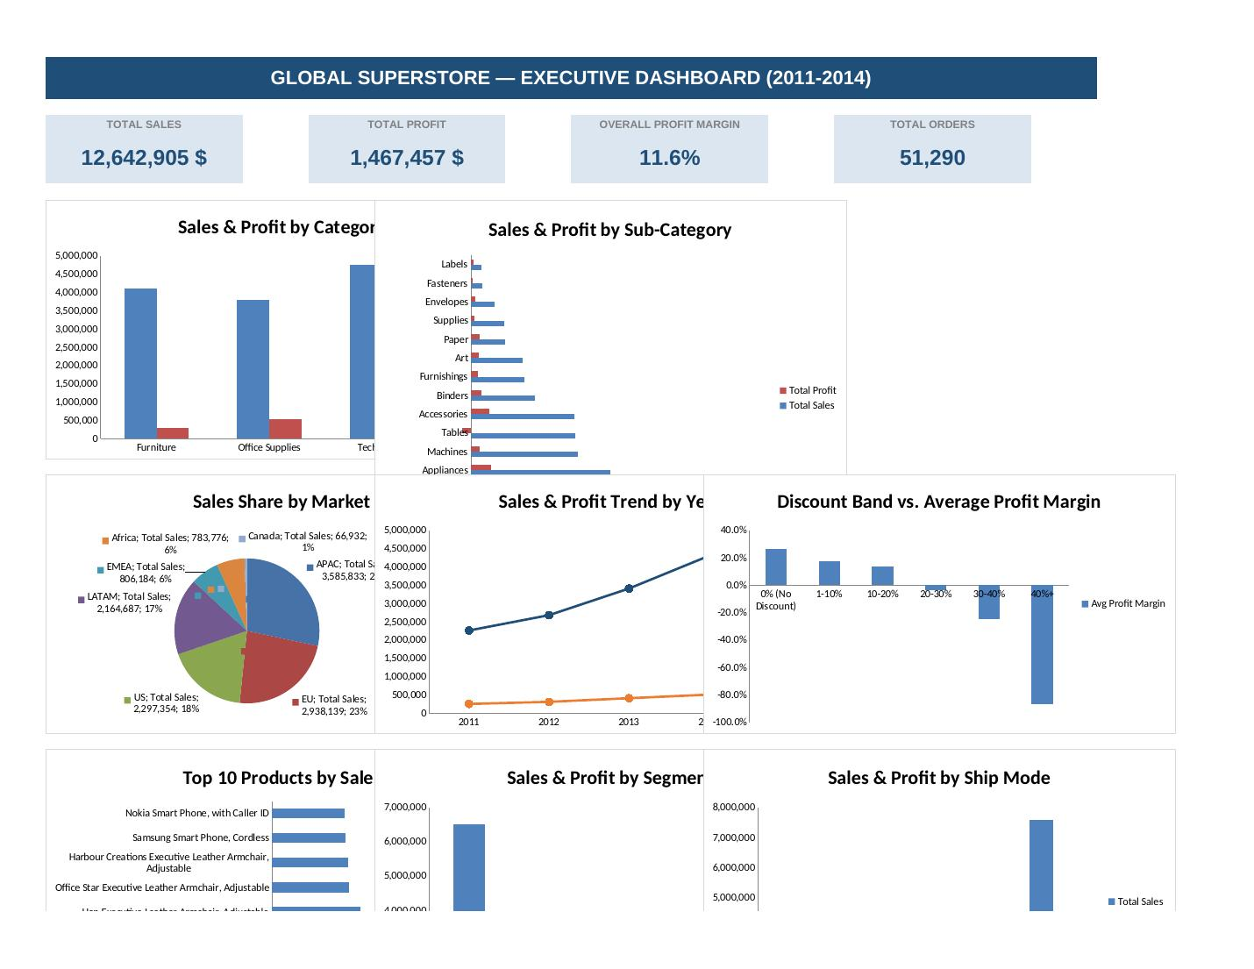
Figure 1 — Dashboard: KPIs, Category/Sub-Category, Market share, Year trend, Discount impact
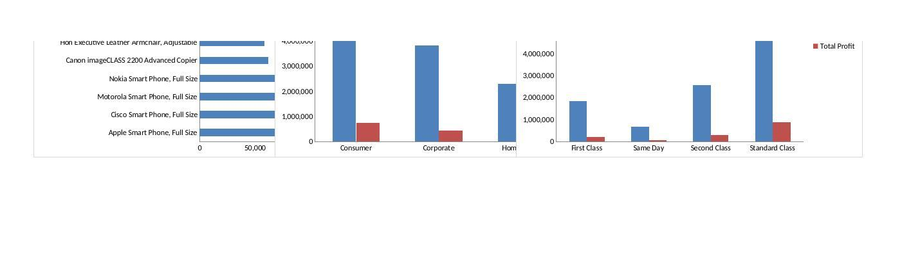
Figure 2 — Dashboard (continued): Top 10 Products, Segment and Ship Mode breakdowns

8. Key Findings — Answers to the Business Questions
Q1. Which Category / Sub-Category generate the most Sales and Profit — which Sub-Categories sell well but lose money?
Technology leads on both Sales ($4.74M) and Profit ($663.8K, 14.0% margin); Office Supplies follows closely on profit ($518.5K). Furniture has the weakest margin (6.9%). At sub-category level, Phones and Copiers post the highest sales with healthy profit, but Tables is a loss-maker: $757K in sales produced a NEGATIVE $64.1K profit (-8.5% margin) — heavy discounting on Tables is eroding profitability.
Q2. Which Regions and Markets are strongest / weakest?
Central region and the APAC market are the standout performers (Central: $2.82M sales / $311K profit; APAC: $3.59M sales / $436K profit). Canada is the smallest market by volume but has the highest margin (26.6%). EMEA is the weakest major market: $806K sales but only $43.9K profit (5.4% margin), the lowest of any market.
Q3. How do Sales and Profit trend year-over-year (2011-2014)?
Both Sales and Profit grew every year: Sales rose from $2.26M (2011) to $4.30M (2014), roughly 90% growth over four years; Profit rose from $249K to $504K over the same period. Margin stayed fairly flat (about 11-12%) each year, meaning growth was driven mainly by volume rather than by improving margins.
Q4. How does Discount level affect Profit Margin?
Discounting shows a clear breakeven point: orders with 0% discount average a 26.5% profit margin, and margin falls steadily as discount increases, turning NEGATIVE once discounts exceed about 20%. Orders discounted 20-30% average -3.9% margin, 30-40% average -24.6%, and 40%+ average -87.0%, meaning roughly 10,400 orders in the dataset are being sold at a loss. Recommendation: cap discretionary discounts at 15-20% outside of clearance events.
Q5. Which Segment and Ship Mode combinations are most profitable?
Consumer is the largest segment by both Sales ($6.51M) and Profit ($749K), though all three segments convert at a similar approximately 11.5-12.0% margin, so segment mix alone is not a strong profitability lever. Standard Class dominates shipping volume ($7.58M sales / $891K profit), and all ship modes convert at a similar approximately 11.4-11.8% margin, so shipping speed does not materially affect profitability.
Q6. Who / what are the Top 10 customers and products by Sales?
Tom Ashbrook is the top customer ($40.5K in sales, $6.3K profit), followed by Tamara Chand and Greg Tran. Notably, Sean Miller (#5, $35.2K in sales) is unprofitable overall (-$410 profit) despite high spend. Among products, phones and copiers dominate the top 10 by sales, led by the Apple Smart Phone ($86.9K); the Samsung Smart Phone, Cordless (#9, $48.7K sales) is also a loss-maker (-$198 profit).

9. Assumptions & Limitations
- Order Date and Ship Date are estimated (from Year + week number), not the original transaction timestamps, because the source date fields were corrupted for every row.
- "Market" (7 granular regions) and "Market Group" (6 groupings, US+Canada combined into "North America") are both retained; analyses in this report use "Market" unless otherwise noted.
- All figures are in the currency unit of the source file (unlabeled in the original data); no currency conversion was applied.

10. Conclusion
The cleaned dataset and dashboard show a business that is growing steadily in both Sales and Profit year over year, led by the Technology category and the APAC market, but with two clear risk areas: the Tables sub-category and any order discounted beyond roughly 20%, both of which are net loss-makers. Tightening discount policy above that threshold and reviewing Tables pricing are the two highest-leverage actions suggested by this analysis.

11. Project Files
The full workbook, this document, and the raw/cleaned CSV files are available in the project GitHub repository.

