**Introduction**

1. **Introduction to our project**

**Our project idea is about storing the customer details and also automatically counting the money which you either have to pay or you will get from the customer.**

**You can also add description with the money that for which reason you have to pay or you will get the money from the customer with the date and time so that you do not have to recognize all this things.**

1. **Pictures with description**

**The following image is list of customers which you want to store their account.**

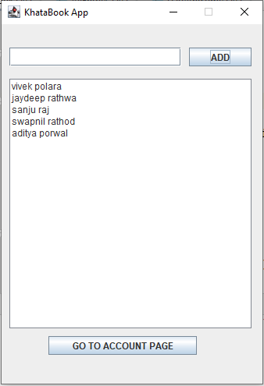

**If you select any of the customer then you press that ‘GO TO ACCOUNT PAGE’ then you will reach to their account pages where you can store the account information of that customer.**

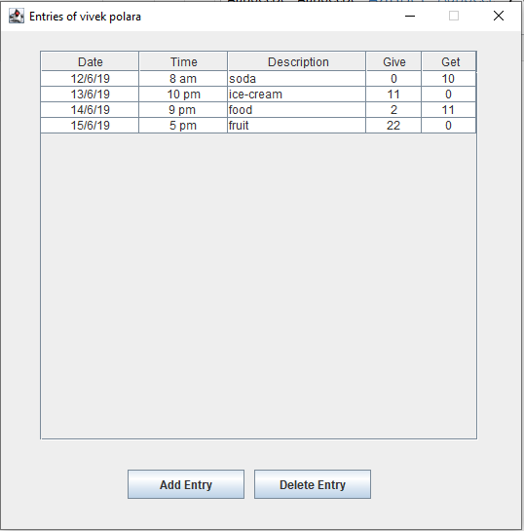

**This image shows you about vivek polara’s entries with date, time, description, give money and get money.**

**If you want delete the entry you can easily delete it.**

**If you want to add entry you can add entry too as shown image below.**

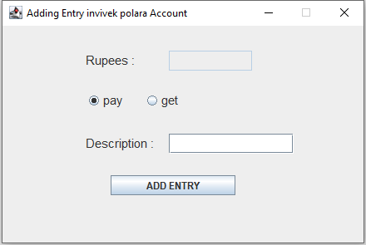

**As you can see in above picture there is rupees option where you can add the money and you can select pay or get by radio button and if you want to add description the you can add the description too.**

**Some functionality remaining to add in this project which shows you the total amount of money you have to pay or you will get.**

**Thank you…**