VulnWebApp (VWA) Security Report

Code Revision: 1.0.0.0

Company: Acme Inc.

Report: VWA20231129

Author: [Hsin-Wen Chang]

Date: [2023/08/30]

**VWA20233008 – Cryptographic Failures - HIGH** **3**

**VWA20233009 – Cryptographic Failures - HIGH**

**VWA20233010 – Injection - HIGH**

**VWA20233011 – Injecction - MEDIUM**

**VWA20233012 – Security Misconfiguration - MEDIUM**

**VWA20233001 – FALSEPOSITIVE - LOW**

**VWA20233002 – FALSEPOSITIVE - LOW**

**VWA20233002 – Broken Access Control - High**

**VWA20233002 – FALSEPOSITIVE - LOW**

**VWA20233002 – FALSEPOSITIVE - LOW**

**VWA20233002 – FALSEPOSITIVE - LOW**

**VWA20233002 – FALSEPOSITIVE - LOW**

**VWA20233002 – FALSEPOSITIVE - LOW**

# 

# **VWA20230830 – Cryptographic Failures - High**

**Vulnerability Exploited:** **Cryptographic Failures**

**Severity:[Critical, High, Medium, Low, Info]**

**System:** VWA Web Application

**Vulnerability Explanation**:

Using deprecated cryptographic functions MD5 in password and is not salted or peppered

**Vulnerability Walk-thru**:

**Recommendations:**

MD5 should never be used in passwords, we need to migrate to bcrypt or another hash that is slow hashing.

https://cheatsheetseries.owasp.org/cheatsheets/Password_Storage_Cheat_Sheet.html

# 

# 

# 

# 

# 

# 

# **VWA20233009 – Cryptographic Failures - Medium**

**Vulnerability Exploited: Cryptographic Failures**

**Severity:[Critical, High, Medium, Low, Info]**

**System:** VWA Web Application

**Vulnerability Explanation**:

Hard-coded passwords frequently result in substantial authentication failures that are challenging for system administrators to identify. The administrator might be compelled to completely disable the product because once discovered, it can be challenging to fix. The back-end credentials could simply be hard-coded into the front-end product by the coder. The password might potentially be extracted by any user of that program. Given how easy it is to extract a password from a binary, client-side system with hard-coded passwords are considerably more dangerous.

**Vulnerability Walk-thru**:

**Recommendations:**

We should never use default passwords.

<https://bandit.readthedocs.io/en/1.7.0/plugins/b106_hardcoded_password_funcarg.html>

<https://cwe.mitre.org/data/definitions/259.html>

# 

# **VWA20233010 – Injection - High**

**Vulnerability Exploited:** **Injection**

**Severity:[Critical, High, Medium, Low, Info]**

**System:** VWA Web Application

**Vulnerability Explanation**:  
By using deprecated cryptographic functions MD5 in password will expose to an attacker's perspective, the optimal place to inject malicious content is in an area that is displayed to either many users or particularly interesting users. Interesting users typically have elevated privileges in the application or interact with sensitive data that is valuable to the attacker. The attacker can engage in a number of malicious actions after injecting the malicious script. Private data, including cookies that may contain session information, could be sent from the victim's computer to the attacker by the attacker. When the victim has administrator rights to control a website, the attacker may make malicious requests to that website on the victim's behalf, which might be extremely risky for that website. To compromise the victim's account on a trustworthy website, an attacker may use phishing attacks to imitate reputable websites and deceive the victim into entering their password. Finally, the script might take advantage of a flaw in the victim's web browser to potentially take control of their computer, a technique known as "drive-by hacking."

**Vulnerability Walk-thru**:

**Recommendations:** https://bandit.readthedocs.io/en/1.7.0/plugins/b703_django_mark_safe.html

# 

# 

# 

# **VWA20233011 – Injection - Medium**

**Vulnerability Exploited:** **Injection**

**Severity:[Critical, High, Medium, Low, Info]**

**System:** VWA Web Application

**Vulnerability Explanation**:

This problem is low severity. Just a warning for those who might not be aware of the potential security concerns surrounding the library.

**Vulnerability Walk-thru**:

**Recommendations:**

By excluding the warning with # nosec B404 on the relevant line, or by altering scan behavior in your Bandit settings, you can disable the alert and have [B602: subprocess_popen_with_shell_equals_true](https://bandit.readthedocs.io/en/latest/plugins/b602_subprocess_popen_with_shell_equals_true.html?highlight=b602) and [B603: subprocess_without_shell_equals_true](https://bandit.readthedocs.io/en/latest/plugins/b603_subprocess_without_shell_equals_true.html#b603-subprocess-without-shell-equals-true) both turned on, which are where actual security issues could happen.

<https://docs.openstack.org/bandit/1.4.0/blacklists/blacklist_imports.html#b404-import-subprocess>

# 

# 

# 

# 

# 

# **VWA20233012 – Security Misconfiguration - Medium**

**Vulnerability Exploited:** **Security Misconfiguration**

**Severity:[Critical, High, Medium, Low, Info]**

**System:** VWA Web Application

**Vulnerability Explanation**:

The product employs XML documents and permits the definition of their structure using a Document Type Definition (DTD), however it does not adequately regulate the quantity of recursive entity definitions.

**Vulnerability Walk-thru**:

**Recommendations:**

The majority of this is based on Christian Heimes' defusedxml work, which may be found at: https://pypi.python.org/pypi/defusedxml/#defusedxml-sax

It is well known that using different XLM methods to parse untrusted XML input leaves one open to XML assaults. The defusedxml equivalents of methods should be used in their place.

# 

# 

# 

# 

# 

# **VWA20233003 – Injection - Medium**

**Vulnerability Exploited:** **Injection**

**Severity:[Critical, High, Medium, Low, Info]**

**System:** VWA Web Application

**Vulnerability Explanation**:

Possible SQL injection vector through string-based query construction.

**Vulnerability Walk-thru**:

SQL query insertion or "injection" via input data provided to an application. It is a typical assault method.

**Recommendations:**

Additionally, this plugin test will look to see if the identified string is used with the execute or executemany Python DBAPI standard methods. If so, there is a reported MEDIUM problem.

# 

# 

# 

# 

# 

# **VWA20233004 – SQLi -​ Critical - High**

**Vulnerability Exploited:** **SQLi**

**Severity:[Critical, High, Medium, Low, Info]**

**System:** VWA Web Application

**Vulnerability Explanation**:

**Vulnerability Walk-thru**:

**Recommendations:**

# **VWA20233005 –** Broken Access Control **- High**

**Vulnerability Exploited:** Broken Access Control

**Severity:[Critical, High, Medium, Low, Info]**

**System:** VWA Web Application

**Vulnerability Explanation**:

We can see that one of the two request objects contains an async call to the server to retrieve the user's current information. By altering the initial request, we can now see that the API used to retrieve the user information is simply returning the data rather than properly validating authentication to see if it is permitted for our user.

**Vulnerability Walk-thru**:

1. After we manipulated the Cookie gain admin rights.
2. Heading to Customers page hit view button.
3. Hit xhr type file go to Resonse tab then open new window.

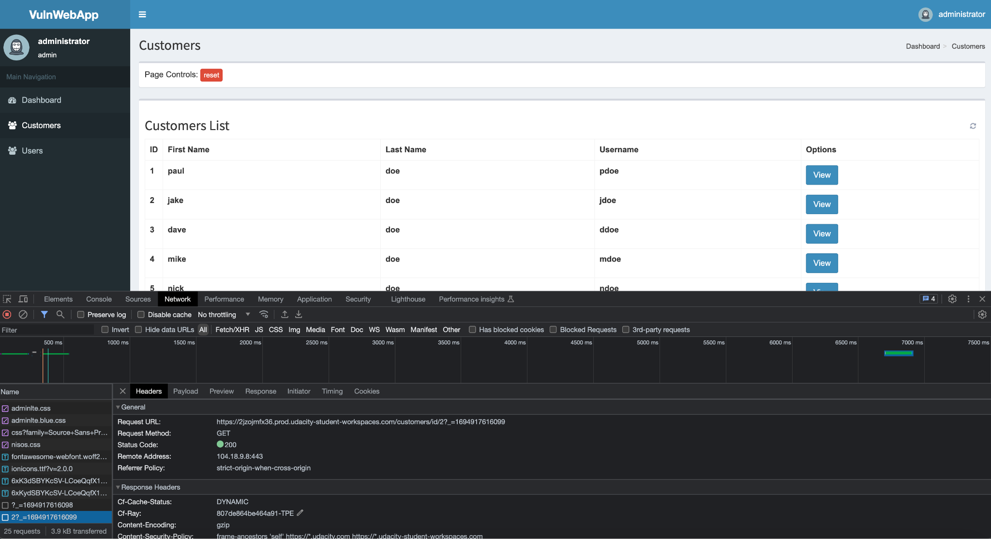

1. You can see by modifying customers/id/2 we can direct retrieve the user information.

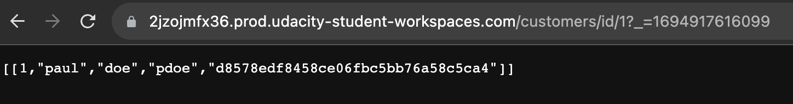

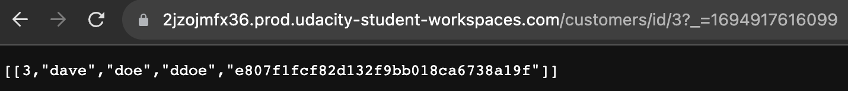

Same as the Users page:

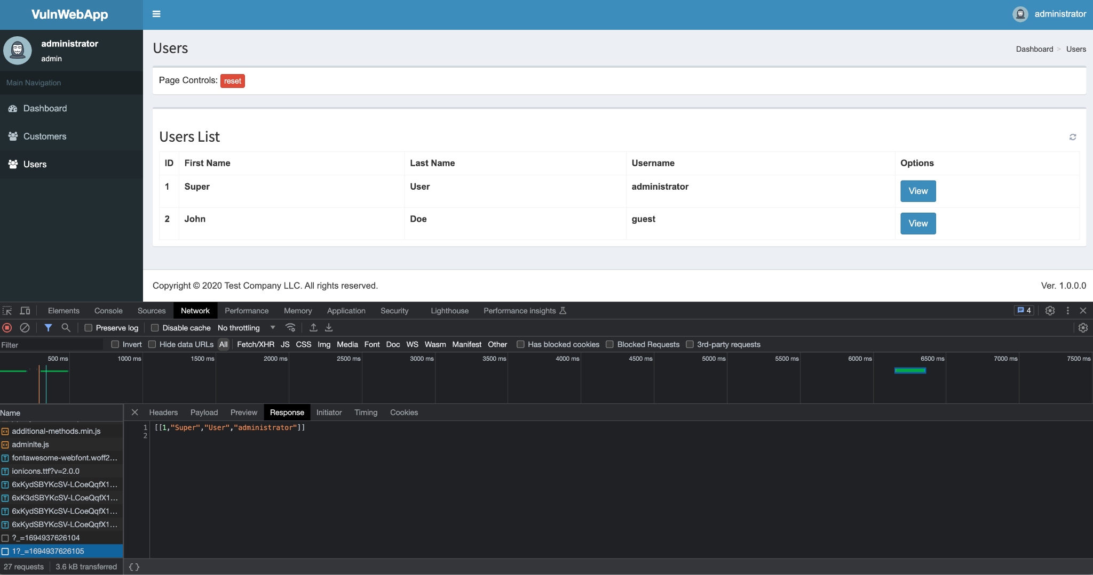

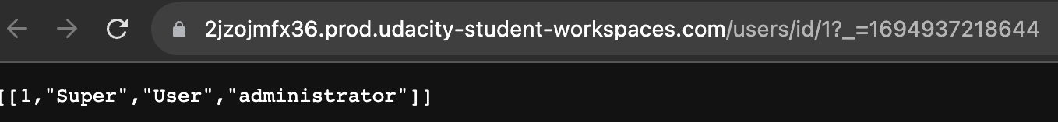

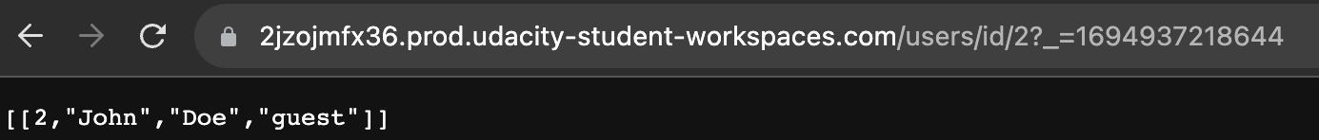

**Recommendations:**

* Rate Limit Data - You can prevent users from scraping all of the data from your web application by rate-limiting their access to the data on the site.
* Revalidate all secure pages - Ensure that all secure pages and endpoints have undergone adequate testing to confirm that access control is operating as expected.
* Deny Access for Non-Public Pages by Default- We should have general rules that automatically refuse access to non-public pages and demand validation in order to access these pages.
* Log Access Failures - You should keep track of not only all access errors, but also IP addresses and users who have a large number of them.

# **VWA20233006 –** Sensitive Data Exposure **- High**

**Vulnerability Exploited:** Sensitive Data Exposure

**Severity:[Critical, High, Medium, Low, Info]**

**System:** VWA Web Application

**Vulnerability Explanation**:

To find out the hash type is MD5, we click on Hash ID. The hash is then pasted once more along with the hash type after selecting Hash Cracking. Since we now know the hash type for the second password, we can proceed directly to the hash cracking to find the password.

**Vulnerability Walk-thru**:

1. After we manipulated the Cookie gain admin rights.
2. Heading to Customers page hit view button.
3. Hit xhr type file go to Resonse tab then the passwords will be exposed. This is considered a security breach

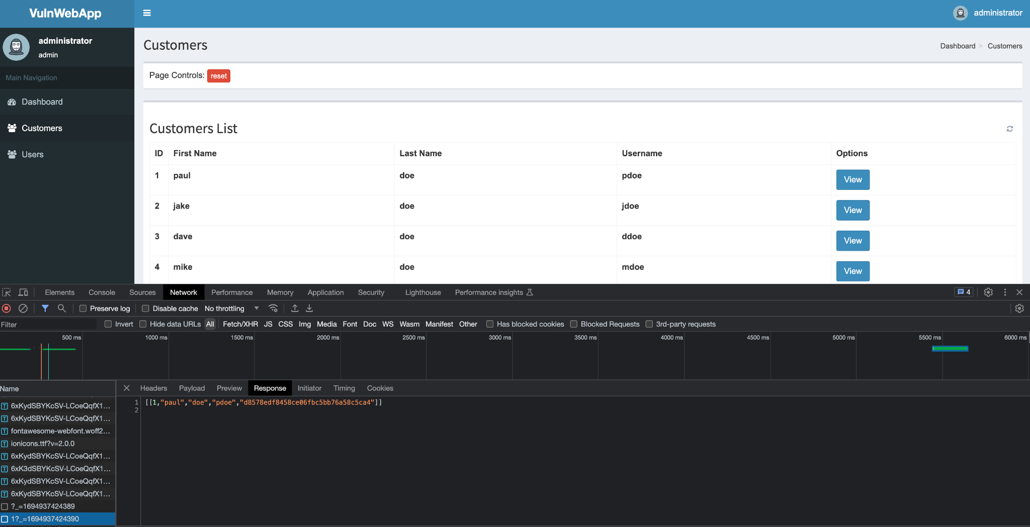

4. Copy paste the hash use hashid.py to find out the hash type is MD5

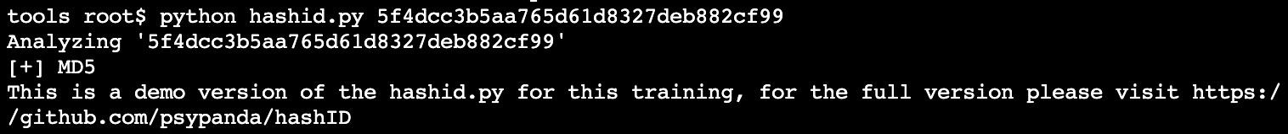

**Recommendations:**

* Check code using Sensitive Data - Must ensure every piece of code using sensitive data is secure and operating as intended.
* Strong Hashing - Use strong adaptive, salted hashing algorithms with a delay factor when creating passwords.
* Limit storing sensitive data to only what is needed - By storing little more sensitive data than is necessary, can lower the risk of web application faces from storing sensitive data..
* Encrypt all data in transit and at rest - By using HTTPS and a strong cipher, you should make sure that all data is secured both in transit and at rest.

# **VWA20233007 – Cryptographic Failures - High**

**Vulnerability Exploited:** **Cryptographic Failures**

**Severity:[Critical, High, Medium, Low, Info]**

**System:** VWA Web Application

**Vulnerability Explanation**:

**Vulnerability Walk-thru**:

**Recommendations:**

# **VWA20233008 – Cryptographic Failures - High**

**Vulnerability Exploited:** **Cryptographic Failures**

**Severity:[Critical, High, Medium, Low, Info]**

**System:** VWA Web Application

**Vulnerability Explanation**:

**Vulnerability Walk-thru**:

**Recommendations:**

# **VWA20233001 – FALSEPOSITIVE - Low**

**Vulnerability Exploited:** **FALSEPOSITIVE**

**Severity:[Critical, High, Medium, Low, Info]**

**System:** VWA Web Application

**Vulnerability Explanation**:

This is a false positive, the code is generate a random resetcode.

**Vulnerability Walk-thru**:

**Recommendations:** This is a false positive, the code is generate a random resetcode.

# 

# 

# 

# 

# 

# 

# 

# **VWA20233002 – FALSEPOSITIVE - Low**

**Vulnerability Exploited:** **FALSEPOSITIVE**

**Severity:[Critical, High, Medium, Low, Info]**

**System:** VWA Web Application

**Vulnerability Explanation**:

This plugin test is part of a family of tests built to check for process spawning and warn appropriately.

Specifically, this test looks for the spawning of a subprocess without the use of a command shell.

**Vulnerability Walk-thru**:

**Recommendations:**

This type of subprocess invocation is not vulnerable to shell injection attacks, but care should still be taken to ensure validity of input.

https://docs.openstack.org/bandit/1.4.0/plugins/subprocess_without_shell_equals_true.html