Realtime System Programming

2020136155

#Lab05

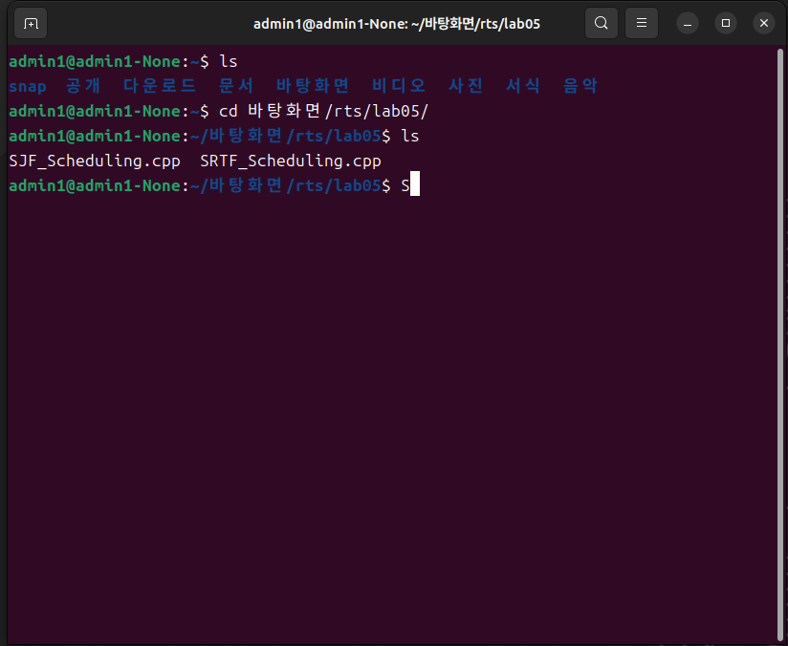

P3

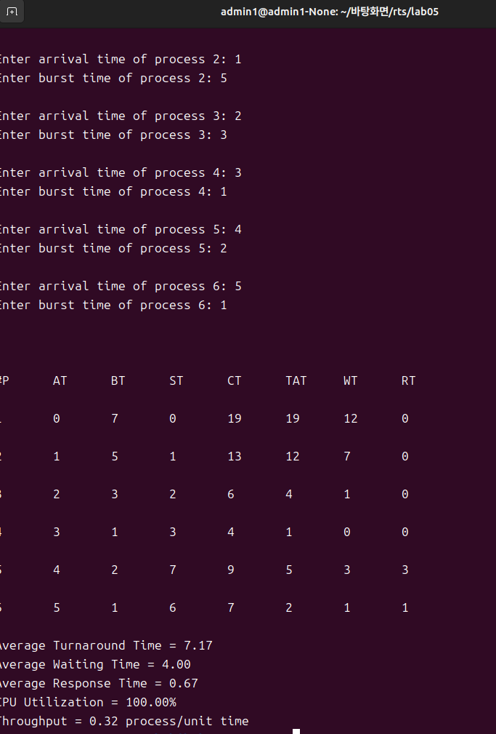

P4

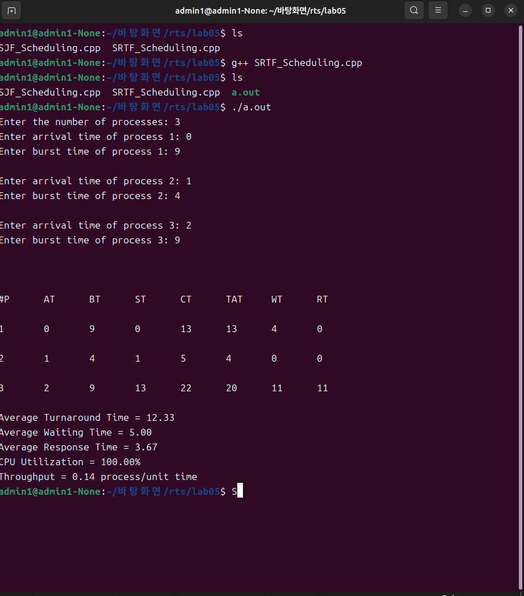

Time 0: P1 arrives (burst time remaining: 9) - P1 runs

Time 1: P2 arrives (burst time remaining: 4) - Preempt P1 and run P2

Time 2: P3 arrives (burst time remaining: 9) - Preempt P2 and run P3

Time 6: P2 completes (waiting time for P2: 6 - 1 = 5)

Time 11: P1 completes (waiting time for P1: 11 - 0 = 11)

Time 20: P3 completes (waiting time for P3: 20 - 2 = 18)

평균 대기 시간 = (5 + 11 + 18) / 3 = 34 / 3 ≒ 11.33 단위

평균 처리 시간 = (9 + 5 + 18) / 3 = 32 / 3 ≒ 10.67 단위

P5

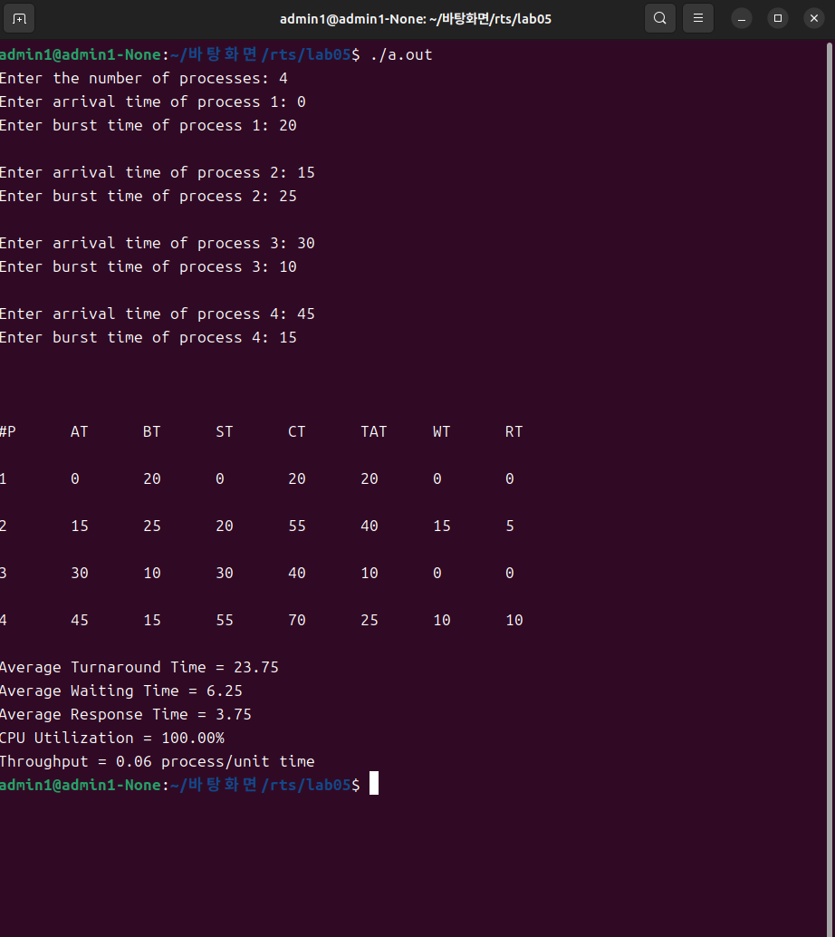

Time 0: P1 arrives (burst time remaining: 20) - P1 runs

Time 15: P2 arrives (burst time remaining: 25) - Preempt P1 and run P2

Time 30: P3 arrives (burst time remaining: 10) - Preempt P2 and run P3

Time 45: P4 arrives (burst time remaining: 15) - P3 continues to run

Time 50: P3 completes (waiting time for P2: 50 - 15 = 35)