Jasper Report

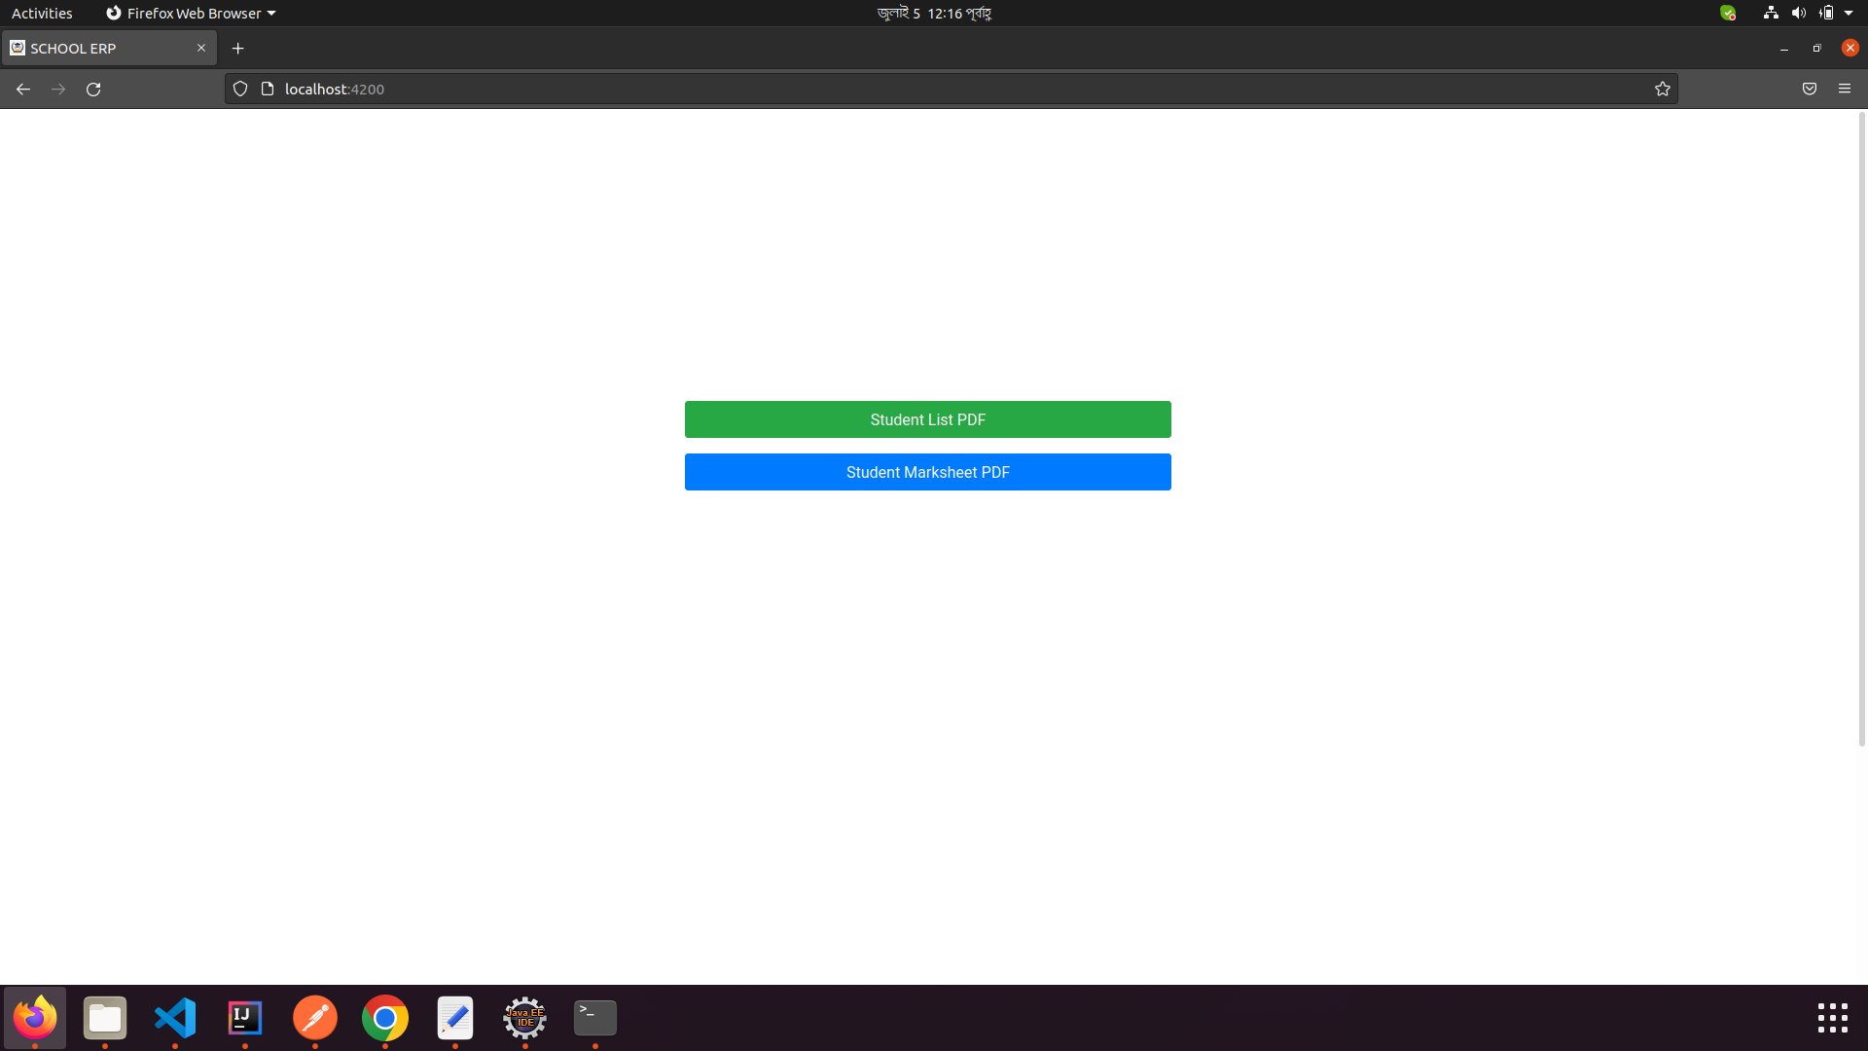
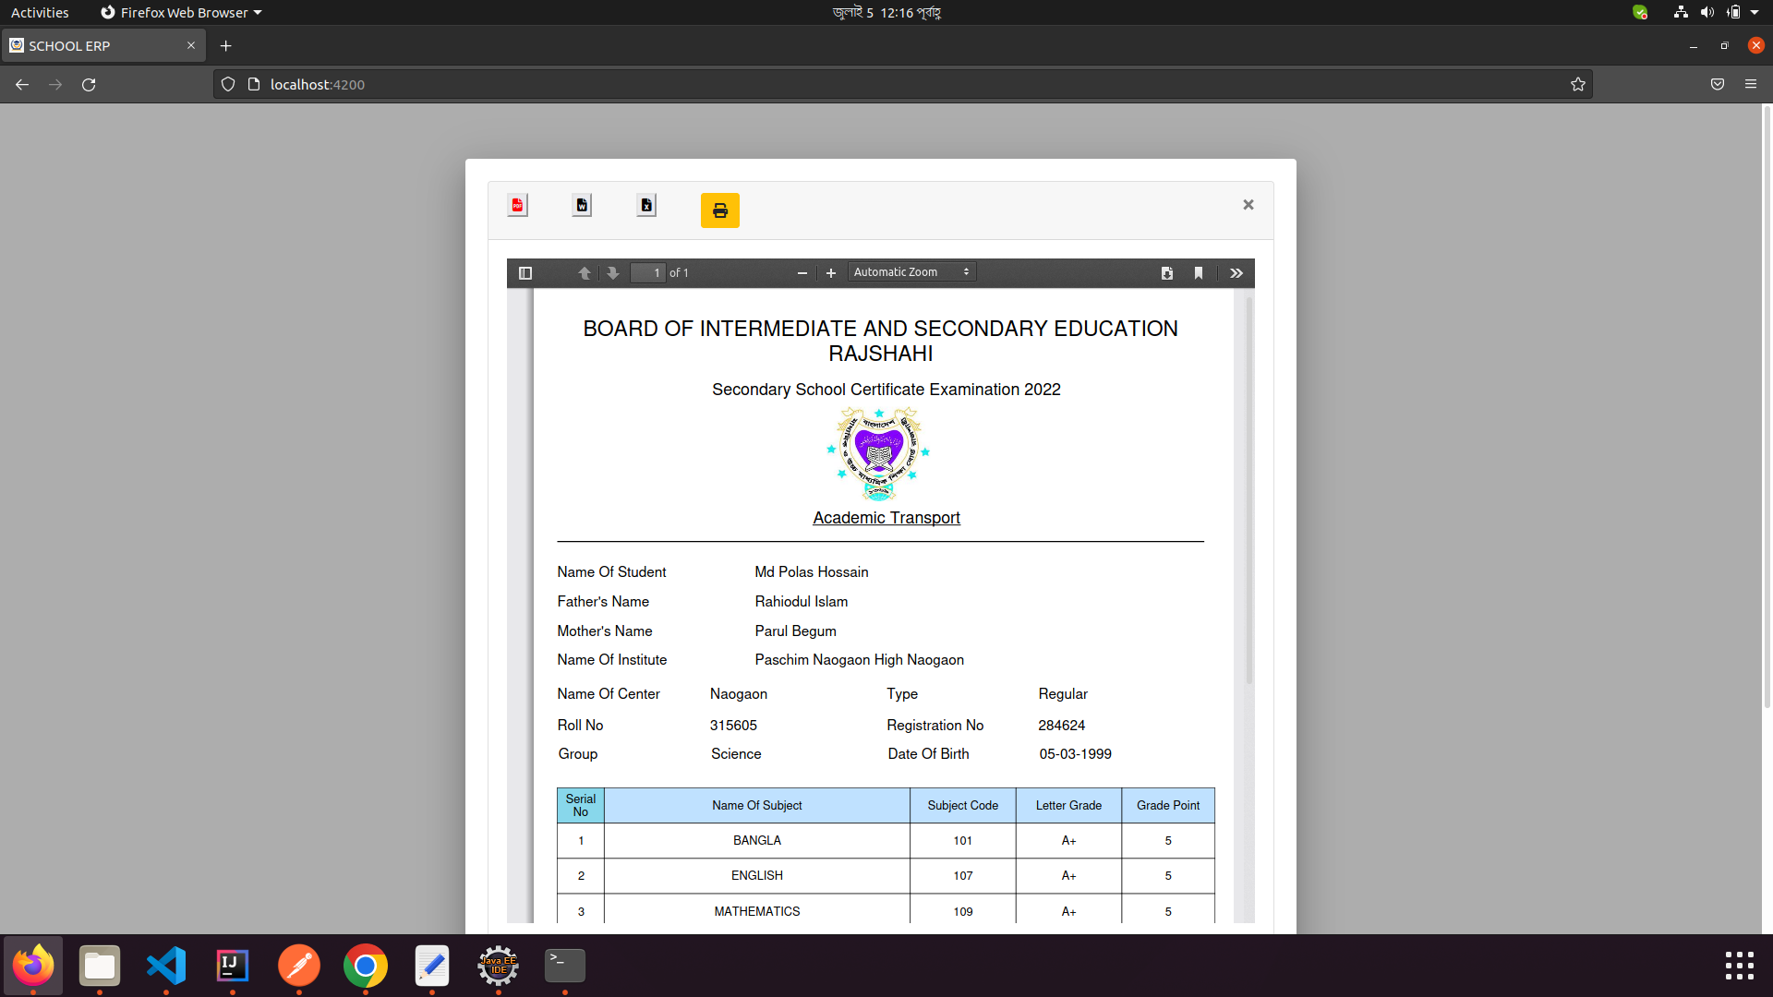
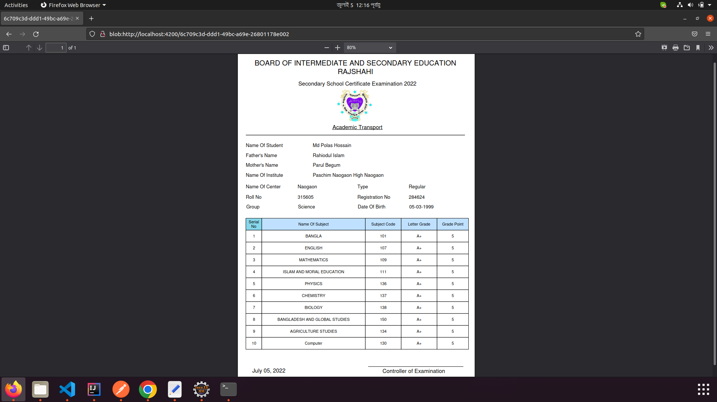
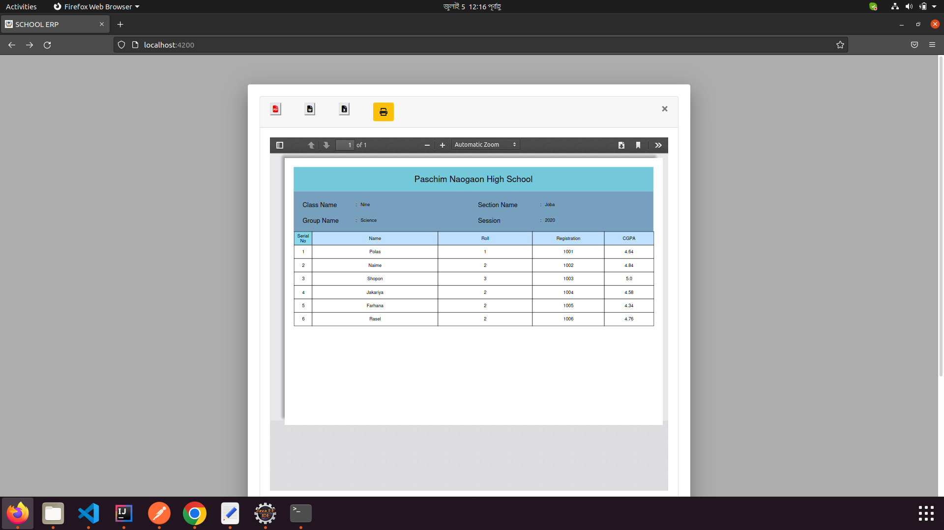

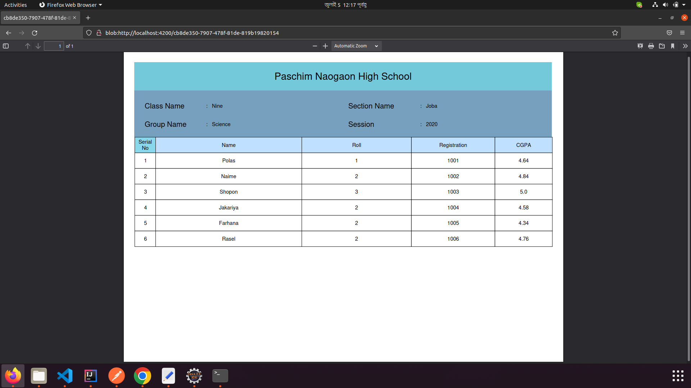

Software:
TIB_js-studiocomm_6.6.0_linux_x86_64.tgz

Plugin:
npm i ngx-spinner
npm i ng2-pdf-viewer@6.0.2
npm i pdfmake@0.1.71
npm i ngx-extended-pdf-viewer@1.8.4
npm i @angular/material@11.1.2
npm i @angular/material-moment-adapter@12.2.9
npm i html-to-pdfmake@2.4.4
npm i moment-timezone
npm i @types/uuid
npm i @material/dialog
npm i @angular/cdk

