**Student Repository System**

Index

1. **Abstract……………………………………………………………………………………………1**
2. **Present Working System…………………………………………………………………..2**
3. **Proposed System………………………………………………………………………………2**
4. **Modules……………………………………………………………………………………………3**
5. **Software requirements……………………………………………………………………..4**
6. **UML Diagrams…………………………………………………………………………………..5**
7. **Wire Frames………………………………………………………………………………………8**
8. **Conclusion………………………………………………………………………………………..13**

**ABSTRACT**

This document outlines a mini project for the .NET Line of Technology (LOT). The project is to develop Student Repository System. The main objective of this Repository system application is to store all the details of the students permanently by using the one-time registration and they get one unique id which is useful to fetch their details to any job application automatically, it saves time for the student.

**Present Working System:**

In the existing repository system, the students have to enter their details every time whenever they required for filling the application. It is time-consuming and sometimes there is a chance of misplacement of data.

**Proposed System:**

In the proposed repository system the students no need to enter their details every time. By using their unique registration id the details are automatically fetched to the application only extra details required are to be entered. The students can update and edit their details in the existed profile whenever they required. It is the user-friendly environment and less time-consuming.

**Modules**

The proposed repository system has two modules.

1. **Admin:**

* Administrator can store and manage all the details of registered students.
* Provides the functionalities that the student can fetch their details whenever required.
* Admin maintains the entire application who is responsible for the activities that are performed in the system.

**2. Student:**

* The student can log in into the system with their login details.
* They can add, delete and modify the existed details in the system.
* Apply and check the jobs in the Portal.

**Software Requirements:**

* Operating System : Windows
* Database : SQL Server 2014
* IDE :Visual Studio 2019
* Platform : .Net
* Web server : IIS
* Front End: Javascript, CSS, Html.

**UML Diagrams**

Usecase Diagram:

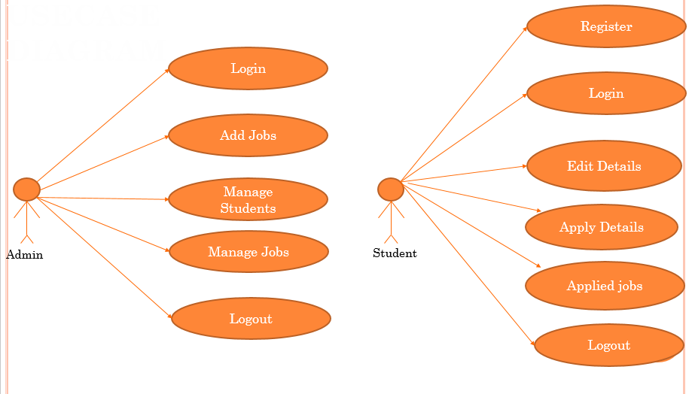

FlowChart:

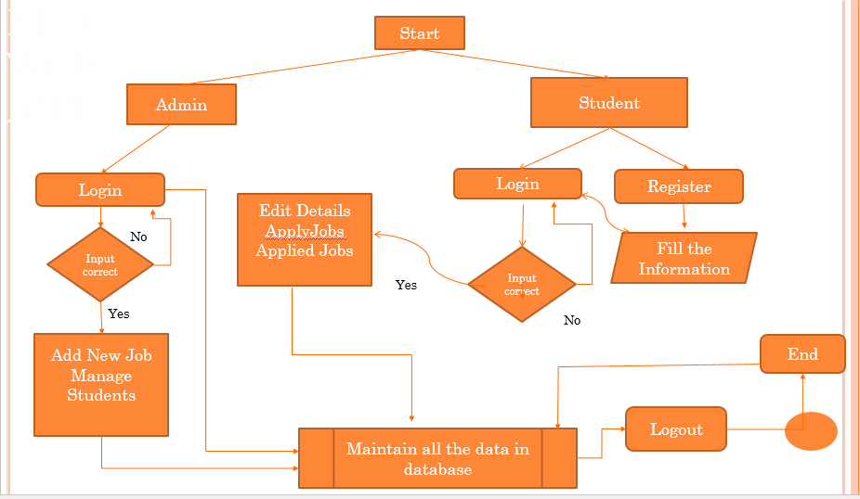

ER diagram:

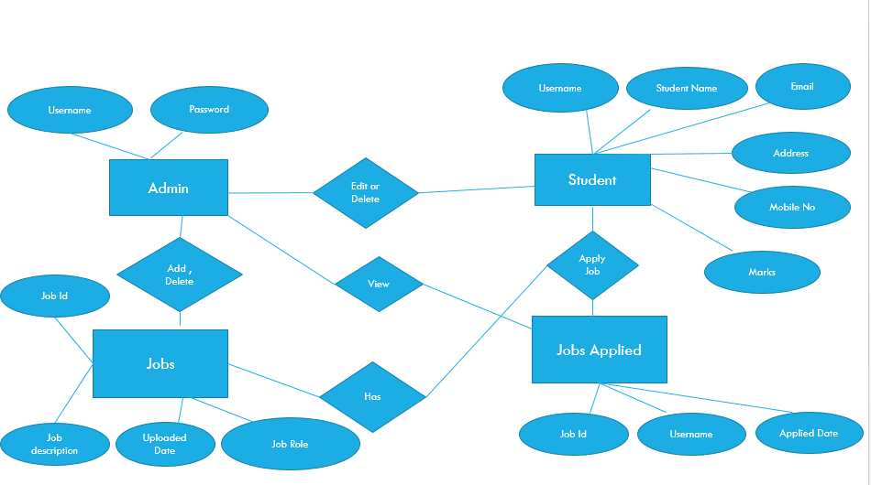

Class Diagram:

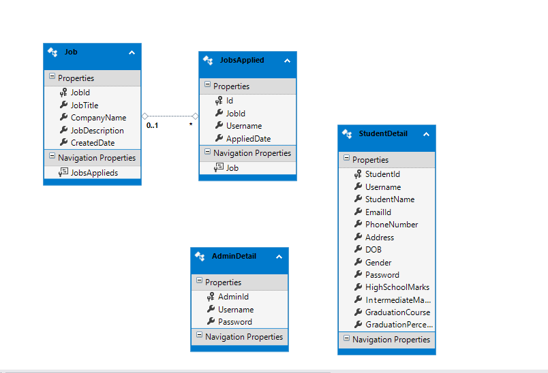

Sequence Diagram:

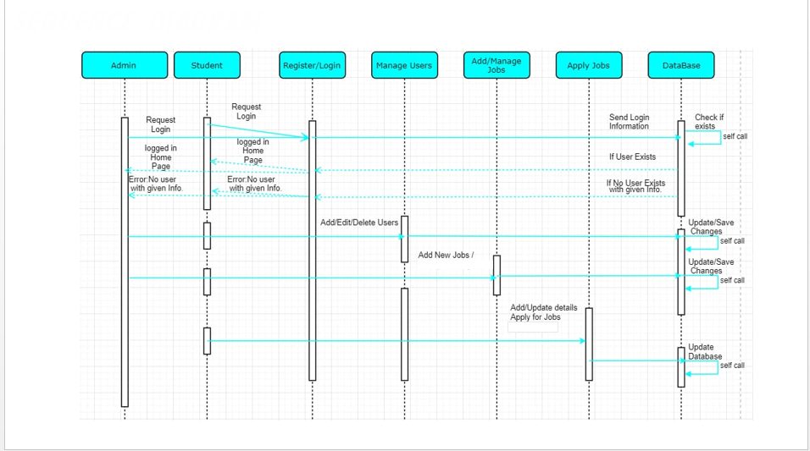

**Wire Frames**

Main Page:

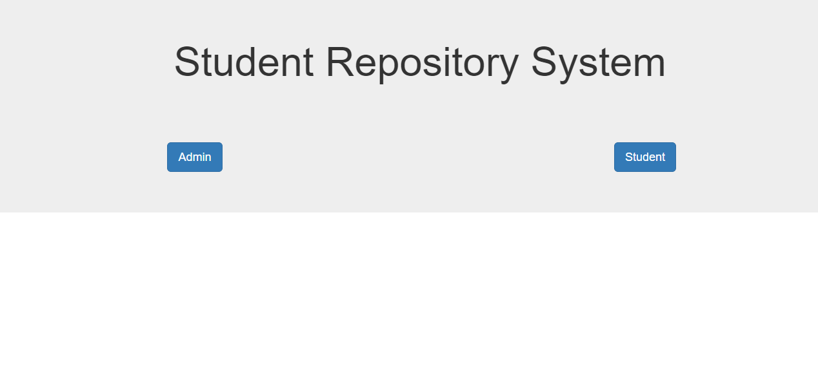

Admin Login:

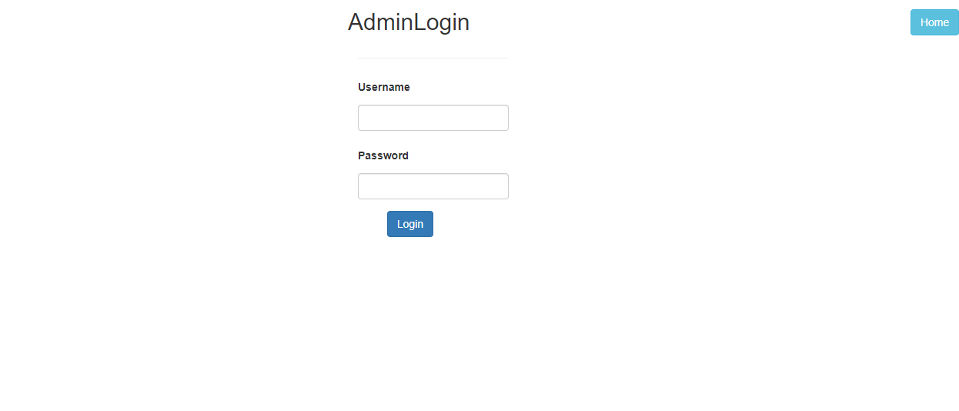

Add Jobs:

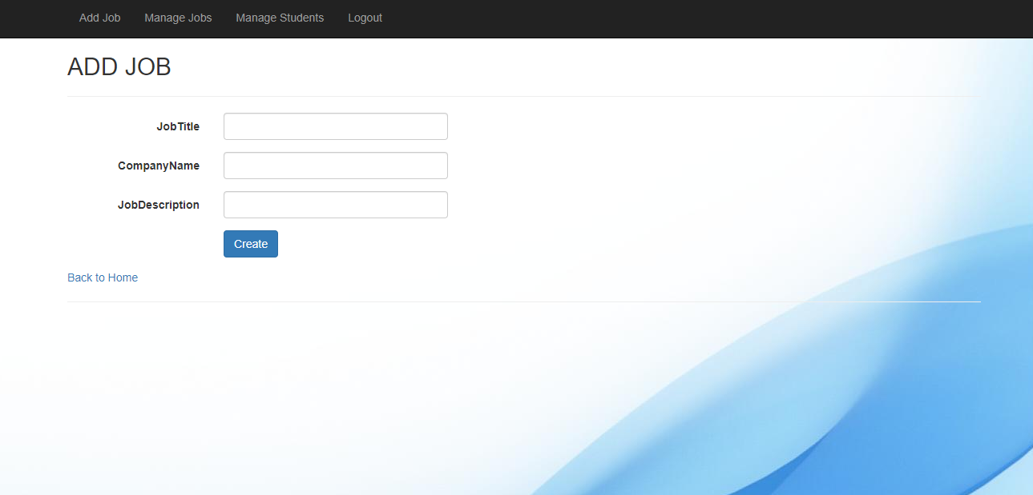

Manage Students:

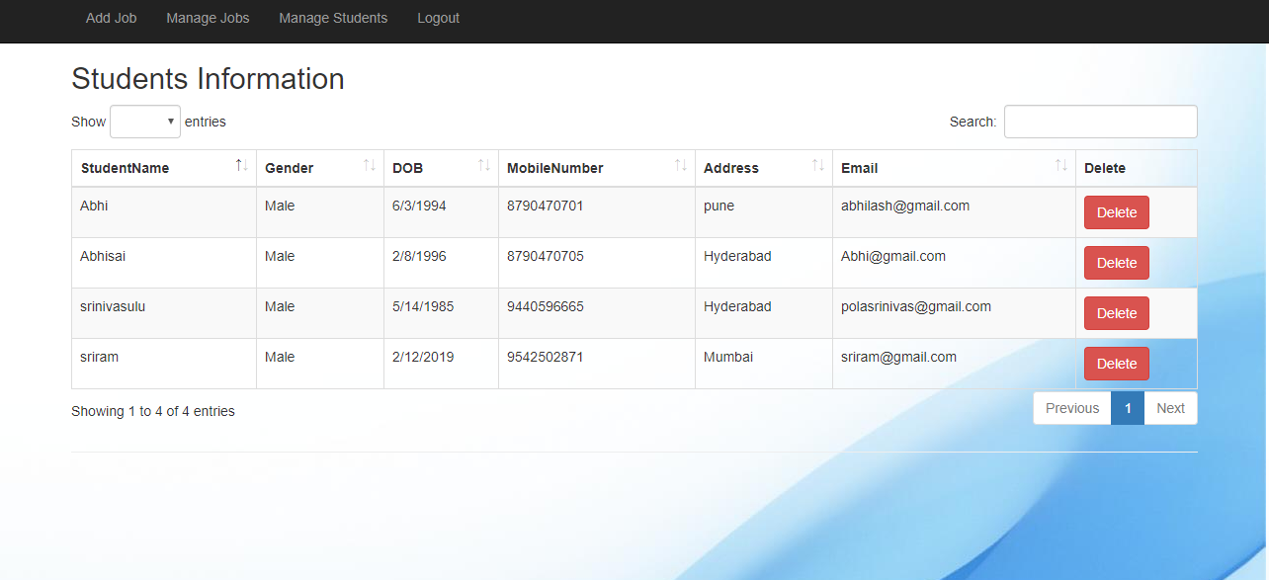

Manage Jobs: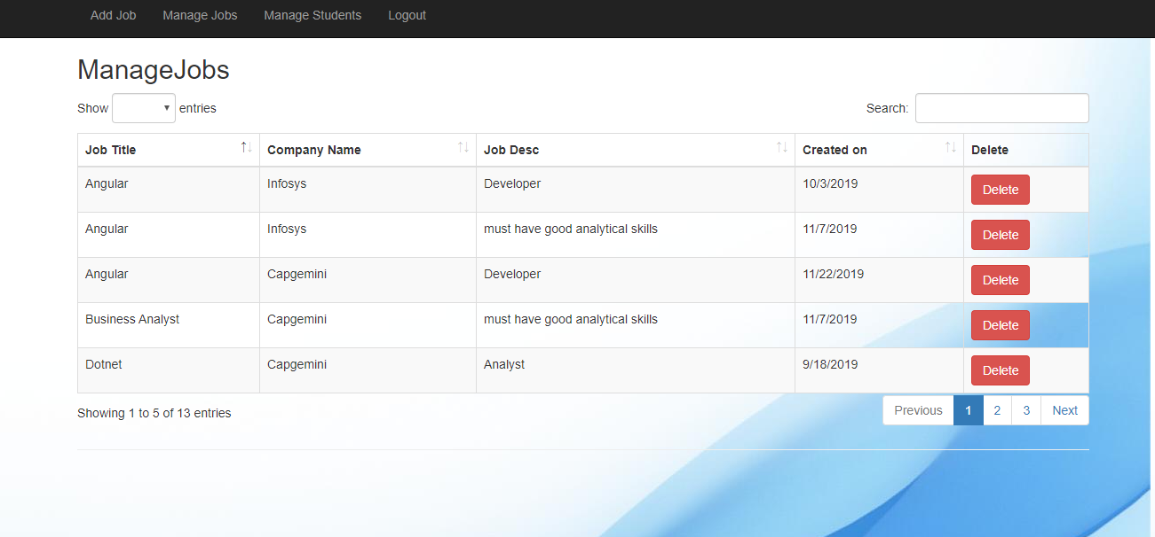

Student Login:

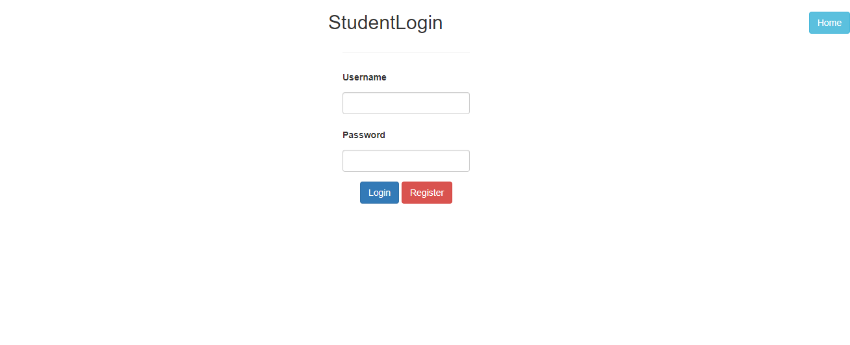

Student Register:

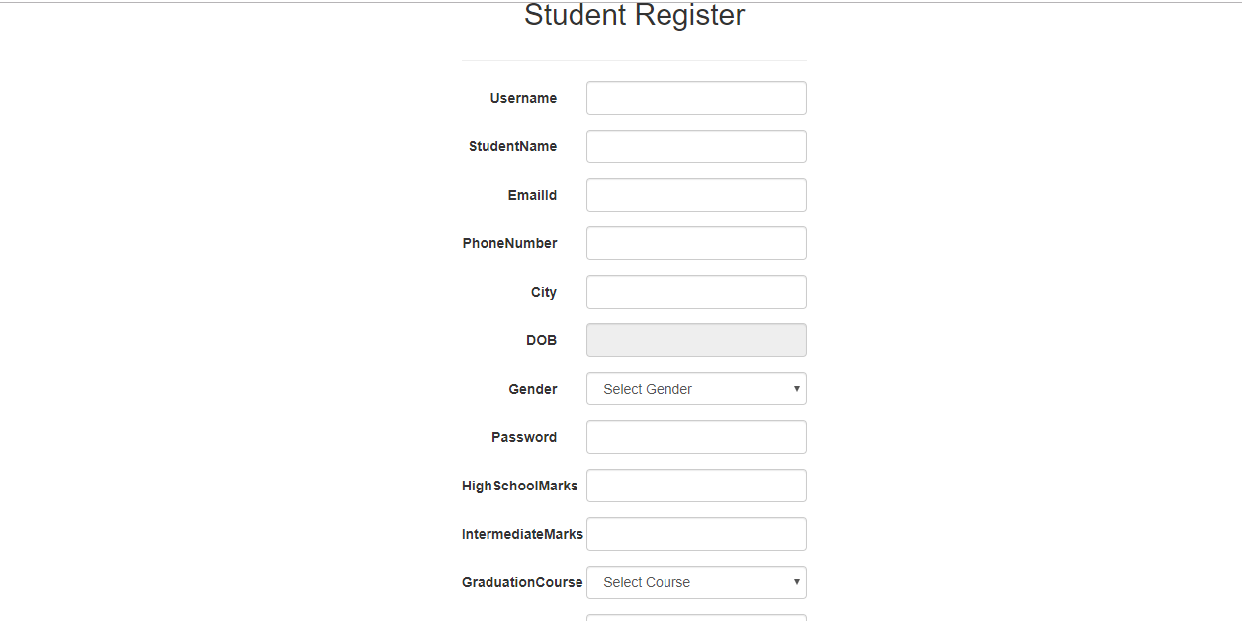

Apply Job:

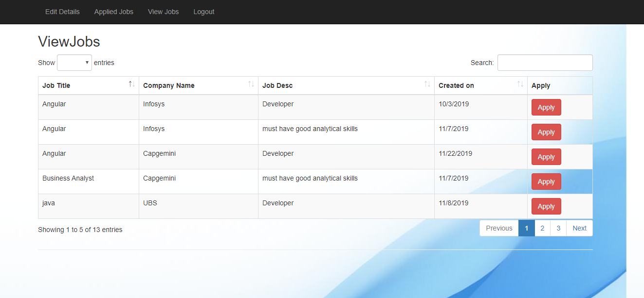

View Applied Jobs:

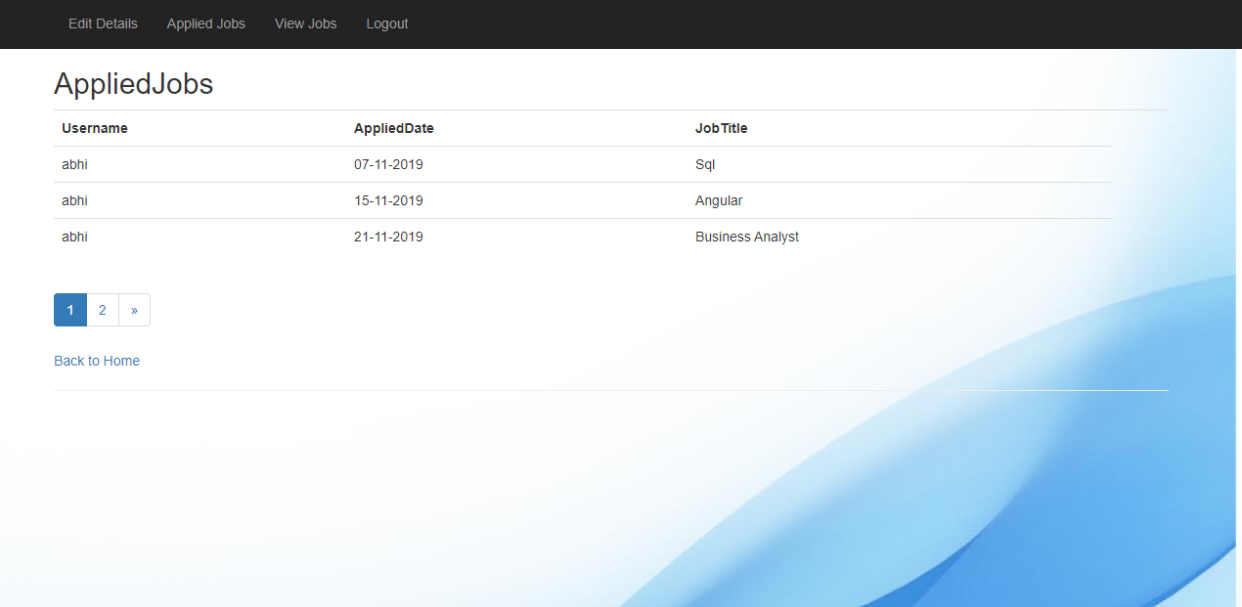

Edit Details:

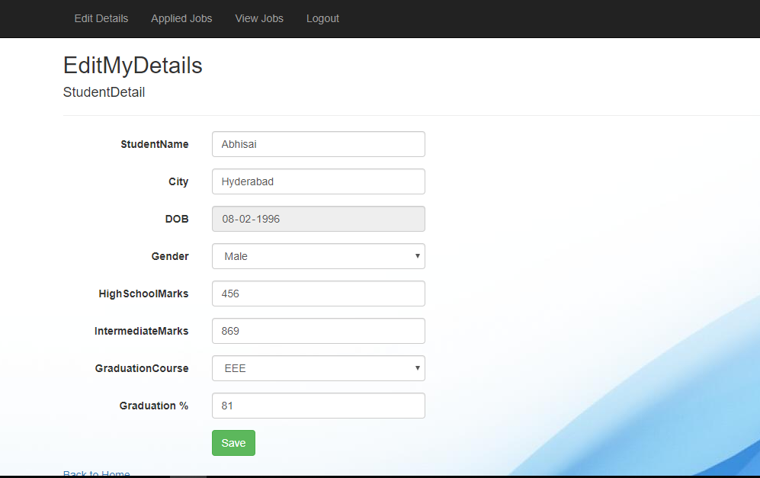

**Conclusion:**

The project aim to develop a student repository system. In order to provide a solution to current problems and increase the efficiency. Thus our system meets very basic and necessary needs of a students.