SQL Retail analytics PROJECT OVERVIEW

Create Tables & . Insert Data (Auto Generate 1000 Rows)
CREATE TABLE customers (
customer_id NUMBER,
customer_name VARCHAR2(50)
);
-- Customers
INSERT INTO customers
SELECT LEVEL, 'Cust_'||LEVEL FROM dual CONNECT BY LEVEL<=50;
CREATE TABLE stores (
store_id NUMBER,
store_name VARCHAR2(50)
);
-- Stores
INSERT INTO stores VALUES (1,'CMR');
INSERT INTO stores VALUES (2,'SR');
INSERT INTO stores VALUES (3,'Lucky');
CREATE TABLE products (
product_id NUMBER,
category VARCHAR2(50)
);
-- Products
INSERT INTO products VALUES (1,'Electronics');
INSERT INTO products VALUES (2,'Fashion');
INSERT INTO products VALUES (3,'Grocery');
INSERT INTO products VALUES (4,'Home');
CREATE TABLE sales (
sale_id NUMBER,
customer_id NUMBER,
store_id NUMBER,
product_id NUMBER,
sale_date DATE,
amount NUMBER,
quantity NUMBER,
discount NUMBER
);
-- Sales (1000 rows)
INSERT INTO sales
SELECT
LEVEL,
MOD(LEVEL,50)+1,
MOD(LEVEL,3)+1,
MOD(LEVEL,4)+1,
DATE '2025-01-01' + MOD(LEVEL,90),
ROUND(DBMS_RANDOM.VALUE(100,10000)),
MOD(LEVEL,5)+1,
CASE WHEN MOD(LEVEL,4)=0 THEN NULL ELSE ROUND(DBMS_RANDOM.VALUE(10,500)) END
FROM dual
CONNECT BY LEVEL <= 1000;

1)Data Understanding:
Question:
1) Find total number of transactions.
Query:
select count(*) As Total_transactions
From sales;
Output:
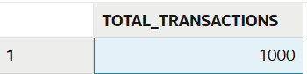
Question:
2) Find total revenue generated.
Query:
select sum(amount)As total_revenue
from sales;
Output:
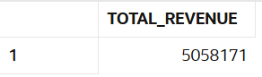

Question:
3) Find total unique customers.
Query:
select count(Distinct customer_id) As Unique_customers
from sales;
Output:
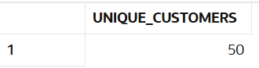

Question:
4) Find average order value.
Query:
select avg(amount)As Avg_order_value
from sales;
Output:
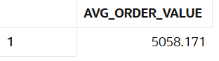

Question:
5)Find total quantity sold.
Query:
select sum(quantity)As total_quantity_sold
from sales;
Output:
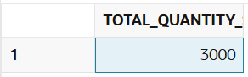

Question:
6) Find minimum and maximum sale amount.
Query:
select min(amount)As min_sale,
max(amount)As max_sale
from sales;

Output:
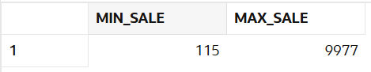

Question:
7)Find average discount given.
Query:
select avg(discount)As avg_discount
from sales;
Output:
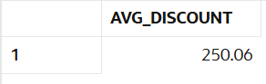

Question:
8) Find total sales per store.
Query:
select store_id,sum(amount)As total_sales
from sales
group by store_id;
Output:
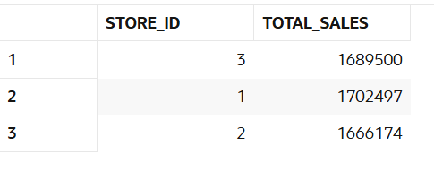
Question:
9)Find total sales per category.
Query:
select p.category,Sum(s.amount)As total_sales
from sales s
Join products p ON s.product_id=p.PRODUCT_ID
group by p.CATEGORY;
Output:
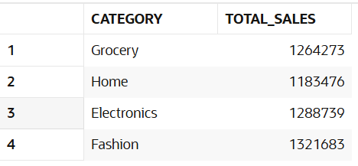

Question:
10) Find number of transactions per day.
Query:
select sale_date, count(*)As transactions
from sales
group by sale_date;
Output:
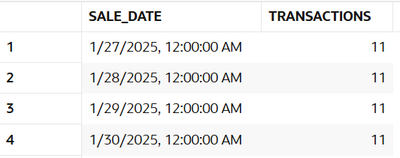

2)Data Cleaning:
Question:
11) Replace NULL discount with 0.
Query:
select nvl(discount,0)As fixed_discount
from sales;
Output:
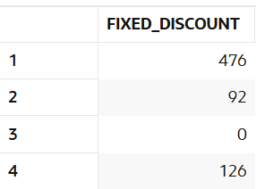

Question:
12) Find number of NULL discounts.
Query:
select count(*)As null_discounts
from sales
where discount is null;
Output:
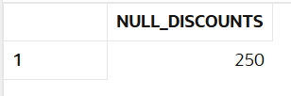

Question:
13) Calculate net revenue (amount - discount).
Query:
SELECT amount,
NVL(discount, 0) AS discount,
amount - NVL(discount, 0) AS net_revenue
FROM sales;
Output:
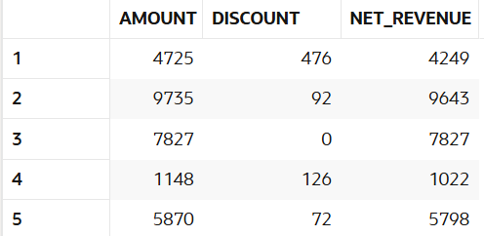

Question:
14) Replace NULL quantity with 1.
Query:
select nvl(quantity,1)as Fixed_quantity
from sales;
Output:
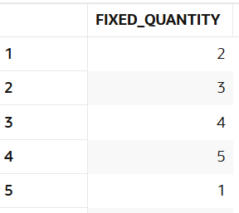

Question:
15) Identify rows where amount is NULL.

Query:
select * From sales
where amount is NULL;
Output:

Question:
16) Use COALESCE to handle multiple NULL columns.
Query:
select COALESCE(discount,0)as discount_value
from sales;
Output:
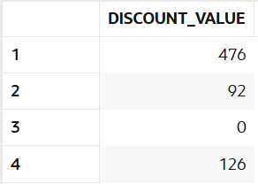

Question:
17) Create a cleaned column for revenue.
Query:
SELECT amount - NVL(discount, 0) AS cleaned_revenue
FROM sales;
Output:
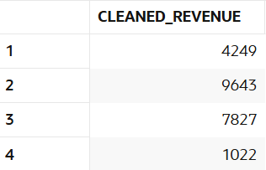
Question:
18) Check percentage of missing data.
Query:
SELECT
(COUNT(CASE WHEN discount IS NULL THEN 1 END) * 100.0) / COUNT(*) AS percent_missing
FROM sales;
Output:
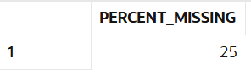

Question:
19) Flag rows with missing values.
Query:
SELECT
sale_id,customer_id,store_id,product_id,sale_date,
amount,quantity,discount,
CASE
WHEN amount IS NULL
OR quantity IS NULL
OR discount IS NULL
THEN 'Missing'
ELSE 'Complete'
END AS data_flag
FROM sales;
Output:
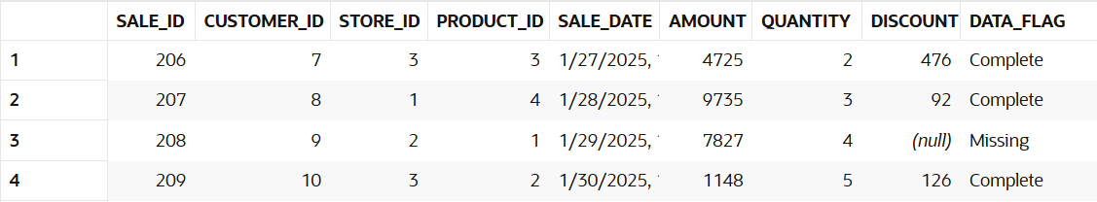

3. Filtering (WHERE)
Question:
21) Find sales in last 30 days.
Query:
SELECT *
FROM sales
WHERE sale_date >= SYSDATE - 30;
Output:

Question:
22) Find sales above 5000.
Query:
select *
from sales
where sale_id >= 5000;
Output: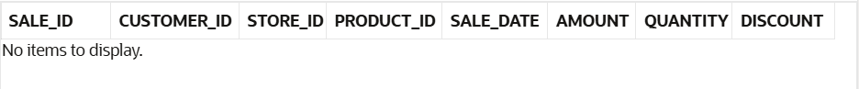
Question:
23) Find sales between 1000 and 5000.
Query:
select *
from sales
where sale_id between 1000 and 5000;
Output:
Question:
24) Find sales from CMR store.
Query:
SELECT s.*
FROM sales s
JOIN stores st ON s.store_id = st.store_id
WHERE st.store_name = 'CMR';
Output:
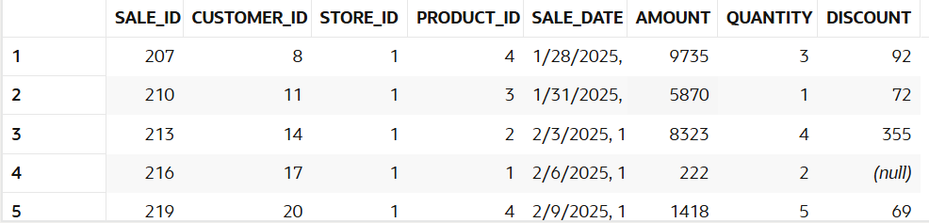

Question:
25) Find Electronics category sales.
Query:
select s.*
from sales s
JOIN products p ON s.product_id=p.PRODUCT_ID
where p.category='Electronics';
Output:
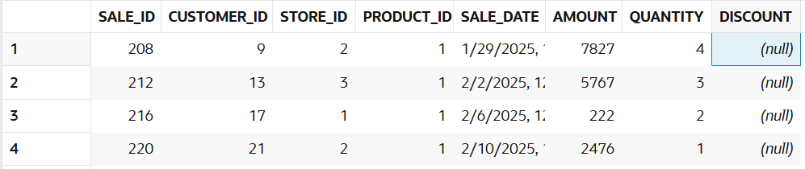

Question:
26) Find sales excluding Grocery category.
Query:
SELECT s.*
FROM sales s
JOIN products p ON s.product_id = p.product_id
WHERE p.category != 'Grocery';
Output: 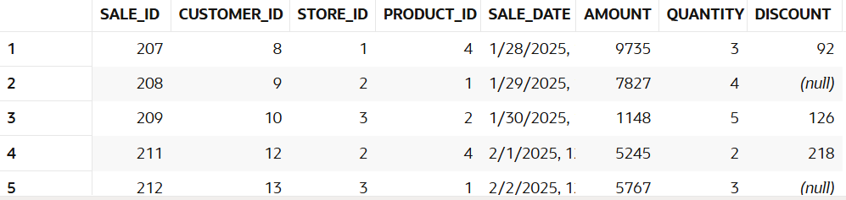

Question:
27) Find customers from specific store.
Query:
SELECT DISTINCT s.customer_id
FROM sales s
JOIN stores st ON s.store_id = st.store_id
WHERE st.store_name = 'CMR';
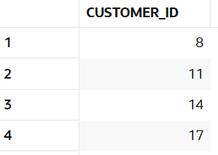

Question:
28) Find high discount transactions.
Query:
Select *
from sales
where discount = (Select max(discount)
from sales);
Output:
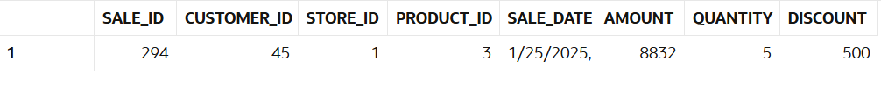

Question:
29) Find low quantity sales.
Query:
Select *
from sales
where quantity = (Select max(quantity)
from sales);

Output:
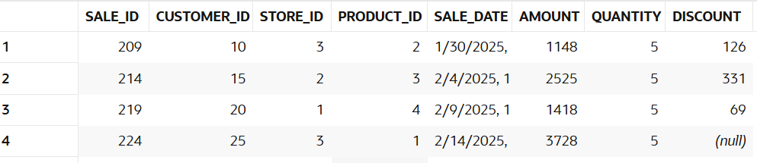

Question:
30) Find recent transactions.
Query:
SELECT *
FROM sales
ORDER BY sale_date DESC;
Output:
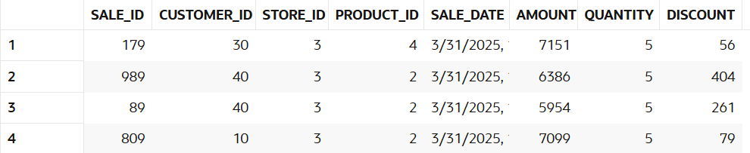

4. Aggregation (GROUP BY)
Question:
31) Revenue per store.
Query:
SELECT st.store_name, SUM(s.amount) AS total_revenue
FROM sales s
JOIN stores st ON s.store_id = st.store_id
GROUP BY st.store_name;
Output:
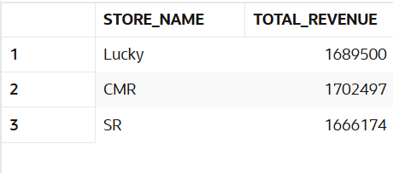

Question:
32) Revenue per category.
Query:
SELECT p.category, SUM(s.amount) AS total_revenue
FROM sales s
JOIN products p ON s.product_id = p.product_id
GROUP BY p.category;
Output:
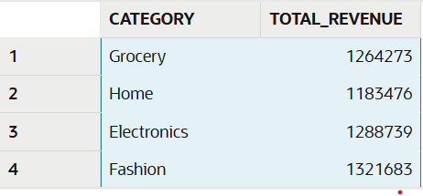

Question:
33) Revenue per customer.
Query:
SELECT c.customer_name, SUM(s.amount) AS total_spending
FROM sales s
JOIN customers c ON s.customer_id = c.customer_id
GROUP BY c.customer_name;
Output:
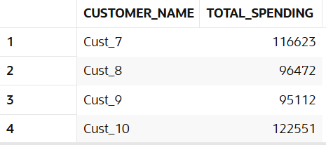

Question:
34)Monthly revenue.
Query:
SELECT TO_CHAR(sale_date, 'YYYY-MM') AS month,
SUM(amount) AS revenue
FROM sales
GROUP BY TO_CHAR(sale_date, 'YYYY-MM');
Output:
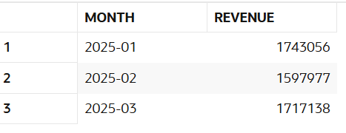

Question:
35)Daily revenue.
Query:
SELECT sale_date, SUM(amount) AS daily_revenue
FROM sales
GROUP BY sale_date;

Output:
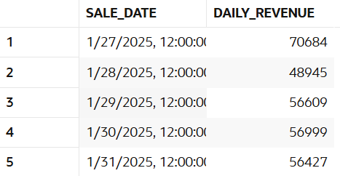

Question:
36)Average sales per store.
Query:
SELECT st.store_name, AVG(s.amount) AS avg_sales
FROM sales s
JOIN stores st ON s.store_id = st.store_id
GROUP BY st.store_name;
Output:
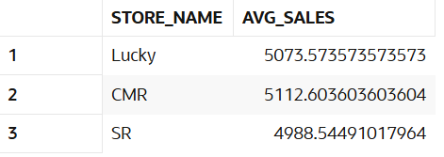

Question:
37)Total quantity per category.
Query:
SELECT p.category, SUM(s.quantity) AS total_quantity
FROM sales s
JOIN products p ON s.product_id = p.product_id
GROUP BY p.category;
Output:
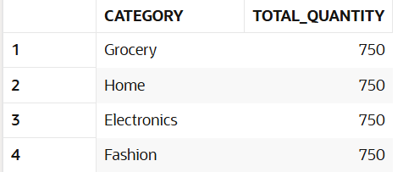

Question:
38)Total discount per store.
Query:
SELECT st.store_name, SUM(NVL(s.discount,0)) AS total_discount
FROM sales s
JOIN stores st ON s.store_id = st.store_id
GROUP BY st.store_name;
Output:
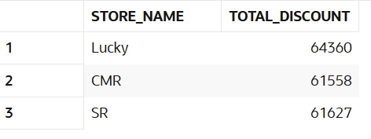

Question:
39)Customer-wise total spending.
Query:
SELECT c.customer_name, SUM(s.amount) AS total_spent
FROM sales s
JOIN customers c ON s.customer_id = c.customer_id
GROUP BY c.customer_name;
Output:

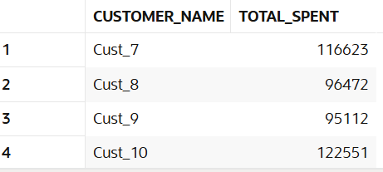

Question:
40)Store-wise transaction count.
Query:
SELECT st.store_name, COUNT(*) AS transactions
FROM sales s
JOIN stores st ON s.store_id = st.store_id
GROUP BY st.store_name;
Output:
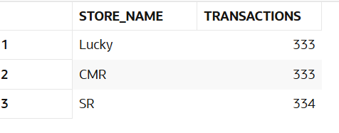

5. HAVING
Question:
41)Customers with revenue > 20000.
Query:
SELECT c.customer_name, SUM(s.amount) AS total_revenue
FROM sales s
JOIN customers c ON s.customer_id = c.customer_id
GROUP BY c.customer_name
HAVING SUM(s.amount) > 20000;
Output:
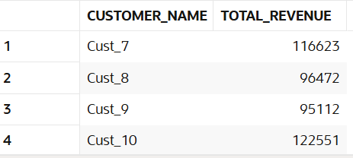

Question:
42)Stores with revenue > 100000.
Query:
SELECT st.store_name, SUM(s.amount) AS revenue
FROM sales s
JOIN stores st ON s.store_id = st.store_id
GROUP BY st.store_name
HAVING SUM(s.amount) > 100000;
Output:
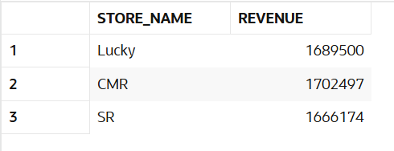

Question:
43)Categories with avg sales > 3000.
Query:
SELECT p.category, AVG(s.amount) AS avg_sales
FROM sales s
JOIN products p ON s.product_id = p.product_id
GROUP BY p.category
HAVING AVG(s.amount) > 3000;
Output:
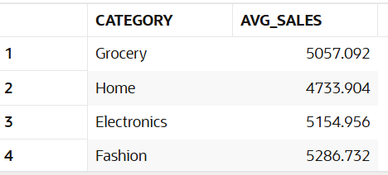

Question:
44)Customers with more than 5 transactions.
Query:
SELECT c.customer_name, COUNT(*) AS transactions
FROM sales s
JOIN customers c ON s.customer_id = c.customer_id
GROUP BY c.customer_name
HAVING COUNT(*) > 5;
Output:
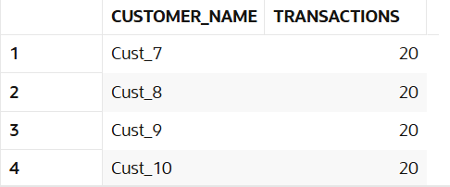

Question:
45)Stores with high discount usage.
Query:
SELECT st.store_name, SUM(NVL(s.discount,0)) AS total_discount
FROM sales s
JOIN stores st ON s.store_id = st.store_id
GROUP BY st.store_name
HAVING SUM(NVL(s.discount,0)) > 50000;
Output:
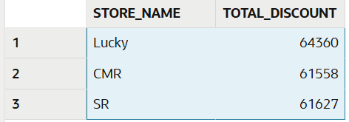

Question:
46)Categories with low performance.
Query:
SELECT p.category, SUM(s.amount) AS revenue
FROM sales s
JOIN products p ON s.product_id = p.product_id
GROUP BY p.category
HAVING SUM(s.amount) < 100000;
Output:
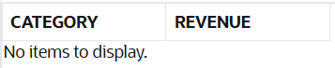

Question:
47)Customers with high avg order value.
Query:
SELECT c.customer_name, AVG(s.amount) AS avg_order
FROM sales s
JOIN customers c ON s.customer_id = c.customer_id
GROUP BY c.customer_name
HAVING AVG(s.amount) > 3000;
Output:
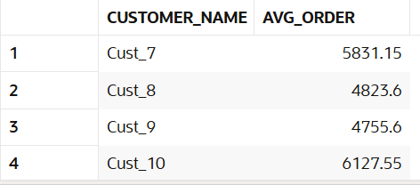

Question:
48)Find top 5 customers using HAVING.
Query:
SELECT c.customer_name, SUM(s.amount) AS total_revenue
FROM sales s
JOIN customers c ON s.customer_id = c.customer_id
GROUP BY c.customer_name
HAVING SUM(s.amount) > 0
ORDER BY total_revenue DESC
FETCH FIRST 5 ROWS ONLY;
Output:
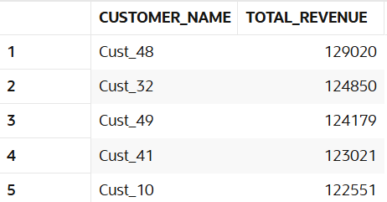

Question:
49)Stores with max transactions.
Query:
SELECT st.store_name, COUNT(*) AS transactions
FROM sales s
JOIN stores st ON s.store_id = st.store_id
GROUP BY st.store_name
HAVING COUNT(*) = (
SELECT MAX(cnt)
FROM (
SELECT COUNT(*) AS cnt
FROM sales
GROUP BY store_id
)
);
Output:
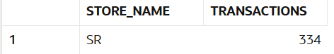

Question:
50)Categories with high growth.
Query:
SELECT p.category, SUM(s.amount) AS total_revenue
FROM sales s
JOIN products p ON s.product_id = p.product_id
GROUP BY p.category
HAVING SUM(s.amount) > 100000;
Output:
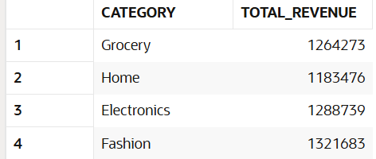

6. CASE WHEN
Question:
51)Classify customers as High/Medium/Low spenders.
Queries:
SELECT c.customer_name,
SUM(s.amount) AS total_spent,
CASE
WHEN SUM(s.amount) > 20000 THEN 'High'
WHEN SUM(s.amount) BETWEEN 10000 AND 20000 THEN 'Medium'
ELSE 'Low'
END AS spender_type
FROM sales s
JOIN customers c ON s.customer_id = c.customer_id
GROUP BY c.customer_name;
Output:
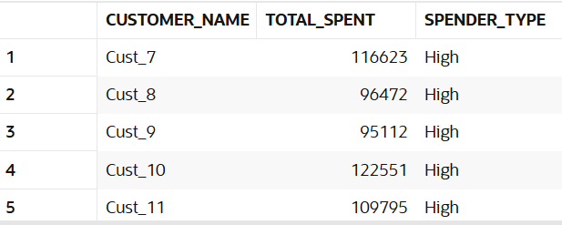

Question:
52)Classify transactions as Big/Small.
Query:
SELECT sale_id, amount,
CASE
WHEN amount > 5000 THEN 'Big'
ELSE 'Small'
END AS transaction_type
FROM sales;
Output:
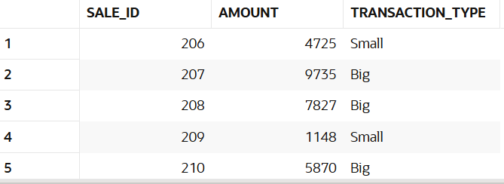

Question:
53)Create discount flag.
Query:
SELECT sale_id, discount,
CASE
WHEN NVL(discount,0) > 0 THEN 'Discount Applied'
ELSE 'No Discount'
END AS discount_flag
FROM sales;
Output:
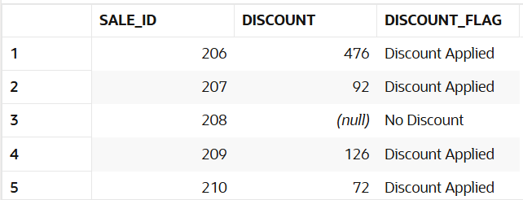

Question:
54)Segment stores based on revenue
Query:
SELECT st.store_name,
SUM(s.amount) AS revenue,
CASE
WHEN SUM(s.amount) > 150000 THEN 'Top Store'
ELSE 'Normal Store'
END AS store_segment
FROM sales s
JOIN stores st ON s.store_id = st.store_id
GROUP BY st.store_name;
Output:
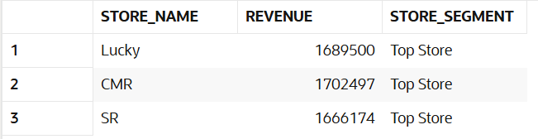

Question:
55)Categorize customers based on frequency.
Query:
SELECT c.customer_name,
COUNT(*) AS transactions,
CASE
WHEN COUNT(*) > 10 THEN 'Frequent'
WHEN COUNT(*) BETWEEN 5 AND 10 THEN 'Regular'
ELSE 'Rare'
END AS frequency_type
FROM sales s
JOIN customers c ON s.customer_id = c.customer_id
GROUP BY c.customer_name;
Output:
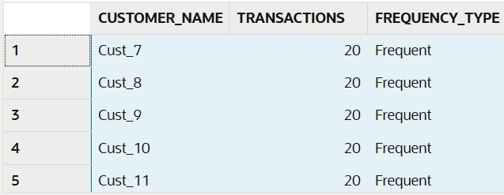

Question:
56)Create sales buckets.
Query:
SELECT sale_id, amount,
CASE
WHEN amount < 1000 THEN 'Low'
WHEN amount BETWEEN 1000 AND 5000 THEN 'Medium'
ELSE 'High'
END AS sales_bucket
FROM sales;
Output:
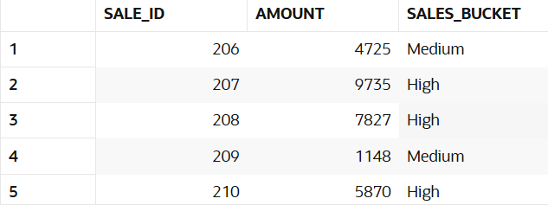

Question:
57)Identify premium customers.
Query:
SELECT c.customer_name,
SUM(s.amount) AS total_spent,
CASE
WHEN SUM(s.amount) > 30000 THEN 'Premium'
ELSE 'Regular'
END AS customer_type
FROM sales s
JOIN customers c ON s.customer_id = c.customer_id
GROUP BY c.customer_name;
Output:
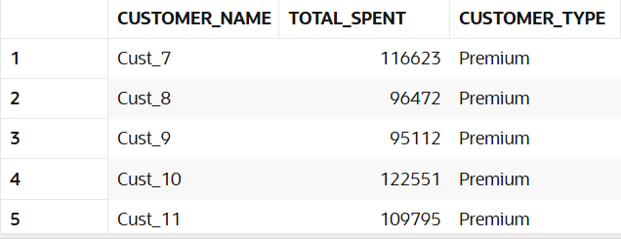

Question:
58)Mark high-value transactions.
Query:
SELECT sale_id, amount,
CASE
WHEN amount > 7000 THEN 'High Value'
ELSE 'Normal'
END AS value_flag
FROM sales;
Output:
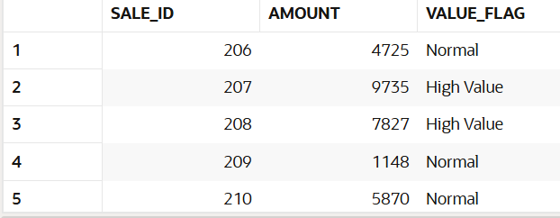

Question:
59)Classify categories based on performance.
Query:
SELECT p.category,
SUM(s.amount) AS revenue,
CASE
WHEN SUM(s.amount) > 150000 THEN 'High Performance'
ELSE 'Low Performance'
END AS category_status
FROM sales s
JOIN products p ON s.product_id = p.product_id
GROUP BY p.category;
Output:
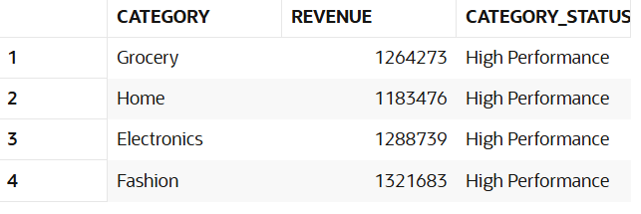

Question:
60)Create custom labels for reporting.
Query:
SELECT sale_id, amount, quantity,
CASE
WHEN amount > 5000 AND quantity >= 3 THEN 'Bulk High Sale'
WHEN amount > 5000 THEN 'High Sale'
WHEN quantity >= 3 THEN 'Bulk Sale'
ELSE 'Normal'
END AS custom_label
FROM sales;
Output:
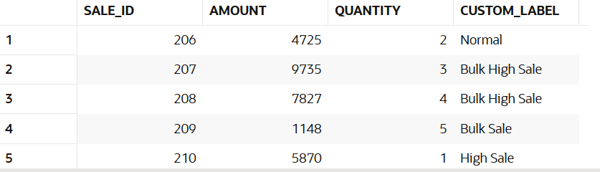

7. JOINS (Multiple Tables)
Question:
61)Join sales with customers table.
Query:
SELECT s.*, c.customer_name
FROM sales s
JOIN customers c ON s.customer_id = c.customer_id;
Output:
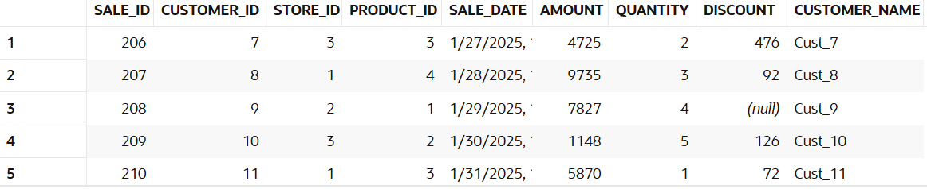

Question:
62)Join sales with stores table.
Query:
SELECT s.*, st.store_name
FROM sales s
JOIN stores st ON s.store_id = st.store_id;
Output:
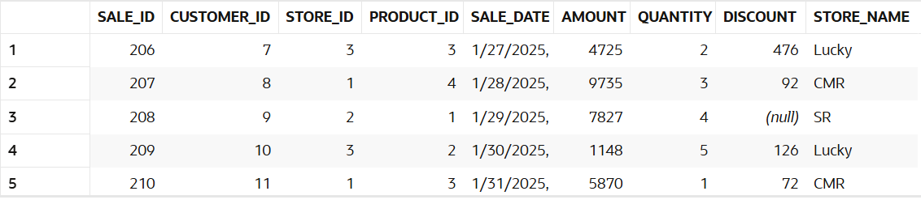

Question:
63)Join sales with products table.
Query:
SELECT s.*, p.category
FROM sales s
JOIN products p ON s.product_id = p.product_id;
Output:
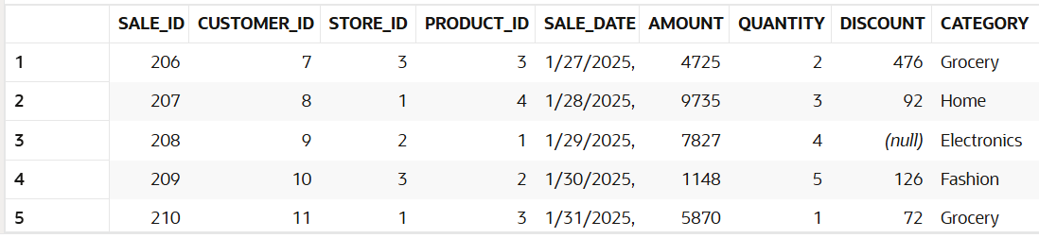

Question:
64)Find customer name with store name and sales.
Query:
SELECT c.customer_name, st.store_name, s.amount
FROM sales s
JOIN customers c ON s.customer_id = c.customer_id
JOIN stores st ON s.store_id = st.store_id;
Output:

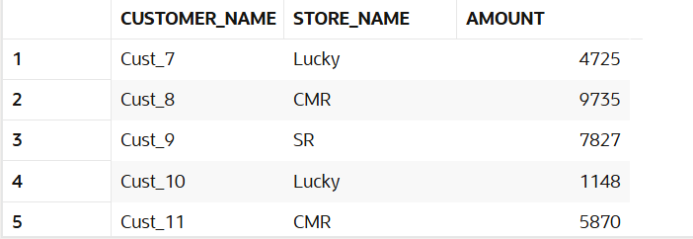

Question:
65)Find category-wise revenue using joins.
Query:
SELECT p.category, SUM(s.amount) AS revenue
FROM sales s
JOIN products p ON s.product_id = p.product_id
GROUP BY p.category;
Output:
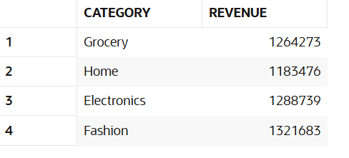

Question:
66)Find store-wise customer count.
Query:
SELECT st.store_name, COUNT(DISTINCT s.customer_id) AS customer_count
FROM sales s
JOIN stores st ON s.store_id = st.store_id
GROUP BY st.store_name;
Output:
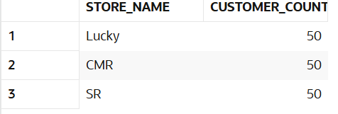

Question:
67)Find top product per store.
Query:
SELECT *
FROM (
SELECT st.store_name, p.product_id, SUM(s.amount) AS revenue,
RANK() OVER (PARTITION BY st.store_name ORDER BY SUM(s.amount) DESC) rnk
FROM sales s
JOIN stores st ON s.store_id = st.store_id
JOIN products p ON s.product_id = p.product_id
GROUP BY st.store_name, p.product_id
)
WHERE rnk = 1;
Output:
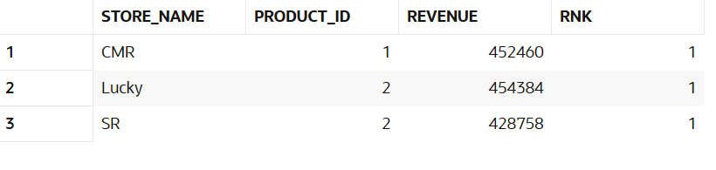

Question:
68)Find customers who purchased from multiple stores.
Query:
SELECT c.customer_name
FROM sales s
JOIN customers c ON s.customer_id = c.customer_id
GROUP BY c.customer_name
HAVING COUNT(DISTINCT s.store_id) > 1;
Output:
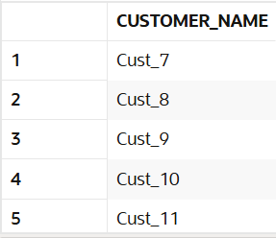

Question:
69)Find sales with product category.
Query:
SELECT s.sale_id, p.category, s.amount
FROM sales s
JOIN products p ON s.product_id = p.product_id;
Output:
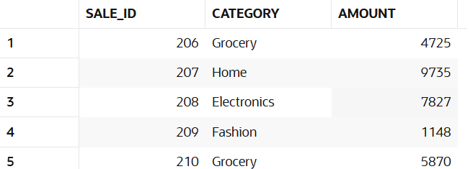

Question:
70)Find revenue per customer per store.
Query:
SELECT c.customer_name, st.store_name, SUM(s.amount) AS revenue
FROM sales s
JOIN customers c ON s.customer_id = c.customer_id
JOIN stores st ON s.store_id = st.store_id
GROUP BY c.customer_name, st.store_name;
Output:
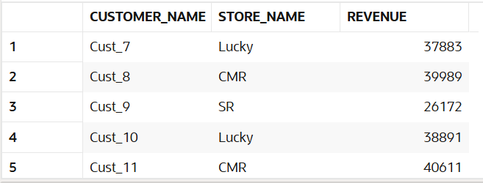

Question:
71)Find customers with no transactions (LEFT JOIN).
Query:
SELECT c.customer_name
FROM customers c
LEFT JOIN sales s ON c.customer_id = s.customer_id
WHERE s.customer_id IS NULL;
Output:
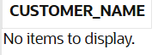

Question:
72)Find missing product mappings.
Query:
SELECT s.*
FROM sales s
LEFT JOIN products p ON s.product_id = p.product_id
WHERE p.product_id IS NULL;
Output:
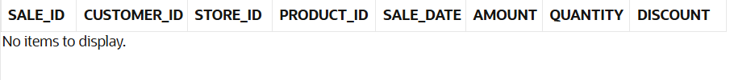
Question:
73)Find store performance using joins.
Query:
SELECT st.store_name, SUM(s.amount) AS revenue
FROM sales s
JOIN stores st ON s.store_id = st.store_id
GROUP BY st.store_name;
Output:
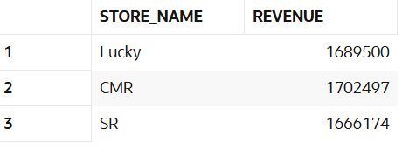

Question:
74)Find cross-category purchases.
Query:
SELECT c.customer_name
FROM sales s
JOIN customers c ON s.customer_id = c.customer_id
GROUP BY c.customer_name
HAVING COUNT(DISTINCT s.product_id) > 1;
Output:
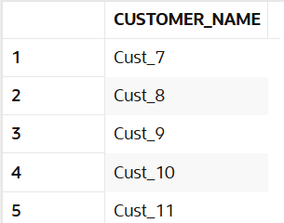

Question:
75)Find total revenue using joins.
Query:
SELECT SUM(s.amount) AS total_revenue
FROM sales s
JOIN products p ON s.product_id = p.product_id;
Output:
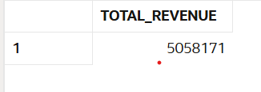

8. Window Functions
Question:
76)Calculate total spend per customer using window function.
Query:
SELECT s.*,
SUM(amount) OVER (PARTITION BY customer_id) AS total_spend
FROM sales s;
Output:
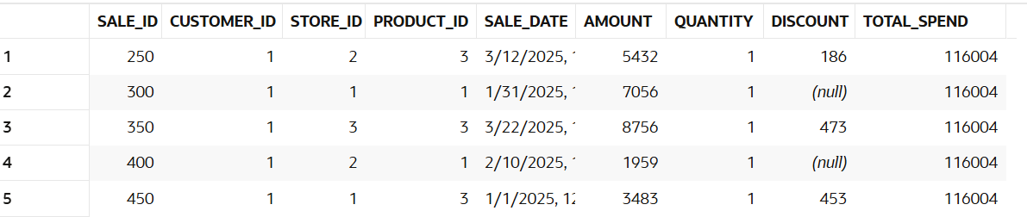

Question:
77)Rank customers by revenue.
Query:
SELECT customer_id,
SUM(amount) AS revenue,
RANK() OVER (ORDER BY SUM(amount) DESC) AS rank
FROM sales
GROUP BY customer_id;
Output:
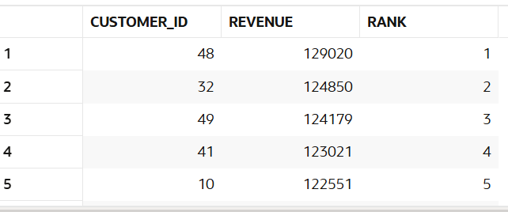

Question:
78)Find top customer per store.
Query:
SELECT *
FROM (
SELECT store_id, customer_id,
SUM(amount) AS revenue,
RANK() OVER (PARTITION BY store_id ORDER BY SUM(amount) DESC) rnk
FROM sales
GROUP BY store_id, customer_id
)
WHERE rnk = 1;
Output:
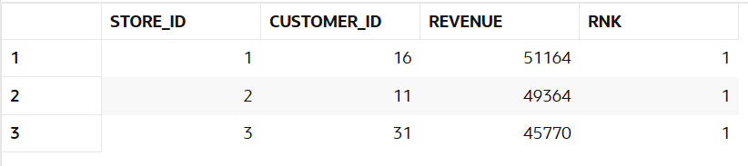

Question:
79)Calculate running total of sales.
Query:
SELECT sale_date, amount,
SUM(amount) OVER (ORDER BY sale_date) AS running_total
FROM sales;
Output:
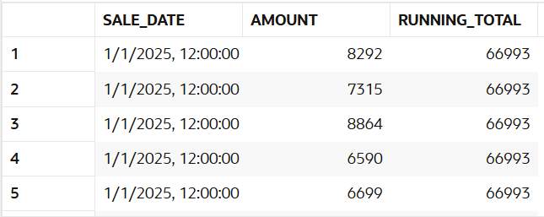

Question:
80)Find previous sale using LAG.
Query:
SELECT sale_id, amount,
LAG(amount) OVER (ORDER BY sale_date) AS previous_sale
FROM sales;
Output:
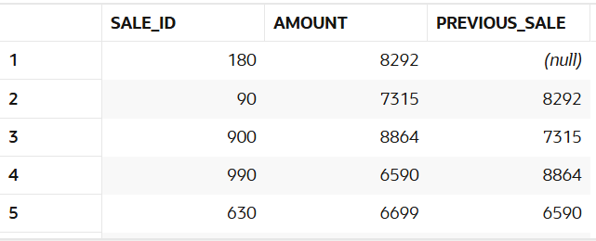

Question:
81)Find next sale using LEAD.
Query:
SELECT sale_id, amount,
LEAD(amount) OVER (ORDER BY sale_date) AS next_sale
FROM sales;
Output:
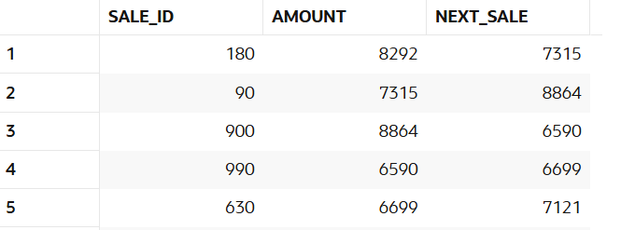

Question:
82)Calculate sales growth.
Query:
SELECT sale_id, amount,
amount - LAG(amount) OVER (ORDER BY sale_date) AS growth
FROM sales;
Output:
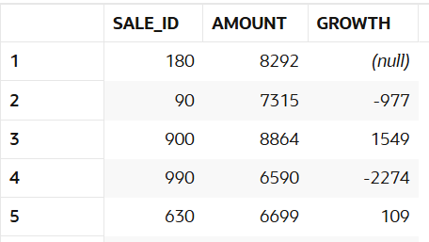

Question:
83)Find difference between transactions.
Query:
SELECT sale_id, amount,
amount - LAG(amount) OVER (ORDER BY sale_date) AS difference
FROM sales;
Output:
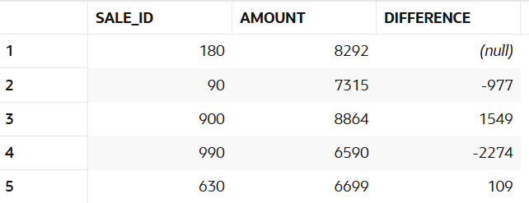

Question:
84)Calculate cumulative revenue.
Query:
SELECT sale_date,
SUM(amount) OVER (ORDER BY sale_date) AS cumulative_revenue
FROM sales;
Output:
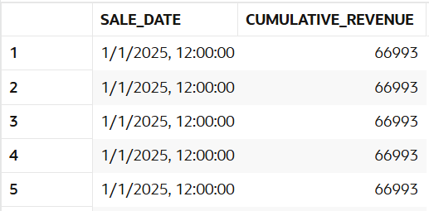

Question:
85)Find moving average of sales.
Query:
SELECT sale_date, amount,
AVG(amount) OVER (ORDER BY sale_date ROWS BETWEEN 2 PRECEDING AND CURRENT ROW) AS moving_avg
FROM sales;
Output:
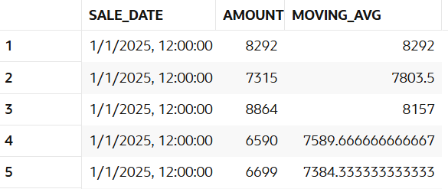

Question:
86)Rank stores by revenue.
Query:
SELECT store_id,
SUM(amount) AS revenue,
RANK() OVER (ORDER BY SUM(amount) DESC) AS rank
FROM sales
GROUP BY store_id;
Output:
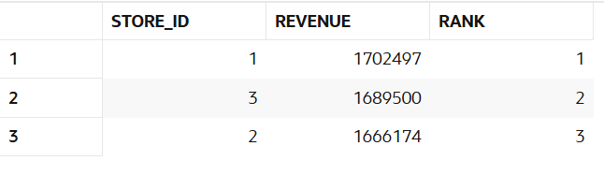

Question:
87)Find second highest sale.
Query:
SELECT *
FROM (
SELECT sale_id, amount,
DENSE_RANK() OVER (ORDER BY amount DESC) rnk
FROM sales
)
WHERE rnk = 2;
Output:
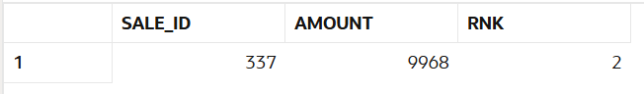

Question:
88)Partition data by store and analyze.
Query:
SELECT store_id, sale_id, amount,
SUM(amount) OVER (PARTITION BY store_id) AS store_total
FROM sales;
Output:
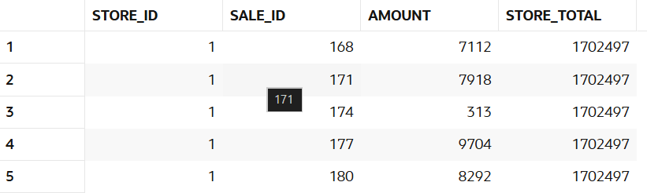

Question:
89)Find customer ranking per store.
Query:
SELECT store_id, customer_id,
SUM(amount) AS revenue,
RANK() OVER (PARTITION BY store_id ORDER BY SUM(amount) DESC) AS rank
FROM sales
GROUP BY store_id, customer_id;
Output:
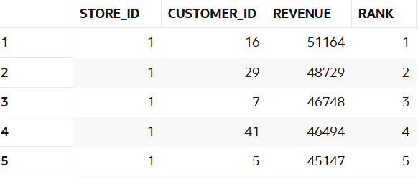

Question:
90)Calculate frequency using window.
Query:
SELECT customer_id,
COUNT(*) OVER (PARTITION BY customer_id) AS frequency
FROM sales;
Output:
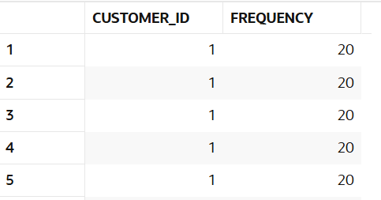

9. NTILE / Segmentation
Question:
91) Divide customers into 4 segments.
Query:
SELECT customer_id,
SUM(amount) AS revenue,
NTILE(4) OVER (ORDER BY SUM(amount) DESC) AS segment
FROM sales
GROUP BY customer_id;
Output:
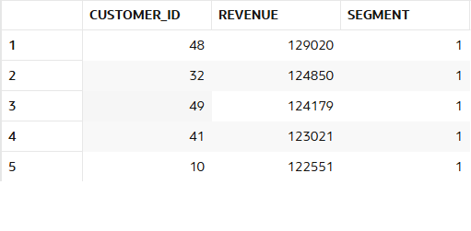

Question:
92) Identify top 25% customers.
Query:
SELECT *
FROM (
SELECT customer_id,
SUM(amount) AS revenue,
NTILE(4) OVER (ORDER BY SUM(amount) DESC) AS segment
FROM sales
GROUP BY customer_id
)
WHERE segment = 1;
Output:
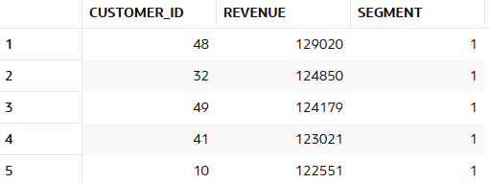

Questions:
93) Identify bottom 25% customers.
Query:
SELECT *
FROM (
SELECT customer_id,
SUM(amount) AS revenue,
NTILE(4) OVER (ORDER BY SUM(amount) DESC) AS segment
FROM sales
GROUP BY customer_id
)
WHERE segment = 4;
Output:
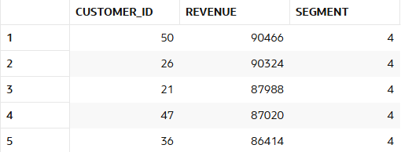

Question:
94) Segment stores into 3 groups.
Query:
SELECT store_id,
SUM(amount) AS revenue,
NTILE(3) OVER (ORDER BY SUM(amount) DESC) AS segment
FROM sales
GROUP BY store_id;
Output:
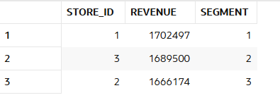
Question:
95) Create quartiles based on revenue.
Query:
SELECT customer_id,
SUM(amount) AS revenue,
NTILE(4) OVER (ORDER BY SUM(amount)) AS quartile
FROM sales
GROUP BY customer_id;
Output:
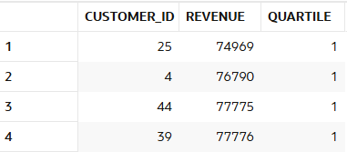

Question:
96) Segment customers per store.
Query:
SELECT store_id, customer_id,
SUM(amount) AS revenue,
NTILE(3) OVER (PARTITION BY store_id ORDER BY SUM(amount) DESC) AS segment
FROM sales
GROUP BY store_id, customer_id;
Output:
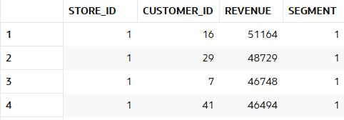

Question:
97) Identify premium segment.
Query:
SELECT *
FROM (
SELECT customer_id,
SUM(amount) AS revenue,
NTILE(4) OVER (ORDER BY SUM(amount) DESC) AS segment
FROM sales
GROUP BY customer_id
)
WHERE segment = 1;
Output:
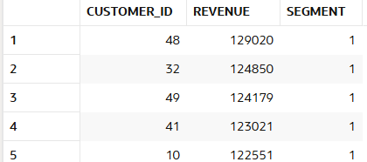

Question:
98) Find mid-level customers.
Query:
SELECT *
FROM (
SELECT customer_id,
SUM(amount) AS revenue,
NTILE(4) OVER (ORDER BY SUM(amount) DESC) AS segment
FROM sales
GROUP BY customer_id
)
WHERE segment IN (2,3);
Output:
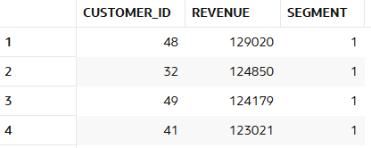

Question:
99) Analyze bucket distribution.
Query:
SELECT segment, COUNT(*) AS customer_count
FROM (
SELECT customer_id,
NTILE(4) OVER (ORDER BY SUM(amount) DESC) AS segment
FROM sales
GROUP BY customer_id
)
GROUP BY segment;
Output:
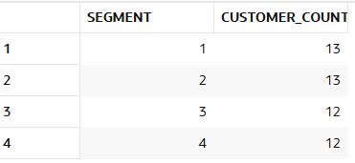

Question:
100)Create marketing segments.
Query:

SELECT customer_id,
SUM(amount) AS revenue,
CASE
WHEN NTILE(4) OVER (ORDER BY SUM(amount) DESC) = 1 THEN 'Premium'
WHEN NTILE(4) OVER (ORDER BY SUM(amount) DESC) = 2 THEN 'Gold'
WHEN NTILE(4) OVER (ORDER BY SUM(amount) DESC) = 3 THEN 'Silver'
ELSE 'Basic'
END AS segment
FROM sales
GROUP BY customer_id;
Output:
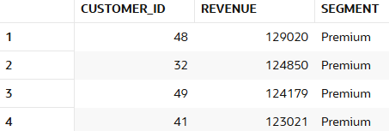

10. FIRST_VALUE / LAST_VALUE
Question:
101)Find highest sale.
Query:
SELECT MAX(amount) AS highest_sale
FROM sales;
Output:
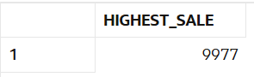

Question:
102)Find lowest sale.
Query:
SELECT MIN(amount) AS lowest_sale
FROM sales;
Output:
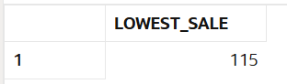

Question:
103)Compare each sale with highest.
Query:
SELECT sale_id, amount,
MAX(amount) OVER () AS highest_sale,
amount - MAX(amount) OVER () AS difference
FROM sales;
Output:
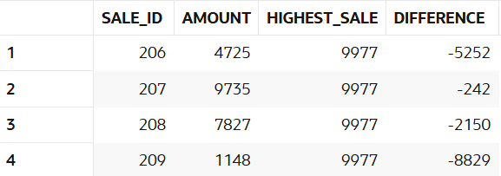

Question:
104)Compare each sale with lowest.
Query:
SELECT sale_id, amount,
MIN(amount) OVER () AS lowest_sale,
amount - MIN(amount) OVER () AS difference
FROM sales;
Output:
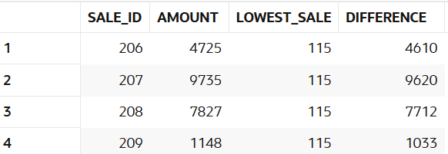

Question:
105)Find highest sale per store.
Query:
SELECT store_id,
MIN(amount) AS lowest_sale
FROM sales
GROUP BY store_id;
Output:
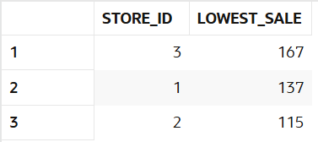

Question:
106)Find lowest sale per store.
Query:
SELECT p.category,
SUM(s.amount) AS revenue,
RANK() OVER (ORDER BY SUM(s.amount) DESC) AS rank
FROM sales s
JOIN products p ON s.product_id = p.product_id
GROUP BY p.category;
Output:
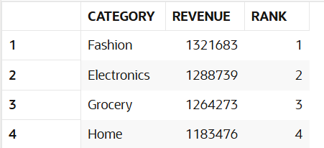

Question:
107)Compare category performance.
Query:
SELECT p.category,
SUM(s.amount) AS revenue,
RANK() OVER (ORDER BY SUM(s.amount) DESC) AS rank
FROM sales s
JOIN products p ON s.product_id = p.product_id
GROUP BY p.category;
Output:
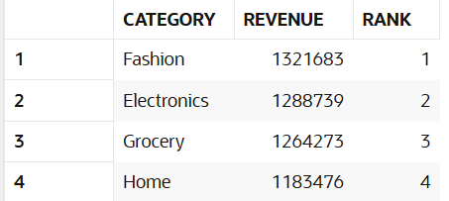

Question:
108)Find best customer per store.
Query:
SELECT *
FROM (
SELECT store_id, customer_id,
SUM(amount) AS revenue,
RANK() OVER (PARTITION BY store_id ORDER BY SUM(amount) DESC) rnk
FROM sales
GROUP BY store_id, customer_id
)
WHERE rnk = 1;
Output:
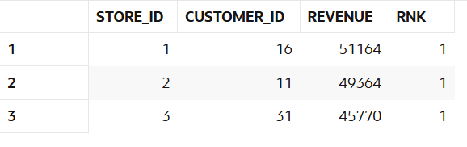

Question:
109)Find worst performing category.
Query:
SELECT *
FROM (
SELECT p.category,
SUM(s.amount) AS revenue,
RANK() OVER (ORDER BY SUM(s.amount)) rnk
FROM sales s
JOIN products p ON s.product_id = p.product_id
GROUP BY p.category
)
WHERE rnk = 1;
Output:
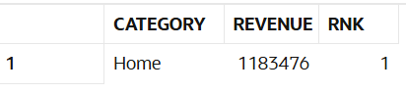

Question:
110)Analyze gap between best and worst.
Query:
SELECT
MAX(amount) AS highest_sale,
MIN(amount) AS lowest_sale,
MAX(amount) - MIN(amount) AS gap
FROM sales;
Output:
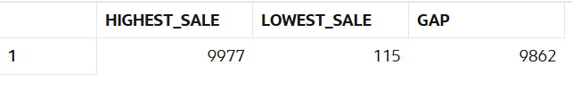

11. Date Analysis
Question:
111)Find daily sales.
Query:
SELECT sale_date, SUM(amount) AS daily_sales
FROM sales
GROUP BY sale_date
ORDER BY sale_date;
Output:
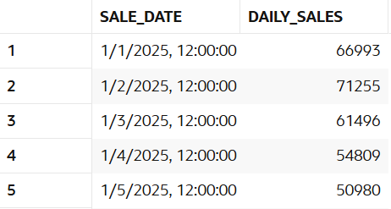

Question:
112)Find monthly sales.
Query:
SELECT TO_CHAR(sale_date, 'YYYY-MM') AS month,
SUM(amount) AS monthly_sales
FROM sales
GROUP BY TO_CHAR(sale_date, 'YYYY-MM')
ORDER BY month;
Output:
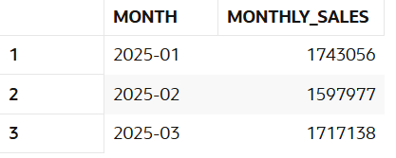

Question:
113)Find weekend sales.
Query:
SELECT *
FROM sales
WHERE TO_CHAR(sale_date, 'DY') IN ('SAT','SUN');
Output:
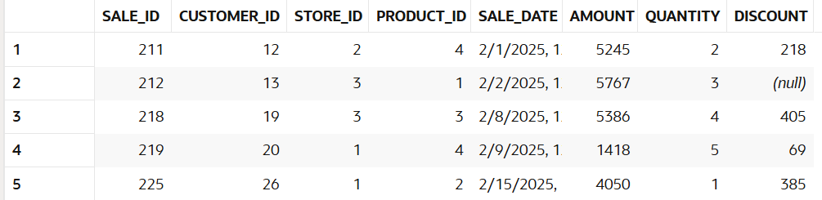

Question:
114)Find first sale date.
Query:
SELECT MIN(sale_date) AS first_sale_date
FROM sales;
Output:
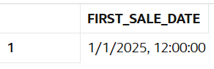
Question:
115)Find last sale date.
Query:
SELECT MAX(sale_date) AS last_sale_date
FROM sales;
Output:
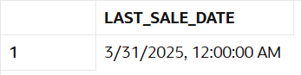

Question:
116)Find sales in specific month.
Query:
SELECT *
FROM sales
WHERE TO_CHAR(sale_date, 'YYYY-MM') = '2025-02';
Output:
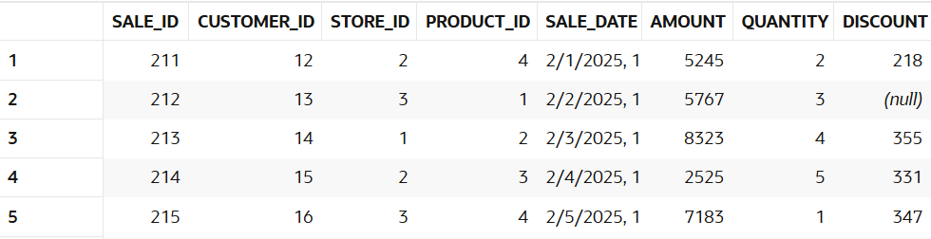
Question:
117)Find sales growth month-wise.
Query:
SELECT month,
revenue,
revenue - LAG(revenue) OVER (ORDER BY month) AS growth
FROM (
SELECT TO_CHAR(sale_date, 'YYYY-MM') AS month,
SUM(amount) AS revenue
FROM sales
GROUP BY TO_CHAR(sale_date, 'YYYY-MM')
);
Output:
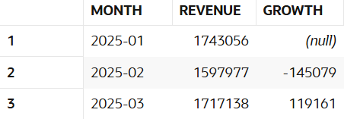

Question:
118)Find inactive customers (30 days).
Query:
SELECT c.customer_name
FROM customers c
LEFT JOIN sales s ON c.customer_id = s.customer_id
GROUP BY c.customer_name
HAVING MAX(s.sale_date) < SYSDATE - 30 OR MAX(s.sale_date) IS NULL;
Output:
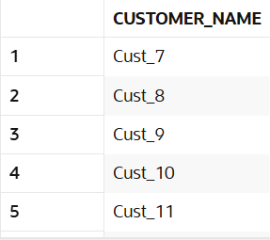

Question:
119)Find repeat customers.
Query:
SELECT c.customer_name, COUNT(*) AS transactions
FROM sales s
JOIN customers c ON s.customer_id = c.customer_id
GROUP BY c.customer_name
HAVING COUNT(*) > 1;
Output:
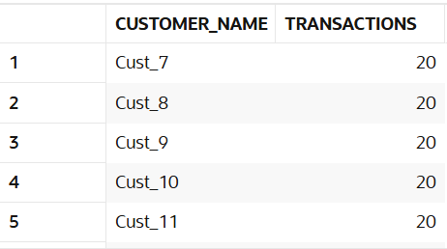

Question:
120)Find sales trend.
Query:
SELECT TO_CHAR(sale_date, 'YYYY-MM') AS month,
SUM(amount) AS revenue
FROM sales
GROUP BY TO_CHAR(sale_date, 'YYYY-MM')
ORDER BY month;
Output:
