Operator learning in Mechanics and Materials
Mechanics and materials are gradually becoming data-rich due to rapid advances in experimental science and high-performance multiscale computing. There has been a growing interest in the field of solid mechanics for developing data-driven and learning-based methods to characterize, understand, model, and design material/structural systems. With data-driven approaches, it is possible to remove/relax the need for ad hoc constitutive models for describing the material behavior, to achieve fast multi-scale computation for structures as well as to generate optimal designs. This talk will survey operator-learning methods developed for mechanics and materials, including (i) data-driven surrogate models for classes of PDEs, (ii) discovery of constitutive relations for materials with complex, history-dependent behavior, and (iii) hybrid computational frameworks that couple learning with physics for complex geometries.
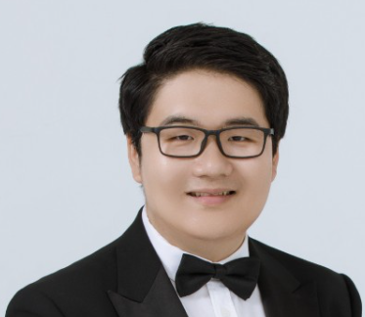
Bio:
Burigede Liu is Granta Design Assistant Professor at the University of Cambridge. He received his Ph.D. in Engineering at University of Cambridge in 2019. He was a postdoc in Department of Mechanical and Process Engineering at ETH Zurich (2019) and a postdoctoral fellow in Mechanical and Civil Engineering at California Institute of Technology (2019-2021). Prof Liu's research interest includes data-driven mechanics; uncertainty quantification of materials; micro-mechanics of metals, composites and mechanical meta-materials as well as quantum computing.

​

