**Chapter 4**

**What:** How do I join two tables?

1.

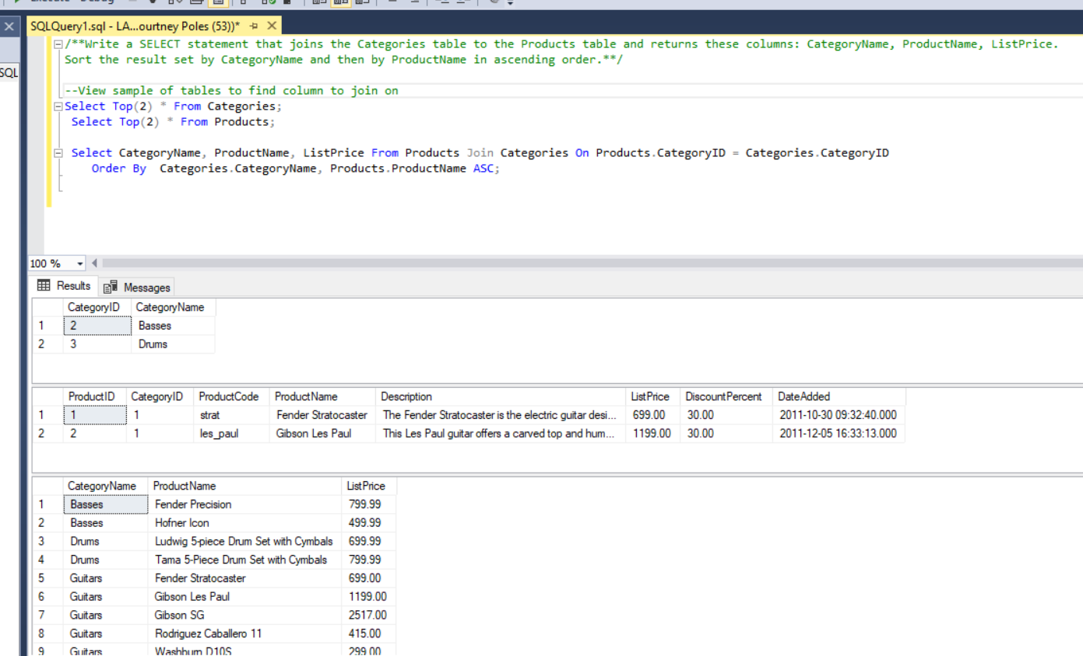

2.

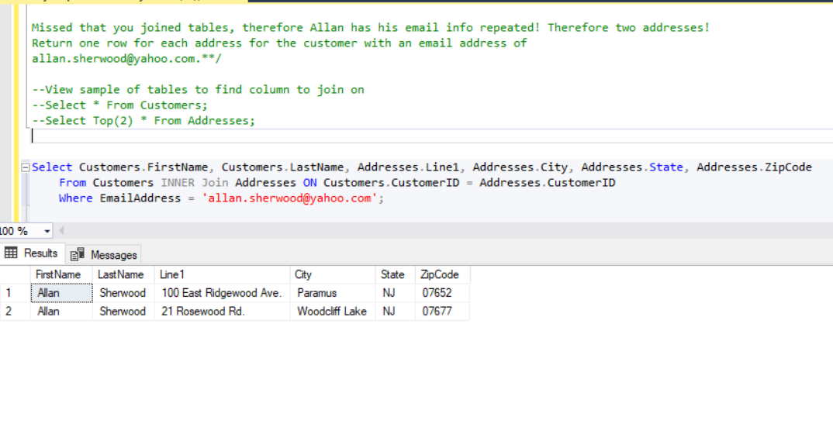

3.

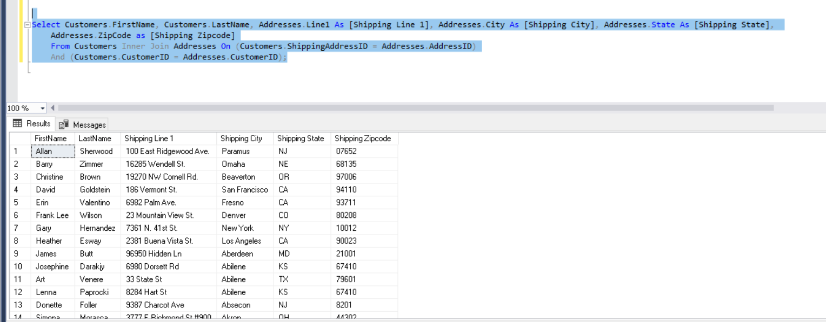

4.

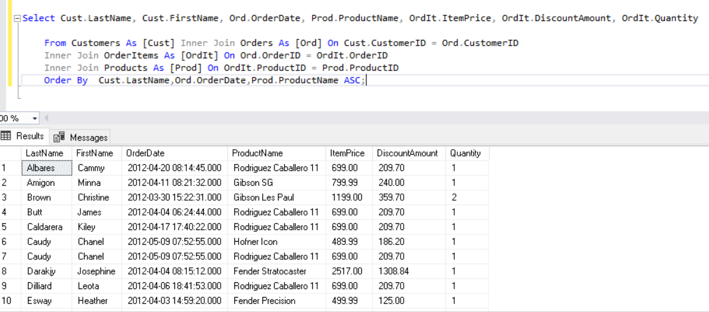

5.

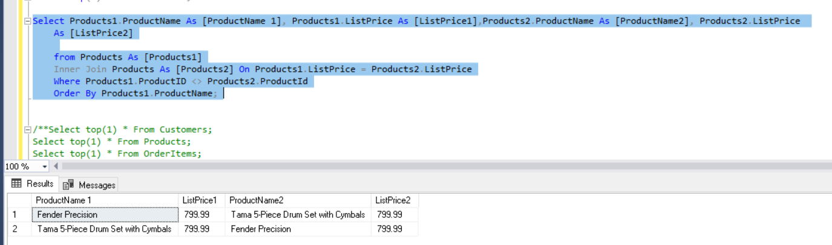

6.

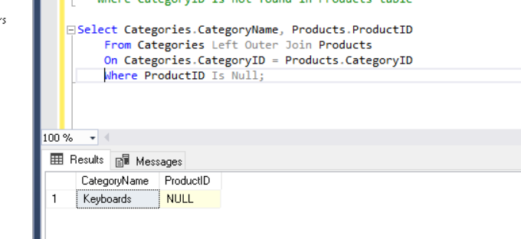

7. How do I create a single calculated field based on a condition without writing an IF Then (Case) statement?

Select and filter results for each conditioned desired, then union each result set together.

