MATLAB App Designer

App Designer is an environment for building MATLAB® apps. It simplifies the process of laying out the visual components of a user interface. It includes a full set of standard user interface components, as well as a set of gauges, knobs, switches, and lamps to create control panels and human-machine interfaces.

More information about the supported UI components/Features:

URL: https://www.mathworks.com/products/matlab/app-designer.html

Screen for Transfer-Function Synthesis:

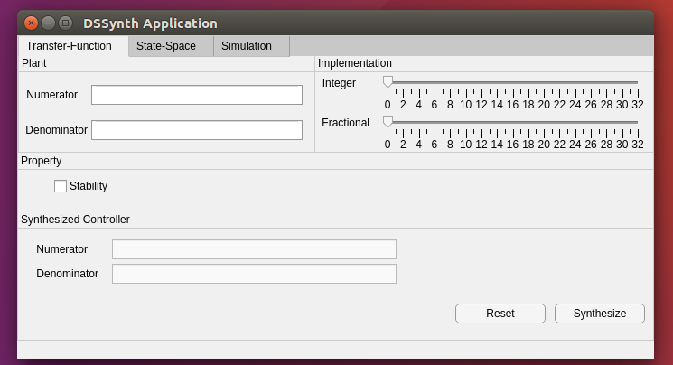
Plant (transfer-function representation)
- Numerator: vector with the coefficients for numerator;
- Denominator: vector with the coefficients for denominator;
Implementation (fixed-point representation)
- Integer: value for the integer bits;
- Fractional: value for the fractional bits;
Property
- Stability: checkbox to select the property to be considered during the synthesization;
Synthesized Controller
- Numerator and Denominator for the controller after the synthesis.
Buttons:
- Reset: clear all fields fulfilled;
- Synthesize: perform the controller synthesis using DSSynth Tool;

Screen for State-Space Synthesis:

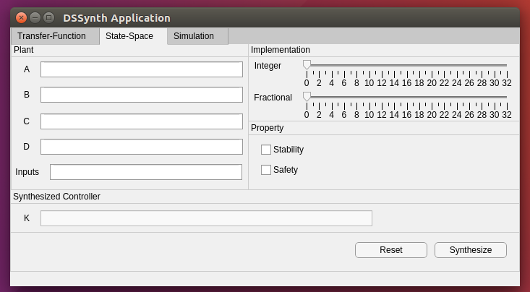
Plant (state-space representation)
- A, B, C, D: matrices with the coefficients related to the plant;
- Inputs: vector with the inputs to be eurmployed during the synthesization;
Implementation (fixed-point representation)
- Integer: value for the integer bits;
- Fractional: value for the fractional bits;
Property
- Stability/Safety: checkboxes to select the property to be considered during the synthesization;
Synthesized Controller
- Feedback Matrix (Matrix K) after the synthesis.
Buttons:
- Reset: clear all fields fulfilled;
- Synthesize: perform the controller synthesis using DSSynth Tool;

Screen with Digital System Simulation:

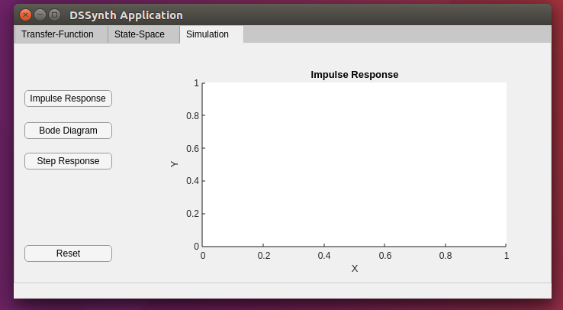

Simulate the system in order to show graphically the synthesized controller:

- Impulse Response
- Bode Diagram
- Step Response

