Binary search trees

A tree consists of:

• a set of *nodes*

• a set of *edges*, each of which connects a pair of nodes

The node at the "top" of the tree is called the *root* of the tree.

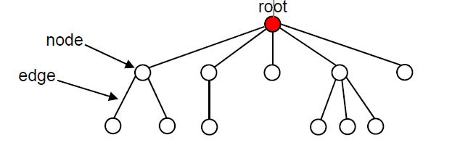

• A node’s *ancestors* are its parent, its parent’s parent, etc.

• A node’s *descendants* are its children, their children, etc.

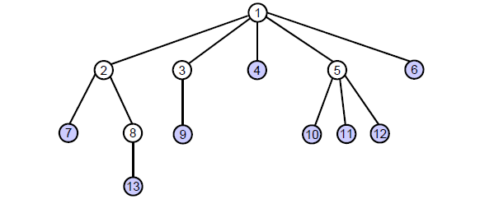

• A *leaf node* is a node without children.

• An *interior node* is a node with one or more children.

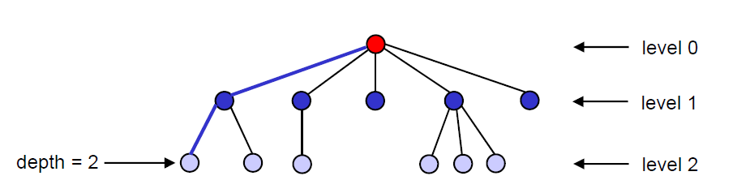

• Nodes with the same depth form a *level* of the tree.

• The *height* of a tree is the maximum depth of its nodes.

*Successor of x = the smallest key which is bigger than x.key (in homework requirement)*

-Trees

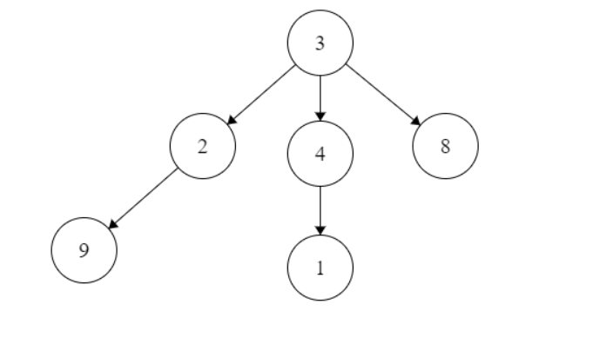

-Binary trees

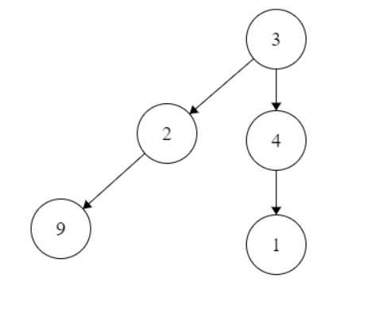

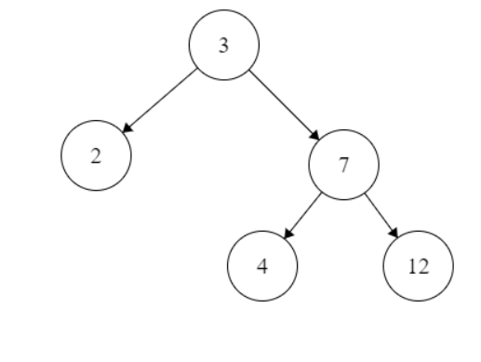-Binary search trees

Each of the basic operations on a binary search tree runs in O(h) time, where h is the height of the tree