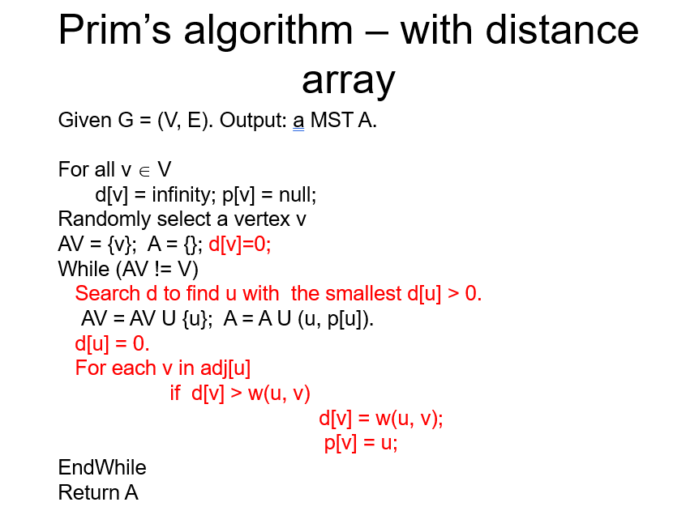

Prim using Prio Queue

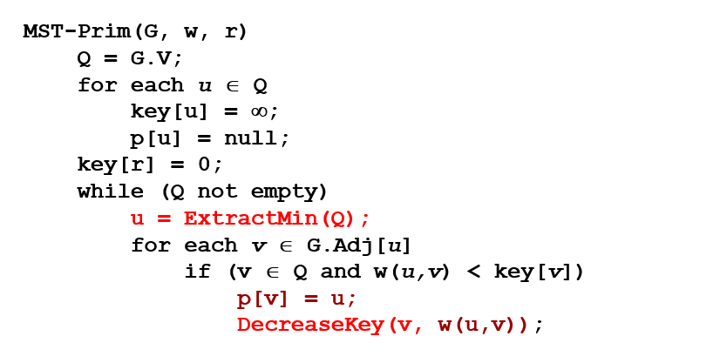

Initialization

* Maintain a priority queue. Init all values with infinity v.key = inf
* For an arbitrary vertex set v.key = 0
* Initial empty set S

Do this until the queue is empty:

* Extract min from the queue and add it to S
* Update adjacent values

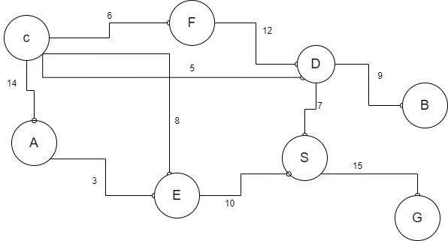

Prio Queue:

A – inf

B – inf

C – inf

…

S – 0

* Start with S -> extract S form prio queue -> add S to the set -> update adjacent vertices in prio queue
* Next is D -> extract D form prio queue -> add D to the set -> update values
* Next is C -> extract C form prio queue -> add C to the set -> update values
* Next is F -> extract F form prio queue -> add F to the set -> update values
* Next is E -> extract E form prio queue -> add E to the set -> update values
* Next is A, B and G

Underline all edges with the same weight as vertex key

