1. Setup in word

To set in word: a. Go to the Insert tab and select Symbol 

b. Click on ‘More Symbols’ and search for the desired symbol

c. Select symbol and click on ‘AutoCorrect’

d. In the replace field write the name that you want to be replaced with the symbol



1. Intro

˥ - not

˅ - disjunctie (OR)

˄ - conjunctie (AND)

→ - implicatie logica

|  |  |  |
| --- | --- | --- |
| P ˅ q | F | T |
| F | F | T |
| T | T | T |

|  |  |  |
| --- | --- | --- |
| P ˄ q | F | T |
| F | F | F |
| T | F | T |

CNF – Conjunctive Normal Form

BDD – Binary Decision Diagram

CNF = o conjunctie (˄) de disjunctii (˅) de literali, clause

(x ˅ ˥z) ˄ (˥y) ˄ (y ˅ z) – CNF

(x ˅ ˥y ˅ z) – CNF

x ˅ ˥y ˄ z – NOT CNF

1. Exemple transformare in CNF

1. x ˅ (y ˄ z) = (x ˅ y) ˄ (x ˅ z)

2. (p ˄ q) ˅ (p ˄ ˥q) = ((p ˄ q) ˅ p) ˄ ((p ˄ q) ˅ ˥q)

= ((p ˅ p) ˄ (q ˅ p)) ˄ ((p ˅ ˥q) ˄ (q ˅ ˥q))

p → q ⬄ ˥p ˅ q

˥(p → q) ⬄ p ˄ ˥q

3. a → (b → c) = a → (˥b ˅ c)

= ˥a ˅ (˥ b ˅ c) – o clauza cu disjunctii

4. ˥ ((a ˄ b) ˅ ((a → (b ˄ c)) -> c)) = ˥(a ˄ b) ˄ ˥((a → (b ˄ c)) -> c)

= (˥a ˅ ˥b) ˄ ˥((˥a ˅ (b ˄ c)) → c)

= (˥a ˅ ˥b) ˄ ˥(˥(˥a ˅ (b ˄ c)) ˅ c)

= (˥a ˅ ˥b) ˄ (˥a ˅ (b ˄ c)) ˄ ˥c

= (˥a ˅ ˥b) ˄ (˥a ˅ b) ˄ (˥a ˅ c) ˄ ˥c

5. (p → (q → r)) → (p → (r → q)) = (p → (˥q ˅ r)) → (p → (˥r ˅ q))

= (˥p ˅ (˥q ˅ r)) → (˥p ˅ (˥r ˅ q))

= ˥(˥p ˅ (˥q ˅ r)) ˅ (˥p ˅ (˥r ˅ q))

= (p ˄ (q ˄ ˥r)) ˅ (˥p ˅ (˥r ˅ q))

= (p ^ q ^˥r) ˅ (˥p ˅ ˥r ˅ q)

= (p ˅ ˥p ˅ ˥r ˅ q) ˄ (q ˅ ˥p ˅ ˥r ˅ q) ˄ (˥r ˅ ˥p ˅ ˥r ˅ q)

a. b. c.

a. p ˅ ˥p => true tot timpul

b. q ˅ q = q => (q ˅ ˥p ˅ ˥r ˅ q) ⬄ (q ˅ ˥p ˅ ˥r)

c. ˥r ˅ ˥r = ˥r => (˥r ˅ ˥p ˅ ˥r ˅ q) ⬄ (q ˅ ˥p ˅ ˥r)

a + b + c => (p ˅ ˥p ˅ ˥r ˅ q) ˄ (q ˅ ˥p ˅ ˥r ˅ q) ˄ (˥r ˅ ˥p ˅ ˥r ˅ q) ⬄ (q ˅ ˥p ˅ ˥r)

4. Exemple transformare BDD

f = (a ˄ b) ˅ (c ˄ d)

f | a=T ⬄ b ˅ (c ˄ d) f| b=T ⬄ T ˅ (c ˄ d) = T

f| b = F ⬄ c ˄ d f| c=T ⬄ d f|d = T⬄ T

f|d = F ⬄ F

f| c=F ⬄ F

f| a = F ⬄ c ˄ d f| c=T ⬄ d f|d = T⬄ T

f|d = F ⬄ F

f| c=F ⬄ F

stanga – false

dreapta - true

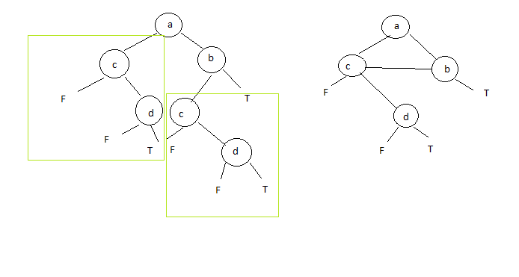

Tema: transformati in CNF

1. ˥ ((p ˄ q) ˄ (r ˅ (˥(p → (q ˄ r))))

2. (p → q) → ((q → r) → (p → r))

