**CREATING FACEBOOK API FOR YOUR PLUGIN**

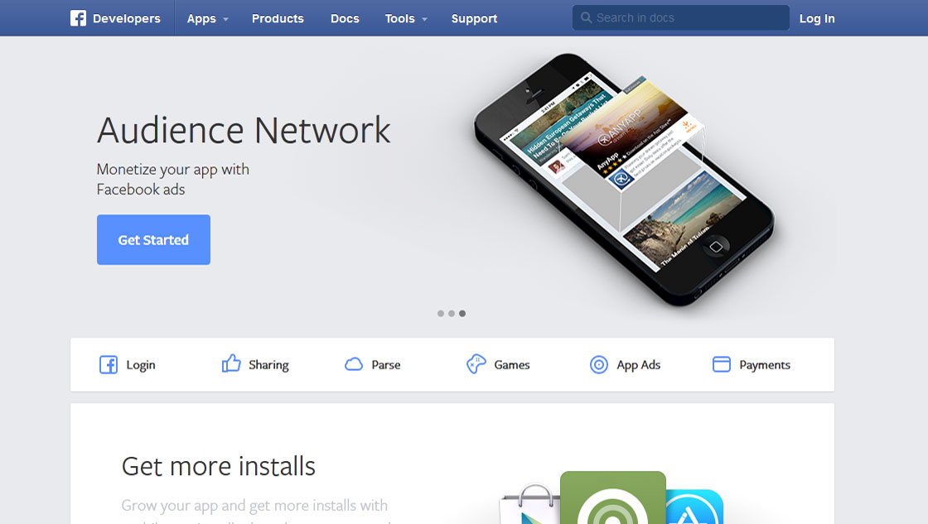

1. **Go to link:** [**http://developers.facebook.com**](http://developers.facebook.com)

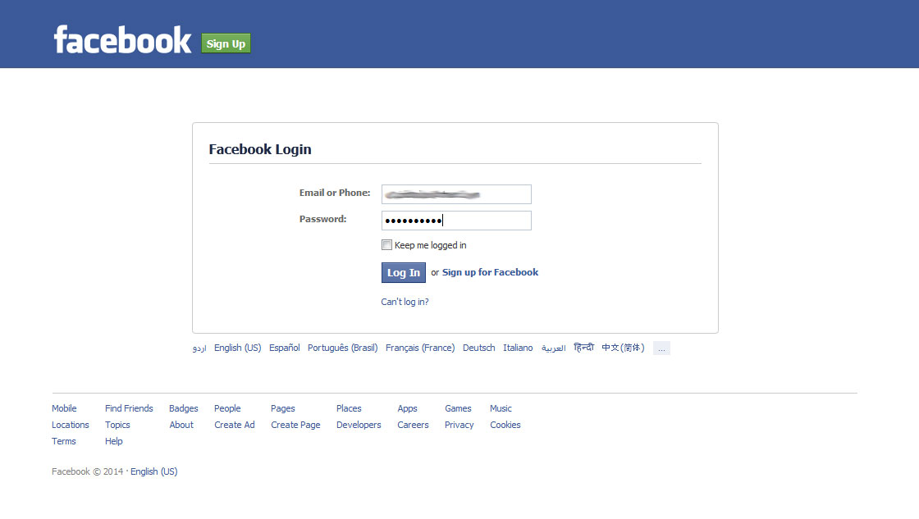

1. **Login with your FACEBOOK account**

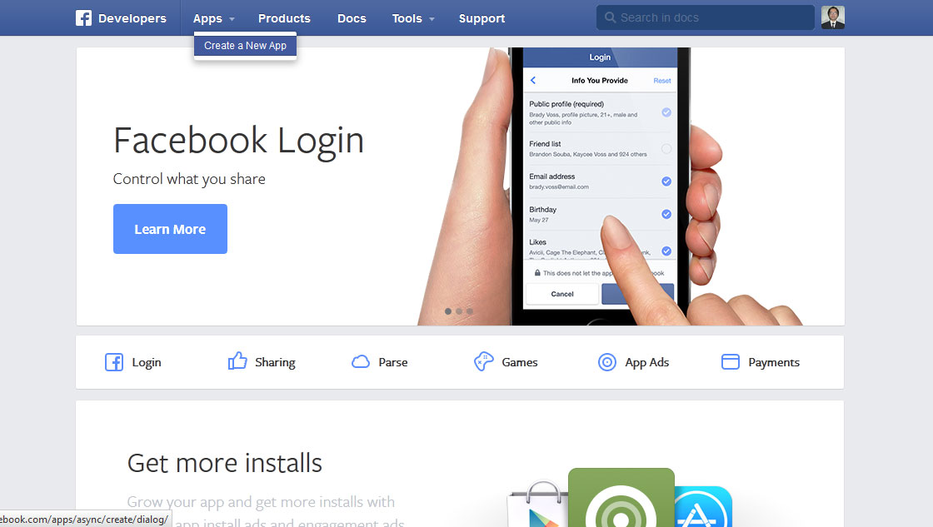

1. **After Login, click on CREATE A NEW APP from top menu**

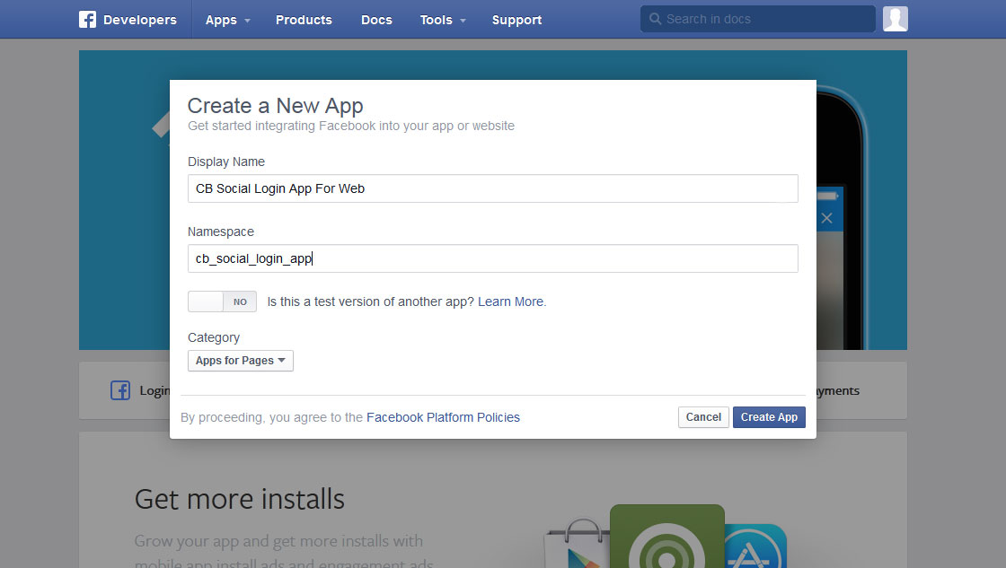

1. **In popup window appearing after click, enter details of your application**

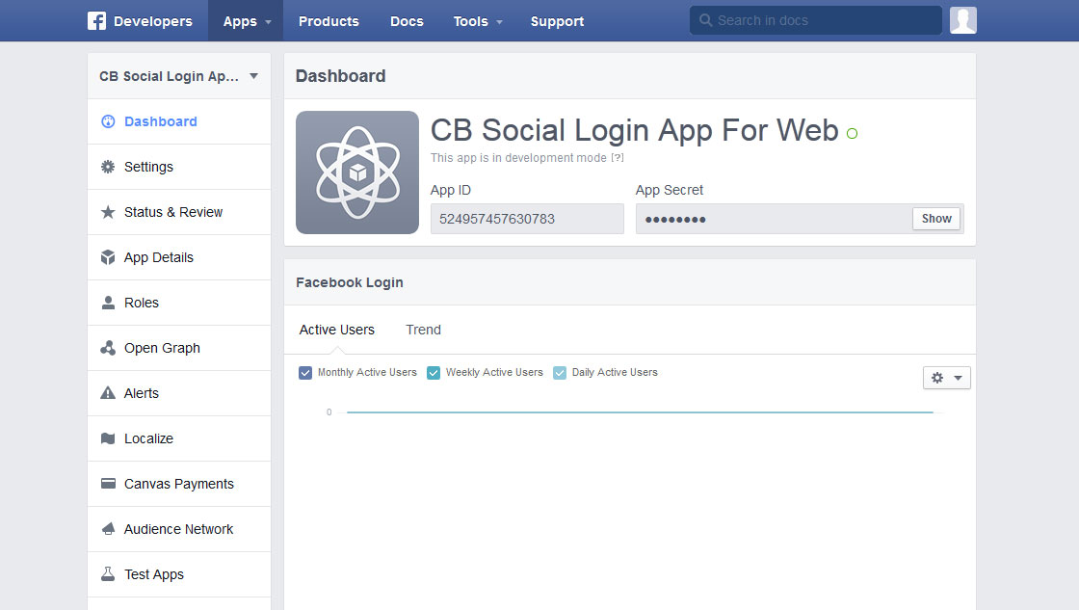

1. **From next application detail screen DASHBOARD, note down your APP ID and APP SECRET. App Secret will be available on screen by clicking SHOW button next to the field.**

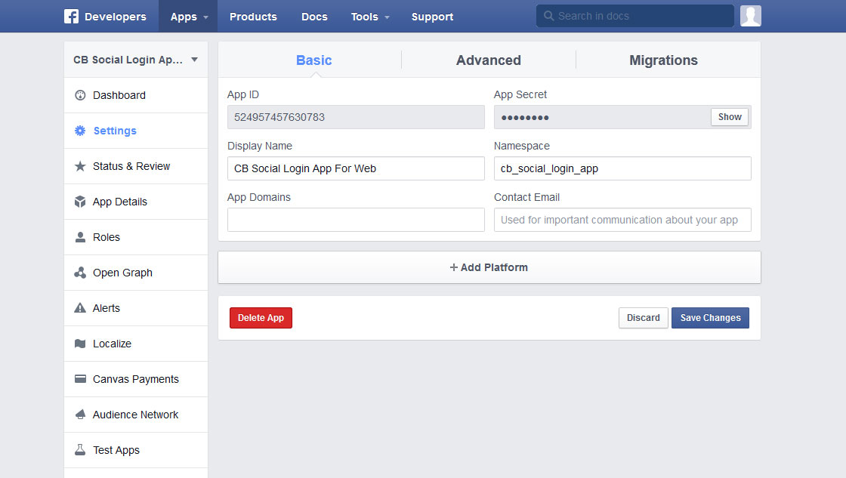

1. **From same screen (left menu), click on SETTINGS and then on ADD PLATFORM**

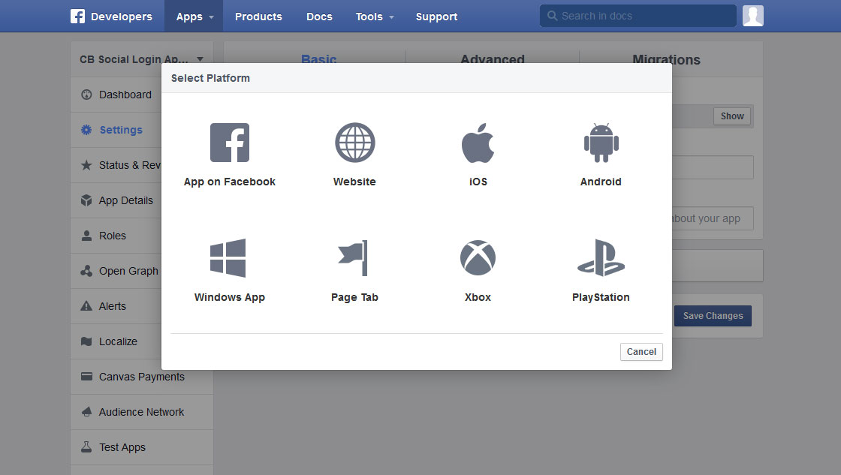

1. **From the popup window appear, click on WEBSITE**

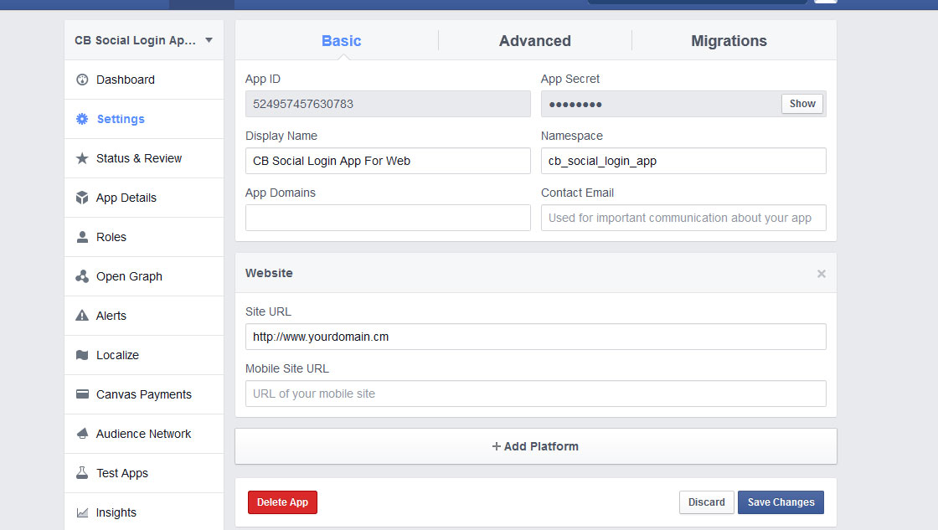

1. **On the same menu after clicking WEBSITE from popup, enter your DOMAIN NAME and click on SAVE CHANGES**

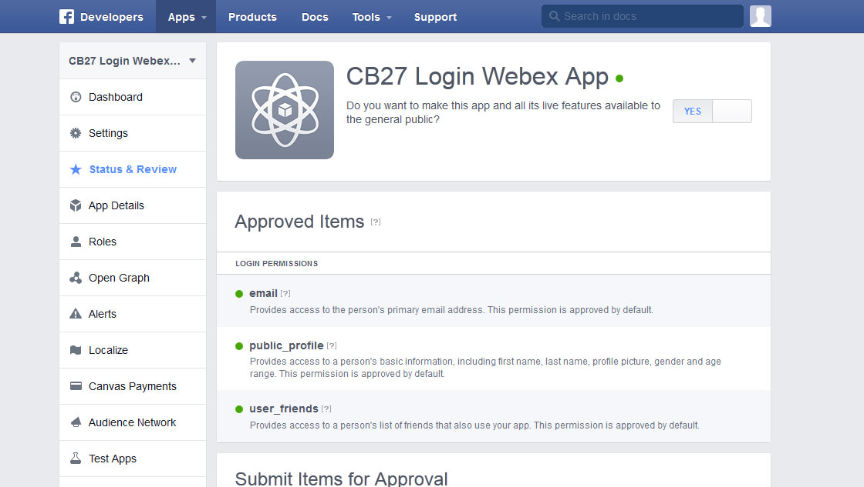

1. **Click on STATUS & REVIEW from left menu and make the App Online by scrolling the NO button to YES.**

**CREATING TWITTER API FOR YOUR PLUGIN**

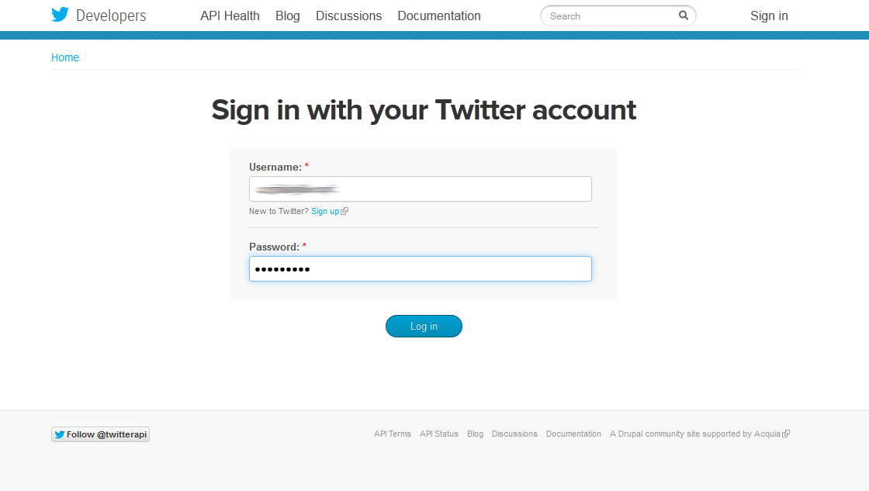

1. **Go to the link: dev.twitter.com and LOGIN with your Twitter username/password**

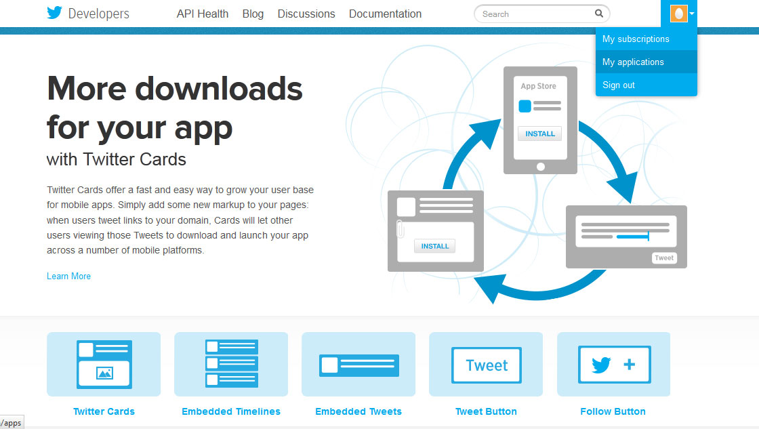

1. **After login, from top user menu click on MY APPLICATION**

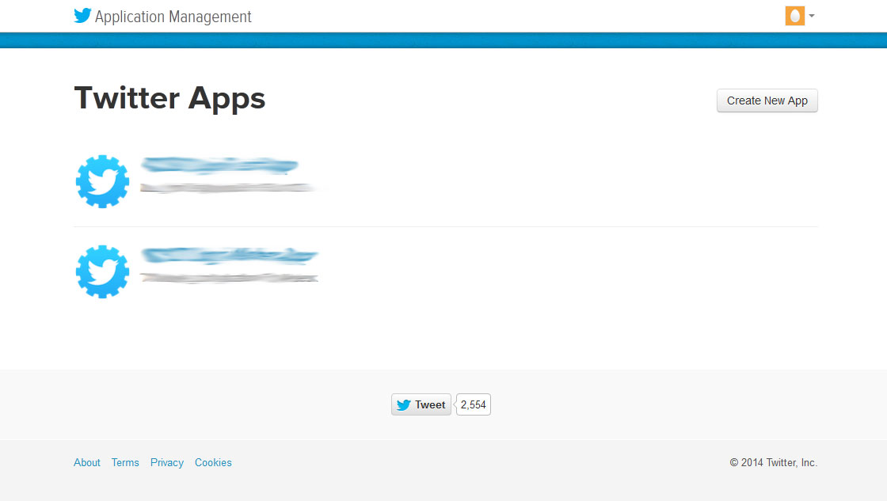

1. **After clicking and next page, Click on CREATE NEW APP button**

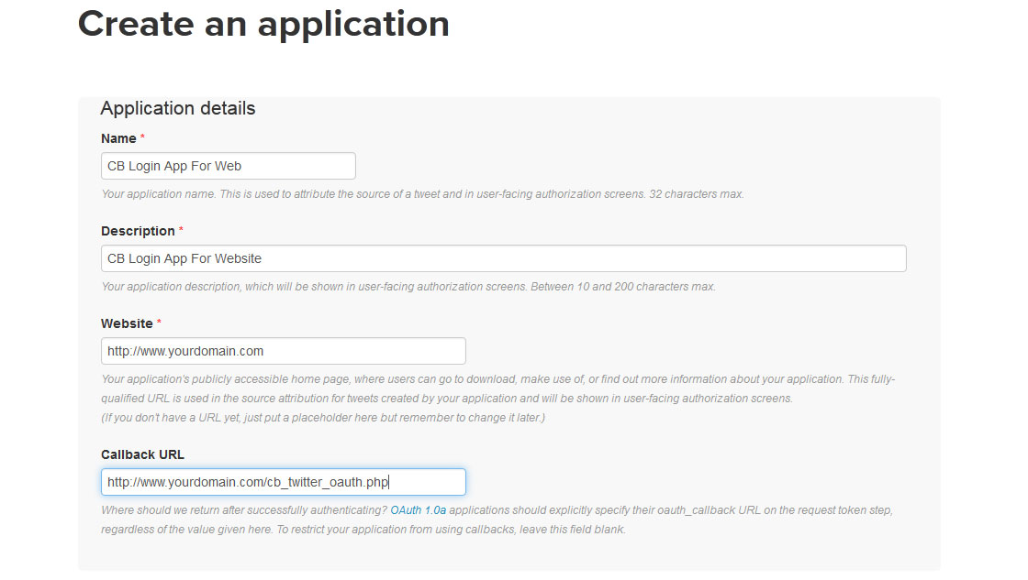

1. **Next screen after clicking the button, will allow you to enter your APP DETAILS**

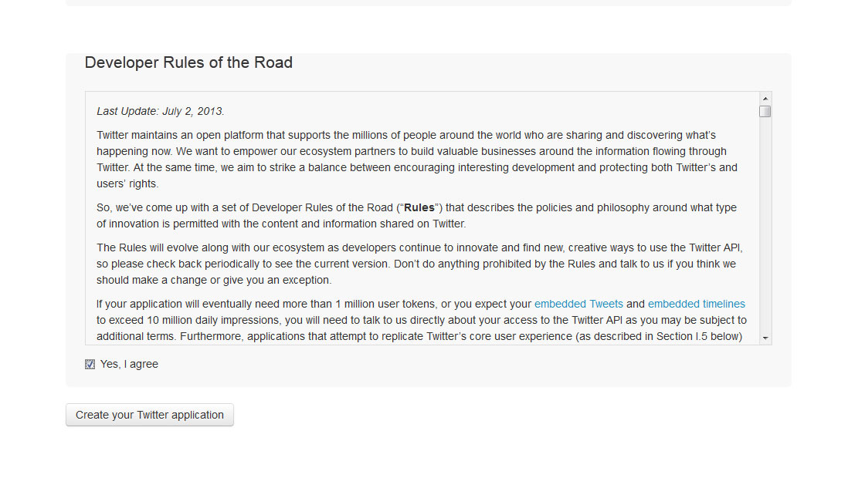

1. **On same page, scroll down, AGREE TO TERMS and click on CREATE YOUR TWITTER APPLICATION**

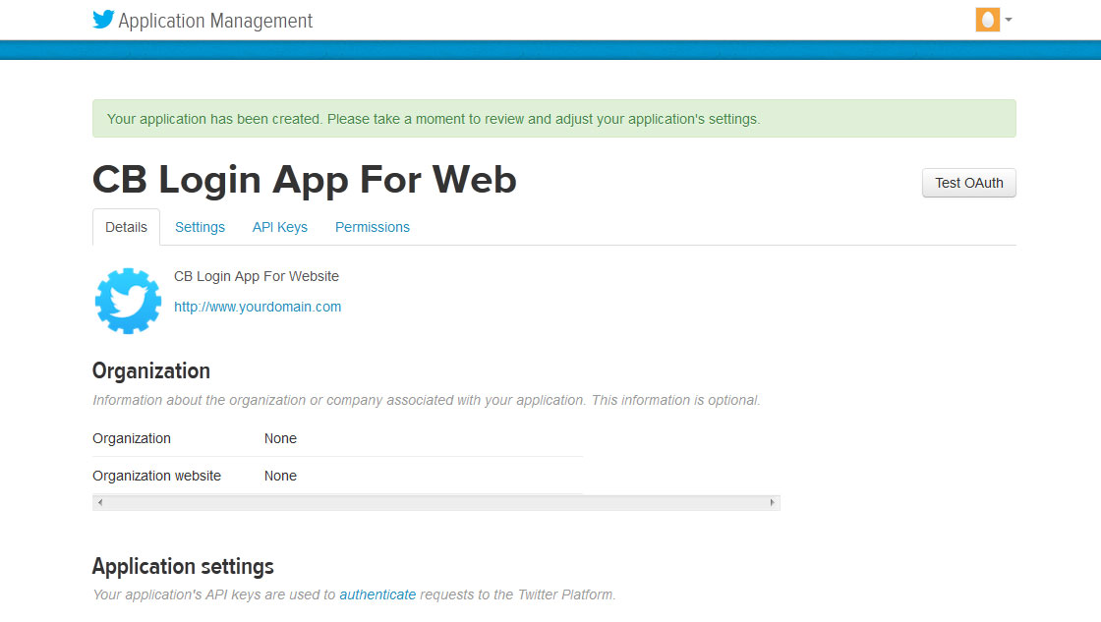

1. **After clicking the Button, next screen confirms creation of your App and shows its DETAILS**

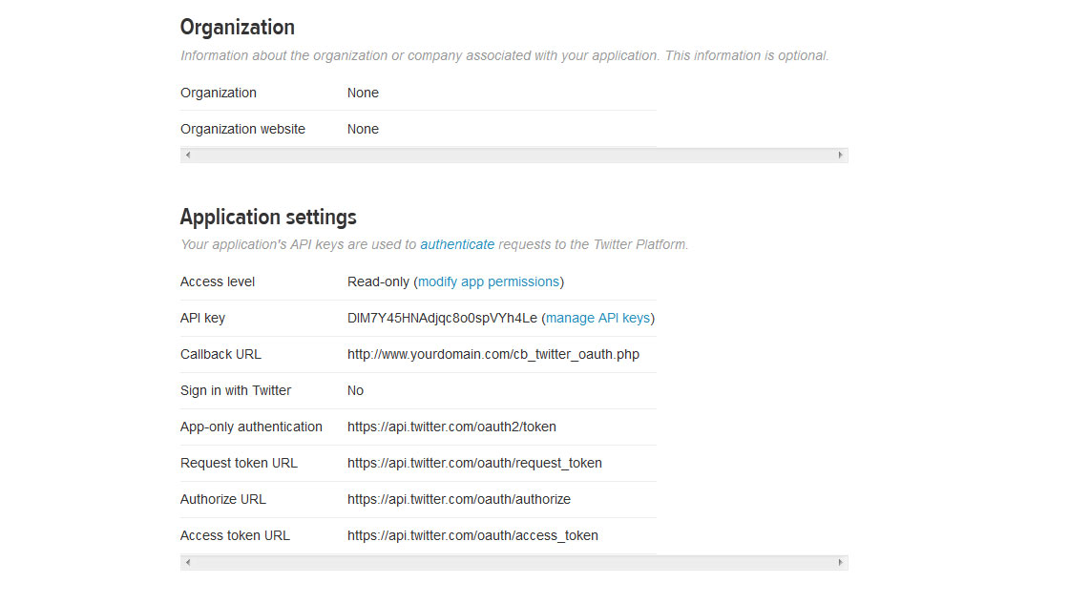

1. **Scroll down and note down details for your App for Plug-in**

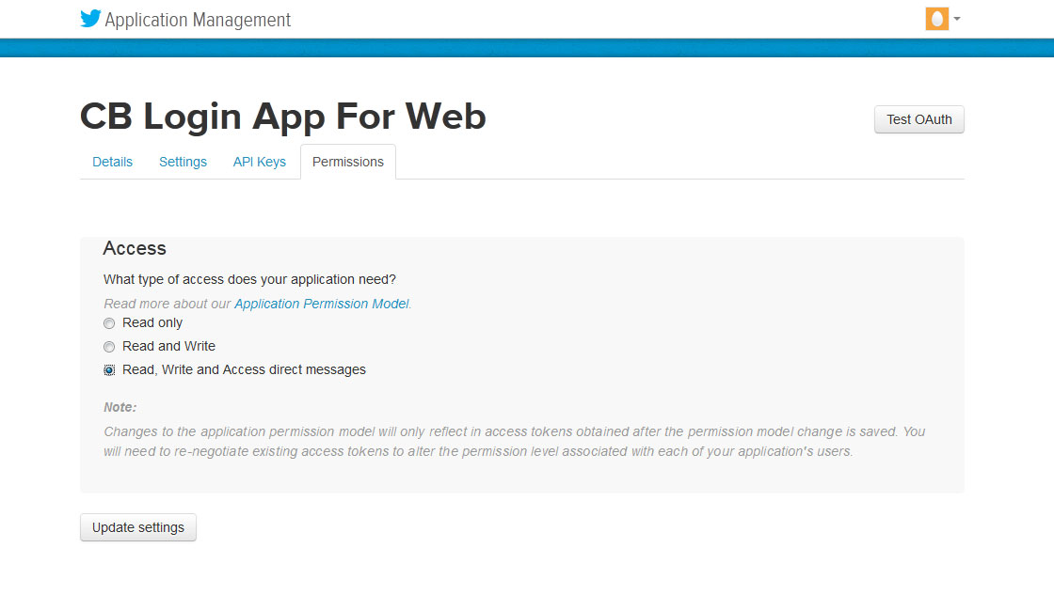

1. **Click on 4th tab named PERMISSIONS and check READ, WRITE AND ACCESS DIRECT MESSAGES, then click the Button UPDATE SETTINGS**

**CREATING LINKEDIN API FOR YOUR PLUGIN**

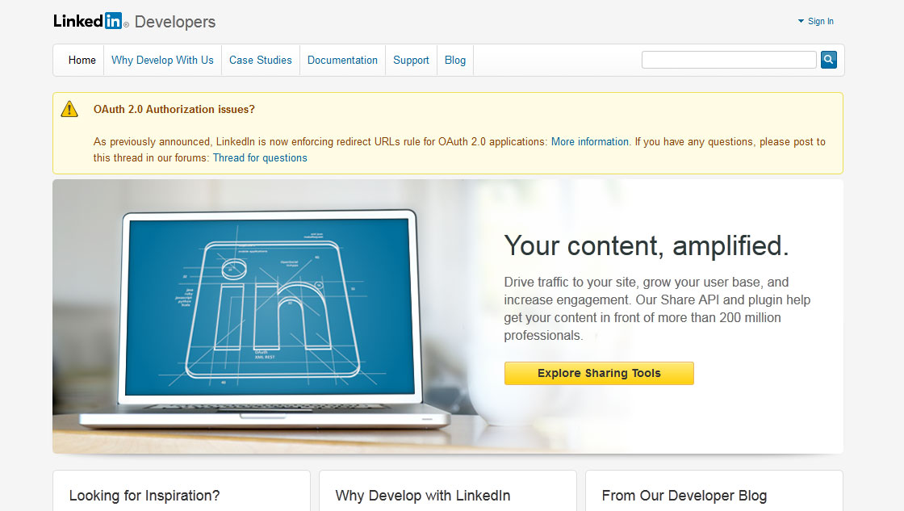

1. **Go to the link: developer.linkedin.com and Click on SIGN IN**

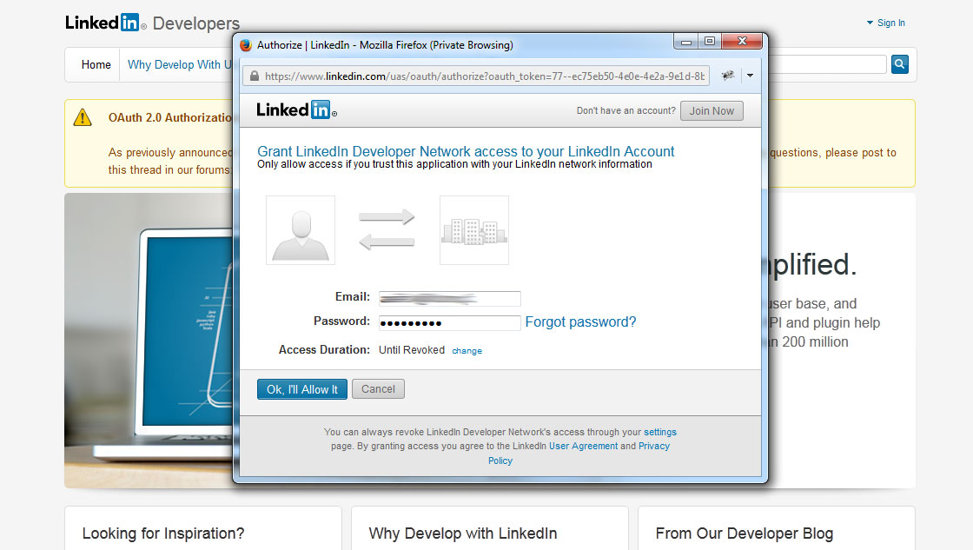

1. **In the popup window appear, enter your LINKEDIN username/password**

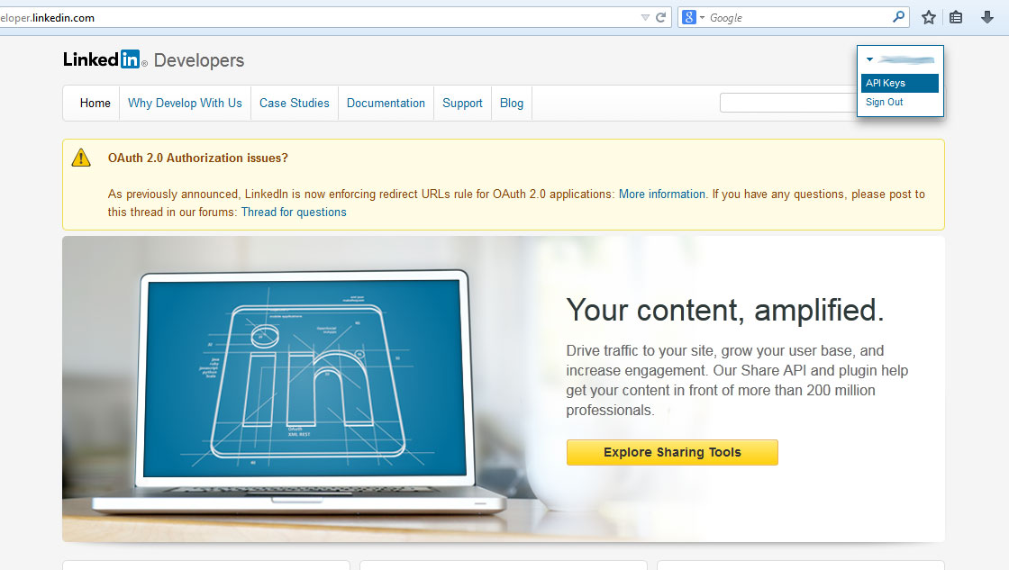

1. **After login, from the top user menu click on API KEYS**

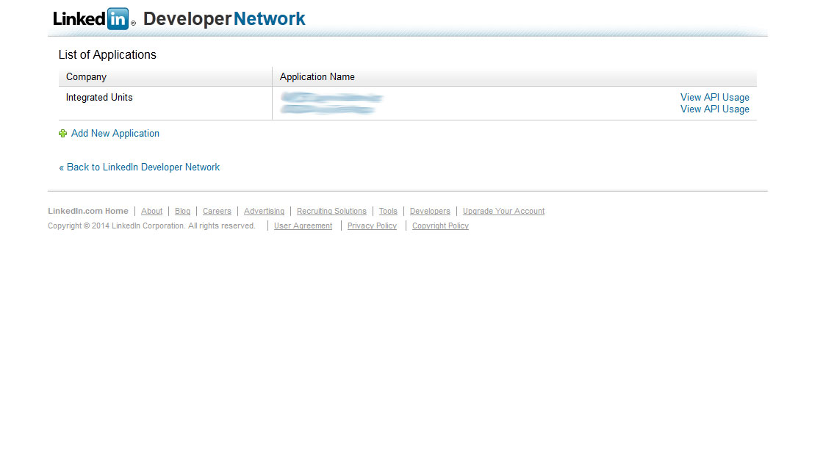

1. **On next screen click the link, ADD NEW APPLICATION**

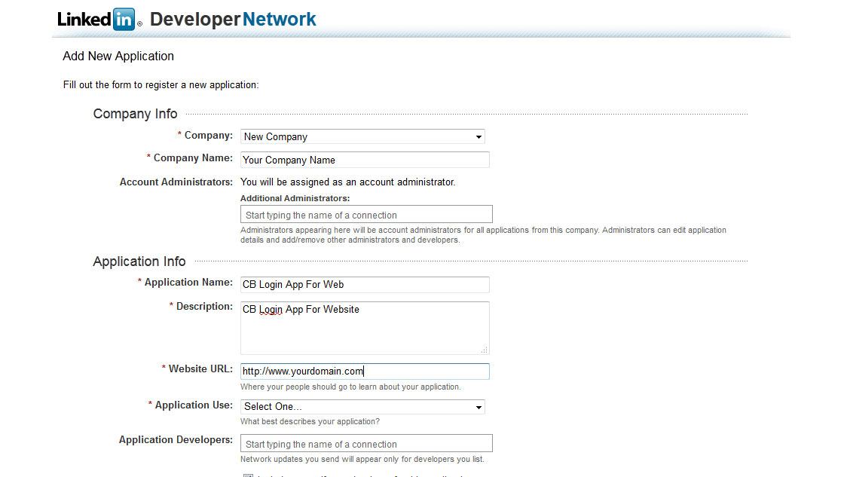

1. **After clicking the Link, next screen allows you to enter details of your App**

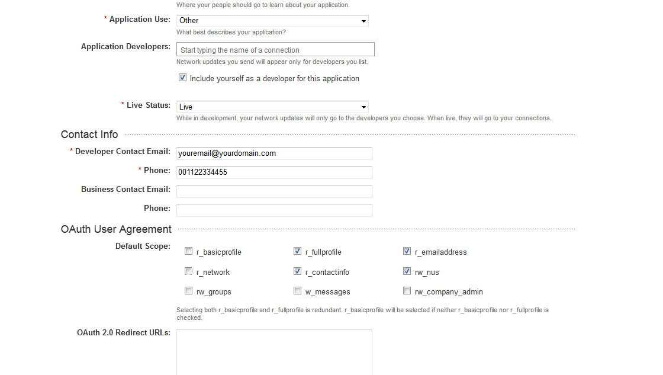

1. **Scroll down on same page and fill the rest of details, and check SCOPES of your App**

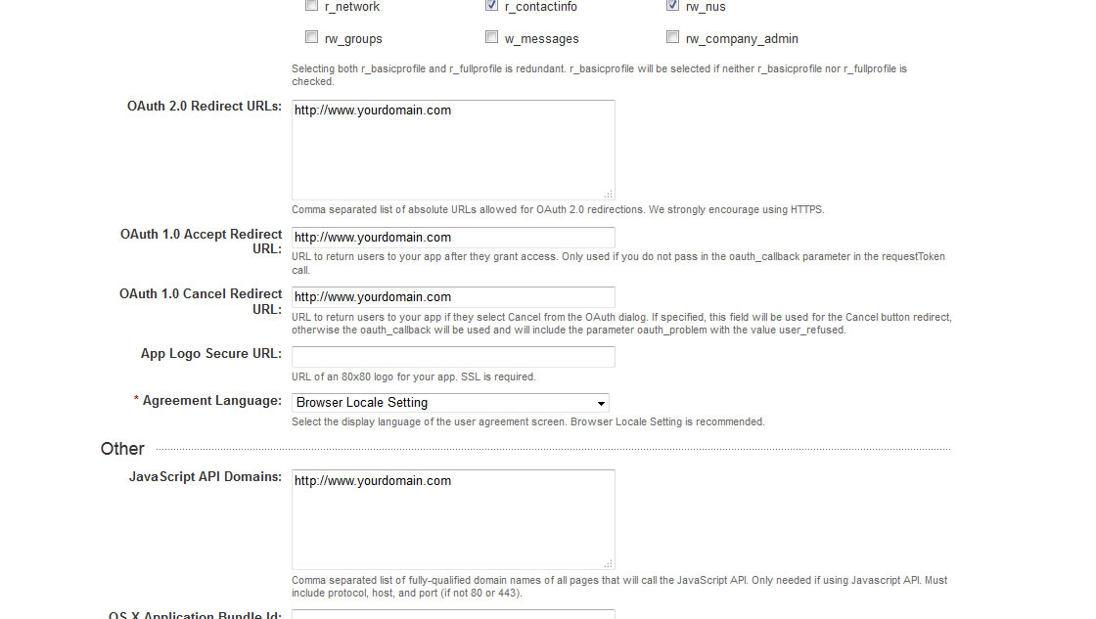

1. **Scroll down further and enter more required details**

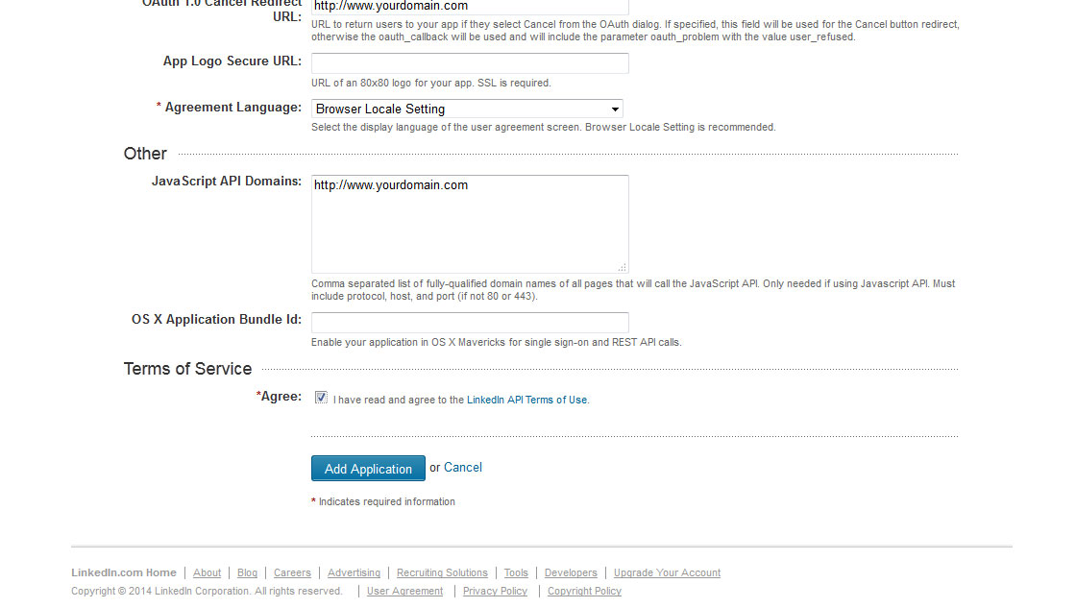

1. **Finally check AGREE TO TERMS and click on ADD APPLICATION BUTTON**

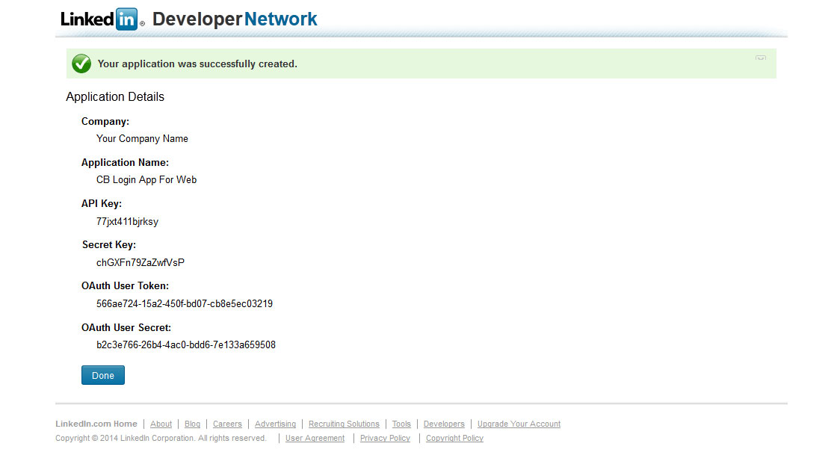

1. **After clicking the button, your APP DETAILS will be presented to you. Note down these.**

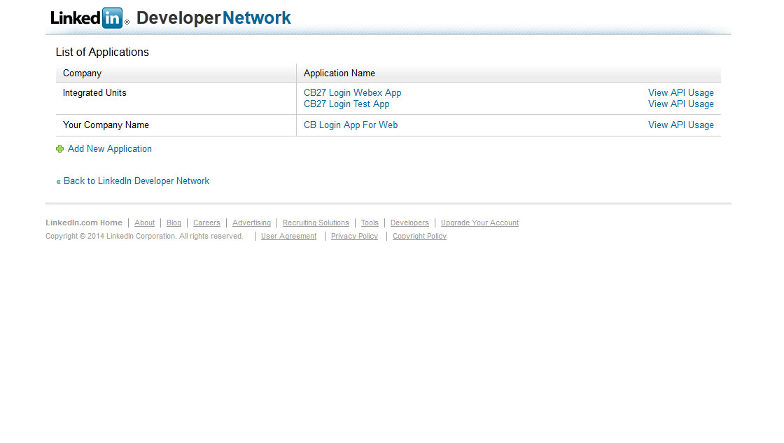

1. **Your APP is created, ready to be used and listed as well.**

**CREATING GOOGLE API FOR YOUR PLUGIN**

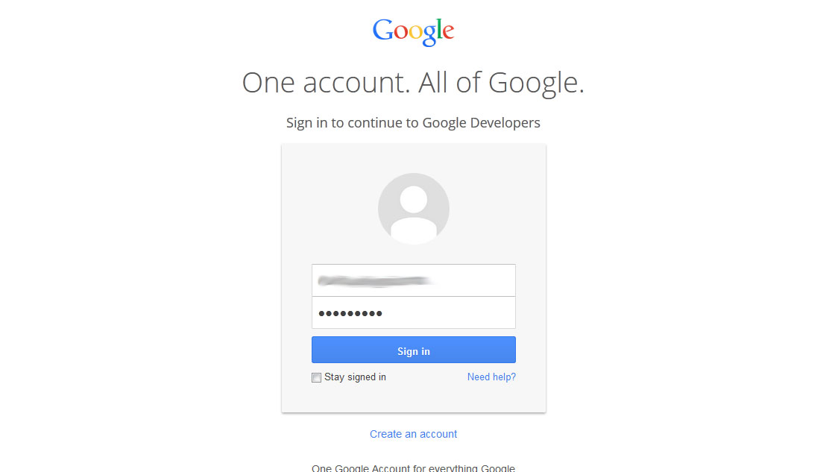

1. **Go to link: console.developers.google.com and LOGIN with your GOOGLE ACCOUNT**

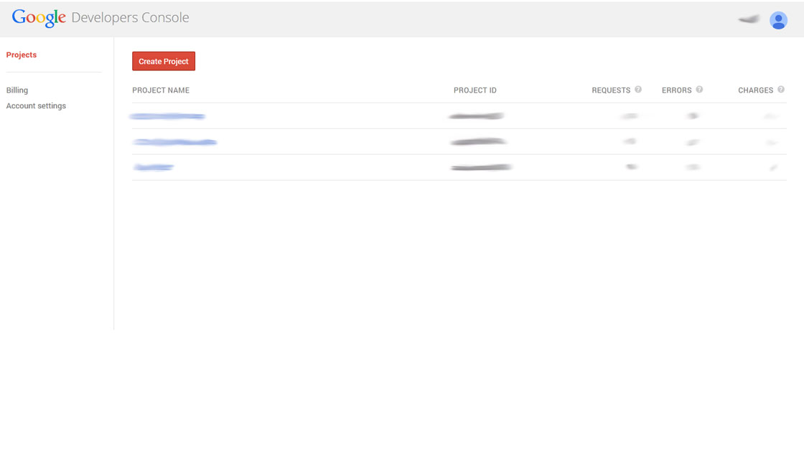

1. **After login and next screen, click on CREATE PROJECT**

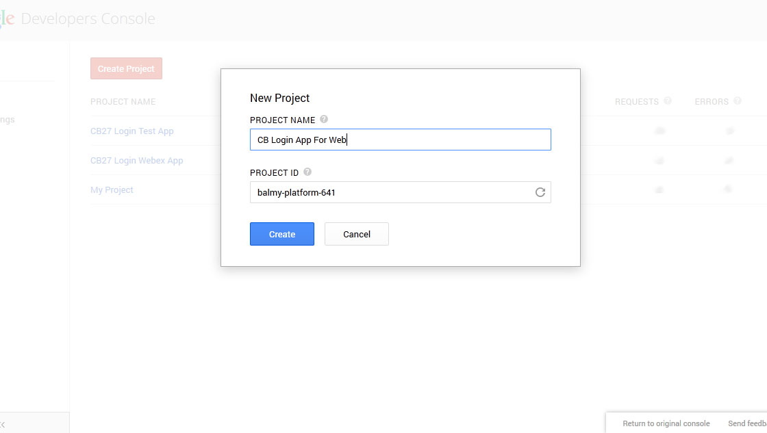

1. **By clicking the button, popup appears to enter your APP’s NAME. Enter your desired name and click on CREATE**

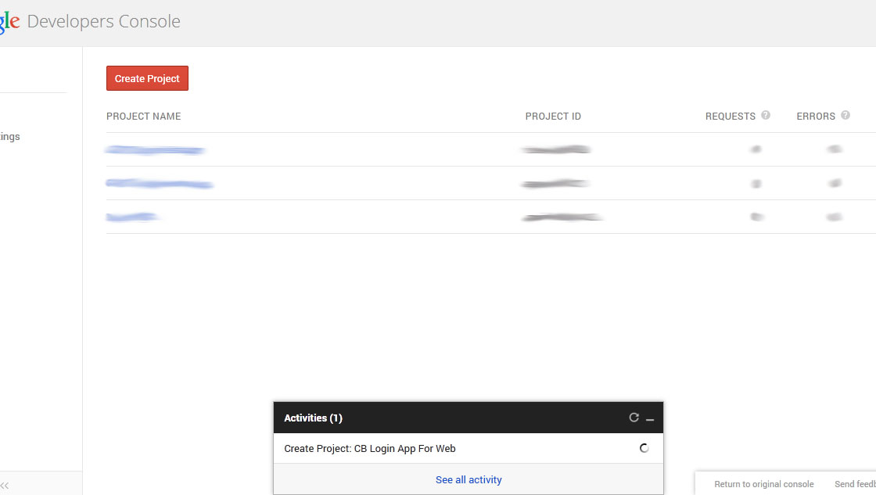

1. **It may take a bit of time for creation of project, with progress shown at bottom of screen**

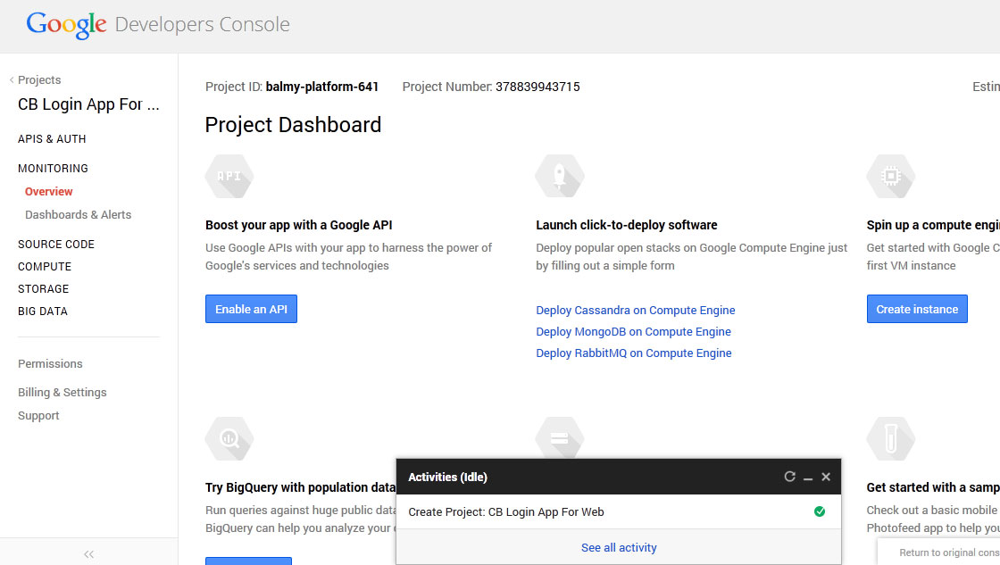

1. **After successful creation, message shown on bottom progress window and LEFT menu to use**

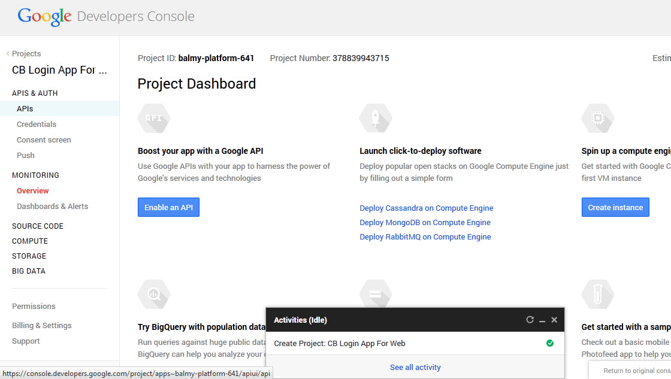

1. **From left menu click on APIs**

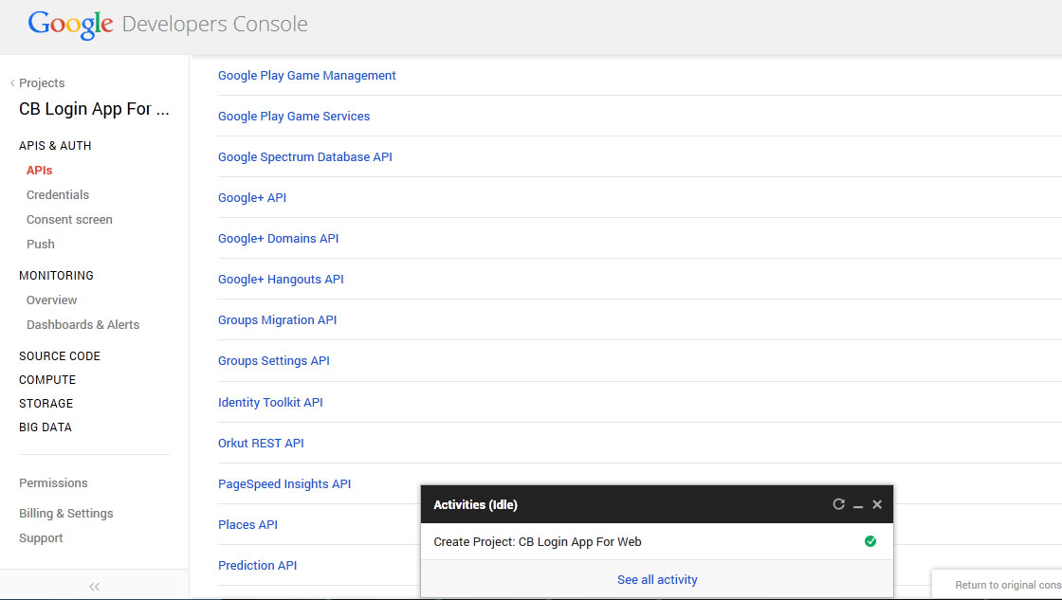

1. **After clicking, the page will show list of services. From these services, locate GOOGLE+ API and TURN IT ON**

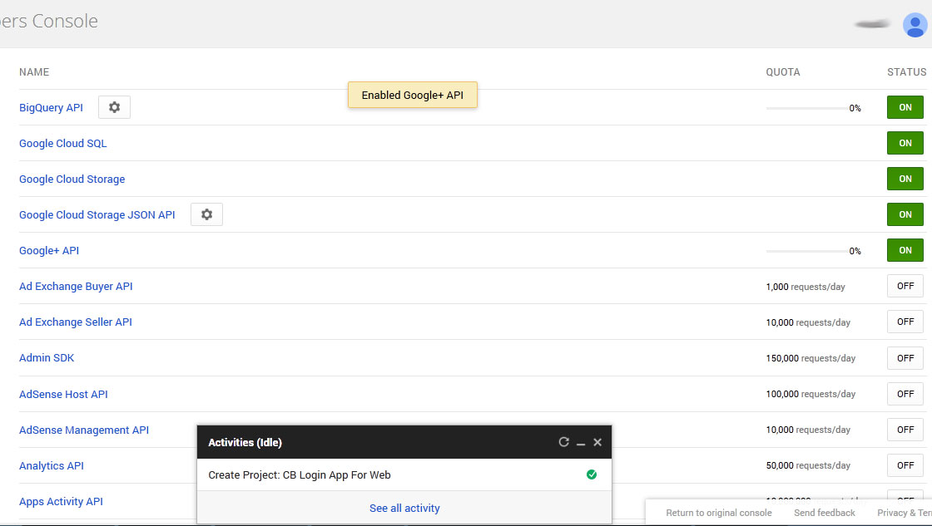

1. **As you turn on the service, it will be shown on top of list as above with GREEN ON BUTTON**

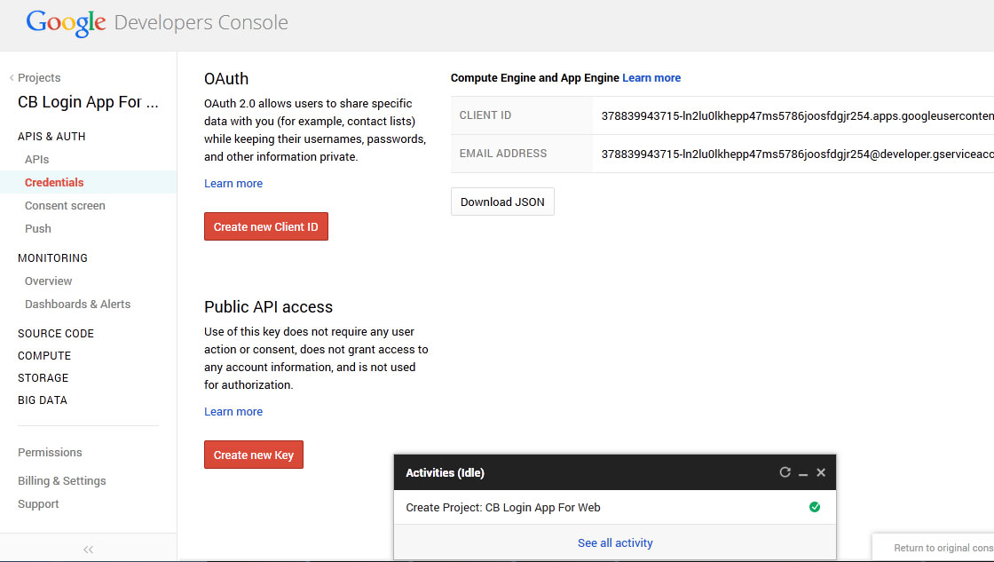

1. **From left menu click on CREDENTIALS, and as page show new contents, click on the Button CREATE NEW CLIENT ID**

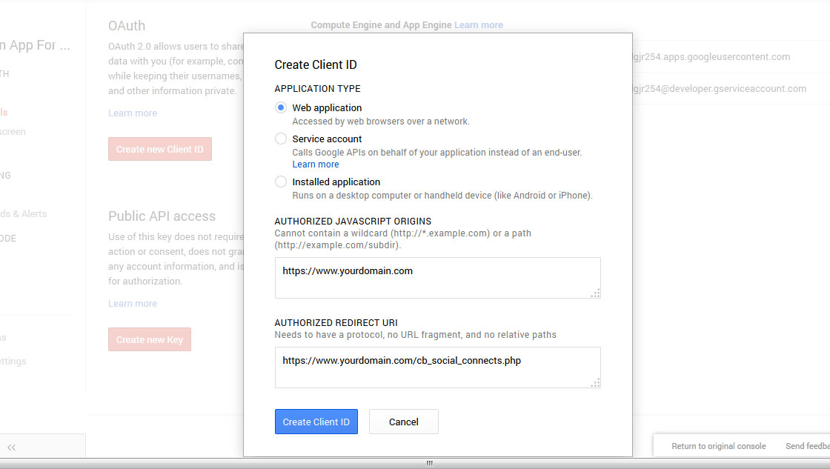

1. **After clicking the Button, in the popup appear, enter your DOMAIN and REDIRECT URL and finally click CREATE CLIENT ID**

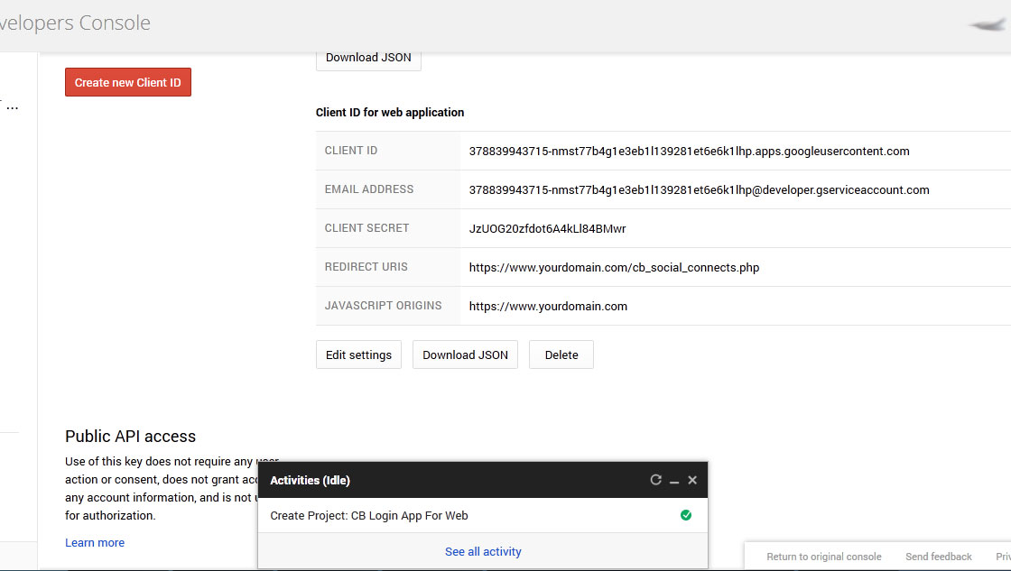

1. **After clicking the Button, you will be shown your APP CREDENTIALS to be used for your plug-in**