POLICORP GSCONNECT

USER GUIDE

Quick Guide to Using PoliCorp GSConnect

Summary
DESCRIPTION 03
USING THE APPLICATION 03
ENABLING PERMISSIONS ON THE SMARTPHONE 06
EXECUTE COMMANDS IN THE TERMINAL ON YOUR SMARTPHONE 08
MAIN FEATURES OF POLICORP GSCONNECT 09
KDE CONNECT MAIN FEATURES 10

LIST OF ILLUSTRATIONS
Figure 01: Opening PoliCorp GSConnect 04
Figure 02: Opening KDE Connect 04
Figure 03: Requesting Pairing in KDE Connect 05
Figure 04: Accepting pairing in PoliCorp GSConnect 05
Figure 05: Controlling PoliCorp GSConnect and KDE Connect 06
Figure 06: Listing supported KDE Connect features 06
Figure 07: Permission to send files on the smartphone 07
Figure 08: Sending file from smartphone to computer 07
Figure 09: Selecting device to execute commands 08
Figure 10: Defining a command 08
Figure 11: Running a command via KDE Connect 09

DESCRIPTION
To integrate your smartphone with your computer using Policorp Linux OEM, the solution consists of two applications, Policorp GSConnect (Linux) and KDE Connect (Mobile). Through these applications, you can pair devices using the same Wi-Fi connection.
Once the connection is established, you can manage phone notifications on your desktop, control media remotely, share files, send URLs, and more. Additionally, it allows users to control their computers remotely using their mobile devices. This means you can use your smartphone to control the mouse cursor, keyboard, file manager, and other features of your computer, even when you are not near it.

Prerequisites

- Policorp GSConnect (Linux): Linux application for installation on the Policorp Linux OEM System.
- KDE Connect (Mobile): The KDE Connect mobile app will be used for pairing devices. You can install the app from the Google Play Store or the App Store.
NOTE: Make sure both devices are connected to the same Wifi network.

USING THE APPLICATION

Open the application on both devices, Policorp GSConnect on your computer and KDE Connect on your smartphone.
On your computer, access Policorp GSConnect by going to the toolbar and clicking on “Device Settings”

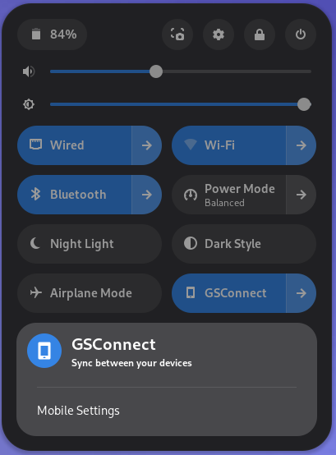
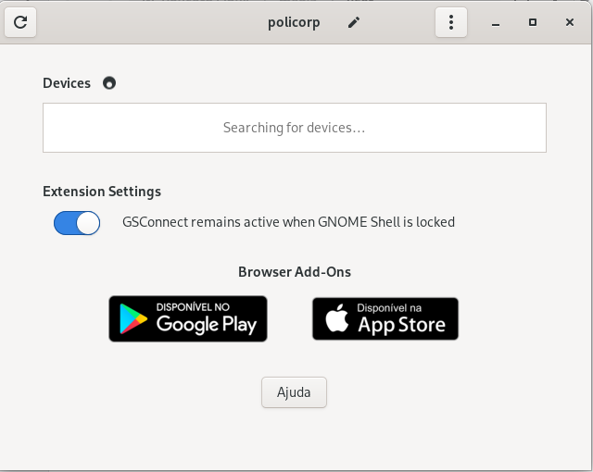
Figure 1: Opening PoliCorp GSConnect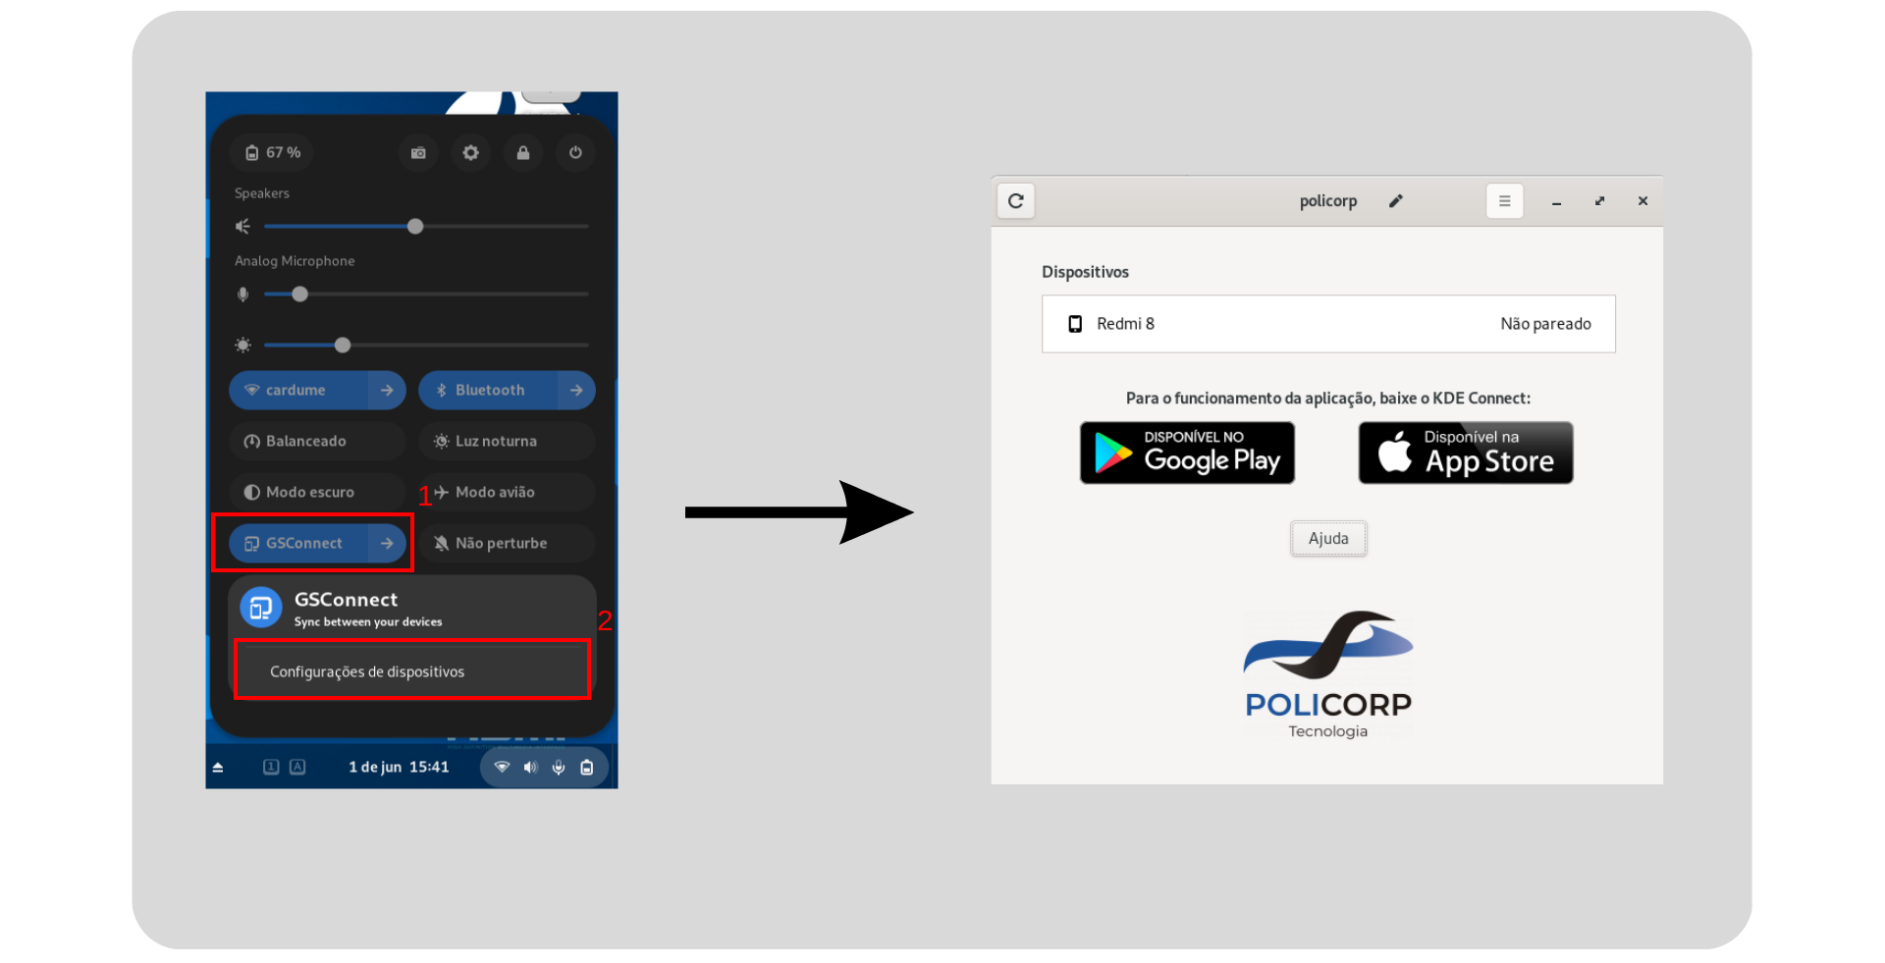
With the Application Window open on your computer, open the KDE Connect application on your smartphone. You will be able to connect to your computer:
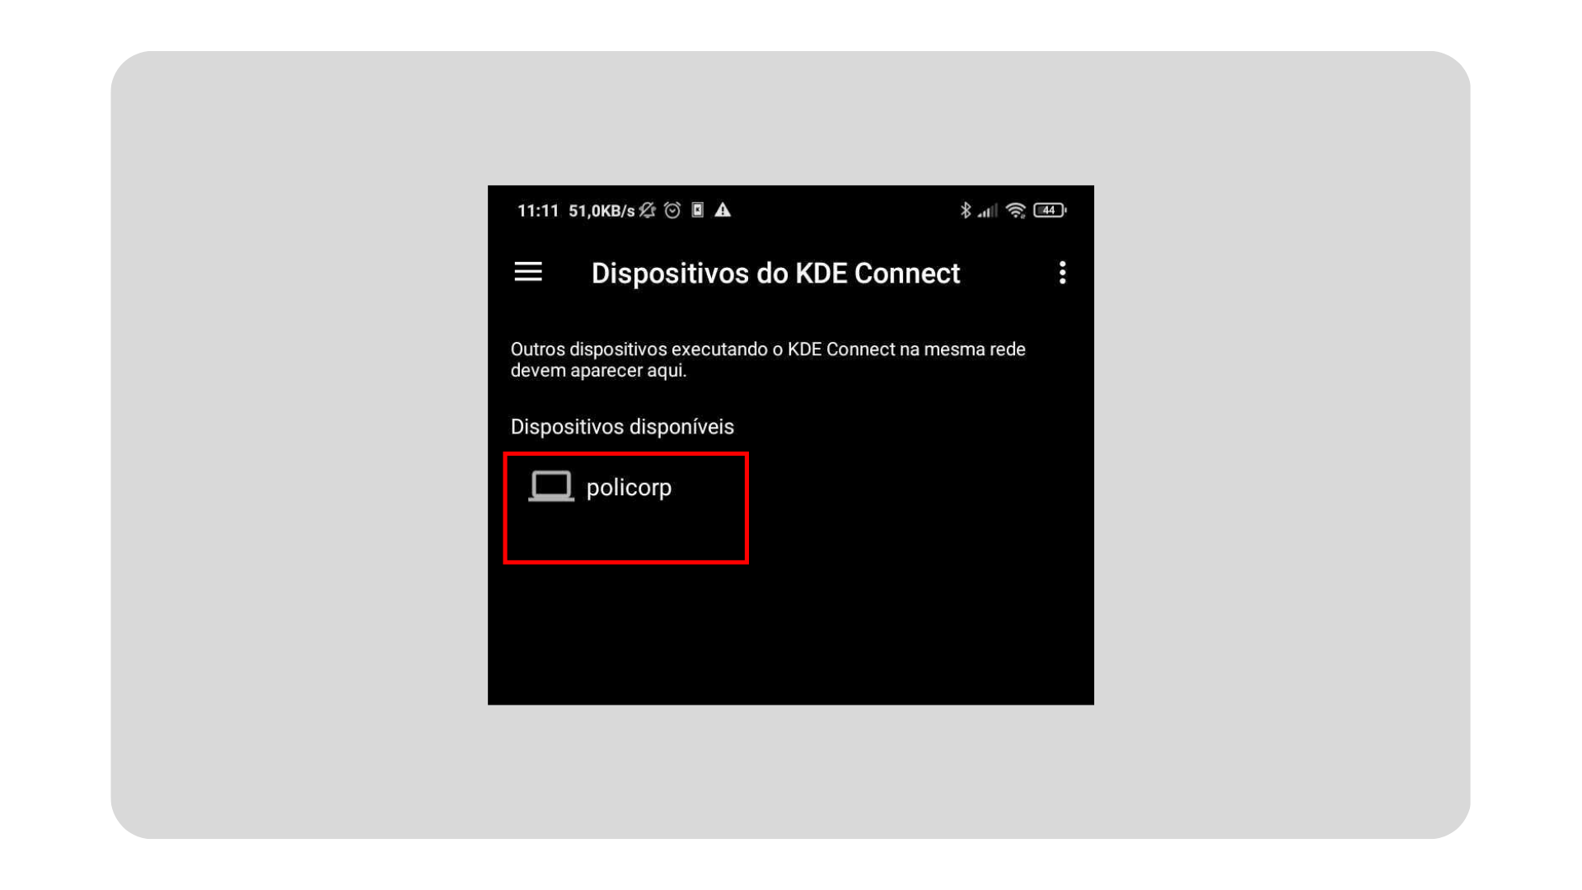Figure 2: Opening KDE Connect
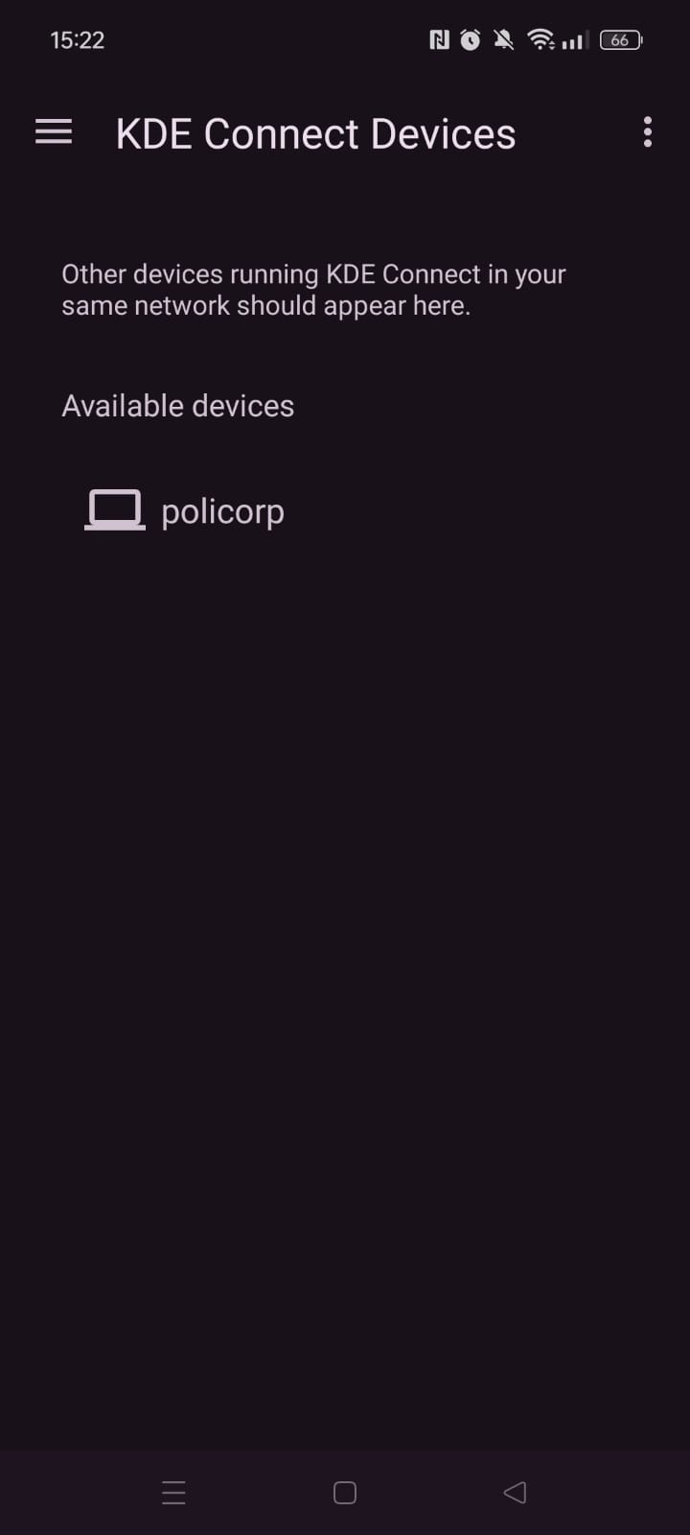

On your smartphone, click on your computer's Identifier. After clicking, press to request permission from your computer:

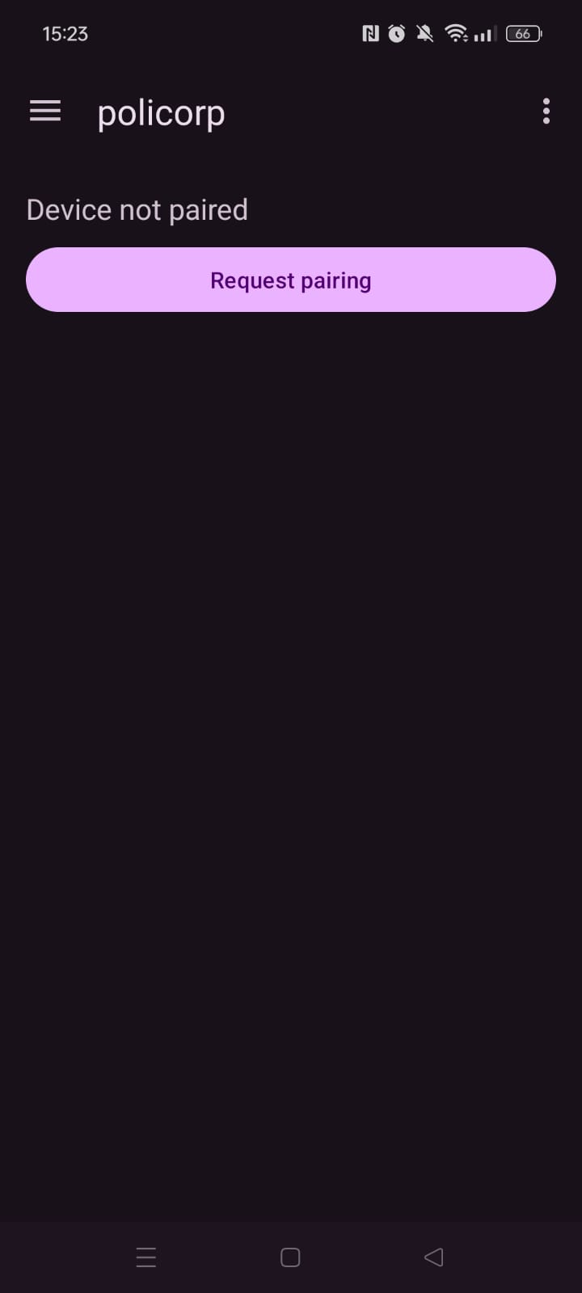

Figure 3: Requesting Pairing in KDE Connect

At the top of your computer screen, a request to access your device will appear, accept it:
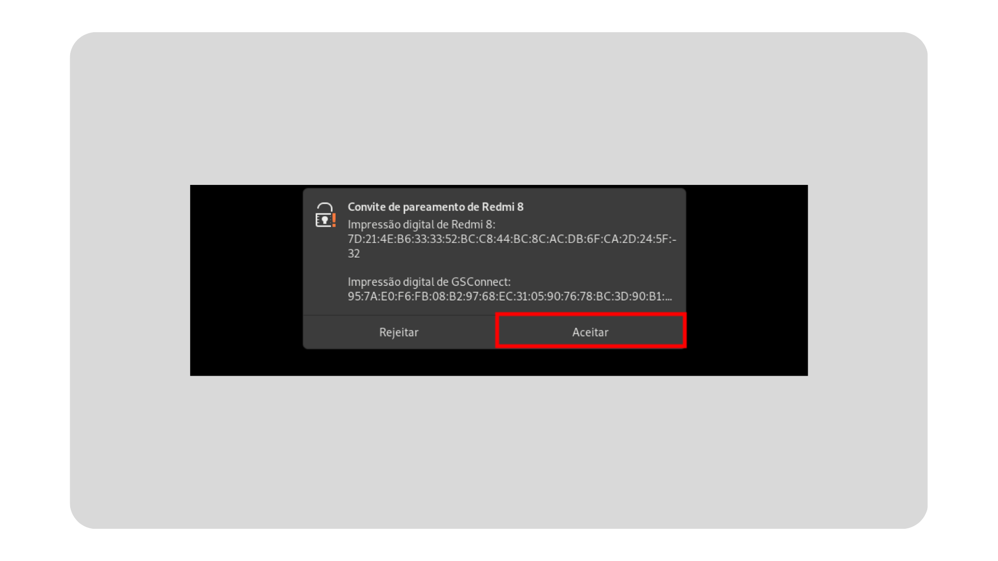Figure 4: Accepting pairing in PoliCorp GSConnect
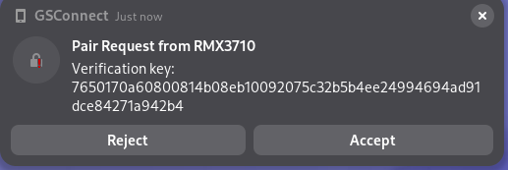

With paired devices, you can control your devices remotely and use their features:
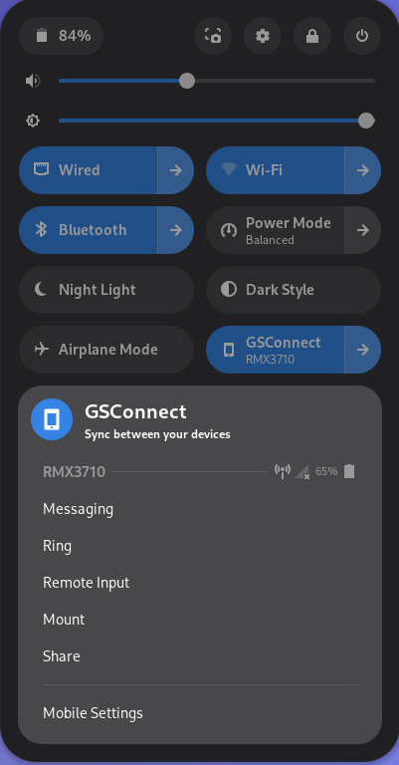
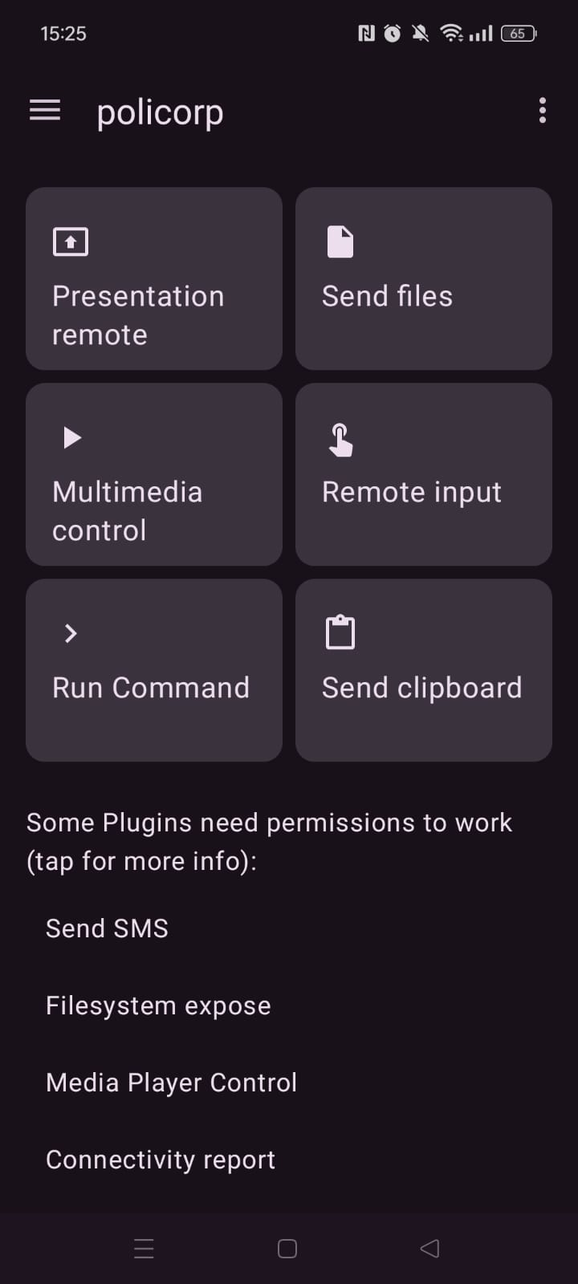

Figure 5: Controlling PoliCorp GSConnect and KDE Connect

ENABLING PERMISSIONS ON THE SMARTPHONE
Depending on your smartphone's operating system, some options may be different or located in different places. However, the general process should be similar. Connect to the desired device, and when paired, the compatible features between the two devices will be listed, as shown in the image below.
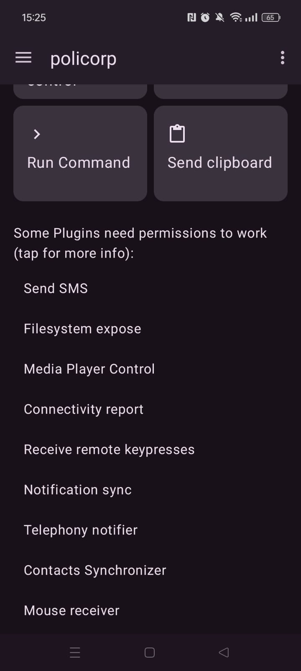

Figure 6: Listing supported KDE Connect features

When you select the “Send files” option, you will be asked for permission to use the files on your Smartphone. After you have given permission, you will be asked where you would like to store the files received on your computer.
After enabling the necessary permissions and saving the storage location in your smartphone's file management app, you can use the functionality to send files from your computer to your smartphone. When you click on “Share”, simply select the desired file and send it to the directory saved by the app on your smartphone. The file will be received and will be available in the indicated directory.
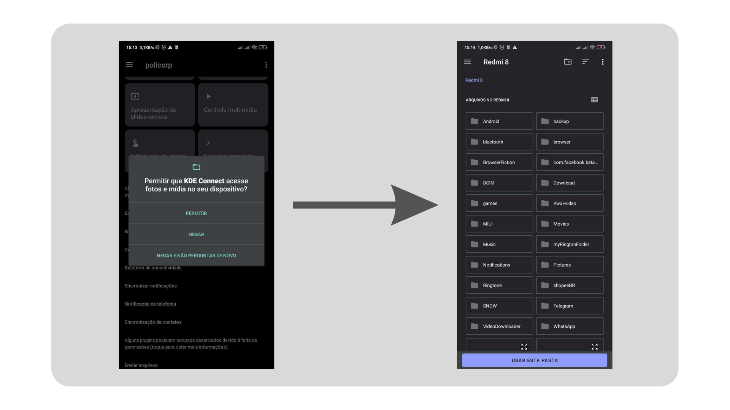Figure 7: Permission to send files on the smartphone
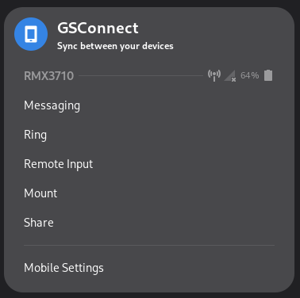
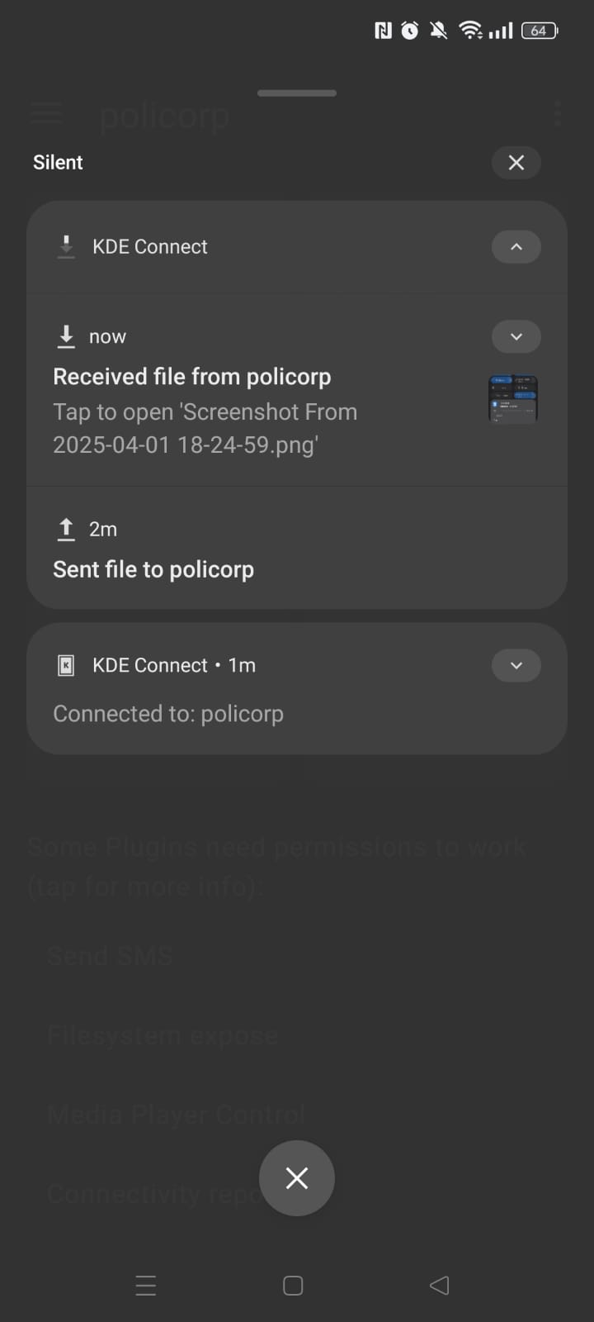
Figure 8: 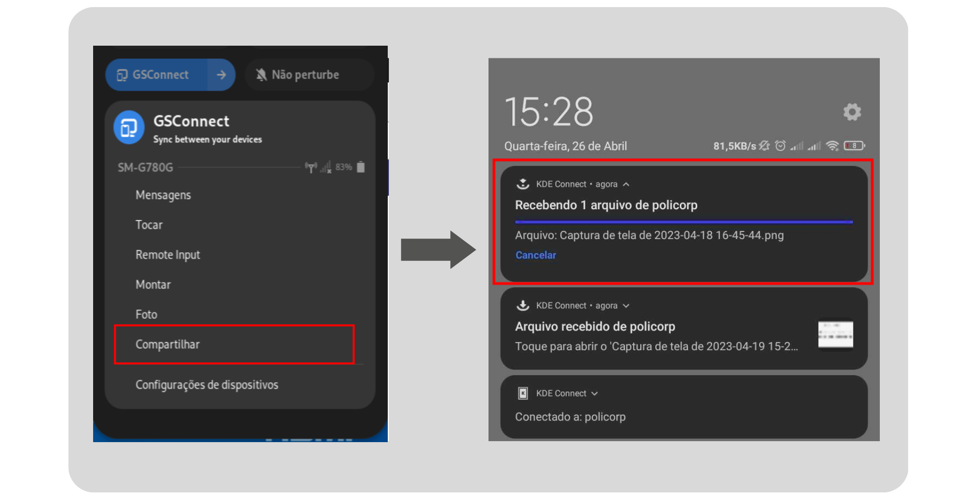Sending file from smartphone to computer

EXECUTE COMMANDS IN THE TERMINAL ON YOUR SMARTPHONE
The Policorp GSConnect application allows you to execute customized commands from your smartphone to your computer. However, it is important to note that these commands must be predefined in GSConnect, and it is not possible to execute commands that require administrator permission (root). To use this functionality, with the device paired, simply access the Device Settings from the taskbar and then access it:
Figure 9: 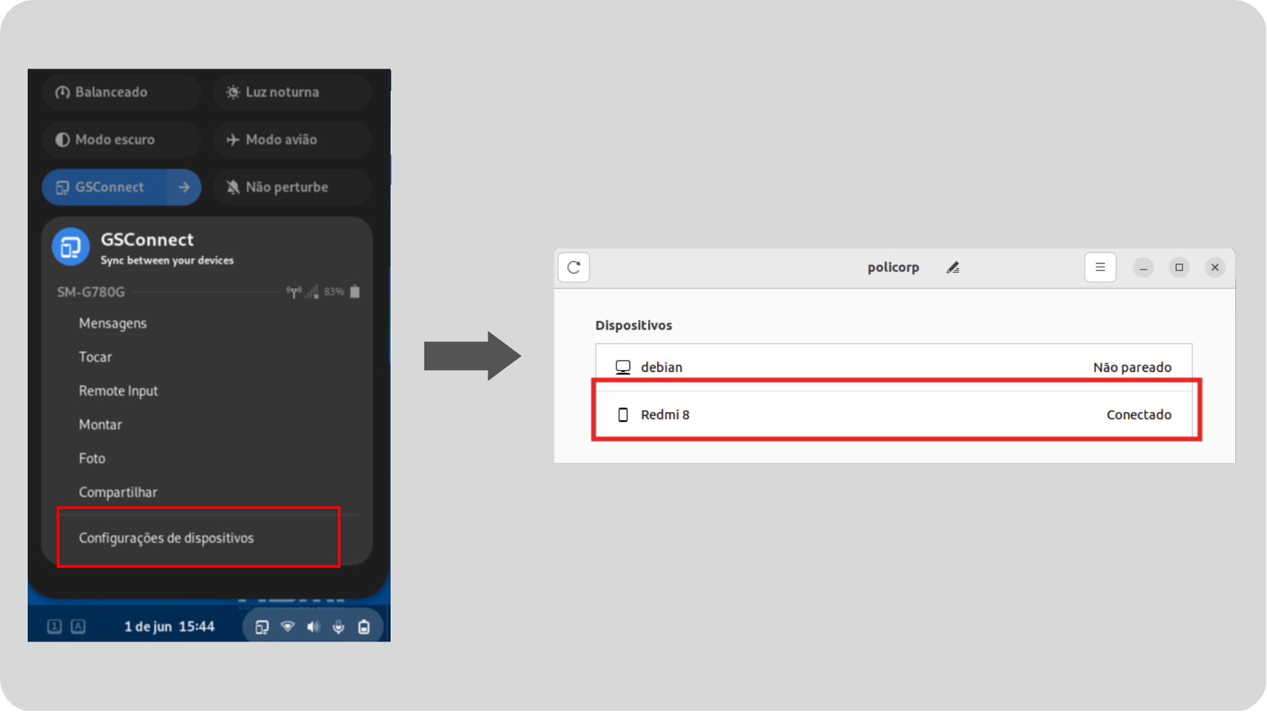Selecting device to execute commands

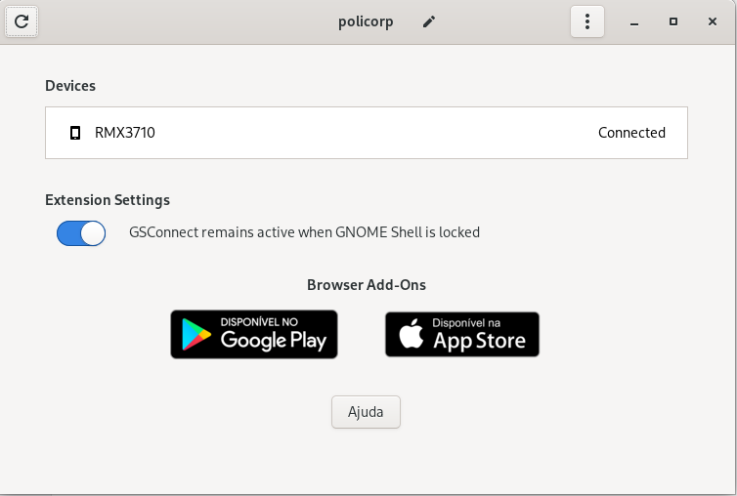

You can find the "+" button in the “Commands” tab, where you can add your own custom commands.
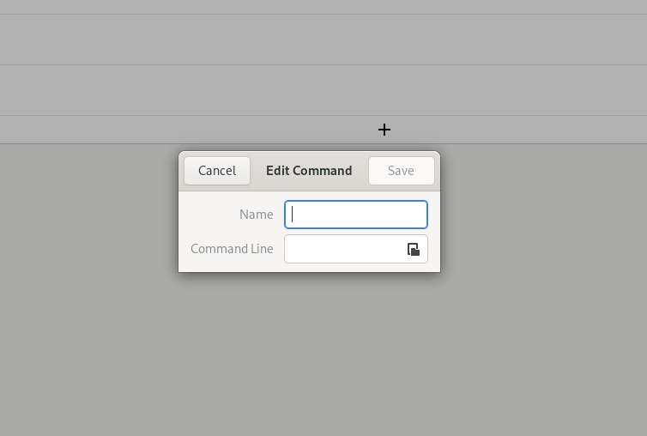
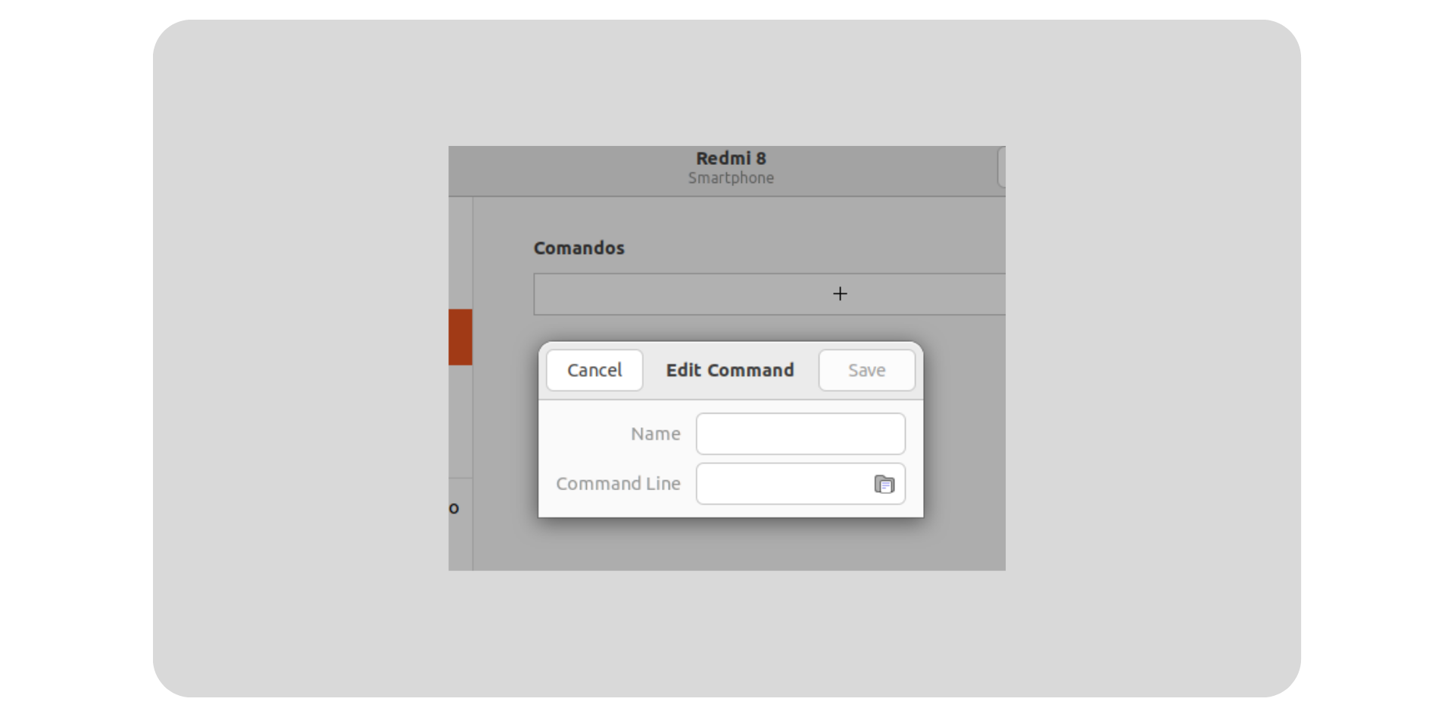Figure 10: Defining a command

In this window, you can define the command identifier (a label that will be displayed in KDE Connect) and the command itself that will be executed.
For example, we will use the identifier “Suspend” and the command “systemctl suspend”. After configuring the command, it will be displayed in the “Run Command” list in KDE Connect. When you execute the command, the instruction is reflected on the computer.

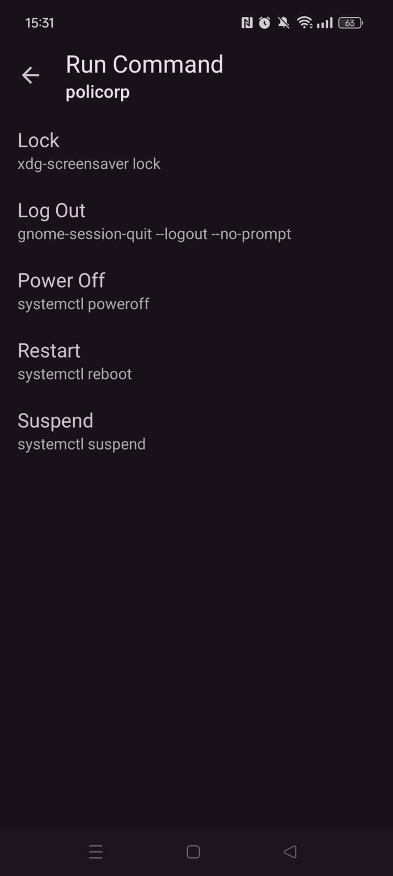
MAIN FEATURES OF POLICORP GSCONNECT (Computer → Smartphone)
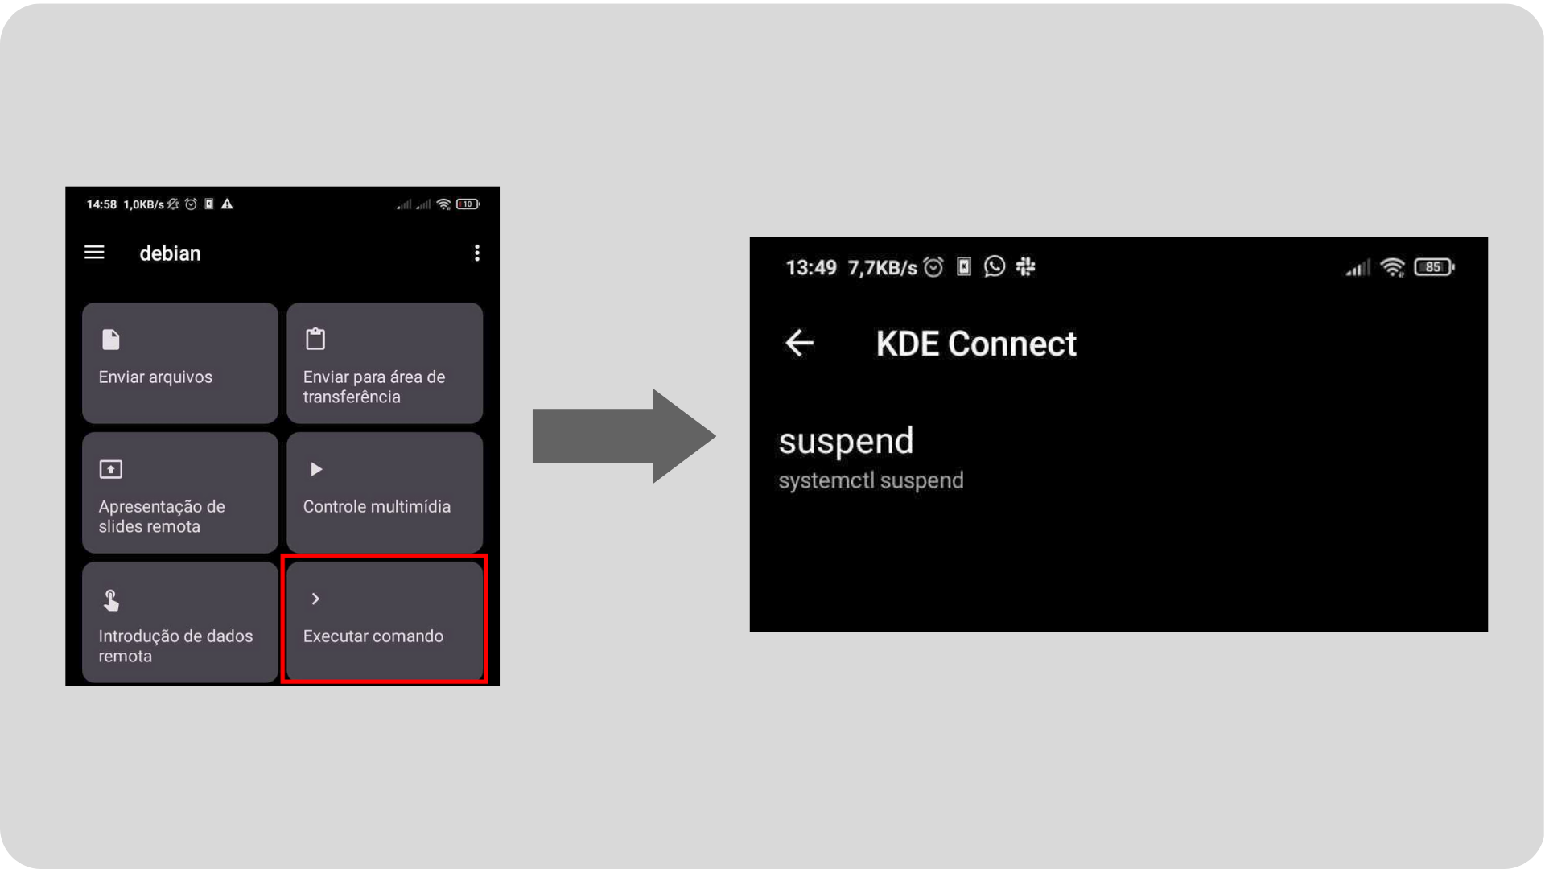Figure 11: Running a command via KDE Connect
- Notifications: Displays notifications from your smartphone on your desktop, including messages, calls, emails, reminders, and other notifications.
- File Sharing: Allows you to share files between your smartphone and your computer through a simple and intuitive interface
- Remote Control: You can control your smartphone from your desktop using your mouse and keyboard. This includes controlling music playback, adjusting the volume, and even unlocking your smartphone.
- Ring: Activate your smartphone's ringtone, a useful feature if you can't find your smartphone at home.

KDE CONNECT MAIN FEATURES (Smartphone → Computer)
- Media Control: KDE Connect mobile allows you to control media playback on your computer, such as music and videos.
- Control presentations: KDE Connect mobile allows you to control slideshows from your computer.
- Remote control: You can control your computer through your smartphone, using the mouse and keyboard.
- File sharing: Allows you to share files between your computer and your smartphone through a simple and intuitive interface.

Send questions and suggestions to the email suporte@policorp.com.br
Enjoy!

