Comparing Literature and Classifier Models

“Raw” Accuracy
With tannin/lignin definition:
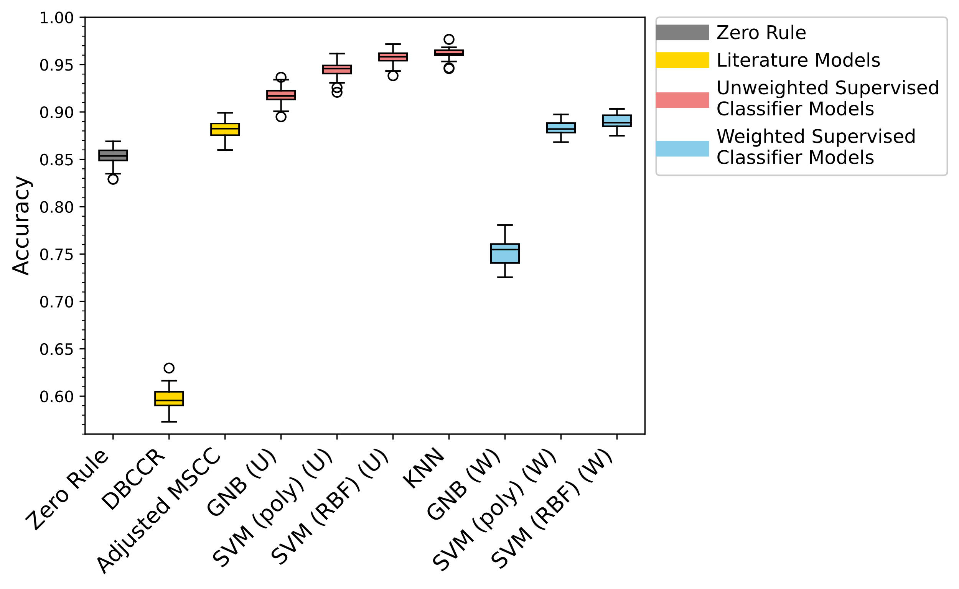
With phytochemical definition:
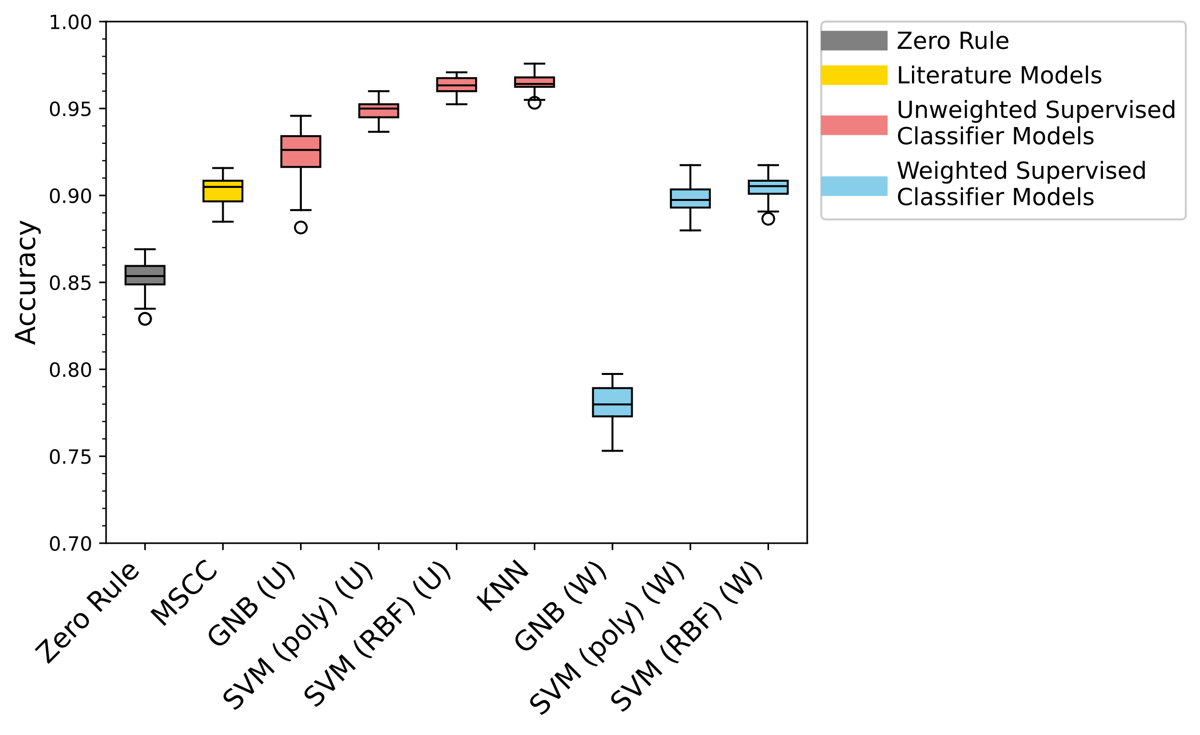

Balanced Accuracy
With tannin/lignin definition:
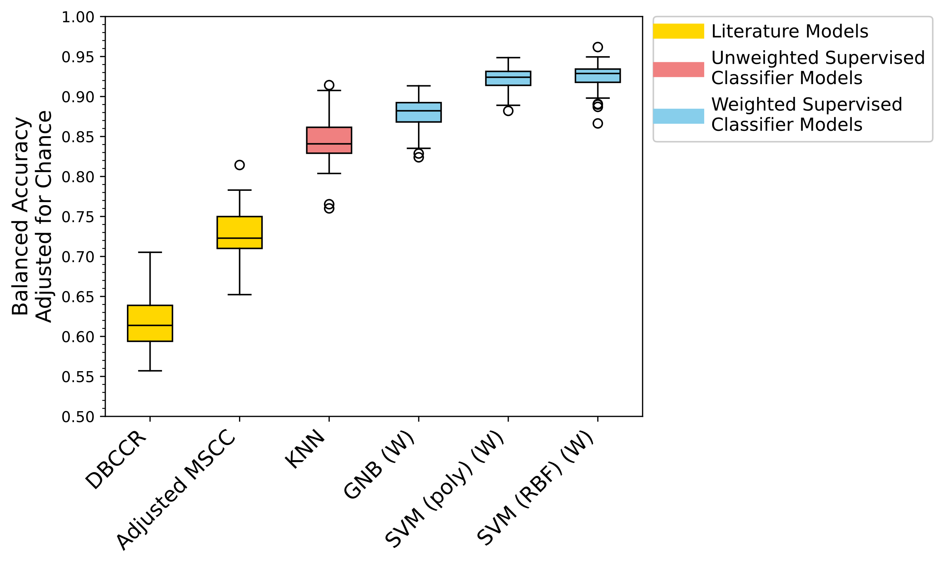
With phytochemical definition:
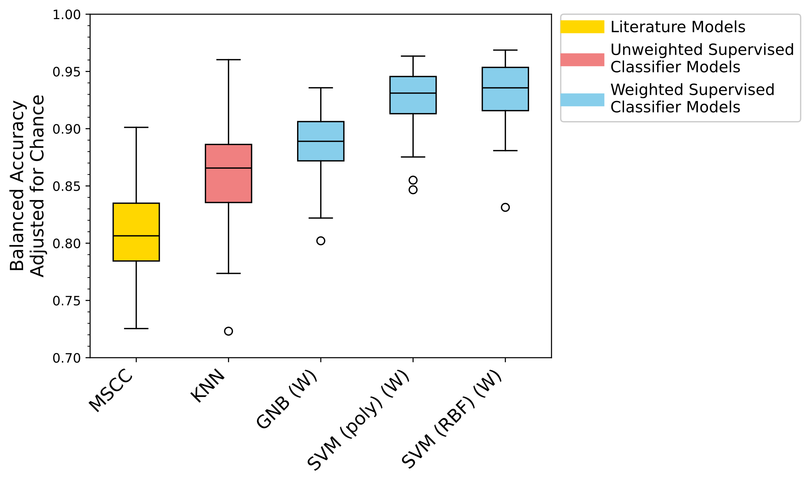

Comparing the Classifier Models (Including PAHs)

“Raw” Accuracy

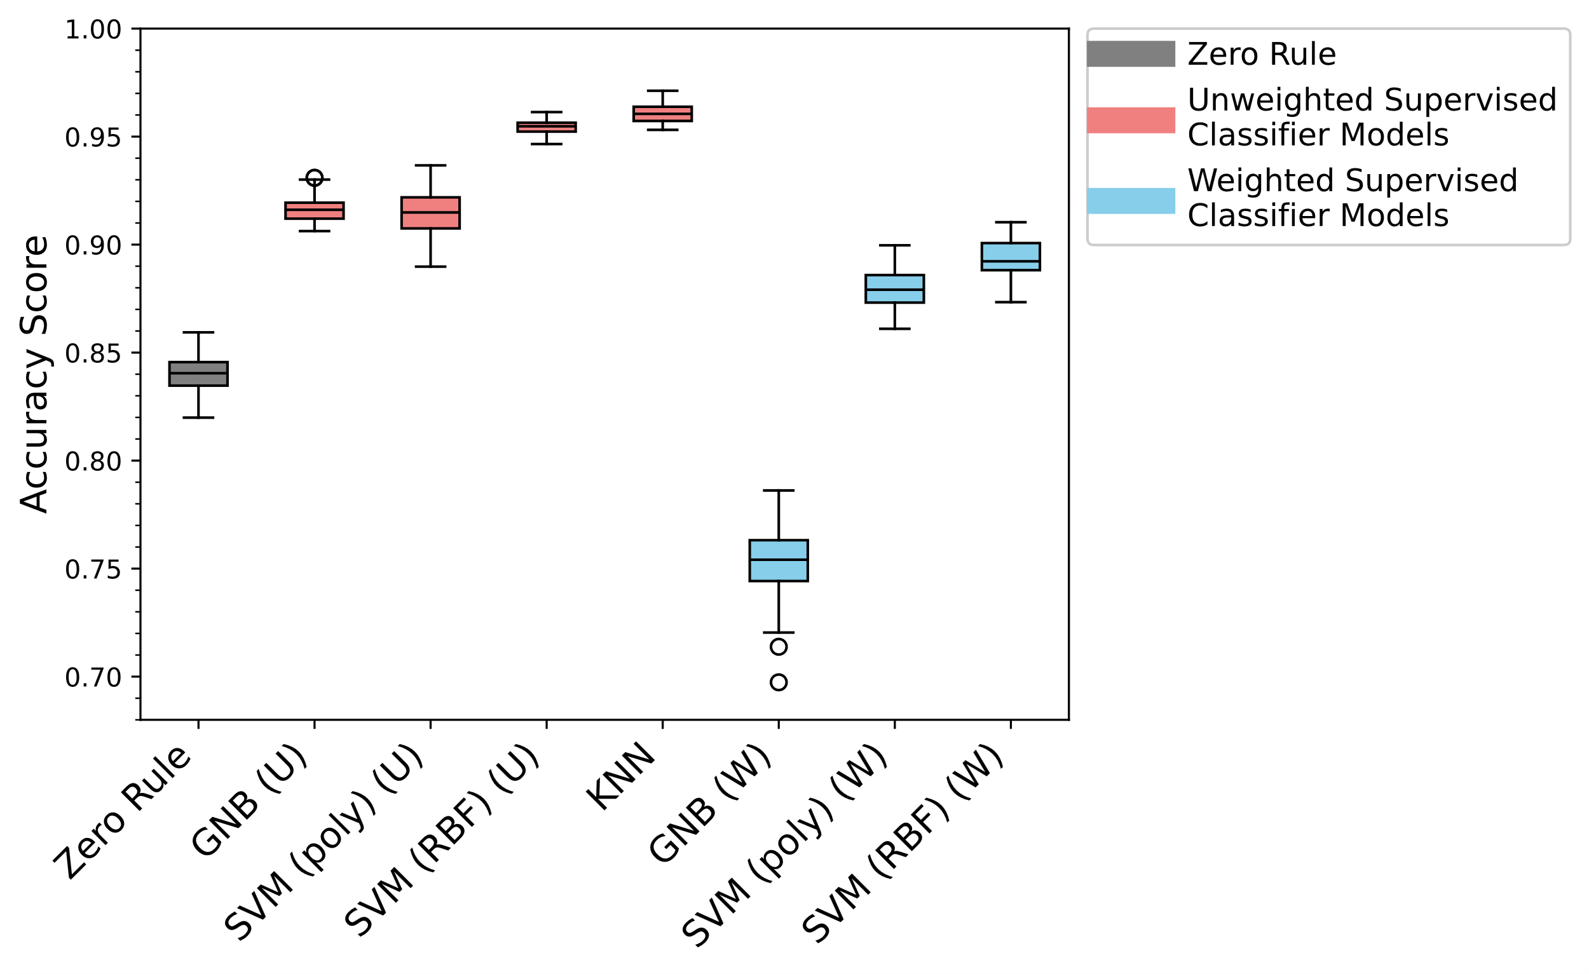
Balanced Accuracy
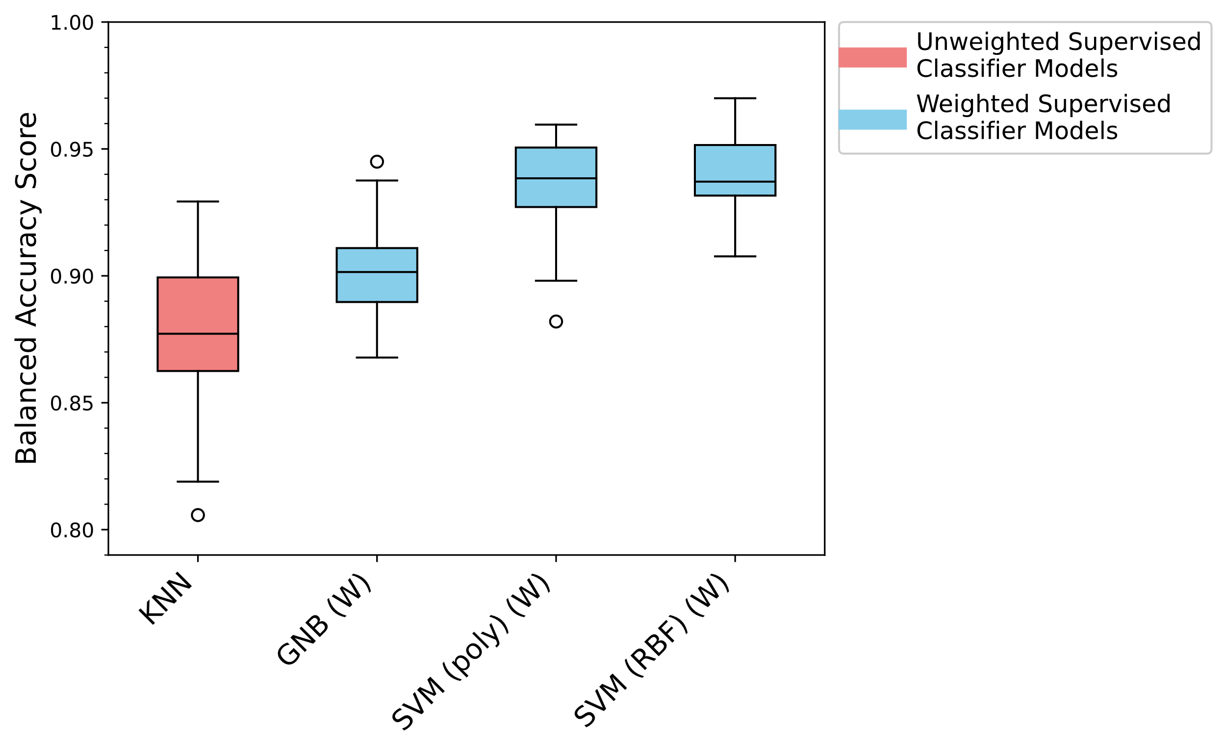

Brier Loss Score
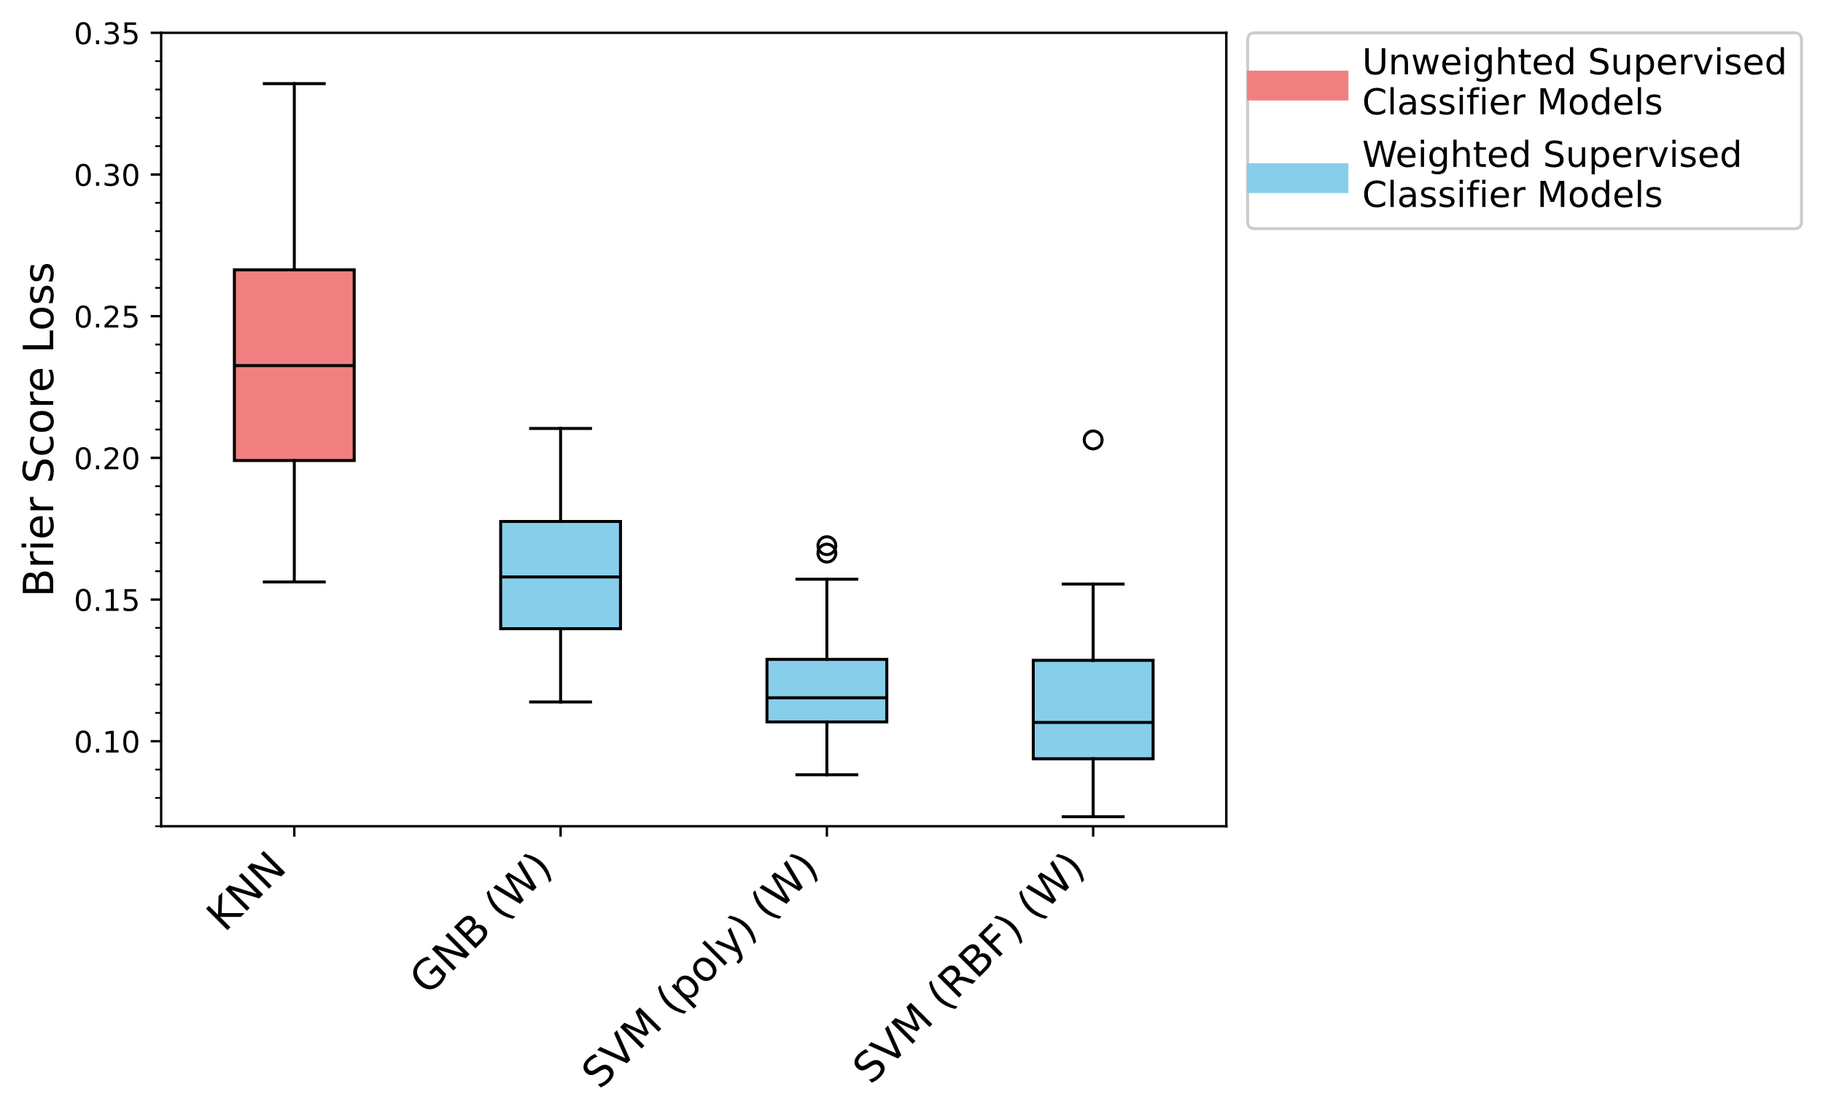

Boxplot or Violin Plot?
Examples:
